1. PSI-BLAST first iteration is the same as a blastp search. Past that point, PSI-BLAST will retrieve the best hits and generate multiple alignment for those. A PSSM will be generated based on the alignment of these hits, with more conserved regions having more weight in the matrix. This way, PSI-BLAST next iteration will “value” the conserved regions and their specific amino acids higher than non-specific regions, bringing more hits with the same motif to your attention. PSI-BLAST may then repeat this process until no new hits are obtained or sooner if one would choose so.

2. PSSM is position-specific scoring matrix, and is used to store information on conserved motifs of sequences. The matrix contains information about positions of elements and their frequency among the chosen sequences. It then stores this information as log odds ratio of elements at this position and frequency– compared to if the sequence was unrelated/random. It can then be used to look for specific motifs in sequences.

3. If PSI-BLAST search converges, it means it can not find any new hits in the next iteration, and PSSM would not change if last query sequences are integrated.

4. https://www.ncbi.nlm.nih.gov/protein/P08487.1?report=fasta

5. https://www.ncbi.nlm.nih.gov/protein/Q95M30.3?report=fasta
Considering “most similar” as highest value hit according to consensus on similarity, E-value and sequence length (some shorter sequences were more identical)
6. MSA allows us to visualise how conserved (and thus important to function) some residues and motifs are. It can also be used to calculate how (relatively) similar or different they are and find points of evolutionary divergence.
7. Conserved sequences are sequences that have remained homologous throughout evolution. Considering presence of genetic drift and steady introduction, deletion or replacement of residues, these residues or motifs remained similar, or conserved, due to their relevance to function under positive selection.
8. Gaps and non-aligned are not coloured. Residues that have positive BLOSUM score are light blue. Residues that match the consensus residue (most conserved) are dark blue.
9.
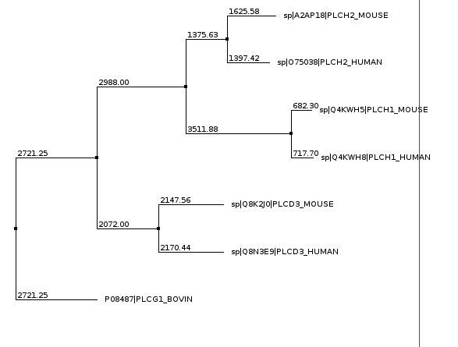

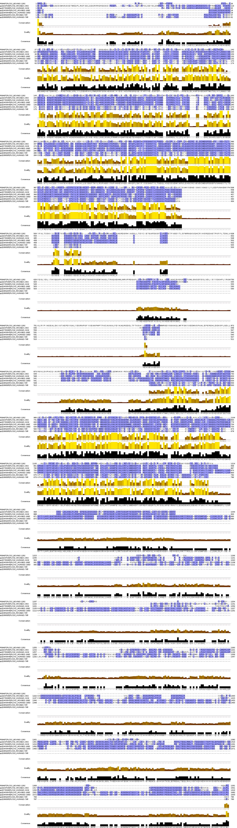
10. ClustalX colour scheme:
Residues are grouped depending on their (predicted) chemical properties.
Thresholds are set differently for different groups, and detailed threshold explanation is found here:
http://www.jalview.org/help/html/colourSchemes/clustal.html
If the residue passes the threshold value, it would be coloured:
K, R = Red (positive charged residues)
E,D = Purple (negative charged residues)
N,Q,S,T = Green (polar residues)
A,I,L,M,F,W,V(Sometimes C) = Blue (hydrophobic residues)
C = Pink or blue (depends on consensus threshold)
G, P = Orange, yellow respectively(>0% threshold, so always coloured)
H, Y = Cyan (aromatic)

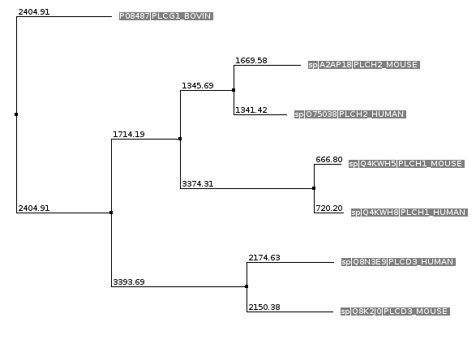
11.
