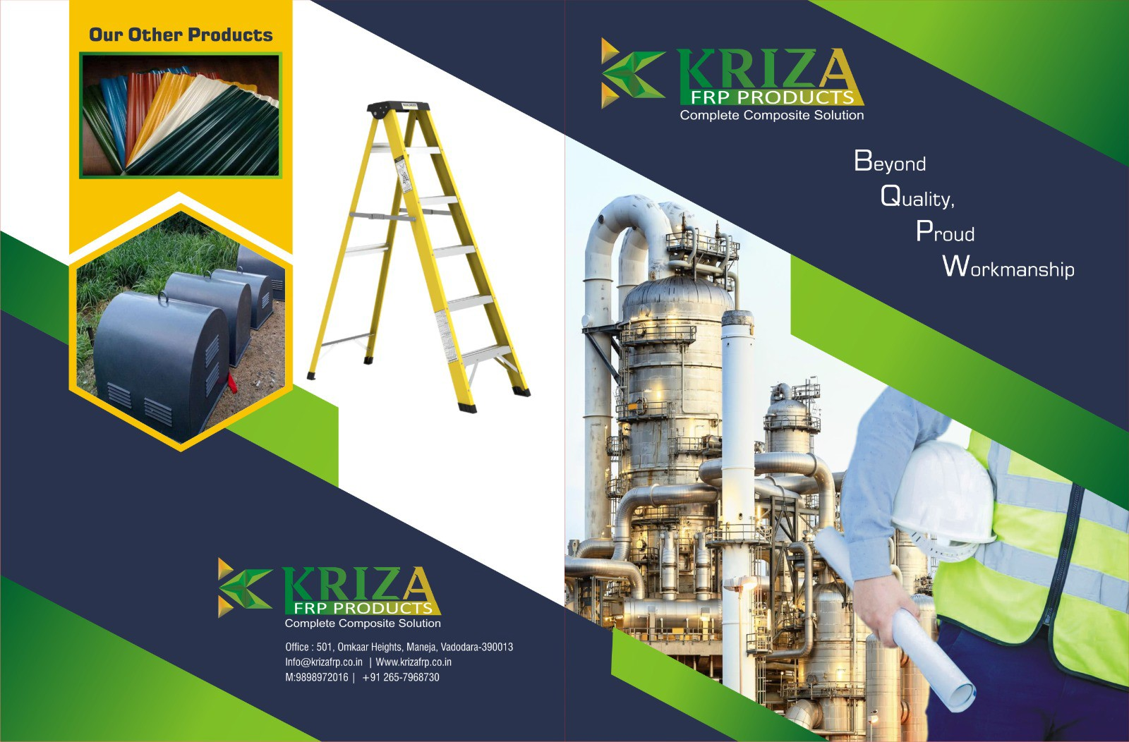

Change logo

FRP PERFORATED TYPE CABLE TRAY
FRP LADDER TYPE CABLE TRAY

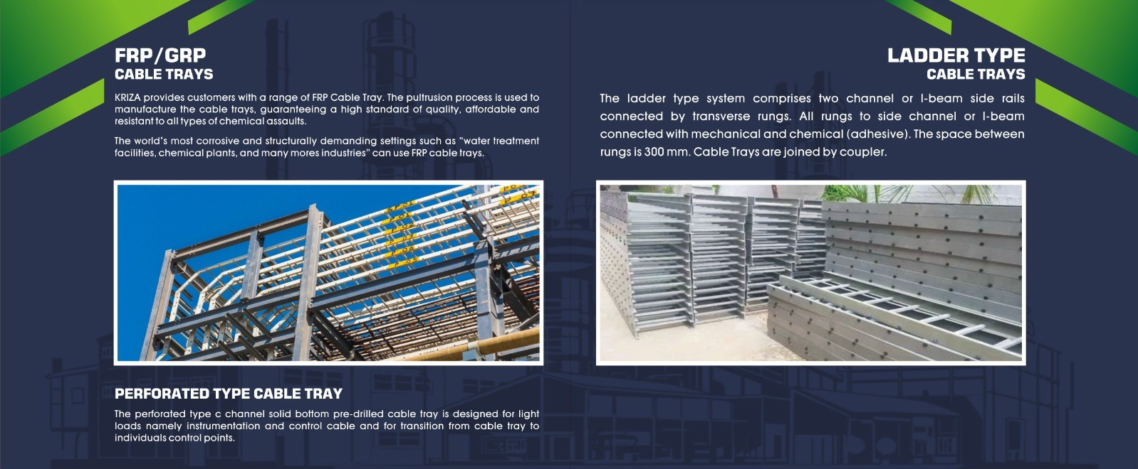
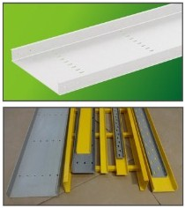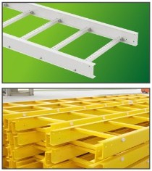
Width (mm) | Height l (mm) | ength (m) | Colour | Resin Type | Accessories
50 | 50 | 3 or as per Customer's requirement | Grey White or  others | Polyester / Vinyl Ester | Bend,Tee, Cover, Cross
100 | 50/ 100
150  200  300  400 | 50  50/ 100  50/ 100  50/ 100
450 | 100
500 | 100
600 | 50/ 100/150

Width (mm) | Height l (mm) | ength (m) | Colour | I Resin Type | Accessories
100 | 75/ 100 | 3 or as per Customer's requirement | Grey While or  others | Polyester I  Vinyl Ester | Bend, Tee, Cover, Cross
300 | 75/ 100
400 | 100/ 150
500 | 100/ 150
600 | 100/ 150
700 | 100/ 150
1000 | 100/ 150
1200 | 100/ 150
1400 | 100/ 150

Perforated Type

45° Horizontal Bend 45° Vertical Internal Bend 45° Vertical External Bend

90° Horizontal Bend 90° Vertical Internal Bend 90° Vertical External Bend

Cross Tee Cover
LADDER Type

Smooth Top Gritted Top Surface Chequered Plate

45° Horizontal Bend 45° Vertical Internal Bend 45° Vertical External Bend 90° Horizontal Bend

Plain Surface Concave Surface Gritted Top Surface

90° Vertical Internal Bend 90° Vertical External Bend Cross Tee

FRP GRATINGS
Plate

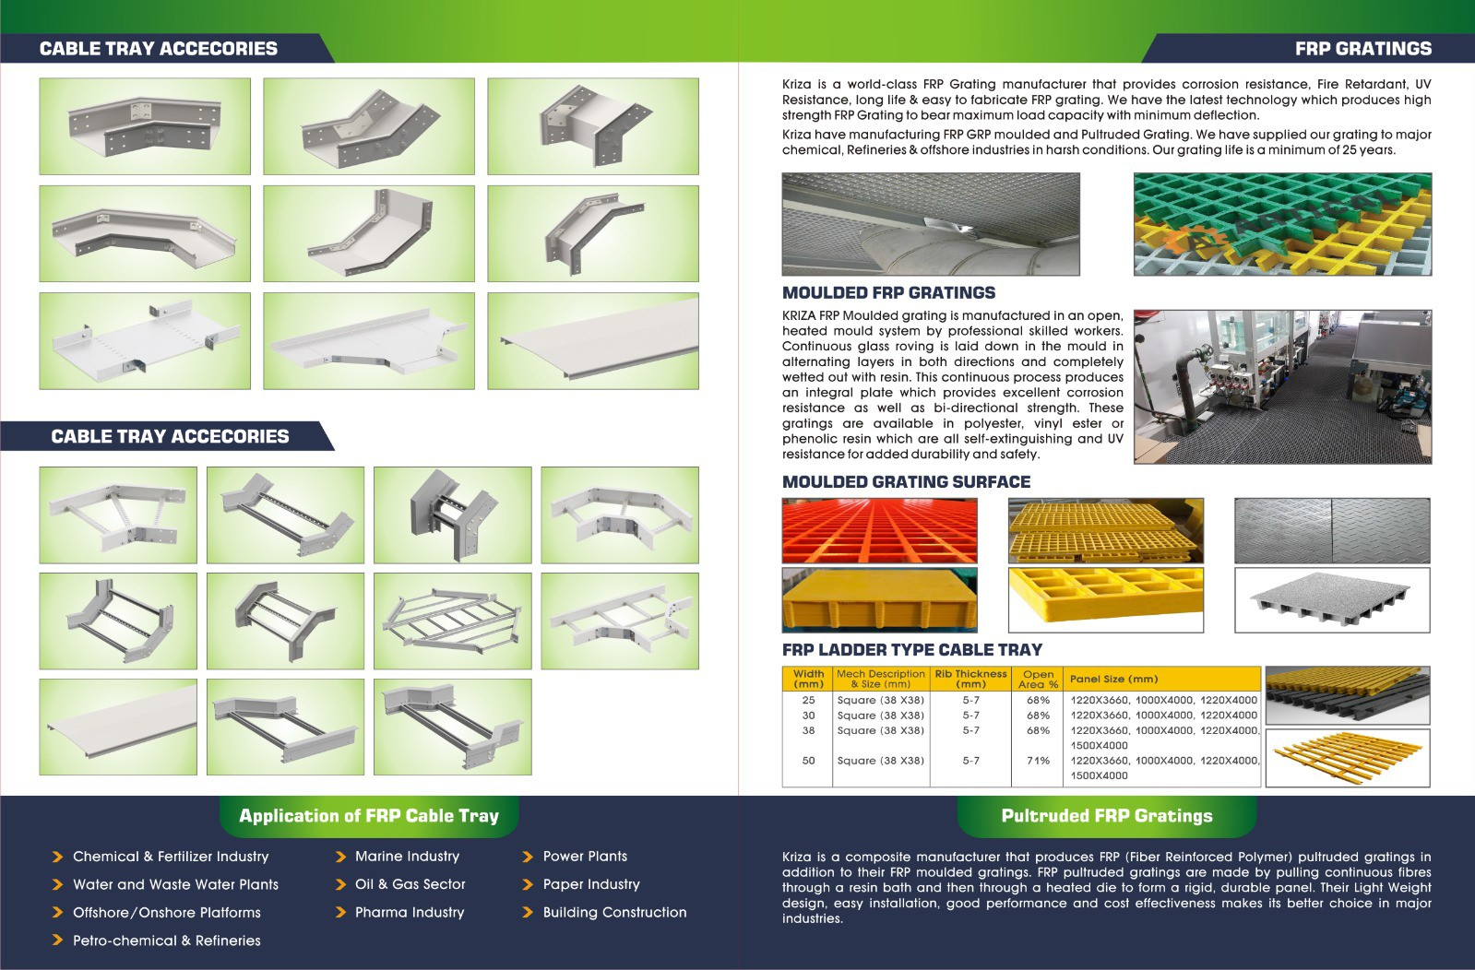Cover Offset Reducer

Straight Reducer

PULTRUTED GRATING SURFACE

H(mm) | w | s | Open  Area (%)
25 | 15 | 25 | 40
25 | 15 | 30 | 50
25 | 15 | 38 | 60
30 | 15 | 25 | 40
30 | 15 | 38 | 60
38 | 15 | 25 | 40
38 | 15 | 30 | 50
38 | 15 | 38 | 60

•

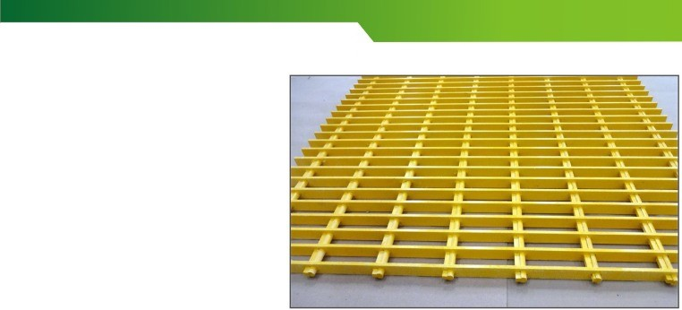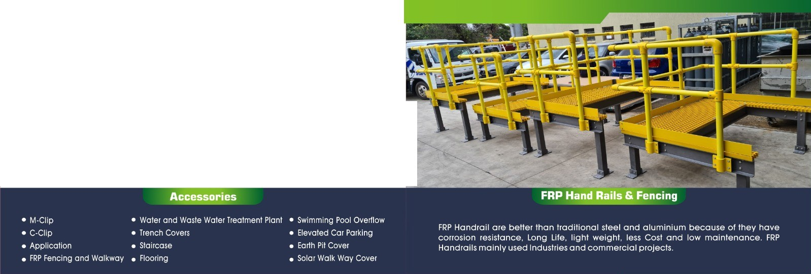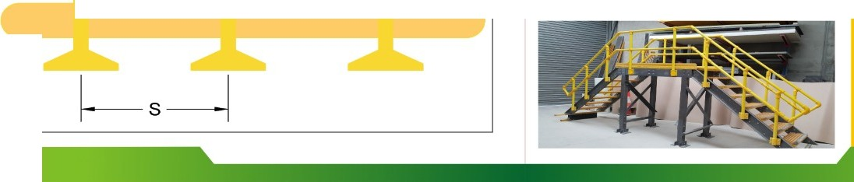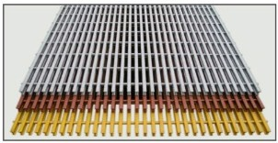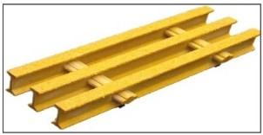Application
- Industrial Platform
- Waler and Waste Wa er Plant
- Chemical Storage Tank
- Railway Two Sides Guardrail
- 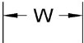Coastal Guardrail
- Transformer Fencing
f • Boundary Fencing
H
t

Features of FRP Handrails
- High strength

- Light weight

- Superb anti corrosion performance

- Maintenance free

- Electric, heat, and sound insulation

- Easy installation

- UV protected

- Electronically transparent

- Anti skid/ slip

- Fire retardant

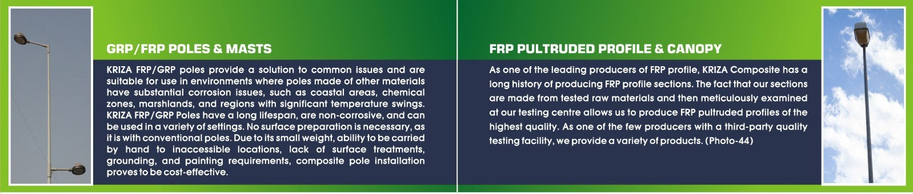

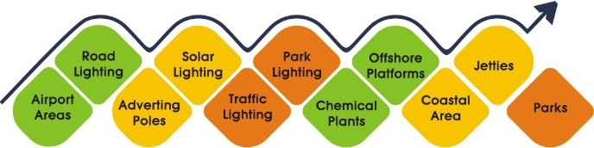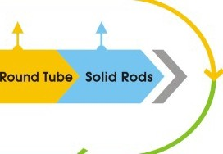
APPLICATION
' .
C-ehannel
'
•
Range:
•
I-beam
Angle
Square

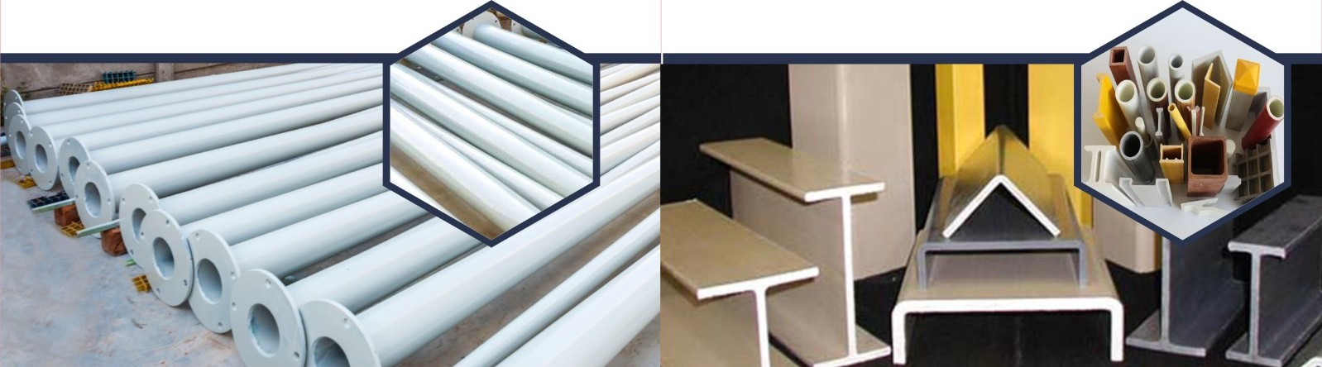

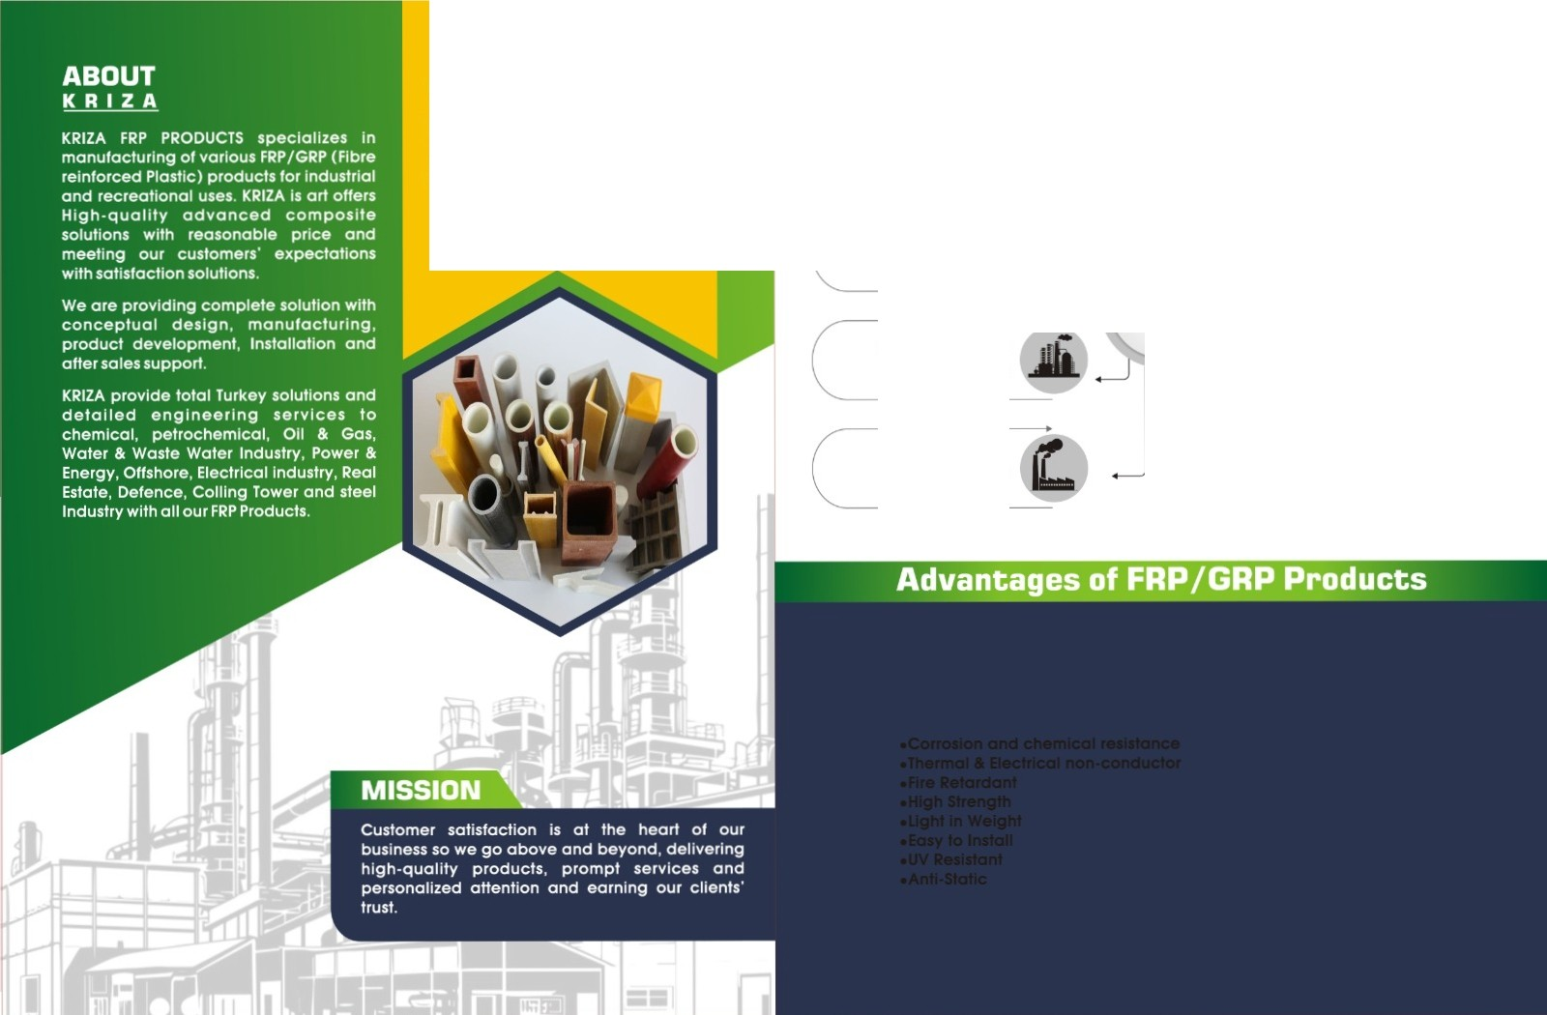VISION
Krlza concentrates on to become w or ld best ma nufa c t ur ed in FRP/GRP Products.

Pharma & Chemical

Oil & Gas

Petrochemical
& Refineries

Textile

Kriza
FRP Cable Tray
L
<f}'t{I' Infrastructures

On Shore & Off Shore

Power Plant

- Real Estate

