
Change Logo

Change Logo

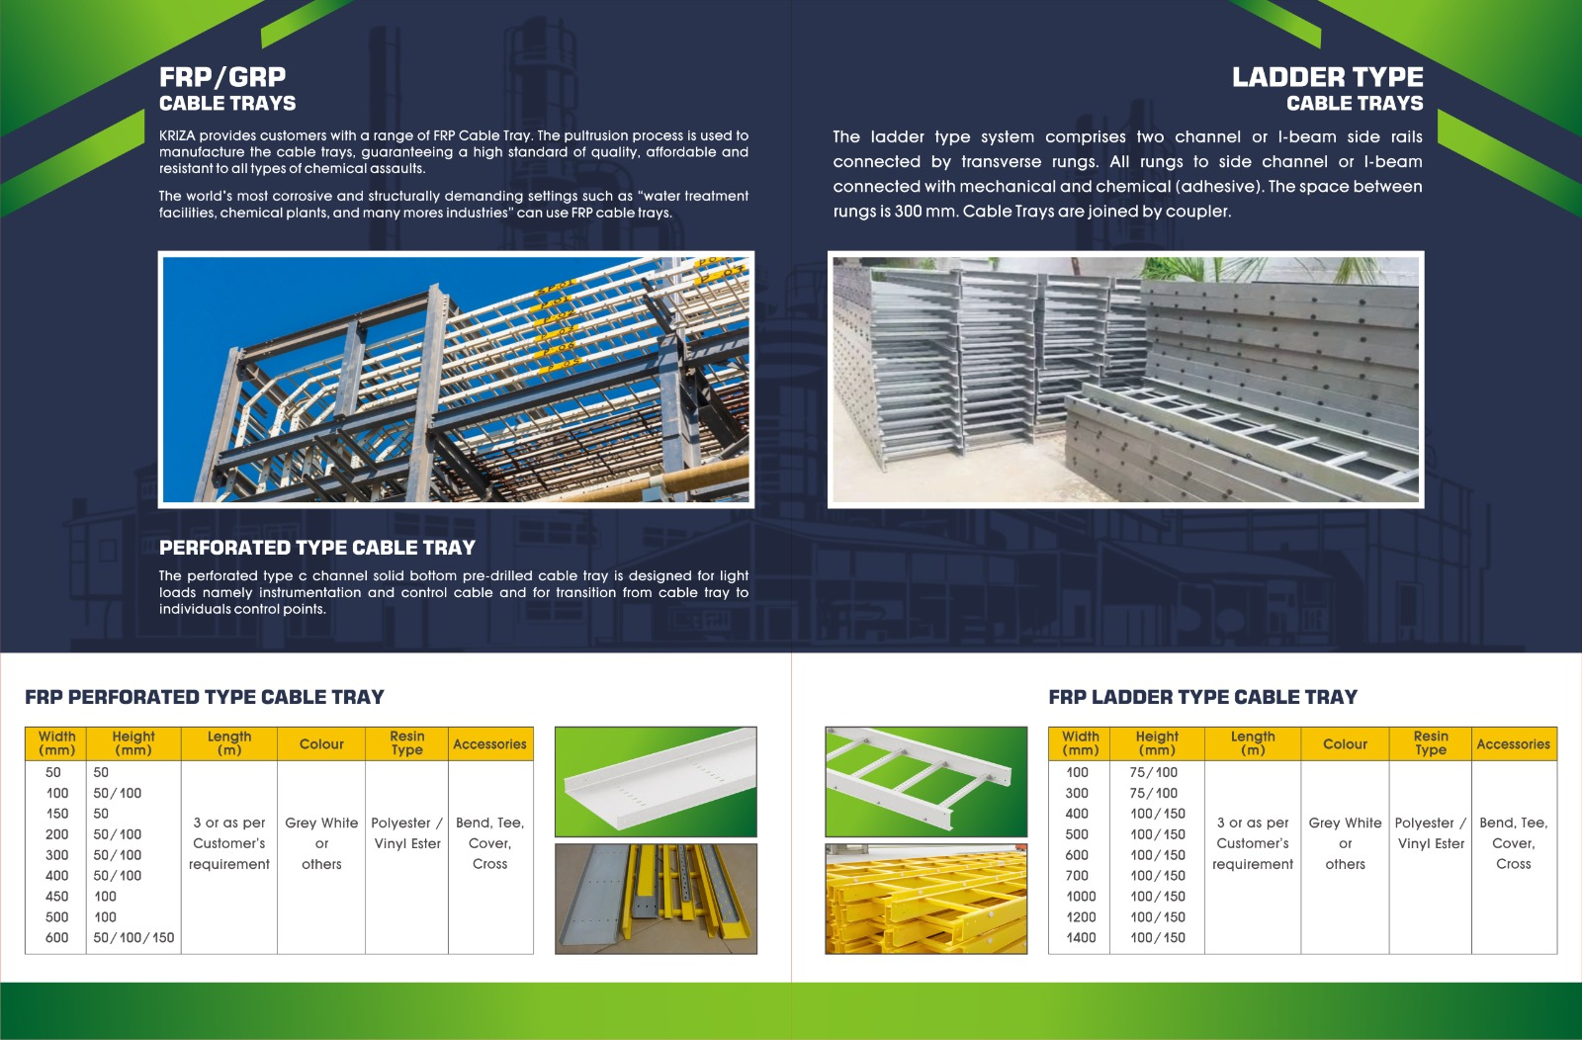

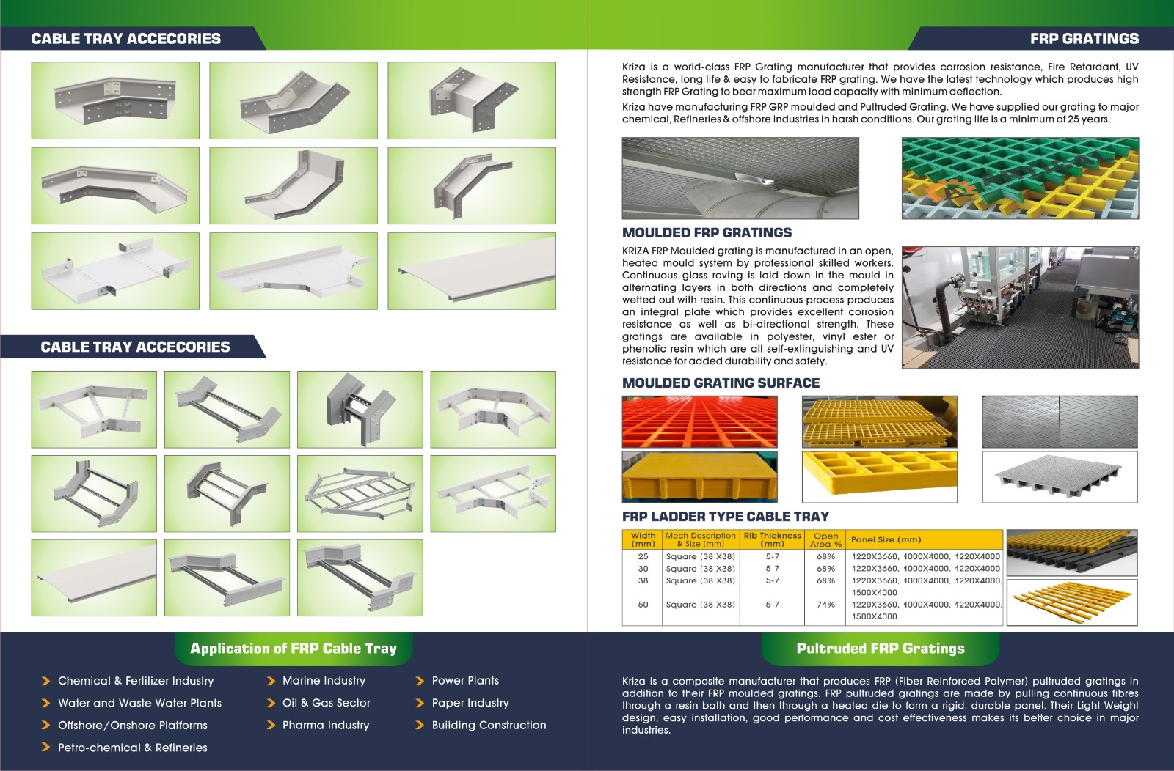
Add “PERFORATED TYPE”

45° Vertical Internal Bend

45° Vertical External Bend

45° Horizontal Bend

90° Vertical Internal Bend
90° Vertical External Bend

90° Horizontal Bend

Cross

TEE

Cover

Add “LADDER TYPE”

SMOOTH TOP

Chequered Plate

Gritted Top Surface

90° Horizontal Bend

45° Vertical Internal Bend

45° Horizontal Bend

45° Vertical External Bend

Plain Surface

FRP MOULDED GRATING

Gritted Top Surface Plate
Concave Surface

TEE

Cross

90° Vertical External Bend

90° Vertical Internal Bend

Straight Reducer

Offset Reducer

Cover

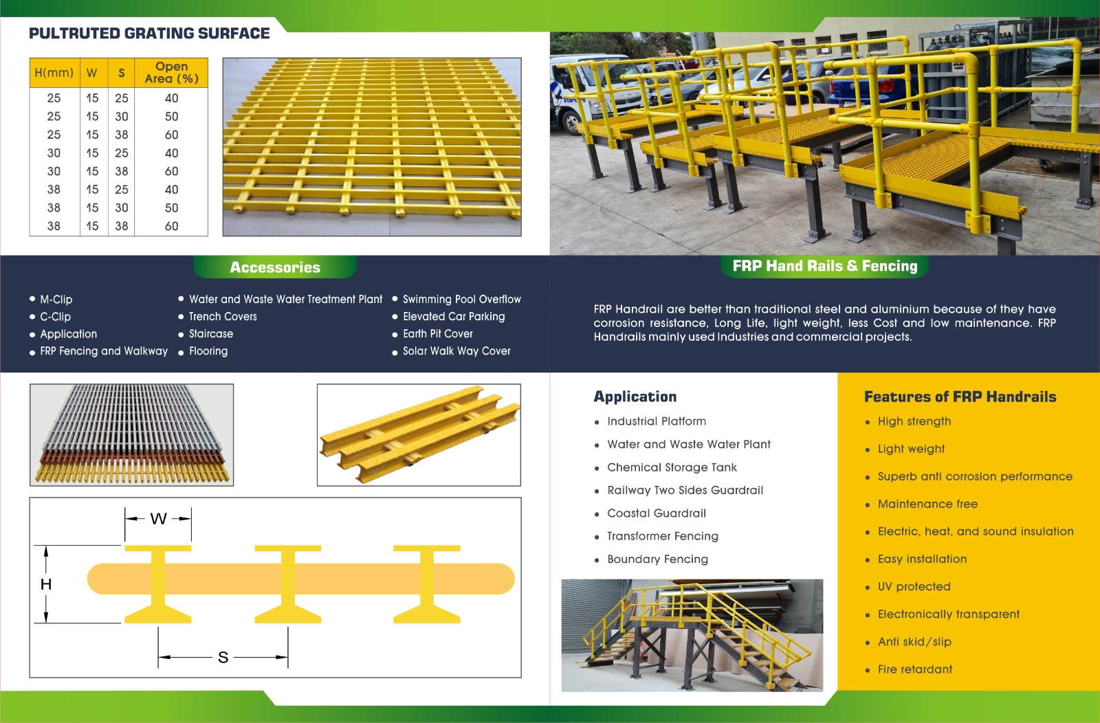

Change Image Location`

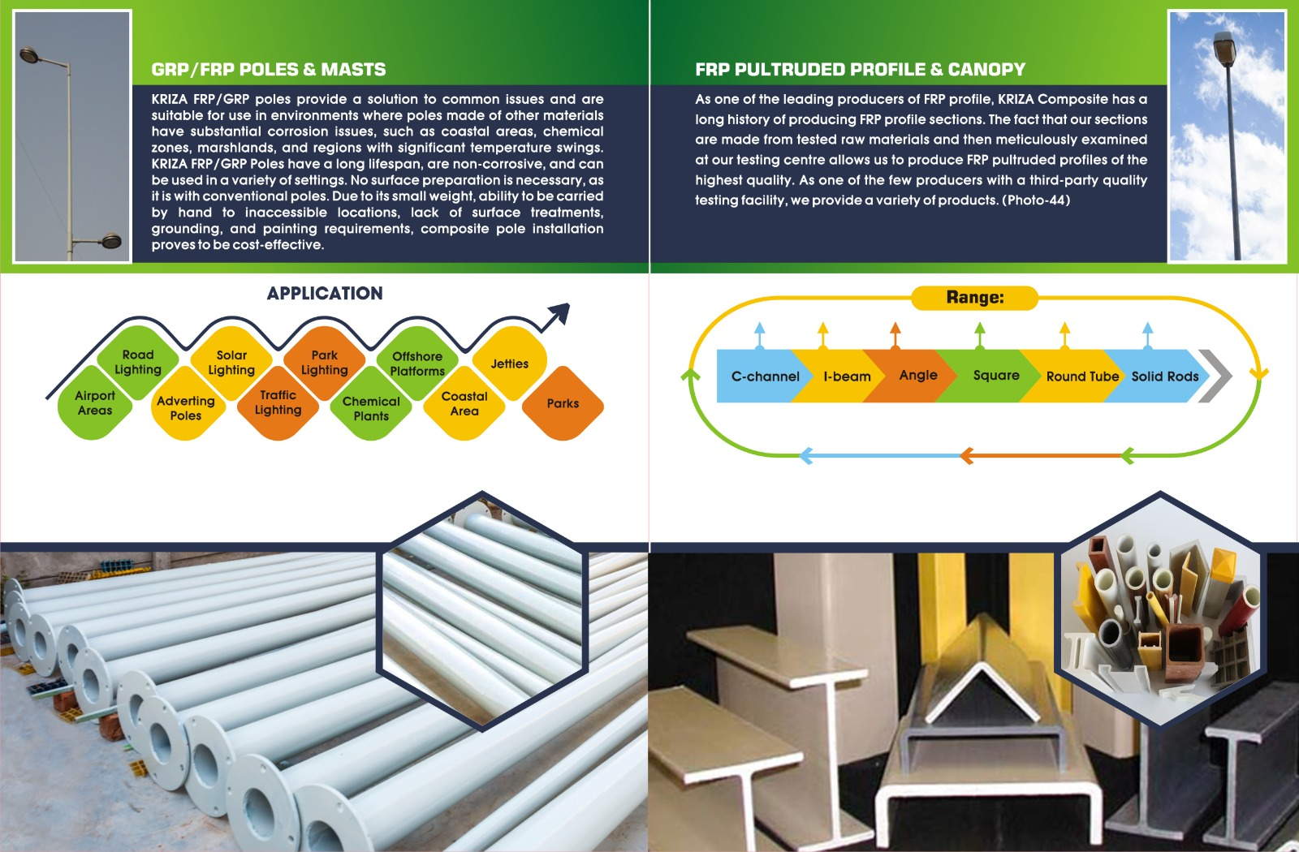

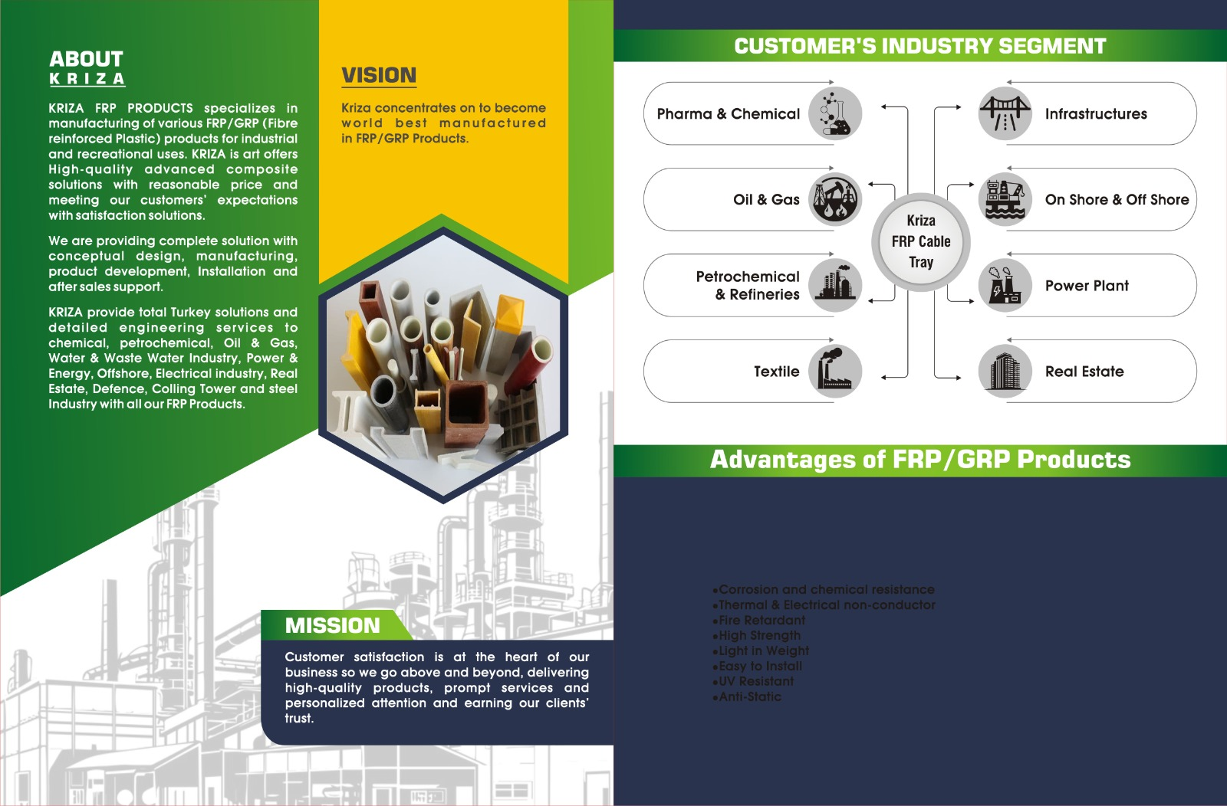

KRIZA FRP PRODUCTS

Change Font Color

