Tkinter Assignment #1

Unit Converter

**Objectives:** Use Tkinter to create a graphical user interface that will complete at least 4 different conversions.

**Tkinter Requirements:**

* A label at the top of the window to describe what the program does.
* A label indicating what is to be typed into the entry box below.
* An entry widget that accepts an int value.
* Radiobuttons for conversions: set to be initially on first button
  + Miles-per-hour to kilometers-per-hour
  + Miles-per-hour to feet-per-sec
  + Miles-per-hour to meters-per-sec
  + Miles-per-hour to furlongs-per-fortnight.
* A button that computes the converted speed when clicked.
* A label that describes the result.
* A label widget that gives the result.

**Needed Conversions:**

* 1 mile = 5280 feet
* 1 hour = 3600 seconds
* 1 mile = 1.609344 kilometers
* 1 furlong = 660 feet
* 1 fortnight = 14 days

**Example:**

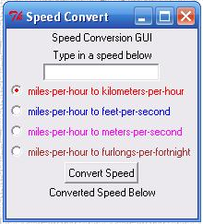 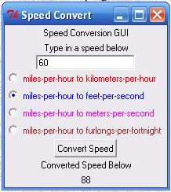

Before After

** Can you have the label “Converted Speed Below” change to “Speed in <new units> Below”? The color of the text of the <new units> should match the color of the text beside the selected radiobutton.