

MCA Application

##### **HANDOVER DOCUMENT**

Document Control

###### Modification History

This document is no longer valid if it has been superseded by a later version.

|  |  |  |  |
| --- | --- | --- | --- |
| **Version** | **Date** | **Author** | **Reason for Change** |
| 1.0 | 16/06/2015 | NMZ | Initial version |

###### Distribution List

This document has been distributed to:

|  |  |  |  |
| --- | --- | --- | --- |
| **Version** | **Date** | **Name** | **Title** |
|  |  |  |  |

###### Approval

This document requires the following approvals:

|  |  |  |  |  |
| --- | --- | --- | --- | --- |
| **Version** | **Date** | **Name** | **Title** | **Signature** |
|  |  |  |  |  |
|  |  |  |  |  |

##### Table of Contents

1 Introduction 4

1.1 Document Purpose 4

1.2 Background 4

1.3 Related Documents 4

2 Logical Architecture 5

3 Deployment 6

3.1 PreRequisites 6

3.2 Deployment 6

3.3 Configuration 6

3.4 Database 6

3.4.1 Assessment table 6

3.4.2 Patient table 6

3.4.3 AuditLog table 7

3.4.4 Disclaimer table 7

3.4.5 Gender table 7

3.4.6 Option table 7

3.4.7 Question table 7

3.4.8 QuestionAnswer table 7

3.4.9 QuestionOption table 7

3.4.10 Role table 7

3.4.11 Status table 7

3.4.12 WorkflowQuestion table 7

3.4.13 WorkflowStage table 8

3.4.14 WorkflowStep table 8

3.4.15 WorkflowVersion table 8

3.5 About the tool 8

3.5.1 Landing page 8

3.5.2 Tutorial page 8

3.5.3 Search page 8

3.5.4 Create New Person page 8

3.5.5 New Assessment page 8

3.5.6 Break page 9

3.5.7 Resume Page 9

3.5.8 Terminating assessment page 9

3.5.9 Completing assessment page 9

3.5.10 Complete page 9

3.6 Sql Queries 9

3.7 Error Logging 9

# Introduction

## Document Purpose

The aim of this document is to provide a step by step procedure on the deployment method and a brief description of each component of the Mental Capacity Assessment application.

## Background

The Mental Capacity Assessment application should be easily deployed/configured to be used. As the product was initially developed for use by Surrey and Borders Partnership NHS Foundation Trust the source files include **Sabp** in the name, these should be renamed as appropriate.

We are pleased to make the MCA web based assessment tool available for organisations to use.  The tool was developed from funding from the Nurse Technology Fund, and we are required to show its effectiveness. We have developed questionnaires to use with staff before and after using the assessment tool to assess changes in knowledge, confidence and satisfaction in undertaking Mental Capacity Act assessments.  We are making this tool available via GITHub on the proviso that organisations agree to use the questionnaires, included on GitHub, and send back the completed questionnaires and demographic information.  Completed sets of questionnaires (Demographic and pre and post Knowledge, Confidence and Satisfaction questionnaires for each person) should be sent to Psychology Dept, Surrey and Borders Partnership NHS Foundation Trust, Ramsay House, West Park, Horton Lane, Epsom KT19 8BP.

## 

# Logical Architecture

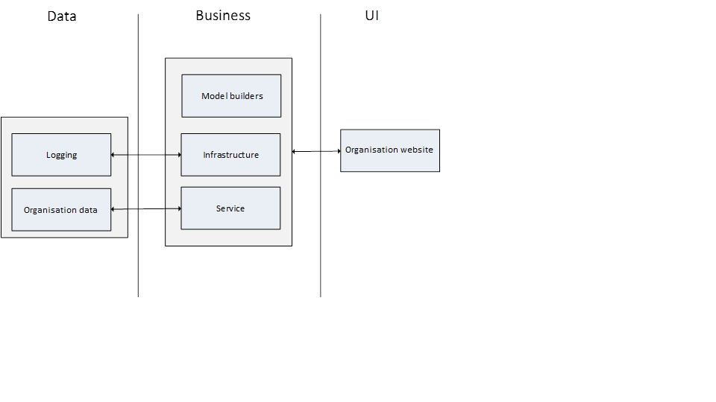

# Deployment of Complied Version

This section provides basic information required to deploy on a setting.

## PreRequisites

The following configuration is required to run the Mental Capacity Act Assessment tool:

1. SQL Server 2008 R2
2. Windows server 2008

Later versions of SQL Server should be supported.

## Deployment

Compiled version - Copy the relevant content to C:\inetpub\<folder>

## Configuration

Take a backup of the web.config file before making the following changes:

In ‘appSettings’, modify the following

ActiveDirectoryDomain – This represents the Active directory domain used by the organisation. The application can be used by the users configured under this.

McaAdministratorsActiveDirectoryGroup – Users under this domain will have administrative privilege on the MCA tool.

ClinicalSystemIdDescription – This is the id displayed on the web pages. Change this to as required by the organisation to be in consistent with the patient’s unique id.

ClinicalSystemName - This should contain the clinical system name where the pdf is uploaded to. For e.g. RiO.

DateOfBirthNumberOfYearsToDisplay – This should contain the number of years that is to be displayed on the date of birth fields.

FeedbackEmailLink – This should contain the entire ‘mailto’ block. For e.g mailto:feedback@email.com?subject=MCA%20feedback&amp;body=MCA%20body where ‘mailto’ contains the email address of the account where feedback on the MCA tool can be sent to, ‘subject’ is the default subject of the email and ‘body’ is the default content of the email.

In ‘connectionStrings’, modify the connection string to connect to the database required.

### TDE Options

The following two links show how to use TDE with SQL Server 2008R2.

<https://msdn.microsoft.com/en-gb/library/bb934049(v=sql.105).aspx>

<http://www.databasejournal.com/features/mssql/transparent-data-encryption-tde-in-sql-server.html>

## Database

Included in the source files are SQL scripts to create the required tables for the app. The tables used by the tool along with their purpose is outlined below:

### Assessment table

This table contains the information related to an assessment including the date assessment started, the decision to be made, assessor name, role of the assessor, name of the decision maker if the assessor is not the decision maker, date assessment ended and a terminated assessment reason if an assessment is terminated.

### Patient table

This table contains the patient information including the first name, last name, clinical system id, date of birth, gender, nhsnumber.

### AuditLog table

This table contains the audit information. Currently the following actions are audited:

1. Search – The 'Action ‘column contains the ‘Index’ value and the ‘Controller’ column contains the ‘Person’ value. The ‘AuditData’ column contains the patient id.
2. Editing a patient information – The ‘Action’ column contains the ‘Edit’ value and the ‘Controller’ column contains ‘Person’ value. The ‘AuditData’ column contains the previous and current values of the person.
3. Rendering a pdf - The ‘Action’ column contains the ‘CreatePdf’ value and the ‘Controller’ column contains the ‘Assessment’ value. The ‘AuditData’ column contains the assessment id and the clinical system id.

Refer section 3.6 to find more information on how to fetch audit data from the database.

### Disclaimer table

This table contains information about a user and their disclaimer acceptance status.

### Gender table

This contains the various gender options available. Currently this is ‘Male’ and ‘Female’

### Option table

This table contains the various options used in the web pages like – Temporary, Permanent, Yes, Single Option, No.

### Question table

This table contains all the questions that is being displayed on the web pages.

### QuestionAnswer table

This table contains the question and answer mapping for each assessment.

### QuestionOption table

This table contains the mapping of options available to a question and the next question depending on the option chosen.

### Role table

This table contains the roles available for the assessor to select from. Currently the roles are – advisor and decision maker.

### Status table

This table contains the status of an assessment. Currently it can be one of the following – ‘In progress’, ‘Complete’, and ‘Break’. An assessment is ‘In progress’ state if it is neither completed nor had a break.

An assessment is in ‘Complete’ state if it is completed. Once an assessment is completed, it cannot be modified.

An assessment is in ‘Break’ if during the assessment, the assessor goes through a break scenario where the assessment cannot be continued and need to be done at a later period of time because of circumstances.

### WorkflowQuestion table

This contains a mapping of question to the stages. Currently there are 5 stages.

### WorkflowStage table

This table contains the list of stages available for the assessment.

### WorkflowStep table

This table contains the current workflow question, the next workflow questions available for the current workflow question and the possible outcomes.

### WorkflowVersion table

This table contains the version number and is unique for a set of assessment questions.

## About the tool

The Mental Capacity Act Assessment tool (henceforth addressed as MCA tool) is developed to aid an assessor to log the information about the capability of a patient to make their decision as per Mental Capacity Act 1985. The tool mainly has the following pages:

### Landing page

This is the home page and provides information about the MCA tool. User can use the tool only if they agree to the Terms and Conditions provided in this page. User agrees to the terms and conditions only once. If the content needs changing later, then the files are located at Sfw.Sabp.Mca.Web\Views\Home\Index.cshtml

### Tutorial page

User can navigate to the tutorial page on agreeing to the terms and conditions of the landing page. This gives an overview of the MCA tool. If the content needs changing later, then the files are located at Sfw.Sabp.Mca.Web\Views\Home\Tutorial.cshtml

### Search page

After the tutorial page, user can navigate to the search page. On this page, an assessment can be searched based Patient id. If the patient is found, then clicking on the patient id on the search result should display all the assessments for that patient. If no patient details are found for the patient id, then ‘Create Person’ option lets the user to create a new patient record.

### Create New Person page

This lets the user to create a new person in the record by entering their details like patient id, first name, last name, date of birth and gender. The Nhs Number is not mandatory. This provides two options –

1. Create a person and begin assessment – this should create a new person and navigate to the new assessment page
2. Cancel – this should navigate back to the search page.

### New Assessment page

This page aids the user to create a new assessment for a person. ‘State the decision to be made’ field contains the decision that is being made about the person’ – it is actually the decision the person needs to make, and we are assessing their capability to make it at this point in time. The ‘Date assessment started’ field contains the current date by default and it is not possible to create an assessment with future date. The ‘Your role’ fields accepts the current role of the assessor. This can be either advisor or ‘Decision maker’. If the selected role is ‘Advisor’, then a new field is displayed for the user to enter the name of the ‘Decision maker’. State the decision to be made’ field contains the decision that is being made about the person. The assessment is created only if the user selects the checkbox ‘Confirm the decision to be made is specific and clearly defined’ and selects the ‘Create and continue’ button. On selecting the ‘Cancel’ button, the user should navigate back to the search page.

There is a ‘Reset’ button displayed on top of each page from Section 2 onwards. On selecting this, all the responses to the questions for that assessment and the current section is cleared.

The ‘Back’ button displayed on top of each page from Section 2 onwards navigates back one page (to the previous question, if the user need to modify the answer).

### Break page

This is a temporary halt where the user cannot continue with the assessment for the patient with the current circumstances. The ‘Back to Home’ button should navigate back to the home page. If the content needs changing later, then the files are located at Sfw.Sabp.Mca.Web\Views\BreakPage\Index.cshtml.

### Resume Page

This page lets the user decide if an incomplete assessment is still valid, continue from the previous break point, restart the answers for a section, resume an assessment, review the assessment completed so far.

### Terminating assessment page

This is displayed if an incomplete assessment is not valid anymore and is being terminated. This page lets the user to input the reason for terminating the assessment, and the date the assessment is terminated. The assessment is marked complete and the pdf is ready to be downloaded.

### Completing assessment page

This page is displayed when the user has completed all the assessment questions. This page is used to capture the assessment completion date.

### Complete page

This page is displayed when an assessment is complete. This allows the user to download the assessment in pdf format.

The ‘AssessorName’ displayed on the web page is the ‘DisplayName’ field from Active Directory. This is currently not configurable.

## Sql Queries

Select * from [Database].dbo.AuditLog

where Controller='Person' and Action='Edit'

This query is used to view the audit data for editing the details of a person.

Select * from [Database].dbo.AuditLog

where Controller='Person' and Action='Index'

This query is used to view the audit data associated with search

Select * from [Database].dbo.AuditLog

where Controller='Assessment' and Action='CreatePdf'

This query is used to view the audit data related to downloading an assessment in pdf format.

## Error Logging

Nlog is used to log the error messages. Nlog.config can be altered to specify the source where the errors can be logged. In the default configuration, MCA application logs all errors to the entry called MCA in the Application event log.

### Setup

Copy the following registry information to a text file and save with a .reg extension. Copy the file to the server that the registry entry should be installed and “double click”. Click “Yes” on the confirmation dialog.

This will install the MCA as an entry in the Application event log into the following location in the registry HKEY_LOCAL_MACHINE\SYSTEM\CurrentControlSet\Services\EventLog\Application\MCA.

#### Registry key

**Windows Registry Editor Version 5.00**

**[HKEY_LOCAL_MACHINE\SYSTEM\CurrentControlSet\Services\EventLog\Application\MCA]**

**"EventMessageFile"=hex(2):43,00,3a,00,5c,00,57,00,69,00,6e,00,64,00,6f,00,77,\**

**00,73,00,5c,00,4d,00,69,00,63,00,72,00,6f,00,73,00,6f,00,66,00,74,00,2e,00,\**

**4e,00,45,00,54,00,5c,00,46,00,72,00,61,00,6d,00,65,00,77,00,6f,00,72,00,6b,\**

**00,5c,00,76,00,34,00,2e,00,30,00,2e,00,33,00,30,00,33,00,31,00,39,00,5c,00,\**

**45,00,76,00,65,00,6e,00,74,00,4c,00,6f,00,67,00,4d,00,65,00,73,00,73,00,61,\**

**00,67,00,65,00,73,00,2e,00,64,00,6c,00,6c,00,00,00**

### Permissions

Permissions need to be granted to allow a user to write to event log entries.

* Open registry editor (Start -> run -> regedit)
* Find the HKEY_LOCAL_MACHINE\SYSTEM\CurrentControlSet\Services\EventLog\Application\MCA registry key
* Right click the key and choose “Permissions”

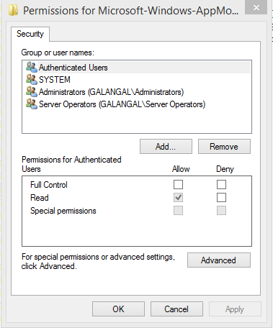

* Click the “Add” button and select the IIS_IUSRS local user group
* Give “Full Control” to the IIS_IUSRS group.

