Unit 1 Practice Quiz: Parent Functions & Graph Analysis
Objectives 1-1 through 1-7
Name: ______________________________ Date: ________________ Period: ________
This is practice only — it will not be graded. An answer key is provided separately so you can check your own work. Use the study guide alongside this if you get stuck.
1-1 Identify each parent function from its graph.
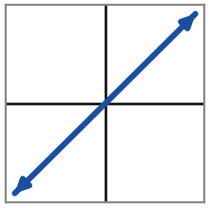  Name: _______________  Equation: f(x) = ___________ | 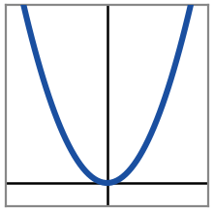  Name: _______________  Equation: f(x) = ___________ | 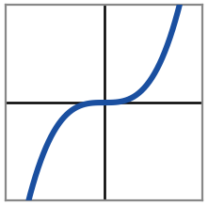  Name: _______________  Equation: f(x) = ___________
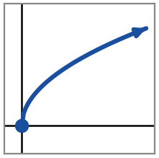  Name: _______________  Equation: f(x) = ___________ | 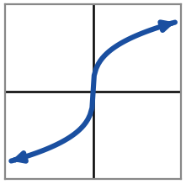  Name: _______________  Equation: f(x) = ___________ | 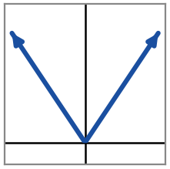  Name: _______________  Equation: f(x) = ___________
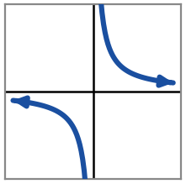  Name: _______________  Equation: f(x) = ___________ | 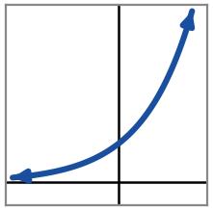  Name: _______________  Equation: f(x) = ___________ | 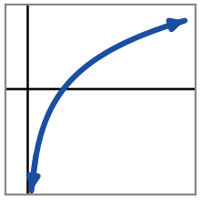  Name: _______________  Equation: f(x) = ___________
1-2 / 1-3 Use each graph of f(x) to answer the questions below.
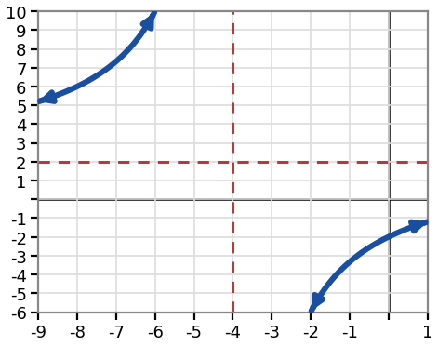  f(x) = (2x − 8) / (x + 4) | Domain: ________________  Range: ________________  Symmetry (even / odd / neither): ________________  Zero(s): ________________  y-intercept: ________________  Vertical asymptote: ________________  Horizontal asymptote: ________________  Relative max / min: ________________
Increasing on: ____________________________
Decreasing on: ____________________________
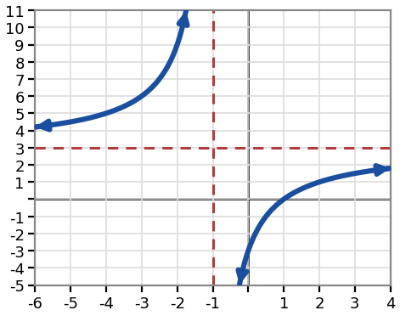  f(x) = (3x − 3) / (x + 1) | Domain: ________________  Range: ________________  Symmetry (even / odd / neither): ________________  Zero(s): ________________  y-intercept: ________________  Vertical asymptote: ________________  Horizontal asymptote: ________________  Relative max / min: ________________
Increasing on: ____________________________
Decreasing on: ____________________________
1-4 Describe the end behavior of each function using infinity notation.
f(x) = x⁴ − 2x² | f(x) = 5^{x}
As x → −∞, f(x) → ________  As x → ∞, f(x) → ________ | As x → −∞, f(x) → ________  As x → ∞, f(x) → ________

f(x) = −3x⁵ + 2x | f(x) = (2/5)^{x}
As x → −∞, f(x) → ________  As x → ∞, f(x) → ________ | As x → −∞, f(x) → ________  As x → ∞, f(x) → ________

1-5 Classify each function as even, odd, or neither. Show f(−x).
f(x) = 2x⁴ − 3x² + 1  Work:  f(−x) = ________________  Classification: ______________ | g(x) = −x⁵ + 4x  Work:  g(−x) = ________________  Classification: ______________ | h(x) = x³ + 2x² − 1  Work:  h(−x) = ________________  Classification: ______________
j(x) = −2x⁶ + 5x²  Work:  j(−x) = ________________  Classification: ______________ | k(x) = 3x³ − 2x  Work:  k(−x) = ________________  Classification: ______________ | m(x) = x⁴ + 3x + 2  Work:  m(−x) = ________________  Classification: ______________
1-6 Use each graph to answer the questions about discontinuities.
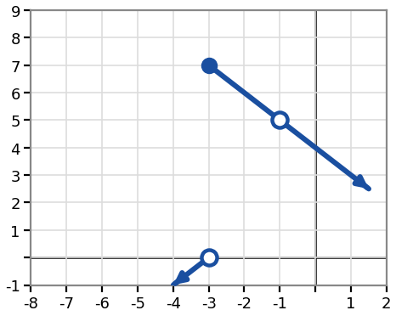 | At x = −3: type of discontinuity = ______________  Height of the graph just to the left: y = ______  Height of the graph just to the right: y = ______  At x = −1: type of discontinuity = ______________  Both sides meet at the same height, y = ______, but f(−1) itself is undefined.
The rational function from 1-2/1-3 (graph 1) also has an infinite discontinuity at x = −4. In words, describe what the graph does:
Approaching from the left: ______________________________________________
Approaching from the right: ______________________________________________
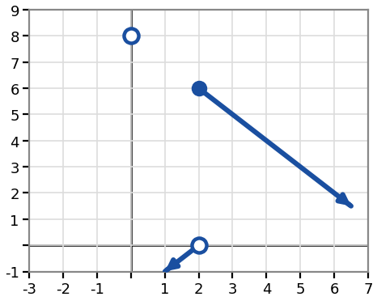 | At x = 2: type of discontinuity = ______________  Height of the graph just to the left: y = ______  Height of the graph just to the right: y = ______  At x = 0: type of discontinuity = ______________  Both sides meet at the same height, y = ______, but f(0) itself is undefined.
The rational function from 1-2/1-3 (graph 2) also has an infinite discontinuity at x = −1. In words, describe what the graph does:
Approaching from the left: ______________________________________________
Approaching from the right: ______________________________________________
1-7 Graph function transformations.
1) Let f(x) = x²
Write the equation of g(x) after applying these transformations, in order: vertical stretch by a factor of 2, shift right 3, shift down 2.
g(x) = ______________________________
2) Let f(x) = ∛x
Write the equation of g(x) after applying these transformations, in order: reflect over the x-axis, shift left 2, shift up 4.
g(x) = ______________________________
3) Let f(x) = log₂x
Write the equation of g(x) after applying these transformations, in order: vertical compression by a factor of 1/2, shift left 1, shift up 3.
g(x) = ______________________________

For each function below, name the horizontal stretch/compression and its factor.
1) h(x) = f(4x) → this is a horizontal ______________ by a factor of ________.
2) h(x) = f((1/4)x) → this is a horizontal ______________ by a factor of ________.

