Unit 1 Practice Quiz: Parent Functions & Graph Analysis
Objectives 1-1 through 1-7
1-1 Identify each parent function from its graph.
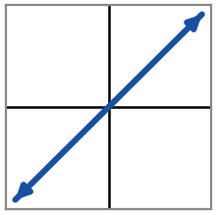  Name: Linear  Equation: f(x) = x | 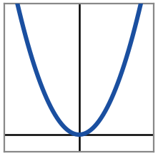  Name: Quadratic  Equation: f(x) = x² | 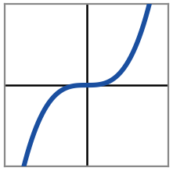  Name: Cubic  Equation: f(x) = x³
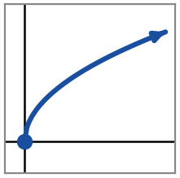  Name: Square Root  Equation: f(x) = √x | 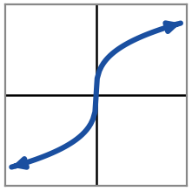  Name: Cube Root  Equation: f(x) = ∛x | 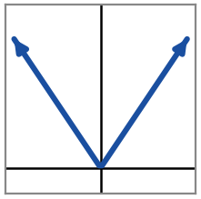  Name: Absolute Value  Equation: f(x) = |x|
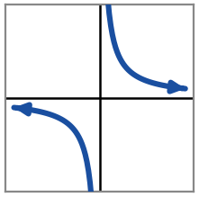  Name: Reciprocal  Equation: f(x) = 1/x | 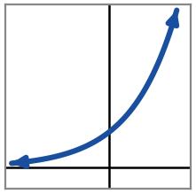  Name: Exponential  Equation: f(x) = 2^{x} | 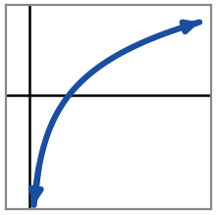  Name: Logarithmic  Equation: f(x) = log₂x
1-2 / 1-3 Use each graph of f(x) to answer the questions below.
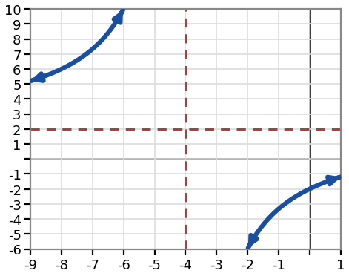  f(x) = (2x − 8) / (x + 4) | Domain: All real x, x ≠ −4  Range: All real y, y ≠ 2  Symmetry (even / odd / neither): Neither  Zero(s): x = 4  y-intercept: (0, −2)  Vertical asymptote: x = −4  Horizontal asymptote: y = 2  Relative max / min: None
Increasing on: (−∞, −4) ∪ (−4, ∞)
Decreasing on: never (none)
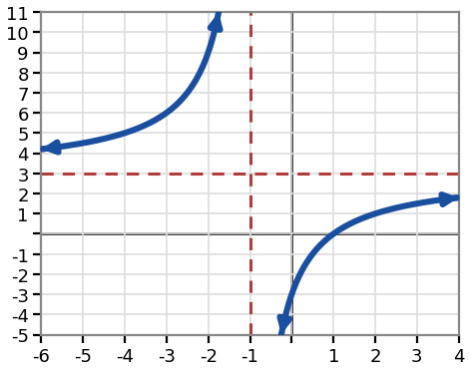  f(x) = (3x − 3) / (x + 1) | Domain: All real x, x ≠ −1  Range: All real y, y ≠ 3  Symmetry (even / odd / neither): Neither  Zero(s): x = 1  y-intercept: (0, −3)  Vertical asymptote: x = −1  Horizontal asymptote: y = 3  Relative max / min: None
Increasing on: (−∞, −1) ∪ (−1, ∞)
Decreasing on: never (none)
1-4 Describe the end behavior of each function using infinity notation.
f(x) = x⁴ − 2x² | f(x) = 5^{x}
As x → −∞, f(x) → +∞  As x → ∞, f(x) → +∞ | As x → −∞, f(x) → 0  As x → ∞, f(x) → +∞

f(x) = −3x⁵ + 2x | f(x) = (2/5)^{x}
As x → −∞, f(x) → +∞  As x → ∞, f(x) → −∞ | As x → −∞, f(x) → +∞  As x → ∞, f(x) → 0

1-5 Classify each function as even, odd, or neither. Show f(−x).
f(x) = 2x⁴ − 3x² + 1  f(−x) = 2x⁴ − 3x² + 1  Classification: Even | g(x) = −x⁵ + 4x  g(−x) = x⁵ − 4x  Classification: Odd | h(x) = x³ + 2x² − 1  h(−x) = −x³ + 2x² − 1  Classification: Neither
j(x) = −2x⁶ + 5x²  j(−x) = −2x⁶ + 5x²  Classification: Even | k(x) = 3x³ − 2x  k(−x) = −3x³ + 2x  Classification: Odd | m(x) = x⁴ + 3x + 2  m(−x) = x⁴ − 3x + 2  Classification: Neither
1-6 Use each graph to answer the questions about discontinuities.
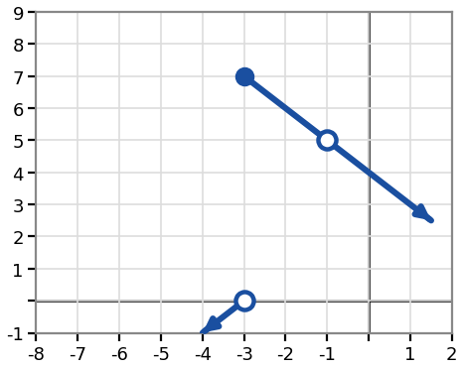 | At x = −3: type of discontinuity = Jump  Height of the graph just to the left: y = 0  Height of the graph just to the right: y = 7  At x = −1: type of discontinuity = Removable (hole)  Both sides meet at the same height, y = 5, but f(−1) itself is undefined.
The rational function from 1-2/1-3 (graph 1) also has an infinite discontinuity at x = −4. In words, describe what the graph does:
Approaching from the left: rises without bound
Approaching from the right: drops without bound
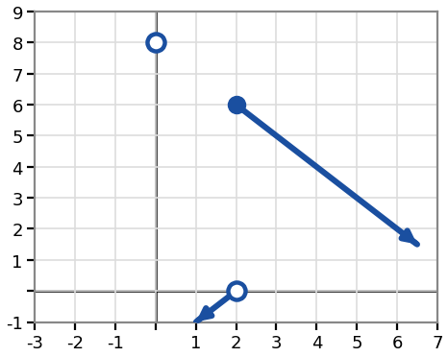 | At x = 2: type of discontinuity = Jump  Height of the graph just to the left: y = 0  Height of the graph just to the right: y = 6  At x = 0: type of discontinuity = Removable (hole)  Both sides meet at the same height, y = 8, but f(0) itself is undefined.
The rational function from 1-2/1-3 (graph 2) also has an infinite discontinuity at x = −1. In words, describe what the graph does:
Approaching from the left: rises without bound
Approaching from the right: drops without bound
1-7 Graph function transformations.
1) Let f(x) = x²
Write the equation of g(x) after applying these transformations, in order: vertical stretch by a factor of 2, shift right 3, shift down 2.
g(x) = 2(x − 3)² − 2
2) Let f(x) = ∛x
Write the equation of g(x) after applying these transformations, in order: reflect over the x-axis, shift left 2, shift up 4.
g(x) = −∛(x + 2) + 4
3) Let f(x) = log₂x
Write the equation of g(x) after applying these transformations, in order: vertical compression by a factor of 1/2, shift left 1, shift up 3.
g(x) = (1/2)log₂(x + 1) + 3

For each function below, name the horizontal stretch/compression and its factor.
1) h(x) = f(4x) → this is a horizontal compression by a factor of 1/4.
2) h(x) = f((1/4)x) → this is a horizontal stretch by a factor of 1/4.

