Unit 1 Study Guide
Objectives 1-1 through 1-7 — Parent Functions & Graph Analysis
Work through each example yourself before reading the explanation. This guide uses different numbers than the quiz, so it will help you practice the method rather than just the answers.
Self-Check Rate yourself honestly before the quiz.
Obj. | Skill | Basic | Interm. | Adv.
1-1 | I can identify a parent function from its graph and write its equation. | ☐ | ☐ | ☐
1-2 / 1-3 | I can find domain, range, symmetry, zeros, y-intercept, asymptotes, and relative max/min from a graph, and describe where it increases or decreases. | ☐ | ☐ | ☐
1-4 | I can describe the end behavior of a polynomial or exponential function using infinity notation. | ☐ | ☐ | ☐
1-5 | I can decide whether a function is even, odd, or neither by working out f(−x). | ☐ | ☐ | ☐
1-6 | I can identify removable, jump, and infinite discontinuities and describe the graph's behavior on each side. | ☐ | ☐ | ☐
1-7 | I can write the equation of a transformed parent function, and describe the transformations in an equation (stretch, compression, reflection, shift). | ☐ | ☐ | ☐
If you can't check at least "Intermediate" for an objective, review that section below before the quiz.
1-1 Identify Parent Functions
Learn to recognize each parent function by its shape, and know its equation.
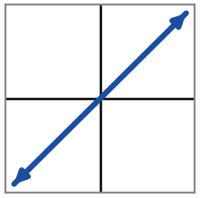  Linear  f(x) = x | 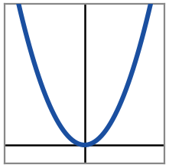  Quadratic  f(x) = x² | 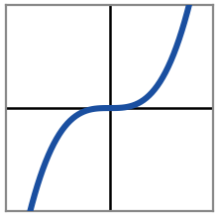  Cubic  f(x) = x³
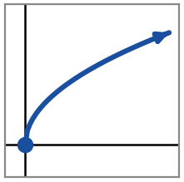  Square Root  f(x) = √x | 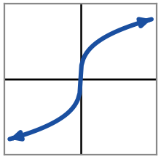  Cube Root  f(x) = ∛x | 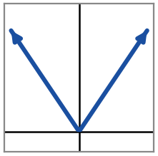  Absolute Value  f(x) = |x|
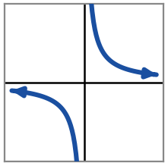  Reciprocal  f(x) = 1/x | 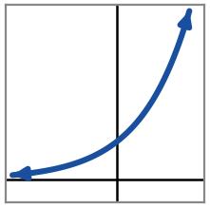  Exponential  f(x) = 2^{x} | 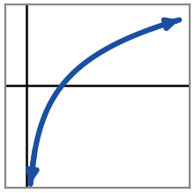  Logarithmic  f(x) = log₂x
1-2 / 1-3 Key Features & Increasing/Decreasing
Domain | every possible x-value the graph uses
Range | every possible y-value the graph uses
Zero(s) | x-value(s) where the graph crosses the x-axis — set the numerator (or f(x)) equal to 0
y-intercept | where the graph crosses the y-axis — evaluate f(0)
Vertical asymptote (VA) | a vertical line the graph gets closer and closer to but never touches — set the denominator equal to 0
Horizontal asymptote (HA) | a horizontal line the graph approaches as x → ±∞
Relative max / min | a point higher (or lower) than the points right around it — not necessarily the highest/lowest point overall
Symmetry | even = mirror image across the y-axis; odd = 180° rotation about the origin; otherwise neither
Increasing / decreasing | read the graph left to right — where it climbs, it's increasing; where it falls, it's decreasing
Worked example:
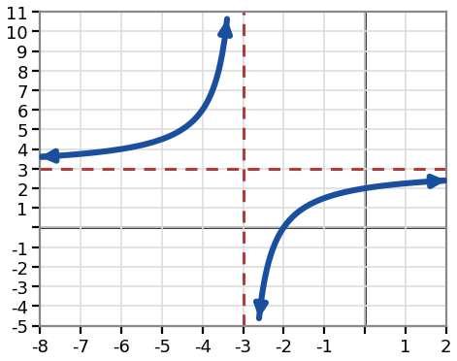  f(x) = (3x + 6) / (x + 3) | Zero: set numerator 3x + 6 = 0 → x = −2  VA: set denominator x + 3 = 0 → x = −3  HA: same degree top & bottom → ratio of leading coefficients → y = 3  y-intercept: f(0) = 6 / 3 = 2 → (0, 2)  Domain: all real x, x ≠ −3 Range: all real y, y ≠ 3  Symmetry: neither Relative max/min: none  Increasing on (−∞, −3) ∪ (−3, ∞); never decreasing.
1-4 End Behavior
Polynomials — depends on degree (even/odd) and the sign of the leading coefficient:
Even degree, + leading coeff | both ends go up: → +∞ on both sides | like x²
Even degree, − leading coeff | both ends go down: → −∞ on both sides | like −x²
Odd degree, + leading coeff | left end down, right end up: −∞ then +∞ | like x³
Odd degree, − leading coeff | left end up, right end down: +∞ then −∞ | like −x³
Exponentials:
Growth (base > 1): left end → 0 right end → +∞
Decay (0 < base < 1): left end → +∞ right end → 0
Worked example:
f(x) = −3x⁴ + x² — degree 4 (even), leading coefficient −3 (negative) → both ends go to −∞
g(x) = 5^{x} — base 5 > 1, so it's growth → as x → −∞, g(x) → 0 as x → ∞, g(x) → +∞
1-5 Even, Odd, or Neither
1. Substitute −x for every x in the function. 2. Simplify. 3. Compare the result to the original f(x):
f(−x) = f(x) (exactly the same) | EVEN
f(−x) = −f(x) (every sign flipped) | ODD
neither of the above | NEITHER
Worked examples:
f(x) = x⁴ − 2x² + 1 → f(−x) = (−x)⁴ − 2(−x)² + 1 = x⁴ − 2x² + 1 = f(x) → EVEN
g(x) = −3x³ + 5x → g(−x) = −3(−x)³ + 5(−x) = 3x³ − 5x = −g(x) → ODD
h(x) = x² − 3x + 2 → h(−x) = (−x)² − 3(−x) + 2 = x² + 3x + 2 — not equal to h(x) or −h(x) → NEITHER
1-6 Discontinuities
Removable (hole) | the two sides meet at the same height, but that one point is missing — an open circle
Jump | the two sides approach different heights — they never meet
Infinite | the graph shoots up or down without bound near a vertical asymptote
Describe the behavior in words — no symbols needed: what y-value does the graph approach from each side? Does it rise or drop without bound?
Worked example:
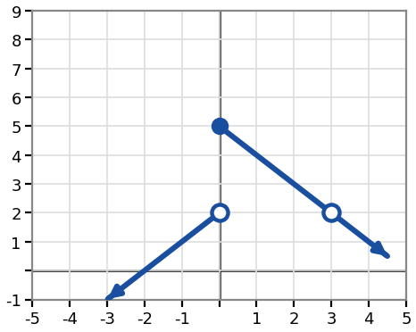 | At x = 0: JUMP discontinuity — left height y = 2, right height y = 5. The two sides don't meet.  At x = 3: REMOVABLE discontinuity (hole) — both sides meet at y = 2, but f(3) itself is undefined.
The rational function above (1-2/1-3 example) has an infinite discontinuity at x = −3. Approaching from the left, the graph rises without bound. Approaching from the right, the graph drops without bound.
1-7 Function Transformations Reference
Every transformation of f(x) uses one of four parameters — a, b, c, d.
Function Notation | Type of Transformation
f(x) + d | Vertical translation up d units
f(x) − d | Vertical translation down d units
f(x + c) | Horizontal translation left c units
f(x − c) | Horizontal translation right c units
−f(x) | Reflection over x-axis
f(−x) | Reflection over y-axis
a · f(x) | Vertical stretch for |a| > 1
a · f(x) | Vertical compression for 0 < |a| < 1
f(bx) | Horizontal compression for |b| > 1
f(bx) | Horizontal stretch for 0 < |b| < 1
Worked example — step by step:
Let f(x) = 1/x. Build g(x) = a · f(x − c) + d, where a = −3, c = 2, d = 1 — one parameter at a time:
Start: | f(x) = 1/x
Apply c = 2 (shift right 2 — replace x with x − 2): | f(x − 2) = 1/(x − 2)
Apply a = −3 (reflect over the x-axis, stretch ×3 — multiply the whole thing by −3): | −3/(x − 2)
Apply d = 1 (shift up 1 — add 1 at the very end): | g(x) = −3/(x − 2) + 1
Order matters: apply c (the shift inside the parentheses) first, then a (multiply), then d (add) last — that's the order things happen to x as it "flows through" the function.
Separately, b only shows up inside f(bx). If h(x) = f(2x) = 1/(2x), then b = 2. Since |b| > 1, the graph is compressed horizontally by a factor of 1/2.

