|  |  |
| --- | --- |
| My ResumÉ Website  Sprint 1 | 6/20/2018 | Lacy Simpson  CSS 405 |

Table of Contents

Project Summary 2

Project Details 2

Platform: World Wide Web 2

Languages: HTML 5, CSS 3, JavaScript 2

Github Username: MrsSimpson 2

Github Link: https://github.com/MrsSimpson/resumeWebsite.git 2

Trello Link: https://trello.com/b/SbUVefUU/css-405-adv-intrnt-cgi-pgr 2

Project Progress for 6/20/2018 2

Completed Actions 3

Screen Shots 3

Retrospective 5

# Project Summary

**The goal of this project is to have a fully functional website by the end of this 8 week course that displays my personal resumé. I will be using HTML5, CSS3, and JavaScript. The code will be written in the VIM editor as an attempt to become more familiar with VIM. Not only will this count as my term project for CSS 405, but it will also be used for future employment opportunities. The resumé website should be clean and easy to read while displaying necessary information about my education, work experience, and career goals.**

# Project Details

### Platform: World Wide Web

### Languages: HTML 5, CSS 3, JavaScript

### Github Username: MrsSimpson

### Github Link: <https://github.com/MrsSimpson/resumeWebsite.git>

### Trello Link: <https://trello.com/b/SbUVefUU/css-405-adv-intrnt-cgi-pgr>

# Project Progress for 6/20/2018

The project is on track and slightly ahead of schedule.The digital copy of the resumé has been revised based on recommendations made by Ms. Jona Burton. The meeting with Ms. Burton proved very helpful and will definitely influence the overall design of my resumé website. The basic design and layout of the website has been chosen, and I have started the HTML code. At this point, I have the index(home), the about me, and the contact HTML pages. I plan to also create an experience or resume HTML page. The navigation menu will need to be completed in all HTML files in the upcoming sprint.

# Completed Actions

#### Met with Jona Burton 6/13

#### Revised digital copy of resumé and saved as PDF

#### Researched resumé website designs and decided on layout

#### Started the HTML code

#### Updated my GitHub repo with HTML files and a copy of my resumé in PDF <https://github.com/MrsSimpson/resumeWebsite>

# Screen Shots

###### Website Design Inspiration

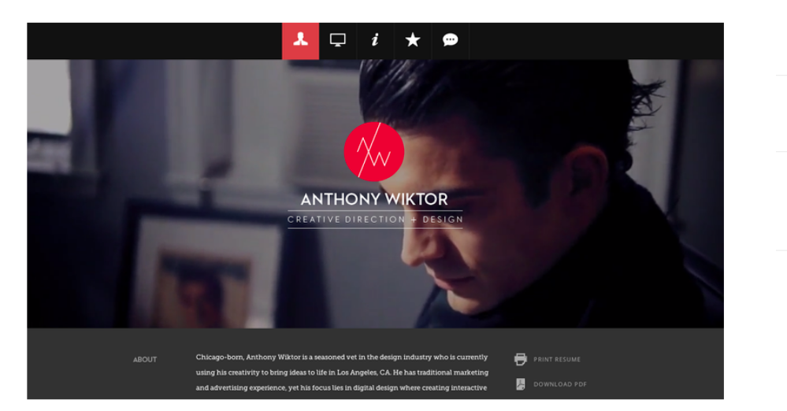

###### index.html

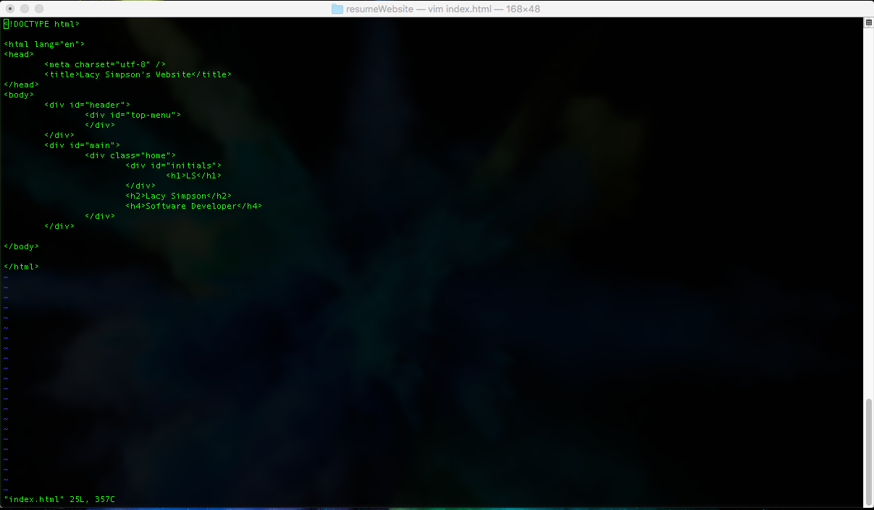

###### aboutme.html

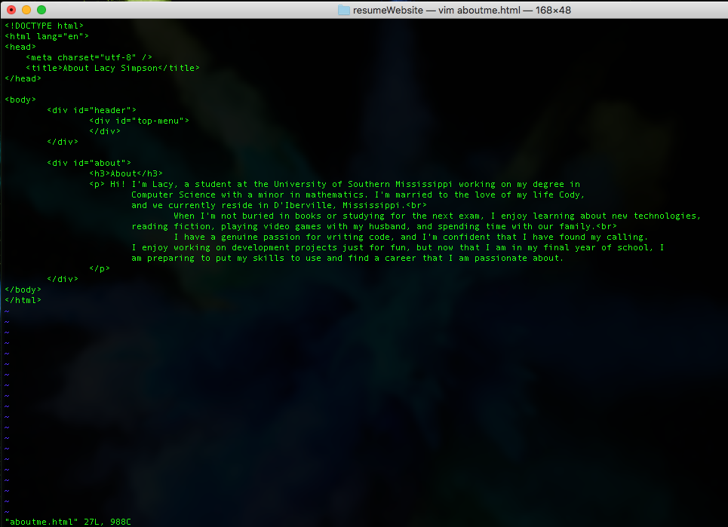

# Retrospective

##### What went right

+ Successfully met with Ms Burton to discuss my original resumé. Her insight was very helpful with the revision and updating of the document.

+ There were many resumé websites to gain information from, so choosing a design that I liked was not difficult.

+ I was successful with the creation of my HTML documents in VIM.

+ Completed all requirements for the deliverable on time without being in a time crunch despite being on vacation over the weekend and studying for two exams.

##### What went wrong

* I should have been more prepared for the discussion that I had with Ms. Burton by reading the career services guide in more detail before the meeting.
* Creating the HTML in VIM was more time consuming than expected due to being unfamiliar with getting around in VIM. More time was needed than I had anticipated for this portion of the project.
* Writing the HTML was not difficult, but due to being unfamiliar with the most of the tags, and general structure, I spent quite a bit of time flipping through the book when writing the HTML.

##### What to do differently

Δ Study the topic at hand in more detail before meetings in the future.

Δ Make time to reread the text book chapters that concern new syntax