
Prince Sultan University
College of Computer & Information Sciences
Information Systems Department
IS499 – Senior Project
Senior Project Final Report
Mirsad (مرصاد)
A Runtime Security Firewall for AI Agents Against Prompt-Injection Attacks

Team member | Student ID | Department
Mohammed Yasser Alanssari | 221110935 | IS (CYS)
Bader Alshuraie | 221110016 | SE
Bader Abdullah Abbod Alyamini | 221110197 | IS (CYS)
Abdulmalik bin Saedan | 221110958 | IS (CYS)
Abdullah Naif Abdullah Al-Orabi | 222110432 | SE (AI & DS)

Supervisor | Dr. Omaia Al-Omari
Semester & Academic Year | Senior Project I & II – Academic Year 2026–2027
Submission Date | ____________________
Supervisor’s Signature | ____________________
Approval Date | ____________________

Acknowledgments
We would like to express our sincere gratitude to our supervisor, Dr. Omaia Al-Omari, for the guidance, patience and constructive feedback provided throughout this project.
We thank the faculty of the Information Systems Department and the College of Computer and Information Sciences at Prince Sultan University for the knowledge and support that made this work possible, and the IS499 course coordinator for organising the senior project. We are also grateful to the open-source communities whose work Mirsad builds on, including the developers of the Model Context Protocol, FastAPI, SQLAlchemy, scikit-learn, React and Ollama, and to the researchers who published the prompt-injection benchmarks and datasets that informed our design.
Finally, we thank our families for their encouragement and patience during the long evenings this project required.

Abstract
Large language model (LLM) agents now read e-mail, browse the web and call business tools through the Model Context Protocol (MCP) and OpenAI-style function calling. Any content an agent reads can carry hidden instructions (indirect prompt injection) that turn an authorised agent against its own organisation, and published defences are almost entirely English-centric. This project built Mirsad (مرصاد), a runtime security gateway that sits between an unmodified agent and its tools. Its objectives were to enforce action-level policy with a median overhead of at most 200 ms per call, to detect injected instructions in Arabic and English with an F1 score of at least 0.85, and to keep humans in control while reducing attack success by at least 80% and wrongly blocking no more than 5% of benign actions. Mirsad combines a declarative YAML policy engine, taint tracking of untrusted and confidential data, an Arabic/English injection detector, human approval through an installable bilingual mobile web app, and an HMAC hash-chained audit log with decision replay. On 48 benign English and Arabic tasks, full protection automatically denied 0.0% of benign calls, escalated 17.6% to a human, and 272 of 272 audited decisions replayed identically. Median added latency was 2.7 ms per call and 166 ms under 50 concurrent sessions. Detector F1 and attack success rate remain pending until the team's attack-labelled evaluation data is complete. Mirsad gives organisations an auditable control point that supports obligations under Saudi Arabia's Essential Cybersecurity Controls and Personal Data Protection Law.

الملخص
أصبح وكلاء النماذج اللغوية الكبيرة يقرؤون البريد الإلكتروني ويتصفحون الويب ويستدعون أدوات الأعمال عبر بروتوكول سياق النموذج (MCP) واستدعاء الدوال على نمط OpenAI. وقد يتضمن أي محتوى يقرؤه الوكيل تعليمات مخفية تحوّل الوكيل المصرَّح له إلى أداة ضد مؤسسته، وهو ما يُعرف بحقن الأوامر غير المباشر، في حين تكاد الدفاعات المنشورة تقتصر على اللغة الإنجليزية. طوّر هذا المشروع «مرصاد» (Mirsad)، وهو بوابة أمنية تعمل أثناء التشغيل بين الوكيل وأدواته دون الحاجة إلى تعديل الوكيل. وتمثلت أهدافه في فرض السياسات على مستوى الإجراءات على ألا يتجاوز وسيط الزمن الإضافي 200 ملّي ثانية لكل استدعاء، وكشف التعليمات المحقونة بالعربية والإنجليزية بمقياس F1 لا يقل عن 0.85، وإبقاء القرار بيد الإنسان مع خفض معدل نجاح الهجمات بنسبة 80% على الأقل، على ألا يتجاوز الحجب الخاطئ للإجراءات السليمة 5%. ويجمع مرصاد بين محرك سياسات تصريحي بصيغة YAML، وتتبّع مصدر البيانات غير الموثوقة والسرية، وكاشف حقن للعربية والإنجليزية، وموافقة بشرية عبر تطبيق ويب ثنائي اللغة قابل للتثبيت على الهاتف، وسجل تدقيق مترابط بسلسلة تجزئة HMAC يتيح إعادة تشغيل القرارات. وفي 48 مهمة سليمة بالعربية والإنجليزية، بلغت نسبة الاستدعاءات السليمة التي رفضتها الحماية الكاملة آليًا 0.0%، وأحالت 17.6% منها إلى مراجع بشري، وطابقت إعادةُ التشغيل القرارَ الأصلي في 272 من أصل 272 قرارًا مسجّلًا. وبلغ وسيط الزمن الإضافي 2.7 ملّي ثانية لكل استدعاء، و166 ملّي ثانية مع 50 جلسة متزامنة. أما مقياس F1 للكاشف ومعدل نجاح الهجمات فما زالا معلّقين إلى حين اكتمال بيانات الهجمات المصنّفة. ويقدّم مرصاد للمؤسسات نقطة تحكم قابلة للتدقيق تدعم وفاءها بضوابط الهيئة الوطنية للأمن السيبراني ونظام حماية البيانات الشخصية.

Table of Contents
Acknowledgments i
Abstract ii
الملخص iii
Table of Contents iv
List of Figures x
List of Tables xiv
List of Acronyms xvii
Chapter 1 – Introduction 1
1.1 Background 1
1.2 Problem Statement 2
1.3 Project Objectives 2
1.4 Scope and Constraints 3
1.5 Stakeholders and User Personas 4
1.5.1 Stakeholder Personas 4
1.6 Industry Relevance & IS Application 5
1.7 Project Timeline (Gantt Chart) 6
Chapter 2 – Literature Review 8
2.1 Overview of Previous Studies 8
2.1.1 LLM agents and tool use 8
2.1.2 Prompt injection: origins and taxonomy 9
2.1.3 Benchmarks for agent security 11
2.1.4 Defences at the model, prompt, runtime and architecture levels 12
2.1.5 Multilingual and Arabic LLM safety 14
2.1.6 Standards and Saudi regulation 15
2.1.7 Foundations used by Mirsad 16
2.2 Comparative Analysis 17
2.3 Research Gap and Positioning 21
Chapter 3 – Methodology 23
3.1 Research Design / Project Approach 23
3.2 Data Collection / Requirements Gathering 24
3.2.1 Elicitation methods 24
3.2.2 Threat model and assumptions 25
3.2.3 Use-case model 25
3.2.4 Requirements specification 29
3.3 System Design & Architecture 32
3.3.1 Architectural style and system context 33
3.3.2 Components and responsibilities 35
3.3.3 Core processes 39
3.3.4 Policy language design 44
3.3.5 Taint-tracking design 47
3.3.6 Injection detector design 49
3.3.7 Database design 50
3.3.8 Security design and threat model 53
3.3.9 Interface design 55
3.3.10 User-interface design 57
3.3.11 Deployment architecture and technology stack 61
3.4 Implementation Strategy 63
3.4.1 Development methodology 63
3.4.2 Mapping to the IS499 deliverables 64
3.4.3 Team roles and responsibilities 65
3.4.4 Development environment, tools and version control 65
3.4.5 Changes from the proposal and their justification 66
3.4.6 Budget 67
3.5 Testing & Validation 67
3.5.1 Test strategy 68
3.5.2 Test environment, tools and responsibilities 70
3.5.3 Entry and exit criteria 71
3.5.4 Continuous integration and the evidence pipeline 72
3.5.5 Metrics 73
3.5.6 Test inventory 73
3.5.7 User acceptance testing 75
3.6 Ethical, Legal & Security Considerations 76
3.6.1 Data privacy and the PDPL 76
3.6.2 Regulatory and standards alignment 76
3.6.3 Security of the gateway itself 76
3.6.4 Responsible handling of attack material 77
3.6.5 Social and professional considerations 77
3.6.6 Licences, third-party components and AI assistance 77
Chapter 4 – Implementation and Evaluation 79
4.1 Implementation 79
4.1.1 Development environment and repository structure 79
4.1.2 Gateway pipeline 80
4.1.3 Policy engine 81
4.1.4 Taint tracker 82
4.1.5 Injection detector 83
4.1.6 Audit log and approvals 83
4.1.7 Protocol adapters and SDK 84
4.1.8 REST API and command line 85
4.1.9 Web dashboard 86
4.1.10 Approver PWA 87
4.1.11 Demonstration workspace and agent 87
4.1.12 Mirsad-Bench 88
4.1.13 Integration issues found and fixed 89
4.2 Evaluation 90
4.2.1 Evaluation setup 90
4.2.2 Detector evaluation 92
4.2.3 Attack resistance on Mirsad-Bench 92
4.2.4 Benign behaviour 93
4.2.5 Performance 96
4.2.6 Security testing of the gateway 98
4.2.7 Audit integrity and reproducibility 99
4.2.8 Usability: approval decision time 99
4.2.9 Success criteria 101
4.2.10 Limitations and threats to validity 102
4.3 Individual and Group Contributions 103
Chapter 5 – Conclusion and Future Work 106
5.1 Summary of Outcomes 106
5.2 Contributions 107
5.3 Lessons Learned 108
5.4 Limitations 108
5.5 Future Work 109
5.6 Concluding Remarks 109
References 111
Appendix A – Standards & Constraints Matrix 120
A.1 Standards, Regulations and Guidelines 120
A.2 Constraints Matrix 123
Appendix B – Test Reports & Validation Results 125
B.1 Test environment and evidence 125
B.2 Requirements traceability matrix 126
B.3 Test case specification 133
B.3.1 Policy language and engine 134
B.3.2 Gateway and protocol adapters 135
B.3.3 Taint tracking 138
B.3.4 Detector and result handling 139
B.3.5 Approvals and audit 141
B.3.6 Administration, user interface, demonstration, benchmark and storage 144
B.4 Security test cases 146
B.5 Test results 148
B.5.1 Execution summary 148
B.5.2 Code coverage 149
B.5.3 Static analysis and dependency scanning 149
B.5.4 Performance 150
B.5.5 Benchmark results on benign tasks 152
B.5.6 Audit verification and decision replay 154
B.5.7 LLM smoke run 154
B.5.8 Results pending team-supplied data 155
B.6 Known limitations and open items 155
Appendix C – System Screenshots / Interface Designs 158
C.1 Administration Dashboard (English) 158
C.2 Dashboard in Arabic and in the Dark Theme 166
C.3 Approver App (English) 168
C.4 Approver App (Arabic) 172
Appendix D – Poster / Presentation Slides 175
Appendix E – Software User Guide 180
E.1 Overview and System Requirements 180
E.2 Installation 181
E.2.1 Python virtual environment 181
E.2.2 Docker Compose with PostgreSQL 181
E.3 Configuration 182
E.4 First Run and Demonstration 183
E.4.1 Initialising and starting the server 183
E.4.2 Local model for the demo agent 183
E.4.3 Running a demonstration 183
E.5 Administration Dashboard 184
E.5.1 Signing in and navigation 184
E.5.2 Overview 185
E.5.3 Activity and audit log 185
E.5.4 Approvals 186
E.5.5 Policies, agents and users 187
E.5.6 Tools, detector playground, demo console and settings 188
E.6 Approver App 190
E.6.1 Installing on Android and iOS 190
E.6.2 Reviewing and deciding 191
E.6.3 Notifications 192
E.6.4 Arabic interface 193
E.7 Writing and Activating Policies 193
E.7.1 Policy structure and an example 193
E.7.2 Validating 194
E.7.3 Activating, monitor mode and rollback 195
E.8 Connecting Agents 195
E.8.1 Before connecting 195
E.8.2 MCP hosts: stdio proxy and HTTP 196
E.8.3 OpenAI-compatible agents 196
E.8.4 Python SDK 196
E.9 Command-Line Reference 197
E.10 Audit Verification, Replay and Export 197
E.11 Training the Detector and Running the Benchmark 198
E.11.1 Detector 198
E.11.2 Benchmark 199
E.12 Troubleshooting and FAQ 199
E.13 Security Recommendations for Operators 200
Appendix F – Stakeholder Questionnaire 202

List of Figures
Figure 1.1: Project schedule with task owners (abbreviations as in the text) and milestones M1–M7 7
Figure 2.1: A three-axis taxonomy of prompt-injection attacks: the channel that carries the text, the technique used to obtain compliance and the attacker's goal (synthesised from the sources reviewed in Section 2.1.2) 10
Figure 3.1: Use-case diagram with misuse cases (black) and the security use cases that mitigate them 26
Figure 3.2: System context: Mirsad sits between the AI agent and the enterprise tools; the attacker influences only the content stored in those tools 33
Figure 3.3: Mirsad architecture: protocol adapters, the call path (policy engine, rate limiter, taint tracker, combining step, human approval), the result path (injection detector, sanitising and spotlighting, taint labelling) and the shared services 34
Figure 3.4: Component (package) diagram. Dashed "injected" arrows are runtime collaborators passed to the gateway's constructor; every package also uses the foundation modules 36
Figure 3.5: Class diagram of the gateway, its collaborating services and the shared data model (signatures simplified; the full interfaces are in the engineering contract) 38
Figure 3.6: Sequence of a tool call through the gateway: decision, execution and inspection of the result 40
Figure 3.7: Decision logic for a tool call. Constraints, rate limits and global rules all report their reasons before the combining step 41
Figure 3.8: Sequence of an escalated call: approval request, notification, human decision and resumption of the waiting call 42
Figure 3.9: State machine of an approval request; every terminal state other than Approved blocks the call 43
Figure 3.10: Context-level (level 0) data-flow diagram of Mirsad 44
Figure 3.11: Level 1 data-flow diagram: processes 1.0 to 6.0 and data stores D1 to D4 44
Figure 3.12: Entity-relationship diagram of the six tables. The solid line is the only enforced foreign key; dashed lines are logical references by value 51
Figure 3.13: Threat model with trust boundaries A to E and the STRIDE categories of each data flow 53
Figure 3.14: Activity and audit page with the detail drawer of an approval decision: summary, previous hash and event hash, and the raw event 59
Figure 3.15: Policy editor in Arabic: the sidebar and controls are mirrored, while the YAML policy stays left-to-right 59
Figure 3.16: Approver PWA in Arabic: pending requests with risk label, countdown and plain-language summary 60
Figure 3.17: Approver PWA request detail in English: risk, countdown, explanation sections and the Approve and Deny buttons 61
Figure 3.18: Deployment architecture: the Mirsad container, the database, optional components and the clients 62
Figure 4.1: Benign false-positive rate, approval friction and utility per defence configuration (scripted agent, denying approver) 95
Figure 4.2: Approval friction on benign calls by language and defence configuration 95
Figure 4.3: Distribution of added latency per call, sequential and with 50 concurrent sessions (server in a separate process, logarithmic scale) 97
Figure 4.4: Gateway latency per benign call by defence configuration (decision plus result inspection, excluding human waiting) 97
Figure B.1: Cumulative distribution of added latency over 1,000 benign calls, server in a separate process (log scale) 151
Figure B.2: Cumulative distribution of added latency over 1,000 benign calls, server in the same process as the client (log scale) 151
Figure B.3: Benign false-positive rate, approval friction and utility per defence configuration with the denying approver (run scripted-benign-deny) 153
Figure B.4: Gateway time per benign call (decision plus result inspection, human wait excluded), p50 and p95, run scripted-benign-deny 154
Figure C.1: Dashboard sign-in page. The language switch at the top right changes the interface to Arabic before signing in, and the second button selects the colour theme 158
Figure C.2: Dashboard Overview after the seeded activity 159
Figure C.3: Activity and audit log 160
Figure C.4: Detail drawer of an audit event (a denied transfer_funds request) 161
Figure C.5: Approvals page. The live pending queue shows each request's risk level, plain-language summary and countdown to expiry with Approve and Deny buttons; the history below records who decided each request and their note 161
Figure C.6: Policy editor with the active YAML policy of the demonstration organisation and its version hash. Changes can be compared with the active version, reverted, validated and activated without restarting the gateway 162
Figure C.7: Agents page: the demonstration agent, the policy agent it is mapped to, its key prefix (the full key is shown only once, when it is created or rotated), last-seen time, and rotate, disable and delete actions 162
Figure C.8: Users page with the three roles and what each may do: administrators manage everything, approvers decide on paused actions, and auditors have read-only access to the audit log, policies and tools 163
Figure C.9: Tools page: the tools discovered from the upstream workspace server and how the active policy profiles each one for the selected agent (allowed, trust of its results, sensitivity, where it sends data, risk and approval mode) 163
Figure C.10: Detector playground scanning a benign mixed Arabic–English supplier message 164
Figure C.11: Demo console: protection switch, scenarios, conversation, tool-call timeline and attacker inbox 165
Figure C.12: Settings page: theme (system, light or dark), language, background notifications for new approvals, account details and server status 165
Figure C.13: Overview page in Arabic. Labels, key figures and time-range buttons are translated and arranged for right-to-left reading 166
Figure C.14: Activity and audit log in Arabic. The navigation moves to the right and the filters and table columns are mirrored, while tool names, agent identifiers and dates keep their left-to-right form 166
Figure C.15: Policy editor in Arabic. The surrounding interface is right-to-left, while the YAML policy stays left-to-right so that it can be edited and reviewed as code 167
Figure C.16: Overview page in the dark theme, which can follow the operating-system setting or be selected in Settings 167
Figure C.17: Approver app sign-in on a phone-sized screen. The app is served by the gateway at /approve and can be installed to the home screen 168
Figure C.18: Pending requests in the approver app: risk level, tool, requesting agent, the start of the plain-language summary, time since the request and countdown, a prompt to turn on push alerts, and Pending and History tabs 169
Figure C.19: Detail of a critical-risk request to delete a customer record: what the agent wants to do, why Mirsad paused it with the layer behind each reason, and Deny and Approve buttons fixed at the bottom of the screen 170
Figure C.20: Full-length capture of the same request, including the section on where the data came from (here no outside data was linked) and the collapsible list of arguments. The fixed Deny and Approve bar appears in the middle only because of the full-page capture method 171
Figure C.21: Pending requests in the Arabic interface. The layout is mirrored, summaries are written in Arabic, and tool names and e-mail addresses keep their original form 172
Figure C.22: Detail of the same deletion request in Arabic, with the summary, the reasons for the pause, and the Approve and Deny buttons in right-to-left order 173
Figure C.23: Full-length capture of the Arabic request detail, including the data-provenance section and the collapsible arguments; as in the English capture, the fixed button bar appears mid-page because of the capture method 174
Figure D.1: CCIS EXPO poster (preview rendering) 176
Figure D.2: Final presentation, slides 1–6 177
Figure D.3: Final presentation, slides 7–12 178
Figure D.4: Final presentation, slides 13–18 179
Figure E.1: Overview page of the dashboard 185
Figure E.2: Activity and audit log with the detail drawer of an approval decision 186
Figure E.3: Approvals page with two pending requests and the decision history 187
Figure E.4: Policies page with the YAML editor 188
Figure E.5: Agents page with the demo agent created by mirsad init --demo 188
Figure E.6: Detector playground scanning an Arabic business e-mail 189
Figure E.7: Demo console with the protection switch, scenario selector and attacker inbox 190
Figure E.8: Approver app: pending requests 191
Figure E.9: Approver app: request detail with the Approve and Deny buttons 192
Figure E.10: Approver app: request detail in Arabic 193

List of Tables
Table 1: Acronyms used in this report xvii
Table 1.1: Project scope 3
Table 1.2: Stakeholders and their interests 4
Table 1.3: Project phases, durations and responsible members (from the D2 work breakdown) 6
Table 1.4: Project milestones 6
Table 2.1: Key studies on agent-security evaluation and their implications for Mirsad 11
Table 2.2: Feature comparison of runtime guardrails, MCP gateways, research systems and Mirsad (N/D = not documented in the sources reviewed) 18
Table 3.1: Use-case catalogue 26
Table 3.2: Use-case specification UC-01 – Invoke tool via gateway 27
Table 3.3: Use-case specification UC-05 – Approve / deny action 28
Table 3.4: Use-case specification UC-08 – Manage policies 28
Table 3.5: Use-case specification UC-14 – Verify audit integrity 28
Table 3.6: Functional requirements 29
Table 3.7: Non-functional requirements 31
Table 3.8: Main design decisions 35
Table 3.9: Components, responsibilities and interfaces 36
Table 3.10: Structure of a policy document (schema version 1) 45
Table 3.11: Reason codes of the policy, detector, approval and system layers 46
Table 3.12: Taint rules evaluated for each tool call 48
Table 3.13: Data dictionary of the database tables 52
Table 3.14: STRIDE analysis of the gateway 53
Table 3.15: Agent-facing interfaces 56
Table 3.16: REST API overview 56
Table 3.17: Sprint plan 63
Table 3.18: IS499 deliverables and where they are addressed 64
Table 3.19: Workstream ownership 65
Table 3.20: Technology stack and justification 65
Table 3.21: Original and revised budget (SAR) 67
Table 3.22: Test levels and the artefacts they verify (V-model) 69
Table 3.23: Exit criteria and their status for the reported version 71
Table 3.24: Continuous-integration jobs 72
Table 3.25: Automated tests by area 74
Table 3.26: Planned user acceptance scenarios 75
Table 4.1: Top-level folders of the Mirsad repository 79
Table 4.2: Issues found and fixed during integration 89
Table 4.3: Defence configurations and approver modes 91
Table 4.4: Evaluation metrics 91
Table 4.5: Detector results on held-out splits (ensemble, threshold 0.5) 92
Table 4.6: Attack success rate (ASR) by defence configuration 93
Table 4.7: Benign results of the scripted agent (48 tasks, 68 calls per configuration) 93
Table 4.8: Full protection by language (scripted agent) 95
Table 4.9: Added latency per tool call (1,000 benign calls) 96
Table 4.10: Security tests of the gateway by STRIDE category 98
Table 4.11: Keystroke-Level Model estimate of the approval decision time (seconds) 100
Table 4.12: Success criteria, targets and measured results 101
Table 4.13: Project Tasks & Task Assignments 103
Table 5.1: Outcomes against the SMART objectives 106
Table A.1: Mapping of standards, regulations and guidelines to Mirsad features and evidence 120
Table A.2: Project constraints and how they were handled 123
Table B.1: Evidence files behind this appendix 125
Table B.2: Requirements traceability matrix 126
Table B.3: Verification status summary 133
Table B.4: Test cases TC-01 to TC-08, policy language and engine 134
Table B.5: Test cases TC-09 to TC-17, gateway and protocol adapters 135
Table B.6: Test cases TC-18 to TC-23, taint tracking 138
Table B.7: Test cases TC-24 to TC-30, detector and result handling 139
Table B.8: Test cases TC-31 to TC-39, approvals and audit 141
Table B.9: Test cases TC-40 to TC-46, administration, UI, demonstration, benchmark and storage 144
Table B.10: Security test cases ST-01 to ST-23 146
Table B.11: Security tests by STRIDE category 148
Table B.12: Test execution summary 148
Table B.13: Statement coverage by package 149
Table B.14: Static analysis and dependency scan results 149
Table B.15: Added latency per tool call (ms) 150
Table B.16: Benign benchmark results per defence and approver 152
Table B.17: Audit verification and replay results 154
Table B.18: Results that need team-supplied attack data 155
Table E.1: Reading guide by audience 180
Table E.2: System requirements 180
Table E.3: Environment variables and defaults 182
Table E.4: Dashboard pages and roles 184
Table E.5: Ways to connect an agent 195
Table E.6: Commands of the mirsad command line 197
Table E.7: Headline results and how they are produced 199
Table E.8: Common problems and solutions 199
Table F.1: Section A – Respondent profile 202
Table F.2: Section B – Importance of capabilities (1 = not important, 5 = critical) 202
Table F.3: Section C – Operational preferences 203
Table F.4: Section D – After a demonstration (optional, 1 = strongly disagree, 5 = strongly agree) 203

List of Acronyms
Table 1: Acronyms used in this report
Acronym | Meaning
AI | Artificial Intelligence
API | Application Programming Interface
ASGI | Asynchronous Server Gateway Interface
ASR | Attack Success Rate
ATLAS | Adversarial Threat Landscape for Artificial-Intelligence Systems (MITRE)
AUC | Area Under the (ROC) Curve
CEL | Common Expression Language
CI | Continuous Integration
CISO | Chief Information Security Officer
CLI | Command-Line Interface
CORS | Cross-Origin Resource Sharing
CPU / GPU | Central / Graphics Processing Unit
CRM | Customer Relationship Management
CSP | Content Security Policy
CSV | Comma-Separated Values
DFD | Data-Flow Diagram
ECC | Essential Cybersecurity Controls (NCA)
ERD | Entity-Relationship Diagram
F1 | Harmonic mean of precision and recall
FPR | False-Positive Rate
FR / NFR | Functional / Non-Functional Requirement
HMAC | Hash-based Message Authentication Code
HS256 | HMAC with SHA-256 (JSON Web Token signature algorithm)
HTML | HyperText Markup Language
HTTP(S) | Hypertext Transfer Protocol (Secure)
IBAN | International Bank Account Number
IP | Internet Protocol
ISO / IEC | International Organization for Standardization / International Electrotechnical Commission
JSON | JavaScript Object Notation
JWT | JSON Web Token
KLM | Keystroke-Level Model
LLM | Large Language Model
MCP | Model Context Protocol
MoSCoW | Must, Should, Could, Won't prioritisation
MSA | Modern Standard Arabic
NCA | National Cybersecurity Authority (Saudi Arabia)
NFKC | Unicode Normalization Form KC (compatibility composition)
NIST | National Institute of Standards and Technology
OPA | Open Policy Agent
ORM | Object-Relational Mapping
OWASP | Open Worldwide Application Security Project
PDPL | Personal Data Protection Law (Saudi Arabia)
PEP | Policy Enforcement Point
PWA | Progressive Web App
RBAC | Role-Based Access Control
ReDoS | Regular-Expression Denial of Service
REST | Representational State Transfer
RMF | Risk Management Framework (NIST AI RMF)
ROC | Receiver Operating Characteristic
RTL | Right-to-Left
SAR | Saudi Riyal
SAST | Static Application Security Testing
SDAIA | Saudi Data and AI Authority
SDK | Software Development Kit
SHA | Secure Hash Algorithm
SIEM | Security Information and Event Management
SMART | Specific, Measurable, Achievable, Relevant, Time-bound
SPAP | Senior Project Agreement and Proposal
SQL | Structured Query Language
SRS | Software Requirements Specification
SSE | Server-Sent Events
SSRF | Server-Side Request Forgery
STRIDE | Spoofing, Tampering, Repudiation, Information disclosure, Denial of service, Elevation of privilege
TLS | Transport Layer Security
UAT | User Acceptance Testing
UC | Use Case
UI / UX | User Interface / User Experience
URL | Uniform Resource Locator
VAPID | Voluntary Application Server Identification (Web Push)
VAT | Value-Added Tax
VM | Virtual Machine
WCAG | Web Content Accessibility Guidelines
XACML | eXtensible Access Control Markup Language
YAML | YAML Ain't Markup Language

Chapter 1 – Introduction

1.1 Background
Large language models (LLMs) have moved quickly from conversational assistants to agents: software that receives a goal in natural language, plans a sequence of steps, and carries those steps out by calling tools. A modern agent can read a mailbox, search a customer relationship management (CRM) system, open web pages and documents, call internal APIs, send messages and even initiate payments. Two technical developments made this practical. The first is native function calling, in which the model emits a structured request (a tool name plus JSON arguments) that the host application executes and whose result is fed back to the model, following the reason-and-act loop popularised by ReAct [1] and tool-learning work such as Toolformer [2]. The second is the Model Context Protocol (MCP) [3], an open protocol that standardises how agents discover and invoke tools hosted by independent servers, so the same agent can be connected to many enterprise systems without bespoke integration code.
This capability creates a new security problem. An agent treats everything placed in its context window as potential instructions, including the content returned by its tools. If an attacker can influence any of that content, for example by sending an e-mail to the organisation, editing a public web page, uploading a CV, or writing a product review, the attacker can embed instructions that the agent may follow as if they came from its user. This class of attack, indirect prompt injection, was first demonstrated against real LLM-integrated applications by Greshake et al. [4] and is ranked first (LLM01) in the OWASP Top 10 for LLM Applications [5]. Standardised benchmarks such as AgentDojo [6] and InjecAgent [7] have since shown that tool-using agents built on leading models remain vulnerable, and that the risk is greatest when three ingredients are present together: access to private data, exposure to untrusted content, and the ability to communicate externally [8].
The Kingdom of Saudi Arabia is investing heavily in artificial intelligence under Vision 2030 [9], with the Saudi Data and AI Authority (SDAIA) issuing AI ethics principles [10] and the National Cybersecurity Authority (NCA) mandating the Essential Cybersecurity Controls (ECC) for national entities [11]. Banks, government service providers and customer-support centres in the Kingdom serve their customers largely in Arabic, so the agents they adopt will need to read and write Arabic. Two facts make this context distinctive. First, the Personal Data Protection Law (PDPL) [12] makes unauthorised disclosure of personal data, exactly the outcome of a successful exfiltration attack, a regulatory violation. Second, almost all published prompt-injection defences and benchmarks are English-centric, while research on multilingual jailbreaks shows that safety measures trained mainly on English degrade on other languages, scripts and transliterations [13], [14], [15].
Mirsad (Arabic مرصاد, "watchtower" or "observation post") is our response: a runtime security gateway that sits between an agent and its tools, inspects every tool call and every tool result, and enforces the organisation's security policy at the point where the agent acts on the world.

1.2 Problem Statement
Organisations that connect LLM agents to business systems currently have no practical, language-aware control point that can stop a hijacked agent from acting on injected instructions. The problem has four parts.
1. Conventional controls cannot see the attack. The malicious instruction travels as ordinary data (an e-mail body, a web page) and the harmful action is issued by an authorised agent using valid credentials. Web application firewalls, identity and access management and data-loss prevention tools observe legitimate traffic and therefore do not intervene.
2. Most defences classify text instead of governing actions. Prompt-injection classifiers and guardrail frameworks operate at the model boundary and produce a probability that a text is malicious. A classifier that misses a novel phrasing provides no further protection, and none of these tools expresses rules such as "this agent may read the CRM but may never export more than 50 records" or "never e-mail data that came from the CRM to an external domain".
3. Architectural defences are hard to adopt. Research designs that separate trusted control flow from untrusted data, such as CaMeL [16] and the design patterns of Beurer-Kellner et al. [17], are strong but require the agent to be rebuilt around a specific architecture, which is unrealistic for organisations that buy or reuse agents.
4. Arabic is largely untested. Detectors and benchmarks are trained and evaluated almost exclusively on English, leaving Modern Standard Arabic, Gulf dialect, Arabizi and mixed Arabic-English injections without measured protection.
The project therefore asks: can a drop-in gateway, placed at the standard tool-calling boundary and requiring no change to the agent, measurably reduce the success of indirect prompt-injection attacks in Arabic and English while keeping legitimate work flowing, adding little latency, and leaving an auditable record of every decision?

1.3 Project Objectives
The proposal (SPAP form) listed six objectives, O1–O6. Following the report template, they are consolidated below into three SMART objectives; the original objectives each one covers are shown in brackets, and the measurable targets are the success criteria agreed in the proposal.
1. Enforce action-level security at the tool boundary (O1, O2, O3). By milestone M5 (March 2027), deliver a model-agnostic gateway that intercepts 100% of the tool calls and tool results of agents that use MCP (stdio and HTTP) or OpenAI-style function calling. The gateway enforces a declarative YAML policy with per-tool and per-parameter constraints and rate limits, uses taint tracking to block or escalate flows of untrusted or confidential data to external destinations, and adds a median latency of no more than 200 ms per tool call.
2. Detect injected instructions in Arabic and English (O4). By milestone M4 (February 2027), build a bilingual (Modern Standard Arabic, Gulf dialect, Arabizi, mixed Arabic-English and English) prompt-injection detector, together with a documented, labelled dataset, that reaches an F1 score of at least 0.85 on held-out Arabic and English test sets that were written separately from the training data.
3. Keep humans in control and prove the effect (O5, O6). By milestone M6 (April 2027), provide a mobile approval application and a web dashboard with a tamper-evident audit log in which every blocked or approved action can be replayed. On an Arabic-extended agent benchmark (Mirsad-Bench), show that the gateway reduces attack success by at least 80% relative to an unprotected baseline while wrongly blocking no more than 5% of benign actions.

1.4 Scope and Constraints
Table 1.1 summarises what is in and out of scope.
Table 1.1: Project scope
 | Items
In scope | Gateway core and adapters (MCP proxy, OpenAI-compatible proxy, Guard API and Python SDK); declarative policy language and engine; taint tracking; Arabic/English injection detector and its dataset; human-approval workflow with an installable mobile web application; administration dashboard; hash-chained audit log with verification and replay; a simulated enterprise workspace and demonstration agent; the Mirsad-Bench benchmark; documentation and an open-source release.
Out of scope | Protecting the LLM itself from direct jailbreaks typed by its own user; network- and host-level security; securing model training data or weights; production-grade high availability, horizontal scaling and multi-tenant isolation; integration with real customer data.

Technical constraints. The project is developed by five students on personal laptops without GPUs. The demonstration agent and an LLM smoke run therefore use an open-weight model (Qwen2.5-7B) run locally through Ollama, the main benchmark uses a deterministic scripted agent, and the detector must run on a CPU within the latency budget. MCP is a young, evolving specification, so protocol handling is isolated behind an adapter layer. The demonstration environment uses simulated data only.
Organisational constraints. Work is limited to two academic semesters with bi-weekly supervisor meetings and a modest budget (Section 3.4.6 and Appendix A.2). Each workstream has a single owner, so cross-training and code review are needed to avoid single points of failure.
Ethical and legal constraints. No real personal data is used; all customers, e-mails and accounts in the demonstration workspace and benchmark are fictional and use reserved .example domains. Attack payloads are used only against the project's own simulated environment. The gateway must not become a privacy risk itself, so secrets are never logged and personal identifiers in the audit log are masked in line with the PDPL [12]. AI-assisted work is disclosed (Section 3.6).

1.5 Stakeholders and User Personas
Table 1.2 lists the stakeholders, their interests and how Mirsad serves them.
Table 1.2: Stakeholders and their interests
Stakeholder | Interest in Mirsad | How Mirsad serves them
Chief Information Security Officer (CISO) / security team | Allow AI agents without creating an uncontrolled data-exfiltration channel; evidence for NCA ECC compliance | Central policies, blocked-attack statistics, tamper-evident audit evidence
Approvers (line managers, security analysts) | Decide quickly on risky actions without reading logs | Push alert with a plain-language Arabic/English summary and one-tap approve/deny
Agent developers / integrators | Secure an existing agent without rewriting it | Drop-in MCP proxy, OpenAI-compatible endpoint, Python SDK
Business users (employees using the agent) | Agent keeps working for legitimate tasks | Low false-positive rate; only high-risk actions are paused
Compliance officers / internal auditors | Reconstruct who allowed what and why | Searchable, exportable, verifiable audit log with decision replay
Data protection officer | PDPL compliance, no leakage of personal data | Taint rules for confidential data, masking of identifiers in logs
IT operations | Simple deployment and low overhead | Single-service deployment (one gateway container plus a database), health endpoint, median added latency target of at most 200 ms
Customers of the organisation (indirect) | Their personal data is not leaked or misused | Exfiltration and destructive actions blocked or escalated

1.5.1 Stakeholder Personas
Persona 1 – Noura Al-Qahtani, Security Operations Analyst (primary user of the approval app). Noura, 29, works in the security operations centre of a Riyadh bank that has deployed an AI assistant for its customer-support team. She is comfortable with security tools but cannot read every log line and is often away from her desk. She needs to know immediately when the assistant attempts something risky, to understand in a few seconds what the agent wants to do and why it was paused, and to decide from her phone. She reads Arabic and English and prefers Arabic on mobile. Goals: fast, confident decisions; no surprises in the audit. Frustrations: alerts without context; false alarms. Mirsad features: push notification, bilingual plain-language summary, "where the data came from" section, decision in under 30 seconds.
Persona 2 – Faisal Al-Harbi, AI Platform Engineer (agent developer). Faisal, 33, integrates LLM agents with the bank's CRM and e-mail through MCP servers and does not want to rewrite agents each time security requirements change. Goals: put a control point in front of existing agents by changing a URL; express rules as configuration; test policies safely. Frustrations: security reviews that block releases; tools that only work with one LLM vendor. Mirsad features: MCP and OpenAI-compatible proxies, YAML policies with validation and monitor mode, detector playground.
Persona 3 – Huda Al-Shehri, Compliance and Internal Audit Officer. Huda, 41, prepares evidence for NCA ECC and PDPL audits. Goals: prove that controls work, reconstruct incidents, export evidence. Frustrations: logs that can be edited silently; decisions that cannot be explained. Mirsad features: HMAC hash-chained audit log, integrity verification, decision replay, CSV/JSON export.

1.6 Industry Relevance & IS Application
Mirsad is an information-systems solution to an organisational problem as much as a technical one. It places a policy enforcement point in the information flow between a new class of actor (the AI agent) and existing business systems, so that the organisation's rules, rather than the model's judgement, decide what data may leave and which actions need a human. This mirrors established IS governance practice: segregation of duties (the agent proposes, a human approves high-risk actions), least privilege (per-tool and per-parameter permissions), and accountability (a verifiable audit trail).
The work is directly relevant to Saudi organisations adopting AI under Vision 2030 [9]. The audit and approval features support NCA ECC requirements for event logging, monitoring and access control [11]; taint tracking and identifier masking support PDPL obligations [12]; and human oversight aligns with SDAIA's AI ethics principles of accountability and human-centricity [10] and with the "Govern" and "Manage" functions of the NIST AI Risk Management Framework [18]. Because Mirsad is model-agnostic and deployable as a single service, it suits banks, government service portals, telecom and e-commerce customer support, sectors in which agents would handle Arabic-language customer data.

1.7 Project Timeline (Gantt Chart)
The project follows the two-semester plan in the approved proposal: Senior Project I (Fall 2026) covers investigation, requirements, design and a working prototype; Senior Project II (Spring 2027) covers the full implementation, testing, evaluation and final delivery. Table 1.3 lists the phases with their durations and responsible members, Table 1.4 lists the milestones and the objectives they evidence, and Figure 1.1 shows the schedule, task owners and milestones. Members are abbreviated as BS (Bader Alshuraie), AO (Abdullah Naif Abdullah Al-Orabi), BY (Bader Abdullah Abbod Alyamini), MA (Mohammed Yasser Alanssari) and AB (Abdulmalik bin Saedan); ALL means the whole team. The weekly breakdown against the IS499 deliverables D1–D6 is given in Section 3.4.
Table 1.3: Project phases, durations and responsible members (from the D2 work breakdown)
Phase | Planned dates | Duration | Responsible
Project management (whole project) | 1 Sep 2026 – 20 May 2027 | 37 weeks | AB
1 Investigation and requirements | 1 Sep – 25 Oct 2026 | 8 weeks | ALL (threat model BY, AB; benchmark and dataset design AB, AO)
2 Design | 18 Oct – 15 Nov 2026 | 4 weeks | BS, BY, MA
3 Prototype (Senior Project I) | 15 Nov – 24 Dec 2026 | 6 weeks | BS, BY, AO, ALL
4 Implementation I | 10 Jan – 20 Feb 2027 | 6 weeks | AO, BY, BS
5 Implementation II | 1 Feb – 20 Mar 2027 | 7 weeks | MA, AB, BS, BY
6 Testing and evaluation | 10 Mar – 20 Apr 2027 | 6 weeks | ALL (benchmark AB, detector evaluation AO, penetration test AB, BY, MA)
7 Finalization | 10 Apr – 20 May 2027 | 6 weeks | MA, BS, ALL

The dates are the baseline of the project plan. Actual progress ran ahead of it: on the evidence date of this report (2026-10-14T07:58:56+00:00), before the M1 baseline date, a working and tested prototype of the components planned for phases 3 to 5 already existed (Chapter 4), while the results that depend on team-authored attack data, which M4 and M6 require, were still open. D2 (Section 3.5) records progress against the baseline.
Table 1.4: Project milestones
ID | Milestone | Target date | Objectives
M1 | Proposal approved; threat model and SRS agreed | 20 Oct 2026 | 1, 2, 3 (scoping)
M2 | Architecture and policy language approved | 15 Nov 2026 | 1
M3 | Prototype intercepts MCP traffic with basic policies (Senior Project I demo) | 20 Dec 2026 | 1
M4 | Taint tracking and Arabic/English detector integrated | 20 Feb 2027 | 1, 2
M5 | Approval app, dashboard and audit log complete | 20 Mar 2027 | 1, 3
M6 | Benchmark results and security testing complete | 20 Apr 2027 | 2, 3
M7 | Final report, poster, presentation and open-source release | 20 May 2027 | all

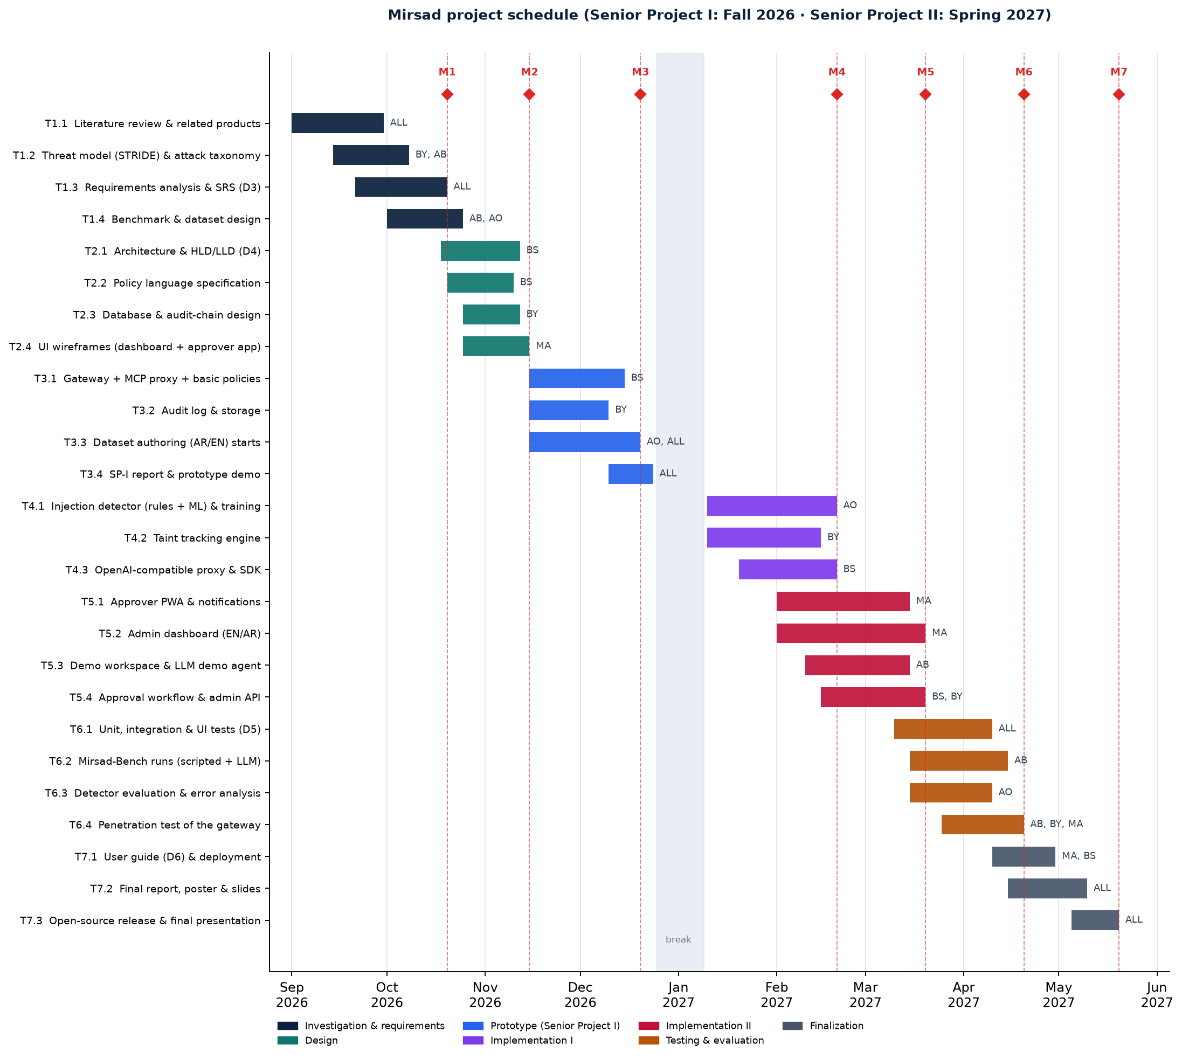
Figure 1.1: Project schedule with task owners (abbreviations as in the text) and milestones M1–M7

Chapter 2 – Literature Review
This chapter reviews the work that Mirsad builds on. Section 2.1 surveys previous studies by theme, Section 2.2 compares existing products and research systems with Mirsad, and Section 2.3 states the gap that Mirsad addresses and the limits of its contribution.
The sources come from six research tracks compiled by the team and fact-checked against primary records (publisher pages, arXiv, standards bodies, official repositories and vendor documentation) on 11 October 2026. Numbers quoted from papers are the values their authors report; the team has not reproduced them, and they are tied to model versions that age quickly. Products are described only as their documentation describes them. Preprints and practitioner blogs are cited where they are the original or most current record of an influential result.

2.1 Overview of Previous Studies

2.1.1 LLM agents and tool use
An LLM agent couples a language model with tools that it can invoke. ReAct [1] established the pattern that most agent frameworks follow: the model alternates between free-text reasoning and actions, and the observation returned by each action is fed into the next reasoning step. On two decision-making benchmarks, ReAct with one or two in-context examples beat imitation- and reinforcement-learning baselines by 34 and 10 absolute points of success rate. Toolformer [2] showed that a model can learn, with little human annotation, when to call an external API, which arguments to pass and how to use the result. Both papers treat tool use as a capability problem, and neither has a threat model for tool outputs: ReAct assumes that observations are honest, and Toolformer's tools are read-only. Nothing in the reason-act-observe loop separates data returned by a tool from instructions, which is the root cause of indirect prompt injection.
Two interfaces carry this loop in practice. OpenAI-style function calling lets the model emit a tool name and JSON arguments that the host application executes. The Model Context Protocol (MCP) [3] standardises discovery and invocation across independent servers: a host uses clients to connect over JSON-RPC 2.0 to servers that expose tools, resources and prompts. The current revision (2026-07-28) is stateless, so each request carries its own protocol version and capabilities. The specification is direct about security. Clients must treat tool annotations as untrusted unless they come from a trusted server, there should always be a human able to deny a tool call, and clients should show tool inputs to the user, validate tool results before passing them to the model and log tool usage for audit. It also says that the protocol cannot enforce these principles and leaves them to implementers. Mirsad can be read as an implementation of these client-side recommendations, placed outside the host so that it works for any agent.
Tool use also does not work equally well in every language. In what its authors describe as the first benchmark of Arabic tool calling, accuracy fell by roughly 5–10% on average when the user wrote in Arabic, whether the tool descriptions were in Arabic or English [19]. Lower accuracy means more malformed or unexpected tool arguments, which per-parameter checks catch whatever their cause.

2.1.2 Prompt injection: origins and taxonomy
Willison named the attack class in September 2022 [20]. He compared it with SQL injection: applications build prompts by concatenating trusted instructions with untrusted input, and the model cannot tell where one ends and the other begins. He suggested that a real fix might resemble parameterised queries but doubted that it was feasible with current architectures. Perez and Ribeiro [21] gave the first systematic study, using their PromptInject framework against GPT-3, and defined two goals that later work adopted: goal hijacking, in which the model abandons its task for one chosen by the attacker, and prompt leaking, in which it reveals its hidden instructions.
The decisive step for agents was indirect prompt injection. Greshake et al. [4] showed that an attacker who never interacts with the model can plant instructions in content that an LLM-integrated application retrieves later, and that the retrieved text can then steer which external APIs the application calls. They built a taxonomy of consequences that includes data theft and self-propagating injections, and demonstrated attacks on Bing's GPT-4-based chat and on code-completion tools. Liu et al. [22] formalised an attack as turning the data of a target task into compromised data that carries an injected task, showed that earlier techniques are special cases of this framework, and combined them into a stronger attack. Mirsad-Bench mirrors this framing: each attack episode pairs a benign user task with an injection task. OWASP ranks prompt injection first (LLM01) among risks to LLM applications [5], and NIST's taxonomy of adversarial machine learning treats indirect injection as an attack made possible by control over resources that the model reads [23].
Across these sources, attacks can be classified on three largely independent axes, summarised in Figure 2.1. The channel is how the malicious text reaches the model: typed by the user (direct injection), planted in data that the agent reads (indirect injection), or hidden in tool metadata. The technique is how the attacker obtains compliance. The goal is what the attacker wants the agent to do. For a tool-using agent, the goals that matter most are data exfiltration, which needs a flow from a private source to a sink that the attacker can reach, and tool misuse, in which legitimate tools are called with harmful arguments. Indirect injection is the channel Mirsad is built for, because it lets an outsider borrow the user's own privileges, data and tools.
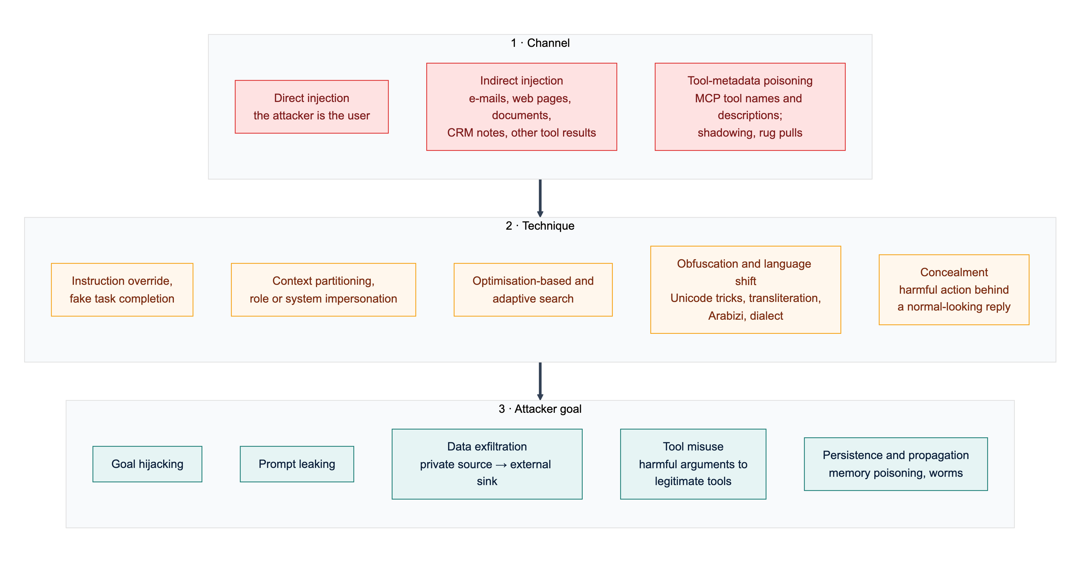
Figure 2.1: A three-axis taxonomy of prompt-injection attacks: the channel that carries the text, the technique used to obtain compliance and the attacker's goal (synthesised from the sources reviewed in Section 2.1.2)
MCP has added channels of its own. Invariant Labs disclosed tool poisoning [24], in which an MCP server hides instructions in a tool description that the model reads in full but the user usually does not see. The same disclosure described shadowing, where one server's description changes how the agent uses another server's trusted tool, and rug pulls, where a description changes after the user has approved it. A later case study [25] described a "toxic agent flow" through the official GitHub MCP server: an issue in a public repository led an agent to copy information from the owner's private repositories into a public pull request. No tool was compromised; the harm came from combining trusted tools with untrusted input. The authors also observed that users often switch tool confirmations to "Always Allow", which argues for asking a human only about risky calls.
Willison's "lethal trifecta" [8] condenses the exfiltration risk: an agent that has access to private data, is exposed to content an attacker controls and can communicate externally can be told to read secrets and send them out, and MCP makes it easy for users to assemble all three without realising it. The risk has already appeared in production. EchoLeak [26] was a zero-click flaw in Microsoft 365 Copilot in which one crafted e-mail caused Copilot to leak internal data. The exploit evaded Microsoft's cross-prompt-injection classifier, bypassed link redaction with reference-style Markdown and used images that the client fetched automatically. Two lessons from EchoLeak shaped Mirsad: a dedicated injection classifier was bypassed in a deployed product, and the fix the authors propose, provenance-based access control, is in effect taint tracking.

2.1.3 Benchmarks for agent security
Benchmarks have moved from text tasks, where success is judged on the model's output, to agents whose success is judged on changes to an environment. Table 2.1 summarises the studies that most influenced Mirsad's evaluation.
BIPIA [27], presented as the first benchmark for indirect injection, found all 25 models tested vulnerable and traced the weakness to models that cannot distinguish informational context from instructions. InjecAgent [7] moved to tool-using agents. It separates direct harm through a tool from data stealing, a two-step pattern in which private data is first read and then transmitted; the second pattern is exactly the source-to-sink flow that taint tracking is designed to break. AgentDojo [6] replaced fixed test cases with a stateful environment in which success is checked by code against the environment's state, and reports utility, utility under attack and targeted attack success rate (ASR) together. Two of its baseline results are central to Mirsad's design. A tool filter, which restricts the agent to the tools a task needs, cut targeted ASR for GPT-4o to about 7% while keeping benign utility (73%, against 69% with no defence). A prompt-injection detector reached similar security (about 8%) but cut benign utility from 69% to 41.5%, and utility under attack from 50% to 21.1%, because of false positives. The authors also note that a tool filter fails when the tools a task needs are enough for the attack, as in 17% of their cases. Later benchmarks extended the attack surface to agent memory and planning [28], web agents [29] and MCP tool metadata [30], [31]. In MCPTox the harm is carried out through legitimate tools, which is why constraining the parameters of every tool matters more than blocking a suspicious one.
Large red-teaming exercises show that static benchmarks overstate robustness. NIST's Center for AI Standards and Innovation extended AgentDojo with remote-code-execution, database-exfiltration and phishing tasks. Red-teaming with the UK AI Security Institute raised ASR from 11% for the strongest baseline attack to 81%, and running each attack 25 times instead of once raised average success from 57% to 80% [32]. A public competition on concealed attacks, in which a harmful action is taken while the final reply looks normal, produced 8,648 successful attacks from about 272,000 attempts against 13 frontier models; every model was vulnerable [33]. When an attack is concealed, the user cannot see it in the chat transcript, so an independent record of tool calls becomes necessary.
Table 2.1: Key studies on agent-security evaluation and their implications for Mirsad
Study | Setting | Main reported finding | Implication for Mirsad
Liu et al. [22] | 5 attacks, 10 defences, 10 LLMs, text tasks | No defence sufficient; detectors miss attacks or raise many false alarms | A detector cannot be the only gate
BIPIA [27] | Indirect injection in 5 scenarios, 25 LLMs | All models vulnerable | Enforce outside the model
InjecAgent [7] | 1,054 cases; 17 user and 62 attacker tools | ReAct GPT-4 agent compromised in 24% of cases (47% with a fixed prefix) | Data stealing is a source-to-sink flow that can be tracked
AgentDojo [6] | 4 stateful suites, 97 user tasks, 629 security cases | Tool filter: about 7% ASR, utility kept. Detector: about 8% ASR, utility 69% to 41.5% | Least privilege first; tune the detector for few false positives
ASB [28] | 10 scenarios, 13 model backbones | Highest average ASR 84.30%; memory and planning also attacked | Treat memory writes as sinks
WASP [29] | Web agents in GitLab and Reddit sandboxes | Up to 86% start following injections; at most about 17% complete them | Stop the first unsafe tool call
MCPTox [30] | 45 live MCP servers, 353 tools, 20 agents | Highest ASR 72.8%; harm done through legitimate tools | Parameter rules on legitimate tools
MSB [31] | 12 MCP attack types, 2,000 instances | MCP-specific attacks missing from earlier benchmarks | Evaluate at the MCP boundary
NIST CAISI [32] | AgentDojo with new high-risk tasks | Red-teaming 11% to 81%; 25 attempts 57% to 80% | Report per task and over repeated attempts
Dziemian et al. [33] | Public competition, 13 frontier models | Every model vulnerable to concealed attacks | Keep an independent audit trail of tool calls

Mirsad-Bench follows the norms these studies set: success is checked on side effects in the environment, utility is reported beside security, false positives on benign tasks are measured, and results are broken down by task and language. It reuses AgentDojo's combination of user tasks and injection tasks on a simulated Saudi company. As far as the team could determine, every benchmark reviewed here is in English; no Arabic benchmark for agent security was found.

2.1.4 Defences at the model, prompt, runtime and architecture levels
Published defences work at four levels, which differ in what an organisation deploying an agent can actually adopt.
Model level. These defences train the model to give less weight to instructions that arrive in data. The instruction hierarchy [34] defines a priority order (system above user above tool output) and trains the model to ignore conflicting lower-priority instructions. SecAlign [35] treats the problem as preference optimisation and reports ASR below 10% even against optimisation-based attacks, at a cost of two to three points on a general-knowledge benchmark. Such defences raise the baseline for everyone who uses the model, but they need the provider's cooperation or open weights and GPU fine-tuning, and they give no guarantee. An organisation that connects a hosted model to MCP servers cannot apply them.
Prompt level. Spotlighting [36] marks untrusted text before it enters the context, by delimiting it, interleaving a marker character through it or encoding it, and tells the model to treat the marked text as data. With GPT-3.5 and GPT-4 it reduced ASR from over 50% to under 2% with little loss of task performance, and Microsoft offers the encoding variant as a preview option of Prompt Shields [37]. Its authors did not test adaptive attackers, and its effect on Arabic script, where marker characters interact with word shape and diacritics, has not been studied.
Runtime detectors. Classifiers screen user input, tool outputs or tool calls. Meta's Llama Prompt Guard 2 [38] is an 86M-parameter classifier with a 512-token window whose model card lists eight supported languages, none of them Arabic, and names vulnerability to adaptive attacks as a limitation. Protect AI's DeBERTa classifier [39] handles English only and is no longer maintained. PIGuard [40] addressed over-defence: on 339 benign sentences full of words common in injections, leading guard models fell to roughly 60% accuracy. Among commercial services, Lakera Guard (now Check Point AI Guardrails) screens tool responses and tool descriptions and states coverage of more than 100 languages, Arabic among them [41], while Microsoft states that Azure Prompt Shields was tested with English only [42]. The only open Arabic model found, Ara-Prompt-Guard [43], was trained on 33,000 machine-translated examples, supports Modern Standard Arabic (MSA) only and has no paper or independent evaluation.
The evaluation literature is consistent about detectors. Hackett et al. [44] evaded six deployed detectors, among them Azure Prompt Shield and Protect AI's models, with character-level tricks such as zero-width characters, homoglyphs, bidirectional text and diacritics; one technique reached 100% evasion against every guardrail on each threat type it was tested on. Nasr et al. [45] scaled up gradient, reinforcement-learning, search-based and human red-teaming attacks against twelve recent defences and bypassed most with over 90% success, including Spotlighting (above 95%) and Meta-SecAlign, a successor of SecAlign (96%). PIGuard was the most resistant detector at 71%. Stacking several detectors did not stop adaptive attacks, and many successful triggers did not look malicious, so they could not be caught without also flagging benign inputs.
Runtime frameworks and policy enforcement. NeMo Guardrails [46] wraps an LLM application in programmable rails written in Colang. Its authors say it should not be used as a standalone safety solution, and its documentation warns that tool results are trusted by default [47]. LlamaFirewall [48] combines Prompt Guard 2, an experimental auditor of the agent's reasoning and a scanner for generated code; on AgentDojo it reduced ASR from 17.6% to 1.75%, while utility fell from 47.7% to 42.7%. Two runtime systems enforce rules instead of classifying text. AgentSpec [49] provides a rule language of trigger, predicate and enforcement, with a pause for human inspection as one enforcement action, and prevented unsafe executions in over 90% of code-agent cases with millisecond-level overhead. Progent [50] applies least privilege through default-deny rules over tool names and arguments, can run as a proxy in front of LLM and MCP endpoints, and sends requests to widen privileges to an approver; it reports AgentDojo ASR falling from 39.9% to 1.0%. Neither system tracks data flow, so neither can tell whether an allowed outbound call carries content supplied by an attacker.
Architecture level. These designs restructure the agent so that untrusted data cannot change its control flow. CaMeL [16] has a privileged LLM write a restricted program from the trusted request alone, a quarantined LLM parse untrusted data without tool access, and an interpreter attach capabilities (provenance and allowed readers) to every value and check policies before each tool call. It completes 77% of AgentDojo tasks with provable security, against 84% for an undefended agent. FIDES [51] labels data for integrity and confidentiality, propagates the labels conservatively through the planner and enforces two generic policies: consequential tools run only from a trusted context, and egress tools send data only to recipients allowed to read it. When a policy is violated, FIDES aborts. Beurer-Kellner et al. [17] generalised these ideas into six design patterns, such as plan-then-execute, while warning that human confirmation is often burdensome and prone to fatigue. A 2026 position paper [52] argues that system-level defences should form the skeleton of agentic systems, with learned models confined to constrained roles and human interaction reserved for ambiguous cases.
For Mirsad, the review leads to the following conclusions. First, detectors are useful signals but weak boundaries: every classifier tested against adaptive attackers was bypassed, and over-defence becomes alert fatigue when a flag triggers a human approval. Second, the strongest results since 2024 come from designs that ask whether an action is allowed given where its inputs came from, rather than whether a text looks malicious. Third, those designs are costly to adopt: CaMeL and FIDES require the agent to be rebuilt. Among the research designs reviewed, only Progent's proxy mode brings deterministic tool-call enforcement to unmodified agents; Section 2.2 shows that some gateway products now do the same for rules on tools and arguments.

2.1.5 Multilingual and Arabic LLM safety
Safety behaviour learned mainly from English data does not transfer evenly to other languages, scripts and dialects. Yong et al. [13] machine-translated harmful instructions into twelve languages and found that low-resource languages, combined, bypassed GPT-4's safeguards about 79% of the time, whereas MSA had a bypass rate of only 3.65%. Deng et al. [14] built MultiJail, unsafe prompts translated by native speakers into nine languages with Arabic among them, and showed that deliberately combining a harmful instruction with a multilingual prompt raised unsafe output to 80.92% for ChatGPT and 40.71% for GPT-4. The most directly relevant result comes from Al Ghanim et al. [15]. GPT-4 and Claude 3 Sonnet mostly refused harmful prompts written in standard Arabic script but produced unsafe output when the same prompts were written in Latin transliteration or Arabizi, the chat style that uses digits such as 3 and 7 for Arabic letters. The authors attribute this to refusal behaviour tied to particular written forms of words. MSA alone is therefore not the hard case; the less standard forms that Saudi users actually type are.
Arabic safety benchmarks matured quickly in 2025 and 2026, and they point the same way. SalamahBench [53] wrote 8,270 harmful prompts in MSA and five regional varieties, including Saudi Arabic, and found robustness across varieties to depend strongly on the model. ArabicDialectSafety [54] showed that a fine-tuned MARBERTv2 encoder (macro-F1 0.95 on binary safety classification) outperformed prompted frontier LLMs, although its dialects do not include Gulf Arabic. ASAS [55] found obfuscation-based attacks the most effective against Arabic-capable models, and poor agreement between an LLM judge and human annotators. All of these benchmarks measure harmful requests to a model; none contains instructions hidden in tool outputs that try to hijack an agent.
Work on Arabic prompt injection is sparse. In the only indirect-injection study found that includes Arabic, instructions hidden in about 500 academic papers changed LLM review outcomes when written in English, Japanese or Chinese but had little or no effect in Arabic [56]. The authors do not explain the result, which may reflect weaker instruction-following in Arabic rather than stronger defences; as Arabic-capable models improve, Arabic injections should be expected to become more effective. MIPIAD [57] is the closest published design to a multilingual detector of indirect injection, combining a small Qwen2.5 classifier with lexical features (best F1 0.9205), but it was evaluated only on synthetic English and Bangla data.
For the detector itself, the CAMeLBERT study [58] found that how closely an Arabic encoder's pre-training variety matches the task data matters more than the amount of pre-training data, which is a concern for Gulf dialect and Arabizi. Mirsad's first detector therefore uses character n-grams with a linear model, combined with weighted Arabic and English rules, including rules for Gulf dialect and Arabizi. Before scoring, a normalisation step removes diacritics, elongation and invisible or bidirectional control characters, and folds letter variants, digits and look-alike characters, in response to the evasion techniques above. The choice favours CPU latency and inspectable features. The model is implemented but has not yet been trained on the team's labelled data, so the packaged detector currently runs its rules only; fine-tuning an Arabic encoder is planned as a second stage (Chapter 5).

2.1.6 Standards and Saudi regulation
International frameworks now agree on the controls that agents need. Under LLM01, OWASP's Top 10 for LLM Applications [5] recommends constraining model behaviour, validating outputs with deterministic code, enforcing least privilege, requiring human approval for high-risk actions and segregating untrusted content, and notes that it is unclear whether fool-proof prevention exists. OWASP's Top 10 for Agentic Applications for 2026 [59] adds risks specific to agents, including agent goal hijack (ASI01) and tool misuse and exploitation (ASI02). NIST's AI Risk Management Framework [18] organises AI risk work into the Govern, Map, Measure and Manage functions, and NIST AI 100-2e2025 [23] recommends designing systems on the assumption that injection will happen, for example by giving access to untrusted data only through well-defined interfaces. With the MCP specification, these documents agree on least privilege, complete mediation, separation of untrusted content, human approval and logging. None of them enforces anything.
Saudi regulation adds concrete obligations. The NCA's Essential Cybersecurity Controls (ECC-2:2024) [11] apply to government entities and operators of critical national infrastructure. Control 2-2-3 requires least privilege, need-to-know and segregation of duties; 2-12-3 requires event logging, continuous monitoring and log retention of at least 12 months; and 4-1 covers third-party cybersecurity, under which third-party MCP servers fall. The Personal Data Protection Law (PDPL) [12], in force since September 2023, requires technical measures to protect personal data (Article 19), requires breaches to be notified (Article 20) and restricts transfers outside the Kingdom (Article 29); its Implementing Regulation [60] sets a 72-hour window for notifying SDAIA of a breach that could cause harm. SDAIA's AI Ethics Principles [10] include privacy and security, reliability and safety, fairness, and accountability, and its Generative AI Guidelines for Government [61] require human review of generative-AI output and keep data classified as restricted or higher out of these tools. These obligations sit within the digital-government goals of Vision 2030 [9]. None of the Saudi documents mentions AI agents or tool calls, so an organisation that deploys agents has to translate them into technical controls itself. Appendix A maps each relevant provision to the Mirsad feature that supports it.

2.1.7 Foundations used by Mirsad
Information-flow control and taint tracking. Denning's lattice model [62] binds every object to a security class and allows a flow only if it respects the ordering of the classes. Labels are combined with a join, so data tends to become more restricted over time, a problem known as label creep. Sabelfeld and Myers [63] surveyed language-based enforcement of noninterference and discussed declassification, the controlled release of information to a lower class. Newsome and Song [64] introduced dynamic taint analysis of unmodified software, with the source, propagation and sink vocabulary that later systems use. All three assume a program whose flows can be analysed. An LLM is opaque and may mix any input into any output, so Mirsad cannot claim noninterference and applies taint at the boundary between tool results and tool calls instead. A session becomes tainted once it has read untrusted content, which is sound but coarse, as in FIDES. Recognisable values such as e-mail addresses, IBANs and record identifiers are tracked back to the result they came from, which is precise but incomplete. Human approval acts as an explicit, logged declassification step.
Reference monitors. Saltzer and Schroeder's design principles [65] justify the gateway architecture: complete mediation (every tool call passes through the gateway), fail-safe defaults (unlisted tools are denied), least privilege (rules per tool and parameter) and separation of privilege (a human approves high-risk calls).
Tamper-evident logging and policy languages. Schneier and Kelsey [66] combined hash chains with message authentication codes for forensic audit logs and stated the limits of any such scheme: entries written after a compromise cannot be protected, and cryptography can detect deletion but not prevent it. Mirsad's audit log chains events with HMAC-SHA-256 [67]. Because HMAC is symmetric, whoever holds the key could rewrite the chain, and truncation of the newest entries can only be detected against a copy of the head hash kept outside the gateway. For policy, XACML 3.0 [68] separates the policy enforcement point from the policy decision point and the attribute sources that inform it, resolves conflicts with combining algorithms, and lets a decision carry obligations. In Mirsad the gateway is the enforcement point and the YAML policy engine the decision point; the taint tracker and detector supply attributes, and "require approval" behaves like an obligation.
Threat modelling and human-AI interaction. Shostack's method of data-flow diagrams with trust boundaries and STRIDE threat categories [69] structures Mirsad's threat model (Section 3.3.8). For the approval workflow, Amershi et al. [70] give 18 validated guidelines for human-AI interaction, among them making clear why the system acted and supporting efficient correction and dismissal. Parasuraman et al. [71] show that automation can be set to different levels for analysis, decision and action, and warn that supervising automation brings complacency and workload problems. Mirsad therefore automates analysis and decision for most calls and asks a human only about calls that its policy marks as high-risk.

2.2 Comparative Analysis
Table 2.2 compares Mirsad with the commercial products, open-source projects and research systems closest to it. The criteria follow from Section 2.1: where the control sits; whether it enforces action-level rules on tools and their parameters; whether it tracks where data came from; whether its injection detection covers Arabic; whether it offers human approval; whether its log is tamper-evident; and whether it is open source. Each cell records only what the cited sources state as of 11 October 2026. "N/D" (not documented) means that nothing was found in the pages reviewed, not that the capability is absent, and vendor detection claims were not tested by the team. The Mirsad row describes the implemented prototype.
Table 2.2: Feature comparison of runtime guardrails, MCP gateways, research systems and Mirsad (N/D = not documented in the sources reviewed)
System | Deployment point | Action-level policy (tool / parameter) | Taint / data flow | Arabic injection detection | Human approval | Tamper-evident audit | Open source
Lakera Guard / Check Point AI Guardrails [41], [72] | Screening API for model and tool messages | Tool allow-list; parameter rules N/D | N/D | Yes (vendor claim) | N/D | N/D | No
NVIDIA NeMo Guardrails [46], [47] | Library or service around the LLM | Custom rails written in code | No; tool results trusted by default | N/D | N/D | N/D | Yes
Meta LlamaFirewall with Prompt Guard 2 [48], [38] | Library in the agent loop | N/D | No (audits reasoning) | Not listed (8 languages) | N/D | N/D | Yes
Azure Prompt Shields with Foundry agents [37], [73], [42] | Model I/O; agent tool responses (preview) | Tool allow-list; parameter rules N/D | No (Spotlighting marks only) | Tested in English only | Approval primitive; interface left to developer | N/D | No
AWS Bedrock Guardrails with AgentCore Policy [74], [75], [76], [77] | AgentCore Gateway (tool layer) | Yes: Cedar rules, default deny | Partial: session history, no provenance labels | Yes (Standard tier) | Policy pattern; no approval app documented | Partial: opt-in signed log digests | No
Google Model Armor [78] | Model I/O screening API | No per-tool or parameter rules | No (stateless) | Not among tested languages | N/D | N/D | No
Protect AI LLM Guard [79], [39] | Library on prompts and outputs | No | No | No (English only) | No | No | Yes (archived)
Invariant Guardrails and Gateway (Snyk) [80], [81] | LLM and MCP proxy | Yes: tool and argument rules | Partial: call-sequence rules | N/D | N/D | N/D | Yes (maintenance unclear)
Docker MCP Gateway [82] | MCP gateway with containerised servers | Tool on/off; parameters via custom interceptors | No | No detector | N/D | Call logs; integrity N/D | Yes
agentgateway [83] | MCP and agent proxy | Yes: CEL rules including arguments | No | N/D | N/D | N/D | Yes
IBM ContextForge [84] | MCP federation gateway with plugins | Via OPA plugin on arguments | N/D | English-only plugin | N/D | N/D | Yes
Progent (research) [50] | Library or LLM/MCP proxy | Yes: default-deny argument rules | No | Not applicable | For privilege expansion | N/D | N/D
AgentSpec (research) [49] | Hooks in the agent framework | Yes: trigger-predicate rules | No | Not applicable | Yes (user inspection) | N/D | N/D
CaMeL (research) [16], [85] | Inside the agent (custom interpreter) | Yes: policies on arguments and capabilities | Yes: data-flow graph | Not applicable | Proposed for deployment | No | Yes (unmaintained)
FIDES (research) [51] | Inside the agent (planner) | Trusted-action and permitted-flow policies | Yes: integrity and confidentiality labels | Not applicable | No (aborts) | N/D | N/D
Mirsad | Tool-layer gateway: MCP, OpenAI-compatible proxy, Guard API | Yes: YAML rules, default deny, rate limits | Yes: session and value level (coarser than CaMeL) | Yes: AR/EN rules now, model awaiting training data; F1 pending | Yes: installable bilingual PWA | Yes: HMAC chain per decision, with replay | Yes (Apache-2.0)

The systems in the table fall into five groups, each with characteristic strengths and weaknesses.
Screening services and classifiers (Lakera, Azure Prompt Shields, Google Model Armor, Bedrock Guardrails, Prompt Guard 2, LLM Guard) are easy to adopt, and two of them (Lakera and the Standard tier of Bedrock Guardrails) are the only products in the sample that document Arabic coverage. However, they return a verdict and leave enforcement to the application, they are bypassed by adaptive attackers (Section 2.1.4), and most were tested only in English. Hosted services also receive every prompt and tool output, which matters under the PDPL's rules on transfers outside the Kingdom.
Guardrail frameworks (NeMo Guardrails, LlamaFirewall) are open source and layered, but security at the tool layer has to be programmed by hand, NeMo trusts tool results by default, components that call an LLM add latency and can themselves be injected, and neither documents an approval workflow or a durable audit store.
Cloud agent platforms (AWS AgentCore Policy, Azure Foundry). AgentCore Policy is the closest commercial analogue to Mirsad: deterministic, default-deny Cedar policies on tool names and input parameters outside the agent's code [74], temporal conditions on session history such as requiring an earlier approval action [75], and CloudTrail log files that can be validated with chained, signed digests [77]. However, it enforces only on traffic routed through an AgentCore Gateway in AWS, documents no provenance labels, models approval as a policy pattern rather than an application for approvers, and offers only opt-in, file-level log integrity. Azure Foundry offers per-tool allow-lists and an approval gate for MCP tools but leaves the approver's interface and the audit trail to the developer [73].
MCP gateways (Docker MCP Gateway, agentgateway, IBM ContextForge) are vendor-neutral, open-source infrastructure with container isolation, tool authorisation and, in agentgateway and ContextForge, rules on tool arguments. None documents taint tracking, an approval channel or a tamper-evident log, and the only documented injection filter wraps the archived English-only LLM Guard model. They are possible hosts for a component like Mirsad rather than complete alternatives to it.
Research policy and information-flow systems (Progent, AgentSpec, Invariant Guardrails, CaMeL, FIDES) give the strongest guarantees. CaMeL and FIDES track data flow precisely, and AgentSpec shows that deterministic rule enforcement, including a pause for human inspection, adds only millisecond-level overhead. On the other hand, CaMeL and FIDES require the agent to be rebuilt, at a cost in utility; Progent, AgentSpec and Invariant's sequence rules do not track where a value came from; research code is often unmaintained; and none of them evaluates the approval interface or documents a tamper-evident record.
Model-level defences such as SecAlign are absent from the table because they are properties of a model rather than components an organisation can deploy. They complement a gateway: a hardened model lowers the rate of attacks that reach the tool boundary, and the gateway contains the ones that do.

2.3 Research Gap and Positioning
The review supports six observations. Detectors and model-level defences are bypassed by adaptive attackers [45], so a classifier cannot be the security boundary. The strongest system-level guarantees require the agent to be rebuilt [16], [51], while deployable tool-layer controls enforce rules on tools and arguments but do not track provenance [50], [74]. Arabic is barely covered, and no Arabic benchmark of indirect injection against tool-using agents was found. Human approval is offered as a primitive rather than a product, and its interface is not evaluated [17]. Audit integrity is an afterthought: only AWS documents cryptographic log validation, at the level of log files. Finally, the MCP specification and Saudi regulations state obligations but leave their enforcement for agents to implementers [3], [11], [12].
Gap statement. As of October 2026, none of the products, open-source projects or research prototypes reviewed documents, in one vendor-neutral and self-hostable component, all five of the following: (1) declarative per-tool and per-parameter policy enforced at the MCP and function-calling boundary; (2) taint labels that follow untrusted tool output to externally visible sinks; (3) an injection detector designed for Arabic as well as English; (4) a ready-to-use human approval channel outside the agent; and (5) a tamper-evident audit trail of every decision. AWS AgentCore Policy covers the first well and the third and fifth partly, but only inside AWS. agentgateway and Invariant cover the first in open source, and Invariant also covers part of the second. CaMeL covers the second most rigorously, but only as a research agent architecture.
Positioning. Mirsad's contribution is integration and localisation rather than a new security primitive. It combines techniques that the literature has validated separately: default-deny rules on tools and parameters in the style of Progent, Invariant and Cedar; taint rules adapted from FIDES's trusted-action and permitted-flow policies; spotlighting as an optional extra layer; Arabic-aware normalisation and Arabizi rules that respond to the documented evasion techniques; human approval treated as a logged declassification step; and an HMAC-chained audit log with decision replay. It places them in one open-source gateway that needs no change to the agent, and evaluates the result on Arabic and English scenarios with a method adapted from AgentDojo. Mirsad does not claim to be the only tool-layer firewall, the only system with per-parameter policy or the only Arabic-capable detector, because AgentCore Policy, agentgateway, Invariant, Lakera and Bedrock Guardrails each contradict one of those claims. Its taint tracking is also weaker than CaMeL's, because a proxy cannot see the data flow inside the model.
Limits. Several limits follow from this position and from the literature reviewed.
- Coarse taint causes approval friction. Session-level taint over-approximates, and label creep turns into approval requests; Section 4.2.4 measures this friction on Mirsad-Bench. Whether approvers can handle it without fatigue has not yet been tested with users.
- Value matching is incomplete. An agent that paraphrases, translates or re-encodes data defeats value-level matching, and only the session-level rules then apply.
- The detector is a signal, not a boundary. Attackers who can query it will find inputs that evade it, as they have for every detector in Section 2.1.4.
- Detection accuracy and attack success are not yet measured. Both depend on attack-labelled data written by the team (Section 3.6.4); Sections 4.2.2 and 4.2.3 report them once that data exists.
- Scope. Mirsad mediates tool calls only. Backdoors planted during training, supply-chain compromise of MCP servers, tools that bypass the gateway, and harm that occurs only in text, such as a biased summary, are outside its reach.
- Audit trust. The HMAC chain reveals tampering only by parties who do not hold the key, and truncation of the newest events needs an external anchor.
- A moving landscape. The products compared change month to month, and several of the open-source projects reviewed have been archived or have lost their hosted services. The comparison reflects the documentation available on 11 October 2026.

Chapter 3 – Methodology
This chapter explains how the project was approached, how requirements were obtained, how the system is designed, how it was built and tested, and which ethical, legal and security considerations shaped it.

3.1 Research Design / Project Approach
Mirsad is primarily an implementation project with a quantitative evaluation, i.e. a design-science approach [86]: an artefact (the gateway) is built to address an identified organisational problem and is then evaluated against criteria fixed in advance. A purely qualitative design would not answer the central question of Section 1.2, which is about measurable reductions in attack success, false positives and latency. A purely experimental study without a working artefact would not satisfy the IS499 learning outcomes, which require designing, implementing and evaluating an information system.
The evaluation is quantitative and comparative:
- Controlled experiments on Mirsad-Bench. The same user tasks and attacks are run against an unprotected agent (baseline) and against the agent behind Mirsad, under several configurations (full protection and ablations with single layers enabled). Two agent types are used: a deterministic worst-case compliant agent that always obeys any injected instruction that reaches it, which isolates the effect of the gateway from the model's own robustness, and a real LLM agent (Qwen2.5-7B), so far exercised only in a smoke run of 4 tasks.
- Classifier evaluation. The injection detector is evaluated with precision, recall, F1, false-positive rate and ROC-AUC on held-out test sets written separately from the training data, plus, once the team adds it, an external public English dataset for out-of-distribution evidence.
- Performance measurement. Added latency is measured over HTTP against a direct tool call.
- Verification. Automated unit, integration and API tests, security tests of the gateway itself, and audit-replay checks confirm that the functional and non-functional requirements are met.
The success criteria in Section 1.3 were set in the proposal before implementation, which protects the evaluation from being tuned to the results.

3.2 Data Collection / Requirements Gathering

3.2.1 Elicitation methods
Mirsad addresses an emerging threat for which there is no installed user base to observe, so requirements were gathered from several complementary sources rather than from a single existing system:
1. Document and standards analysis. The approved proposal (SPAP), the OWASP Top 10 for LLM Applications [5], the MCP specification [3], the NCA Essential Cybersecurity Controls [11], the PDPL [12] and the NIST AI RMF [18] were analysed for obligations that a control point must satisfy (logging, access control, human oversight, personal-data protection).
2. Literature and benchmark analysis. Attack taxonomies and threat models from Greshake et al. [4], AgentDojo [6] and InjecAgent [7] were used to derive the attacker goals the gateway must defeat (exfiltration, destructive actions, fraud, phishing, persistence) and the success metrics.
3. Analysis of existing solutions. The documentation of commercial and open-source guardrails was reviewed (Section 2.2) to identify missing capabilities, which became the differentiating requirements (action-level policy, taint tracking, Arabic detection, approval, verifiable audit).
4. Threat modelling. A STRIDE analysis of the data-flow diagram (Section 3.3.8) produced the security requirements of the gateway itself (authentication, integrity of the audit log, fail-safe approvals, input limits).
5. Personas and scenarios. The personas of Section 1.5.1 and end-to-end usage scenarios of the simulated workspace were used to write use cases and to set usability targets such as deciding on an approval in under 30 seconds.
6. Prototyping and supervisor reviews. Under the agreed process, requirements are refined iteratively: working increments, starting with the Senior Project I prototype at milestone M3, are demonstrated in the bi-weekly supervisor meetings, and the resulting changes are recorded as backlog items.
Selection criteria. Sources were chosen by three criteria. The first was authority over the target setting: the standards and regulations that a Saudi organisation deploying agents must answer to or is likely to adopt (OWASP Top 10 for LLM Applications, NCA ECC, PDPL, NIST AI RMF and the MCP specification itself). The second was relevance to tool-using agents and indirect injection rather than chat-only jailbreaks. The third, for benchmarks, was an evaluation method that judges attack success on the side effects of tool calls and reports utility beside security, as AgentDojo and InjecAgent do, so that the method could be adapted to Arabic scenarios.
Tools. Research notes and the product comparison were kept as Markdown files under version control (docs/research/); the use-case, data-flow and threat-model diagrams were drawn in Mermaid (docs/diagrams/); and the requirements, use cases and acceptance criteria were written as tables in the report sources, so that the SRS (D3) and this chapter share one copy.
Primary stakeholder data. No interviews have been held and the stakeholder questionnaire in Appendix F has not been administered yet, so the requirements rest on the documentary sources above rather than on practitioner input. The team plans to administer the questionnaire, in particular its Section D, together with the user study described in Section 4.2.8, and to report aggregate results with the number of respondents.

3.2.2 Threat model and assumptions
The gateway protects against an external attacker who can place content in data sources that the agent reads (send an e-mail, publish or edit a web page, upload a document, write a review or support ticket, or poison a CRM note through a public form), which is the indirect prompt-injection model of [4]. The attacker cannot modify the agent's code, its system prompt, the gateway or its configuration, and cannot read the gateway's secrets. The attacker succeeds if the agent performs an action that serves the attacker: sending data to an attacker-controlled destination, deleting or corrupting records, transferring money, sending phishing messages, or planting instructions for later. The LLM itself is treated as untrusted after it has read untrusted content: Mirsad does not try to make the model robust, it constrains what the model's tool calls can achieve. Insider attacks on the audit log are considered up to the point of an attacker who does not hold the HMAC key.

3.2.3 Use-case model
Figure 3.1 shows the actors and use cases. Besides the four human roles (approver, administrator, auditor and agent developer) the AI agent is modelled as a system actor, and the attacker is modelled as a misuse actor following the misuse-case technique: each misuse case is linked to the use case it threatens and to the security use case that mitigates it.
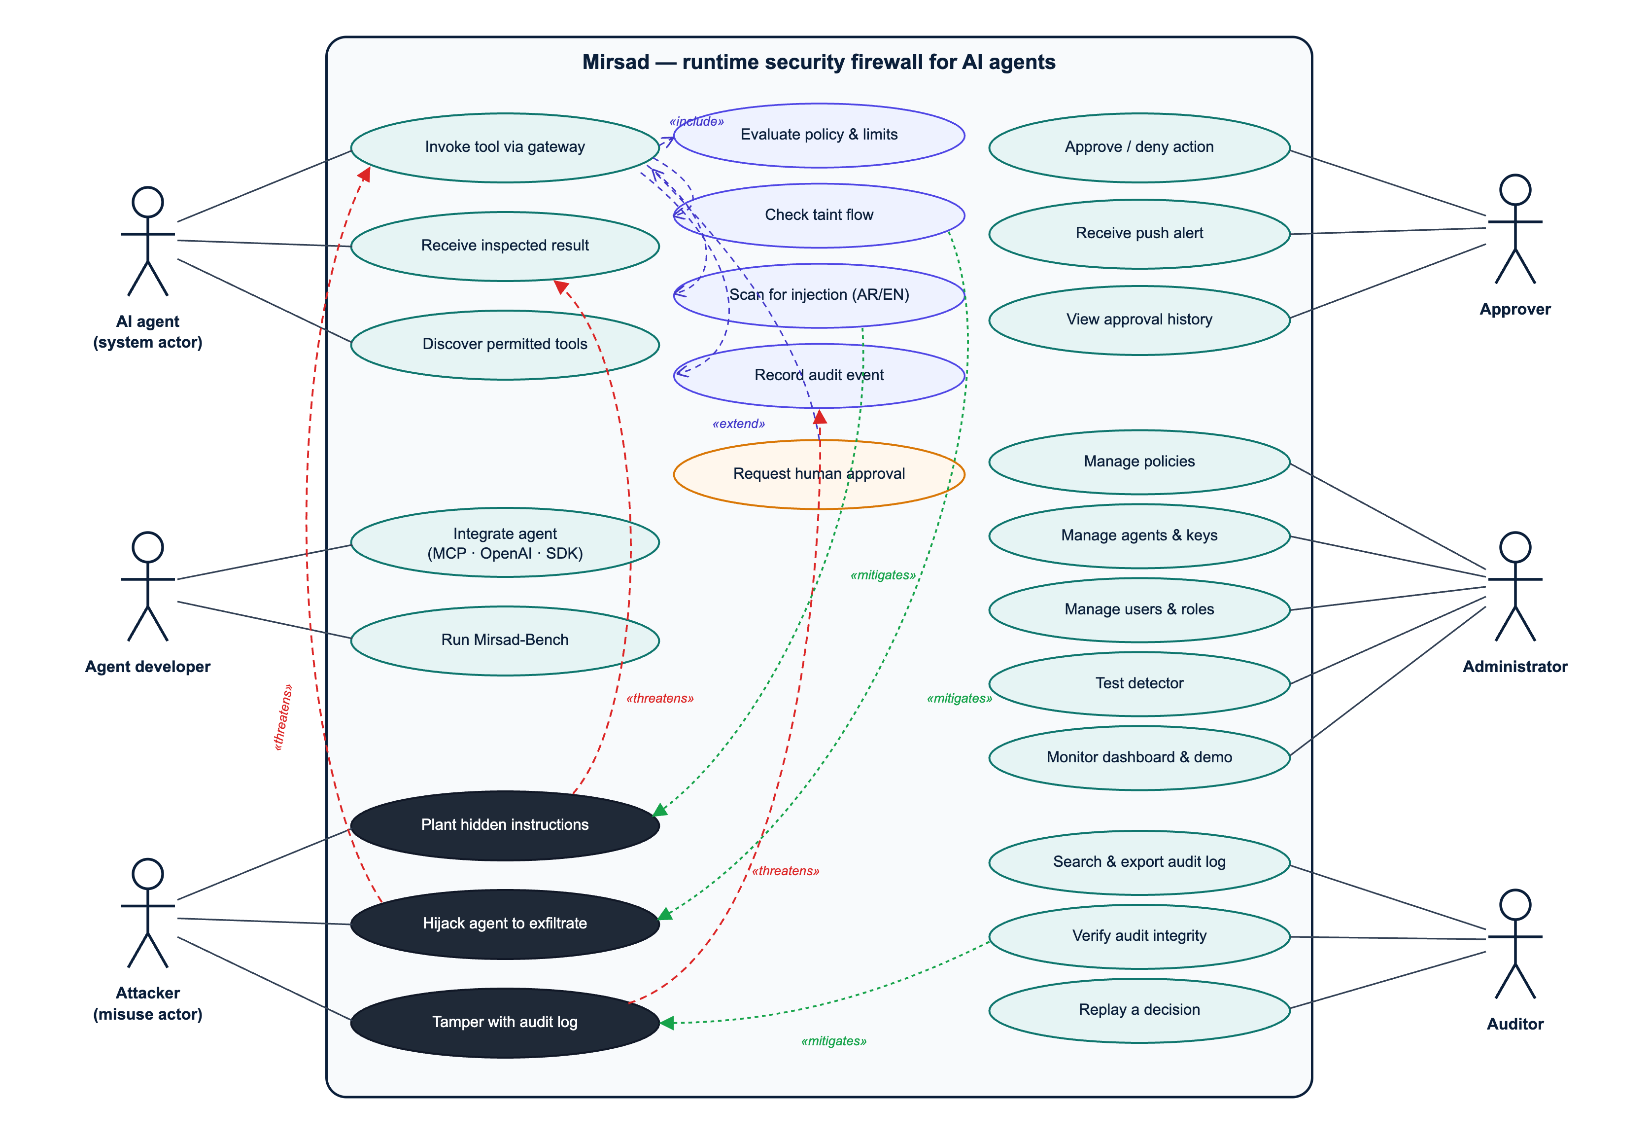
Figure 3.1: Use-case diagram with misuse cases (black) and the security use cases that mitigate them
Table 3.1: Use-case catalogue
ID | Use case | Primary actor | Summary
UC-01 | Invoke tool via gateway | AI agent | The agent calls a tool; Mirsad authenticates the agent, evaluates policy, rate limits and taint, possibly asks for approval, executes the call and returns the inspected result.
UC-02 | Receive inspected result | AI agent | Mirsad scans the tool result, sanitises or blocks injected instructions, labels trust and sensitivity, and returns spotlighted content.
UC-03 | Discover permitted tools | AI agent | The agent lists tools and sees only those allowed for it.
UC-04 | Integrate agent | Agent developer | Connect an agent through the MCP proxy, the OpenAI-compatible endpoint or the SDK.
UC-05 | Approve / deny action | Approver | Review a pending high-risk action on the phone and decide.
UC-06 | Receive push alert | Approver | Get a real-time notification when an action is paused.
UC-07 | View approval history | Approver | Review past decisions and notes.
UC-08 | Manage policies | Administrator | Edit, validate, activate or roll back the YAML policy.
UC-09 | Manage agents and keys | Administrator | Register agents, issue, rotate and revoke API keys.
UC-10 | Manage users and roles | Administrator | Create approvers, auditors and administrators.
UC-11 | Test detector | Administrator | Paste Arabic or English text and see the detector's score and highlighted spans.
UC-12 | Monitor dashboard and demo | Administrator | Watch live statistics; run the demonstration agent in protected and unprotected modes.
UC-13 | Search and export audit log | Auditor | Filter events and export evidence.
UC-14 | Verify audit integrity | Auditor | Recompute the HMAC hash chain and locate any tampering.
UC-15 | Replay a decision | Auditor | Re-evaluate a stored decision with its stored policy version and inputs.
UC-16 | Run Mirsad-Bench | Agent developer | Reproduce the evaluation with scripted or LLM agents and ablations.
MC-01 | Plant hidden instructions | Attacker | Place instructions in an e-mail, web page, document or CRM note the agent will read (mitigated by UC-02).
MC-02 | Hijack agent to exfiltrate | Attacker | Make the agent send confidential data or money to the attacker (mitigated by UC-01 policy, taint and approval).
MC-03 | Tamper with audit log | Attacker / insider | Modify or delete audit records to hide an incident (mitigated by UC-14).

Table 3.2, Table 3.3, Table 3.4 and Table 3.5 specify the four core use cases.
Table 3.2: Use-case specification UC-01 – Invoke tool via gateway
Field | Description
Actors | AI agent (primary); Approver (secondary, only when escalated)
Preconditions | The agent is registered and holds a valid API key; an active policy exists; the upstream tool server is reachable.
Trigger | The agent's model emits a tool call (MCP tools/call, an OpenAI tool_calls entry, or a Guard API request).
Main flow | 1. Adapter authenticates the agent key and builds a ToolCall. 2. Policy engine resolves the tool profile, checks that the tool is allowed, evaluates parameter constraints, rate limits and global rules, and resolves the sink. 3. Taint tracker evaluates the call against the session's provenance state. 4. Gateway combines reasons (deny-overrides) and computes the risk score. 5. The decision is appended to the audit log. 6. The call is forwarded to the upstream tool. 7. UC-02 inspects the result. 8. The inspected result is returned to the agent.
Alternative flows | A1 (deny): at step 4 the action is DENY; the agent receives a bilingual explanation and the call never reaches the tool. A2 (approval): at step 4 approval is required; UC-05 is triggered and the call waits; approved → continue at 6, denied or expired → A1. A3 (monitor mode): the would-be decision is logged but the call is always forwarded.
Exceptions | E1 invalid key → HTTP 401, audited as authentication failure; E2 upstream error → error result returned to the agent and audited; E3 request larger than 1 MB → HTTP 413.
Postconditions | Exactly one tool_call.decision event (and, if executed, one tool_result.inspection event) exists in the hash chain for the call.
Requirements | FR1.1–FR1.3, FR2.1–FR2.4, FR3.3, FR5.1, FR6.1, NFR1, NFR3

Table 3.3: Use-case specification UC-05 – Approve / deny action
Field | Description
Actors | Approver (primary)
Preconditions | The approver is logged in to the approval app (role approver or admin); a request is pending.
Trigger | The gateway escalates a call (REQUIRE_APPROVAL) and publishes approval.requested.
Main flow | 1. The app shows a notification and adds the request to the pending list with a risk badge and a countdown. 2. The approver opens it and reads the plain-language summary ("what", "why paused", "where the data came from"). 3. The approver optionally expands the raw arguments. 4. The approver taps Approve or Deny, optionally adds a note, and confirms. 5. The server records the decision, resumes the waiting call and audits approval.decided.
Alternative flows | A1: the request expires before step 4 → status EXPIRED, the call is denied. A2: another approver decides first → the app refreshes and shows the outcome.
Postconditions | The approval record stores the decision, the approver's username, the time and the note.
Requirements | FR5.1–FR5.3, NFR4, NFR6, NFR7

Table 3.4: Use-case specification UC-08 – Manage policies
Field | Description
Actors | Administrator
Preconditions | Logged in with role admin.
Main flow | 1. Open the Policies page; the active YAML and version history are shown. 2. Edit the YAML. 3. Press Validate; errors are listed with line numbers. 4. Review the diff against the active version. 5. Press Activate and confirm. 6. The new version is stored, the gateway hot-swaps its policy and policy.activated is audited.
Alternative flows | A1: validation fails → activation disabled. A2: roll back by activating an earlier version. A3: switch to mode: monitor to trial a policy without enforcement.
Requirements | FR2.1, FR2.5, FR7.1

Table 3.5: Use-case specification UC-14 – Verify audit integrity
Field | Description
Actors | Auditor or administrator
Main flow | 1. Press "Verify chain" (or run mirsad audit verify). 2. The server recomputes the HMAC of every event in sequence order and compares it with the stored hash and the next event's prev_hash. 3. The result shows the number of events checked, the head hash, and either "intact" or the first sequence number where the chain breaks.
Postconditions | An audit.verified event records the check.
Requirements | FR6.1, FR6.3, NFR3, NFR7

3.2.4 Requirements specification

Functional requirements
Functional requirements are grouped by the eight capabilities in the proposal (FR1–FR8) and refined into testable sub-requirements. Priorities use the MoSCoW scale (M = must, S = should, C = could). Each requirement has an acceptance criterion; the test cases that verify it are listed in the requirements traceability matrix (Appendix B of the final report; deliverable D5, Section B.2).
Table 3.6: Functional requirements
ID | Requirement | Pri. | Acceptance criterion
FR1.1 | The gateway shall act as an MCP server towards agents and an MCP client towards upstream MCP servers over stdio and streamable HTTP, forwarding tools/list and tools/call. | M | An MCP client connected through Mirsad lists and calls upstream tools; results are identical to a direct connection when the policy allows.
FR1.2 | The gateway shall expose an OpenAI-compatible /v1/chat/completions endpoint that inspects tool messages before forwarding and checks returned tool_calls. | M | A denied tool call is removed from the response and replaced by an explanation; tool messages are sanitised.
FR1.3 | The gateway shall expose a Guard API (/v1/guard/tool-call, /v1/guard/tool-result, /v1/tools/{tool}/invoke) and a Python SDK for frameworks that execute tools themselves. | M | SDK guard decorator blocks a denied call by raising MirsadBlocked.
FR1.4 | Each agent shall only discover the tools its policy allows (least-privilege discovery). | S | tools/list and GET /v1/tools omit tools with allow: false.
FR2.1 | The system shall load policies written in a declarative YAML language with per-agent tool entries, glob patterns, defaults, global rules and a monitor mode. | M | All shipped policies validate; invalid documents are rejected with line-numbered messages.
FR2.2 | The policy engine shall evaluate per-parameter constraints (max, min, max_length, enum, not_in, pattern, not_pattern, domain_in, domain_not_in, max_items, type, required), each with a configurable violation action (deny or require approval). | M | Each operator has passing and violating test cases.
FR2.3 | The policy engine shall enforce sliding-window rate limits per agent and tool. | M | The (n+1)-th call inside the window is denied with code RATE_LIMIT.
FR2.4 | Reasons from all layers shall be combined with a deny-overrides algorithm, and every decision shall carry machine-readable reason codes and bilingual explanations. | M | A call with one deny reason is denied regardless of other reasons.
FR2.5 | Administrators shall be able to validate, activate and roll back policy versions at run time without restarting the gateway. | S | Activation hot-reloads the policy and creates a policy.activated audit event.
FR3.1 | Every tool result shall be labelled with a trust level (trusted/untrusted) and a sensitivity level (public/internal/confidential) from its tool profile. | M | The audit event for each inspection records both labels.
FR3.2 | The taint tracker shall record identifying values (e-mail addresses, URLs, domains, IBANs, phone numbers, identifiers and text n-grams) from results, with their source tool, call and field. | M | Values embedded in JSON and in free text are both extracted.
FR3.3 | The gateway shall escalate or block calls to external sinks after untrusted content was ingested, calls that carry confidential values to external sinks, and calls whose destination value originated in untrusted content. | M | The three taint rules fire on attack fixtures and do not fire when replying to a sender or e-mailing a CRM contact.
FR3.4 | After an injection has been detected in a session, high-risk tools shall require approval. | S | TAINT_AFTER_INJECTION fires for high/critical tools in that session only.
FR4.1 | Every untrusted tool result, and every result of a tool marked scan (for example CRM records), shall be scanned for embedded instructions in English, Modern Standard Arabic, Gulf dialect, Arabizi and mixed text, producing a score, label, language and highlighted spans. | M | Detector F1 ≥ 0.85 on the held-out Arabic and English test sets.
FR4.2 | Text shall be normalised before detection (Unicode NFKC, invisible and bidirectional control characters, Arabic diacritics and letter variants, homoglyphs), and obfuscation shall itself be reported as a signal. | M | Zero-width, homoglyph and diacritic-obfuscated payloads are detected.
FR4.3 | Depending on policy, detected content shall be sanitised (offending spans removed), blocked (content withheld) or flagged; untrusted content shall be spotlighted (data-marked) before reaching the model. | M | Sanitised output no longer contains the payload; spotlighting wrapper present.
FR5.1 | High-risk actions (payments, deletions, bulk exports, outbound messages under taint) shall be suspended and an approval request with full context created. | M | The call blocks until a decision or timeout.
FR5.2 | Approvers shall receive a real-time notification and a plain-language Arabic/English summary that explains what the agent wants to do, why it was paused and where the data came from. | M | Summary mentions the tool, destination and source of tainted data.
FR5.3 | Approvers shall approve or deny from a mobile application with an optional note; requests not decided before the timeout shall expire and be denied (fail-safe). | M | Expired requests resolve to DENY; double decisions are rejected.
FR6.1 | Every intercepted event shall be appended to an HMAC-SHA-256 hash-chained audit log with secrets and personal identifiers masked. | M | Verification detects modification, deletion and reordering of events.
FR6.2 | Users shall search, filter, view and export (CSV/JSON) audit events in the dashboard. | M | Filters by agent, tool, action, type, session, time and text return correct pages.
FR6.3 | Any stored decision shall be replayable: the system re-evaluates it with the stored policy version and inputs and reports whether the outcome matches. | M | 100% of benchmark decisions replay to the same action.
FR7.1 | Administrators shall manage agents and their API keys (create, rotate, disable), users and roles (admin, approver, auditor), policies and tool registrations. | M | API keys are shown only once and stored hashed.
FR7.2 | The dashboard shall show live statistics (calls, blocked, approvals, detections, latency) and a detector playground. | S | Overview reflects new events without reload (SSE).
FR8.1 | The system shall ship a simulated enterprise workspace (e-mail, CRM, web, documents, payments) exposed as an MCP server and a demonstration LLM agent. | M | Demo scenarios run in protected and unprotected modes.
FR8.2 | The system shall ship Mirsad-Bench, a reproducible benchmark harness with English and Arabic scenarios, ablation configurations and metric reports. | M | One command (scripts/run_bench.sh) reproduces the benchmark result tables of the evaluation (final report, Chapter 4; deliverable D5, Section B.5).

Non-functional requirements
Table 3.7: Non-functional requirements
ID | Quality attribute | Requirement | Measure / verification
NFR1 | Performance | Median added latency ≤ 200 ms per tool call, excluding time waiting for a human. | Latency benchmark over 1,000 HTTP calls (p50, p95, p99).
NFR2 | Interoperability / portability | Model-agnostic: no dependency on a specific LLM provider; standard protocols only (MCP, OpenAI-style JSON). | Same gateway used by an MCP client and by an OpenAI-compatible agent backed by a local model.
NFR3 | Security | Agents authenticate with API keys (stored as SHA-256 hashes) and humans with JWTs and role-based access; secrets are never logged; audit integrity is verifiable; security headers, body-size limits and login throttling are applied. | Security test suite (Section 4.2.6 of the final report), redaction tests, SAST and dependency scans.
NFR4 | Usability | An approver can understand and decide on a request in under 30 seconds on a phone; UI available in Arabic (RTL) and English. | Keystroke-Level Model estimate and task walkthrough.
NFR5 | Deployability | Deployable with a single docker compose up (or one script without Docker). | Deployment guide (Appendix E); local run script verified.
NFR6 | Reliability / fail-safe | If the approver does not respond, the call is denied; internal errors in a tool never crash the gateway and are reported to the agent safely. | Expiry and executor-failure tests.
NFR7 | Accountability | Every allowed, denied or approved action is attributable to an agent, session, policy version and (for approvals) a named human. | Audit event schema; replay test.
NFR8 | Privacy | Personal identifiers (national ID, IBAN, card numbers) are masked in logs; demo data is synthetic. | Redaction unit tests.
NFR9 | Maintainability | Modular layers with typed interfaces, ≥ 80% statement coverage of the core package, linted code, documented APIs. | Coverage report, Ruff, OpenAPI docs.
NFR10 | Accessibility | Dashboard and approval app follow WCAG 2.2 AA basics: keyboard navigation, labels, contrast ≥ 4.5:1, no colour-only signals, reduced motion. | UI review checklist.
NFR11 | Scalability (bounded) | Single node handles ≥ 50 concurrent agent sessions; state is in a relational database (SQLite in development, PostgreSQL in deployment). | Concurrency test in the latency benchmark.

Business rules and constraints
- BR1: Unknown agents and tools not mentioned in the policy are denied (default-deny).
- BR2: Payments and record deletions always require human approval, whatever the risk score.
- BR3: No more than 50 customer records may be exported or e-mailed in one call.
- BR4: E-mail to domains outside the organisation requires approval; data originating from untrusted content may never choose its own destination.
- BR5: An approval request expires after 120 seconds (configurable) and expiry means denial.
- BR6: Audit events are append-only; no user role can edit or delete them through the application.

3.3 System Design & Architecture
This section defines the design of Mirsad as built: its architecture and context, components, core processes, policy language, taint tracking, injection detector, database, security design, interfaces, user interface and deployment. The design follows the engineering contract docs/dev/BUILD_SPEC.md (Section 3.4.1), and every diagram was drawn from, or checked against, the code in src/mirsad/; the Mermaid sources are kept in docs/diagrams/.
Four protection principles [65] guided the design:
- Complete mediation. Every tool call and every tool result passes through one enforcement point.
- Fail-safe defaults. Unknown agents and undeclared tools are denied, and an internal error, an unavailable audit log or an unanswered approval request ends in denial.
- Least privilege. Permissions are granted per agent, per tool and per argument, and an agent only discovers the tools its policy allows.
- Separation of privilege. High-risk actions need a human approver, and the auditor role can review the audit log without being able to change policies.

3.3.1 Architectural style and system context
Mirsad is a policy enforcement point (PEP) in the sense of the XACML reference architecture [68]. The gateway (mirsad.gateway.Gateway) is the PEP and the PolicyEngine is the policy decision point; the taint tracker and the injection detector act as attribute providers that supply the provenance of the session's data and evidence about tool results; human approval is an obligation that must be discharged before an escalated call proceeds; and the audit log records every decision. Unlike a conventional PEP, Mirsad mediates in two directions. The call path checks what the agent wants to do before the tool runs, and the result path inspects what the tool returned before the model reads it, because indirect prompt injection arrives inside tool results [4].
Placing the enforcement point at the tool-calling boundary, rather than inside the model or the agent's code, was the central architectural decision. It makes Mirsad independent of the model (NFR2), requires no change to the agent apart from its tool endpoint, and governs actions rather than text. Designs that restructure the agent, such as CaMeL [16] and the patterns of Beurer-Kellner et al. [17], give stronger guarantees but cannot be added to an existing agent. Privilege-control systems such as Progent [50] are closest to Mirsad's policy layer; Mirsad adds data-flow tracking, Arabic-aware detection, human approval and a verifiable audit trail around such a layer.
Figure 3.2 shows the system context. The agent calls enterprise tools through Mirsad on behalf of a business user; the attacker can only place content in systems the agent reads, such as e-mail, web pages and documents; approvers decide on their phones; and administrators and auditors work in the dashboard.
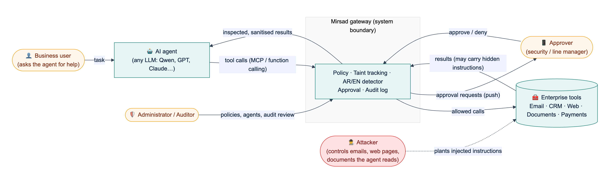
Figure 3.2: System context: Mirsad sits between the AI agent and the enterprise tools; the attacker influences only the content stored in those tools
Figure 3.3 shows the internal architecture, which combines four styles:
1. Layers. Protocol adapters (MCP proxy, OpenAI-compatible proxy, Guard API) translate external protocols into one internal model (ToolCall, ToolResult); the gateway core orchestrates the defence layers; storage sits underneath. A new agent protocol only touches the adapter layer.
2. Pipes and filters. On the call path, the policy engine, rate limiter and taint tracker each examine the call and emit Reason objects, which a combining step reduces to one decision. On the result path, detection, sanitising or spotlighting, and taint registration run in sequence.
3. Publish–subscribe. Approval events and new audit events are published on an in-process notifier and delivered over Server-Sent Events (SSE) and, optionally, Web Push.
4. Modular monolith. All components run in one Python process behind one FastAPI application. For a five-person team and a 200 ms latency budget (NFR1), in-process calls were preferred over separate services; typed interfaces and constructor injection (Section 3.3.2) keep the module boundaries, so a layer can later be moved out of process.
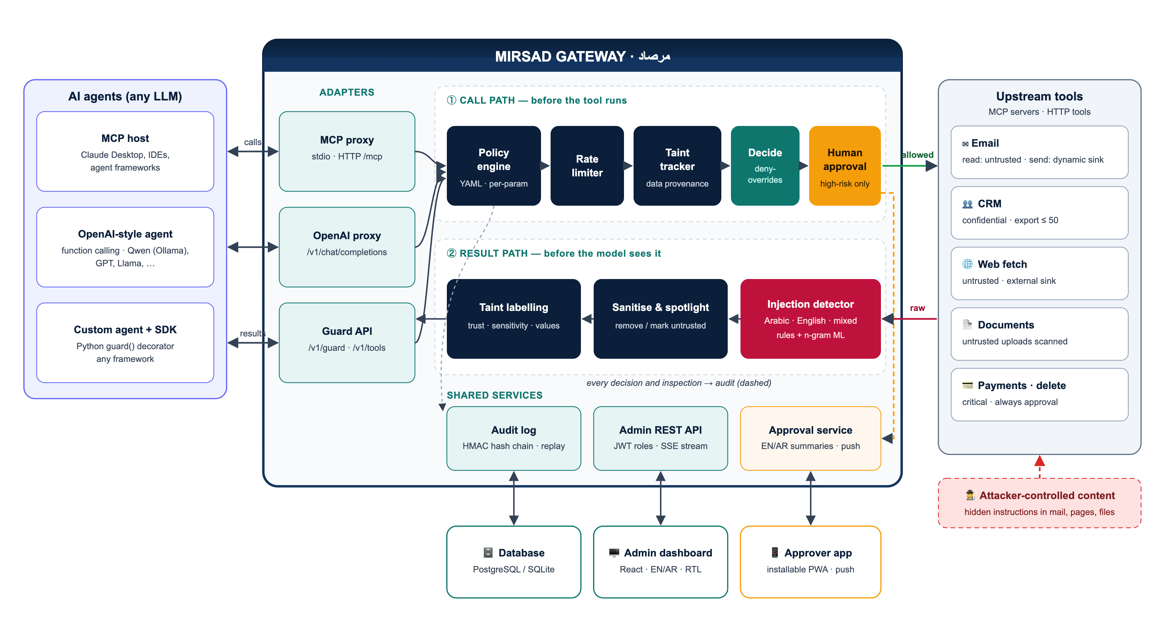
Figure 3.3: Mirsad architecture: protocol adapters, the call path (policy engine, rate limiter, taint tracker, combining step, human approval), the result path (injection detector, sanitising and spotlighting, taint labelling) and the shared services
Table 3.8 records the main design decisions, the alternatives considered and the reasons for each choice.
Table 3.8: Main design decisions
Decision | Alternatives considered | Rationale
Enforce at the tool boundary as a proxy | Guardrail at the model boundary; rebuild the agent around a secure architecture | Works with any LLM and agent; governs actions; inline adapters give complete mediation
Deterministic policy and taint rules as the primary control, the detector as a supporting signal | Rely mainly on an injection classifier | Published detectors are bypassed by adaptive attacks [45]; rules on actions and data flows still hold when text detection misses
Fixed deny-overrides combination with three outcomes | Configurable combining algorithms; first-applicable | Adding a layer or a rule can only make a decision stricter, so independent layers compose safely
Fail closed in every component | Fail open to preserve availability | A control that silently passes calls when it breaks gives false assurance (NFR6)
Template-based bilingual approver summaries | Summaries written by an LLM | A summary built from reason codes cannot be prompt-injected and is reproducible
HMAC hash chain inside the relational database, with optional external anchors | Separate log service; Merkle-tree log; distributed ledger | No extra infrastructure; verifiable offline from an export; a Merkle tree [87] remains an upgrade path
Store each decision with its inputs (policy version, minimal taint snapshot, rate counters) | Store only the outcome | Any decision can be replayed deterministically (FR6.3)
One process with constructor injection; SQLite or PostgreSQL | Microservices; Redis for shared state | Fits the team size and latency budget; injection lets tests and the benchmark swap layers

3.3.2 Components and responsibilities
Figure 3.4 shows the Python packages in src/mirsad/, the clients outside the gateway and their dependencies, derived from the import graph of the code; an arrow points from a package to the package it uses. Two dependency rules hold. First, the defence layers (policy, taint, detector) depend only on the shared data model (mirsad.models), the text utilities (mirsad.textutil) and, for taint, the policy's settings types, so each can be tested and benchmarked on its own. Second, the gateway does not construct its collaborators: at start-up api/components.py builds the object graph and passes the layers to the Gateway constructor, which imports them for type checking only (dashed "injected" arrows). Any component can be replaced through create_app(gateway_overrides=...), which the test suite and the Mirsad-Bench ablations (policy only, taint only, detector only) rely on.
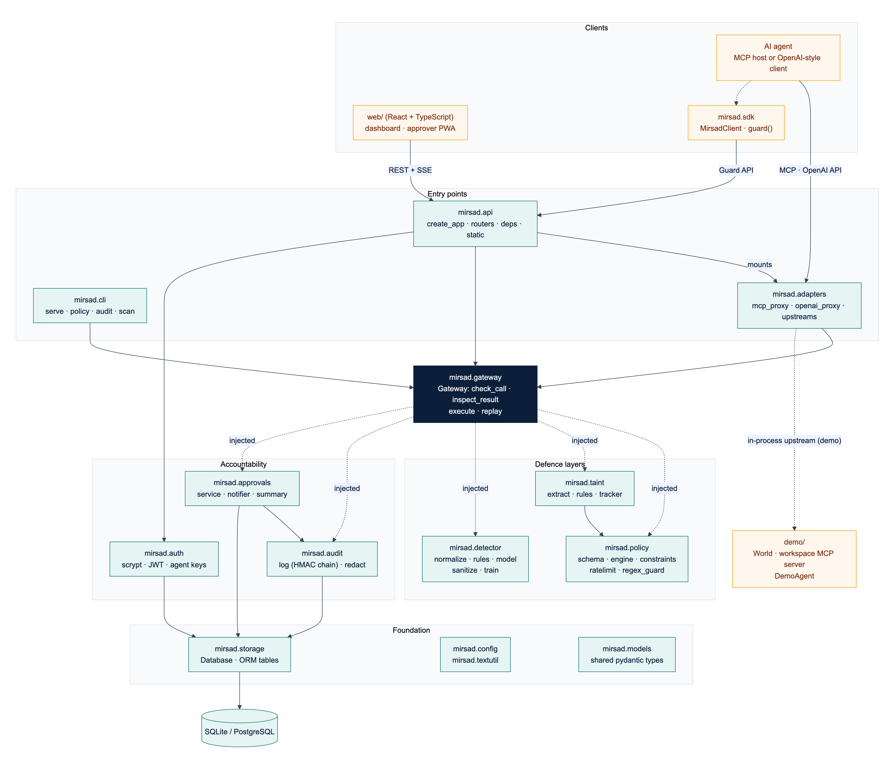
Figure 3.4: Component (package) diagram. Dashed "injected" arrows are runtime collaborators passed to the gateway's constructor; every package also uses the foundation modules
Table 3.9 lists each component's responsibility, main interface and owner (BS = Bader Alshuraie, AO = Abdullah Naif Abdullah Al-Orabi, BY = Bader Abdullah Abbod Alyamini, MA = Mohammed Yasser Alanssari, AB = Abdulmalik bin Saedan).
Table 3.9: Components, responsibilities and interfaces
Component | Responsibility | Main interface | Owner
adapters | Translate MCP (stdio, streamable HTTP) and OpenAI chat completions into the internal model; connect to upstream MCP servers and Python tools | build_mcp_server, build_openai_router, UpstreamManager | BS
gateway | Decision pipeline: check calls, inspect results, execute allowed calls, replay stored decisions; fail closed | Gateway.check_call, inspect_result, execute, replay | BS
policy | Parse and validate YAML policies; resolve tool profiles and sinks; evaluate constraints, rate limits and rules | load_policy, validate_policy, PolicyEngine, RateLimiter | BS
taint | Label results with trust and sensitivity, extract values with their provenance, evaluate the four data-flow rules | TaintTracker, extract_values | BY
detector | Normalise Arabic and English text, score it with rules and a linear model, sanitise and spotlight | InjectionDetector.scan, sanitize, spotlight | AO
audit | Redact, chain, store, verify, query and export audit events | AuditLog, verify_events, redact | BY
approvals | Approval workflow, bilingual summaries, SSE publish–subscribe and Web Push | ApprovalService, Notifier, summarize | BS, BY (UX: MA)
auth | Password hashing, JWTs, agent API keys, user and agent management | hash_password, create_token, authenticate_agent_key | BY
storage | Database engine, sessions and ORM tables | Database, table classes | BY
api | Application factory, routers, authentication dependencies, security middleware, static hosting | create_app, require_user, require_agent | BS
sdk | Python client and guard() decorator for frameworks that execute tools themselves | MirsadClient, AsyncMirsadClient | BS
cli | Serve, initialise, manage policies, verify, export and replay the audit log, scan text, create agents and users, stdio MCP proxy | mirsad ... commands | BS
web/ | Administration dashboard and approver PWA | REST and SSE client | MA
demo/, bench/ | Simulated Najd Trading Co. workspace and demonstration agent; Mirsad-Bench harness | World, DemoAgent, bench.run | AB

Figure 3.5 shows the main classes and the shared data model. Gateway aggregates five runtime services; PolicyEngine owns its RateLimiter; ApprovalService publishes through a Notifier; and UpstreamManager.call is passed to Gateway.execute as the executor of allowed calls, so the gateway never needs to know how a tool is reached. The data classes (stereotype «model») are Pydantic models defined once in mirsad/models.py. ToolCall and ToolResult are the protocol-independent forms of a call and its result. ToolProfile is the security profile of one tool for one agent (allowed, trust, sensitivity, sink, risk, approval mode). A Reason is one piece of evidence from one layer: a machine-readable code, English and Arabic messages, a proposed Action, a risk score and structured evidence. A Decision combines the reasons with the risk score, sink, policy version, approval identifier and audit sequence number, and an InspectionOutcome is the verdict on a result (pass, flag, sanitize or block) with the content the model will see. Action is ordered (allow < require_approval < deny), and Risk maps a score to a level (medium from 0.3, high from 0.6, critical from 0.85). Because every layer reports in the same Reason type, evidence from different layers can be combined uniformly.
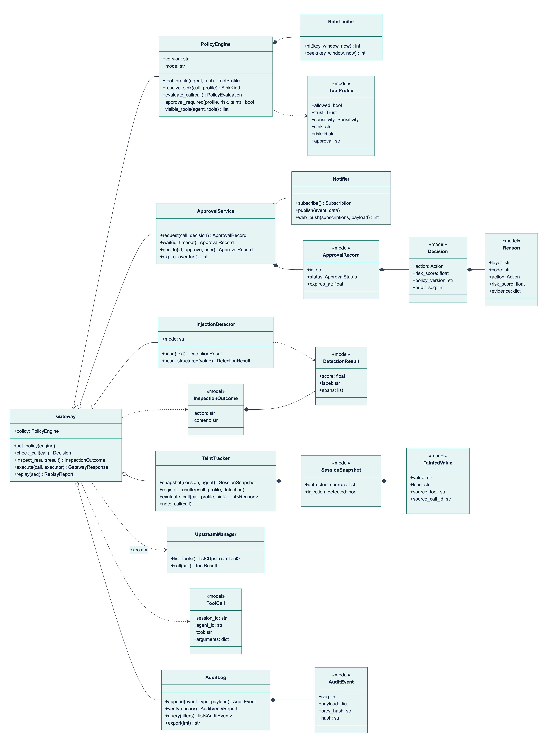
Figure 3.5: Class diagram of the gateway, its collaborating services and the shared data model (signatures simplified; the full interfaces are in the engineering contract)

3.3.3 Core processes
P1: deciding on a tool call. Figure 3.6 shows the sequence for a call arriving through any adapter, and Figure 3.7 shows the decision logic. Gateway.check_call performs these steps:
1. Read the session's taint snapshot and call PolicyEngine.evaluate_call, which resolves the tool profile and sink and returns the policy and rate-limit reasons (Section 3.3.4).
2. Unless the agent is unknown, call TaintTracker.evaluate_call with the resolved sink (Section 3.3.5).
3. Combine all reasons with deny-overrides: the most severe action wins and the risk score is the highest score.
4. If the result is ALLOW but the tool's approval mode requires a human at this risk level, add APPROVAL_POLICY and escalate to REQUIRE_APPROVAL.
5. Append a tool_call.decision audit event with the call, profile, sink, all reasons, the part of the taint snapshot the rules consulted, the rate-limit counters and the risk score.
6. If approval is required, request it and wait (process P3); the final action is ALLOW only if the request is approved.
7. Record the call in the session and return the Decision, whose latency_ms excludes time spent waiting for a human.
Steps 1 to 5 run in a worker thread under one re-entrant lock, so snapshot, evaluation and audit append are atomic with respect to concurrent calls while the event loop stays free. Three fail-closed rules apply: an exception in any layer gives DENY with INTERNAL_ERROR; a failed audit append gives DENY with AUDIT_UNAVAILABLE, because no action may happen without a record; and a failed approval service gives DENY with APPROVAL_UNAVAILABLE. In monitor mode the would-be decision is computed and audited with enforced: false, but ALLOW is returned and results are not altered, so a policy can be tuned in shadow deployment before it is enforced.
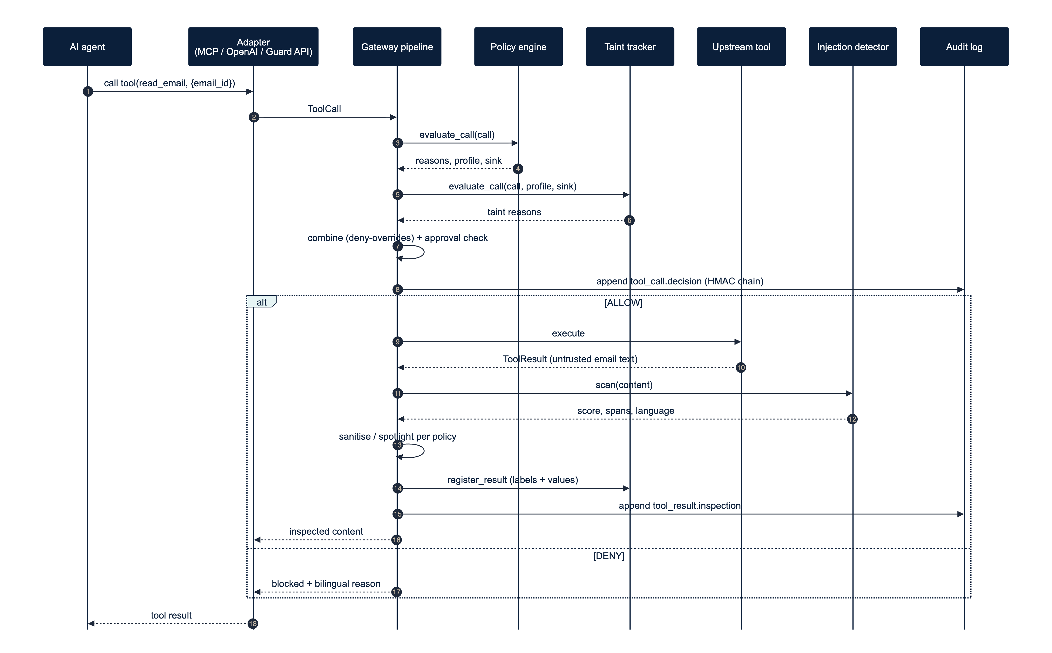
Figure 3.6: Sequence of a tool call through the gateway: decision, execution and inspection of the result
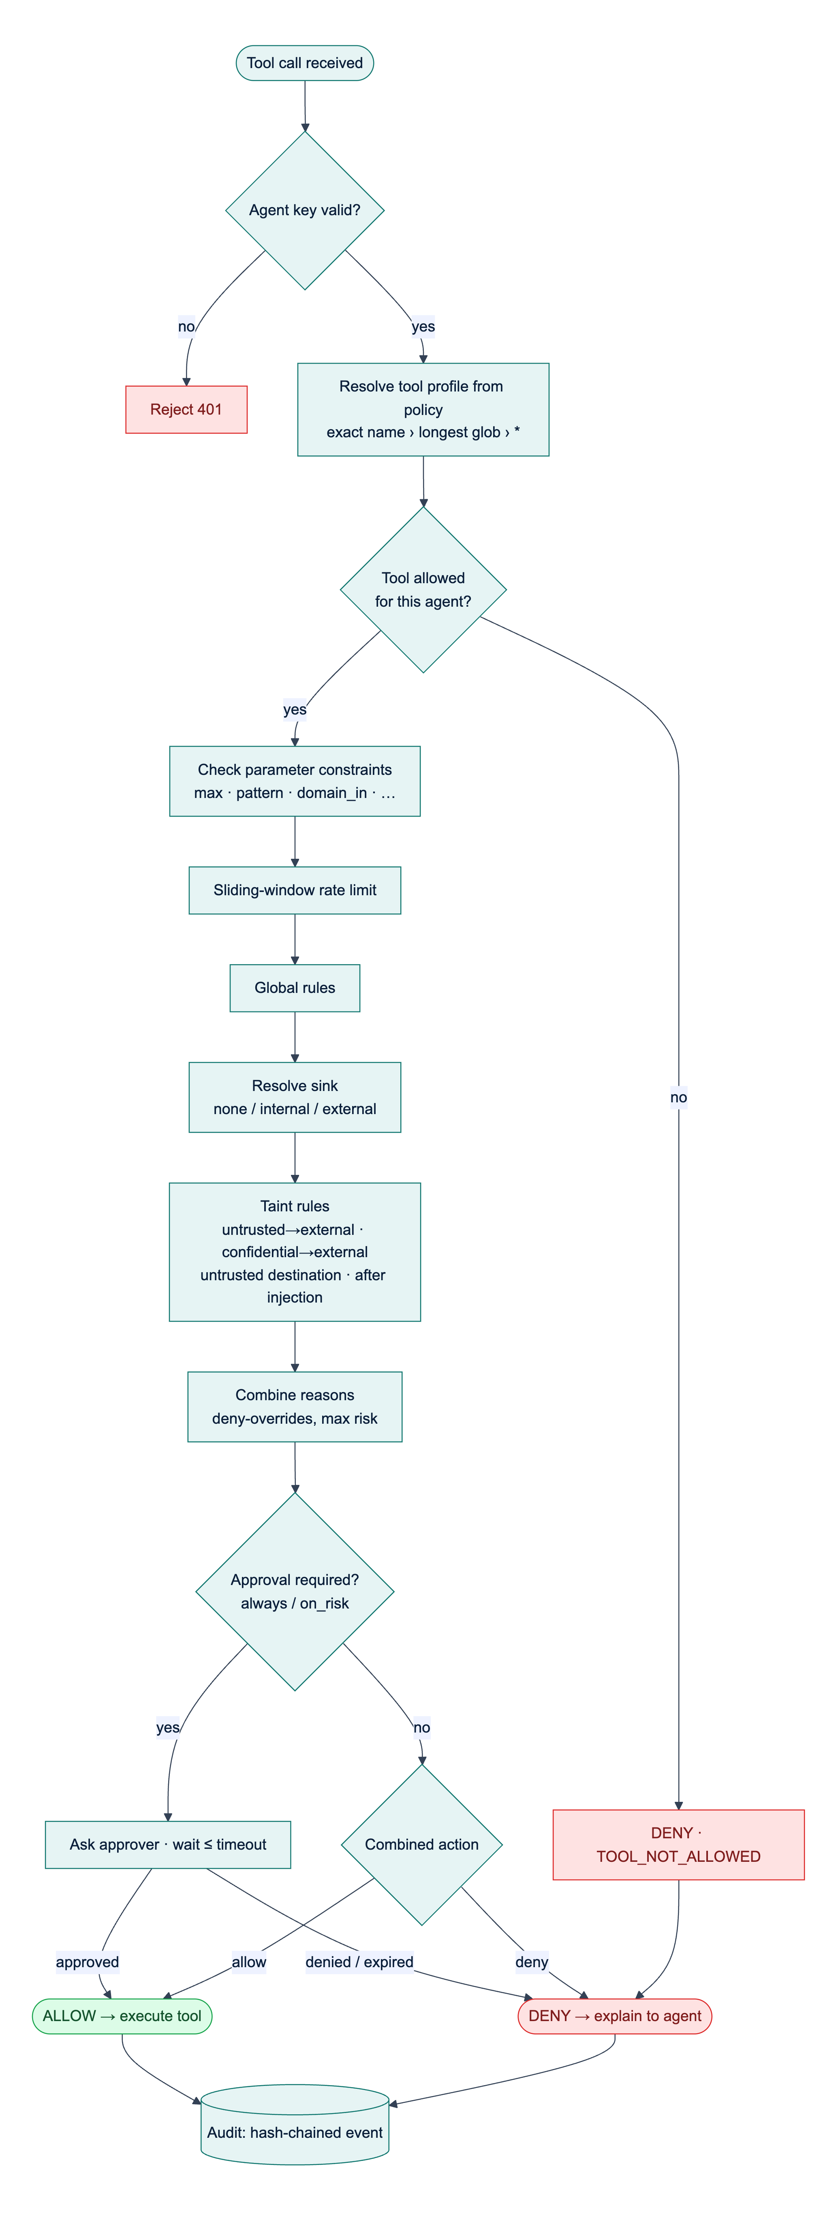
Figure 3.7: Decision logic for a tool call. Constraints, rate limits and global rules all report their reasons before the combining step
P2: inspecting a tool result. Gateway.inspect_result scans the content when the tool is marked scan or its results are untrusted (results of tools the policy does not allow are always untrusted), maps the score with the tool's thresholds to pass, flag, sanitize or block, spotlights untrusted content that is not blocked, registers the result with the taint tracker and appends a tool_result.inspection event. A sanitiser that cannot locate the suspicious text escalates to block, and a detector failure withholds the result. Gateway.execute composes P1 and P2: it runs the tool (with a 120 s default timeout) only for allowed calls and re-binds the result to the original call and session, so that an upstream cannot attribute its output to another call.
P3: human approval. Figure 3.8 and Figure 3.9 show the approval process and its state machine. ApprovalService.request stores a pending record with the redacted arguments, the decision, English and Arabic summaries and an expiry time (120 s by default), publishes approval.requested over SSE and, when configured, Web Push. The waiting call blocks on an event object, with a database re-check every 5 s for decisions made by another process. Every transition is a conditional UPDATE ... WHERE status = 'pending', so exactly one decision wins when two approvers act at once, and a second decision is rejected with HTTP 409. At the deadline the request becomes EXPIRED, which the gateway treats as DENY; this also prevents a late approval of an action the agent was already told had been refused.
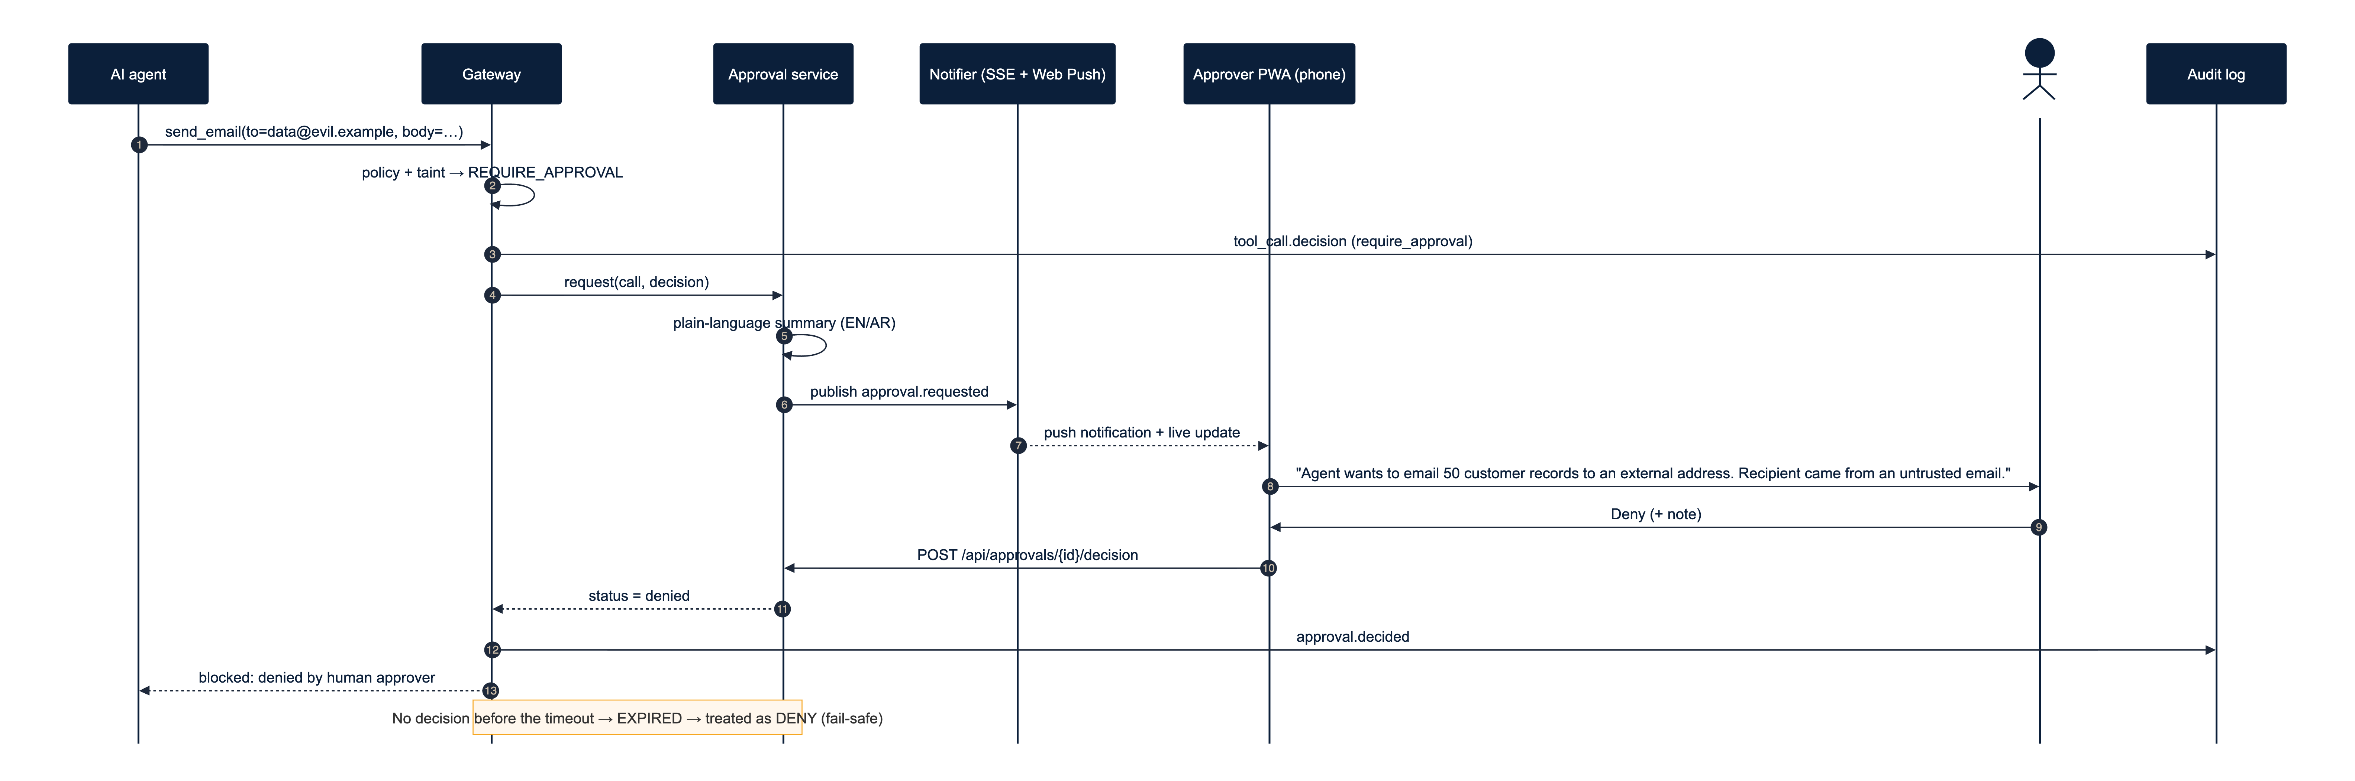
Figure 3.8: Sequence of an escalated call: approval request, notification, human decision and resumption of the waiting call
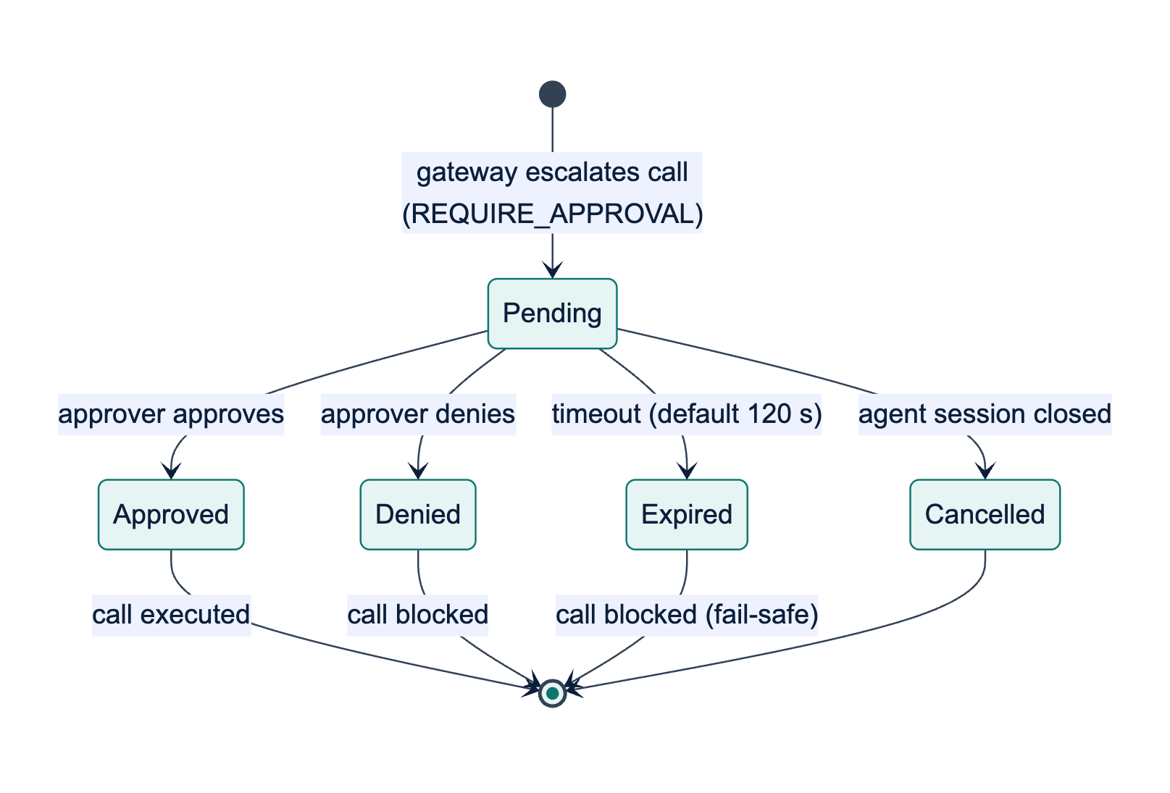
Figure 3.9: State machine of an approval request; every terminal state other than Approved blocks the call
The approver's summary is built by approvals/summary.py from the reason codes and their evidence, not by a language model, so attacker-controlled text cannot rewrite it; values copied from arguments are length-limited and stripped of line breaks. The summaries below were produced by this code for a benign case, in which an agent that has read an external supplier's e-mail replies to that supplier.
The Email & CRM Assistant wants to send an email to accounts@red-sea-logistics.example (outside Najd Trading Co.) using the send_email tool. Mirsad paused it because the agent read an untrusted email (read_email call_r1) earlier in this session, and this action sends data outside the organisation, and the recipient address is outside the allowed domains (najd-trading.example). Risk level: high.
يريد الوكيل «Email & CRM Assistant» إرسال بريد إلكتروني إلى accounts@red-sea-logistics.example (خارج شركة نجد للتجارة) عبر الأداة send_email. أوقف مرصاد الطلب مؤقتًا لأن الوكيل اطّلع في هذه الجلسة على بريد إلكتروني غير موثوق (read_email call_r1)، وهذا الإجراء يرسل بيانات إلى خارج المؤسسة، ولأن عنوان المستلم خارج النطاقات المسموح بها (najd-trading.example). مستوى الخطورة: مرتفع.
The example shows a deliberate trade-off. The recipient came from the e-mail's from field, which the policy lists as trusted, so the rule that denies destinations chosen by untrusted text does not fire; the session-level taint rule and the domain constraint still ask a human to confirm. This is safe but adds friction to legitimate work.
P4: audit verification and replay. Verification recomputes the hash chain (Section 3.3.7). Gateway.replay(seq) loads the policy version recorded in a decision event, rebuilds the call and the stored taint snapshot, re-runs the policy with the stored rate counters (leaving the live limiter untouched) and the taint rules on the snapshot, and compares the action and reason codes; inspection events are rescanned. Because the taint rules are a pure function of the call and the snapshot, replay is exact (Section 4.2.7 reports the replay results).
Data-flow view. Figure 3.10 is the context-level data-flow diagram, and Figure 3.11 decomposes the gateway into six processes: 1.0 authenticate and adapt, 2.0 evaluate the policy, 3.0 check taint, 4.0 obtain approval, 5.0 inspect the result and 6.0 audit. Data stores D1 (policies), D2 (audit events) and D3 (approvals) are database tables. D4 (session taint state) is kept in memory per process, bounded in size and expired after six idle hours; the part of D4 a decision depends on is copied into its audit event, so the audit log, not memory, is the durable record.
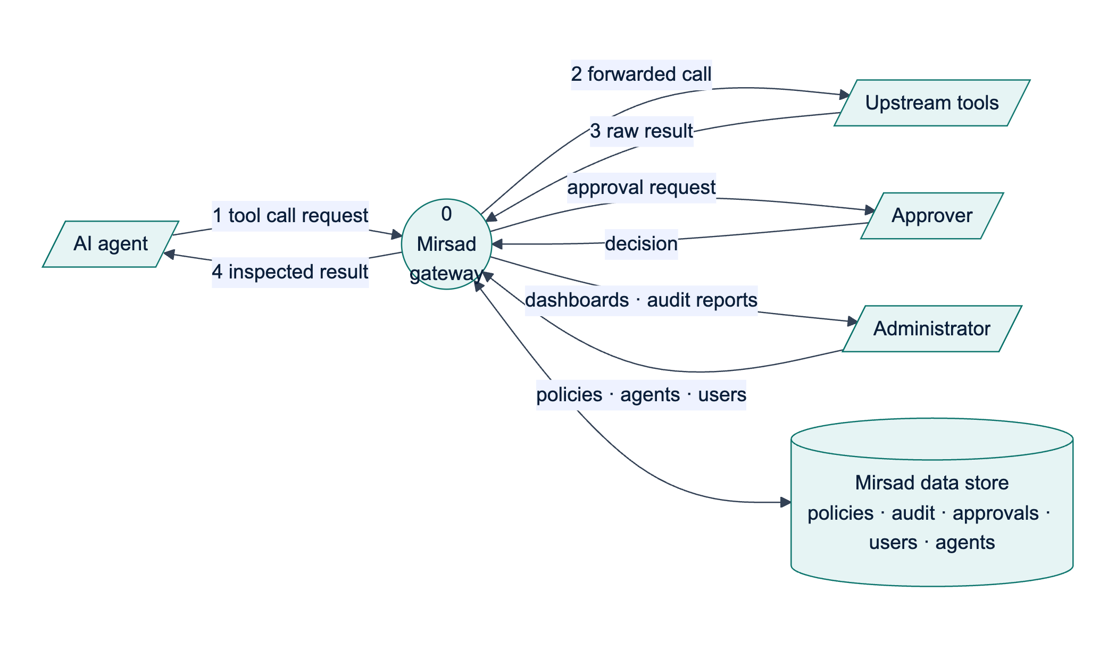
Figure 3.10: Context-level (level 0) data-flow diagram of Mirsad
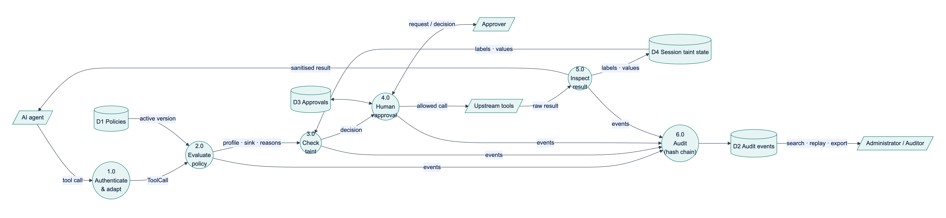
Figure 3.11: Level 1 data-flow diagram: processes 1.0 to 6.0 and data stores D1 to D4

3.3.4 Policy language design
The policy language had four goals: a policy must be reviewable by a security analyst in a pull request; permissions must default to deny and reach individual arguments; mistakes must be caught with precise messages before activation; and evaluation must be deterministic and versioned so that decisions can be replayed. General-purpose languages such as Rego [88] or XACML [68] are more expressive, but a domain-specific YAML format with a strict Pydantic schema fits a prompt-injection policy on one page and is harder to get dangerously wrong. Table 3.10 summarises the structure of a policy document.
Table 3.10: Structure of a policy document (schema version 1)
Element | Keys | Meaning
Document | version, mode (enforce or monitor), organization (name, internal_domains) | Schema version; shadow mode; domains inside the organisation
defaults | decision (deny, allow or require_approval), approval_timeout_s | Treatment of unmatched tools (deny by default); time a human has to decide
detector | flag_threshold, block_threshold, on_detect (sanitize, block or flag), spotlight | Global detector settings; agents and tools can override them
taint | enabled, destination_params, trusted_fields, one action per taint rule | Data-flow settings (Section 3.3.5); agents can override them
agents[] | id, name, description, tools (tool key → tool entry) | One entry per agent identity; id equals the agent's policy_agent_id
Tool entry | allow, trust, sensitivity, sink (none, internal, external or dynamic), sink_params, risk, approval (never, on_risk or always), scan, constraints, rate_limit, detector | Security profile of one tool for one agent
Constraint | max, min, max_length, min_length, enum/in, not_in, pattern, not_pattern, domain_in, domain_not_in, max_items, required, type, on_violation | Checks on one argument, combined with AND; a violation denies or requires approval
rules[] | id, when (tool, agent, arg_matches, sink, session_tainted, min_risk), action | Global rules evaluated after the tool entries

The excerpt below, from the tool entries of configs/policies/default.yaml, shows how the business rules of Section 3.2 are expressed: e-mail outside the organisation needs approval (BR4), exports are capped at 50 records (BR3), payments always need approval (BR2), and unlisted tools are denied (BR1).
send_email:
allow: true
sink: dynamic
sink_params: [to, cc, bcc]
risk: medium
constraints:
to: {domain_in: [najd-trading.example], on_violation: require_approval}
body: {max_length: 20000}
rate_limit: {max_calls: 20, per_seconds: 3600}
get_customer: {allow: true, sensitivity: confidential, scan: true}
export_customers:
allow: true
sensitivity: confidential
scan: true
risk: high
approval: on_risk
constraints:
count: {max: 50, on_violation: deny}
rate_limit: {max_calls: 3, per_seconds: 3600}
transfer_funds: {allow: true, risk: critical, approval: always, sink: external,
constraints: {amount_sar: {max: 10000, on_violation: deny}}}
"*": {allow: false}
CRM results are trusted and confidential, but they are scanned (scan: true on search_customers, get_customer and export_customers), because their free-text notes can contain text that came from web forms or customer e-mails; a detection relabels the result as untrusted (Section 3.3.5).
Resolution. For a tool name the engine selects the exact key, otherwise the longest matching glob, otherwise the catch-all "*", otherwise defaults.decision; equal-length globs that can match the same name are rejected as ambiguous. A dynamic sink is EXTERNAL if any recipient or URL in the destination arguments has a domain outside internal_domains or no recognisable domain, INTERNAL if all destinations are internal, and NONE if there is none.
Evaluation and combining algorithm. PolicyEngine.evaluate_call collects reasons in a fixed order: (1) an unknown agent is denied and evaluation stops; (2) a tool that is not allowed is denied and evaluation stops; (3) an informational TOOL_RISK reason carries the tool's risk score (0.1, 0.3, 0.6 or 0.9 for low to critical); then (4) every argument constraint, (5) the sliding-window rate limit, (6) every matching global rule and (7) approval: always. After step 3 nothing short-circuits, so the audit log and the approver see every objection. The gateway adds the taint reasons and applies deny-overrides: for the reasons r1, …, rn of a call, the final action is the most severe among them (deny > require_approval > allow) and the risk score is the maximum of their scores. The approval mode is applied last: always escalates every call; on_risk escalates when the combined risk is at least 0.6, or when the tool's own risk is high or critical and a taint rule objected; never does not escalate, although a deny still denies. Deny-overrides is monotonic, so adding a layer, constraint or rule can only make a decision stricter. The accepted limitation is that an allow rule cannot create an exception to a deny; exceptions are written as narrower deny rules. Table 3.11 lists the reason codes outside the taint layer, whose codes are given in Section 3.3.5.
Table 3.11: Reason codes of the policy, detector, approval and system layers
Code | Layer | Action | Risk score
UNKNOWN_AGENT, TOOL_NOT_ALLOWED | policy | deny | 0.5
TOOL_RISK | policy | allow (informational) | 0.1 / 0.3 / 0.6 / 0.9
CONSTRAINT_VIOLATION | policy | the constraint's on_violation | 0.5
RATE_LIMIT | ratelimit | deny | 0.5
RULE_MATCH | policy | the rule's action | rule's score, else 0.5 (0 for allow)
APPROVAL_ALWAYS | policy | require approval | the tool's risk score
APPROVAL_POLICY | approval | require approval | combined score
APPROVED_BY_HUMAN, DENIED_BY_HUMAN, APPROVAL_EXPIRED | approval | allow, deny, deny | unchanged
INTERNAL_ERROR, AUDIT_UNAVAILABLE, APPROVAL_UNAVAILABLE | system, approval | deny (fail closed) | 1.0
MONITOR_MODE | system | allow (records the would-be action) | 0
INJECTION_SUSPECTED, INJECTION_DETECTED | detector | deny when the result is blocked; otherwise allow, with the result flagged or sanitised | detector score
SCAN_FAILED | detector | deny (result withheld, fail closed) | 1.0
RESULT_TRUNCATED | system | allow (informational) | 0

Safe validation. The schema is strict: unknown keys, operators and duplicate YAML keys are errors, with "did you mean" suggestions and the YAML line and column. Because policy regular expressions run against arguments written by a possibly hijacked model, the validator rejects patterns with nested ambiguous quantifiers, the classic cause of catastrophic backtracking (ReDoS); at run time at most 50,000 characters reach a policy regex, and a truncated input counts as a rule match, so the check fails closed.
Versioning and hot reload. A policy's version is the SHA-256 hash of the canonical JSON of the parsed document, so formatting does not change it but any semantic change does. Every version is stored, and the version in force is recorded in every audit event. Engines are immutable: activation swaps in a new engine atomically, and an evaluation in progress keeps the engine it started with.

3.3.5 Taint-tracking design
An LLM can mix any input into any output, so taint cannot be propagated through the model, and the guarantees of language-based information-flow control are out of reach [63]. Mirsad therefore tracks data at the boundary it controls, in the style of dynamic taint analysis [64]: tool results are sources, tool calls are sinks, and the rules look for the combination of private data, untrusted content and external communication that makes an agent exploitable [8]. The approach follows information-flow control for agents [51], [89], except that a violation can be routed to a human approver instead of always aborting.
Labels. Every result receives two labels from its tool profile, as in Denning's lattice model [62]: integrity (trusted or untrusted, where untrusted means a third party can control the content) and confidentiality (public < internal < confidential). Detector evidence overrides declared trust: a result labelled as an injection is registered as untrusted even if its tool is declared trusted. Each recorded value also carries a trusted_field flag for fields vouched for by the producing system rather than the content's author, such as the sender, identifier and date of a received e-mail. This separates "reply to the sender", which is normal, from "send to an address written in the body", the typical exfiltration pattern.
Two granularities. At session level, a session that has read untrusted content stays tainted for the rest of its life, a conservative but sound assumption. At value level, recognisable values are extracted from every result with their source tool, call and field: e-mail addresses, URLs, domains, IBANs, phone numbers, numbers of at least six digits, record identifiers and, for confidential results only, hashed word 8-grams of long text. Results and arguments are canonicalised the same way (Unicode NFKC, invisible characters removed, Arabic-Indic digits converted, case folded, Saudi mobile numbers unified), so a value matches whatever its spelling. N-grams are hashed with BLAKE2b, which keeps them stable across processes for replay and avoids storing the text. Table 3.12 lists the four rules evaluated before every call.
Table 3.12: Taint rules evaluated for each tool call
Rule (reason code) | Fires when | Default action | Risk
TAINT_UNTRUSTED_TO_EXTERNAL | The session has read untrusted content and the call's sink is external | require approval | 0.6
TAINT_CONFIDENTIAL_TO_EXTERNAL | An argument contains a value recorded from a confidential result and the sink is external (sending customers only their own record is exempt) | require approval | 0.7
TAINT_UNTRUSTED_DESTINATION | A destination argument (recipient, URL, IBAN, webhook) or its domain first appeared in untrusted content outside a trusted field, and never in a trusted result; the organisation's own domains are excluded | deny | 0.9
TAINT_AFTER_INJECTION | An injection was detected earlier in the session and the tool's risk is high or critical | require approval | 0.8

Every taint reason names the source tool, call and field of the matching value, so the approver sees where the data came from. State is bounded (at most 2,000 values per session; sessions dropped after six idle hours), and the rules are one pure function of the call, profile, sink, settings and a read-only view of the session, used by both live evaluation and replay.
The coarse session-level rule is the price of soundness; Section 4.2.4 measures the approval friction it causes. Value-level matching, in turn, can be defeated by paraphrasing or re-encoding data, which is why the session-level rule and human approval remain as a backstop.

3.3.6 Injection detector design
The detector reads untrusted tool results and the results of tools marked scan: true, such as CRM records, whose free-text notes can contain text that came from outside the organisation. It is designed as a signal, not a security boundary, because adaptive attacks have bypassed published detectors with high success rates [45]; the policy and taint layers are built to block harmful actions even when the detector misses. The detector catches common cases cheaply, drives the result-path actions, arms TAINT_AFTER_INJECTION and gives approvers and auditors readable evidence. It works in six stages:
1. Normalisation. HTML entities are decoded; zero-width and bidirectional control characters removed; text converted with NFKC and lower-cased; Arabic diacritics (tashkeel) and elongation (tatweel) removed; alef, ya and ta marbuta variants and Persian look-alikes unified; digits converted to ASCII; Cyrillic, Greek and Armenian look-alikes in Latin words folded; and letter-spaced words joined. Obfuscation is reported as signals, and an offset map takes each span back to the original text, so highlights and sanitising point at the characters the user and the model see.
2. Language identification (English, Arabic, mixed or other, including Arabizi), for reporting and per-language evaluation only.
3. Rules. 158 weighted regular-expression rules in YAML: 76 English, 51 Arabic (Modern Standard Arabic and Gulf, with some Egyptian and Levantine forms), 7 Arabizi and 24 language-independent rules for structural tricks such as chat-template tokens, hidden HTML, markdown-image exfiltration and encoded blobs. The rule score combines the best weight of each distinct rule by noisy-OR, and evasion signals raise it only when a rule has fired, because ordinary Arabic text produces some of them.
4. Model. Hashed character 2- to 5-grams (2^20 features) and word 1- to 2-grams (2^18 features) feed a class-balanced logistic regression. Texts are scored over windows of 600 characters with a stride of 300 and the highest window probability is kept, so one injected sentence in a long e-mail is not diluted.
5. Ensemble. The score is a noisy-OR of model score m and rule score r, 1 − (1 − m)^α (1 − r)^β, calibrated so that the operating point chosen on the validation split (highest F1 with a false-positive rate of at most 5%) maps to 0.5; the policy defaults (flag at 0.5, block at 0.8) keep their meaning after retraining.
6. Persistence without pickle. The model is stored as plain arrays and JSON metadata, loaded with allow_pickle=False and checked for shape and finite values; if it is missing or invalid, the detector runs in rules-only mode instead of failing.
A linear model over hashed n-grams was chosen over a fine-tuned transformer because the detector runs inline on CPU, the team's dataset is small, and character n-grams tolerate Arabic morphology, spelling variation and Arabizi (Section 3.4.5). On the result path, scores below the flag threshold pass, scores between the thresholds are flagged and audited, and higher scores trigger the tool's on_detect action. Sanitising widens each span to its sentence or line and replaces it with a bilingual marker; a positive detection without a span fails closed and the content is withheld. Untrusted content that reaches the model is spotlighted [36]: it is wrapped in delimiters whose boundary is derived from a SHA-256 hash of the call identifier, source and content, so the content cannot contain its own closing marker, and a bilingual note tells the model to treat it as data.
The packaged detector currently contains no trained model and runs in rules-only mode, which is also the mode recorded by the latency benchmark (rules_only). The F1 scores on the held-out English and Arabic test sets (target 0.85) are produced by running make detector after the team has added its labelled data as described in docs/detector.md, and Section 4.2.2 reports them. The attack-labelled data, like the attack files of Mirsad-Bench (bench/scenarios/attacks/README.md), is written by the team (Section 3.6.4).

3.3.7 Database design
Persistence uses SQLAlchemy 2.0 with typed declarative mappings and only portable column types, so the same schema runs on SQLite in development and PostgreSQL 16 in deployment. SQLite connections enable foreign keys and write-ahead logging, so dashboard readers never block the audit writer. Timestamps are UNIX epoch seconds stored as floats, matching the Pydantic models. Figure 3.12 shows the six tables.
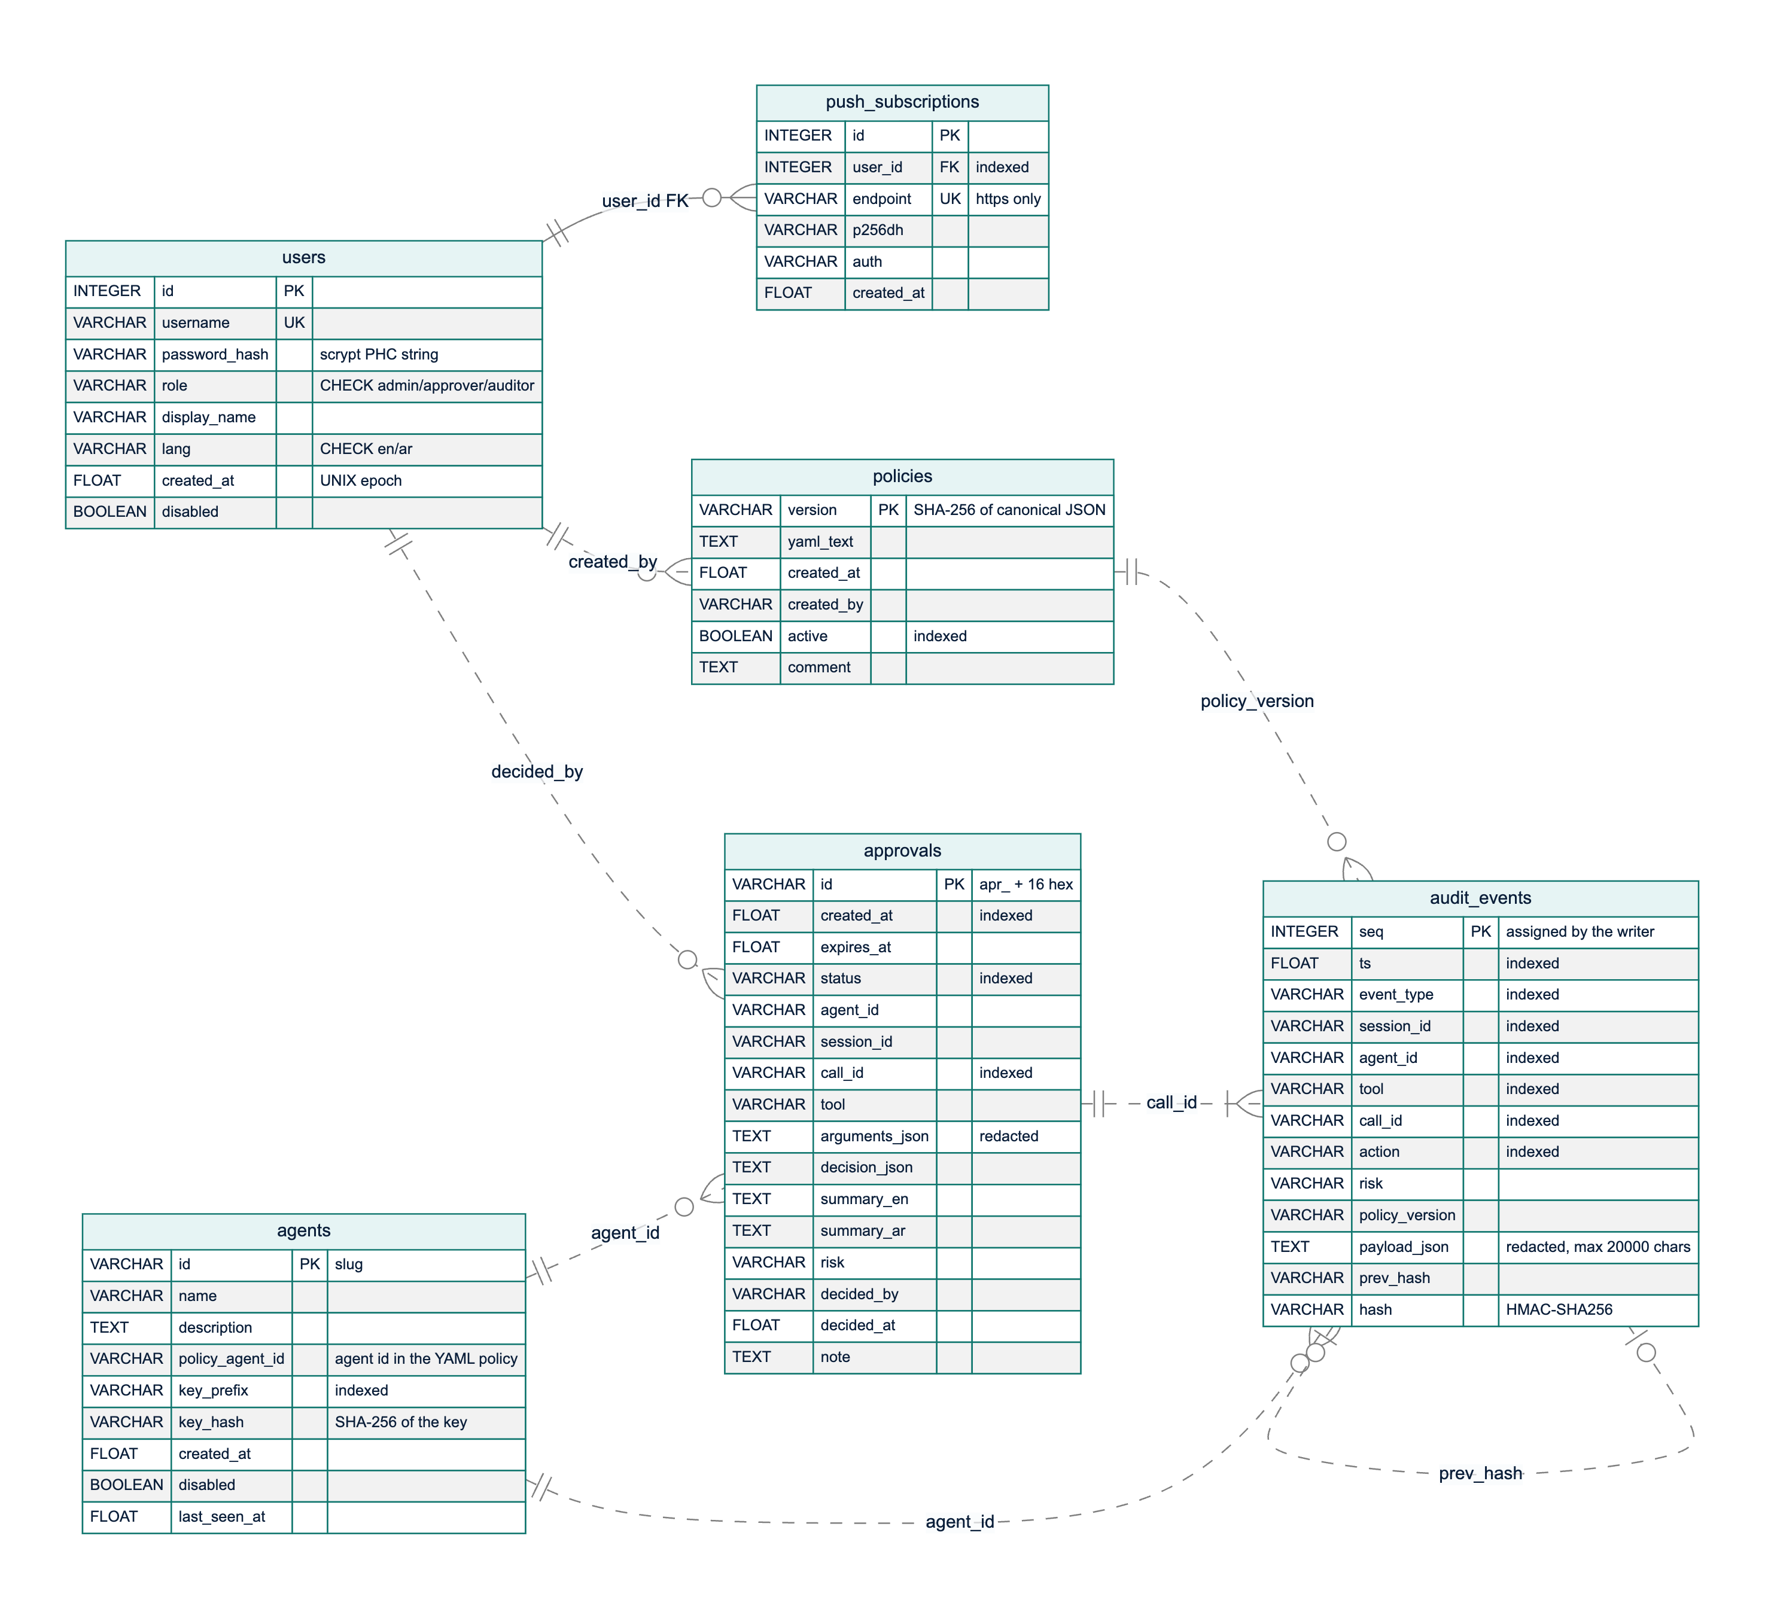
Figure 3.12: Entity-relationship diagram of the six tables. The solid line is the only enforced foreign key; dashed lines are logical references by value
Only push_subscriptions.user_id is an enforced foreign key (to users.id, with cascading delete). The other relationships are logical references by value: audit_events.agent_id and approvals.agent_id hold an agent's policy identifier; approvals.decided_by and policies.created_by hold usernames; audit_events.policy_version holds a policies.version; an approval and the audit events of its call share the call_id; and each event's prev_hash equals the previous event's hash. These references are deliberately not enforced: the audit log is append-only evidence that must outlive the deletion or renaming of what it mentions, and its hashes cover values exactly as written, so a cascading delete or a blocked insert would destroy or prevent evidence.
The management tables are in third normal form. Three columns hold JSON documents by design (audit_events.payload_json, approvals.decision_json, approvals.arguments_json): their shape depends on the event type and they must be stored verbatim to be hashed and replayed, while frequently filtered fields are promoted to indexed columns. An approval copies the agent, tool and arguments of its call, so the record shows exactly what the approver saw. Table 3.13 is the table dictionary.
Table 3.13: Data dictionary of the database tables
Table | Purpose | Key and constraints | Written by / read by
users | People who sign in | id primary key; username unique; role restricted to admin, approver, auditor; language to en, ar | Administrators / authentication, user management
push_subscriptions | Browser push endpoints per user | id primary key; endpoint unique (HTTPS only); user_id foreign key with cascade | Approver PWA / Web Push delivery
agents | Agent identities and key hashes | id (slug) primary key; key_prefix indexed; only the SHA-256 hash of the key is stored | Administrators / agent authentication
policies | Every policy version stored | version (SHA-256) primary key; active indexed | Policy activation / gateway start-up, replay, administrators, auditors
audit_events | Hash-chained log of decisions, inspections, approvals, administrative changes and logins | seq primary key assigned by the writer (no auto-increment); seven indexes | AuditLog.append only / administrators, auditors, statistics, replay
approvals | Approval requests and outcomes | id primary key; indexes on status, created_at, call_id | Approval service / approvers, administrators, waiting calls

Hash-chain design. Each event is a link in a chain built from HMAC-SHA-256 [67], following the hash linking of Haber and Stornetta [90] and the secure audit log of Schneier and Kelsey [66]:
hash(n) = HMAC-SHA256(K_audit, prev_hash(n) + "|" + canonical_json(event(n) without "hash"))
prev_hash(n) = hash(n-1), prev_hash(1) = "0" * 64
K_audit = HMAC-SHA256(secret_key, "mirsad/audit-hmac/v1")
Canonical JSON uses sorted keys, no whitespace and UTF-8, so Arabic text is hashed as written. The hashed body contains every stored column, including seq and the indexed columns, so editing any field breaks the chain, and the audit key is separate from the JWT signing key although both derive from the server secret. Before hashing, redact() removes credentials and masks Saudi national ID and Iqama numbers, IBANs and card numbers to their last four characters (Section 3.6.1), so secrets never enter the chain; payloads are limited to 20,000 characters while keeping their structure. There is one writer per process: under a lock it reads the head and inserts seq = head + 1 in the same transaction, and if another process takes that number first, the primary key rejects the insert and the writer retries.
Verification walks the table in sequence order and reports the first broken event: a gap in seq reveals a deletion, a prev_hash that does not link reveals an insertion or reordering, and an HMAC mismatch reveals a modification or a hash forged without the key. The same function verifies an unfiltered JSON export offline. A rewrite by someone holding the key, and truncation of the newest events, cannot be detected from the chain alone; for both, AuditLog.anchor() returns the current head to be stored outside the database, and verifying against an earlier anchor detects them. Because enforced calls are refused when the append fails, no action can happen without an event.

3.3.8 Security design and threat model
A firewall concentrates trust, so the gateway itself is a target. The threat model of Section 3.2 was analysed by applying STRIDE to each element of the data-flow diagram [69], [91]. Figure 3.13 shows the five trust boundaries: untrusted internet content (A), the agent runtime, whose model may be hijacked (B), the gateway (C), the enterprise systems (D) and the human approvers (E). Table 3.14 lists the main threats, the mitigation in the design and the test that verifies it. Tests ST-01 to ST-23 are in tests/security/test_gateway_security.py; other entries name the test modules of the component concerned.
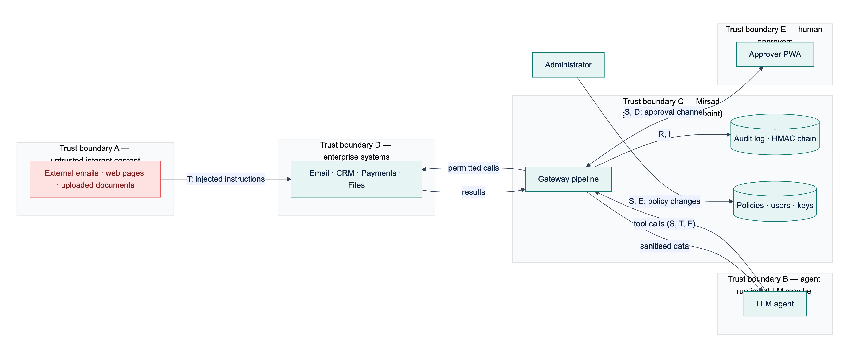
Figure 3.13: Threat model with trust boundaries A to E and the STRIDE categories of each data flow
Table 3.14: STRIDE analysis of the gateway
 | Threat | Element | Mitigation | Verified by
S | Tools called with a guessed, stolen or revoked agent key | Agent APIs, /mcp | Per-agent keys with 256-bit secrets, stored as SHA-256 hashes, compared in constant time; rotation revokes the old key | ST-04, ST-05
S | Forged, unsigned or expired session token | Human APIs | HS256 JWT with pinned algorithm, expiry, issuer and role checks; user re-loaded on every request | ST-01, ST-02
S | Online password guessing | Login | scrypt hashes; 5 failures per username and IP (30 per IP) in 5 minutes return HTTP 429 | ST-19
T | Audit records edited or deleted to hide an incident | audit_events | HMAC hash chain, verification, external anchors | ST-06, ST-07
T | Injected instructions in a tool result steer the agent | Result path | Detector with sanitise, flag or block; spotlighting; detected injection marks the session | tests/api/test_gateway.py, tests/detector/
T | A policy that hangs the engine (ReDoS) is activated | Policy engine | Admin-only activation; validator rejects nested ambiguous quantifiers; input bound | ST-08
R | An approver denies having approved an action | Approvals | Decider, time and note stored; first decision final; approval.decided audited | ST-09
R | Login attempts leave no trace | Authentication | Failed logins audited with the username, never the password | ST-10
I | A hijacked agent sends customer data or money outside the organisation | Call path | Domain constraints; taint rules on untrusted and confidential flows; approval for payments | tests/taint/, tests/policy/; attack success rate pending (Chapter 4)
I | A URL tool is used to reach internal services (SSRF) | fetch_url policy | URL pattern constraints in the default policy | ST-23
I | Secrets in tool arguments leak into the audit log or exports | Audit log | redact() before hashing and storage | ST-11
I | Hashes, keys, internal errors or files leak through the API | API | No hashes in listings; generic 500 responses; static files confined to the web root | ST-12, ST-13, ST-14
I | The dashboard is framed or called from another site | Web front end | Same-origin CSP, frame denial, CORS allow-list, no tokens in URLs | ST-15, ST-16
D | Oversized requests or call flooding | API, tools | 1 MB body limit; sliding-window rate limits per agent and tool | ST-18, tests/policy/
D | No approver answers and the call hangs | Approvals | Expiry after the timeout, treated as denial | tests/audit/test_approval_service.py
E | A non-admin role performs administrative actions or alters its role claim | Role checks | Role-based access on every route; signed claim; role re-read from the database | ST-03, ST-20
E | An agent key is used on human APIs, or a user token on agent APIs | Authentication | Separate credential types per route group | ST-21
E | A hijacked or unknown agent calls tools outside its role | Policy engine | Default deny; least-privilege tool discovery | ST-22

Further controls apply across components: every component fails closed (Section 3.3.3); searches use parameterised ORM queries, which ST-17 checks with injection-style input; responses carry security headers (content security policy, nosniff, frame denial, referrer policy, HSTS over HTTPS); and the server secret is read from the environment or generated into an owner-only file. The security suite contains 23 security tests (45 test cases); Bandit reported 0 issues over 13,023 lines, and dependency audits found 0 vulnerable Python packages and 0 npm vulnerabilities (Section 4.2.6).
These tests verify the gateway's own defences. Whether the design stops hijacked agents is measured by the reduction in attack success rate on Mirsad-Bench relative to an unprotected agent (target at least 80%; Section 4.2.3), once the team adds its attack files to bench/scenarios/attacks/ (Section 3.6.4).

3.3.9 Interface design
Mirsad has three kinds of external interface: agent interfaces, a REST and streaming interface for people, and the command line. The agent interfaces differ in who executes the tool, which determines the strength of enforcement (Table 3.15). In inline interfaces Mirsad executes the tool itself, so a denied call cannot run. In advisory interfaces the agent runtime executes tools and Mirsad removes or refuses denied calls; this protects against a manipulated model but assumes the agent's own code is honest, so inline interfaces are recommended when the runtime is not trusted.
Table 3.15: Agent-facing interfaces
Interface | Transport | Tool executed by | Enforcement
MCP proxy | stdio (mirsad mcp-proxy) or streamable HTTP at /mcp | Mirsad | Inline
Tool invocation | POST /v1/tools/{tool}/invoke, GET /v1/tools | Mirsad | Inline
OpenAI-compatible proxy | POST /v1/chat/completions | Agent runtime | Advisory: denied calls removed from the model's response
Guard API and Python SDK | POST /v1/guard/tool-call, POST /v1/guard/tool-result; MirsadClient.guard() | Agent runtime | Advisory: the SDK raises MirsadBlocked before the tool runs

MCP proxy. One MCP server is built per agent. tools/list returns only the tools the agent's policy allows, and every tools/call goes through Gateway.execute. Any refusal or internal failure returns an MCP error result with a bilingual explanation whose reason texts are clipped, so a block message cannot re-inject a long attacker-controlled value into the model's context. Only inspected text is returned; MCP structured content is never forwarded, because the sanitiser does not rewrite it.
OpenAI-compatible proxy. For each request the proxy (1) replaces every role: tool message with its inspected version, (2) removes tool definitions the policy does not allow, (3) forwards the request to the configured LLM endpoint without the agent's key, and (4) checks every returned tool call, removing denied calls, appending a bilingual explanation and setting finish_reason to stop when no call remains. Streaming is rejected, because a tool call must be complete before it can be checked.
REST and streaming API. People authenticate with a JWT from POST /api/auth/login; agents use their API key in the Authorization or X-Mirsad-Key header. Agent keys are rejected on /api/* and user tokens on /v1/*. Table 3.16 groups the endpoints. Bodies are JSON, errors have the form {"detail": ...}, status codes follow HTTP semantics (401, 403, 404, 409 for a conflicting decision or duplicate, 413 for bodies over 1 MB, 422, 429), and an OpenAPI description is generated from the typed models. Live updates use SSE on GET /api/stream, read with fetch and an Authorization header so that tokens never appear in URLs. The mirsad command line covers operations that should not depend on the web interface, such as policy activation, audit verification, export and replay, and agent and user creation.
Table 3.16: REST API overview
Group | Endpoints | Principal | Purpose
Health and authentication | GET /healthz; POST /api/auth/login; GET /api/auth/me | none; any user | Liveness and version; sign-in; current user
Agent gateway | /v1/guard/tool-call, /v1/guard/tool-result, /v1/tools, /v1/tools/{tool}/invoke, /v1/chat/completions, /mcp | agent key | Check, inspect, discover and execute tool calls
Approvals | GET /api/approvals, GET /api/approvals/{id}, POST /api/approvals/{id}/decision | admin, approver | Pending queue, history and decisions
Live updates | GET /api/stream (SSE); GET /api/push/vapid, POST /api/push/subscribe, POST /api/push/unsubscribe | any user | Approval and audit events; Web Push subscriptions
Audit | GET /api/audit/events, GET /api/audit/events/{seq}, POST /api/audit/verify, POST /api/audit/events/{seq}/replay, GET /api/audit/export | admin, auditor | Search, verify, replay, export (JSON or CSV)
Policies | GET /api/policies, GET /api/policies/{version}, POST /api/policies/validate, PUT /api/policies, POST /api/policies/{version}/activate | admin; auditor read-only | Versions, validation, activation, rollback
Agents and users | /api/agents (list, create, update, delete, rotate key); /api/users (list, create, update, delete) | admin | Identity management; keys shown only once
Tools, statistics, detector | GET /api/tools; GET /api/stats/overview, GET /api/stats/timeseries; POST /api/detector/scan | admin, auditor; any user | Tool profiles; dashboard figures; detector playground
Demonstration | /api/demo/chat, /state, /reset, /scenarios, /scenarios/{id}/apply | any user, demo mode only | Simulated workspace and demo agent

3.3.10 User-interface design
Mirsad has two front ends built from one React and TypeScript code base: the administration dashboard at / and the installable approver PWA at /approve. They share the API client, live-stream reader, translation dictionaries, explanation components and design tokens, and the gateway serves both from its own origin, so a strict content security policy that allows only same-origin scripts holds. The interface follows these principles:
1. Plain language first, evidence on demand. A request opens with three short sections, What the agent wants to do, Why Mirsad paused it and Where the data came from, followed by the raw arguments, collapsed by default. This applies the human–AI interaction guidelines of explaining why the system acted and supporting efficient correction [70]. Only escalated calls reach a human, to limit the alert fatigue and complacency that automation research warns about [71].
2. Bilingual and right-to-left by design. Every string exists in English and Modern Standard Arabic with the same keys, which tests enforce. Choosing Arabic sets the document's language and direction, and CSS logical properties mirror the whole layout without separate stylesheets. Identifiers such as tool names, addresses, hashes and YAML stay left-to-right inside isolation elements, and server messages are bilingual at the source (message_ar, summary_ar).
3. Accessibility to WCAG 2.2 level AA [92]. Pages use semantic landmarks; every control has a label; everything works from the keyboard; dialogs trap and restore focus; live regions announce new requests; colour is never the only signal; contrast is checked by a test; reduced-motion preferences are respected; and touch targets in the approver app are at least 44 × 44 pixels.
4. Safe, deliberate actions. Approve and Deny open a confirmation sheet that restates the consequence and takes an optional note; the buttons are disabled when a request has expired or the phone is offline; API keys and generated passwords are shown once; and text from agents and tools is always rendered as text, never as HTML.
5. Speed for the approver. The target is a decision in under 30 seconds on a phone (NFR4): pending requests are sorted by soonest expiry with a countdown, and a push notification opens the request directly.
The dashboard has ten pages (Overview, Activity and audit, Approvals, Policies, Agents, Users, Tools, Detector playground, Demo console, Settings); the sidebar shows only the pages the signed-in role may use, and the API rejects any request outside that role. Figure 3.14 shows the audit-event drawer with its hash-chain fields and replay and verification actions, and Figure 3.15 shows the policy editor in Arabic with the mirrored layout. Figure 3.16 and Figure 3.17 show the approver app's pending list in Arabic and a request in English. The screenshots were taken from the running system with the simulated workspace; Appendix C contains the complete set.
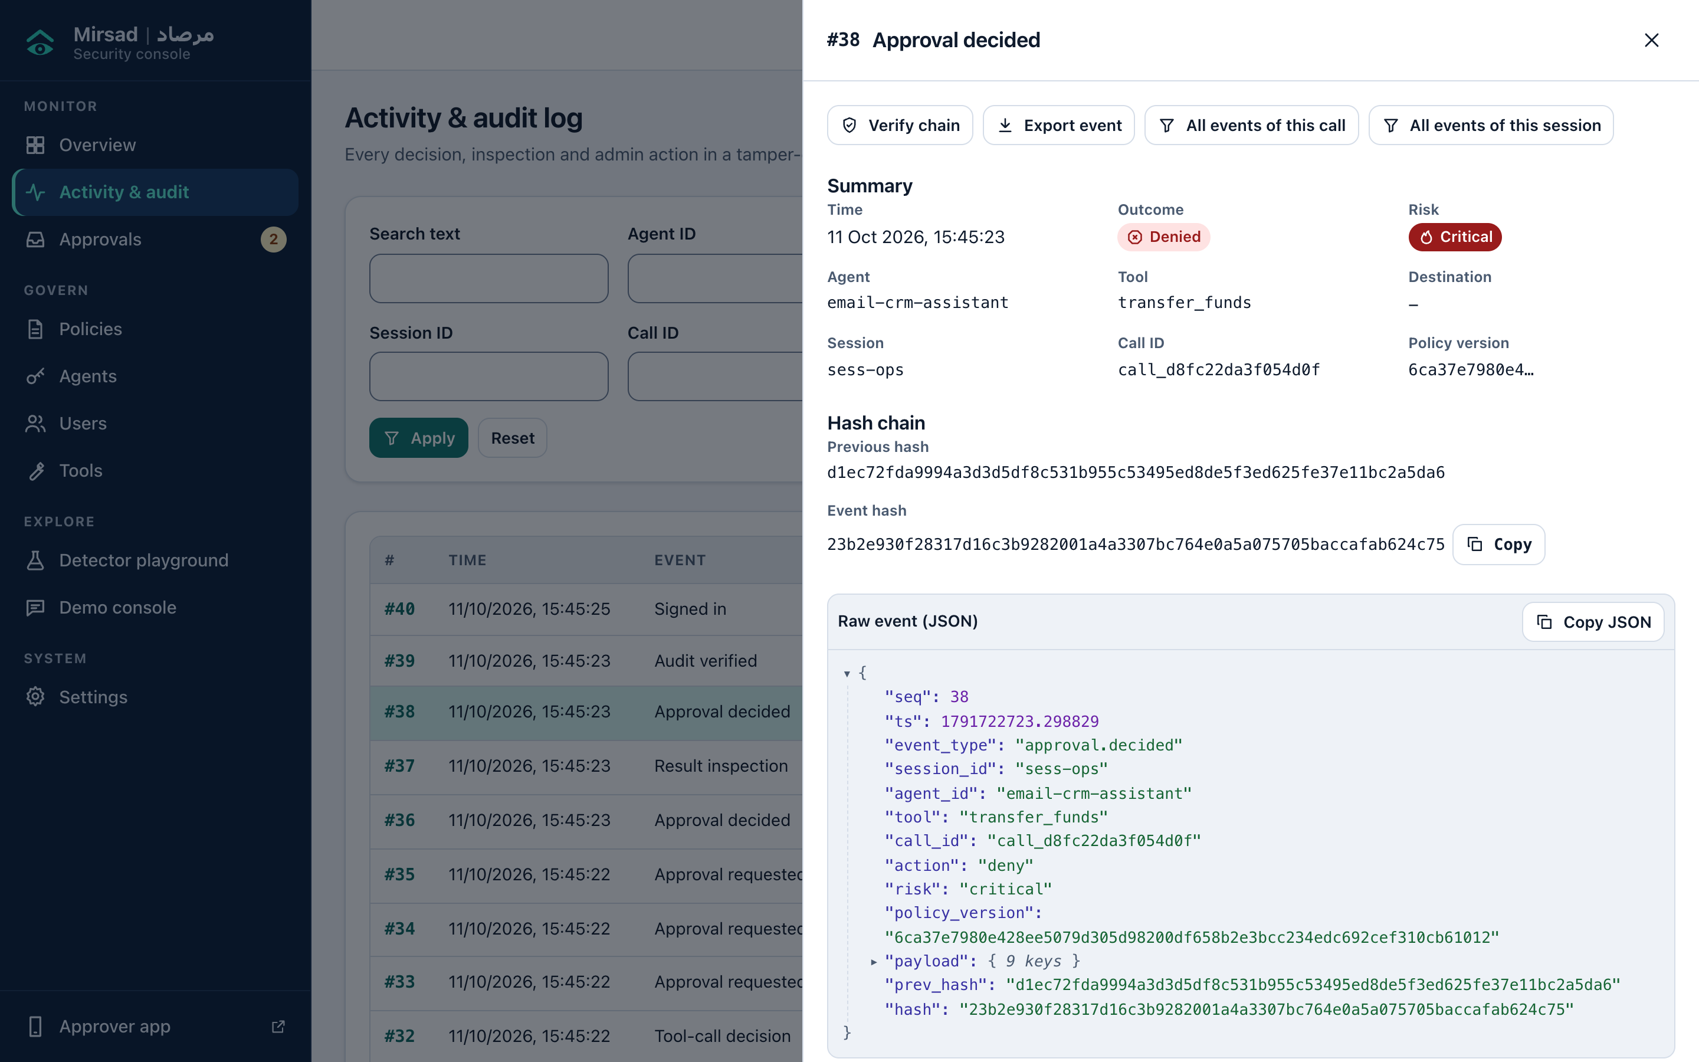
Figure 3.14: Activity and audit page with the detail drawer of an approval decision: summary, previous hash and event hash, and the raw event
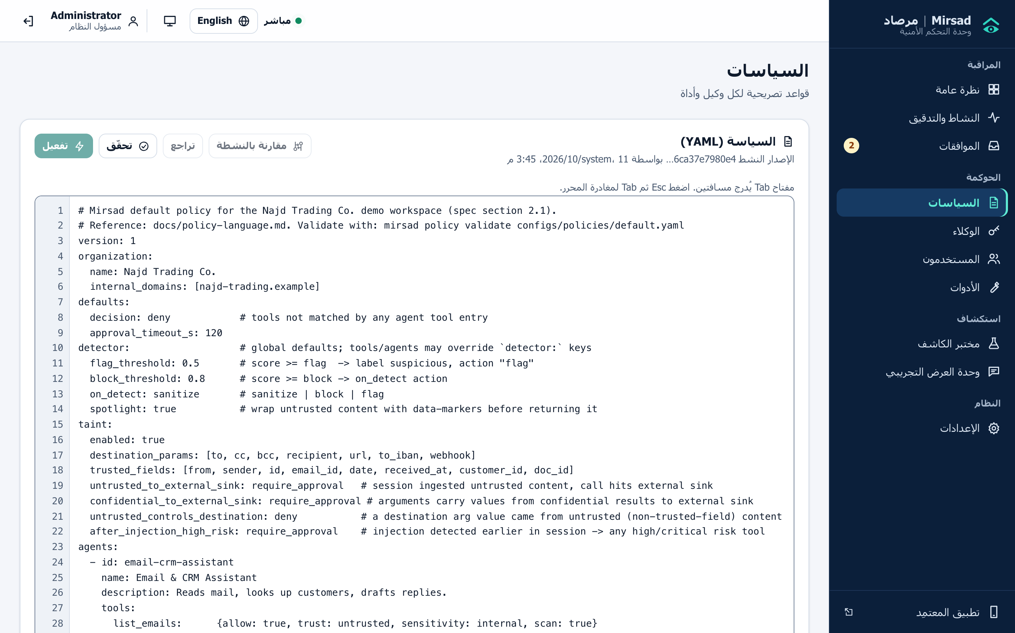
Figure 3.15: Policy editor in Arabic: the sidebar and controls are mirrored, while the YAML policy stays left-to-right
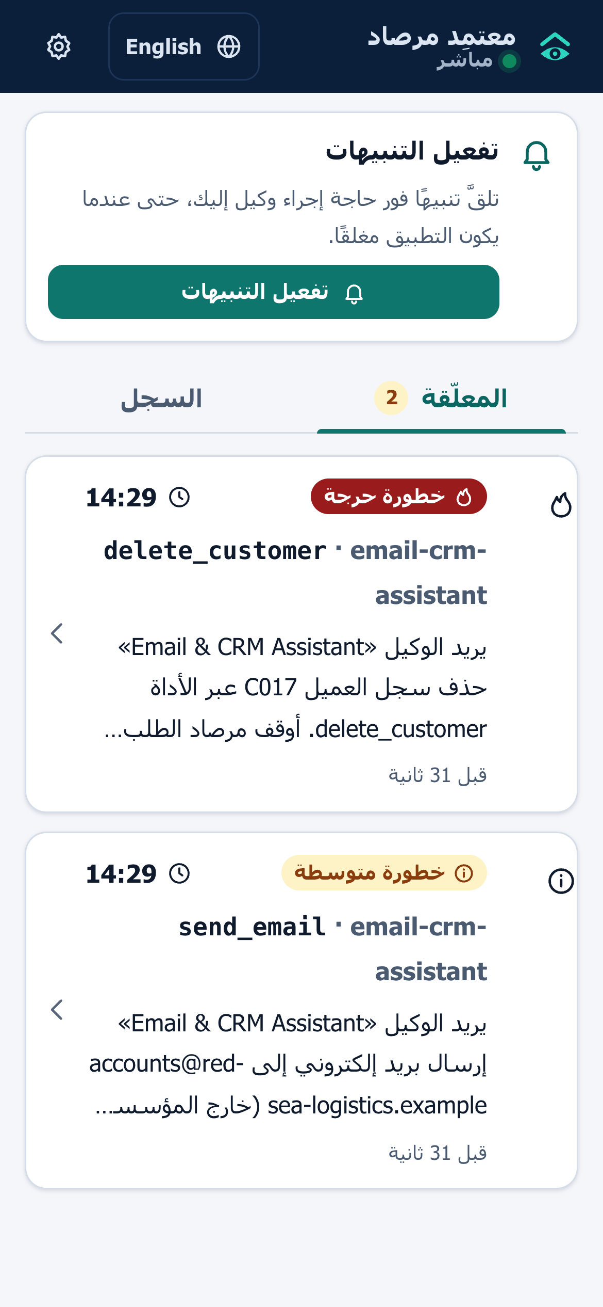
Figure 3.16: Approver PWA in Arabic: pending requests with risk label, countdown and plain-language summary
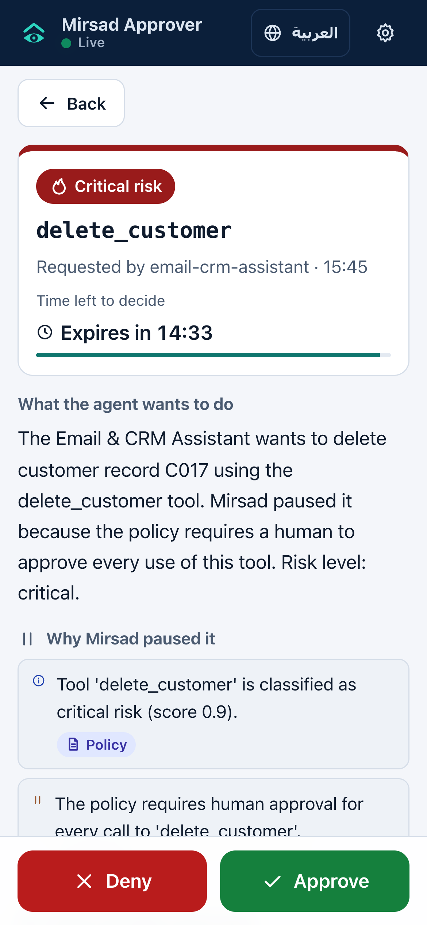
Figure 3.17: Approver PWA request detail in English: risk, countdown, explanation sections and the Approve and Deny buttons
The approver app is a progressive web app rather than a native application (Section 3.4.5). A web application manifest makes it installable on Android and iOS [93], and a service worker caches the application shell for offline use and receives push messages [94]; decisions always require a connection. Web Push works on Android and, for apps added to the home screen, on iOS 16.4 and later [95]. Service workers and push require HTTPS [96], which the deployment design reflects.

3.3.11 Deployment architecture and technology stack
Figure 3.18 shows the deployment architecture. The reference deployment is a Docker Compose stack on one server or virtual machine:
- `mirsad` container. A multi-stage image in which a Node.js stage builds the web applications and a Python 3.12 stage installs the gateway. It runs as a non-root user, keeps its data in a /data volume, exposes port 8700 and has a health check on /healthz.
- `db` container. PostgreSQL 16 with its own volume and readiness check; the gateway is configured to start only when the database is ready. Development and the benchmark use SQLite instead.
- Ollama container (optional). Enabled with the demo profile to serve Qwen2.5-7B for the demonstration agent.
- Upstream tools. Declared in configs/upstreams.yaml as in-process MCP servers, subprocesses over stdio, or remote servers over streamable HTTP.
Agents connect over HTTPS with their API key, and browsers and phones over HTTPS with a JWT. TLS is terminated by a reverse proxy in front of the container, which is not part of the Compose file; HTTPS is mandatory for the approver PWA. The Redis node in the figure marks an optional extension for sharing rate-limit counters between replicas and is not implemented: rate limits are kept in memory per process (Section 3.4.5), which fits the single-node scope. Configuration comes from MIRSAD_ environment variables or a .env file (database URL, server secret, approval timeout, Web Push keys, CORS origins, demonstration switch); a missing secret is generated and stored in an owner-only file.
The Compose files are written but have not been executed, because Docker was not available on the build machine (Section 4.1.1), and the policy and upstream paths must be set explicitly for the mirsad service (Appendix E.2.2).
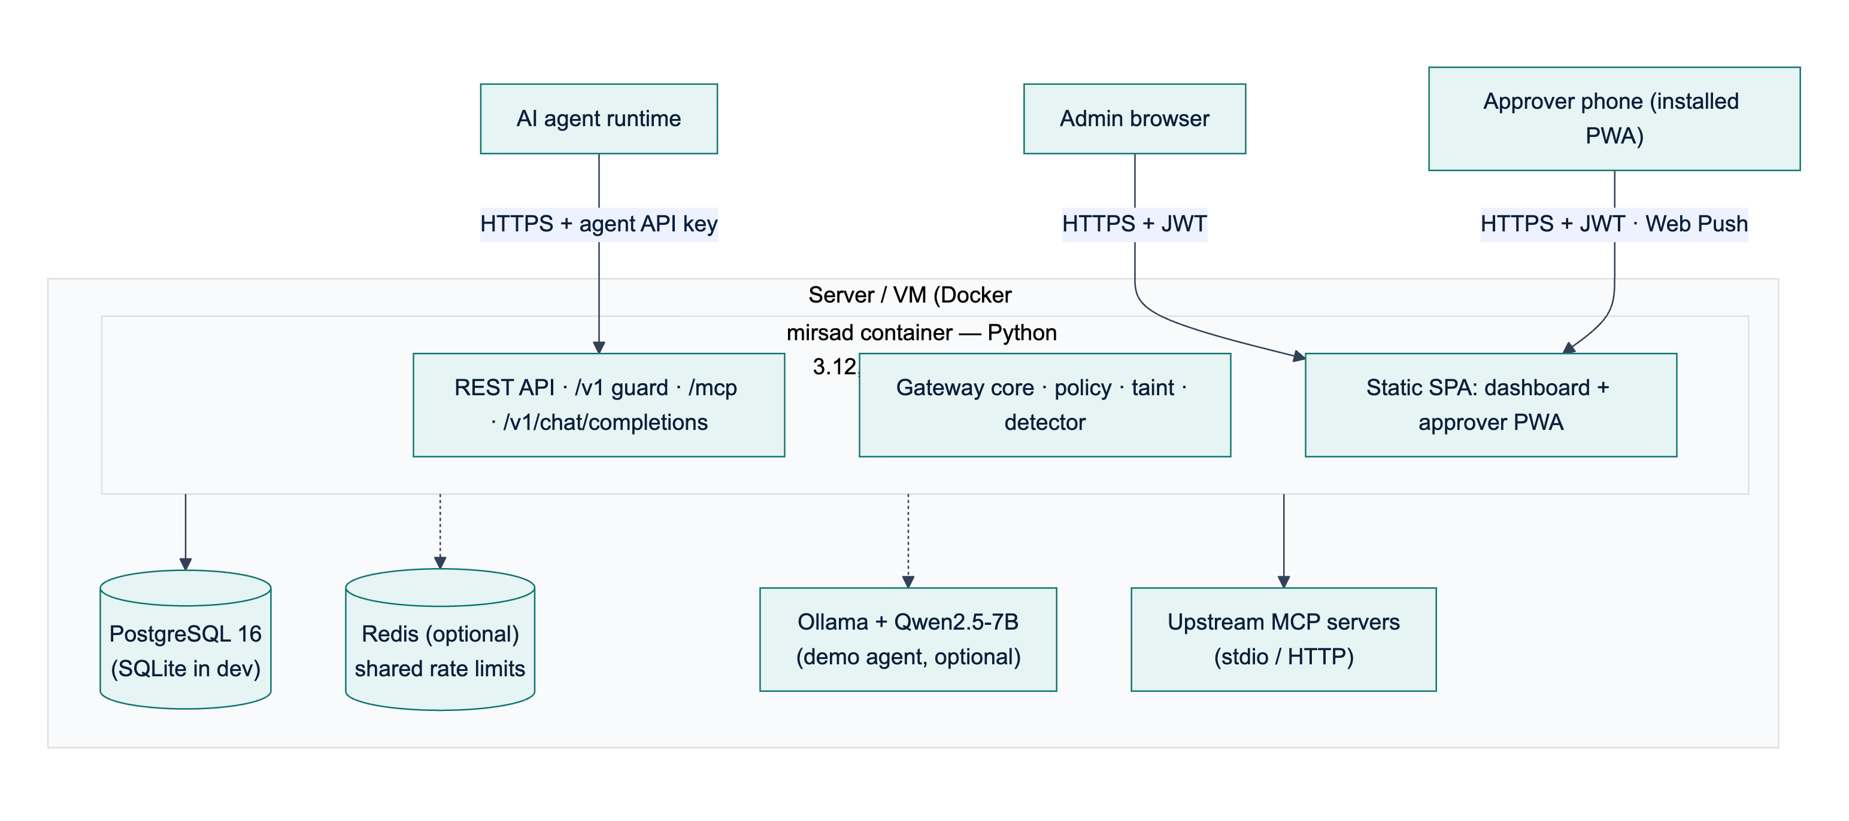
Figure 3.18: Deployment architecture: the Mirsad container, the database, optional components and the clients
The design targets one node serving at least 50 concurrent agent sessions (NFR11) with a median added latency of at most 200 ms (NFR1); Chapter 4 reports the measured latency (Section 4.2.5). Scaling beyond one node would require moving rate-limit counters and session taint state into a shared store, which is future work. The technologies of each layer and the reasons for choosing them are given in the technology-stack table of Section 3.4.4.

3.4 Implementation Strategy

3.4.1 Development methodology
The team's agreed working method is Scrum [97]: two-week sprints, a product backlog, sprint reviews in the bi-weekly supervisor meetings and a short retrospective at the end of each sprint. Its working rules build security activities into every sprint rather than leaving them to the end (a DevSecOps approach): threat modelling during design, review of every pull request by a second member, automated tests, linting, static analysis and dependency scanning in continuous integration, and a dedicated security-testing sprint before the final evaluation. Investigation, requirements, design, implementation and testing are iterated inside sprints, and the Senior Project I prototype (milestone M3) is the first planned complete increment.
The build was organised around a written engineering contract (docs/dev/BUILD_SPEC.md) that fixes the public interface of every component (names, arguments, return types, REST endpoints and database tables) before implementation starts. Because each workstream owns separate packages and codes against the contract, the five workstreams can be developed in parallel; shared data types live in a single module (mirsad/models.py) owned by the integrator, and Section 4.1.13 lists the integration issues that remained.
Table 3.17 lists the seventeen sprints and the milestones they close. It is the baseline plan. Actual progress ran ahead of it: the components planned for sprints S6 to S13 already existed as a working, tested prototype on the evidence date of this report (2026-10-14T07:58:56+00:00), before the M1 baseline date, while the results that depend on team-authored attack data remain open. Section 1.7 and D2 (Section 3.5) compare the plan with the actual progress.
Table 3.17: Sprint plan
Sprint | Dates | Sprint goal | Milestone
S1 | 1–14 Sep 2026 | Literature review, product analysis, team setup, repository and CI skeleton
S2 | 15–28 Sep 2026 | Threat model (STRIDE), attack taxonomy, stakeholder personas
S3 | 29 Sep–12 Oct 2026 | SRS (D3): functional and non-functional requirements, use cases
S4 | 13–26 Oct 2026 | Benchmark and dataset design; requirement baseline agreed | M1
S5 | 27 Oct–9 Nov 2026 | Architecture, engineering contract, policy-language specification, database design
S6 | 10–23 Nov 2026 | UI wireframes; gateway core and MCP proxy | M2
S7 | 24 Nov–7 Dec 2026 | Policy engine, rate limiter, audit log and storage
S8 | 8–21 Dec 2026 | Prototype demonstration and Senior Project I report | M3
S9 | 10–23 Jan 2027 | Taint tracking; detector normalisation and rules
S10 | 24 Jan–6 Feb 2027 | Detector model, dataset pipeline, OpenAI-compatible proxy and SDK
S11 | 7–20 Feb 2027 | Detector training and evaluation; integration | M4
S12 | 21 Feb–6 Mar 2027 | Approval workflow, approver PWA, notifications
S13 | 7–20 Mar 2027 | Dashboard, demo workspace and demo agent | M5
S14 | 21 Mar–3 Apr 2027 | Test specification and automated tests (D5); benchmark runs
S15 | 4–17 Apr 2027 | Security testing of the gateway; latency and evaluation report
S16 | 18 Apr–1 May 2027 | User guide (D6), deployment, documentation | M6
S17 | 2–20 May 2027 | Final report, poster, presentation and open-source release | M7

3.4.2 Mapping to the IS499 deliverables
The IS499 syllabus defines deliverables D1–D6 on a one-semester calendar. Table 3.18 shows where each deliverable is produced in the two-semester plan and where it appears in this report.
Table 3.18: IS499 deliverables and where they are addressed
Syllabus deliverable | Syllabus week | Mirsad artefact and timing | Location
D1 Project proposal | 1 | SPAP form, approved at M1 | Chapter 1
D2 Work plan and budget | 2–3 | Sprint plan, Gantt chart, budget with price evidence (S1–S4) | Sections 1.7, 3.4.1, 3.4.6; separate D2 document
D3 Software requirements specification | 4–5 | SRS (S3–S4) | Section 3.2; separate D3 document
D4 High- and low-level design | 6–7 | Architecture, components, UML, database and UI design (S5–S6) | Section 3.3; separate D4 document
Midterm report (D1–D4) | 8 | Senior Project I report (S8) | Chapters 1–3
Implementation iterations 1 and 2 | 9–12 | Increments of sprints S7–S13 | Section 4.1
D5 Test case specification and results | 13 | Test plan, automated suites, results (S14–S15) | Sections 3.5, 4.2; Appendix B
D6 Software user guide | 13 | Installation, administration and approver guide (S16) | Appendix E; separate D6 document
Final report and presentation | 14–15 | This report, poster and slides (S17) | Appendix D

3.4.3 Team roles and responsibilities
Table 3.19: Workstream ownership
Member | Department | Workstream and main responsibilities
Bader Alshuraie | SE | Gateway core, protocol adapters (MCP proxy, OpenAI-compatible proxy, Guard API, SDK), policy language and engine, REST API and CLI
Abdullah Naif Abdullah Al-Orabi | SE (AI & DS) | Arabic/English injection detector: normalisation, rules, model, dataset pipeline, training and evaluation
Bader Abdullah Abbod Alyamini | IS (CYS) | Taint tracking engine; tamper-evident audit log, redaction, verification and replay; database design
Mohammed Yasser Alanssari | IS (CYS) | Administration dashboard and approver PWA (bilingual, accessible), notifications, approval workflow UX
Abdulmalik bin Saedan | IS (CYS) | Project management; simulated workspace and demonstration agent; Mirsad-Bench; security testing of the gateway
All members |  | Literature review, requirements, design reviews, integration, code review, report, poster and presentation

3.4.4 Development environment, tools and version control
All code is kept in a single Git repository. The agreed working rules are a protected main branch, feature branches, and pull requests that need one review and a green CI run before merging. The continuous-integration workflow (GitHub Actions, .github/workflows/ci.yml) defines three jobs (Section 3.5.4): a Python job with linting (Ruff), the test suite with coverage, static application security testing (Bandit) and dependency vulnerability scanning (pip-audit); a web job with the TypeScript type check, the web unit tests and a production build; and a Docker image build that runs after both. No CI run is recorded in reports/.
Table 3.20: Technology stack and justification
Layer | Technology | Why it was chosen
Gateway and API | Python 3.12, FastAPI, Uvicorn, Pydantic v2 | Asynchronous I/O for concurrent tool calls; typed request/response models; automatic OpenAPI documentation
Agent protocols | Official MCP Python SDK (v2), httpx | Standards-compliant MCP client and server (stdio and streamable HTTP); OpenAI-compatible JSON over HTTP
Persistence | SQLAlchemy 2.0; SQLite (development), PostgreSQL (deployment) | Portable ORM with typed models; zero-setup local database; production database without code changes
Policy language | YAML + strict Pydantic schema | Human-readable, reviewable in pull requests, validated with line-numbered errors
Detector | scikit-learn (hashed character and word n-grams, logistic regression), NumPy, rule engine | Designed to run on a CPU within the latency budget (target below 10 ms for a 2 KB text); transparent features; model stored without pickle
Security | scrypt (hashlib), PyJWT, HMAC-SHA-256, pywebpush (VAPID) | Standard primitives; no custom cryptography
Web UI and approver app | React 18, TypeScript, Vite, Recharts; installable PWA (manifest + service worker) | One code base for the dashboard and the mobile approval app; works on Android and iOS without app stores
Demonstration agent | Ollama with Qwen2.5-7B (local), OpenAI-compatible API | Free, private, runs on a laptop; strong Arabic support; native tool calling
Quality and security testing | pytest, pytest-asyncio, pytest-cov, Vitest, Testing Library, Ruff, Bandit, pip-audit | Automated unit, integration, API, UI and security tests
Documentation | Markdown, Mermaid, Matplotlib, python-docx, Playwright | Diagrams and figures regenerated from source; screenshots captured from the running system; reports built reproducibly
Packaging | Docker, Docker Compose, GitHub Actions | One-command deployment and repeatable builds

3.4.5 Changes from the proposal and their justification
Engineering judgement led to five deliberate changes from the tools listed in the proposal. Each keeps the proposal's objectives intact.
1. Installable progressive web app instead of Flutter for the approval app. A PWA built with the same React code base as the dashboard installs to the home screen on Android and iOS, supports system notifications and offline caching, avoids app-store registration fees and review delays, and could be built and tested on the team's machines. Wrapping it as a store app (Capacitor or Flutter) remains possible future work.
2. Classical detector instead of fine-tuning XLM-RoBERTa / CAMeLBERT. The latency budget (NFR1), CPU-only deployment and the size of the team-built dataset favour a character n-gram linear model combined with weighted rules. It is designed to run in milliseconds on a CPU (target below 10 ms for a 2 KB text, measured once a model is trained), and its features are inspectable. Fine-tuning a multilingual encoder is planned as an optional second stage (Chapter 5).
3. SQLite and PostgreSQL without Redis. Rate limits are kept in memory per gateway process; Redis would only be needed for multiple replicas, which are out of scope.
4. Standard Web Push (VAPID) instead of Firebase Cloud Messaging. Web Push is an open standard supported by the PWA and avoids a dependency on a proprietary service.
5. Own benchmark harness (Mirsad-Bench) instead of running AgentDojo directly. AgentDojo's environments are English-only and its standard runs assume hosted model APIs. Mirsad-Bench reuses its methodology (user tasks × injection tasks, attack success rate and utility) on a simulated Saudi enterprise with Arabic scenarios and runs fully offline. Burp Suite and OWASP ZAP were likewise replaced by an automated security test suite that can run in CI (Section 4.2.6).

3.4.6 Budget
The proposal's budget of 1,660 SAR was revised to 1,185 SAR in the D2 Work Plan and Budget (Section 5.3), mainly because development and most of the evaluation use local models and the approval app is a PWA rather than a store app (Section 3.4.5). Table 3.21 summarises both budgets; D2 gives the price evidence for each line.
Table 3.21: Original and revised budget (SAR)
Line | Proposal | Revised | Justification
LLM API usage | 750 | 450 | Local models for development; one confirmatory run per cloud provider
Cloud VM (2 vCPU, 4 GB, 6 months) | 600 | 540 | Priced from plans that can be ordered
Google Play registration | 100 | 0 | PWA instead of store apps
Domain and TLS | 60 | 45 | .com domain; free Let's Encrypt certificate
Contingency | 150 | 150 | VAT, card and exchange fees, price changes and benchmark reruns
Total | 1,660 | 1,185 | Saving of 475 SAR

If no funding is approved, the project can still be built, evaluated and demonstrated at 0 SAR with local models, free hosting tiers and free certificates, at the cost of the limitations listed in D2 (Section 5.4).

3.5 Testing & Validation
This section explains how Mirsad is verified, meaning that it is built correctly against its specification, and validated, meaning that it does its job of stopping hijacked agents without getting in the way of legitimate work. It covers the test strategy, the test levels and tools, the entry and exit criteria, the continuous-integration pipeline, the metrics, the test inventory and the planned user acceptance testing. The test case specification, the requirements traceability matrix (Table B.2) and the full test report are in Appendix B. Section 4.2 discusses the results.

3.5.1 Test strategy
The strategy uses the concepts and documentation structure of ISO/IEC/IEEE 29119 [98] and is organised as a V-model. Each development artefact on the left of the V has a test level on the right that checks it (Table 3.22). The requirements in Section 3.2 are checked by end-to-end tests and by the benchmark. The architecture and the engineering contract (docs/dev/BUILD_SPEC.md) are checked by integration and API tests, and the design of each package by unit tests. The test design followed three principles.
1. Requirement-driven and risk-based. Every functional and non-functional requirement is traced to at least one automated test (Table B.2). Most effort went to the parts whose failure would either let an attack through or block legitimate work: the policy engine, the taint rules, the fail-closed paths of the gateway, the approval workflow and the audit chain.
2. Negative cases are first-class. Every rule has a case where it must fire and a case where it must not. The bulk-export rule is tested at 50 and 51 recipients (boundary values). Each constraint operator is tested with one passing and one violating value (equivalence classes). The legitimate counterpart of an "untrusted destination" is a reply to the sender of an e-mail, and that reply must not be blocked. The security suite attacks the gateway itself with forged tokens, database tampering and path traversal.
3. Deterministic and offline. Tests use temporary SQLite files, seeded synthetic data (the fictional Najd Trading Co. on reserved .example domains), explicit timestamps for rate-limit windows, and fake components where a unit has to be isolated. Tests that need the local language model carry the pytest marker llm and are left out of the default run, because model output is not stable enough to serve as a pass/fail gate.
Test data and attack material. This report contains no prompt-injection text, and apart from the eight Demo Console scenarios (demo/scenarios.py), which the demo tests load to check that they plant their text into the simulated workspace (Section 3.6.4), neither does the repository. A test that needs content to be scored as an injection uses a neutral placeholder marker together with a stub detector rule. Everything that happens after the detector produces its score, that is thresholds, sanitising, spotlighting, taint registration, audit and replay, then runs the production code. These tests therefore show how Mirsad handles a detection. They do not show how well the detector detects real attacks. Detector accuracy and attack success rate are measured separately, once the team's attack-labelled data is complete (Section 3.5.6).
Table 3.22: Test levels and the artefacts they verify (V-model)
Level | Verifies | Scope and techniques | Tools and location
Unit | Design of each package (policy, taint, detector, audit, approvals, auth, adapters, demo, bench) | One package at a time, with fakes for its neighbours. Equivalence classes and boundary values for constraints and rate limits, decision tables for reason combination, concurrency tests for the rate limiter, audit chain and approvals | pytest, pytest-asyncio; tests/<area>/
Integration | Engineering contract between packages | Real policy engine, taint tracker, detector, sanitiser, audit log, approvals and in-process MCP server wired together; the same storage, audit, approval and authentication code against PostgreSQL | tests/integration/, tests/api/test_integration_real.py, tests/taint/test_taint_integration.py
API and contract | REST, MCP and OpenAI-compatible interfaces | Application driven through an HTTP client: status codes, roles, schemas, error bodies; OpenAPI document compared with the specified routes; web client parsed against captured server records | httpx; tests/api/, tests/adapters/, web/tests/contract.test.tsx
End-to-end | User-visible behaviour | Real CLI (mirsad init --demo), the application built by mirsad serve on a real port, plain HTTP calls, an approval sent from a second operating-system process, the stdio MCP proxy started as a subprocess | tests/api/test_e2e_http.py, tests/adapters/test_adapters_mcp_proxy.py
UI | Dashboard and approver PWA | Component tests in a simulated browser (jsdom): approve/deny flow, Arabic right-to-left rendering, bilingual dictionaries, SSE parsing, colour contrast of the design tokens | Vitest, Testing Library; web/tests/
Security | Security requirements from the STRIDE analysis | 23 security tests (ST-01 to ST-23; 45 test cases) against the running application, grouped by STRIDE category [69] | tests/security/test_gateway_security.py
Static analysis | Code quality and insecure code patterns | Linting with security rules, static application security testing, strict TypeScript type checking | Ruff, Bandit, TypeScript compiler
Dependency scanning | Known vulnerabilities in third-party packages | Advisory databases for Python and npm packages | pip-audit, npm audit
Performance | NFR1 and NFR11 | 1,000 benign HTTP calls, sequential and with 50 concurrent sessions; server in the same process and in a separate process | bench/latency.py
System evaluation | Objectives 1–3 (Section 1.3) | Mirsad-Bench: 48 benign tasks in English and Arabic, five defence configurations, two approver behaviours, audit verification and replay of every decision; LLM smoke run; attack episodes once the team's attack files exist | bench/, scripts/run_bench.sh
Acceptance (UAT) | Stakeholder needs: use cases UC-01, UC-05, UC-08, UC-13 to UC-15 and NFR4 | Scenario-based sessions in which the supervisor and two to three security practitioners operate the system on prepared requests in the simulated workspace (Section 3.5.7) | Planned; questionnaire in Appendix F, Section D

3.5.2 Test environment, tools and responsibilities
All recorded runs were made on a team member's laptop (Apple silicon, macOS) with Python 3.12 and Node.js. The CI workflow is configured to run the same suites on Linux; no CI run is recorded in reports/. Python tests use pytest with pytest-asyncio and pytest-cov. HTTP-level tests drive the FastAPI application through httpx, either in memory or over a real socket served by uvicorn. The PostgreSQL tests start a throwaway server from the pgserver package, so no database has to be installed. Web tests use Vitest with Testing Library and jsdom. The llm-marked tests and the LLM smoke run use Qwen2.5-7B [99] served locally by Ollama.
Each workstream owner writes and maintains the unit and API tests for their own packages (Section 3.4.3). The security suite, Mirsad-Bench and the latency benchmark belong to the security-testing and benchmark workstream (Abdulmalik bin Saedan). Under the agreed working rules, every pull request needs a second reviewer and a passing CI run before it is merged (Section 3.4.4).

3.5.3 Entry and exit criteria
A test level starts only when its entry criteria hold:
- Unit and API tests: the public interface of the component is fixed in the engineering contract and the code passes the linter.
- Integration and end-to-end tests: the unit suites of every package involved pass.
- Benchmark runs: the scenario files validate (python -m bench.loader) and the full automated suite passes, so that benchmark numbers always come from tested code.
- Reported results: the evidence pipeline (Section 3.5.4) has been run on the version being reported.
Table 3.23 lists the exit criteria for a release candidate, together with the values measured for the version described in this report. The first ten criteria are gates: a candidate that misses any of them is not released. The lint and type-check gate is enforced by the CI workflow, but its result is not stored with the evidence, so it is shown as not recorded. The last two are project success criteria that cannot be measured until attack data exists. They are reported as open rather than estimated.
Table 3.23: Exit criteria and their status for the reported version
Criterion | Target | Measured | Status
Automated Python tests (all areas, llm marker excluded) | all pass, none skipped | 1,281 of 1,281 passed, 0 skipped | Met
Web UI tests | all pass | 194 of 194 passed | Met
Statement coverage of src/mirsad (NFR9) | ≥ 80% | 94.4% | Met
Lint (Ruff) and type check (tsc --noEmit) | no findings | no report stored in reports/ (B.5.3) | Not recorded
Static application security testing (Bandit) | no medium or high findings | 0 findings of any severity | Met
Known-vulnerable dependencies | none | pip-audit: 0 of 124 packages; npm audit: 0 | Met
STRIDE security suite | all pass | 45 test cases passed | Met
Median added latency per tool call (NFR1) | ≤ 200 ms, judged on the sequential median and on the separate-process layout | 2.7 ms sequential; 166 ms with 50 sessions (separate process) | Met
Benign false-positive rate with full protection | ≤ 5% | 0.0% | Met (rules-only detector)
Benchmark decisions that replay to the same action (FR6.3) | 100% | 272 of 272 and 272 of 272 | Met
Detector F1 on the English / Arabic held-out test sets | ≥ 0.85 | [pending] / [pending] | Pending data
Attack success rate reduction against the unprotected baseline | ≥ 80% | [pending] | Pending data

3.5.4 Continuous integration and the evidence pipeline
The CI workflow (.github/workflows/ci.yml) is configured to run on every pull request and every push to the main branch. Table 3.24 shows its three jobs. A failing step stops the job, and under the agreed working rules a pull request is not merged with a red build. No CI run is recorded in reports/, so the results in this report come from the local evidence pipeline described below.
Table 3.24: Continuous-integration jobs
Job | Steps | The build fails when
python | Install the project with development extras; ruff check on source, tests, demo, bench and scripts; pytest -m "not llm" with coverage; bandit -r src; pip-audit | any lint finding, failing test, Bandit finding or vulnerable dependency
web | npm ci; tsc --noEmit; Vitest; production build with Vite | a type error, failing test or build error
docker | Build the container image (runs only after both other jobs pass) | the image does not build

Two checks are not yet enforced by CI. The 80% coverage target is read from the coverage report rather than enforced with a --cov-fail-under threshold, and npm audit runs in the evidence pipeline and in make security but not in the workflow.
The numbers in this report come from a separate evidence pipeline, scripts/run_evidence.sh. It re-runs the Python suite (writing JUnit XML and a coverage JSON file), the web suite, Bandit, pip-audit and npm audit, both latency benchmarks and both scripted Mirsad-Bench runs (through scripts/run_bench.sh), and it trains the detector when labelled data is present. scripts/collect_results.py then gathers every result into reports/results_summary.json. The report builder (scripts/build_docs.py) reads each number in this document from that file when the document is generated. A number in the text therefore cannot drift away from the evidence, and a value that has not been produced yet prints as "[pending]" instead of being estimated.

3.5.5 Metrics
The following metrics are collected. Definitions of the benchmark metrics follow docs/benchmark.md.
- Test execution: number of tests per area, and passed, failed and skipped counts. A test is one pytest item or one Vitest case, so each parametrised case counts separately.
- Code coverage: statement coverage of the mirsad package. Branch coverage is not collected.
- Static analysis and dependencies: number of findings per tool, and number of packages with a known advisory.
- Latency: added latency per call, which is the HTTP round trip through Mirsad minus the direct in-process tool call, paired call by call. It is reported as p50, p95 and p99, together with throughput and HTTP errors. Time spent waiting for a human is excluded by design.
- Benchmark: utility, the share of episodes whose success predicate holds. Benign false-positive rate (FPR), the share of benign calls denied automatically. Approval friction, the share of benign calls handed to a human. Final block rate, the share of benign calls that did not run in the end. Result false-positive rate, the share of benign tool results that the detector sanitised or blocked. Approval recall, the share of tasks that legitimately need approval in which a human was asked. Gateway latency, the decision plus result inspection per call. Attack success rate (ASR), and ASR reduction = 1 − ASR(defence) / ASR(none).
- Audit integrity: the result of hash-chain verification and the share of decisions whose replay gives the same action.
- Detector: precision, recall, F1, false-positive rate and ROC-AUC on each held-out split, and scan latency for a 2 KB text.
- Usability (NFR4): an analytical estimate of approval time with the Keystroke-Level Model [100] (Section 4.2.8). Approval times of real users have not been measured yet.
- Acceptance: for each acceptance scenario of Section 3.5.7, whether each participant accepts it, with the number of participants.
FPR and friction are reported separately on purpose. A policy can deny no benign call and still cost a lot of human time if it escalates too often, and the two numbers show these two costs.

3.5.6 Test inventory
Table 3.25 lists the automated tests by area. The Python suite has 56 test files. Two further files hold only llm-marked tests (tests/demo/test_llm.py and tests/bench/test_bench_llm.py) and are not part of the recorded run.
Table 3.25: Automated tests by area
Area | Files | What the tests cover | Owner | Tests
policy | 7 | Schema and validator messages, every constraint operator, rate limiter, rules, sink resolution, ReDoS guard for policy regexes, shipped policies and policy documentation | Bader Alshuraie | 265
adapters | 4 | MCP proxy (stdio and HTTP), OpenAI-compatible proxy, upstream manager, Python SDK | Bader Alshuraie | 78
api | 10 | Gateway pipeline, Guard API, admin API, authentication and roles, HTTP hardening, SSE stream, CLI, demo endpoints, real-component integration and end-to-end HTTP | Bader Alshuraie | 185
taint | 4 | Value extraction, the four taint rules and their exemptions, session tracker, replay from snapshots | Bader Abdullah Abbod Alyamini | 93
audit | 8 | Hash chain and tamper detection, query and export, redaction, storage, approval service, approver summaries, notifier and Web Push, authentication core | Bader Abdullah Abbod Alyamini | 240
detector | 9 | Normalisation, language identification, rules, model persistence, ensemble, sanitiser and spotlighting, dataset builder, training and metrics | Abdullah Naif Abdullah Al-Orabi | 227
demo | 4 | Simulated workspace, MCP workspace server, demo scenarios, demo agent loop | Abdulmalik bin Saedan | 72
bench | 7 | Scenario loader and schema, episodes and predicates, attack-episode construction, planting, survival markers and stop attribution (neutral placeholder text only), defence configurations, agents, metrics, runner and latency benchmark | Abdulmalik bin Saedan | 68
security | 1 | STRIDE security suite ST-01 to ST-23 | Abdulmalik bin Saedan | 45
integration | 2 | PostgreSQL compatibility, cross-module wiring | All members | 8
Python total | 56 |  |  | 1,281
web | 10 | API client, SSE client, contract with server records, approver PWA and dashboard pages, i18n dictionaries, colour contrast, countdown, span highlighting | Mohammed Yasser Alanssari | 194

Two measurements cannot be produced by this inventory yet: detector precision, recall and F1, and the attack success rate. Both depend on attack-labelled data written by the team (Section 3.6.4). Detector metrics are produced by running make detector after the team adds labelled batches and separate held-out test batches to data/detector/raw/ (procedure in docs/detector.md, Section 11.4). The attack success rate is produced by Mirsad-Bench, which already executes attack episodes (Section 4.1.12), once the team adds injection tasks and attack templates to bench/scenarios/attacks/. Until then, every place in this report that needs these values shows "[pending]".

3.5.7 User acceptance testing
The levels above verify the system against its specification. User acceptance testing validates it with the people it is built for: whether an approver, an administrator and an auditor can complete their main tasks with the real interfaces and accept the result. Table 3.26 lists the planned acceptance scenarios. They are run in the simulated Najd Trading Co. workspace with prepared, benign requests, by the supervisor and two to three security practitioners recruited by the team, each of whom records "accept" or "reject" per scenario with a reason. Section D of the questionnaire in Appendix F is completed after the session. No session has been held yet; outcomes will be reported with the number of participants, and no result is estimated before then.
Table 3.26: Planned user acceptance scenarios
ID | Use case / requirement | Actor | Steps | Acceptance criterion | Evidence
AT-01 | UC-01, BR4 | Agent developer | Run the demonstration agent through the gateway on a benign task that e-mails an outside supplier, then on one that e-mails a colleague | The outside e-mail is paused and not sent until a decision is made; the internal e-mail is sent without a pause | Audit events of both sessions
AT-02 | UC-05, NFR4 | Approver | Receive a paused request on a phone, read the summary and approve or deny it | The participant can say why the action was paused from the summary alone and decides within 30 seconds | Request and decision times from the approval record; questionnaire items D1 and D2
AT-03 | UC-05, NFR4 | Approver | As AT-02 with the interface in Arabic | As AT-02; the participant judges the Arabic layout and summary readable | As AT-02
AT-04 | UC-08 | Administrator | Edit the policy to allow a new partner domain, validate it, review the difference, activate it, then roll back | Errors are reported with line numbers; the change applies to the next call without a restart; rollback restores the earlier version | policy.activated audit events
AT-05 | UC-13, UC-14 | Auditor | Find the events of one session, verify the hash chain and export the events as JSON | The events are found with the filters, verification reports an intact chain and the export verifies offline | Export file and verification output
AT-06 | UC-15 | Auditor | Replay a stored decision from the dashboard | The replay reports the same action and the policy version that made the original decision | Replay output

3.6 Ethical, Legal & Security Considerations

3.6.1 Data privacy and the PDPL
Mirsad is designed so that the security tool does not itself become a privacy risk. The Saudi Personal Data Protection Law [12] requires that personal data be processed only for a legitimate purpose, minimised, protected against unauthorised disclosure, and that breaches be reported. The design responds as follows:
- Synthetic data only. All customers, e-mails, documents and bank accounts in the demonstration workspace and in Mirsad-Bench are fictional; e-mail addresses and web sites use the reserved .example domain, and phone numbers and IBANs are clearly fake. The detector dataset contains no real personal data.
- Masking in the audit log. Before an event is hashed and stored, secrets (API keys, bearer tokens, JWTs, passwords, private keys) are removed and personal identifiers (Saudi national ID numbers, IBANs, payment-card numbers) are masked to their last four characters. The log keeps its forensic value (which tool, which destination, which decision) without becoming a second copy of customer data.
- Purpose limitation. Taint tracking stores only the identifying values needed to recognise a data flow (addresses, identifiers, hashed n-grams) and expires idle sessions.
- Breach prevention as a primary goal. The taint rule "confidential data to an external sink" exists specifically to prevent the kind of unauthorised disclosure the PDPL penalises.

3.6.2 Regulatory and standards alignment
Appendix A maps the system's controls to the NCA Essential Cybersecurity Controls [11] (event logging and monitoring, identity and access management, cybersecurity in third-party and cloud services), to the OWASP Top 10 for LLM Applications [5] (LLM01 prompt injection, LLM02 sensitive information disclosure, LLM06 excessive agency), to the NIST AI RMF functions [18] and to SDAIA's AI ethics principles [10]. Human approval of high-risk actions implements the principles of human oversight and accountability; the audit log and decision replay implement transparency and explainability towards auditors.

3.6.3 Security of the gateway itself
A firewall concentrates trust, so it becomes a target. The STRIDE analysis (Section 3.3.8) produced security requirements that are built into the gateway. Agents authenticate with per-agent API keys stored only as SHA-256 hashes, and people with salted scrypt password hashes and short-lived JWTs under role-based access control (admin, approver, auditor). Failed logins are throttled and audited, every response carries security headers, and request bodies are size-limited. Regular expressions in policies are validated and their input is bounded to limit denial-of-service risk. The audit log is HMAC-chained, so undetected modification requires the server's secret key, and approval requests fail safe: expiry means denial. The gateway was tested with its own security test suite, static analysis and dependency scanning (Section 4.2.6).

3.6.4 Responsible handling of attack material
Evaluating a prompt-injection defence requires attack material, which is dual-use: it helps defenders test systems but could also help attackers. This report contains no attack payloads or attack templates, and the automated tests use neutral placeholders wherever content must be scored as an injection (Section 3.5.1). The only injected instructions in the repository are the short illustrative texts of the eight Demo Console scenarios (demo/scenarios.py), which address the simulated workspace and its reserved .example addresses and are used only for live demonstration. The attack material needed for the evaluation, namely the attack-labelled detector batches and the Mirsad-Bench attack files, is written and reviewed by team members, is used only against the project's simulated workspace and fictional organisation, and is not reproduced in this report, which publishes only aggregate metrics. Whether that material is released, and in what form (for example with restricted access), will be decided after the review, following the practice of public benchmarks such as AgentDojo [6]. No attack is run against any third-party system or service.

3.6.5 Social and professional considerations
- Approver workload. The approval workflow is designed to ask humans only about high-risk actions, with a short plain-language summary in their preferred language, to avoid alert fatigue and rubber-stamping.
- Inclusiveness and accessibility. The dashboard and approval app are fully bilingual (Arabic with right-to-left layout, and English) and follow WCAG 2.2 basics (keyboard navigation, labels, sufficient contrast, no colour-only signals).
- Honest claims. Prompt injection is not a solved problem; detectors can be evaded by novel phrasings. The report presents Mirsad as one layer of defence in depth, reports false positives, approval friction and limitations openly, and marks every unmeasured result, including detection misses and attack success, as pending (Chapters 4 and 5).
- Professional codes. The team followed the principles of the ACM Code of Ethics and Professional Conduct [101] on avoiding harm, honesty, respecting privacy and accepting professional review.

3.6.6 Licences, third-party components and AI assistance
All third-party software used by Mirsad is open source. Almost all runtime dependencies use permissive MIT, BSD or Apache-2.0 licences (e.g. FastAPI, SQLAlchemy, scikit-learn, React and the MCP SDK); the Web Push library pywebpush uses the weak-copyleft MPL-2.0 licence, which permits use in an Apache-2.0 project as long as the library itself is distributed unmodified with its source available. The full list is in docs/THIRD_PARTY.md; the public deepset/prompt-injections dataset (Apache-2.0) is planned as an optional external English test set, to be downloaded by the team. Mirsad itself is released under the Apache-2.0 licence. The Qwen2.5 model used for the demonstration agent is used under its published licence.
In line with the proposal's commitment and university policy, the team discloses that an AI coding and writing assistant (Anthropic's Claude) was used during the project to help generate source code and tests, draft documentation and report text, author parts of the benign synthetic Arabic/English dataset batches and the benign benchmark user tasks, and produce diagrams. The assistant was not used to write the attack material for the evaluation (the attack-labelled detector batches and the Mirsad-Bench attack files); that material is written and reviewed by team members (Section 3.6.4). AI-assisted outputs were treated like any other contribution: they were checked by the automated test suite, the evaluation results come only from actual executions of the system, every literature reference was verified against its original source, and the team members remain responsible for the originality, correctness and understanding of all submitted work.

Chapter 4 – Implementation and Evaluation
This chapter describes how Mirsad was built (Section 4.1), evaluates it against the success criteria fixed in the proposal (Section 4.2) and records how the work was divided (Section 4.3).
Every number in Section 4.2 is read from the result files under reports/, which scripts/run_evidence.sh regenerates (tests with coverage, security scans, latency benchmark, Mirsad-Bench and, when labelled data exists, detector training) before scripts/collect_results.py writes reports/results_summary.json. The values printed here were collected on 2026-10-14T07:58:56+00:00 (UTC); Appendix B.1 records the platform and when each part of the evidence was produced. Results that depend on attack-labelled data, which the team is still preparing, print as "[pending]" and fill in automatically once the result files exist.

4.1 Implementation

4.1.1 Development environment and repository structure
Mirsad was developed and measured on an Apple M5 laptop with 16 GB of memory running macOS 26.5 (arm64), Python 3.12 and Node.js 24. The demonstration agent and the LLM benchmark runs use Qwen2.5-7B [99], served locally by Ollama through its OpenAI-compatible endpoint [102]. Backend code is typed Python with Pydantic v2 models, linted with Ruff; the web front ends are strict TypeScript. A GitHub Actions workflow (.github/workflows/ci.yml) defines the continuous-integration checks: Ruff, the Python tests with coverage, Bandit, pip-audit, the TypeScript type check, the web tests, a production web build and a Docker image build. No CI run is recorded in reports/: the evidence in this chapter was produced locally with scripts/run_evidence.sh and, for Mirsad-Bench, scripts/run_bench.sh (Appendix B.1). These scripts run the tests, Bandit, pip-audit, npm audit and the benchmarks, but not Ruff, the TypeScript type check or the Docker build. Docker was not available on the build machine, so the Dockerfile and docker-compose.yml (gateway plus PostgreSQL 16) are written but have not been executed.
The code base contains 15,839 lines of Python in the mirsad package, 5,138 lines in the demonstration workspace and the benchmark, 13,451 lines of Python tests and 10,213 lines of TypeScript. Table 4.1 lists the top-level folders.
Table 4.1: Top-level folders of the Mirsad repository
Folder | Contents
src/mirsad/ | Gateway package: gateway.py, policy/, taint/, detector/, audit/, approvals/, storage/, auth.py, adapters/, sdk/, api/, cli.py and static/ (built web apps)
web/ | React and TypeScript source of the dashboard, the approver PWA and their shared layer, with Vitest tests
demo/ | Simulated Najd Trading Co. workspace, its MCP server, the demonstration agent and the Demo Console scenarios
bench/ | Mirsad-Bench (loader, agents, defences, metrics, runner, reports) and the latency benchmark; scenarios/ holds the user tasks
configs/ | Policies (default.yaml, monitor.yaml, strict-banking.yaml) and upstream tool servers (upstreams.yaml)
data/detector/ | Detector dataset: benign batches and generated splits; the team adds its attack-labelled batches here and public datasets under data/detector/external/
tests/ | Python tests by area (adapters, api, audit, bench, demo, detector, integration, policy, security, taint)
docs/ | Component documentation, the engineering contract (dev/BUILD_SPEC.md), diagrams, figures and report sources
scripts/ | Setup, demo, benchmark and evidence scripts, screenshot capture and the report builder
reports/ | Generated evidence: test results, coverage, security scans, benchmark runs and results_summary.json

Each workstream implemented the public interfaces of the engineering contract (BUILD_SPEC.md, Section 3.4.1) and requested new dependencies through docs/dev/deps-requests/ instead of editing shared files, which kept integration short and made the remaining seams visible (Section 4.1.13).

4.1.2 Gateway pipeline
The class Gateway in mirsad/gateway.py is the single enforcement point that every adapter calls. check_call decides on a tool call before it runs, inspect_result processes a tool result before the agent sees it, and execute chains the two around an executor supplied by the adapter.
check_call collects the reasons of the policy engine and then those of the taint tracker (using the sink the policy resolved) and combines them with a deny-overrides rule (mirsad/models.py): the most severe action wins and the risk score is the highest score of any reason.
def combine_reasons(reasons: list[Reason]) -> tuple[Action, float]:
"""Deny-overrides combination: the most severe action wins; risk is the max score."""
action = Action.ALLOW
score = 0.0
for r in reasons:
if r.action.severity > action.severity:
action = r.action
score = max(score, r.risk_score)
return action, score
If the combined action is ALLOW but the tool's approval setting asks for a human (approval: always, or approval: on_risk with a combined risk of at least 0.6 or a high-risk tool after a taint rule fired), the gateway adds an APPROVAL_POLICY reason and escalates. The decision is audited together with the call, the tool profile, the sink, every reason, a reduced taint snapshot, the rate-limit counters and the risk score, which are exactly the inputs needed to replay it (Section 4.1.6).
The pipeline fails closed: an exception in any layer yields a DENY with code INTERNAL_ERROR, and a call whose audit record cannot be written is denied with AUDIT_UNAVAILABLE, because an unrecorded action would violate NFR7. The synchronous evaluation runs in a worker thread under a lock, so concurrent sessions cannot interleave their updates to taint state and the audit chain. And when approval is required, check_call waits for a decision or the timeout, treats expiry as denial [65] and audits approval.decided; the reported latency excludes this human wait. In mode: monitor the decision is computed and audited with enforced: false but the call is allowed, for shadow deployment while a policy is tuned.
inspect_result treats results of unknown or disallowed tools as untrusted, truncates very large results (200,000 characters by default) and runs the detector when the profile asks for scanning. The score is mapped to pass, flag, sanitise or block with the thresholds of the tool's policy, and untrusted content that is not blocked is spotlighted: wrapped in data markers with a bilingual note telling the model to treat it as data [36]. The original, unsanitised result is registered with the taint tracker so that provenance survives sanitising, and a tool_result.inspection event records the detection, the action and a SHA-256 digest of the content. execute also overwrites the call, session and agent identifiers on whatever the upstream returns, so an upstream cannot attribute its output to another call.

4.1.3 Policy engine
The policy language of Section 3.3 is implemented in mirsad/policy/. schema.py parses YAML into strict Pydantic models and reports errors with line numbers. PolicyEngine compiles a document once, splitting each agent's tool entries into exact names, globs ordered by specificity and a catch-all, and computes the version hash of Section 3.3.4 that every audit event names.
evaluate_call collects reasons in the fixed order of Section 3.3.4. The rate limiter is an in-memory sliding window per agent, tool and optionally session, with caps on timestamps per key and on keys, so a misbehaving agent cannot exhaust memory. In replay mode the engine uses the counts stored in the audit event and leaves the limiter untouched.
The sink decides whether the taint rules about external destinations apply. For tools declared sink: dynamic, such as send_email, it is computed from the destination arguments, and a destination without a recognisable domain counts as external:
def resolve_sink(self, call: ToolCall, profile: ToolProfile) -> SinkKind:
"""Static sinks as declared; ``dynamic`` by the domains of the destination arguments.
A non-empty destination value with no recognisable e-mail/URL/host domain is
treated as EXTERNAL: an unknown destination must not count as internal.
"""
if profile.sink != "dynamic":
return SinkKind(profile.sink)
pieces = [piece for param in profile.sink_params for piece in iter_pieces(call.arguments.get(param))]
if not pieces:
return SinkKind.NONE
internal = self.internal_domains()
for piece in pieces:
domains = piece_domains(piece)
if not domains or any(not domain_matches(d, internal) for d in domains):
return SinkKind.EXTERNAL
return SinkKind.INTERNAL
Policy regular expressions run against arguments that a hijacked model may have produced, so a badly written pattern is a denial-of-service vector. regex_guard.py rejects patterns with nested ambiguous quantifiers at validation time and never passes more than 50,000 characters to a policy expression (for global rules, a longer argument counts as a match, so the check fails closed). Patterns are also applied to an NFKC-normalised copy with invisible characters removed, so full-width or zero-width variants of a blocked host name do not pass a not_pattern check. Gateway.set_policy swaps the engine atomically at run time, and every version is kept in the policies table so that old decisions can be replayed with the policy that made them.

4.1.4 Taint tracker
mirsad/taint/ implements provenance tracking in the tradition of information-flow control and dynamic taint analysis [62], [64], at the granularity a gateway can observe: values in tool results that reappear in later tool arguments. register_result extracts identifying values from structured and free-text results: e-mail addresses, URLs, domains, IBANs, phone numbers, long numbers, identifiers and, for confidential results only, BLAKE2b hashes of overlapping eight-word windows, so a copied passage can be recognised without storing it. Each value keeps its source tool, call, field, trust and sensitivity, and whether it came from a trusted field such as an e-mail's sender. A session keeps at most 2,000 values (n-gram hashes may use half, so a long document cannot push identifiers out) and is discarded after six idle hours.
evaluate_call in mirsad/taint/rules.py implements the four rules of Table 3.12 as one pure function of the call, profile, sink, settings and a view of the session state, and the same function serves live evaluation and replay. The evidence of each taint reason names the source tool, call and field, which the approver sees as "where the data came from".
Integration exposed two details. The tracker needs the organisation's internal domains, which belong to the active policy and can change at run time, so mirsad/api/components.py gives the tracker a function that reads the domains from the gateway's active policy instead of a fixed list. The second detail concerns replay: a full session snapshot can exceed the 20,000-character limit on audit payloads, and a truncated snapshot no longer reproduces the decision. minimal_snapshot therefore stores the session flags and only the values the rules consulted for the call.

4.1.5 Injection detector
The detector in mirsad/detector/ implements the six stages of Section 3.3.6. normalize() keeps a map from each normalised character to its original position, so spans found in the normalised text can be highlighted and removed in the text the user and the model see. It records evasion tricks as signals that raise the score only when a rule has also fired, because ordinary Arabic and multilingual text produces some of them. The rules are plain YAML files in mirsad/detector/rules/, so they can be reviewed like policies. combine_scores in model.py computes the noisy-OR ensemble with the exponents and calibration point tuned on the validation split only; calibration maps the tuned operating point to 0.5, so the policy's flag_threshold: 0.5 and block_threshold: 0.8 keep their meaning after retraining. Weights are loaded with allow_pickle=False and checks on type, shape and finiteness, because a pickled model file would be executable code, and a missing or invalid model leaves the detector in rules-only mode instead of failing.
No trained model is packaged yet. Training needs attack-labelled batches and separately written test batches, which the team is still preparing (Section 4.2.2), so every detector-dependent number in this chapter comes from rules-only mode. The dataset tooling is complete and tested: build_dataset validates the batches, removes duplicates by normalised-text hash, sends held-out batches only to the test splits, augments only the training split and checks for leakage; train tunes on the validation split and writes per-split metrics, a threshold sweep, latencies and figures to reports/. The 227 detector tests use neutral placeholder text only.

4.1.6 Audit log and approvals
The audit log (mirsad/audit/log.py) implements the HMAC-SHA-256 hash chain of Section 3.3.7 in the audit_events table [67], [66], [87]. compute_hash reads the hashed fields by attribute access rather than through a model dump, so the hashed values are exactly the stored ones. The HMAC key is derived from the application secret with a fixed label, which keeps it separate from the key that signs login tokens. Before an event is hashed, redact() removes API keys, bearer tokens, JWTs, passwords and private keys, and masks payment-card numbers (validated with the Luhn check), Saudi national identifiers and IBANs; oversized payloads are then truncated field by field. verify() walks the chain in order and reports the first sequence number at which a gap, a broken link or an HMAC mismatch appears. An optional external anchor, the head sequence number and hash stored outside the database, also reveals truncation of the tail. Appends are serialised by a lock and retried on a sequence conflict when several processes share one database.
Gateway.replay reads a stored decision, rebuilds the policy engine of the stored version from the policy store, and re-evaluates the call with the stored taint snapshot and rate-limit counts. For an inspection event it re-scores the stored content with the current detector. The report states whether the replayed action matches the original one.
The approval workflow (mirsad/approvals/) stores each request with its call, decision, bilingual summary, risk and expiry time. A decision is applied with a conditional update that succeeds only while the request is still pending, so two approvers cannot both decide and a late decision on an expired request is rejected:
def _transition(self, approval_id: str, status: ApprovalStatus, *, user: str | None,
note: str | None, now: float) -> bool:
"""Atomically move a pending approval to ``status``; False if it was no longer pending."""
with self.db.session() as sess:
row = sess.get(ApprovalRow, approval_id)
if row is None:
raise ApprovalNotFound(approval_id)
decision = Decision.model_validate_json(row.decision_json)
decision_json = decision.model_copy(update={"approval_status": status.value}).model_dump_json()
result = sess.execute(
update(ApprovalRow)
.where(ApprovalRow.id == approval_id, ApprovalRow.status == ApprovalStatus.PENDING.value)
.values(status=status.value, decided_by=user, decided_at=now, note=note, decision_json=decision_json)
.execution_options(synchronize_session=False)
)
return bool(result.rowcount)
Requests and decisions are published on an in-process notifier that feeds the Server-Sent Events (SSE) stream used by the dashboard and the PWA, and a Web Push message is sent to subscribed devices when VAPID keys are configured. A maintenance loop in the API expires overdue requests every few seconds. The summary generator (summary.py) writes one to three sentences in English and in Arabic stating what the agent wants to do, why Mirsad paused it and where the data came from. Since integration it names the organisation from the active policy (for example "outside Najd Trading Co.") instead of a generic phrase.

4.1.7 Protocol adapters and SDK
UpstreamManager (mirsad/adapters/upstreams.py) connects Mirsad to the real tools: MCP servers loaded in-process, started over stdio or reached over streamable HTTP through the MCP Python SDK version 2, and plain Python functions registered as tools. It discovers tool schemas, routes each call to its upstream and applies timeouts. A broken connection is re-established for the next call, but the failed call itself is not retried, because it may already have had a side effect.
The MCP proxy (mcp_proxy.py) presents Mirsad to an agent as a single MCP server [3]. Tool listing is filtered by the policy, so an agent discovers only the tools it may call (FR1.4). The handler on_call_tool turns each tools/call request into a ToolCall and passes it to Gateway.execute with the upstream manager as executor; if the gateway itself raises, the handler returns a generic error result instead of the exception text.
A denied call comes back as an MCP tool error whose text explains the reason in English and Arabic. The same server is offered over stdio (mirsad mcp-proxy, which forwards to a running gateway) and over streamable HTTP at /mcp, where each request is authenticated with the agent's key.
The OpenAI-compatible proxy (openai_proxy.py) implements POST /v1/chat/completions for agents that use function calling. Before forwarding a request to the model, it replaces every role: tool message with the inspected, sanitised and spotlighted content. After the model answers, it checks every returned tool_calls entry with check_call, removes the denied entries, appends an explanation and sets finish_reason to stop when nothing is left to run. The session identifier is taken from the X-Mirsad-Session header or derived from a hash of the first user message.
For frameworks that run tools themselves, the Python SDK (mirsad/sdk/) wraps the Guard API. Its guard decorator checks a call before the decorated function runs and raises MirsadBlocked instead of running it when the call is denied; otherwise it sends the return value for inspection and returns the inspected content, raising again if the result is blocked.

4.1.8 REST API and command line
mirsad.api.create_app builds the object graph once (database, audit log, notifier, approval service, policy store and engine, taint tracker, detector, upstream manager and gateway) and mounts the routers specified in Section 3.3: agent endpoints under /v1 and /mcp, human endpoints under /api, the SSE stream and the two static web apps. Agents authenticate with mk_ keys that are stored only as SHA-256 hashes and compared in constant time. People log in with scrypt-hashed passwords [103] and receive short-lived HS256 JSON Web Tokens [104] carrying one of three roles: admin, approver or auditor. Failed logins are throttled per user name and IP address and audited without the password.
Two ASGI middlewares wrap the whole application, including the mounted MCP endpoint. The first adds a strict Content Security Policy (script-src 'self'), X-Content-Type-Options: nosniff, X-Frame-Options: DENY, a no-referrer policy and no-store caching for API responses. The second rejects request bodies larger than 1 MB with status 413, whether the size is declared in a header or only discovered while streaming. Policies are stored as versions in the database; activating one hot-swaps the gateway's engine and audits a policy.activated event. A background loop (_maintenance) expires overdue approvals and picks up policy activations made by another process, such as the command line, every few seconds; a failed cycle is logged and the loop continues.
The mirsad command line, built with Click, covers the operations an administrator needs without the web interface: serve, init --demo, policy validate and policy activate, audit verify, audit export and audit replay, scan, agent create, user create, detector train and mcp-proxy.

4.1.9 Web dashboard
The dashboard and the approver app are one React 18, TypeScript and Vite code base (web/) that is built into two pages served by the gateway at / and /approve. Both share an API client, the live-event stream, the bilingual dictionaries, the styles and the components. The browser's EventSource cannot send an Authorization header, and a token in the query string would leak into server logs and browser history, so the live stream is read with fetch and an incremental parser that follows the WHATWG event-stream rules and reconnects with exponential backoff. All assets are served from the same origin and there are no inline scripts, so the strict Content Security Policy set by the API holds.
The dashboard has ten pages behind a login: Overview, Activity and audit, Approvals, Policies, Agents, Users, Tools, Detector playground, Demo console and Settings. The Overview page (Figure C.2 in Appendix C) summarises calls, decisions, pending approvals, detections, gateway overhead and the state of the audit chain, and it updates live as agents act.
Every user-facing string exists in English and Arabic, and a unit test checks that the two dictionaries have identical keys and placeholders. Choosing a language sets the language and direction of the whole document, and the style sheets use logical (start/end) properties, so the layout mirrors for Arabic (Figure C.14): one effect in the shared layer sets lang and dir on the root element whenever the language changes.
A dark theme follows the system setting or the user's choice (Figure C.16), and a unit test checks WCAG AA contrast [92] for every pair of foreground and background colour tokens in both themes.
The Activity page lists audit events with filters by agent, tool, outcome, event type, session, call, time and free text. Selecting an event opens a detail drawer (Figure C.4) with the outcome, risk, policy version, both hashes of the chain link and the raw event, and with buttons to verify the chain, export the event and show all events of the same call or session. Decision events also list each reason with its layer, the detector spans and the taint provenance, and they can be replayed from the drawer.
The Policies page (Figure C.6) is a YAML editor with validation, a line-by-line comparison with the active version, activation and rollback. The Detector playground (Figure C.10) scans pasted English or Arabic text and shows the score, its model and rule components, the detected language, highlighted spans and evasion signals. Its built-in samples are ordinary business texts, and the team can add its own labelled samples in a separate file.

4.1.10 Approver PWA
The approver app is an installable progressive web app defined by a web app manifest and a service worker [93], [94]. It installs to the home screen on Android and iOS, where Web Push is also available to web apps added to the home screen [95]. The service worker precaches the application shell, uses a network-first strategy for the approval API so that the last known queue stays visible offline, and bypasses the SSE stream and every non-GET request. It also receives Web Push messages and shows a system notification; its notificationclick handler focuses an open approver window and moves it to the paused request, or opens a new window on that request.
The pending list (Figure C.21) shows one card per request with a risk badge, the tool, the requesting agent, the start of the summary and the time left. The detail screen (Figure C.19 and Figure C.22) shows the risk, the tool, the requester and a countdown, followed by three sections: "What the agent wants to do" (the plain-language summary), "Why Mirsad paused it" (one card per reason, labelled with its layer) and "Where the data came from" (the taint evidence). The raw arguments are collapsed by default. Approve and Deny stay fixed at the bottom of the screen; either button opens a confirmation sheet that restates the consequence and accepts an optional note. If another approver has already decided, the server rejects the second decision and the app shows the outcome. Before signing out, the app removes its push subscription so that a shared phone stops receiving another person's alerts.

4.1.11 Demonstration workspace and agent
demo/world.py simulates the fictional Najd Trading Co. as a deterministic, seeded World: 120 customers with Arabic and English names, 30 e-mails, 12 web pages and 12 documents. It exposes 12 business tools: list_emails, read_email, send_email, search_customers, get_customer, export_customers, update_customer_note, delete_customer, fetch_url, list_documents, read_document and transfer_funds. Tools with side effects record what they did (outbox, HTTP log, deletions, exports, transfers, note changes), so a benchmark or the dashboard can tell exactly what an agent caused. Every address uses the reserved .example domain and every IBAN and phone number is fake. The method plant() inserts text into an e-mail, a web page, a document or a CRM note at the start, middle or end; the Demo console and the attack episodes of Mirsad-Bench use it to place content where an agent will read it.
demo/workspace_server.py exposes the same world as an MCP server, which the gateway loads in-process by default (it can also run over stdio). demo/agent.py contains the demonstration agent: a tool-calling loop over the OpenAI-compatible API with a bilingual system prompt and at most eight steps, with three interchangeable backends (direct and unprotected, in-process through the gateway, and over HTTP with an agent key). The dashboard's Demo console runs this agent on eight curated scenarios that cover five attacker goals (exfiltration, destruction, fraud, phishing and privilege abuse). One example is an invoice e-mail with appended text that asks the agent to export the customer list and e-mail it to an outside address. The console can switch protection on and off, shows a timeline of the agent's steps with Mirsad's decision for each, and shows an "attacker inbox" with whatever reached the attacker. These scenarios exist for live demonstration only; no result in Section 4.2 is computed from them. Each one plants a short illustrative instruction aimed at the simulated workspace, so demo/scenarios.py is the one place in the repository where such instructions are written out (Section 3.6.4).

4.1.12 Mirsad-Bench
Mirsad-Bench (bench/) adapts the methodology of AgentDojo and InjecAgent [6], [7] to the simulated Saudi enterprise. bench/loader.py validates the scenario files against a JSON schema and checks every planned action against the tool schemas of the demonstration workspace. The suite currently holds 48 benign user tasks: 24 in English and 24 in Arabic (14 in Modern Standard Arabic and 10 in Gulf dialect). They cover e-mail reading, CRM lookups and updates, internal and external replies, web and document reading, small exports, and four tasks that legitimately need a human (a vendor payment and the deletion of a duplicate customer record, in each language). Each task has a plan of tool calls, a success predicate evaluated on the side effects of the world, and a reads list that records which content it reads and therefore where injected text could appear.
The five defence configurations are produced by transforming the default policy in bench/defenses.py, so every configuration runs the same production code paths. For example, taint_only and detector_only drop all constraints, rate limits and global rules and set every allowed tool to approval: never, and policy_only and detector_only switch taint tracking off.
The configurations without a detector use a stand-in that scores every text as benign. Each episode gets a fresh world, a fresh policy engine (so rate-limit counters cannot leak between episodes) and a fresh taint tracker; the audit log and the approval service are shared within one configuration, which makes the per-configuration audit chain and replay check meaningful. The human approver is replaced by an automatic decider in one of three modes: deny rejects every escalation, approve accepts every escalation and oracle accepts exactly the calls that match the user's plan, which models a human who knows what the user asked for. The runner appends one JSON line per finished episode, so an interrupted run resumes where it stopped, records a SHA-256 fingerprint of the scenario files, verifies the audit chain after each configuration and, with --replay-check, replays every audited decision. bench/metrics.py computes the metrics of Section 4.2.1 per configuration and per language, Arabic variety and task category, and bench/report.py writes JSON, Markdown and Matplotlib figures. bench/latency.py measures the HTTP overhead against the real FastAPI application (Section 4.2.5).
Attack episodes are implemented in bench/attacks.py. An episode combines a user task with an injection task and an attack template, both written by the team, plants the rendered text in one of the task's reads targets with World.plant(), and records a survival marker that shows whether the planted text still reaches the agent after the gateway has inspected the result. In attack episodes the ScriptedAgent is worst-case compliant, as designed in Section 3.1: the first time a result it receives still contains the planted text, it performs the injection task's actions through the gateway. Each episode is graded on the user task (utility under attack) and on the injection predicate (attack success), and an attack that fails is attributed to the layer that stopped it (approval, policy, taint or detector, or not_reached when the planted text never reached the agent). The runner executes these episodes automatically (--episodes auto, the default) once bench/scenarios/attacks/*.yaml defines injection tasks and attack templates, and tests/bench/test_bench_attacks.py tests construction, planting, survival markers and attribution with neutral placeholder text. No attack files exist yet, so no attack episode has been run and the ASR columns print as "[pending]" (Section 4.2.3).

4.1.13 Integration issues found and fixed
Integration was tracked as a checklist (docs/dev/INTEGRATOR_TODO.md), and the security test suite of Section 4.2.6 added findings of its own. Table 4.2 lists the issues that were fixed in code; the last column states how each fix was verified, and two fixes still lack a dedicated regression test.
Table 4.2: Issues found and fixed during integration
Issue | Fix | Verified by
A tool that raised an unexpected exception returned the raw exception text to the agent, which could reveal file paths, host names or stack details | The upstream manager returns a generic bilingual message and logs the details server-side; Gateway.execute reports only the exception type and stores the message in the audit log | Security test ST-13
A taint rule that an administrator had downgraded to allow still raised the risk score and counted as "taint fired", so it still forced approval through approval: on_risk | Downgraded taint reasons stay in the decision as evidence but are excluded from the risk score and from the approval condition | Integration test (two cases)
The taint tracker used a fixed list of internal domains, so a policy change left it with stale domains | The tracker receives a function that reads the active policy (Section 4.1.4) | Integration test
Approval summaries said "outside the organisation" | The gateway copies the organisation name from the policy into the approval service at start-up and on every policy swap | Integration test
Full taint snapshots could exceed the audit payload limit, which broke replay | minimal_snapshot stores only the values the rules consulted | Replay sweep (Section 4.2.7)
The taint tracker must see the original result, not the sanitised one, or provenance is lost | inspect_result registers the original result | Code review (no dedicated test yet)
The benchmark shared one rate limiter between episodes, which distorted the false-positive rate | Fresh policy engine and taint tracker per episode | Benchmark test
Source files contained literal bidirectional control characters, which can make code display differently from how it executes (the "Trojan Source" problem) | The Python sources write the isolate characters used in bilingual messages as \u2068 and \u2069 escapes | Source scan
React Router and Vitest versions with published security advisories | Upgraded to react-router-dom 7.18.4 and Vitest 5.0.3 | npm audit (Section 4.2.6)
The example rule in the specification used a regular expression with exponential backtracking | Replaced by a linear-time equivalent; the validator now rejects nested ambiguous quantifiers | Security test ST-08
CORS did not allow the X-Mirsad-Session and X-Upstream-Authorization headers | Both added to the allowed headers | Code review (no dedicated test yet)

The error-message fix in the upstream manager distinguishes argument errors (ValueError and TypeError), whose message the agent needs in order to correct its call, from every other exception, which is logged server-side and replaced by a generic bilingual message. The default policy's rule no-bulk-export-to-email, which limits bulk e-mailing of customer records, now counts at-signs with a pattern that cannot backtrack.
Three small items remain open (duplicate login throttling, the demonstration agent's embedded policy and a few literal direction marks in web files); Appendix B.6 lists them.

4.2 Evaluation

4.2.1 Evaluation setup
All measurements were taken on the development machine described in Section 4.1.1 (Apple M5, 16 GB, macOS 26.5, Python 3.12). The gateway used the current default policy (configs/policies/default.yaml, in which CRM results are scanned; Section 3.3.4), SQLite for storage, and the detector in rules-only mode because no trained model exists yet. Two agents were used. The scripted agent executes each task's plan exactly and is deterministic, so differences between configurations are caused by the gateway alone. The LLM agent is the demonstration agent driven by Qwen2.5-7B through Ollama at temperature 0, with at most eight steps; it shows how a real model's choices interact with the gateway. Table 4.3 lists the defence configurations and approver modes.
Table 4.3: Defence configurations and approver modes
Configuration | Meaning
none | No gateway: tools run directly against the world (baseline)
full | Default policy, taint tracking and detector with sanitising and spotlighting
policy_only | Allow-list, constraints, rate limits, global rules and approval policy; no taint tracking, no detector
taint_only | Tool profiles (trust, sensitivity, sink, risk) and taint rules; no constraints, rate limits, rules, approval policy or detector
detector_only | Tool profiles and the detector with sanitising and spotlighting; nothing else
Approver deny | Every escalation is rejected (a reviewer who rejects anything unusual)
Approver approve | Every escalation is accepted (a reviewer who approves without reading)
Approver oracle | Exactly the calls in the user's plan are accepted (a reviewer who knows what the user asked for)

The metrics follow AgentDojo's split between utility and attack success [6] and add the costs that matter for a gateway (Table 4.4).
Table 4.4: Evaluation metrics
Metric | Definition
Utility | Share of episodes whose success predicate holds on the world's side effects
Benign false-positive rate (FPR) | Benign calls denied by the automatic layers ÷ benign calls
Approval friction | Benign calls escalated to a human ÷ benign calls
Final block rate | Benign calls that did not run in the end (automatic or human denial) ÷ benign calls
Result false-positive rate | Benign tool results the detector sanitised or blocked ÷ results inspected
Attack success rate (ASR) | Attack episodes whose injection predicate holds ÷ attack episodes
ASR reduction | 1 − ASR(defence) ÷ ASR(none)
Gateway latency | Decision plus result inspection per call as reported by the gateway, excluding human waiting time
Added latency | HTTP round trip through Mirsad minus the time of a direct in-process tool call, paired per call
Detector precision, recall, F1, FPR, ROC-AUC | Standard classification metrics at the calibrated threshold 0.5 on held-out splits
Replay agreement | Audited decisions whose replay gives the same action ÷ decisions replayed

4.2.2 Detector evaluation
The detector is to be evaluated on three held-out test splits written separately from the training data (English, Arabic and mixed Arabic-English) and, once the team adds it, on an external public English dataset for out-of-distribution evidence. The target is an F1 score of at least 0.85 on both the English and the Arabic test sets (Objective 2). The values in Table 4.5 are read from the evaluation output when the report is built.
Table 4.5: Detector results on held-out splits (ensemble, threshold 0.5)
Split | n | Precision | Recall | F1 | FPR | ROC-AUC | F1 rules only | F1 model only
test_en | [pending] | [pending] | [pending] | [pending] | [pending] | [pending] | [pending] | [pending]
test_ar | [pending] | [pending] | [pending] | [pending] | [pending] | [pending] | [pending] | [pending]
test_mixed | [pending] | [pending] | [pending] | [pending] | [pending] | [pending] | [pending] | [pending]
External (test_ext_deepset) | [pending] | [pending] | [pending] | [pending] | [pending] | [pending] | [pending] | [pending]

Status: pending team-supplied data. These results have not been measured. The repository holds only benign training batches; the attack-labelled training, validation and held-out test batches are written by the team (Section 3.6.4). make detector then trains and calibrates the model on the training and validation splits only and fills this table (Appendix E.11.1).
What has been measured about the detector is its behaviour on benign content in the running system. Under full protection with the oracle approver, the detector inspected 68 benign tool results, including the CRM look-ups that the default policy scans; it flagged 0% of them and sanitised or blocked 0% (Table 4.7 gives the result false-positive rate of every configuration). This is evidence about over-defence on the business content of the benchmark, in rules-only mode; it says nothing about recall, and it must be measured again once a trained model is packaged. A separate pre-training check of the rules-only fallback on the team's benign dataset batches did flag some records, more of them in the Arabic batch, where polite imperatives and forms of address resemble injected instructions (docs/detector.md, Section 13.5). That check is not yet part of the recorded evidence, so its rates are not quoted here; Section 5.3 draws the lesson. Scan latency for a 2 KB text with the trained ensemble: [pending] ms (target: below 10 ms).

4.2.3 Attack resistance on Mirsad-Bench
Attack resistance is the central quantitative claim of the project: the gateway should reduce the attack success rate by at least 80% relative to the unprotected baseline (Objective 3). Table 4.6 will be filled from three benchmark runs: the scripted agent with an oracle approver (a careful human), the scripted agent with an approve-all approver (which isolates the automatic layers, because every escalation is let through) and the LLM agent with an oracle approver.
Table 4.6: Attack success rate (ASR) by defence configuration
Configuration | ASR, scripted, oracle | ASR, scripted, approve-all | ASR, LLM, oracle | ASR reduction, scripted, oracle
none | [pending] | [pending] | [pending] | –
full | [pending] | [pending] | [pending] | [pending]
policy_only | [pending] | [pending] | – | [pending]
taint_only | [pending] | [pending] | – | [pending]
detector_only | [pending] | [pending] | – | [pending]

Status: pending team-supplied attack files. No attack episode has been run, so no attack success rate has been measured. The harness executes attack episodes (Section 4.1.12) once the team adds its injection tasks (attacker goals expressed as tool actions with a success predicate) and attack templates in English, Arabic and mixed text to bench/scenarios/attacks/, following the README in that folder; python -m bench.loader validates them. scripts/run_bench.sh then produces the scripted-oracle, scripted-approve and LLM runs, for example python -m bench.run --agent scripted --episodes attack --defense all --approver oracle --replay-check --out reports/bench/scripted-attack-oracle, and scripts/collect_results.py fills Table 4.6 (Appendix E.11.2).
Even when these runs exist, they will measure Mirsad against non-adaptive attacks written in advance. Attackers who adapt to a known defence have broken every published prompt-injection defence they were tested against [45], [105], and Mirsad's design assumes that the detector will be evaded: the policy and taint layers constrain what a hijacked agent can do, whatever the text says. The ablation columns are meant to show how much each layer contributes on its own.

4.2.4 Benign behaviour
The benign evaluation answers the other half of the question: how much legitimate work the gateway costs. All 48 user tasks were run with the scripted agent under every defence configuration, once with the denying approver and once with the oracle approver. Each configuration made 68 benign tool calls. Table 4.7 summarises the results and Figure 4.1 plots them.
Table 4.7: Benign results of the scripted agent (48 tasks, 68 calls per configuration)
Configuration | Approver | Utility | FPR | Friction | Final block | Result FP
none | – | 100.0% | 0.0% | 0.0% | 0.0% | –
full | deny | 75.0% | 0.0% | 17.6% | 17.6% | 0.0%
policy_only | deny | 75.0% | 0.0% | 17.6% | 17.6% | n/a
taint_only | deny | 87.5% | 0.0% | 8.8% | 8.8% | n/a
detector_only | deny | 100.0% | 0.0% | 0.0% | 0.0% | 0.0%
full | oracle | 100.0% | 0.0% | 17.6% | 0.0% | 0.0%
policy_only | oracle | 100.0% | 0.0% | 17.6% | 0.0% | n/a
taint_only | oracle | 100.0% | 0.0% | 8.8% | 0.0% | n/a
detector_only | oracle | 100.0% | 0.0% | 0.0% | 0.0% | 0.0%

The results show the following.
- Automatic denials. The benign false-positive rate under full protection was 0.0%, against the 5% target; Table 4.7 gives the rate of every ablation. Where the detector was enabled, it sanitised or blocked the share of benign results given in the Result FP column. The caveat is that the detector ran rules-only and that the tasks were written by the team.
- Friction comes from the policy's intended escalation paths. Under full protection, 17.6% of benign calls (12 of 68) were escalated to a human. The reason codes recorded in reports/bench/scripted-benign-deny/summary.md account for them: external e-mail replies, each of which triggered both the domain_in constraint on to (CONSTRAINT_VIOLATION, 6 calls) and TAINT_UNTRUSTED_TO_EXTERNAL (6), exports (APPROVAL_POLICY, 2) and the calls in the tasks that legitimately need a human (APPROVAL_ALWAYS, 4). Excluding the approval-required tasks, the unexpected friction was 12.9%.
- The approver decides the utility cost. With the oracle approver, utility under full protection was 100%. With an approver who rejects everything it was 75% (81.8% excluding the approval-required tasks), which is the cost of a reviewer who refuses every external reply and export.
- The policy layer is needed for high-risk tools. The approval recall, the share of approval-required tasks in which a human was asked about the legitimate payment or deletion, was 0% for taint_only and 0% for detector_only, against 100% under full protection.
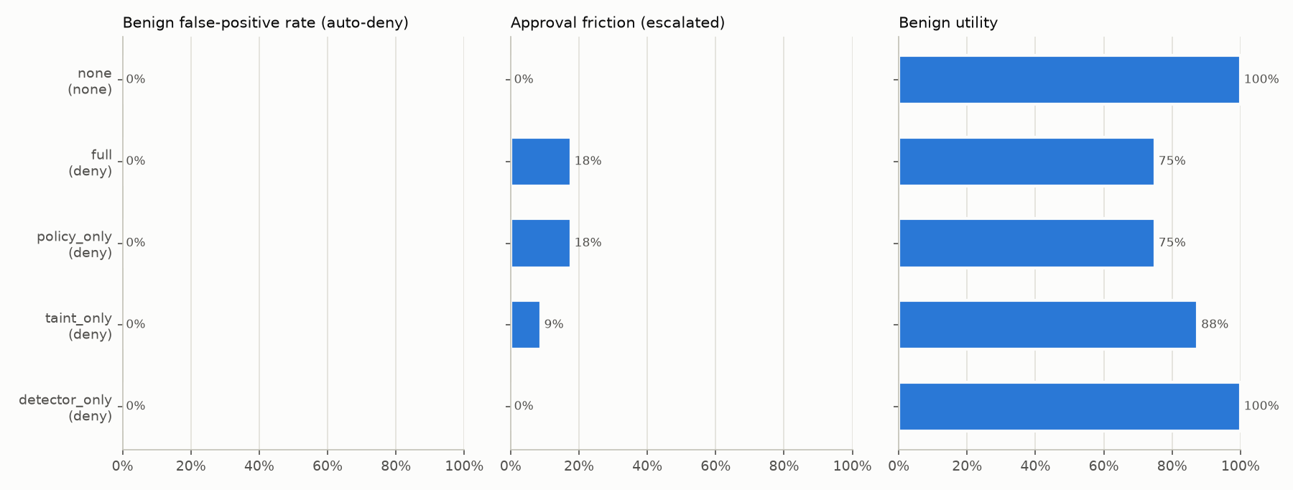
Figure 4.1: Benign false-positive rate, approval friction and utility per defence configuration (scripted agent, denying approver)
Table 4.8 and Figure 4.2 break the full-protection results down by language. Friction was 17.6% for English and 17.6% for Arabic tasks; the policy and taint layers act on tool names, arguments and provenance, which do not depend on the language of the prompt. Within Arabic, friction was 12.5% for the Gulf-dialect tasks and 22.2% for the Modern Standard Arabic tasks; any difference reflects which task categories were written in each variety, not the dialect itself.
Table 4.8: Full protection by language (scripted agent)
Language | Calls | Utility (deny) | Utility (oracle) | FPR | Friction
English | 34 | 75.0% | 100.0% | 0.0% | 17.6%
Arabic | 34 | 75.0% | 100.0% | 0.0% | 17.6%

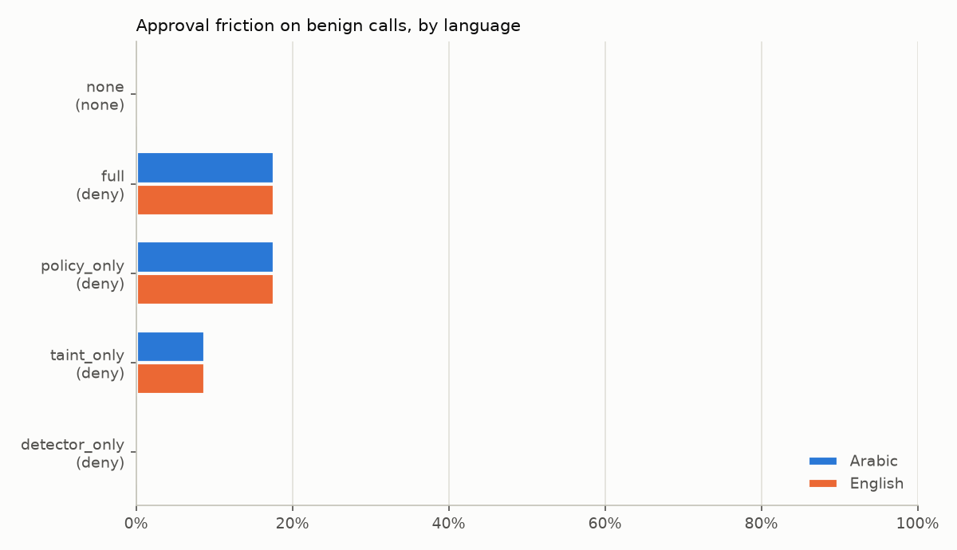
Figure 4.2: Approval friction on benign calls by language and defence configuration
A smoke run with the LLM agent (4 tasks, 2 in English and 2 in Arabic, with and without Mirsad) gave a utility of 75% without and 75% with Mirsad; of the 6 protected calls, 0% were denied and 0% escalated. Both configurations failed the same Arabic CRM-update task, in which the model wrote a generic note instead of the requested phone number; this is a model error that the gateway did not cause. So few episodes make a smoke test, not a utility estimate.

4.2.5 Performance
The latency benchmark (bench/latency.py) starts the real FastAPI application with the default policy and agent-key authentication, sends 50 warm-up calls and then 1,000 benign read-only calls spread over six tools, first one at a time and then from 50 concurrent sessions. For each call it subtracts the time of the same tool call made directly in-process from the HTTP round trip through Mirsad. It was run twice: with the server in a thread of the benchmarking process, and with the server in a separate process, which removes the competition between client and server for Python's global interpreter lock. Table 4.9 gives the results and Figure 4.3 their distribution.
Table 4.9: Added latency per tool call (1,000 benign calls)
Scenario | p50 (ms) | p95 (ms) | p99 (ms) | Throughput (req/s) | HTTP errors
Sequential, separate process | 2.7 | 6.0 | 6.1 | 317 | 0
50 concurrent sessions, separate process | 165.5 | 208.0 | 216.1 | 291 | 0
Sequential, in-process | 2.6 | 5.9 | 6.0 | 317 | 0
50 concurrent sessions, in-process | 204.8 | 880.1 | 1304.3 | 154 | 0

One request at a time, Mirsad adds a median of 2.7 ms per call, of which the gateway's own decision and inspection account for 2.1 ms; the rest is HTTP handling and authentication. NFR1 is assessed on this median and on the separate-process layout, which matches a real deployment (Section 3.5.3). Under 50 concurrent sessions with the server in its own process, the median rises to 166 ms, against the 200 ms target. With client and server sharing one interpreter it is 205 ms; that layout measures the client competing with the server for Python's global interpreter lock, not a deployment, so it is reported as context only. No request failed in either layout, so the single node served 50 concurrent sessions correctly (NFR11).
The concurrent numbers are mostly queueing. With the server in its own process, the time the gateway itself reported per call grew from a median of 2.1 ms to 159.5 ms, because the decision pipeline holds one lock while it evaluates and appends to the audit chain, and the SQLite writes serialise behind it. This is the price of the design choice in Section 4.1.2 that keeps taint state and the hash chain consistent. The in-process run additionally shares one interpreter between client and server, which explains its long tail (p95 880 ms). A deployment that expects sustained concurrency should therefore be measured with several workers and PostgreSQL before a concurrency figure is quoted; finer-grained locking per session is a possible improvement.
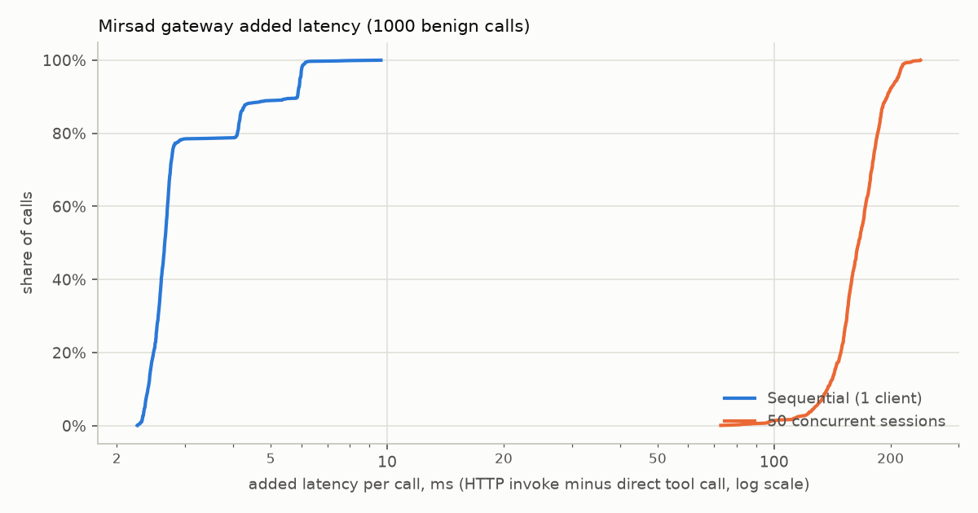
Figure 4.3: Distribution of added latency per call, sequential and with 50 concurrent sessions (server in a separate process, logarithmic scale)
Within the benchmark, where calls run in-process without HTTP, the gateway's median cost per call was 1.8 ms under full protection, against 0.9 ms for the policy layer alone (Figure 4.4). The difference is mostly the detector scan and the taint bookkeeping on each result.
Figure 4.4: Gateway latency per benign call by defence configuration (decision plus result inspection, excluding human waiting)

4.2.6 Security testing of the gateway
A firewall that concentrates trust becomes a target itself, so the gateway was tested against its own threat model. The STRIDE analysis of the data-flow diagram [69], [91] produced the security tests in tests/security/test_gateway_security.py. They replace the manual Burp Suite and OWASP ZAP pass planned in the proposal (Section 3.4.5) with checks that run on every change. The suite has 23 security tests (ST-01 to ST-23) that expand to 45 test cases; all of them passed in the evidence run (Table 4.10).
Table 4.10: Security tests of the gateway by STRIDE category
Category | Tests | What is checked
Spoofing | ST-01 to ST-05 | Every management route requires authentication; forged, unsigned, expired and malformed tokens are rejected; editing the role claim of a valid token does not grant admin rights; rotating an agent key revokes the old key; malformed agent keys are rejected
Tampering | ST-06 to ST-08 | Modifying or deleting an audit row is detected by chain verification; a policy containing a catastrophic regular expression is rejected
Repudiation | ST-09, ST-10 | Approval decisions are attributed to the approver and cannot be changed; failed logins are audited without the password
Information disclosure | ST-11 to ST-17 | Secrets in tool arguments are redacted in the audit log; user and agent listings never return hashes or keys; tool failures do not leak internal details; static file paths cannot escape the web root; security headers are present; CORS rejects unknown origins; SQL-like filter values are treated as data
Denial of service | ST-18, ST-19 | Oversized request bodies are rejected; repeated failed logins are throttled
Elevation of privilege | ST-20 to ST-23 | Approver and auditor roles cannot perform admin actions; agent keys cannot use human APIs and human tokens cannot act as agents; unlisted tools and unknown agents are denied by default; the default policy blocks requests from fetch_url to loopback, link-local metadata and internal addresses

The other automated checks gave the following results.
- Static analysis. Bandit reported 0 issues over 13,023 lines of code. The configuration skips only the rule against assert statements (B101) and excludes the tests, and the report records no inline nosec suppressions, so the zero is not the result of silencing findings. Ruff's security rules (the S set) are part of the lint configuration, but no Ruff report is stored in reports/ (Appendix B.5.3).
- Dependency audit. pip-audit checked 124 Python packages and found 0 with known vulnerabilities; npm audit over the web app's 231 dependencies, including development dependencies, reported 0 vulnerabilities after the React Router and Vitest upgrades (Section 4.1.13).
- PostgreSQL compatibility. The tests in tests/integration/test_postgres.py run the storage, audit chain, authentication and approval code against a real PostgreSQL server started by the pgserver package: appending and verifying the chain, detecting tampering, a user and agent-key round trip, and the full approval lifecycle. They passed in the recorded run, which supports the claim that the same code runs on SQLite in development and PostgreSQL in deployment.
- Test suite and coverage. All 1,281 Python tests (0 failures) and all 194 web tests (38 Vitest suites in the 10 test files of web/tests/) passed. Statement coverage of the mirsad package was 94.4% of 9,763 statements; the lowest package, the adapters, reached 90.3%.
The automated suite does not replace an independent penetration test. It checks the threats the team identified, with the inputs the team chose; Section 4.2.10 returns to this.

4.2.7 Audit integrity and reproducibility
Every benchmark configuration verified its audit chain after its episodes, and every audited decision was replayed with the stored policy version, taint snapshot and rate-limit counts. In the denying-approver run, 272 of 272 decisions replayed to the same action, and in the oracle run 272 of 272: four protected configurations with 68 decisions each. Every chain verified (Appendix B.5.6). The LLM smoke run replayed 6 of 6 decisions, and both latency runs ended with an intact chain. This meets the acceptance criterion of FR6.3 ("100% of benchmark decisions replay to the same action"). The tampering tests ST-06 and ST-07, and their PostgreSQL counterpart, show the other side: a modified or deleted row is detected and the first broken sequence number is reported.
Replay is exact because every source of variation is captured. Policy versions are content hashes stored in the database, the taint rules are a pure function of a stored snapshot, rate-limit counts are stored with the decision, and the scripted benchmark uses a fixed world seed. The benchmark runner also stores a SHA-256 fingerprint of the scenario files and warns when a resumed run was graded with different files. The fingerprint does not cover the policy, so the reported runs were executed from scratch after the last change to the default policy (Appendix B.1). The whole evidence base of this chapter can be regenerated with one command (scripts/run_evidence.sh), and the report itself reads its numbers from the generated files, so the text and the evidence cannot drift apart silently.

4.2.8 Usability: approval decision time
The usability target (NFR4) is that an approver can understand a paused request and decide on it in under 30 seconds on a phone. No user study has been run yet. As a first, transparent estimate, the approval flow of the PWA was modelled with the Keystroke-Level Model (KLM) of Card, Moran and Newell [100], using their standard operator times: mental preparation M = 1.35 s, pointing P = 1.10 s and a key or button press K = 0.28 s (their value for an average non-secretary typist, used here as a conservative press time). The KLM was defined for keyboard and mouse; a tap on a phone is modelled as P + K = 1.38 s, an assumption rather than a measured value. Three further assumptions are needed:
- Opening time. The PWA opens on the request detail within R = 1.0 s of tapping the notification (assumed, not measured; the notification links directly to the request).
- Reading rate. The approver reads at 200 words per minute, i.e. 0.30 s per word. This is an assumption chosen to be slower than fluent silent reading to allow for a small screen, technical identifiers and reading in a second language; a sensitivity check follows.
- Reading load. Word counts come from the real summary generator. Case A is the paused deletion shown in Figure C.19 (summary 34 words, reason cards 19 words). Case B is an external e-mail escalated by both the domain constraint and the untrusted-content taint rule, the most common escalation in the benchmark (summary 57 words, reason cards 51 words). The confirmation sheet adds 13 words.
Table 4.11 gives the step-by-step estimate.
Table 4.11: Keystroke-Level Model estimate of the approval decision time (seconds)
Step | Operators | Case A | Case B
Notice the notification and decide to open it | M | 1.35 | 1.35
Tap the notification | P + K | 1.38 | 1.38
PWA opens on the request | R (assumed) | 1.00 | 1.00
Read "What the agent wants to do" | 34 / 57 words × 0.30 | 10.20 | 17.10
Decide | M | 1.35 | 1.35
Tap Approve or Deny | P + K | 1.38 | 1.38
Read the confirmation sheet | 13 words × 0.30 | 3.90 | 3.90
Tap the confirm button (no note) | P + K | 1.38 | 1.38
Total, reading the summary |  | 21.94 | 28.84
Optional: also read every reason card | 19 / 51 words × 0.30 | +5.70 | +15.30
Total, reading everything |  | 27.64 | 44.14

Under these assumptions an approver who reads the plain-language summary decides within the 30-second target in both cases, with little margin in case B. An approver who also reads every reason card of a multi-reason request needs about 44 s, and at a slower reading rate of 150 words per minute even the summary-only path of case B takes about 36 s. Typing a note would add time in every case. This suggests two design changes: the summary carries the decision, so it should stay short, and the reason cards of multi-reason requests could be collapsed by default or reduced to one line each, since they largely repeat the summary. The Arabic summaries of the same requests are shorter in words (30 and 51), but no Arabic reading rate was assumed.
The KLM predicts the time of an expert who makes no errors; it does not measure understanding or trust. The estimate should therefore be confirmed with a small user study in which security practitioners decide on prepared requests on their own phones while their decision time is recorded, followed by Section D of the questionnaire in Appendix F (in particular D1, "I understood why the action was paused from the approval summary alone", and D2, "I could decide on the request in under 30 seconds").

4.2.9 Success criteria
Table 4.12 compares the measured results with the success criteria of the proposal (Section 1.3) and with the supporting requirement targets of Chapter 3.
Table 4.12: Success criteria, targets and measured results
Criterion | Target | Measured | Status
Interception of tool calls and results (MCP over stdio and HTTP, OpenAI-style function calling) | 100% of calls pass through the gateway | MCP proxy (stdio and streamable HTTP), OpenAI-compatible proxy and Guard API all route through Gateway.execute or check_call; 78 adapter tests pass | Met (functional tests)
Declarative YAML policy with per-tool and per-parameter constraints and rate limits | Implemented and validated | All constraint operators, globs, rules, rate limits and monitor mode implemented; 265 policy tests pass | Met
Taint tracking blocks or escalates flows of untrusted or confidential data to external destinations | Rules fire on such flows, not on legitimate replies | Four taint rules implemented; 93 taint tests pass; no benign call denied | Met (functional); effect on attacks pending
Median added latency per tool call (NFR1) | ≤ 200 ms, judged on the sequential median and the separate-process layout | 2.7 ms sequential; 166 ms with 50 concurrent sessions (separate process). Context only: 205 ms when client and server share one interpreter | Met (separate process)
Detector F1 on held-out English and Arabic test sets | ≥ 0.85 each | English [pending]; Arabic [pending] | Pending data
Attack success reduction relative to the unprotected baseline | ≥ 80% | [pending] | Pending data
Benign actions wrongly blocked | ≤ 5% | 0.0% under full protection (68 benign calls per configuration, detector rules-only) | Met
Approval app, dashboard and tamper-evident audit log in which every blocked or approved action can be replayed | All decisions replayable | 272 / 272 and 272 / 272 decisions replayed identically; all chains verified | Met
NFR4: decision time on a phone | < 30 s | KLM estimate 21.9 s and 28.8 s reading the summary; 44.1 s reading every reason of a multi-reason request | Partially verified (user study pending)
NFR9: statement coverage of the core package | ≥ 80% | 94.4% | Met
NFR11: concurrent agent sessions on one node | ≥ 50 | 50 sessions, 0 errors | Met
NFR3: security testing of the gateway | Suite passes; no known vulnerable dependencies | 45 STRIDE cases pass; Bandit 0 issues; 0 vulnerable Python and 0 vulnerable npm packages | Met
NFR5: deployment with one docker compose up | Works | Not executed: Docker was not available on the build machine | Not verified (Docker unavailable)

No criterion is shown as not met. The two most important outcomes of the proposal, detector F1 and the reduction of attack success, cannot be judged until the team's attack data exists; the decision-time target needs a user study; and the Docker deployment needs to be executed on a machine with Docker.

4.2.10 Limitations and threats to validity
Results not yet available. The detector has not been trained and no attack episode has been run, so the two headline claims of the project are untested. Until they are, the evaluation shows that Mirsad is cheap for legitimate work, not that it stops attacks. The benign false-positive rate and the detector's result false-positive rate were also measured with the rules-only detector and must be re-measured with the trained model, whose operating point is tuned for a false-positive rate of at most 5% on the validation split.
Internal validity. The scripted agent replays fixed plans, so the benign results show the effect of the gateway on correct behaviour but not how a real model's wording and tool choices interact with the policy; the LLM run has only 4 tasks. The oracle approver is an idealised human and the denying approver a pessimistic one; real approvers fall between them and can also approve a harmful request. The user tasks, the default policy and the escalation paths were written by the same team, which may favour low friction; for example, the policy deliberately escalates every external e-mail, and a different policy would give different numbers.
External validity. All results come from one simulated organisation with 48 tasks, one local model, one laptop, SQLite and a single server worker. Real deployments have other tools, larger and noisier data, other languages and dialects, and more load. The concurrency results in particular should be repeated with several workers and PostgreSQL.
Construct validity. "False positive" counts only automatic denials; escalations are reported separately as friction, because a paused call costs a human's time but does not fail the task by itself. "Added latency" is measured against an in-process tool call and therefore includes HTTP handling that a direct remote tool call would also incur. The KLM estimate depends on assumed reading and opening times and on standard operator values defined for desktop input.
Security evaluation. The STRIDE suite tests the threats the team identified with inputs the team chose. It is not an independent penetration test, it does not include fuzzing of the API, and it does not model adaptive attackers who study the policy, the rules and the detector [45], [105]. Spotlighting and the detector are expected to be bypassed by such attackers; the policy and taint layers are the intended backstop, and their effect remains to be measured.
Engineering limitations. The gateway serialises decisions behind one lock, which limits throughput under concurrency. The Docker deployment has not been executed. The open integration items listed in Appendix B.6 (duplicate login throttling, the demonstration agent's embedded policy, the remaining literal direction marks in web files) are small but should be closed. The screenshots also show minor ordering defects where Latin names, times and Arabic text meet on one line (for example the version line of the Arabic Policies page and the requester line of the Arabic approval detail), which isolating those values in the markup would fix.

4.3 Individual and Group Contributions
The work was divided into the five workstreams of Table 3.19. Table 4.13 maps the main project tasks to the members who carried them out, following the workstream ownership and the task owners of the project plan (docs/pm/plan.yaml).
Table 4.13: Project Tasks & Task Assignments
TASK | DETAILS | ASSIGNED TEAM MEMBERS
PROJECT SETUP | Repository and branch rules, continuous-integration workflow, development environment (Python 3.12, Node.js, local Ollama model), Scrum board, engineering contract and shared data types | Abdulmalik bin Saedan (coordination, environment); Bader Alshuraie (engineering contract and shared types); all members (local setup)
PROJECT PROPOSAL | SPAP form: problem statement, objectives O1–O6, success criteria, initial plan and budget | All members, coordinated by Abdulmalik bin Saedan
REQUIREMENTS GATHERING AND ANALYSIS | Literature and product review; STRIDE threat model and attack taxonomy; functional and non-functional requirements, use cases and personas (SRS); benchmark and dataset design; stakeholder questionnaire | All members; threat model: Bader Abdullah Abbod Alyamini and Abdulmalik bin Saedan; benchmark and dataset design: Abdulmalik bin Saedan and Abdullah Naif Abdullah Al-Orabi
SYSTEM DESIGN | Architecture and high- and low-level design; policy-language specification; database and audit-chain design; detector and dataset design; wireframes of the dashboard and approver app | Bader Alshuraie (architecture, policy language); Bader Abdullah Abbod Alyamini (database, audit chain); Abdullah Naif Abdullah Al-Orabi (detector); Mohammed Yasser Alanssari (user interface)
DEVELOPMENT | Gateway pipeline, protocol adapters, SDK, policy engine, REST API and CLI; detector, rule base and dataset pipeline; taint tracker, audit log, redaction and storage; approval workflow; dashboard and approver PWA; demonstration workspace and agent; Mirsad-Bench | Bader Alshuraie; Abdullah Naif Abdullah Al-Orabi; Bader Abdullah Abbod Alyamini; Mohammed Yasser Alanssari; Abdulmalik bin Saedan (each for their workstream); approval workflow and admin API: Bader Alshuraie and Bader Abdullah Abbod Alyamini
TESTING & VALIDATION | Unit, integration and UI tests of each area; benchmark runs and latency measurement; detector evaluation; security testing of the gateway; integration checklist | All members (tests of their areas); Abdulmalik bin Saedan (benchmark, latency, security testing); Abdullah Naif Abdullah Al-Orabi (detector evaluation); Bader Abdullah Abbod Alyamini and Mohammed Yasser Alanssari (security testing)
DEPLOYMENT | Docker image and Compose file (gateway and PostgreSQL), setup and demo scripts, production web build, installation and user guide | Mohammed Yasser Alanssari and Bader Alshuraie (deployment, user guide); Abdulmalik bin Saedan (demo and evidence scripts)
FINAL REPORT & PRESENTATION | Report chapters, figures, poster, slides and open-source release | All members, coordinated by Abdulmalik bin Saedan

Bader Alshuraie (SE) owned the core of the gateway: the decision pipeline in gateway.py, the policy language with its schema, validator and engine, the rate limiter and the protection against unsafe regular expressions, the protocol adapters (upstream manager, MCP proxy over stdio and HTTP, OpenAI-compatible proxy), the Python SDK, the REST API and the command line. Alshuraie was also responsible for the architecture and the policy-language specification that the other workstreams coded against. The policy, adapter and API areas account for 265, 78 and 185 tests respectively.
Abdullah Naif Abdullah Al-Orabi (SE, AI and DS) owned the Arabic and English injection detector: the normalisation with its offset map and evasion signals, language identification including Arabizi, the YAML rule base and its matcher, the hashed n-gram model with sliding windows, the noisy-OR ensemble and its calibration, pickle-free model persistence, sanitising and spotlighting, and the dataset pipeline with group splitting, train-only augmentation and leakage checks. Al-Orabi was also responsible for the dataset schema and labelling guideline that the team's data must follow. The detector area has 227 tests, none of which contains adversarial text.
Bader Abdullah Abbod Alyamini (IS, CYS) owned the taint tracker (value extraction, session store, the four rules and minimal snapshots for replay) and the audit layer: the HMAC hash chain with verification and external anchors, redaction of secrets and personal identifiers, query and export, the database schema and storage layer, and the authentication primitives. Alyamini contributed to the threat model, the approval workflow and the security testing. The taint and audit areas have 93 and 240 tests.
Mohammed Yasser Alanssari (IS, CYS) owned the two web front ends: the bilingual, accessible administration dashboard with its ten pages and the installable approver PWA with its service worker, Web Push, deep links, confirmation flow and offline shell, together with the shared live-event client and the English and Arabic dictionaries. Alanssari also owned the user-facing side of the approval workflow, contributed to the security testing and to the deployment and user guide. The web code has 194 tests, including contrast and dictionary-consistency checks.
Abdulmalik bin Saedan (IS, CYS) managed the project (plan, sprints, coordination and integration checklist) and owned the simulated Najd Trading Co. workspace with its MCP server, the demonstration agent and Demo console scenarios, Mirsad-Bench with its scenarios, defence configurations, metrics and latency benchmark, the security test suite of the gateway and the evidence scripts that produce the numbers in this chapter. The benchmark, demonstration and security areas have 68, 72 and 45 tests.
All members took part in the literature review, the requirements, the design reviews, code review and integration, and the report, poster and presentation. As disclosed in Section 3.6.6, an AI coding assistant was used across the workstreams; here, owning an area means that the member designed, reviewed, tested and integrated its code, can explain it, and is accountable for it.

Chapter 5 – Conclusion and Future Work
This chapter compares the results with the objectives of Section 1.3 and then states the project's contributions, the lessons learned, the limitations and the work that should follow.

5.1 Summary of Outcomes
The team built the gateway described in the proposal and measured everything that can be measured without attack data. Table 5.1 compares each SMART objective with its result. Values shown as [pending] are filled in automatically from reports/results_summary.json once the corresponding runs exist.
Table 5.1: Outcomes against the SMART objectives
Objective | Target | Result | Status
1. Action-level security at the tool boundary | Intercept tool calls and results over MCP (stdio, HTTP) and OpenAI-style function calling; YAML policy; taint tracking | All four integration paths (MCP proxy, OpenAI-compatible proxy, Guard API, Python SDK) route through one decision pipeline; 78 adapter, 265 policy and 93 taint tests pass | Met
1. Latency | Median added latency ≤ 200 ms per call | Sequential: 2.7 ms median, 6.0 ms p95. 50 concurrent sessions: 166 ms median, 208 ms p95 (server in its own process) | Met (median, separate process)
2. Arabic/English detector | F1 ≥ 0.85 on held-out English and Arabic test sets | English F1 [pending]; Arabic F1 [pending]; detector and training pipeline implemented (227 tests) | Pending data
3. Human control and audit | Mobile approval app, dashboard, tamper-evident log, replay of every decision | Approver PWA and dashboard in English and Arabic; audit chains verified after every benchmark configuration; 272 of 272 audited decisions replayed to the same action | Met
3. Benign false positives | ≤ 5% of benign actions wrongly blocked | 0.0% of 68 benign calls denied automatically (full protection) | Met for this task set
3. Attack reduction | ASR reduced by ≥ 80% against the unprotected baseline | ASR reduction [pending] | Pending data

Objective 1. Interception was verified functionally by the adapter, API and integration suites rather than expressed as a measured percentage. The latency benchmark ran 1,000 benign calls with the detector in rules-only mode. One call at a time, Mirsad added a few milliseconds. Under concurrent load the median was 166 ms with the server in its own process, the deployment layout on which the 200 ms target is judged, and 205 ms when client and server shared one interpreter, a layout reported only as context (Section 4.2.5). Queueing dominated the tail: in the shared layout the p95 rose to 880 ms.
Objective 2. The detector pipeline (Arabic and Unicode normalisation, weighted rules, a hashed n-gram model with pickle-free persistence, sanitising, spotlighting and dataset tooling) is implemented and tested, but its accuracy has not been measured. Detector F1 on the held-out Arabic and English test sets is produced by running make detector after the team adds its attack-labelled batches to data/detector/raw/ (procedure in docs/detector.md, Section 11.4). Attack material is written by the team (Section 3.6.4). Until a model is trained, the packaged detector runs in its rules-only fallback, and every number in this chapter was measured in that mode.
Objective 3. On the 48 benign English and Arabic tasks of Mirsad-Bench, full protection automatically denied 0.0% of benign calls and escalated 17.6% to a human, all on the policy's intended escalation paths (external e-mail, exports, payments and deletions). With an approver who knows what the user asked for, utility stayed at 100%; with an approver who rejects every request it fell to 75%. In a smoke run of 4 tasks with the Qwen2.5-7B agent, utility was 75% with Mirsad and 75% without it. Attack success rate and its reduction are not yet measured: the harness executes attack episodes (Section 4.1.12), but the team's attack files are not yet in bench/scenarios/attacks/, so no attack episode has been run.

5.2 Contributions
1. A model-agnostic enforcement point at the tool boundary. One decision pipeline serves MCP clients (stdio and streamable HTTP), OpenAI-compatible agents and any framework through the Guard API and Python SDK, so an existing agent is protected by changing a URL or a command.
2. A policy language for agent actions. Rules such as "no more than 50 customer records per export" or "e-mail outside the company needs approval" are written as reviewable YAML, validated with line-numbered errors, and activated or rolled back at run time.
3. Taint tracking with provenance. Each escalation names the tool, call and field a value came from, so the approver sees evidence instead of the agent's own account of what it is doing.
4. Arabic-aware detection tooling. Normalisation handles diacritics, letter variants, Arabic-Indic digits, invisible and bidirectional characters and homoglyphs, and the rules cover Modern Standard Arabic, Gulf dialect and Arabizi alongside English.
5. Verifiable accountability. The HMAC hash-chained audit log detects modified and deleted events, and each stored decision can be replayed against its stored policy version and inputs.
6. Mirsad-Bench. An offline benchmark with Arabic (MSA and Gulf) and English tasks, five defence configurations, approver models and a replay check, licensed with the rest of the code under Apache-2.0.

5.3 Lessons Learned
- Fixing the interfaces first paid off. The engineering contract (docs/dev/BUILD_SPEC.md) let each workstream code against fixed interfaces, and the defects found during integration clustered at the seams (Section 4.1.13). For example, storing the full taint snapshot in each audit event exceeded the payload cap and would have broken replay, so the gateway now stores a minimal snapshot.
- A false-positive rate alone hides the cost of a policy. With 0.0% of benign calls denied automatically, 17.6% still needed a human, mainly because the default policy escalates every external e-mail. Friction must be reported next to the false-positive rate, and it is decided by the policy more than by the detector.
- Benchmark predicates must be strict. In the first LLM smoke run, a loose success predicate counted a vague CRM note as a completed task, which showed how easily a benchmark can overstate utility.
- Arabic needs its own evaluation. Polite imperatives and forms of address in ordinary Arabic business text overlap with the wording of injected instructions. In a pre-training check, the rules-only fallback flagged more records in the team's Arabic benign batch than in the English one (Section 4.2.2), so every detector metric has to be broken down by language and variety.
- Process layout changes latency results. Running the load generator inside the server process inflated tail latency; a separate server process gave a much lower p95 for the same workload. Performance claims must state the layout they were measured with.

5.4 Limitations
- Protection is not yet quantified. Without attack-labelled data, the evaluation shows what Mirsad costs legitimate work, not how much protection it gives.
- Evaluation scope. The scripted agent replays a fixed plan, and the LLM run is a smoke test of 4 tasks rather than an estimate of utility. The oracle approver is an idealised human; real approvers' decision time and quality were not measured, and no user study has been carried out.
- Taint matching is literal. Values are recognised only when they reappear verbatim after normalisation, so an agent that paraphrases, translates or re-encodes data defeats value matching. Session-level taint is coarse enough to cause approval friction.
- Protocol coverage. Only MCP tools are proxied; resources, prompts and sampling are not, non-text content is dropped rather than inspected, and the OpenAI-compatible proxy does not support streaming.
- Single-node deployment. Rate limits live in memory in one process, measurements used SQLite on one laptop, and tail latency under concurrency is high. The Docker Compose deployment was not exercised in the measured environment.
- Audit and notification gaps. The log has no retention or erasure mechanism, anchoring of the chain head is manual, and neither Web Push delivery to real phones nor an automated accessibility audit has been tested.
- Adaptive attackers. Adaptive attacks have bypassed a wide range of published prompt-injection defences, including detection-based ones [45], [105]. Mirsad's policy and taint layers do not depend on recognising attack wording, but no adaptive red-team evaluation has been run against them.

5.5 Future Work
1. Transformer-based Arabic detector. Once the dataset exists, fine-tune an Arabic or multilingual encoder such as AraBERT, MARBERT, CAMeLBERT or XLM-R [106], [107], [58], [108], compare it with the n-gram model per language and variety, and distil it if needed to fit the CPU latency budget.
2. Store-packaged mobile app. Wrap the approver PWA with Capacitor or rebuild it in Flutter for organisations that require managed apps, adding native push and biometric confirmation of decisions.
3. Multi-replica deployment. Move rate-limit counters and live notifications to shared infrastructure (PostgreSQL or Redis), run several workers behind a load balancer, and repeat the concurrency benchmark.
4. Richer information-flow control. Replace session-level taint with value-level labels based on lattice information-flow models [62], [63], and offer a CaMeL-style mode in which a plan derived only from the trusted user request constrains later tool calls [16].
5. Fuller MCP coverage. Proxy and inspect MCP resources and prompts, handle sampling and non-text content, and track new revisions of the specification [3].
6. User study with practitioners. Measure approvers' decision time and understanding of the bilingual summaries with security practitioners in Saudi organisations, starting from the questionnaire in Appendix F.
7. Red-team evaluation with adaptive attacks. Commission an independent red-team exercise that includes adaptive, optimisation-based attacks, and tag test cases and audit events with MITRE ATLAS technique identifiers [109].
8. Certification readiness against NCA ECC. Close the gaps listed in Appendix A (log retention of at least 12 months, SIEM forwarding, automatic external anchoring of the audit chain, and a formal mapping to the ECC-2:2024 controls [11]) so that an adopting organisation can use Mirsad's evidence in an assessment.

5.6 Concluding Remarks
Mirsad shows that the tool-calling boundary is a workable control point for AI agents. One gateway can apply an organisation's rules to every action an agent takes, explain each decision in Arabic and English, ask a human when the stakes are high, and keep a record that can be verified and replayed. In the benign evaluation it denied 0.0% of legitimate calls automatically and added little latency, and its remaining cost comes from policy choices that an organisation can see and tune. Whether this layered design reduces the success of real Arabic and English injection attacks still has to be shown by the attack evaluation, and the benchmark and evidence pipeline are ready to produce that result once the team's data is in place.

References
[1] S. Yao, J. Zhao, D. Yu, N. Du, I. Shafran, K. Narasimhan, and Y. Cao, "ReAct: Synergizing reasoning and acting in language models," in Proc. 11th Int. Conf. Learn. Represent. (ICLR), Kigali, Rwanda, 2023.
[2] T. Schick, J. Dwivedi-Yu, R. Dessì, R. Raileanu, M. Lomeli, E. Hambro, L. Zettlemoyer, N. Cancedda, and T. Scialom, "Toolformer: Language models can teach themselves to use tools," in Adv. Neural Inf. Process. Syst. (NeurIPS), vol. 36, 2023, pp. 68539–68551, doi: 10.52202/075280-2997.
[3] Model Context Protocol, "Specification," protocol revision 2026-07-28. Accessed: Oct. 11, 2026. [Online]. Available: https://modelcontextprotocol.io/specification/2026-07-28.
[4] K. Greshake, S. Abdelnabi, S. Mishra, C. Endres, T. Holz, and M. Fritz, "Not what you've signed up for: Compromising real-world LLM-integrated applications with indirect prompt injection," in Proc. 16th ACM Workshop Artif. Intell. Secur. (AISec '23), Copenhagen, Denmark, 2023, pp. 79-90, doi: 10.1145/3605764.3623985.
[5] OWASP GenAI Security Project, "OWASP Top 10 for LLM Applications 2025," OWASP Foundation, Nov. 2024. Accessed: Oct. 11, 2026. [Online]. Available: https://genai.owasp.org/resource/owasp-top-10-for-llm-applications-2025/
[6] E. Debenedetti, J. Zhang, M. Balunović, L. Beurer-Kellner, M. Fischer, and F. Tramèr, "AgentDojo: A dynamic environment to evaluate prompt injection attacks and defenses for LLM agents," in Adv. Neural Inf. Process. Syst. 37 (NeurIPS 2024), Datasets and Benchmarks Track, 2024, pp. 82895-82920, doi: 10.52202/079017-2636.
[7] Q. Zhan, Z. Liang, Z. Ying, and D. Kang, "InjecAgent: Benchmarking indirect prompt injections in tool-integrated large language model agents," in Findings Assoc. Comput. Linguist.: ACL 2024, Bangkok, Thailand, Aug. 2024, pp. 10471-10506, doi: 10.18653/v1/2024.findings-acl.624.
[8] S. Willison, "The lethal trifecta for AI agents: private data, untrusted content, and external communication," Simon Willison's Weblog, Jun. 16, 2025. Accessed: Oct. 11, 2026. [Online]. Available: https://simonwillison.net/2025/Jun/16/the-lethal-trifecta/
[9] Kingdom of Saudi Arabia, Saudi Vision 2030, Riyadh, Saudi Arabia, Apr. 2016. Accessed: Oct. 11, 2026. [Online]. Available: https://www.vision2030.gov.sa/media/rc0b5oy1/saudi_vision203.pdf
[10] Saudi Data and Artificial Intelligence Authority (SDAIA), AI Ethics Principles, Doc. SDAIA-P114E, ver. 1, Riyadh, Saudi Arabia, May 2025 (English edition; the principles were adopted in Sep. 2023). Accessed: Oct. 11, 2026. [Online]. Available: https://sdaia.gov.sa/en/SDAIA/about/Documents/ai-principles.pdf
[11] National Cybersecurity Authority, Essential Cybersecurity Controls (ECC-2:2024), Riyadh, Saudi Arabia, 2024. Accessed: Oct. 11, 2026. [Online]. Available: https://cdn.nca.gov.sa/api/files/public/upload/86e09090-44e4-481f-bc28-355673607654_ECC--2024-EN.pdf
[12] Kingdom of Saudi Arabia, Personal Data Protection Law, Royal Decree No. M/19 of 9/2/1443H (16 Sep. 2021), Council of Ministers Resolution No. 98 of 7/2/1443H, amended by Royal Decree No. M/148 of 5/9/1444H (Mar. 2023). Accessed: Oct. 11, 2026. [Online]. Available: https://laws.boe.gov.sa/BoeLaws/Laws/LawDetails/b7cfae89-828e-4994-b167-adaa00e37188/1
[13] Z.-X. Yong, C. Menghini, and S. H. Bach, "Low-resource languages jailbreak GPT-4," presented at the NeurIPS 2023 Workshop on Socially Responsible Language Modelling Research (SoLaR), 2023, arXiv:2310.02446. [Online]. Available: https://arxiv.org/abs/2310.02446
[14] Y. Deng, W. Zhang, S. J. Pan, and L. Bing, "Multilingual jailbreak challenges in large language models," in Proc. 12th Int. Conf. Learn. Represent. (ICLR), 2024. [Online]. Available: https://arxiv.org/abs/2310.06474
[15] M. Al Ghanim, S. Almohaimeed, M. Zheng, Y. Solihin, and Q. Lou, "Jailbreaking LLMs with Arabic transliteration and Arabizi," in Proc. 2024 Conf. Empirical Methods Natural Lang. Process. (EMNLP), Miami, FL, USA, Nov. 2024, pp. 18584–18600, doi: 10.18653/v1/2024.emnlp-main.1034.
[16] E. Debenedetti et al., "Defeating prompt injections by design," arXiv:2503.18813, Mar. 2025 (v2, Jun. 2025).
[17] L. Beurer-Kellner et al., "Design patterns for securing LLM agents against prompt injections," arXiv:2506.08837, Jun. 2025.
[18] E. Tabassi, "Artificial Intelligence Risk Management Framework (AI RMF 1.0)," National Institute of Standards and Technology, Gaithersburg, MD, USA, NIST AI 100-1, Jan. 2023, doi: 10.6028/NIST.AI.100-1.
[19] K. Kubrak, A. El-Moselhy, A. Alsulami, R. Altuwaim, H. I. Fawaz, and F. Alsaby, "Arabic prompts with English tools: A benchmark," presented at the LLMs, Big Data, and Multilinguality for All (LLMs4All) Workshop, IEEE BigData 2025, Macau, Dec. 2025, arXiv:2601.05101. [Online]. Available: https://arxiv.org/abs/2601.05101
[20] S. Willison, "Prompt injection attacks against GPT-3," Simon Willison's Weblog, Sep. 12, 2022. Accessed: Oct. 11, 2026. [Online]. Available: https://simonwillison.net/2022/Sep/12/prompt-injection/
[21] F. Perez and I. Ribeiro, "Ignore previous prompt: Attack techniques for language models," presented at the NeurIPS ML Safety Workshop, 2022, arXiv:2211.09527. [Online]. Available: https://arxiv.org/abs/2211.09527
[22] Y. Liu, Y. Jia, R. Geng, J. Jia, and N. Z. Gong, "Formalizing and benchmarking prompt injection attacks and defenses," in Proc. 33rd USENIX Security Symp. (USENIX Security 24), Philadelphia, PA, USA, Aug. 2024, pp. 1831-1847.
[23] A. Vassilev, A. Oprea, A. Fordyce, H. Anderson, X. Davies, and M. Hamin, "Adversarial machine learning: A taxonomy and terminology of attacks and mitigations," National Institute of Standards and Technology, Gaithersburg, MD, USA, NIST AI 100-2e2025, Mar. 2025, doi: 10.6028/NIST.AI.100-2e2025.
[24] L. Beurer-Kellner and M. Fischer, "MCP security notification: Tool poisoning attacks," Invariant Labs Blog, Apr. 1, 2025. Accessed: Oct. 11, 2026. [Online]. Available: https://invariantlabs.ai/blog/mcp-security-notification-tool-poisoning-attacks
[25] M. Milanta and L. Beurer-Kellner, "GitHub MCP exploited: Accessing private repositories via MCP," Invariant Labs Blog, May 26, 2025. Accessed: Oct. 11, 2026. [Online]. Available: https://invariantlabs.ai/blog/mcp-github-vulnerability
[26] P. Reddy and A. S. Gujral, "EchoLeak: The first real-world zero-click prompt injection exploit in a production LLM system," in Proc. AAAI Symp. Ser., vol. 7, no. 1, 2025, pp. 303-311, doi: 10.1609/aaaiss.v7i1.36899.
[27] J. Yi, Y. Xie, B. Zhu, E. Kiciman, G. Sun, X. Xie, and F. Wu, "Benchmarking and defending against indirect prompt injection attacks on large language models," in Proc. 31st ACM SIGKDD Conf. Knowl. Discov. Data Min. V.1 (KDD '25), Toronto, ON, Canada, 2025, pp. 1809-1820, doi: 10.1145/3690624.3709179.
[28] H. Zhang, J. Huang, K. Mei, Y. Yao, Z. Wang, C. Zhan, H. Wang, and Y. Zhang, "Agent Security Bench (ASB): Formalizing and benchmarking attacks and defenses in LLM-based agents," in Proc. 13th Int. Conf. Learn. Represent. (ICLR), 2025, arXiv:2410.02644.
[29] I. Evtimov, A. Zharmagambetov, A. Grattafiori, C. Guo, and K. Chaudhuri, "WASP: Benchmarking web agent security against prompt injection attacks," in Adv. Neural Inf. Process. Syst. 38 (NeurIPS 2025), Datasets and Benchmarks Track, 2025, pp. 22436-22458, doi: 10.52202/085713-0666.
[30] Z. Wang, Y. Gao, Y. Wang, S. Liu, H. Sun, H. Cheng, G. Shi, H. Du, and X. Li, "MCPTox: A benchmark for tool poisoning on real-world MCP servers," in Proc. AAAI Conf. Artif. Intell., vol. 40, no. 42, 2026, pp. 35811-35819, doi: 10.1609/aaai.v40i42.40895.
[31] D. Zhang, Z. Li, X. Luo, X. Liu, P. Li, and W. Xu, "MCP Security Bench (MSB): Benchmarking attacks against Model Context Protocol in LLM agents," in Proc. 14th Int. Conf. Learn. Represent. (ICLR), 2026, arXiv:2510.15994.
[32] National Institute of Standards and Technology, Center for AI Standards and Innovation, "Technical blog: Strengthening AI agent hijacking evaluations," Jan. 17, 2025 (updated Dec. 19, 2025). Accessed: Oct. 11, 2026. [Online]. Available: https://www.nist.gov/news-events/news/2025/01/technical-blog-strengthening-ai-agent-hijacking-evaluations
[33] M. Dziemian et al., "How vulnerable are AI agents to indirect prompt injections? Insights from a large-scale public competition," arXiv:2603.15714, 2026. [Online]. Available: https://arxiv.org/abs/2603.15714
[34] E. Wallace, K. Xiao, R. Leike, L. Weng, J. Heidecke, and A. Beutel, "The instruction hierarchy: Training LLMs to prioritize privileged instructions," arXiv:2404.13208, 2024. [Online]. Available: https://arxiv.org/abs/2404.13208
[35] S. Chen, A. Zharmagambetov, S. Mahloujifar, K. Chaudhuri, D. Wagner, and C. Guo, "SecAlign: Defending against prompt injection with preference optimization," in Proc. 2025 ACM SIGSAC Conf. Computer and Communications Security (CCS '25), 2025, pp. 2833-2847, doi: 10.1145/3719027.3744836.
[36] K. Hines, G. Lopez, M. Hall, F. Zarfati, Y. Zunger, and E. Kıcıman, "Defending against indirect prompt injection attacks with spotlighting," in Proc. Conf. Applied Machine Learning in Information Security (CAMLIS 2024), CEUR Workshop Proceedings, vol. 3920, Arlington, VA, USA, Oct. 2024, pp. 48-62. Accessed: Oct. 11, 2026. [Online]. Available: https://ceur-ws.org/Vol-3920/paper03.pdf
[37] Microsoft, "Prompt Shields in Azure AI Content Safety," Microsoft Learn, Aug. 28, 2026. Accessed: Oct. 11, 2026. [Online]. Available: https://learn.microsoft.com/en-us/azure/ai-services/content-safety/concepts/jailbreak-detection
[38] Meta, "Llama Prompt Guard 2 86M," model card, Hugging Face. Accessed: Oct. 11, 2026. [Online]. Available: https://huggingface.co/meta-llama/Llama-Prompt-Guard-2-86M.
[39] ProtectAI.com, "Fine-tuned DeBERTa-v3-base for prompt injection detection (deberta-v3-base-prompt-injection-v2)," Hugging Face model card, 2024. Accessed: Oct. 11, 2026. [Online]. Available: https://huggingface.co/protectai/deberta-v3-base-prompt-injection-v2.
[40] H. Li, X. Liu, N. Zhang, and C. Xiao, "PIGuard: Prompt injection guardrail via mitigating overdefense for free," in Proc. 63rd Annu. Meeting Assoc. Comput. Linguistics (Vol. 1: Long Papers), Vienna, Austria, Jul. 2025, pp. 30420-30437, doi: 10.18653/v1/2025.acl-long.1468.
[41] Check Point Software Technologies, "Prompt Defense," Check Point AI Security documentation. Accessed: Oct. 11, 2026. [Online]. Available: https://docs.lakera.ai/docs/prompt-defense
[42] Microsoft, "Region availability and service limits - Azure AI Content Safety," Microsoft Learn, Sep. 18, 2026. Accessed: Oct. 11, 2026. [Online]. Available: https://learn.microsoft.com/en-us/azure/ai-services/content-safety/region-availability
[43] NAMAA-Space, "Ara-Prompt-Guard_V0," Hugging Face model card, 2025. Accessed: Oct. 11, 2026. [Online]. Available: https://huggingface.co/NAMAA-Space/Ara-Prompt-Guard_V0.
[44] W. Hackett, L. Birch, S. Trawicki, N. Suri, and P. Garraghan, "Bypassing LLM guardrails: An empirical analysis of evasion attacks against prompt injection and jailbreak detection systems," in Proc. 1st Workshop on LLM Security (LLMSEC), Vienna, Austria, Aug. 2025, pp. 101-114.
[45] M. Nasr et al., "The attacker moves second: Stronger adaptive attacks bypass defenses against LLM jailbreaks and prompt injections," in Proc. 35th USENIX Security Symp. (USENIX Security 26), Baltimore, MD, USA, Aug. 2026, pp. 1467-1486.
[46] T. Rebedea, R. Dinu, M. N. Sreedhar, C. Parisien, and J. Cohen, "NeMo Guardrails: A toolkit for controllable and safe LLM applications with programmable rails," in Proc. 2023 Conf. Empirical Methods in Natural Language Processing: System Demonstrations, Singapore, Dec. 2023, pp. 431-445, doi: 10.18653/v1/2023.emnlp-demo.40.
[47] NVIDIA, "Tools integration with the NeMo Guardrails library," NVIDIA NeMo Guardrails Library Developer Guide. Accessed: Oct. 11, 2026. [Online]. Available: https://docs.nvidia.com/nemo/guardrails/latest/integration-with-third-party-libraries/tools-integration
[48] S. Chennabasappa et al., "LlamaFirewall: An open source guardrail system for building secure AI agents," arXiv:2505.03574, May 2025.
[49] H. Wang, C. M. Poskitt, and J. Sun, "AgentSpec: Customizable runtime enforcement for safe and reliable LLM agents," in Proc. IEEE/ACM 48th Int. Conf. Software Engineering (ICSE '26), Apr. 2026, pp. 2938-2950, doi: 10.1145/3744916.3764546.
[50] T. Shi et al., "Progent: Securing AI agents with privilege control," arXiv:2504.11703, Apr. 2025 (v3, May 2026).
[51] M. Costa et al., "Securing AI agents with information-flow control," arXiv:2505.23643, May 2025.
[52] C. Xiang et al., "Architecting secure AI agents: Perspectives on system-level defenses against indirect prompt injection attacks," arXiv:2603.30016, Mar. 2026.
[53] O. Abdelnasser, F. Alharbi, K. Khasawneh, I. Alouani, and M. E. Fouda, "SalamahBench: Dialect and category level safety evaluation of Arabic language models," arXiv:2603.04410, 2026. [Online]. Available: https://arxiv.org/abs/2603.04410
[54] W. Zaghouani, M. R. Biswas, K. K. Aldous, and M. Bessghaier, "ArabicDialectSafety: A dialect-aware benchmark for Arabic content safety classification," in Findings Assoc. Comput. Linguistics: EMNLP 2026, to appear; arXiv:2608.01291, 2026. [Online]. Available: https://arxiv.org/abs/2608.01291
[55] F. Abed, H. Khan, M. S. Bari, B. Khan, and A. Abujabal, "Redteaming leading Arabic LLMs with ASAS," arXiv:2608.21985, Aug. 2026. [Online]. Available: https://arxiv.org/abs/2608.21985
[56] P. Theocharopoulos, A. Kulkarni, and M. Magimai.-Doss, "Multilingual hidden prompt injection attacks on LLM-based academic reviewing," arXiv:2512.23684, Dec. 2025. [Online]. Available: https://arxiv.org/abs/2512.23684
[57] A. M. Muhtadi and M. R. Tazwar, "MIPIAD: Multilingual indirect prompt injection attack defense with Qwen–TF-IDF hybrid and meta-ensemble learning," arXiv:2605.07269, May 2026. [Online]. Available: https://arxiv.org/abs/2605.07269
[58] G. Inoue, B. Alhafni, N. Baimukan, H. Bouamor, and N. Habash, "The interplay of variant, size, and task type in Arabic pre-trained language models," in Proc. 6th Arabic Natural Lang. Process. Workshop (WANLP), Kyiv, Ukraine (Virtual), Apr. 2021, pp. 92–104.
[59] OWASP GenAI Security Project, "OWASP Top 10 for Agentic Applications for 2026," OWASP Foundation, Dec. 2025. Accessed: Oct. 11, 2026. [Online]. Available: https://genai.owasp.org/resource/owasp-top-10-for-agentic-applications-for-2026/
[60] Saudi Data and Artificial Intelligence Authority (SDAIA), Implementing Regulation of the Personal Data Protection Law and Regulation on Personal Data Transfer outside the Kingdom, Riyadh, Saudi Arabia, Sep. 2023. Accessed: Oct. 11, 2026. [Online]. Available: https://dgp.sdaia.gov.sa/wps/portal/pdp/knowledgecenter
[61] Saudi Data and Artificial Intelligence Authority (SDAIA), Generative Artificial Intelligence Guidelines for Government, Doc. SDAIA-P116E, ver. 1, Riyadh, Saudi Arabia, May 2025 (English edition; first released Jan. 2024). Accessed: Oct. 11, 2026. [Online]. Available: https://sdaia.gov.sa/en/SDAIA/about/Files/GenAIGuidelinesForGovernmentENCompressed.pdf
[62] D. E. Denning, "A lattice model of secure information flow," Commun. ACM, vol. 19, no. 5, pp. 236–243, May 1976, doi: 10.1145/360051.360056.
[63] A. Sabelfeld and A. C. Myers, "Language-based information-flow security," IEEE J. Sel. Areas Commun., vol. 21, no. 1, pp. 5–19, Jan. 2003, doi: 10.1109/JSAC.2002.806121.
[64] J. Newsome and D. Song, "Dynamic taint analysis for automatic detection, analysis, and signature generation of exploits on commodity software," in Proc. 12th Annu. Netw. Distrib. Syst. Secur. Symp. (NDSS), San Diego, CA, USA, Feb. 2005.
[65] J. H. Saltzer and M. D. Schroeder, "The protection of information in computer systems," Proc. IEEE, vol. 63, no. 9, pp. 1278–1308, Sep. 1975, doi: 10.1109/PROC.1975.9939.
[66] B. Schneier and J. Kelsey, "Secure audit logs to support computer forensics," ACM Trans. Inf. Syst. Secur., vol. 2, no. 2, pp. 159–176, May 1999, doi: 10.1145/317087.317089.
[67] H. Krawczyk, M. Bellare, and R. Canetti, "HMAC: Keyed-hashing for message authentication," RFC 2104, Feb. 1997, doi: 10.17487/RFC2104.
[68] E. Rissanen, Ed., "eXtensible Access Control Markup Language (XACML) Version 3.0," OASIS Standard, Jan. 22, 2013. Accessed: Oct. 11, 2026. [Online]. Available: https://docs.oasis-open.org/xacml/3.0/xacml-3.0-core-spec-os-en.html
[69] A. Shostack, Threat Modeling: Designing for Security. Indianapolis, IN, USA: John Wiley & Sons, 2014, ISBN: 978-1-118-80999-0.
[70] S. Amershi, D. Weld, M. Vorvoreanu, A. Fourney, B. Nushi, P. Collisson, J. Suh, S. Iqbal, P. N. Bennett, K. Inkpen, J. Teevan, R. Kikin-Gil, and E. Horvitz, "Guidelines for human-AI interaction," in Proc. CHI Conf. Human Factors Comput. Syst. (CHI '19), Glasgow, U.K., 2019, pp. 1–13, doi: 10.1145/3290605.3300233.
[71] R. Parasuraman, T. B. Sheridan, and C. D. Wickens, "A model for types and levels of human interaction with automation," IEEE Trans. Syst., Man, Cybern. A, Syst. Humans, vol. 30, no. 3, pp. 286–297, May 2000, doi: 10.1109/3468.844354.
[72] Check Point Software Technologies, "Policies," Check Point AI Security documentation. Accessed: Oct. 11, 2026. [Online]. Available: https://docs.lakera.ai/docs/policies
[73] Microsoft, "Connect agents to MCP server endpoints," Microsoft Learn, Aug. 26, 2026. Accessed: Oct. 11, 2026. [Online]. Available: https://learn.microsoft.com/en-us/azure/foundry/agents/how-to/tools/model-context-protocol
[74] Amazon Web Services, "Policy in Amazon Bedrock AgentCore: Control agent interactions," Amazon Bedrock AgentCore Developer Guide. Accessed: Oct. 11, 2026. [Online]. Available: https://docs.aws.amazon.com/bedrock-agentcore/latest/devguide/policy.html
[75] Amazon Web Services, "Temporal policies," Amazon Bedrock AgentCore Developer Guide. Accessed: Oct. 11, 2026. [Online]. Available: https://docs.aws.amazon.com/bedrock-agentcore/latest/devguide/policy-temporal.html
[76] Amazon Web Services, "Languages supported by Amazon Bedrock Guardrails," Amazon Bedrock User Guide. Accessed: Oct. 11, 2026. [Online]. Available: https://docs.aws.amazon.com/bedrock/latest/userguide/guardrails-supported-languages.html
[77] Amazon Web Services, "Validating CloudTrail log file integrity," AWS CloudTrail User Guide. Accessed: Oct. 11, 2026. [Online]. Available: https://docs.aws.amazon.com/awscloudtrail/latest/userguide/cloudtrail-log-file-validation-intro.html
[78] Google Cloud, "Model Armor overview," Google Cloud documentation, updated Oct. 9, 2026. Accessed: Oct. 11, 2026. [Online]. Available: https://docs.cloud.google.com/model-armor/overview
[79] Protect AI, "llm-guard: The security toolkit for LLM interactions," GitHub repository. Accessed: Oct. 11, 2026. [Online]. Available: https://github.com/protectai/llm-guard
[80] Invariant Labs, "invariant: Guardrails for secure and robust agent development," GitHub repository. Accessed: Oct. 11, 2026. [Online]. Available: https://github.com/invariantlabs-ai/invariant
[81] Invariant Labs, "invariant-gateway," GitHub repository. Accessed: Oct. 11, 2026. [Online]. Available: https://github.com/invariantlabs-ai/invariant-gateway
[82] Docker, "docker mcp gateway run," Docker Docs CLI reference. Accessed: Oct. 11, 2026. [Online]. Available: https://docs.docker.com/reference/cli/docker/mcp/gateway/run/
[83] agentgateway, "MCP authorization," agentgateway documentation. Accessed: Oct. 11, 2026. [Online]. Available: https://agentgateway.dev/docs/standalone/main/mcp/mcp-authz/
[84] IBM, "ContextForge (mcp-context-forge)," GitHub repository. Accessed: Oct. 11, 2026. [Online]. Available: https://github.com/IBM/mcp-context-forge
[85] Google Research, "camel-prompt-injection: Code for the paper 'Defeating Prompt Injections by Design'," GitHub repository. Accessed: Oct. 11, 2026. [Online]. Available: https://github.com/google-research/camel-prompt-injection
[86] A. R. Hevner, S. T. March, J. Park, and S. Ram, "Design science in information systems research," MIS Quarterly, vol. 28, no. 1, pp. 75–105, Mar. 2004, doi: 10.2307/25148625.
[87] S. A. Crosby and D. S. Wallach, "Efficient data structures for tamper-evident logging," in Proc. 18th USENIX Secur. Symp., Montreal, QC, Canada, Aug. 2009.
[88] Open Policy Agent, "Policy language," OPA Documentation. Accessed: Oct. 11, 2026. [Online]. Available: https://www.openpolicyagent.org/docs/policy-language.
[89] F. Wu, E. Cecchetti, and C. Xiao, "System-level defense against indirect prompt injection attacks: An information flow control perspective," arXiv:2409.19091, Sep. 2024.
[90] S. Haber and W. S. Stornetta, "How to time-stamp a digital document," J. Cryptol., vol. 3, no. 2, pp. 99–111, 1991, doi: 10.1007/BF00196791.
[91] Microsoft, "Threats - Microsoft Threat Modeling Tool - Azure," Microsoft Learn. Accessed: Oct. 11, 2026. [Online]. Available: https://learn.microsoft.com/en-us/azure/security/develop/threat-modeling-tool-threats.
[92] A. Campbell, C. Adams, R. B. Montgomery, M. Cooper, and A. Kirkpatrick, Eds., "Web Content Accessibility Guidelines (WCAG) 2.2," W3C Recommendation, Oct. 5, 2023 (updated Dec. 12, 2024). Accessed: Oct. 11, 2026. [Online]. Available: https://www.w3.org/TR/WCAG22/
[93] M. Cáceres, D. Murphy, and C. Liebel, Eds., "Web Application Manifest," W3C Working Draft, Oct. 9, 2026. Accessed: Oct. 11, 2026. [Online]. Available: https://www.w3.org/TR/appmanifest/
[94] M. Chintala and Y. Yanagisawa, Eds., "Service Workers Nightly," W3C Candidate Recommendation Draft, Sep. 17, 2026. Accessed: Oct. 11, 2026. [Online]. Available: https://www.w3.org/TR/service-workers/
[95] B. Eidson and J. Simmons, "Web Push for Web Apps on iOS and iPadOS," WebKit Blog, Feb. 16, 2023. [Online]. Available: https://webkit.org/blog/13878/web-push-for-web-apps-on-ios-and-ipados/. Accessed: Oct. 11, 2026.
[96] MDN contributors, "Service Worker API," MDN Web Docs, Mozilla. [Online]. Available: https://developer.mozilla.org/en-US/docs/Web/API/Service_Worker_API. Accessed: Oct. 11, 2026.
[97] K. Schwaber and J. Sutherland, "The 2020 Scrum Guide," Nov. 2020. Accessed: Oct. 11, 2026. [Online]. Available: https://scrumguides.org/scrum-guide.html
[98] Software and Systems Engineering — Software Testing — Part 1: General Concepts, ISO/IEC/IEEE 29119-1:2022, Feb. 2022.
[99] A. Yang et al. (Qwen Team), "Qwen2.5 technical report," arXiv:2412.15115, Dec. 2024 (rev. Jan. 2025). [Online]. Available: https://arxiv.org/abs/2412.15115
[100] S. K. Card, T. P. Moran, and A. Newell, "The keystroke-level model for user performance time with interactive systems," Commun. ACM, vol. 23, no. 7, pp. 396–410, Jul. 1980, doi: 10.1145/358886.358895.
[101] Association for Computing Machinery, ACM Code of Ethics and Professional Conduct. New York, NY, USA: ACM, Jun. 2018.
[102] Ollama, "OpenAI compatibility," Ollama Docs. [Online]. Available: https://docs.ollama.com/api/openai-compatibility. Accessed: Oct. 11, 2026.
[103] C. Percival and S. Josefsson, "The scrypt password-based key derivation function," RFC 7914, Aug. 2016, doi: 10.17487/RFC7914.
[104] M. Jones, J. Bradley, and N. Sakimura, "JSON Web Token (JWT)," RFC 7519, May 2015, doi: 10.17487/RFC7519.
[105] Q. Zhan, R. Fang, H. S. Panchal, and D. Kang, "Adaptive attacks break defenses against indirect prompt injection attacks on LLM agents," in Findings Assoc. Comput. Linguistics: NAACL 2025, Albuquerque, NM, USA, Apr. 2025, pp. 7116-7132, doi: 10.18653/v1/2025.findings-naacl.395.
[106] W. Antoun, F. Baly, and H. Hajj, "AraBERT: Transformer-based model for Arabic language understanding," in Proc. 4th Workshop Open-Source Arabic Corpora Process. Tools (OSACT4), with a Shared Task on Offensive Language Detection, Marseille, France, May 2020, pp. 9–15.
[107] M. Abdul-Mageed, A. Elmadany, and E. M. B. Nagoudi, "ARBERT & MARBERT: Deep bidirectional transformers for Arabic," in Proc. 59th Annu. Meeting ACL and 11th IJCNLP, Vol. 1, Aug. 2021, pp. 7088-7105, doi: 10.18653/v1/2021.acl-long.551.
[108] A. Conneau, K. Khandelwal, N. Goyal, V. Chaudhary, G. Wenzek, F. Guzmán, E. Grave, M. Ott, L. Zettlemoyer, and V. Stoyanov, "Unsupervised cross-lingual representation learning at scale," in Proc. 58th Annu. Meeting Assoc. Comput. Linguistics (ACL), Online, Jul. 2020, pp. 8440–8451, doi: 10.18653/v1/2020.acl-main.747.
[109] MITRE Corporation, "MITRE ATLAS: Adversarial Threat Landscape for AI Systems," knowledge base, release 2026.09, Sep. 2026. Accessed: Oct. 11, 2026. [Online]. Available: https://atlas.mitre.org
[110] OWASP GenAI Security Project, Agentic Security Initiative, "Agentic AI – Threats and Mitigations," ver. 1.1, OWASP Foundation, Dec. 2025 (ver. 1.0 first published Feb. 2025). Accessed: Oct. 11, 2026. [Online]. Available: https://genai.owasp.org/resource/agentic-ai-threats-and-mitigations/
[111] Information Technology - Artificial Intelligence - Management System, ISO/IEC 42001:2023, 1st ed., ISO/IEC JTC 1/SC 42, Dec. 2023.
[112] Information Security, Cybersecurity and Privacy Protection - Information Security Management Systems - Requirements, ISO/IEC 27001:2022, 3rd ed., ISO/IEC JTC 1/SC 27, Oct. 2022.
[113] Systems and Software Engineering — Life Cycle Processes — Requirements Engineering, ISO/IEC/IEEE 29148:2018, Nov. 2018.
[114] Qwen Team, "Qwen2.5-7B-Instruct," model card, Hugging Face. Accessed: Oct. 11, 2026. [Online]. Available: https://huggingface.co/Qwen/Qwen2.5-7B-Instruct.
[115] Internet Security Research Group, "About Let's Encrypt," Let's Encrypt. [Online]. Available: https://letsencrypt.org/about/. Accessed: Oct. 11, 2026.

Appendix A – Standards & Constraints Matrix
This appendix records how Mirsad relates to the standards, regulations and guidelines that apply to an AI-agent security gateway deployed in Saudi Arabia (Table A.1), and how the project handled its technical, economic, time, legal, ethical, social, environmental and accessibility constraints (Table A.2).
Two points govern how the first table should be read. First, Mirsad supports an organisation's compliance but does not make it compliant: conformity with ISO/IEC 27001, ISO/IEC 42001, the NCA Essential Cybersecurity Controls or the PDPL is a property of the organisation's management system, processes and deployment, not of one software component. Second, the evidence column cites only artefacts that exist in the repository or in reports/, and lists as gaps the provisions that the current version does not yet cover. Those gaps feed the future work in Section 5.5.

A.1 Standards, Regulations and Guidelines
Table A.1: Mapping of standards, regulations and guidelines to Mirsad features and evidence
Standard / guideline | Relevant provisions | Mirsad features | Evidence and gaps
OWASP Top 10 for LLM Applications 2025 [5] | LLM01 Prompt Injection (direct and indirect, including multilingual and obfuscated input)  LLM02 Sensitive Information Disclosure  LLM06 Excessive Agency | Detector, sanitising and spotlighting of untrusted tool results (FR4)  Taint rules for untrusted or confidential data reaching external destinations (FR3)  Default-deny tool allow-lists, per-parameter constraints, rate limits and approval of high-risk tools (FR2, FR5) | Policy, taint and detector test suites; Mirsad-Bench benign runs (Chapter 4)  Gap: protection against attacks not yet measured (attack data pending)
OWASP agentic guidance: Top 10 for Agentic Applications 2026 [59]; Agentic AI – Threats and Mitigations [110] | ASI01 Agent Goal Hijack  ASI02 Tool Misuse and Exploitation  ASI03 Identity and Privilege Abuse  ASI09 Human-Agent Trust Exploitation | Taint escalation after untrusted reads and the after-injection rule for high-risk tools  Per-agent tool profiles and argument constraints  Per-agent API keys stored as SHA-256 hashes; agent keys cannot call human APIs  Approval screens show the concrete arguments, the reasons and where the data came from, not the agent's own explanation | Security tests ST-04, ST-05, ST-21 and ST-22  Approval detail screen (Figure C.19)
NIST AI RMF 1.0 [18] | Govern, Map, Measure and Manage functions; "secure and resilient" and "accountable and transparent" characteristics | Versioned policies with author and comment (Govern)  Threat model, use cases and misuse cases (Map)  Mirsad-Bench, latency benchmark and detector metrics pipeline (Measure)  Runtime enforcement and human approval (Manage) | reports/results_summary.json  Policy versions in the dashboard (Figure C.6)
NIST AI 100-2e2025 [23] | Indirect prompt injection through resources the model reads; mitigations by detection, filtering, spotlighting and designing on the assumption that injection will occur; agent hijacking | The gateway constrains tool calls whatever the model has read; detector and spotlighting of untrusted content; taint rules on the data path | Threat model (Section 3.2); detector and gateway tests
MITRE ATLAS [109] | AML.T0051 LLM Prompt Injection (.001 Indirect)  AML.T0053 AI Agent Tool Invocation  AML.T0086 Exfiltration via AI Agent Tool Invocation | Misuse cases MC-01 and MC-02 (Table 3.1), mitigated by detection, policy, taint and approval | Gap: test cases and audit events are not yet tagged with ATLAS technique identifiers
ISO/IEC 42001:2023 [111] | AI management system: operational control, monitoring and human oversight of AI systems | Reviewable agent policies; recorded human oversight decisions (who decided, when, with which note); log of AI-system events | policy.activated and approval.decided audit events  Mirsad supplies controls and evidence for an AI management system; it is not one
ISO/IEC 27001:2022 [112] | Annex A access control, logging and monitoring controls | Role-based access (administrator, approver, auditor); per-agent keys with rotation; tamper-evident log; live event stream; JSON and CSV export | Security tests ST-01 to ST-03, ST-06, ST-07 and ST-20
NCA ECC-2:2024 [11] | 2-2-3 least privilege, need-to-know and segregation of duties  2-7 data protection by classification  2-12-3 event logging and monitoring  2-15 web application security  1-6-3 secure integration between applications  4-1 third-party cybersecurity | Per-tool and per-parameter authorisation; a human approver separate from the agent  Sensitivity labels (public, internal, confidential) drive the taint rules  Append-only HMAC-chained log with verification  Security headers, request-size limit, login throttling  Authenticated, policy-checked tool integration  Third-party MCP servers reach an agent only through tools the policy allows (default-deny), and their results can be declared untrusted and scanned | Security tests ST-15, ST-18 and ST-19; Bandit, pip-audit and npm audit reports  Gap: no configured retention period (ECC requires at least 12 months) and no SIEM connector
Saudi PDPL [12] and its Implementing Regulation [60] | Technical and organisational protection of personal data (Art. 19); breach notification (Art. 20, with 72 hours set in the Implementing Regulation); transfers outside the Kingdom (Art. 29); data minimisation | Taint rule for confidential data reaching external destinations  Destination allow-lists (domain_in) on outbound tools  Secrets removed and national IDs, IBANs and card numbers masked before audit events are stored  Synthetic demonstration data only | Redaction unit tests and ST-11  The audit trail supports scoping an incident  Gap: no erasure mechanism, because deleting events breaks the chain
SDAIA AI Ethics Principles [10] | Privacy and security; reliability and safety; transparency and explainability; accountability and responsibility; fairness | Reason codes with English and Arabic explanations; human approval of high-risk actions; decision replay; metrics reported separately for Arabic and English | Approval friction under full protection: 17.6% for Arabic and 17.6% for English tasks  Gap: detector error rates per language and variety pending data
SDAIA Generative AI Guidelines for Government [61] | Human review of generative-AI output; restricted data kept out of generative-AI tools | Human approval of consequential actions; sensitivity labels and taint rules | Approval workflow tests
MCP specification, revision 2026-07-28 [3] | Clients should keep a human able to deny tool calls, show inputs before a call, validate results before they reach the model and log tool use; servers must validate inputs, enforce access control and rate-limit | Approval with the full arguments; result inspection before the model sees the result; audit of every call; argument constraints and rate limits at the proxy; least-privilege tool discovery (FR1.4) | Adapter and integration tests  Gap: MCP resources, prompts and sampling are not proxied
WCAG 2.2 [92] | Level AA basics: keyboard operation, labels, contrast, no information by colour alone, reduced motion | Semantic HTML with labelled controls; risk shown as icon and text; light and dark themes; prefers-reduced-motion; right-to-left Arabic layout | 194 web component tests; UI review checklist (NFR10)  Gap: no automated accessibility audit and no testing with assistive technologies
ISO/IEC/IEEE 29148:2018 [113] | Well-formed, verifiable and traceable requirements | Requirement identifiers, MoSCoW priorities and acceptance criteria (Table 3.6, Table 3.7); use-case specifications; traceability to test cases | Section 3.2; D3 SRS
ISO/IEC/IEEE 29119 [98] | Test processes, test documentation and test design techniques | Test plan, test-case specification and results; unit, integration, API, security and UI test levels; tests configured to run in continuous integration | 1,281 of 1,281 Python tests and 194 web tests pass; statement coverage 94.4% (Appendix B)
IETF RFCs and API description standards: HMAC [67], JWT [104], scrypt [103], OpenAPI | Standard cryptographic and interface building blocks instead of custom ones | HMAC-SHA-256 hash chain for the audit log; HS256 JSON Web Tokens for human sessions; scrypt password hashing; Web Push with VAPID keys; OpenAPI description generated by FastAPI at /openapi.json | Security tests ST-02, ST-03, ST-06 and ST-07; docs/api.md

The gaps in Table A.1 share a pattern. Mirsad already produces the evidence that the standards ask for (decisions, reasons, approvals, verifiable logs), but the surrounding operational features (retention and archival, SIEM forwarding, ATLAS tagging, erasure) are still to be built. These features are needed before an organisation could rely on Mirsad's logs in an NCA ECC or PDPL assessment.

A.2 Constraints Matrix
Table A.2: Project constraints and how they were handled
Constraint type | Constraint | How it was handled | Remaining effect
Technical | Personal laptops without GPUs; a young and fast-changing MCP specification; a latency budget of 200 ms per tool call | Local open-weight model (Qwen2.5-7B through Ollama) for the demonstration agent and the LLM benchmark runs  CPU-only detector (weighted rules plus a linear n-gram model)  Protocol handling isolated in an adapter layer built on the MCP Python SDK v2  Added latency measured in every evidence run | Measurements come from one laptop and a single server process; the transformer detector and multi-replica deployment are future work
Economic | Student budget set in the proposal | Free, open-source stack; local models instead of paid APIs for development and evaluation; a PWA instead of store apps, which avoids developer-account fees  The proposal's 1,660 SAR budget was revised to 1,185 SAR, with price evidence and a zero-cost fallback, in the D2 work plan and budget | Paid model APIs and cloud hosting are needed only for an optional confirmatory run and a public demonstration
Time | Two semesters; five students, each owning one workstream | Contract-first design (docs/dev/BUILD_SPEC.md) so that workstreams could proceed in parallel  Two-week sprints with MoSCoW priorities  A scripted evidence pipeline (scripts/run_evidence.sh) that regenerates every result | Lower-priority items deferred to future work (Section 5.5)
Legal | PDPL, NCA ECC, software and dataset licences | Synthetic data only, with reserved .example domains  Masking of personal identifiers in the audit log  Permissive open-source dependencies; Mirsad licensed under Apache-2.0  Attacks are run only against the project's own simulated workspace | The detector dataset's datasheet (data/detector/DATASHEET.md) is still to be written by the data authors
Ethical | Dual-use attack material; honest reporting; use of an AI assistant | Attack material for the evaluation is to be authored and reviewed by team members only and is not reproduced in this report (Section 3.6.4); the demonstration scenarios contain only short illustrative instructions aimed at the simulated workspace  Results that have not been measured are shown as pending, never estimated  AI assistance disclosed (Section 3.6.6) | Detector F1 and attack success rate stay pending until the team adds its data
Social | Approvers' workload and alert fatigue; Arabic-speaking users and approvers | Escalation only on policy-defined high-risk paths  Plain-language summaries in Arabic and English  Persona-driven design (Section 1.5.1) | Approver workload and comprehension not yet measured with real users
Environmental and sustainability | Energy use of AI components; long-term maintainability of the software | No GPU training; the detector is designed to scan a text in milliseconds on a CPU (target below 10 ms for a 2 KB text, measured once a model is trained)  Development inference ran on the team's existing laptops  Documented, tested open-source code base that others can maintain | Energy consumption was not measured
Accessibility | Users with different abilities, languages and devices | WCAG 2.2 AA basics in both web applications  Full right-to-left Arabic interface; dark theme; reduced motion  Approver app designed to install from the browser on Android and iOS without an app store | No automated accessibility audit yet; Web Push delivery not yet tested on real phones

Appendix B – Test Reports & Validation Results
This appendix is the test case specification and test report (deliverable D5). Section 3.5 describes the test strategy. This appendix contains the evidence: the requirements traceability matrix (B.2), the specification of representative test cases in the style of ISO/IEC/IEEE 29119-3 [98] (B.3), the security test cases (B.4), the measured results (B.5) and the open items (B.6). Every number below is read from the result files listed in Table B.1 when the document is built. A value shown as "[pending]" has not been produced yet. Python test files are under tests/<area>/ and web test files under web/tests/. A test name such as test_policy_engine.py::test_unknown_agent_is_denied identifies one automated test function.

B.1 Test environment and evidence
The recorded results were collected into reports/results_summary.json on 2026-10-14T07:58:56+00:00 (UTC). The tests, scans and latency benchmarks were run by scripts/run_evidence.sh (the separate-process latency run finished at 2026-10-14T06:51:13+00:00), on macOS-26.5.1-arm64-arm-64bit with Python 3.12.15. The Mirsad-Bench runs were executed from scratch by scripts/run_bench.sh and the LLM smoke command at 2026-10-14T07:31:54+00:00 (first audit check of the denying run), with the current default policy, in which CRM results are scanned. The injection detector ran in its rules-only fallback mode, because no trained model is packaged yet (detector mode recorded by the latency benchmark: rules_only). Every detector-dependent number in this appendix was therefore measured without the statistical model.
Table B.1: Evidence files behind this appendix
File | Content
reports/tests/junit.xml | Python test run (pytest -m "not llm"), one record per test with its outcome
reports/tests/vitest.json | Web test run (Vitest), one record per test case
reports/coverage.json | Statement coverage of the mirsad package (coverage.py)
reports/security/bandit.json, pip-audit.json, npm-audit.json | Static analysis and dependency scan reports
reports/bench/latency.json, latency-process.json | Latency benchmark with the server in the same process and in a separate process
reports/bench/scripted-benign-deny/, scripted-benign-oracle/, llm-smoke/ | Mirsad-Bench runs: episode records, summaries, audit-verification and replay results, figures
reports/results_summary.json | All of the above collected by scripts/collect_results.py; the source of the placeholders in this report

B.2 Requirements traceability matrix
Table B.2 maps every functional requirement, non-functional requirement and business rule of Section 3.2 to the design component that implements it, the automated tests that verify it, and its verification status. The status values are:
- Verified: the acceptance criterion is checked by passing automated tests or by recorded measurements.
- Partially verified: part of the criterion is checked automatically. The reason names the part that is not.
- Pending data: the criterion needs attack-labelled data that the team is still preparing (Section 3.5.6).
TC and ST numbers refer to the test case specifications in B.3 and B.4.
Table B.2: Requirements traceability matrix
ID | Design component | Verifying tests | Status
FR1.1 | MCP proxy (adapters/mcp_proxy.py), upstream manager (adapters/upstreams.py) | test_adapters_mcp_proxy.py::test_tools_are_filtered_by_policy_and_schemas_pass_through  test_adapters_mcp_proxy.py::test_allowed_call_returns_inspected_content  test_adapters_mcp_proxy.py::test_run_stdio_proxy_end_to_end_subprocess  test_integration_real.py::test_mcp_streamable_http_endpoint_on_the_real_app  test_adapters_upstreams.py::test_stdio_upstream_lists_calls_and_reconnects_after_crash | Verified (TC-09 to TC-11)
FR1.2 | OpenAI-compatible proxy (adapters/openai_proxy.py) | test_adapters_openai_proxy.py::test_denied_tool_call_is_removed_and_explained  test_adapters_openai_proxy.py::test_tool_messages_are_inspected_before_forwarding  test_adapters_openai_proxy.py::test_partial_denial_keeps_allowed_calls  test_adapters_openai_proxy.py::test_request_validation | Verified (TC-12, TC-13)
FR1.3 | Guard API (api/routers/guard.py), Python SDK (sdk/client.py) | test_api_guard.py::test_tool_call_allow  test_api_guard.py::test_tool_call_deny  test_api_guard.py::test_invoke_denied_tool_is_never_executed  test_adapters_sdk.py::test_guard_denied_call_does_not_run  test_adapters_sdk.py::test_guard_blocked_result_raises | Verified (TC-14, TC-15)
FR1.4 | PolicyEngine.visible_tools; tool listing in the MCP proxy, OpenAI proxy and GET /v1/tools | test_api_guard.py::test_visible_tools_are_filtered_by_policy  test_adapters_openai_proxy.py::test_tool_definitions_are_filtered_by_policy  test_adapters_mcp_proxy.py::test_visible_tools_failure_exposes_nothing  test_policy_engine.py::test_unknown_agent_profile_and_visible_tools | Verified (TC-09)
FR2.1 | Policy schema and validator (policy/schema.py), engine (policy/engine.py), monitor mode in gateway.py | test_policy_schema.py::test_every_shipped_policy_validates  test_policy_schema.py::test_yaml_syntax_error_has_line_number  test_policy_schema.py::test_unknown_key_reports_line_and_suggestion  test_policy_engine.py::test_tool_resolution_precedence  test_gateway.py::test_monitor_mode_allows_but_audits_would_be_decision | Verified (TC-01, TC-02, TC-16)
FR2.2 | Constraint evaluator (policy/constraints.py) | test_policy_constraints.py::test_operator_passes_and_violates (19 operator cases)  test_policy_constraints.py::test_on_violation_require_approval_is_propagated  test_policy_constraints.py::test_domain_in_accepts_subdomains_but_not_lookalikes  test_policy_constraints.py::test_not_pattern_sees_through_fullwidth_and_zero_width_obfuscation | Verified (TC-03, TC-04)
FR2.3 | Sliding-window rate limiter (policy/ratelimit.py) | test_policy_engine.py::test_rate_limit_window_on_export_customers  test_policy_ratelimit.py::test_hit_counts_calls_inside_the_window  test_policy_ratelimit.py::test_window_slides_and_old_calls_expire  test_policy_ratelimit.py::test_concurrent_hits_are_all_counted | Verified (TC-05)
FR2.4 | Deny-overrides combination (combine_reasons in models.py), bilingual reason messages | test_policy_engine.py::test_constraint_violations_combine_with_deny_overrides  test_policy_constraints.py::test_arabic_text_in_messages_is_present_for_every_operator  test_gateway.py::test_explain_decision_is_bilingual  test_taint_rules.py::test_reasons_are_bilingual_serialisable_and_name_the_tool | Verified (TC-06)
FR2.5 | Policy store and activation (api/routers/policies.py, Gateway.set_policy), mirsad policy activate | test_api_admin.py::test_policy_activation_hot_reloads_the_gateway_and_is_audited  test_api_admin.py::test_invalid_policy_is_rejected_and_not_activated  test_gateway.py::test_policy_hot_swap_applies_to_next_call  test_cli.py::test_policy_activate_persists_and_audits  ui.test.tsx: "rolls back to an older version after confirmation" | Verified (TC-40)
FR3.1 | Tool profiles (PolicyEngine.tool_profile), Gateway.inspect_result | test_e2e_http.py::test_agent_tool_calls_follow_the_default_policy  test_gateway.py::test_benign_untrusted_result_passes_with_spotlight  test_gateway.py::test_result_of_disallowed_tool_is_treated_as_untrusted  test_taint_tracker.py::test_register_result_updates_sources_sensitivity_injection_and_values | Partially verified: trust and sensitivity labels on returned results are asserted; the inspection audit event stores the full tool profile (gateway.py), but no test asserts that field
FR3.2 | Value extraction (taint/extract.py), tracker (taint/tracker.py) | test_taint_extract.py::test_structured_results_keep_field_paths_and_trusted_flags  test_taint_extract.py::test_argument_candidates_find_values_embedded_in_long_and_encoded_strings  test_taint_extract.py::test_iban_spacing_and_case_normalised_and_lookalikes_rejected  test_taint_integration.py::test_structured_result_plus_free_text_content_records_both | Verified (TC-23)
FR3.3 | Taint rules (taint/rules.py) combined in Gateway.check_call | test_taint_rules.py::test_untrusted_content_then_external_sink_requires_approval  test_taint_rules.py::test_confidential_crm_phone_inside_external_email_body_is_flagged  test_taint_rules.py::test_attacker_address_inside_an_email_body_controls_destination  test_taint_rules.py::test_replying_to_the_sender_is_not_flagged_as_untrusted_destination  test_taint_rules.py::test_crm_email_is_not_an_untrusted_destination_even_if_also_in_untrusted_text  test_api_guard.py::test_untrusted_result_then_external_call_needs_approval | Verified (TC-18 to TC-21)
FR3.4 | TAINT_AFTER_INJECTION rule; per-session state in taint/tracker.py | test_taint_rules.py::test_high_risk_tool_after_injection_requires_approval  test_taint_rules.py::test_low_risk_tool_after_injection_is_not_flagged  test_taint_rules.py::test_high_risk_tool_without_injection_is_not_flagged  test_taint_tracker.py::test_sessions_are_isolated_by_session_and_agent  test_gateway.py::test_injection_is_sanitized_and_taints_session | Verified (TC-22, TC-29)
FR4.1 | Detector (detector/normalize.py, rules.py, model.py, detector.py, language.py); training and evaluation (train.py, build_dataset.py) | test_detector.py::test_result_fields_and_latency  test_detector.py::test_spans_point_into_the_original_text  test_detector.py::test_benign_arabic_business_text_is_below_flag_threshold  all tests in test_language.py  test_train.py::test_metrics_report_structure  test_train.py::test_tuning_never_looks_at_test_splits | Pending data: score, label, language and spans are verified; F1 ≥ 0.85 needs the team's attack-labelled test sets (B.5.8)
FR4.2 | Normaliser and evasion signals (detector/normalize.py, detector/rules.py) | test_normalize.py::test_zero_width_characters_are_removed_and_signalled  test_normalize.py::test_cyrillic_lookalikes_inside_latin_word_are_folded  test_normalize.py::test_stacked_diacritics_raise_tashkeel_signal  test_normalize.py::test_bidi_controls_are_removed_and_signalled  test_detector.py::test_spans_survive_invisible_characters  test_rules.py::test_evasion_signals_amplify_only_real_hits | Partially verified: normalisation and obfuscation signals are verified; the detection rate on obfuscated attack texts needs team-supplied data
FR4.3 | Sanitiser and spotlighting (detector/sanitize.py), Gateway.inspect_result | test_sanitize.py::test_exact_rules_remove_only_the_span  test_sanitize.py::test_block_mode_withholds_everything_with_bilingual_notice  test_sanitize.py::test_spotlight_structure  test_sanitize.py::test_positive_detection_without_spans_fails_closed  test_gateway.py::test_suspicious_result_is_flagged_not_modified  test_api_guard.py::test_invoke_sanitizes_poisoned_upstream_output | Verified with neutral placeholder content (TC-27 to TC-29)
FR5.1 | Approval workflow (approvals/service.py), Gateway.check_call | test_e2e_http.py::test_external_email_waits_for_an_approval_sent_from_a_second_process  test_gateway.py::test_approval_granted_by_human_allows_and_excludes_wait_from_latency  test_policy_engine.py::test_approval_always_tool  test_api_guard.py::test_tool_call_approved_by_human_via_api | Verified (TC-31)
FR5.2 | Approver summaries (approvals/summary.py), notifier with SSE and Web Push (approvals/notifier.py), approver PWA | test_approval_summary.py::test_english_summary_matches_the_reference_example  test_approval_summary.py::test_arabic_summary_is_arabic_and_mentions_tool_and_destination  test_approval_summary.py::test_every_reason_code_yields_a_short_summary  test_approval_service.py::test_request_triggers_web_push_and_prunes_stale_subscriptions  test_api_stream.py::test_sse_relays_approval_lifecycle_and_audit_events  contract.test.tsx: "yields the \"data came from\" source and the reasons that paused the call" | Verified (TC-32, TC-33)
FR5.3 | ApprovalService decide, wait and expiry; approver PWA (web/src/approver/) | test_approval_service.py::test_wait_timeout_marks_expired_and_publishes  test_approval_service.py::test_decide_twice_raises_value_error  test_approval_service.py::test_concurrent_deciders_exactly_one_wins  test_gateway.py::test_approval_timeout_denies_as_expired  ui.test.tsx: "lists the pending request, explains it and approves it after confirmation" | Verified (TC-34, TC-35, TC-42, ST-09)
FR6.1 | Hash-chained audit log (audit/log.py), redaction (audit/redact.py) | test_audit_chain.py::test_verify_detects_modified_payload  test_audit_chain.py::test_verify_detects_deleted_row  test_audit_chain.py::test_verify_detects_reordered_rows  test_audit_chain.py::test_verify_detects_forged_rechain_without_key  test_audit_chain.py::test_payload_is_redacted_before_storage | Verified (TC-36, TC-37, ST-06, ST-07)
FR6.2 | AuditLog.query and export, audit router (api/routers/audit.py), dashboard Activity page | test_audit_query.py::test_query_filters_by_each_column  test_audit_query.py::test_query_time_range  test_audit_query.py::test_query_text_search_payload_tool_agent_case_insensitive  test_audit_query.py::test_query_pagination_and_ordering  test_audit_query.py::test_export_csv_rows_and_header  test_api_admin.py::test_audit_list_filter_and_detail  test_api_admin.py::test_audit_export_json_and_csv | Verified (TC-38)
FR6.3 | Gateway.replay, taint snapshots, versioned policy store | test_gateway.py::test_replay_decision_matches_original  test_gateway.py::test_replay_uses_the_policy_version_recorded_in_the_event  test_gateway.py::test_replay_reproduces_taint_from_stored_snapshot  test_api_admin.py::test_replay_after_policy_change_uses_recorded_version  test_e2e_http.py::test_audit_verify_replay_and_csv_export  benchmark replay sweep (Table B.17) | Verified (TC-39)
FR7.1 | Authentication core (auth.py), agent, user and tool routers | test_api_admin.py::test_agent_crud_shows_key_once  test_api_admin.py::test_user_crud_never_returns_hashes  test_api_admin.py::test_last_admin_is_protected  test_api_admin.py::test_tools_listing_shows_profiles_per_agent  test_auth_core.py::test_rotate_agent_key_invalidates_old_key  ui.test.tsx: "creates a user with a server-generated password and shows it once" | Verified (TC-41, ST-04, ST-12)
FR7.2 | Statistics and stream routers (api/routers/stats.py, stream.py), detector playground, dashboard Overview | test_api_admin.py::test_stats_overview_shape_and_counts  test_api_admin.py::test_stats_timeseries_buckets  test_api_stream.py::test_sse_relays_approval_lifecycle_and_audit_events  test_api_guard.py::test_detector_playground  sse.test.ts (SSE parser and connectStream) | Partially verified: statistics, the SSE stream and the browser SSE client are tested; no automated UI test shows the Overview page updating on a live event
FR8.1 | Simulated workspace (demo/world.py), MCP workspace server, demo agent and scenarios, /api/demo/* | test_world.py::test_data_is_fake and the other tests in test_world.py  test_server.py::test_list_tools  test_scenarios.py::test_apply_scenario_plants_payload  test_api_demo.py::test_unprotected_agent_leaks_to_attacker_inbox  test_api_demo.py::test_protected_agent_is_stopped_by_the_gateway | Verified with a scripted model stub (TC-43); the live-model test (tests/demo/test_llm.py) is llm-marked and not in the recorded run
FR8.2 | Mirsad-Bench (bench/) | test_bench_loader.py::test_suite_has_enough_benign_tasks_in_both_languages  test_bench_agents.py::test_legitimate_approval_tasks_are_escalated_and_oracle_approves  test_bench_metrics.py::test_fpr_friction_and_utility  test_bench_metrics.py::test_attack_success_rate_math  test_bench_run.py::test_runner_writes_outputs_and_resumes  test_bench_attacks.py::test_policy_denial_stops_a_large_export_under_full_defense  test_bench_attacks.py::test_approval_and_taint_attribution  test_bench_attacks.py::test_runner_auto_mode_runs_both_kinds_and_writes_the_asr_figure | Partially verified (TC-44, TC-46): scripts/run_bench.sh regenerates the benign result tables (B.5.5) and executes attack episodes when attack files exist; the attack tables need team-supplied attack files
NFR1 | Gateway pipeline; latency benchmark (bench/latency.py) | test_bench_run.py::test_latency_benchmark_small  latency benchmark over 1,000 calls (Table B.15) | Verified
NFR2 | Protocol adapters; demo agent over the OpenAI-compatible API to a local model | test_adapters_mcp_proxy.py::test_run_stdio_proxy_end_to_end_subprocess  test_integration_real.py::test_mcp_streamable_http_endpoint_on_the_real_app  test_adapters_openai_proxy.py::test_allowed_tool_calls_pass_through_unchanged  LLM smoke run with Qwen2.5-7B (B.5.7) | Verified
NFR3 | auth.py, HTTP hardening (api/security.py), redaction, regex guard (policy/regex_guard.py) | Security suite ST-01 to ST-23 (B.4)  all tests in test_auth_core.py and test_redaction.py  test_api_http.py::test_security_headers_on_every_response  test_api_http.py::test_request_body_over_1mb_is_rejected  Bandit, pip-audit and npm audit (Table B.14) | Verified
NFR4 | Approver PWA (web/src/approver/), approver summaries | ui.test.tsx: approver PWA tests  all tests in i18n.test.ts  test_approval_summary.py::test_every_reason_code_yields_a_short_summary | Partially verified: Arabic right-to-left rendering and the approve flow are tested; the 30-second decision time rests on an analytical Keystroke-Level Model estimate (Section 4.2.8), and no approver has been timed yet
NFR5 | Dockerfile, docker-compose.yml, mirsad init and mirsad serve, scripts/run_demo.sh | test_e2e_http.py::test_init_demo_then_login_and_overview  test_cli.py::test_init_demo_creates_agent_and_honours_admin_password  CI docker job (defined; no run recorded) | Partially verified: the local start with init and serve is tested end to end; a docker compose up run is not recorded in reports/
NFR6 | Fail-closed paths in gateway.py and the adapters; approval expiry | test_gateway.py::test_approval_timeout_denies_as_expired  test_gateway.py::test_execute_executor_exception_returns_safe_error_and_is_audited  test_gateway.py::test_execute_times_out_slow_tools  test_gateway.py::test_audit_failure_fails_closed  test_gateway.py::test_policy_exception_fails_closed  test_gateway.py::test_detector_failure_blocks_untrusted_result  test_adapters_openai_proxy.py::test_gateway_failures_fail_closed | Verified (TC-15, TC-17, TC-34, ST-13)
NFR7 | Audit event schema (gateway.py, audit/log.py) | test_gateway.py::test_principal_is_recorded_in_audit_payload  test_gateway.py::test_allow_low_risk_call_is_audited_with_replay_payload  test_api_admin.py::test_policy_activation_hot_reloads_the_gateway_and_is_audited | Verified (ST-09)
NFR8 | Redaction (audit/redact.py); synthetic demo data | test_redaction.py::test_saudi_national_id_and_iqama_masked_to_last_four  test_redaction.py::test_iban_masked_except_country_and_last_four  test_redaction.py::test_luhn_valid_card_masked_to_last_four  test_world.py::test_data_is_fake | Verified (ST-11)
NFR9 | Whole code base | Statement coverage (Table B.13)  Ruff (Table B.14)  test_e2e_http.py::test_openapi_document_covers_the_spec_routes  test_policy_docs.py::test_documentation_exists_and_covers_every_operator | Verified
NFR10 | Web UI (web/src/), design tokens | all tests in contrast.test.ts (53 colour pairs in both themes: text ≥ 4.5:1, focus ring and UI components ≥ 3:1)  all tests in i18n.test.ts  ui.test.tsx (controls located by accessible role and name) | Partially verified: contrast and accessible names are tested automatically; keyboard navigation, no colour-only signals and reduced motion depend on the UI review checklist, which is not recorded in reports/
NFR11 | Single-node gateway; storage on SQLite and PostgreSQL (storage/database.py) | latency benchmark with 50 concurrent sessions (Table B.15)  all tests in test_postgres.py  test_storage_db.py::test_schema_compiles_for_postgresql  test_gateway.py::test_concurrent_calls_keep_a_consistent_audit_chain | Verified (TC-45); tail latency under concurrency is high (B.5.4)
BR1 | Default deny in PolicyEngine | test_policy_engine.py::test_unknown_agent_is_denied  test_policy_engine.py::test_unmatched_tool_with_default_deny  test_gateway.py::test_unlisted_tool_is_denied | Verified (TC-08, ST-22)
BR2 | approval: always for transfer_funds and delete_customer in the default policy | test_policy_engine.py::test_approval_always_tool  test_e2e_http.py::test_agent_tool_calls_follow_the_default_policy  test_bench_agents.py::test_legitimate_approval_tasks_are_escalated_and_oracle_approves | Verified (TC-06, TC-44)
BR3 | count and limit constraints; rule no-bulk-export-to-email | test_policy_engine.py::test_default_bulk_export_rule  test_policy_engine.py::test_default_rule_regex_is_linear_on_adversarial_bodies  test_e2e_http.py::test_agent_tool_calls_follow_the_default_policy | Verified (TC-07)
BR4 | domain_in constraint on send_email; TAINT_UNTRUSTED_DESTINATION | test_policy_engine.py::test_external_recipient_needs_approval_by_constraint  test_taint_rules.py::test_attacker_address_inside_an_email_body_controls_destination  test_policy_scenarios.py::test_scenario_injected_email_exfiltration | Verified (TC-04, TC-20)
BR5 | defaults.approval_timeout_s; expiry in ApprovalService | test_approval_service.py::test_wait_timeout_marks_expired_and_publishes  test_approval_service.py::test_record_deadline_expires_without_explicit_timeout  test_gateway.py::test_approval_timeout_denies_as_expired | Verified (TC-34); tests use short timeouts, the 120 s default is configuration
BR6 | Audit router exposes only list, get, verify, replay and export | Route definitions in api/routers/audit.py  ST-06 and ST-07 (direct database edits are detected) | Partially verified: no write route exists, but no test asserts their absence

Table B.3: Verification status summary
Requirement group | Verified | Partially verified | Pending data | Total
Functional requirements (FR1.1–FR8.2) | 21 | 4 | 1 | 26
Non-functional requirements (NFR1–NFR11) | 8 | 3 | 0 | 11
Business rules (BR1–BR6) | 5 | 1 | 0 | 6
Total | 34 | 8 | 1 | 43

B.3 Test case specification
The 46 test cases below are a representative selection from the automated suites, covering every area and every requirement group. Each one is specified with the fields of an ISO/IEC/IEEE 29119-3 test case: identifier, requirement, objective, preconditions and inputs, expected result, actual result and the automated procedure that executes it. All test cases are automated. The actual result is taken from the recorded run (reports/tests/junit.xml and reports/tests/vitest.json), in which every test passed. Where a test needs content that the detector scores as an injection, it uses a neutral placeholder rather than real attack text (Section 3.5.1).

B.3.1 Policy language and engine
Table B.4: Test cases TC-01 to TC-08, policy language and engine
ID | Req. | Objective | Preconditions / inputs | Expected result | Actual | Automated test
TC-01 | FR2.1 | Every shipped policy is valid | Each YAML file in configs/policies/ | validate_policy returns no errors; each policy defines at least one agent | Pass | test_policy_schema.py::test_every_shipped_policy_validates
TC-02 | FR2.1 | Validation errors are located and actionable | Policy with a misspelt tool key (sinkk) | Error starts with "line 8, column 44" and suggests sink | Pass | test_policy_schema.py::test_unknown_key_reports_line_and_suggestion
TC-03 | FR2.2 | Every constraint operator accepts a valid value and rejects an invalid one | 19 operator cases, each with a passing and a violating value (e.g. max: 10 with 10 and 11) | Passing value: no reason. Violating value: one CONSTRAINT_VIOLATION (deny) with evidence param, operator, expected, actual and different English and Arabic messages | Pass | test_policy_constraints.py::test_operator_passes_and_violates
TC-04 | FR2.2, BR4 | domain_in is not fooled by look-alike domains | domain_in: [najd-trading.example]; an address at a subdomain and addresses at two look-alike domains | Subdomain accepted; both look-alikes violate domain_in | Pass | test_policy_constraints.py::test_domain_in_accepts_subdomains_but_not_lookalikes
TC-05 | FR2.3 | Sliding-window rate limit | export_customers limited to 3 calls per 3,600 s; calls at t = 0, 1, 2, 3 s and at t = 3,603 s | Calls 1–3 allowed; call 4 denied with RATE_LIMIT (count 4, max 3); allowed again once the window has slid | Pass | test_policy_engine.py::test_rate_limit_window_on_export_customers
TC-06 | FR2.4, BR2 | Deny overrides require-approval | transfer_funds with amount_sar 20,000 (limit 10,000; tool always needs approval) | Reasons TOOL_RISK, CONSTRAINT_VIOLATION, APPROVAL_ALWAYS; combined action DENY | Pass | test_policy_engine.py::test_constraint_violations_combine_with_deny_overrides
TC-07 | BR3 | Bulk-export rule at its boundary | send_email whose body lists 51 addresses, then 50 | 51: RULE_MATCH by no-bulk-export-to-email, deny. 50: rule does not fire | Pass | test_policy_engine.py::test_default_bulk_export_rule
TC-08 | BR1 | Unknown agents are denied | Call from an agent id that is not in the policy | Single reason UNKNOWN_AGENT, action DENY; English and Arabic messages name the agent | Pass | test_policy_engine.py::test_unknown_agent_is_denied

B.3.2 Gateway and protocol adapters
Table B.5: Test cases TC-09 to TC-17, gateway and protocol adapters
ID | Req. | Objective | Preconditions / inputs | Expected result | Actual | Automated test
TC-09 | FR1.1, FR1.4 | MCP clients see only permitted tools, with unchanged schemas | MCP client connected to the proxy; the policy makes two of the upstream tools visible | tools/list returns exactly those two tools; input schemas equal the upstream schemas | Pass | test_adapters_mcp_proxy.py::test_tools_are_filtered_by_policy_and_schemas_pass_through
TC-10 | FR1.1 | A denied MCP call is not executed and is explained | Gateway denies send_email to an outside address | MCP error result; the upstream tool never runs; the text names the tool, the reason code and the data source in English and Arabic | Pass | test_adapters_mcp_proxy.py::test_denied_call_is_not_executed_and_explained
TC-11 | FR1.1, NFR2 | The stdio proxy works as a separate process | An MCP client launches run_stdio_proxy as a subprocess that forwards to a live HTTP gateway | Tool list filtered; allowed call returns sanitised content; denied call returns an error; only the allowed tool runs upstream | Pass | test_adapters_mcp_proxy.py::test_run_stdio_proxy_end_to_end_subprocess
TC-12 | FR1.2 | Denied tool calls are removed from the model's reply | The upstream model returns a send_email tool call that the gateway denies | tool_calls removed; finish_reason becomes stop; appended assistant text explains the block in English and Arabic | Pass | test_adapters_openai_proxy.py::test_denied_tool_call_is_removed_and_explained
TC-13 | FR1.2 | Tool messages are inspected before they reach the model | Conversation whose tool message carries flagged content | Forwarded message contains the sanitise marker instead of the flagged text; tool name resolved from the preceding tool_calls | Pass | test_adapters_openai_proxy.py::test_tool_messages_are_inspected_before_forwarding
TC-14 | FR1.3 | The SDK decorator blocks denied calls | Function decorated with client.guard; the gateway denies the call | MirsadBlocked raised at stage call; the function body does not run | Pass | test_adapters_sdk.py::test_guard_denied_call_does_not_run
TC-15 | FR1.3, NFR6 | The SDK fails closed | Gateway unreachable (connection refused); guarded delete_customer | MirsadError raised; the guarded function does not run | Pass | test_adapters_sdk.py::test_guard_fails_closed_when_gateway_unreachable
TC-16 | FR2.1 | Monitor mode records but does not enforce | Policy in mode: monitor; a call to a disallowed tool, then to a tool that always needs approval | Both calls return ALLOW; the audit event stores the would-be action deny with enforced: false; no approval is requested | Pass | test_gateway.py::test_monitor_mode_allows_but_audits_would_be_decision
TC-17 | NFR6 | Tool failures neither crash the gateway nor leak internals | Executor raises an exception whose message contains an internal file path | Generic error returned to the agent without the path; tool_call.error audit event stored | Pass | test_gateway.py::test_execute_executor_exception_returns_safe_error_and_is_audited

B.3.3 Taint tracking
Table B.6: Test cases TC-18 to TC-23, taint tracking
ID | Req. | Objective | Preconditions / inputs | Expected result | Actual | Automated test
TC-18 | FR3.3 | Untrusted content followed by an external sink is escalated | Session reads an e-mail (untrusted), then sends a message to an outside partner | TAINT_UNTRUSTED_TO_EXTERNAL, REQUIRE_APPROVAL, risk 0.6; evidence names the source tool and call id | Pass | test_taint_rules.py::test_untrusted_content_then_external_sink_requires_approval
TC-19 | FR3.3 | A confidential value inside free text is caught | Session reads a CRM customer, then e-mails an outside address with the customer's phone number inside the body | TAINT_CONFIDENTIAL_TO_EXTERNAL (kind phone, parameter body, field phone, source get_customer), REQUIRE_APPROVAL | Pass | test_taint_rules.py::test_confidential_crm_phone_inside_external_email_body_is_flagged
TC-20 | FR3.3, BR4 | A destination chosen by untrusted content is denied | Inbox listing whose message body contains an outside address; the agent then sends to that address | TAINT_UNTRUSTED_DESTINATION, DENY, risk 0.9, field [0].body; English and Arabic messages name the domain | Pass | test_taint_rules.py::test_attacker_address_inside_an_email_body_controls_destination
TC-21 | FR3.3 | A reply to the sender is not an untrusted destination | Session reads an e-mail and replies to its sender (trusted from field) | No TAINT_UNTRUSTED_DESTINATION; TAINT_UNTRUSTED_TO_EXTERNAL still present because the sink is external | Pass | test_taint_rules.py::test_replying_to_the_sender_is_not_flagged_as_untrusted_destination
TC-22 | FR3.4 | High-risk tools need approval after a detection | A session result was labelled injection; the agent then calls delete_customer (critical) | TAINT_AFTER_INJECTION, REQUIRE_APPROVAL, risk 0.8; the source call id is recorded | Pass | test_taint_rules.py::test_high_risk_tool_after_injection_requires_approval
TC-23 | FR3.2 | Arabic text matching ignores diacritics | Arabic CRM note recorded from a confidential result; an outgoing e-mail body copies the note with different diacritics | TAINT_CONFIDENTIAL_TO_EXTERNAL with kind ngram, field notes and readable Arabic evidence | Pass | test_taint_rules.py::test_arabic_confidential_note_copied_with_different_diacritics_is_flagged

B.3.4 Detector and result handling
Table B.7: Test cases TC-24 to TC-30, detector and result handling
ID | Req. | Objective | Preconditions / inputs | Expected result | Actual | Automated test
TC-24 | FR4.2 | Zero-width characters are removed and reported | Ordinary words with a zero-width space, joiner or word joiner inserted | Normalised text without them; zero_width_chars signal; every offset maps back to the original character | Pass | test_normalize.py::test_zero_width_characters_are_removed_and_signalled
TC-25 | FR4.2 | Homoglyphs are folded | Latin words containing Cyrillic look-alike letters | Folded to Latin; homoglyphs and mixed_scripts signals raised | Pass | test_normalize.py::test_cyrillic_lookalikes_inside_latin_word_are_folded
TC-26 | FR4.1 | Benign Arabic business text is not flagged | Neutral Arabic business sentences; rules-only detector | Score below 0.5, label benign, language ar | Pass | test_detector.py::test_benign_arabic_business_text_is_below_flag_threshold
TC-27 | FR4.3 | Sanitising removes only the flagged span | Sentence containing a neutral placeholder phrase matched by a rule | Placeholder replaced by the sanitise marker; the rest of the text is unchanged | Pass | test_sanitize.py::test_exact_rules_remove_only_the_span
TC-28 | FR4.3 | Untrusted content is spotlighted | Untrusted text from read_email with a call id | Header and footer carry the source and call id; English and Arabic notes follow the header; the body is unchanged inside | Pass | test_sanitize.py::test_spotlight_structure
TC-29 | FR4.3, FR3.4 | The gateway sanitises a flagged result and marks the session | Untrusted result containing a neutral test marker that the stub rule scores as an injection | Action sanitize; marker removed; reason INJECTION_DETECTED; session snapshot records the injection; audit action sanitize | Pass | test_gateway.py::test_injection_is_sanitized_and_taints_session
TC-30 | FR4.1 | Test data cannot influence training or tuning | Train twice; before the second run, replace each test split by half of its records with flipped labels | Identical weights and ensemble configuration; only the test metrics differ | Pass | test_train.py::test_tuning_never_looks_at_test_splits

B.3.5 Approvals and audit
Table B.8: Test cases TC-31 to TC-39, approvals and audit
ID | Req. | Objective | Preconditions / inputs | Expected result | Actual | Automated test
TC-31 | FR5.1 | A call waits for a human who decides from another process | Server prepared with mirsad init --demo; the agent e-mails an outside supplier; an approver approves from a separate Python process | The agent's HTTP call blocks while the request is pending and nothing is sent; afterwards ALLOW with APPROVED_BY_HUMAN, the e-mail is sent, latency_ms excludes the wait, one approval.decided event | Pass | test_e2e_http.py::test_external_email_waits_for_an_approval_sent_from_a_second_process
TC-32 | FR5.2 | The English summary says what, why and where from | Approval for send_email to an outside address that came from an untrusted e-mail | Three sentences: the action and destination (outside Najd Trading Co.), why Mirsad paused it with the source e-mail, and the risk level | Pass | test_approval_summary.py::test_english_summary_matches_the_reference_example
TC-33 | FR5.2 | Argument values cannot add sentences to the summary | A to argument containing line breaks, text imitating a system instruction and a 300-character run | Summary contains no line break; long values are clipped | Pass | test_approval_summary.py::test_attacker_controlled_values_cannot_inject_sentences
TC-34 | FR5.3, BR5 | Undecided requests expire and stay closed | Pending request; wait with a 0.2 s timeout; a late approval attempt | Status EXPIRED; approval.decided published with status expired; the late decision is rejected | Pass | test_approval_service.py::test_wait_timeout_marks_expired_and_publishes
TC-35 | FR5.3 | Exactly one decision wins | Six concurrent decisions on one request | One decision succeeds; the other five raise ValueError | Pass | test_approval_service.py::test_concurrent_deciders_exactly_one_wins
TC-36 | FR6.1 | Reordered audit rows are detected | Five events; the sequence numbers of events 2 and 3 are swapped in the database | Verification fails with first bad sequence 2 | Pass | test_audit_chain.py::test_verify_detects_reordered_rows
TC-37 | FR6.1 | A rewrite by the key holder is detected with an external anchor | Five events; anchor saved; event 2 rewritten and the chain recomputed with the real key | Verification without the anchor passes (documented limit); with the anchor it fails at sequence 5 | Pass | test_audit_chain.py::test_key_holder_rewrite_passes_chain_but_fails_external_anchor
TC-38 | FR6.2 | Audit filters return the right events | Populated log; filters by agent, tool, action, event type, session and call id, then a combination | Each filter returns the expected count; the combined filter returns the single matching event | Pass | test_audit_query.py::test_query_filters_by_each_column
TC-39 | FR6.3 | Replay uses the recorded policy version | A call is denied; a new policy that allows it is activated; the original event is replayed | New calls are allowed; the replay returns DENY with match true and the original policy version | Pass | test_api_admin.py::test_replay_after_policy_change_uses_recorded_version

B.3.6 Administration, user interface, demonstration, benchmark and storage
Table B.9: Test cases TC-40 to TC-46, administration, UI, demonstration, benchmark and storage
ID | Req. | Objective | Preconditions / inputs | Expected result | Actual | Automated test
TC-40 | FR2.5 | Policies are hot-reloaded, audited and can be rolled back | Administrator activates a new policy with PUT /api/policies, then reactivates the first version | The next call uses the new version; rate counters survive; one policy.activated event attributed to the administrator; rollback restores the first version | Pass | test_api_admin.py::test_policy_activation_hot_reloads_the_gateway_and_is_audited
TC-41 | FR7.1 | Agent keys are shown once and can be rotated | Administrator creates an agent, lists agents, rotates the key, disables and deletes the agent | The key (mk_…) appears only in the create response, never in listings or audit events; the old key is rejected (401) after rotation; each change is audited | Pass | test_api_admin.py::test_agent_crud_shows_key_once
TC-42 | FR5.3, NFR4 | The approver PWA works in Arabic | A pending request rendered with the Arabic language setting | Right-to-left layout showing the Arabic summary, the reason and an Arabic approve button | Pass | ui.test.tsx: approver PWA, "renders right-to-left in Arabic with the Arabic summary and reason"
TC-43 | FR8.1 | The demonstration shows the effect of protection | Demo chat with a scripted model stub whose plan e-mails an outside address; protection off, then on | Off: the message reaches the attacker inbox. On: the call is denied, the attacker inbox stays empty and the decision is audited with the demo user | Pass | test_api_demo.py::test_unprotected_agent_leaks_to_attacker_inbox  test_api_demo.py::test_protected_agent_is_stopped_by_the_gateway
TC-44 | FR8.2, BR2 | The benchmark escalates legitimate high-risk tasks | Tasks en-approval-transfer-01 and ar-approval-delete-01 under full protection with the oracle approver | Both tasks escalated and approved; utility true; every decision replays to the same action | Pass | test_bench_agents.py::test_legitimate_approval_tasks_are_escalated_and_oracle_approves
TC-45 | NFR11 | The audit chain works on PostgreSQL | Throwaway PostgreSQL server (pgserver); 25 events containing Arabic text | Chain verifies with 25 events checked; the query finds all 25 events; the JSON export contains the Arabic text | Pass | test_postgres.py::test_audit_chain_appends_and_verifies_on_postgres
TC-46 | FR8.2 | Attack episodes are built, planted, scored and attributed to the layer that stops them | A neutral placeholder template and a placeholder injection task (a customer export above the 50-record limit) planted into a document that a benign user task reads; scripted agent; defences none and full, and detector_only with a stub rule | none: the placeholder text is delivered and the injection predicate holds. full: the export is denied by the policy constraint, the episode is attributed stopped_by = policy and the user task still succeeds. detector_only: the planted text is sanitised, never delivered, and the episode is attributed to the detector | Pass | test_bench_attacks.py::test_policy_denial_stops_a_large_export_under_full_defense  test_bench_attacks.py::test_scripted_agent_does_not_comply_when_the_detector_removes_the_text

B.4 Security test cases
The security suite (tests/security/test_gateway_security.py) tests the gateway itself against the threats found in the STRIDE analysis [69], [91]. It replaces the manual Burp Suite and OWASP ZAP pass planned in the proposal with checks that run on every change. Each case runs against the full FastAPI application with real authentication, storage and audit components. Some cases are parametrised over several routes, roles or inputs; the result column gives the number of passing instances. Each case is listed under the STRIDE category of the test-file section in which it is defined. A few cases also cover a second category (ST-03 elevation of privilege, ST-17 tampering, ST-19 spoofing); Section 3.3.8 maps the same cases to the threats they mitigate.
Table B.10: Security test cases ST-01 to ST-23
ID | STRIDE category | Threat | Expected result | Result
ST-01 | Spoofing | Unauthenticated access to management APIs | Ten management routes (users, agents, policy validation and activation, audit list, verify and export, approvals, statistics, tools) return 401 without a token | Pass (10/10)
ST-02 | Spoofing | Forged or unsigned session tokens | Tokens signed with another key, with algorithm none, expired, malformed or empty all return 401 | Pass
ST-03 | Spoofing | A role claim edited inside a valid token | An approver token whose role is changed to admin without re-signing returns 401 | Pass
ST-04 | Spoofing | Use of a revoked agent key | After rotation the old key returns 401 and the new key 200 | Pass
ST-05 | Spoofing | Guessed or malformed agent keys | Four malformed keys return 401 | Pass
ST-06 | Tampering | Editing an audit row in the database | Verification fails and names the edited sequence number | Pass
ST-07 | Tampering | Deleting an audit row | Verification fails | Pass
ST-08 | Tampering | A policy containing a catastrophic-backtracking regular expression | Validation reports the policy invalid; activation returns 422 | Pass
ST-09 | Repudiation | An approver denies having decided, or a decision is changed later | Decision stored with the approver's name; the waiting call is denied; a second decision returns 409; an approval.decided event is in the audit log | Pass
ST-10 | Repudiation | Failed logins that leave no trace, or leak the password | An auth.login_failed event is recorded; the attempted password does not appear in the audit log | Pass
ST-11 | Information disclosure | Secrets in tool arguments reaching the log | An API-key-shaped value and a password argument are absent from the JSON audit export | Pass
ST-12 | Information disclosure | Hashes or keys in listings | User and agent listings contain no password hash, key hash or full key | Pass
ST-13 | Information disclosure | Stack traces or internal paths in error responses | A failing tool produces a response without the internal path or a traceback | Pass
ST-14 | Information disclosure | Path traversal through static file serving | Four traversal paths (plain, URL-encoded, encoded dots, under /approve) return no file from outside the web root | Pass (4/4)
ST-15 | Information disclosure | Clickjacking and content-type sniffing | X-Frame-Options: DENY, X-Content-Type-Options: nosniff, a CSP with frame-ancestors 'none' and a Referrer-Policy on API responses | Pass
ST-16 | Information disclosure | Cross-origin use of the API from an untrusted site | An unknown origin is not echoed in the CORS header; the configured origin is | Pass
ST-17 | Information disclosure | SQL injection through audit search filters | Three SQL-injection-style filter values return 200 with no results; the audit chain still verifies | Pass (3/3)
ST-18 | Denial of service | Oversized request bodies | A body over 1 MB returns 413 | Pass
ST-19 | Denial of service | Password brute force | Repeated failures lead to 429; the correct password is also refused with 429 inside the window | Pass
ST-20 | Elevation of privilege | Approvers or auditors performing administrator actions | Six role and route combinations return 403 | Pass (6/6)
ST-21 | Elevation of privilege | Mixing agent and human credentials | An agent key on a human API returns 401; an administrator token on an agent API returns 401 | Pass
ST-22 | Elevation of privilege | Calling an unlisted tool, or using an agent bound to an unknown policy agent | Both calls are denied | Pass
ST-23 | Elevation of privilege | Server-side request forgery through fetch_url under the default policy | Loopback, cloud-metadata, localhost and file: URLs are denied | Pass (4/4)

Table B.11: Security tests by STRIDE category
STRIDE category | Test cases
Spoofing | ST-01 to ST-05
Tampering | ST-06 to ST-08
Repudiation | ST-09, ST-10
Information disclosure | ST-11 to ST-17
Denial of service | ST-18, ST-19
Elevation of privilege | ST-20 to ST-23
Total | 23 security tests; 45 test cases passed in the recorded run

B.5 Test results

B.5.1 Execution summary
Table B.12: Test execution summary
Suite | Runner | Tests | Passed | Failed | Skipped
Python, all areas (-m "not llm") | pytest | 1,281 | 1,281 | 0 | 0
Web UI (10 test files, 38 suites) | Vitest | 194 | 194 | 0 | –

The per-area breakdown of the Python tests is in Table 3.25 (Section 3.5.6). The two llm-marked tests were not part of the recorded run. The LLM smoke run in B.5.7 exercises the same model integration through the benchmark harness.

B.5.2 Code coverage
Table B.13: Statement coverage by package
Package or module | Responsibility | Statements covered
adapters | MCP proxy, OpenAI-compatible proxy, upstream manager | 90.3%
api | FastAPI application, routers, HTTP hardening | 91.2%
approvals | Approval service, notifier, approver summaries | 96.2%
audit | Hash-chained log, verification, query, export, redaction | 96.1%
auth | Password hashing, tokens, agent keys, login throttling | 96.2%
cli | mirsad command line | 92.4%
config | Settings | 95.8%
detector | Normalisation, rules, model, sanitiser, dataset and training | 96.9%
gateway | Decision pipeline, inspection, replay | 90.7%
models | Shared data types | 100.0%
policy | Policy language, engine, rate limiter, regex guard | 94.9%
sdk | Python client SDK | 94.4%
storage | Database engine and tables | 99.3%
taint | Taint extraction, rules, tracker | 96.5%
textutil | Shared text helpers (Arabic folding, domains) | 98.2%
Total | 9,763 statements | 94.4%

Coverage is statement coverage only. In the recorded run every package is above the 80% target of NFR9. The lowest values are in the protocol adapters and the gateway. Their uncovered lines are mostly exception handlers and rarely taken edge cases, such as replaying an event whose audit payload was truncated. The stdio entry point of the MCP proxy is exercised by TC-11, but it runs in a subprocess that coverage does not measure.

B.5.3 Static analysis and dependency scanning
Table B.14: Static analysis and dependency scan results
Tool | Scope | Configuration | Result
Ruff | src, tests, demo, bench, scripts | Rule sets E, F, W, I, B, UP and S (security rules from flake8-bandit); S and B relaxed in tests | No report stored in reports/
Bandit | src (13,023 lines of code) | Default rule set; B101 (assert) skipped | 0 findings at any severity
TypeScript compiler | web/ | strict mode, tsc --noEmit | No report stored in reports/
pip-audit | Installed Python packages (124; the editable project itself skipped) | PyPI advisory database | 0 packages with a known vulnerability
npm audit | Web dependencies (231 packages, development dependencies included) | npm advisory database | 0 vulnerabilities

The CI workflow defines Ruff and the TypeScript compiler as checks, but neither stores a report file and no CI run is recorded, so these two results are not part of the recorded evidence.

B.5.4 Performance
The latency benchmark (bench/latency.py) starts the real application with the default policy and agent-key authentication. It sends 1,000 benign read-only calls spread over six tools, first one at a time and then from 50 concurrent sessions. Added latency is the HTTP round trip through Mirsad minus the direct in-process call of the same tool. The benchmark was run twice: with the server in a separate operating-system process, which is the more realistic set-up, and with the server in a background thread of the benchmarking process.
Table B.15: Added latency per tool call (ms)
Measure | Separate server process | Server in the same process
Sequential, added latency p50 | 2.66 | 2.64
Sequential, added latency p95 | 5.96 | 5.90
Sequential, added latency p99 | 6.12 | 6.01
Sequential, gateway-reported time p50 | 2.06 | 2.04
Sequential throughput (requests/s) | 317 | 317
50 sessions, added latency p50 | 165.5 | 204.8
50 sessions, added latency p95 | 208.0 | 880.1
50 sessions, added latency p99 | 216.1 | 1304.3
50 sessions, gateway-reported time p50 | 159.5 | 2.3
50 sessions, throughput (requests/s) | 291 | 154
50 sessions, HTTP errors | 0 | 0
Audit chain intact after the run (True/False) | True | True

Figure B.1: Cumulative distribution of added latency over 1,000 benign calls, server in a separate process (log scale)
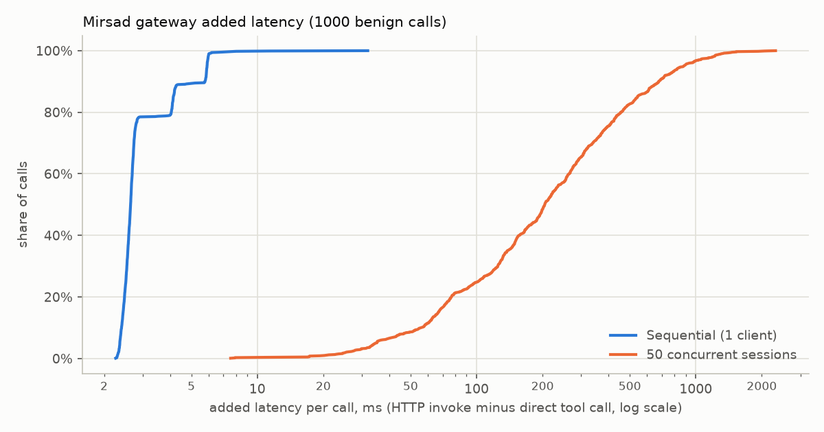
Figure B.2: Cumulative distribution of added latency over 1,000 benign calls, server in the same process as the client (log scale)
With one request at a time, Mirsad adds about 3 ms per call at the median, far below the 200 ms budget of NFR1 (Figure B.1). Under 50 concurrent sessions served by a single uvicorn worker, the median added latency rises to 166 ms with a separate server process and 205 ms when client and server share one Python process (Figure B.2), with 0 and 0 HTTP errors. The separate-process median is the figure assessed against NFR1; in the in-process layout the client competes with the server for one interpreter, which gives a much longer tail. Most of this time is queueing. In the separate-process run, the gateway-reported time itself grows to a median of 159 ms. This suggests that requests wait inside the gateway, where taint registration and audit appends run under one lock and write to SQLite. The concurrency figure should therefore be read as "50 sessions served on one worker", not as a throughput claim. Measurements with several workers and PostgreSQL remain to be done.

B.5.5 Benchmark results on benign tasks
Mirsad-Bench ran the 48 benign user tasks (24 English; 24 Arabic, of which 14 are Modern Standard Arabic and 10 Gulf dialect) with the deterministic scripted agent under each defence configuration. Each configuration made 68 benign tool calls. Two approver behaviours were simulated: deny rejects every escalation, and oracle approves exactly the calls that match the user's task, like a reviewer who knows what the user asked for. The none configuration calls the tools directly and is the same in both runs.
Table B.16: Benign benchmark results per defence and approver
Defence | Approver | Utility | FPR | Friction | Final block | Result FP | Gateway p50 / p95 (ms)
none | – | 100.0% | 0.0% | 0.0% | 0.0% | n/a | n/a
full | deny | 75.0% | 0.0% | 17.6% | 17.6% | 0.0% | 1.77 / 5.30
policy_only | deny | 75.0% | 0.0% | 17.6% | 17.6% | n/a (detector off) | 0.94 / 1.52
taint_only | deny | 87.5% | 0.0% | 8.8% | 8.8% | n/a (detector off) | 1.09 / 1.98
detector_only | deny | 100.0% | 0.0% | 0.0% | 0.0% | 0.0% | 1.45 / 3.76
full | oracle | 100.0% | 0.0% | 17.6% | 0.0% | 0.0% | 1.82 / 5.29
policy_only | oracle | 100.0% | 0.0% | 17.6% | 0.0% | n/a (detector off) | 0.95 / 1.94
taint_only | oracle | 100.0% | 0.0% | 8.8% | 0.0% | n/a (detector off) | 1.08 / 2.16
detector_only | oracle | 100.0% | 0.0% | 0.0% | 0.0% | 0.0% | 1.48 / 4.59

Figure B.3: Benign false-positive rate, approval friction and utility per defence configuration with the denying approver (run scripted-benign-deny)
The main observations are:
- Automatic denials. The FPR and Result FP columns give the share of benign calls denied automatically and of benign tool results sanitised or blocked in each configuration, against the FPR target of at most 5%, with the detector in rules-only mode.
- Friction comes from the policy's intended escalation paths. Under full protection, 12 of the 68 benign calls were escalated. The reason codes recorded in reports/bench/scripted-benign-deny/summary.md are CONSTRAINT_VIOLATION (6) and TAINT_UNTRUSTED_TO_EXTERNAL (6) for e-mails to outside recipients, APPROVAL_ALWAYS (4) for the payment and deletion tasks, and APPROVAL_POLICY (2) for exports. Under full protection, friction was 17.6% for English and 17.6% for Arabic tasks.
- The approver decides the utility cost. With the oracle approver, utility under full protection stays at 100%. With an approver who rejects everything, it falls to 75%.
- The policy layer is needed for high-risk tools. Only the configurations that include the policy layer asked a human about the legitimate payment and deletion tasks (approval recall 100% for full, 0% for taint_only and 0% for detector_only).
- Gateway processing time is a few milliseconds per call in every configuration (Figure B.4).
Figure B.4: Gateway time per benign call (decision plus result inspection, human wait excluded), p50 and p95, run scripted-benign-deny

B.5.6 Audit verification and decision replay
After each benchmark configuration, the harness verified the HMAC hash chain of that configuration's audit log and replayed every recorded tool_call.decision event with its stored policy version and inputs (--replay-check). The latency benchmark verified the chain after its 1,000 calls.
Table B.17: Audit verification and replay results
Run | Audit chains verified (True/False) | Decisions replayed | Same action
scripted-benign-deny (4 protected configurations) | True | 272 | 272
scripted-benign-oracle (4 protected configurations) | True | 272 | 272
llm-smoke (full protection) | True | 6 | 6
Latency benchmark, separate process | True | – | –
Latency benchmark, same process | True | – | –

Every replayed decision reproduced its original action, which meets the acceptance criterion of FR6.3. Tamper detection itself is tested by TC-36, TC-37, ST-06 and ST-07.

B.5.7 LLM smoke run
A smoke run checked that the real model integration works through the gateway. The demonstration agent used Qwen2.5-7B through Ollama at temperature 0 on 4 benign tasks (2 English, 2 Arabic), without protection and with full protection (oracle approver). Utility was 75% without Mirsad and 75% with it. FPR and friction were 0% and 0%. The gateway time over 6 calls was 3.59 ms at the median and 5.52 ms at p95. The same task failed in both configurations (ar-crm-update-02): the episode records show that the model wrote a CRM note without the requested phone number, and the gateway allowed every call. The failure is the model's, not the gateway's. With so few tasks this run is a functional check, not a utility estimate.

B.5.8 Results pending team-supplied data
Table B.18 lists the results that the evidence pipeline produces once attack-labelled data exists. They are not estimated here. The repository currently holds only benign detector batches (data/detector/raw/en-ben.jsonl and ar-ben.jsonl) and no attack files under bench/scenarios/attacks/. Attack material is written and reviewed by the team (Section 3.6.4).
Table B.18: Results that need team-supplied attack data
Result | Value | How it is produced
Detector F1, English held-out test set (target ≥ 0.85) | [pending] | Add labelled training batches and separate held-out test batches (raw/test-*.jsonl) to data/detector/raw/, then run make detector (docs/detector.md, Section 11.4)
Detector F1, Arabic held-out test set (target ≥ 0.85) | [pending] | As above
Detector F1, mixed Arabic–English test set | [pending] | As above
Detector precision / recall, English | [pending] / [pending] | As above
Detector precision / recall, Arabic | [pending] / [pending] | As above
Detector scan latency, 2 KB text, p50 (target < 10 ms) | [pending] ms | Measured by the same training run
Attack success rate, full protection | [pending] | Add injection tasks and attack templates to bench/scenarios/attacks/ (bench/scenarios/attacks/README.md), then run scripts/run_bench.sh, which executes the attack episodes
ASR reduction against the unprotected baseline (target ≥ 80%) | [pending] | As above

B.6 Known limitations and open items
- Detector accuracy and attack success rate are not measured yet (B.5.8). Until they are, the evaluation shows what Mirsad costs legitimate work, but not how much protection it gives against real attacks.
- Tests verify how detections are handled, not detection quality. Functional tests use neutral placeholders scored by a stub rule, so they cannot show whether real Arabic or English injections are recognised.
- All detector-dependent numbers come from the rules-only fallback, because no trained model is packaged. The benchmark, the latency benchmark and the result false-positive rate must be measured again once a model ships.
- No attack episode has been run. The harness executes attack episodes (bench/attacks.py, tested with neutral placeholder text in tests/bench/test_bench_attacks.py), but no attack files exist yet.
- Benchmark coverage is limited. The scripted agent replays task plans exactly, the LLM run covers 4 tasks, and the oracle approver is idealised. Approval quality and decision time of real people are not modelled.
- Usability (NFR4) and accessibility (NFR10) checks are incomplete. The decision-time figure is an analytical Keystroke-Level Model estimate (Section 4.2.8); no approver has been timed in a user study, no acceptance session (Section 3.5.7) has been held, and no UI review checklist is recorded. Keyboard navigation and reduced-motion behaviour are not covered by automated tests.
- Concurrency. Tail latency with 50 sessions on one worker is high, and part of the waiting happens inside the gateway (B.5.4). Multi-worker and PostgreSQL latency have not been measured.
- Deployment. The CI workflow defines a Docker build job, but no CI run, image build or docker compose up is recorded in reports/. The Compose file does not yet set MIRSAD_POLICY_PATH and MIRSAD_UPSTREAMS_PATH for the mirsad service (Appendix E.2.2).
- Coverage scope. Only statement coverage is collected. The 80% target is not enforced by a CI threshold, and npm audit is not part of the CI workflow.
- Excluded tests. The two llm-marked tests are not part of the recorded run.
- Small open integration items. Two classes implement login throttling (mirsad/auth.py and mirsad/api/routers/auth.py) and the application uses the second, so one should be removed. The policy embedded in demo/agent.py for stand-alone use of the demonstration agent lacks the global rule no-bulk-export-to-email and should load configs/policies/default.yaml instead. One literal left-to-right mark remains in the Arabic dictionary of the web app, and isolate characters remain inside two JSON test fixtures captured from the server; they should be written as escapes like the Python sources.
- Benchmark fingerprint. The runner fingerprints the scenario files but not the policy, so a resumed run would not detect a policy change; the reported runs were therefore executed from scratch (B.1).
- Audit integrity has a documented limit. Someone who holds the HMAC key can rewrite history undetected unless an external anchor of the chain head is kept (TC-37).
- Security testing is automated and internal. No external penetration test or adaptive red-team exercise has been carried out against the gateway.

Appendix C – System Screenshots / Interface Designs
All screenshots in this appendix were taken from the running system, not from mock-ups. The script scripts/capture_screenshots.py initialises a temporary installation with demonstration users and the demonstration agent (mirsad init --demo), starts the gateway with the simulated Najd Trading Co. workspace, and generates activity through the real agent API: eight allowed calls (reading e-mail, looking up customers, listing documents, an internal e-mail and a CRM note update), four calls that the policy denies (a 200-record export, a 250,000 SAR transfer, a request to a cloud metadata address and a tool that does not exist), and four calls that need approval. The approver then approves one request and denies another, leaving two pending. Playwright with Chrome captures the dashboard at 1440 × 900 pixels and the approver app at 390 × 844 pixels (a phone-sized screen). All names, addresses, IBANs and records are fictional.
For the capture run the approval timeout was raised from the default 120 seconds to 15 minutes so that pending requests stay open while the pages are captured. This is why the countdowns show about 14–15 minutes (from a 900-second timeout).

C.1 Administration Dashboard (English)
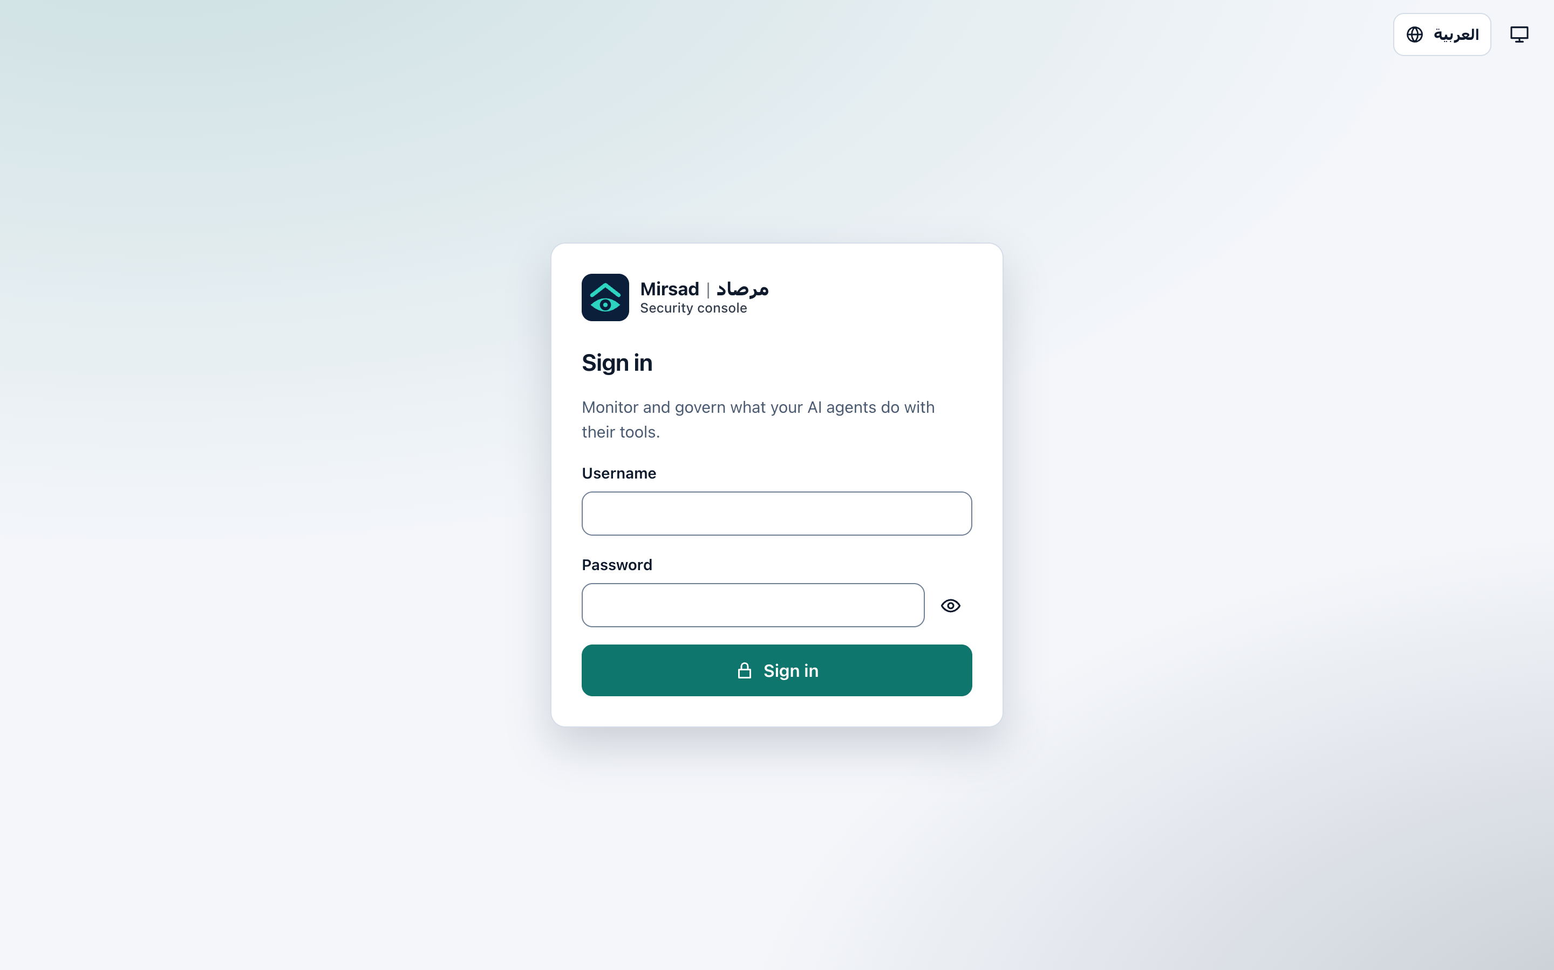
Figure C.1: Dashboard sign-in page. The language switch at the top right changes the interface to Arabic before signing in, and the second button selects the colour theme
The Overview page counts the tool calls that were allowed, denied and sent for approval, the requests still waiting, injection detections and sanitised or blocked results; it also shows the gateway overhead per call, the audit-log integrity card with a Verify now button and the decisions over time.
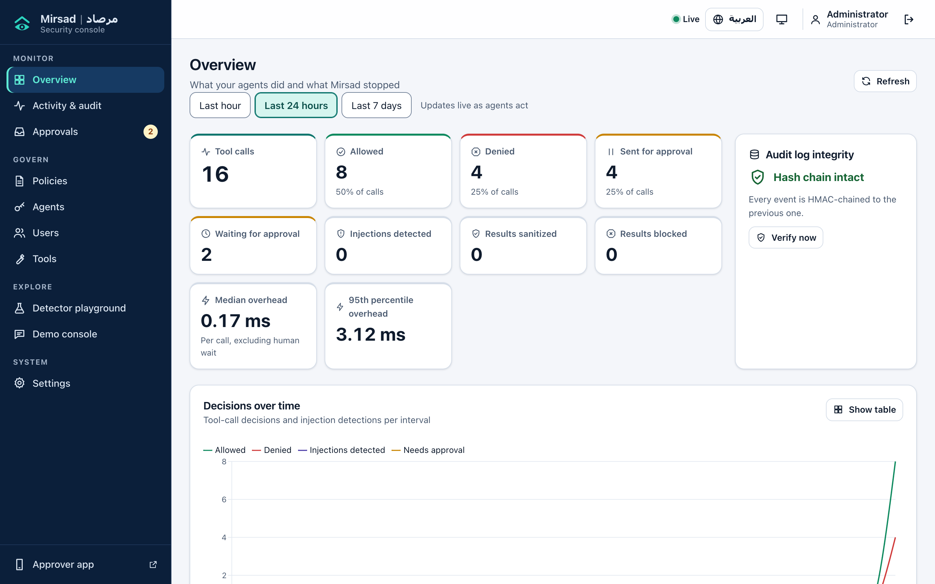
Figure C.2: Dashboard Overview after the seeded activity
The Activity and audit log filters events by text, agent, tool, outcome, event type, session, call and time range, verifies the hash chain and exports results as JSON or CSV. Outcome and risk are shown with an icon and a word, not by colour alone.
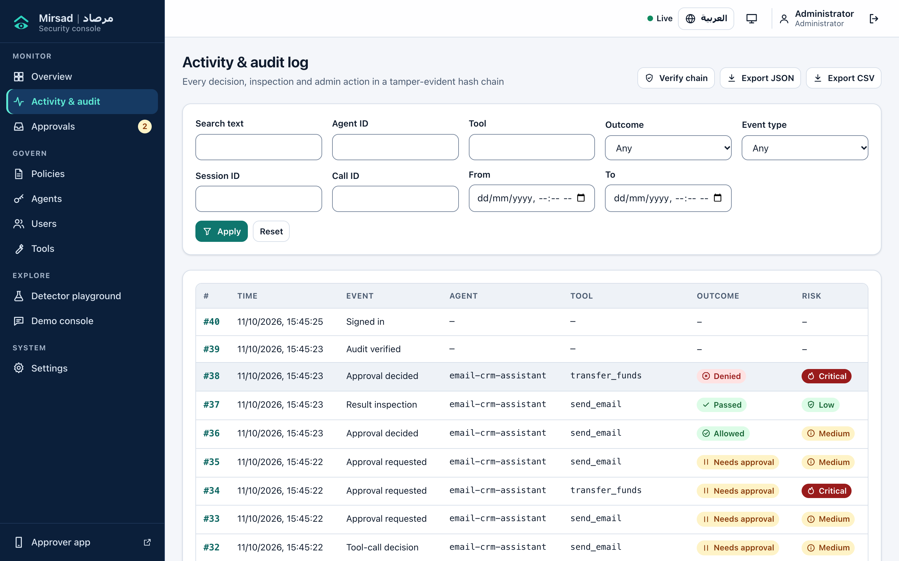
Figure C.3: Activity and audit log
The detail drawer of audit event 38, the approver's denial of a transfer_funds request, shows the summary fields, the previous hash and the event hash that link the event into the HMAC chain, the raw event JSON, and filters for all events of the same call or session.
Figure C.4: Detail drawer of an audit event (a denied transfer_funds request)
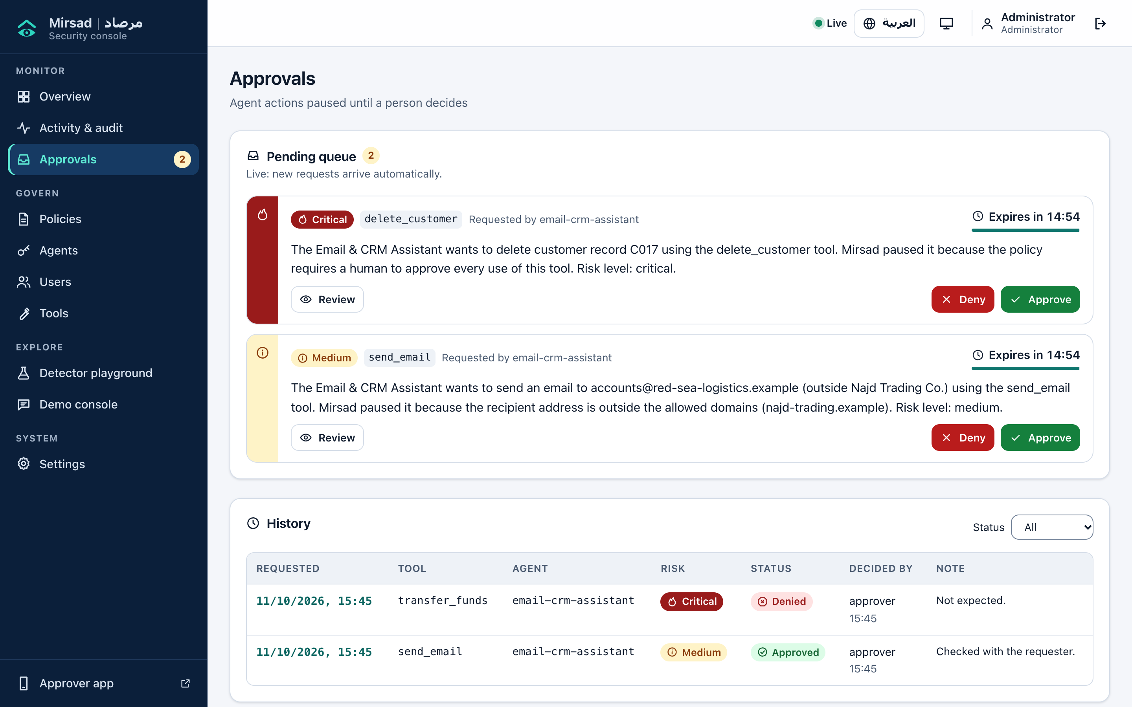
Figure C.5: Approvals page. The live pending queue shows each request's risk level, plain-language summary and countdown to expiry with Approve and Deny buttons; the history below records who decided each request and their note
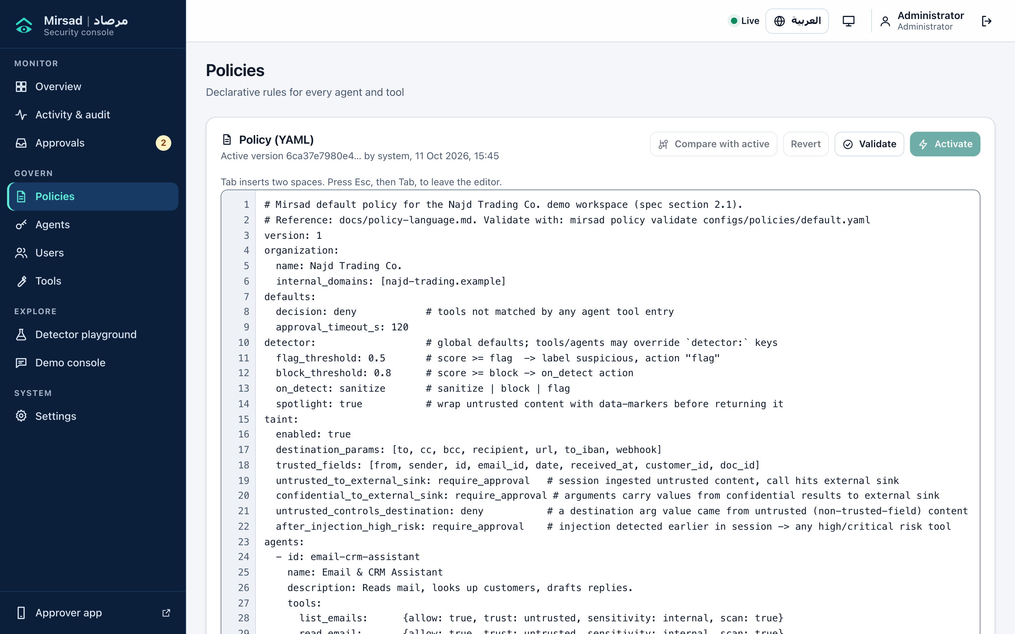
Figure C.6: Policy editor with the active YAML policy of the demonstration organisation and its version hash. Changes can be compared with the active version, reverted, validated and activated without restarting the gateway
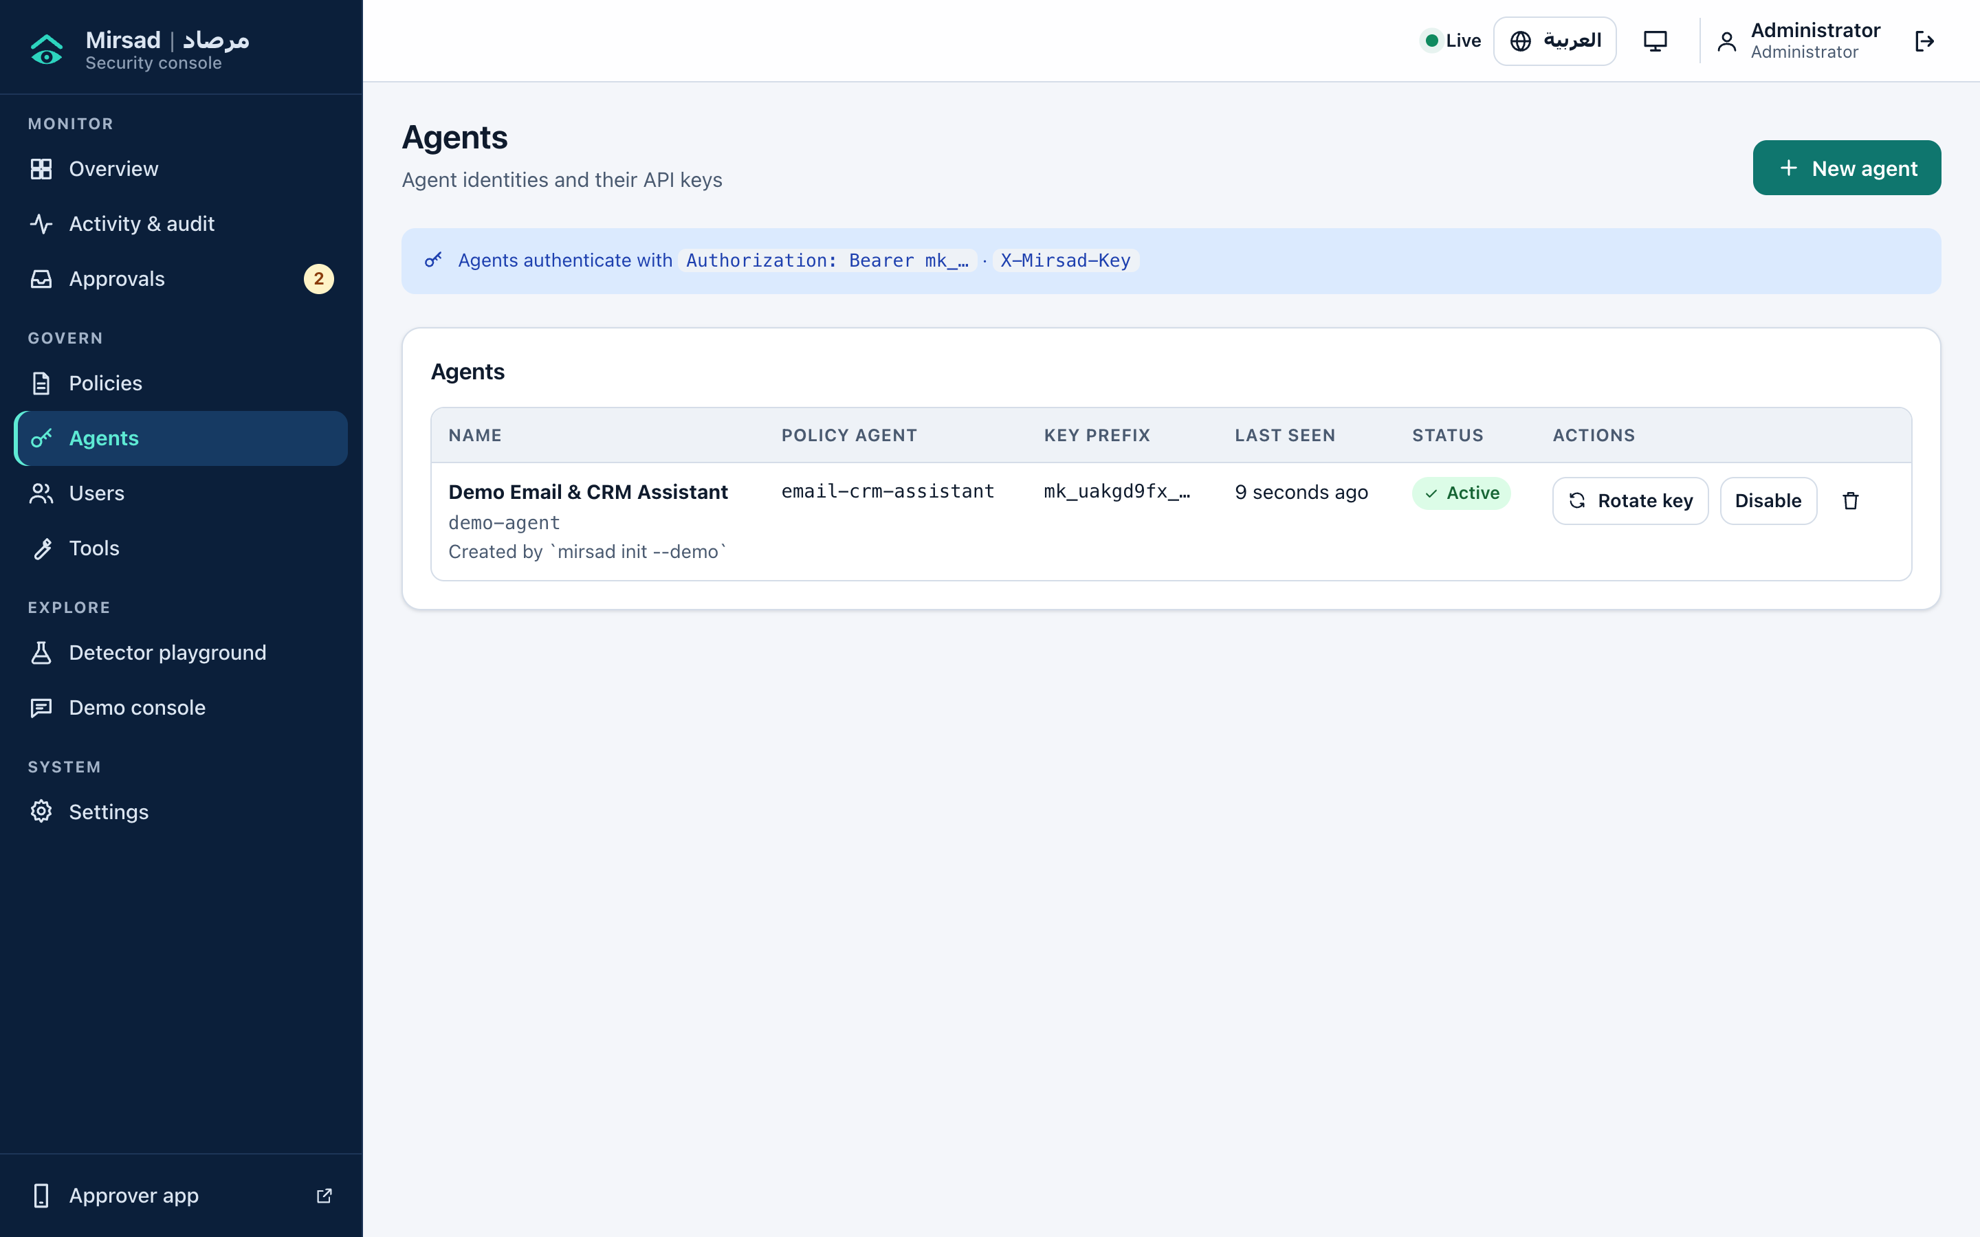
Figure C.7: Agents page: the demonstration agent, the policy agent it is mapped to, its key prefix (the full key is shown only once, when it is created or rotated), last-seen time, and rotate, disable and delete actions
Figure C.8: Users page with the three roles and what each may do: administrators manage everything, approvers decide on paused actions, and auditors have read-only access to the audit log, policies and tools
Figure C.9: Tools page: the tools discovered from the upstream workspace server and how the active policy profiles each one for the selected agent (allowed, trust of its results, sensitivity, where it sends data, risk and approval mode)
The detector playground shows the verdict, the detected language, the model and rule scores, the scan latency, highlighted evidence and obfuscation signals. The model score is 0 because the packaged detector runs in rules-only mode until the model is trained on the team's data.
Figure C.10: Detector playground scanning a benign mixed Arabic–English supplier message
The attacker-inbox panel of the Demo console lists everything that left the organisation's domain; in this capture it shows the external supplier reply that the approver approved during seeding, not an attack.
Figure C.11: Demo console: protection switch, scenarios, conversation, tool-call timeline and attacker inbox
Figure C.12: Settings page: theme (system, light or dark), language, background notifications for new approvals, account details and server status

C.2 Dashboard in Arabic and in the Dark Theme
Figure C.13: Overview page in Arabic. Labels, key figures and time-range buttons are translated and arranged for right-to-left reading
Figure C.14: Activity and audit log in Arabic. The navigation moves to the right and the filters and table columns are mirrored, while tool names, agent identifiers and dates keep their left-to-right form
Figure C.15: Policy editor in Arabic. The surrounding interface is right-to-left, while the YAML policy stays left-to-right so that it can be edited and reviewed as code
Figure C.16: Overview page in the dark theme, which can follow the operating-system setting or be selected in Settings

C.3 Approver App (English)
Figure C.17: Approver app sign-in on a phone-sized screen. The app is served by the gateway at /approve and can be installed to the home screen
Figure C.18: Pending requests in the approver app: risk level, tool, requesting agent, the start of the plain-language summary, time since the request and countdown, a prompt to turn on push alerts, and Pending and History tabs
Figure C.19: Detail of a critical-risk request to delete a customer record: what the agent wants to do, why Mirsad paused it with the layer behind each reason, and Deny and Approve buttons fixed at the bottom of the screen
Figure C.20: Full-length capture of the same request, including the section on where the data came from (here no outside data was linked) and the collapsible list of arguments. The fixed Deny and Approve bar appears in the middle only because of the full-page capture method

C.4 Approver App (Arabic)
Figure C.21: Pending requests in the Arabic interface. The layout is mirrored, summaries are written in Arabic, and tool names and e-mail addresses keep their original form
Figure C.22: Detail of the same deletion request in Arabic, with the summary, the reasons for the pause, and the Approve and Deny buttons in right-to-left order
Figure C.23: Full-length capture of the Arabic request detail, including the data-provenance section and the collapsible arguments; as in the English capture, the fixed button bar appears mid-page because of the capture method

Appendix D – Poster / Presentation Slides
The poster and the final presentation are generated from the project sources by scripts/build_poster.py and scripts/build_slides.py; both read every measured value from reports/results_summary.json at build time, so they always match this report. The editable files are deliverables/Mirsad_Poster.pptx (85 cm × 142 cm, the CCIS EXPO format) and deliverables/Mirsad_Final_Presentation.pptx (18 slides with speaker notes; the full speaker script is in docs/presentation_script.md).
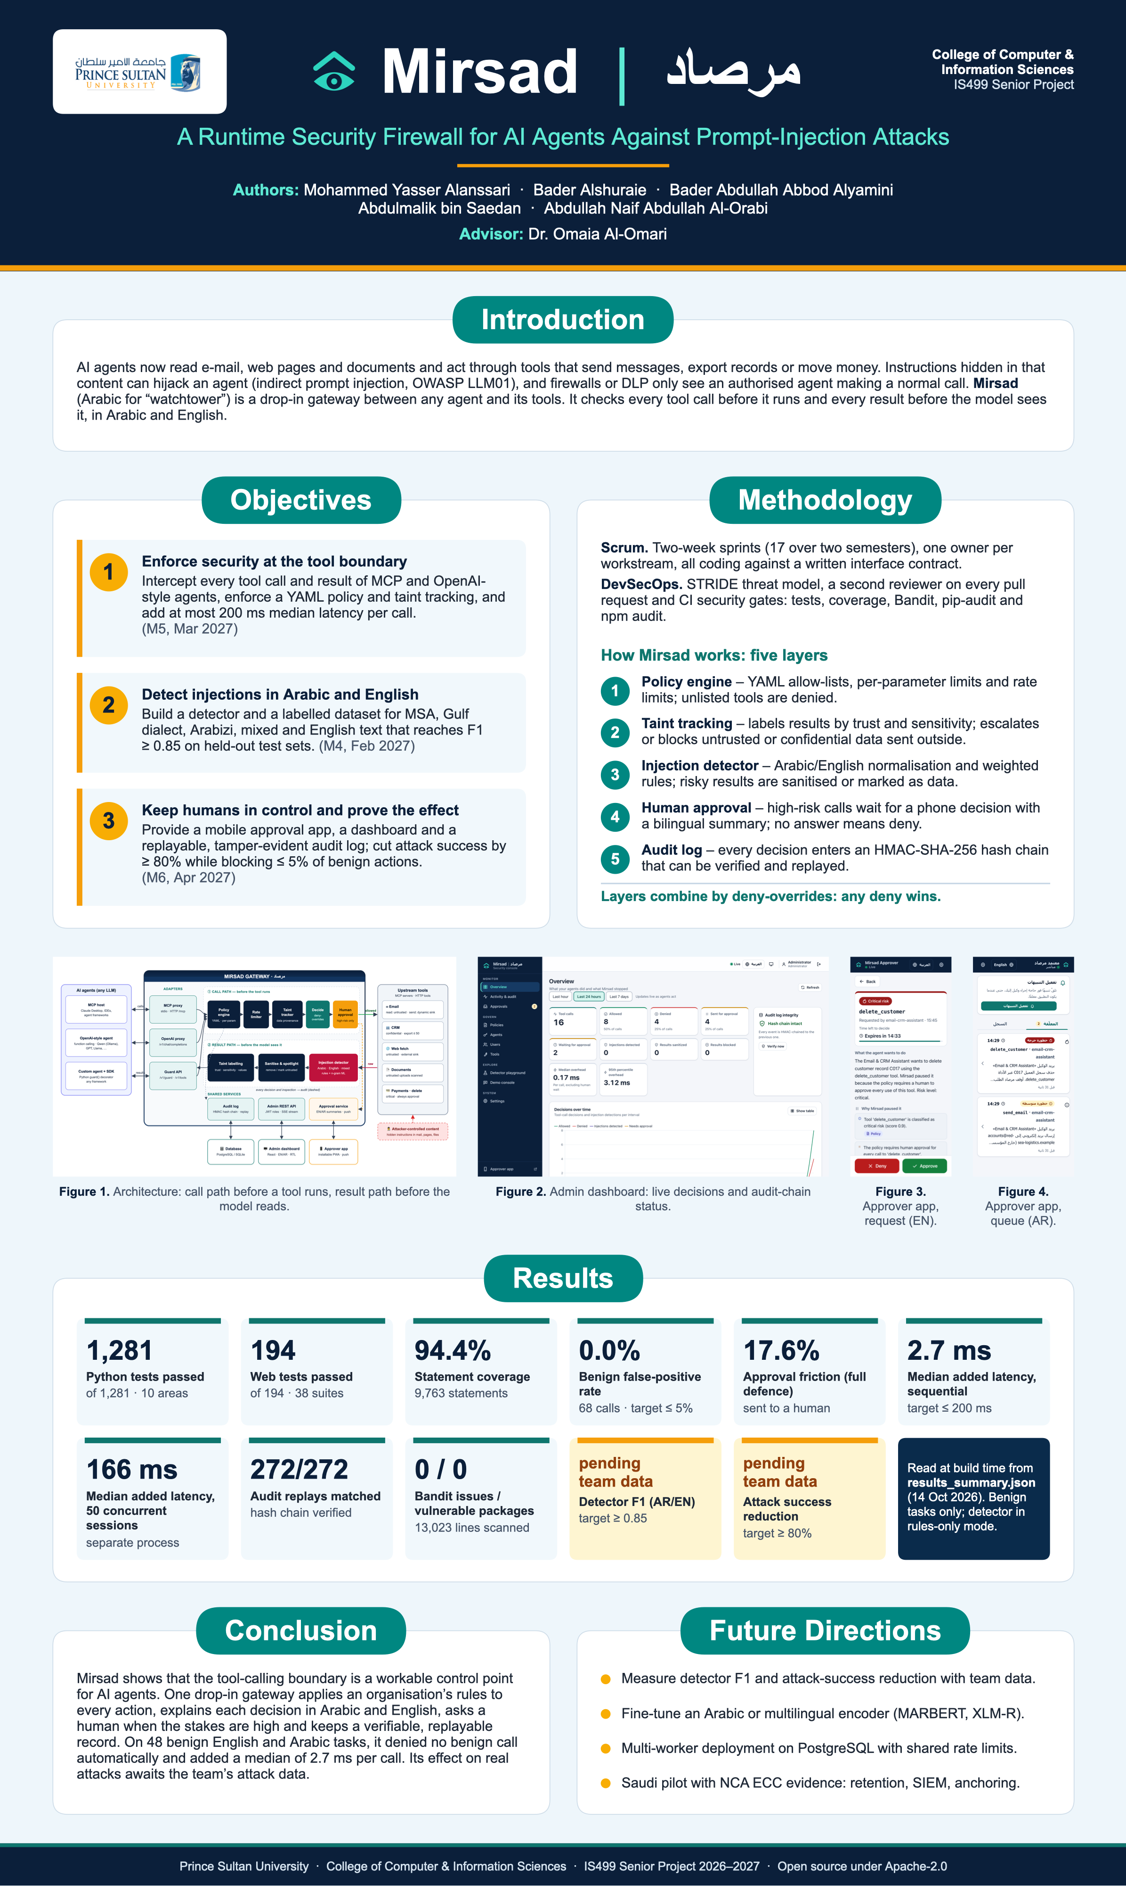
Figure D.1: CCIS EXPO poster (preview rendering)
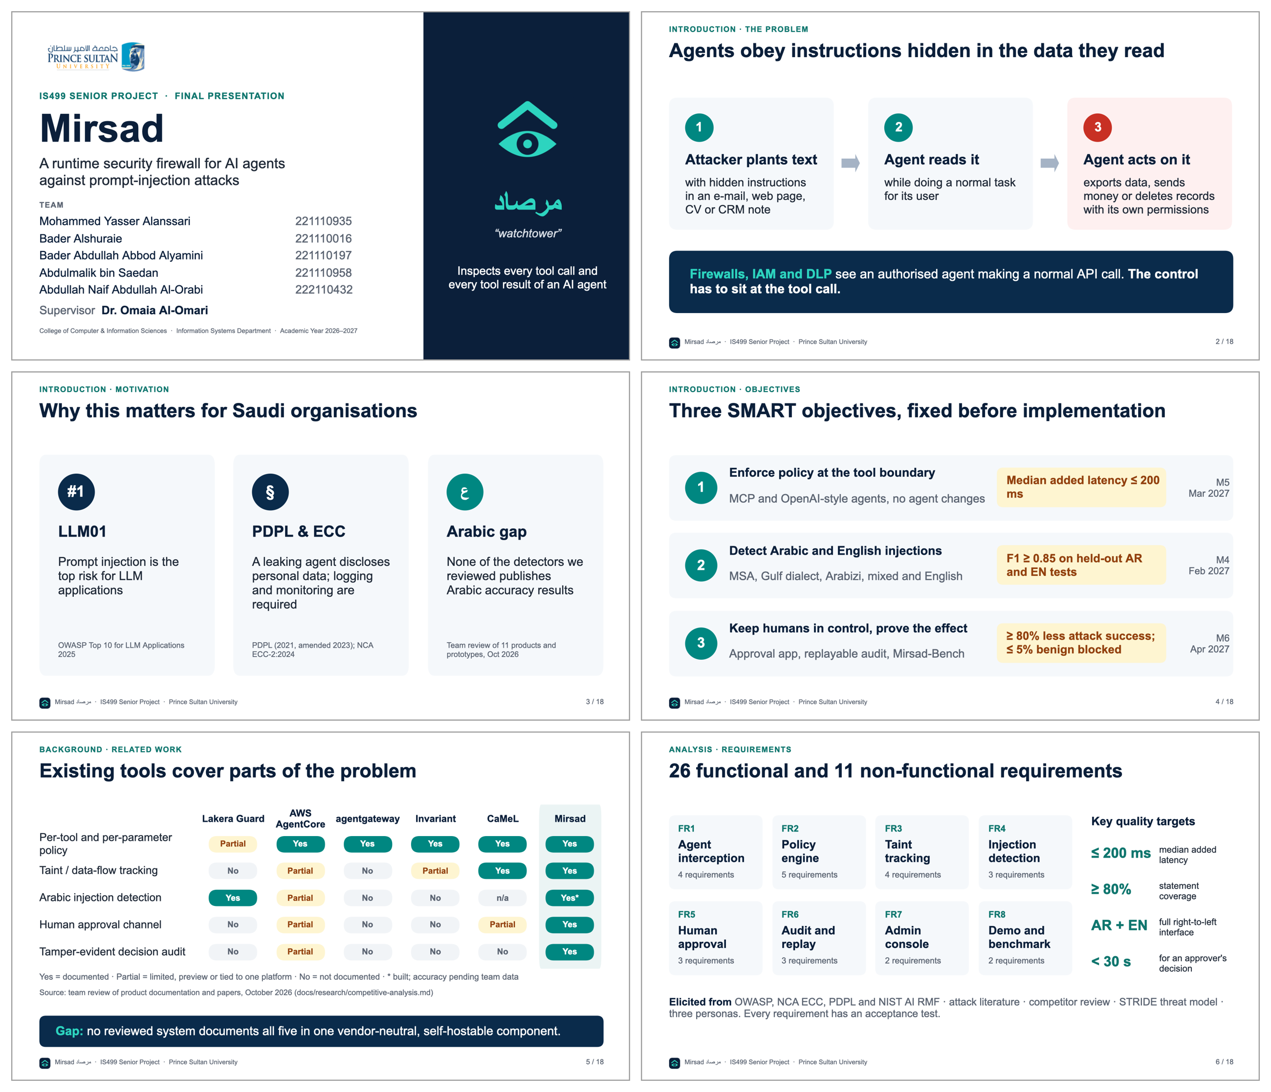
Figure D.2: Final presentation, slides 1–6
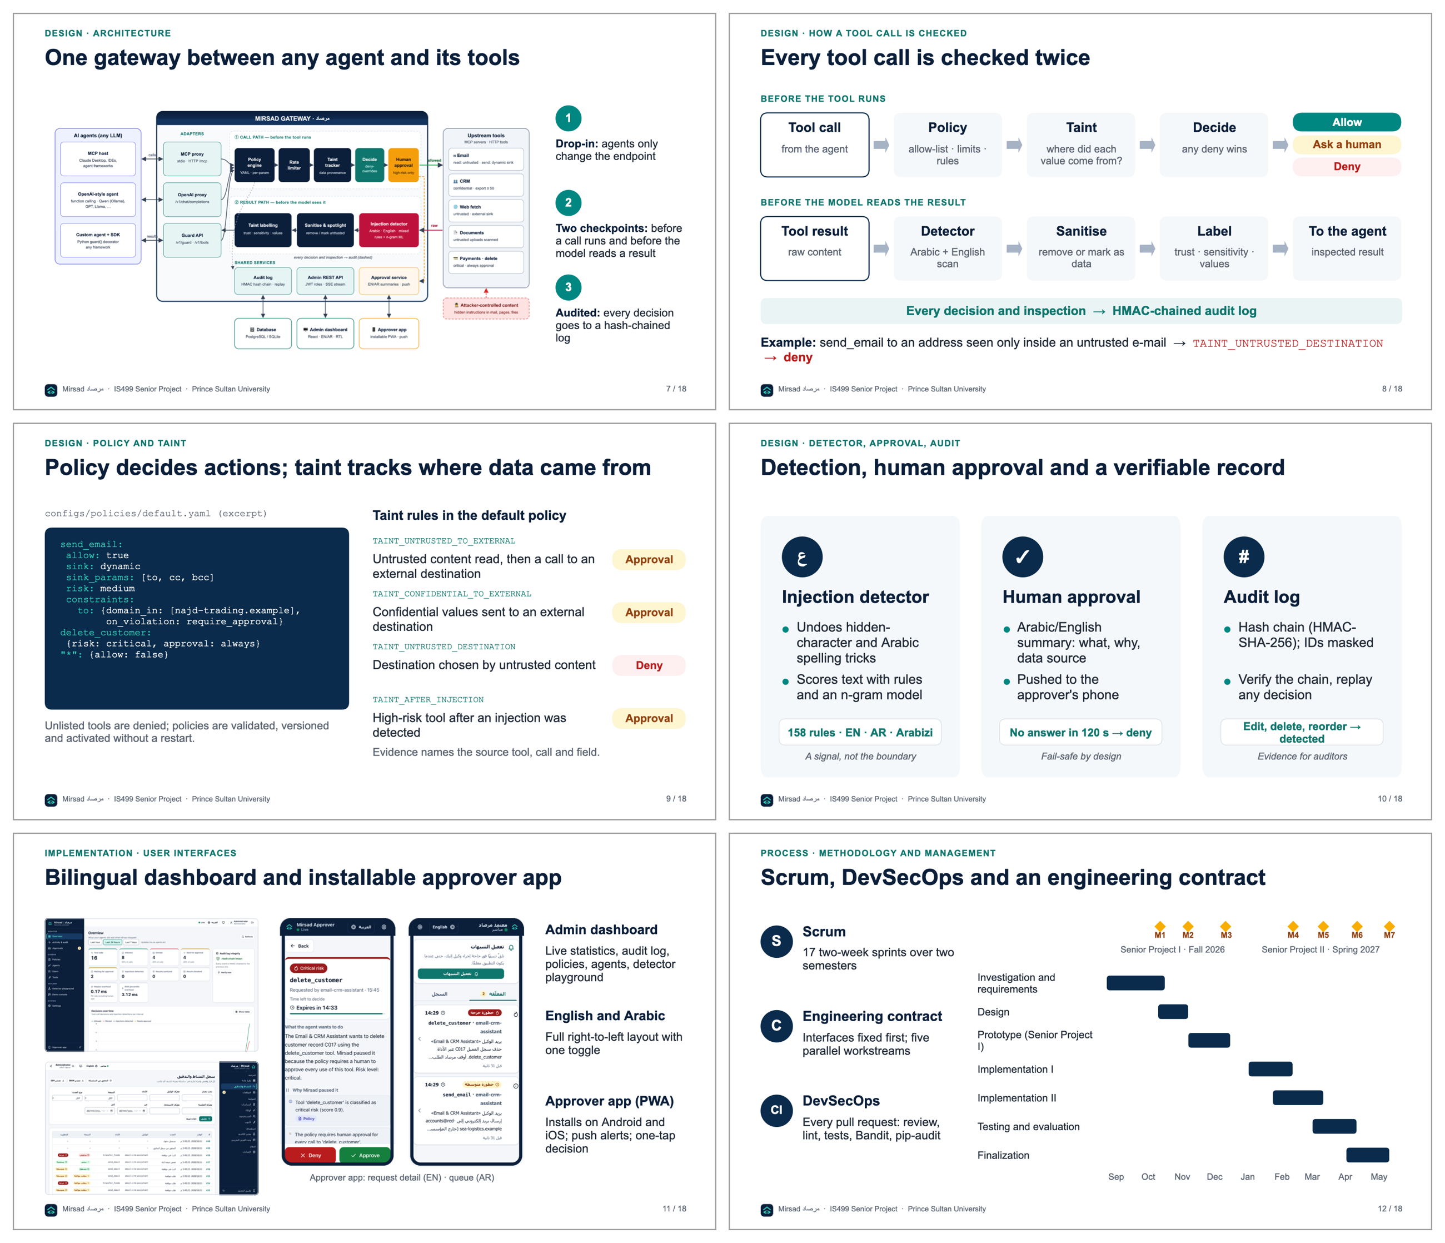
Figure D.3: Final presentation, slides 7–12
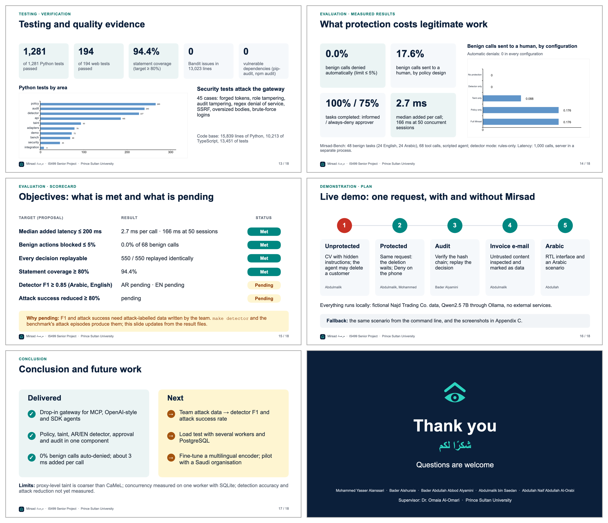
Figure D.4: Final presentation, slides 13–18

Appendix E – Software User Guide
This appendix is the Software User Guide of Mirsad 1.0.0 (IS499 deliverable D6). It explains how to install, configure, operate and integrate the system; Table E.1 shows which sections each reader needs. Commands are run from the project root, and mirsad is equivalent to python -m mirsad.cli. Measured values are read from reports/results_summary.json when the document is built; "[pending]" marks a value that has not been produced yet.
Table E.1: Reading guide by audience
Reader | Typical tasks | Sections
Administrators and IT staff | Install, configure, manage users and agents, write policies, harden the deployment | E.1–E.5, E.7, E.9, E.12, E.13
Approvers | Install the phone app, receive alerts, approve or deny paused actions | E.5.4, E.6
Auditors | Search activity, verify the hash chain, replay decisions, export evidence | E.5.3, E.10
Agent developers | Connect agents through MCP, the OpenAI-compatible proxy or the SDK; train the detector; run the benchmark | E.8, E.11, E.12

E.1 Overview and System Requirements
Mirsad is one Python service (FastAPI on Uvicorn) placed between AI agents and their tools. For each tool call it evaluates the active YAML policy, rate limits and the session's taint state, then allows, denies or pauses the call for a person. After a tool runs, Mirsad scans the result for instructions aimed at the agent, sanitises or blocks them, and marks the content as untrusted data. Every step is written to an audit log whose events are chained with an HMAC [67]. The same process serves the agent endpoints (/mcp for MCP [3], /v1/chat/completions, and the Guard API under /v1/), the dashboard at /, the approver app at /approve and API documentation at /docs.
Table E.2: System requirements
Item | Requirement | Notes
Operating system | macOS or Linux with Bash | Tests and measurements ran on macOS (Apple Silicon); Windows was not tested
Python | 3.11 or later (3.12 recommended)
Node.js | 20.19 or later | Only to rebuild the web app; a build ships in src/mirsad/static/
Database | SQLite (default) or PostgreSQL | Compose uses PostgreSQL 16
Hardware | CPU only | No GPU needed
Demo model (optional) | Ollama serving qwen2.5:7b | Demo Console, demo agent, LLM benchmark
Approver phone | Android (Chrome, Edge, Samsung Internet) or iOS/iPadOS 16.4+ (Safari) | Server reachable over HTTPS

On the development machine the release passed 1,281 of 1,281 Python tests and 194 of 194 web tests (94.4% statement coverage). With the gateway in a separate process, Mirsad added a median of 2.7 ms (p95 6.0 ms) to a sequential tool call over HTTP, with the detector in rules_only mode.

E.2 Installation

E.2.1 Python virtual environment
cd mirsad # repository clone or release archive
./scripts/setup.sh # or: make setup
source .venv/bin/activate
mirsad --version # mirsad, version 1.0.0
The script checks for Python 3.11 or later (PYTHON_BIN selects an interpreter), creates .venv, installs Mirsad in editable mode with the development extras, and runs npm ci in web/ when npm exists. make web rebuilds the dashboard and approver app into src/mirsad/static/; without a build, / returns a short JSON note.

E.2.2 Docker Compose with PostgreSQL
The two-stage Dockerfile builds the web app with Node 22, then installs Mirsad with the PostgreSQL driver on python:3.12-slim, running as the unprivileged user mirsad with data in the /data volume, port 8700 and a /healthz health check. docker-compose.yml defines mirsad, db (postgres:16-alpine) and an optional ollama service in the demo profile.
Status. The Dockerfile and Compose file were written but could not be executed on the development machine because Docker was not available there; treat them as reviewed but untested. PostgreSQL compatibility was verified separately: tests/integration/test_postgres.py starts an embedded PostgreSQL server (pgserver package) and runs the audit chain, tamper detection, authentication and approvals against it. These tests passed in the recorded run (reports/tests/junit.xml).
1. Copy .env.example to .env and replace every value: MIRSAD_SECRET_KEY, MIRSAD_ADMIN_PASSWORD (creates the first administrator at first start), POSTGRES_PASSWORD and MIRSAD_ENABLE_DEMO (false in production).
2. Add the two lines below to the environment of the mirsad service.
3. Run docker compose up -d --build; check with docker compose ps and docker compose logs mirsad.
4. Sign in at http://<host>:8700/ as admin and create approvers on the Users page or with docker compose exec mirsad mirsad user create <name> --role approver.
5. For the demo: MIRSAD_ENABLE_DEMO=true, docker compose --profile demo up -d, docker compose exec ollama ollama pull qwen2.5:7b.
MIRSAD_POLICY_PATH: /app/configs/policies/default.yaml
MIRSAD_UPSTREAMS_PATH: /app/configs/upstreams.yaml
The defaults of these two settings are computed relative to the source tree. In the image, which installs Mirsad as a regular package, they point inside the Python installation, so the server would start with the built-in deny-all policy and no tools. This follows from src/mirsad/config.py and was not observed in a running container; it applies to any non-editable installation.

E.3 Configuration
Settings come from environment variables prefixed MIRSAD_ or from a .env file in the start directory (environment variables win) and are read at start-up. Policies are stored in the database instead (E.7).
Table E.3: Environment variables and defaults
Variable | Default | Purpose
MIRSAD_HOST, MIRSAD_PORT | 127.0.0.1, 8700 | Bind address and port
MIRSAD_DATA_DIR | .mirsad (Docker: /data) | SQLite file, secret.key, credentials.txt
MIRSAD_DATABASE_URL | SQLite in the data directory | SQLAlchemy URL, e.g. postgresql+psycopg://user:pw@host/mirsad
MIRSAD_SECRET_KEY | generated once into secret.key | Signs sign-in tokens; the audit HMAC key is derived from it
MIRSAD_POLICY_PATH | configs/policies/default.yaml | Initial policy when the database has none
MIRSAD_UPSTREAMS_PATH | configs/upstreams.yaml | Tool servers that Mirsad protects
MIRSAD_DETECTOR_MODEL_DIR | src/mirsad/detector/model | Trained detector; rules-only mode when absent
MIRSAD_TOKEN_TTL_HOURS | 12 | Sign-in lifetime
MIRSAD_APPROVAL_TIMEOUT_S | 120 | Time to decide; an expired request is denied
MIRSAD_MAX_RESULT_CHARS | 200000 | Longer tool results are truncated before scanning
MIRSAD_AUDIT_PAYLOAD_MAX_CHARS | 20000 | Size limit of one audit payload
MIRSAD_ENABLE_DEMO | false | Enables the Demo Console endpoints
MIRSAD_LLM_BASE_URL | http://127.0.0.1:11434/v1 | LLM for the OpenAI-compatible proxy and demo agent
MIRSAD_LLM_MODEL, MIRSAD_LLM_API_KEY | qwen2.5:7b, ollama | Default model and upstream credential
MIRSAD_CORS_ORIGINS | the Vite development server (port 5173) | Allowed browser origins (JSON list)
MIRSAD_VAPID_PUBLIC_KEY, MIRSAD_VAPID_PRIVATE_KEY | empty | Enable Web Push (E.6.3)
MIRSAD_VAPID_SUBJECT | mailto:security@najd-trading.example | Contact sent to push services
MIRSAD_LOG_LEVEL | INFO | Log level (standard error)
MIRSAD_ADMIN_PASSWORD, MIRSAD_ADMIN_USERNAME | unset, admin | Creates the first administrator when no user exists
MIRSAD_NEW_USER_PASSWORD | unset | Password for mirsad user create without a prompt
MIRSAD_AGENT_KEY, MIRSAD_URL | unset, http://127.0.0.1:8700 | Agent side: mirsad mcp-proxy and MirsadClient.from_env()

POSTGRES_PASSWORD is used by the Compose file and MIRSAD_API by the web development server.

E.4 First Run and Demonstration

E.4.1 Initialising and starting the server
mirsad init --demo # database, first policy version, users, demo agent
mirsad serve --demo # dashboard /, approver app /approve, API docs /docs
init stores the default policy as the first version, creates the users admin, approver and auditor and, with --demo, the agent demo-agent (policy agent email-crm-assistant). It prints only the path of .mirsad/credentials.txt (mode 600), which holds the generated passwords and the agent key; move them to a password manager and delete the file. Re-running init creates only what is missing. make demo runs both steps through scripts/run_demo.sh. Then sign in at http://127.0.0.1:8700/ as admin, and open /approve as approver in a second window.

E.4.2 Local model for the demo agent
The demo agent uses Ollama's OpenAI-compatible endpoint [102] with Qwen2.5-7B-Instruct [114]. Run ollama pull qwen2.5:7b; curl -s http://127.0.0.1:11434/v1/models should list it. Without the model the Demo Console returns error 502; nothing else depends on it.

E.4.3 Running a demonstration
1. In Demo console, choose a scenario, for example the invoice e-mail whose body hides an instruction to send the customer list outside. Load scenario resets the simulated Najd Trading Co. workspace, plants the content and fills in a harmless user request.
2. Turn Mirsad protection off and send. Whether the agent follows the planted instruction depends on the model; anything that leaves the organisation appears in the Attacker inbox.
3. Reset demo, load the scenario again with protection on and send. The tool-call timeline shows each decision and its reason; paused calls reach the Approvals page and the approver app.
The command line runs the same scenarios and prints an outcome computed from the workspace side effects: python -m demo.agent --list, then python -m demo.agent --protected --scenario invoice-exfil --lang en (or --unprotected; --approve auto-approves escalations).

E.5 Administration Dashboard
The sidebar shows only the pages the signed-in role may use (Table E.4); the API enforces the same roles. The screenshots were captured by scripts/capture_screenshots.py, which starts a demo server, generates activity through the real API and photographs each page in Chrome. That server used a 900-second approval timeout, so countdowns show about 14–15 minutes instead of the default 120 seconds.
Table E.4: Dashboard pages and roles
Page | Roles | Main actions
Overview | all | Key figures, charts, audit chain status
Activity & audit | admin, auditor | Search, inspect, replay, verify, export
Approvals | admin, approver | Live queue, decisions with notes, history
Policies | admin (auditor read-only) | Edit, validate, compare, activate, roll back
Agents, Users | admin | Identities, keys, accounts and roles
Tools | admin, auditor | Discovered tools and their policy treatment
Detector playground | all | Scan Arabic, English or mixed text
Demo console | all (demo mode) | Chat with the demo agent
Settings | all | Theme, language, digits, desktop alerts

E.5.1 Signing in and navigation
After 5 failed sign-ins for one username and address (or 30 from one address) within 5 minutes the page reports "too many attempts" until the window passes. The sign-in lasts while the browser tab is open. The top bar holds the live indicator, the English/العربية toggle, the theme, the account and sign-out.

E.5.2 Overview
The Overview (Figure E.1) summarises the last hour, day or week: tool calls, allowed, denied, sent for approval, waiting, injections detected, results sanitised or blocked, and the median and 95th-percentile gateway overhead (excluding human waiting). Charts show decisions over time, per tool and per defence layer, each with a Show table view. Verify now re-checks the audit chain.
Figure E.1: Overview page of the dashboard

E.5.3 Activity and audit log
A paged list of all audit events, filtered by text, agent, tool, outcome, event type, session, call or time; filters stay in the address so a view can be shared. A row opens the detail drawer (Figure E.2): summary, reasons with bilingual explanations and evidence, detector spans for inspections, taint provenance (which earlier call and field a value came from), arguments, hashes and the raw event, with Verify chain, Export event, All events of this call/session and, for decisions and inspections, Replay (E.10).
Figure E.2: Activity and audit log with the detail drawer of an approval decision

E.5.4 Approvals
The pending queue (Figure E.3) shows paused calls, soonest expiry first, with risk, tool, agent, countdown and a plain-language summary. Review opens the full explanation (E.6.2); Approve and Deny ask for confirmation and an optional note. If another approver decided first, the page says so. The history lists past requests with the decision maker and note.
Figure E.3: Approvals page with two pending requests and the decision history

E.5.5 Policies, agents and users
Policies (Figure E.4) shows the active YAML in a line-numbered editor with Validate (errors link to their line), Compare with active, Activate (diff and change note) and a version history from which administrators can re-activate an older version. Auditors get a read-only view; E.7 explains policy writing.
Agents (Figure E.5) lists agent identities with policy agent, key prefix, last use and status. A new or rotated key appears once, in a dialog that closes only after "I have stored this key" is ticked, together with any warning, for example a policy agent id missing from the active policy. Rotation invalidates the old key immediately; Disable blocks an agent but keeps its history. Users creates accounts with the roles admin, approver or auditor, by default with a server-generated password shown once. The dashboard does not let you change your own role or status, and the last active administrator cannot be demoted, disabled or deleted.
Figure E.4: Policies page with the YAML editor
Figure E.5: Agents page with the demo agent created by mirsad init --demo

E.5.6 Tools, detector playground, demo console and settings
Tools shows each discovered upstream tool and how the active policy treats it per agent (allowed, trust, sensitivity, sink, risk, approval, scanning). The Detector playground (Figure E.6) scans pasted text and shows score, thresholds, verdict, language, model and rule scores, latency, highlighted evidence and obfuscation signals; teams can add labelled samples in src/mirsad/static/assets/playground-samples.json. The Demo console (Figure E.7) holds the protection switch, scenario selector, conversation, tool-call timeline, attacker inbox and a count of workspace changes. The attacker inbox lists every message that left the organisation, including legitimate ones; the item in Figure E.7 is an approved reply to a supplier. The page never displays the planted content itself. Settings covers theme, language, Western or Arabic-Indic digits, desktop alerts and the server version.
Figure E.6: Detector playground scanning an Arabic business e-mail
Figure E.7: Demo console with the protection switch, scenario selector and attacker inbox

E.6 Approver App
The approver app is an installable progressive web app [93], [94] at /approve. Browsers allow installation, service workers and push only on secure origins, so the server must use HTTPS (E.13); http://localhost works only on the same machine.

E.6.1 Installing on Android and iOS
Android (Chrome, Edge or Samsung Internet):
1. Open https://<your-mirsad-host>/approve and sign in with an approver account.
2. Tap Install on the "Install Mirsad Approver" card, or choose Install app / Add to Home screen in the browser menu.
3. Open Mirsad from the home screen, tap Turn on alerts and allow notifications.
iPhone or iPad (Safari; alerts need iOS/iPadOS 16.4 or later):
1. Open the same address in Safari and sign in.
2. Tap Share, Add to Home Screen, Add.
3. Open Mirsad from the home screen (not Safari), tap Turn on alerts and allow. iOS delivers web notifications only to home-screen apps [95].
The sign-in ends when the app is fully closed, by design. The phone screenshots were taken in Chrome emulating a 390 × 844 screen; installation and push delivery on physical phones were not part of the recorded tests.

E.6.2 Reviewing and deciding
Pending (Figure E.8) shows one card per request with risk, countdown, tool, agent and summary. The list updates live, or every 20 s while the live connection is down. The detail view (Figure E.9) has three parts:
- What the agent wants to do: a plain-language summary.
- Why Mirsad paused it: only the reasons that caused the pause, each with its layer.
- Where the data came from: the source tool, call and field of each value that came from outside content.
The arguments follow, collapsed. Approve and Deny open a sheet that restates the consequence and accepts a note, which is audited. Both are disabled when the request has expired or the phone is offline. A request not decided in time is denied, and the waiting agent receives the denial. History lists past requests.
Figure E.8: Approver app: pending requests
Figure E.9: Approver app: request detail with the Approve and Deny buttons

E.6.3 Notifications
While the app runs in the background it shows a system notification for each new request. For alerts while it is closed, the administrator enables Web Push with a VAPID key pair and restarts the server:
python -c "from mirsad.approvals import generate_vapid_keys; print(*generate_vapid_keys(), sep='\n')"
# line 1 -> MIRSAD_VAPID_PUBLIC_KEY, line 2 -> MIRSAD_VAPID_PRIVATE_KEY
Push messages pass, encrypted, through the browser vendor's push service; leave the keys unset if all data must stay on premises. Signing out removes the device's subscription. Push delivery was tested only against a simulated push library, so test it on your own phones first.

E.6.4 Arabic interface
The globe button switches to Arabic, which mirrors the layout right-to-left (Figure E.10); summaries and reasons arrive from the server in Arabic, while tool names, addresses and arguments stay left-to-right. A short instruction for Arabic-speaking approvers:
افتح تطبيق «معتمِد مرصاد» من الشاشة الرئيسية، واضغط على الطلب لتقرأ ما يريد الوكيل فعله، ولماذا أوقفه مرصاد، ومن أين جاءت البيانات. ثم اختر «موافقة» أو «رفض» مع ملاحظة عند الحاجة. إذا انتهت المهلة دون قرار يُرفض الطلب تلقائياً.
Figure E.10: Approver app: request detail in Arabic

E.7 Writing and Activating Policies

E.7.1 Policy structure and an example
A policy is one YAML document with version, mode (enforce or monitor), organization.internal_domains, defaults, detector, taint, agents and rules. Each agent lists its tools with allow, result trust and sensitivity, sink, risk, approval mode, argument constraints and rate limits. The agent id must equal the policy agent of the agent's key. The full reference is docs/policy-language.md; samples are in configs/policies/. This example passed mirsad policy validate:
version: 1
mode: monitor # shadow mode first; change to enforce after tuning
organization:
name: Najd Trading Co.
internal_domains: [najd-trading.example]
defaults: {decision: deny, approval_timeout_s: 120}
agents:
- id: support-assistant
name: Customer Support Assistant
tools:
read_email: {allow: true, trust: untrusted, scan: true}
get_customer: {allow: true, sensitivity: confidential, scan: true}
send_email:
allow: true
sink: dynamic
sink_params: [to, cc, bcc]
risk: medium
constraints:
to: {domain_in: [najd-trading.example], on_violation: require_approval}
rate_limit: {max_calls: 20, per_seconds: 3600}
export_customers:
allow: true
sensitivity: confidential
risk: high
approval: on_risk
constraints:
count: {max: 50, on_violation: deny}
"*": {allow: false}
Evaluating sample calls with the policy engine gave these decisions, which the gateway enforces once mode is enforce: an internal e-mail is allowed; an e-mail to an outside domain is paused (constraint violation); an export of 200 records is denied; an unlisted tool is denied (TOOL_NOT_ALLOWED). A smaller export is paused, because a high risk tool under approval: on_risk always reaches the approval threshold. Reading e-mail marks the session as tainted, so the default taint rules also apply: a later outside e-mail adds TAINT_UNTRUSTED_TO_EXTERNAL, and a recipient copied from an e-mail body is denied.

E.7.2 Validating
Run mirsad policy validate FILE (exit code 1 when invalid) locally or in continuous integration. Errors give line, column, path and a suggestion; two typing mistakes in the example produce:
error: line 16, column 9: agents[0].tools.send_email.sink_param: unknown key 'sink_param' (did you mean 'sink_params'?); ...
error: line 24, column 15: agents[0].tools.export_customers.risk: invalid value 'hgih': ... (did you mean 'high'?)
The validator also rejects duplicate keys, regular expressions prone to catastrophic backtracking, ambiguous tool globs and inconsistent thresholds.

E.7.3 Activating, monitor mode and rollback
Activate a policy with Activate on the Policies page, with mirsad policy activate FILE --comment "..." (a running server picks it up within about 5 s) or with PUT /api/policies. Activation needs no restart, keeps rate-limit counters and is audited as policy.activated. A version is the SHA-256 hash of the normalised document, so comment-only edits keep the version.
In monitor mode the gateway audits what it would have decided but always allows, never pauses and never alters results; such events are tagged "monitor mode: not enforced". A safe rollout is: activate with mode: monitor, review the would-be denials and approvals during normal work, adjust, then activate with mode: enforce. To roll back, re-activate an earlier version from the history, call POST /api/policies/{version}/activate, or activate the old file again (same content, same version).

E.8 Connecting Agents
Mirsad protects only traffic that passes through it. All paths in Table E.5 use the same pipeline and audit log.
Table E.5: Ways to connect an agent
Agent | Mirsad entry point | Agent-side change
MCP host launching local servers (Claude Desktop, IDEs) | mirsad mcp-proxy (stdio) | Replace tool servers with the proxy
MCP client with remote servers | /mcp (streamable HTTP) | URL and authorisation header
OpenAI-compatible client | /v1/chat/completions | base_url and api_key
Python code running its own tools | SDK @guard decorator | Decorate tool functions
Any language | /v1/guard/tool-call, /v1/guard/tool-result | One call before and after each tool

E.8.1 Before connecting
1. Create an agent in the dashboard or with mirsad agent create "Support Assistant" --policy-agent support-assistant --key-file support.key. The key (mk_<prefix>_<secret>) is shown or written once.
2. Make sure the active policy defines that policy agent; otherwise every call is denied with UNKNOWN_AGENT.
3. On the MCP paths Mirsad runs the tools itself: declare the tool servers in configs/upstreams.yaml (inprocess, stdio or http; see docs/integration.md). The shipped file connects only the demo workspace.
4. Remove the agent's direct access to the original tool servers, or it can bypass Mirsad.
5. Use one session id per conversation (X-Mirsad-Session, --session-id or the SDK's session_id); taint tracking works per session.

E.8.2 MCP hosts: stdio proxy and HTTP
mirsad mcp-proxy is a stdio MCP server that forwards each call to a running Mirsad server. For Claude Desktop, in claude_desktop_config.json (macOS: ~/Library/Application Support/Claude/):
{
"mcpServers": {
"mirsad": {
"command": "/opt/mirsad/.venv/bin/mirsad",
"args": ["mcp-proxy", "--url", "https://mirsad.najd-trading.example"],
"env": { "MIRSAD_AGENT_KEY": "mk_xxxxxxxx_yyyyyyyyyyyyyyyy" }
}
}
}
Hosts that support remote servers connect instead to https://<host>/mcp with the header Authorization: Bearer mk_...; the configuration format depends on the host. Either way the host sees only the tools its policy allows, and a denied call returns an MCP tool error explaining the block in English and Arabic.

E.8.3 OpenAI-compatible agents
from openai import OpenAI
client = OpenAI(base_url="https://mirsad.najd-trading.example/v1",
api_key="mk_xxxxxxxx_yyyyyyyyyyyyyyyy",
default_headers={"X-Mirsad-Session": "conversation-42"},
timeout=180) # longer than the approval timeout
Mirsad inspects every role: tool message before forwarding the request to MIRSAD_LLM_BASE_URL (never with the agent key), removes tools the policy forbids, and checks each tool call in the reply, removing denied calls and appending a bilingual explanation. Streaming is not supported (HTTP 400). Here the agent's own code runs the tools, so Mirsad assumes that code is honest; prefer the MCP paths when it is not.

E.8.4 Python SDK
from mirsad.sdk import MirsadClient, MirsadBlocked
mirsad = MirsadClient("https://mirsad.najd-trading.example", api_key="mk_...",
session_id="conversation-42")
@mirsad.guard(name="send_email") # policy tool name
def send(to: str, subject: str, body: str) -> str:
return smtp_send(to, subject, body) # existing tool code
try:
text_for_model = send("ops@najd-trading.example", "Stock report", "...")
except MirsadBlocked as exc:
text_for_model = str(exc) # bilingual explanation for the model
The decorator checks the call, runs the function only if allowed, sends the result for inspection and returns the inspected text; always give the model that text, not the raw value. MirsadClient.from_env() reads MIRSAD_URL and MIRSAD_AGENT_KEY; the default timeout of 150 s covers an approval wait.

E.9 Command-Line Reference
Usage is mirsad [--data-dir DIR] [--log-level LEVEL] COMMAND; results go to standard output and logs to standard error. Table E.6 was compiled from the --help output of version 1.0.0.
Table E.6: Commands of the mirsad command line
Command | Purpose
serve [--host] [--port] [--demo/--no-demo] | Run the gateway, API and web apps
init [--demo] [--admin-password PW] | Create the database, first policy version, users (and demo agent)
policy validate FILE | Check a policy; exit code 1 when invalid
policy activate FILE [--comment TEXT] | Store and activate a policy version
audit verify | Recompute the hash chain; exit code 1 if broken
audit export [--format json|csv] [--out FILE] [--agent-id] [--tool] [--action] [--event-type] [--since] [--until] | Export events (times in epoch seconds)
audit replay SEQ | Re-evaluate a stored decision or inspection
scan TEXT or scan --file FILE | Run the injection detector
agent create NAME --policy-agent ID [--id] [--description] [--key-file FILE] | Register an agent; key printed once or written to a mode-600 file
user create USERNAME --role admin|approver|auditor [--password] [--display-name] [--lang en|ar] | Create a user (password prompted if omitted)
mcp-proxy --agent-key KEY [--url URL] [--session-id ID] | Stdio MCP server forwarding to a running gateway
detector train [ARGS] | Train the detector (python -m mirsad.detector.train)

The Makefile wraps common tasks: make setup, serve, demo, web, test (without model-dependent tests), test-all, lint, security (Bandit, pip-audit, npm audit), bench, latency, detector and docs.

E.10 Audit Verification, Replay and Export
Decisions, inspections, approvals, policy activations, failed sign-ins and user or agent changes are audit events. Each event's hash is an HMAC-SHA-256 over its content and the previous hash, keyed from MIRSAD_SECRET_KEY [67], [87]; secrets are removed and identifiers such as IBANs and national IDs masked before hashing.
Verify with mirsad audit verify, Verify chain in the dashboard or POST /api/audit/verify. The report gives ok, checked, head_seq, head_hash and, on failure, first_bad_seq with the reason (modified event, missing sequence number, broken link or wrong key). The command exits with code 1 on failure, so it can be scheduled.
Replay (mirsad audit replay SEQ or Replay) re-evaluates a tool_call.decision or tool_result.inspection event with the policy version it recorded and reports whether the action matches. Masked or truncated arguments can cause differences, which the report notes; inspections are replayed with the current detector model. In the scripted benchmark 272 of 272 audited decisions replayed to the same action.
Export with mirsad audit export --format json --out audit.json. JSON keeps the chain fields and is the evidence format; CSV is for reading, with formula-like cells escaped. An unfiltered JSON export verifies offline with the key (filtered exports have gaps):
import json
from mirsad.audit import audit_key_from_secret, verify_events
export = json.load(open("audit.json", encoding="utf-8"))
key = audit_key_from_secret(open(".mirsad/secret.key").read().strip()) # or the MIRSAD_SECRET_KEY value
anchor = {"seq": 4, "hash": "<head_hash recorded earlier>"} # optional, see E.13
print(verify_events(export["events"], key, anchor=anchor))
A valid chain shows that nobody without the key changed, removed or reordered events inside it. Deleting the newest events, or a rewrite by a key holder, is detected only against a head recorded earlier outside the database (an anchor); version 1.0 checks anchors in Python, not from the command line.

E.11 Training the Detector and Running the Benchmark

E.11.1 Detector
Mirsad ships without a trained model, so the detector runs in rules-only mode. The attack-labelled data is written and reviewed by the project team (format in docs/detector.md, sections 11–12), not by the AI assistant used during development; data/detector/raw/ currently holds only benign batches. To train a model:
1. Add training batches as data/detector/raw/<batch>.jsonl and separately written test batches as raw/test-<name>.jsonl.
2. Run make detector: it builds the splits (deduplication, split by batch, training-only augmentation, leakage check), trains, selects thresholds on the validation split and writes src/mirsad/detector/model/, reports/detector_metrics.json and figures.
3. Check the test metrics, run pytest tests/detector, and restart the server to load the model.

E.11.2 Benchmark
make bench runs 48 benign English and Arabic user tasks under every defence configuration, with an approver that denies every escalation and one that accepts only what the user asked for, and writes reports/bench/comparison.md (other runs: docs/benchmark.md). scripts/run_evidence.sh re-runs tests, scans and benchmarks, scripts/collect_results.py refreshes reports/results_summary.json, and make docs rebuilds this document.
Attack files are supplied by the team in bench/scenarios/attacks/*.yaml (format in the README of that folder) and checked with python -m bench.loader. Once they exist, make bench (scripts/run_bench.sh) also runs the attack episodes, and the attack success rates fill in.
Table E.7: Headline results and how they are produced
Result | Value | Produced by
Benign false-positive rate, full protection | 0.0% | make bench
Approval friction on benign calls, full protection | 17.6% | make bench
Utility with the plan-aware approver, full protection | 100.0% | make bench
Added latency, sequential median | 2.7 ms | python -m bench.latency --server-process
Detector F1, English test set | [pending] | make detector with team data
Detector F1, Arabic test set | [pending] | make detector with team data
Attack success rate reduction, full vs none | [pending] | Attack episodes with team attack files

E.12 Troubleshooting and FAQ
Table E.8: Common problems and solutions
Symptom | Likely cause | Action
Agent gets 401 | Wrong, rotated or disabled key | Check the key prefix on the Agents page
All calls denied with UNKNOWN_AGENT | Policy agent not in the active policy | Add the agent to the policy
Tool missing or TOOL_NOT_ALLOWED | No allow: true entry for the tool | Add it to the agent's tools
503 on /v1/tools/.../invoke | No upstream tool servers | Check MIRSAD_UPSTREAMS_PATH and the log
Call hangs about two minutes, then denied | Approval expired | Enable approver alerts; raise client timeouts
Demo Console error 502 | Ollama or model missing | ollama pull qwen2.5:7b
"Too many attempts" at sign-in | Login throttling | Wait 5 minutes
/ shows a JSON note | Web app not built | make web
No push alerts | No HTTPS, VAPID keys or permission, or iOS app not on home screen | See E.6.1 and E.6.3
Nothing is blocked | Policy in mode: monitor | Activate with mode: enforce
audit verify fails at sequence 1 | MIRSAD_SECRET_KEY differs from the one that wrote the log | Restore the original key
OpenAI client gets 400 | stream: true | Use non-streaming requests
make detector stops: "train split needs both benign (0) and injection (1) examples" | Only benign batches in data/detector/raw/ (the current state) | Add the team's labelled batches (E.11.1)

Can I run several Mirsad processes behind a load balancer? Not in version 1.0: taint sessions, rate-limit counters and the login throttle live in memory per process.
Does Mirsad send data elsewhere? Only to what you configure: upstream tool servers, the upstream LLM and, with VAPID keys, browser push services.
Does Mirsad stop a user who types a jailbreak? No. It governs tool calls and results; a harmful tool call is still subject to the policy whatever caused it.

E.13 Security Recommendations for Operators
Secret key. Supply MIRSAD_SECRET_KEY from a secrets manager (for example python -c "import secrets; print(secrets.token_urlsafe(48))") rather than the generated secret.key, which sits beside the database and its backups. Restrict the data directory with chmod 700: on the development machine the SQLite file was created with mode 644, while secret.key and credentials.txt were mode 600.
Changing the secret key. It signs sign-in tokens and is the source of the audit HMAC key, so changing it signs everyone out and makes audit verify fail at sequence 1. Version 1.0 cannot re-key the chain. Change it only after a suspected compromise, and first verify, export the log as JSON, record the head and archive the old key separately so the old history stays verifiable offline (E.10).
Agent keys and passwords. Give each agent its own key and rotate keys on a schedule, when staff leave and after any suspected leak. Keep passwords and keys in a password manager, delete credentials.txt, and assign the least powerful role that fits.
TLS reverse proxy. Keep Mirsad on 127.0.0.1 behind a proxy that terminates TLS with a valid certificate, for example from Let's Encrypt [115]. Configure the proxy to send Strict-Transport-Security (Mirsad adds it only when it receives HTTPS itself), to pass /api/stream unbuffered, to allow read timeouts longer than the approval timeout on /v1/* and /mcp, and to restrict those paths to agent networks. Mirsad does not trust forwarded-address headers, so behind a proxy the per-address login throttle is shared by all clients. With Compose, publish port 8700 only to the proxy.
Configuration. Set MIRSAD_ENABLE_DEMO=false, set MIRSAD_CORS_ORIGINS to [] or the dashboard origin, keep defaults.decision: deny, introduce policies in monitor mode, and remove direct routes from agents to tool servers.
Anchoring audit heads. At least daily and after each verification, record head_seq and head_hash from mirsad audit verify somewhere database administrators cannot change, such as an e-mail to auditors or write-once storage [90], and verify exports against these anchors (E.10).
Backups and updates. Back up the database and keep the key elsewhere. Run make security before upgrades; for this release Bandit reported 0 issues, pip-audit 0 vulnerable packages among 124, and npm audit 0 vulnerabilities.

Appendix F – Stakeholder Questionnaire
This questionnaire validates Mirsad's requirement priorities with security and IT practitioners in the target sectors (banking, government services, telecom, e-commerce). It takes about ten minutes, collects no personal data beyond role and sector, and participation is voluntary and anonymous. It is available in English and Arabic; responses are to be summarised in aggregate only.
Consent. "This survey is part of a Prince Sultan University senior project. Your answers are anonymous and used only in aggregate for academic purposes. You may stop at any time. By continuing you agree to take part."
Table F.1: Section A – Respondent profile
# | Question | Answer format
A1 | Which best describes your role? | SOC / security analyst · security manager / CISO · IT / platform engineer · developer · compliance / audit · other
A2 | Sector of your organisation | Banking / finance · government · telecom · healthcare · e-commerce / retail · education · other
A3 | Does your organisation use, pilot or plan to use AI agents that can call tools (e-mail, CRM, APIs)? | In production · piloting · planned within 12 months · no plans
A4 | In which languages do your users and customers communicate with these systems? | Arabic · English · both · other

Table F.2: Section B – Importance of capabilities (1 = not important, 5 = critical)
# | Capability | 1–5
B1 | Blocking an AI agent from sending company data to external addresses
B2 | Rules per tool and per parameter (e.g. "never export more than 50 records")
B3 | Detecting hidden instructions in e-mails, web pages and documents in Arabic
B4 | Detecting hidden instructions in English
B5 | Asking a human to approve high-risk actions (payments, deletions, bulk exports)
B6 | Approving from a mobile phone with a short explanation
B7 | A tamper-evident audit log usable as compliance evidence (NCA ECC, PDPL)
B8 | Working with any LLM provider (no vendor lock-in)
B9 | Low added delay (below 0.2 s per tool call)
B10 | Deployment on-premises / in a Saudi data centre

Table F.3: Section C – Operational preferences
# | Question | Answer format
C1 | Within how many seconds should an approver normally decide on a paused action? | < 30 s · 30–60 s · 1–5 min · > 5 min
C2 | If nobody responds to an approval request, what should happen? | Deny (fail-safe) · allow · escalate to another approver
C3 | What false-alarm rate (benign actions paused) would be acceptable? | < 1% · 1–5% · 5–10% · > 10%
C4 | Preferred language for alerts | Arabic · English · both
C5 | Which actions should always need human approval in your context? | Free text
C6 | What would stop your organisation from adopting a gateway like Mirsad? | Free text

Table F.4: Section D – After a demonstration (optional, 1 = strongly disagree, 5 = strongly agree)
# | Statement | 1–5
D1 | I understood why the action was paused from the approval summary alone.
D2 | I could decide on the request in under 30 seconds.
D3 | The dashboard makes it clear which attacks were blocked and why.
D4 | I would trust the audit log as evidence in an audit.
D5 | The Arabic interface is clear and natural.

Analysis plan. Section B priorities are reported as medians and the share of respondents rating 4–5; items with a median below 3 are candidates to lower in priority, and free-text answers in C5–C6 are coded thematically into new backlog items. Section D gives a small usability check of NFR4 to complement the Keystroke-Level Model estimate in Chapter 4.

