

Prince Sultan University
College of Computer & Information Sciences
Information Systems Department
IS499 – Senior Project Report Template

Cover Page
Project Title: __________________________________________
Team Members: __________________________________________
Student IDs: __________________________________________
Advisor: __________________________________________
Semester & Academic Year: __________________________________________
Submission Date: __________________________________________
Supervisor’s Signature
Approval Date

Acknowledgments
Write your acknowledgments here. Mention your advisor, department faculty, or anyone who provided guidance and support throughout the project.

Abstract
Provide a concise overview (not exceeding 250 words) that includes:
- Background and motivation
- Problem statement
- Objectives
- Proposed methodology or solution
- Results and key findings
- Expected impact
Use clear academic English. Avoid citations, equations, or figures.

الملخص
يقدّم هذا القسم نظرة شاملة ومختصرة عن المشروع بأكمله، تتضمّن خلفية الموضوع، المشكلة المطروحة، الأهداف الرئيسة، المنهجية أو الحل المقترح، النتائج، والأثر المتوقع. يُكتب بلغة أكاديمية واضحة دون مراجع أو جداول، ولا يتجاوز 250 كلمة.

Table of Contents
(Will be auto-generated in Word)

List of Figures
(List all figures and page numbers)

List of Tables
(List all tables and page numbers)

List of Acronyms
(Define all abbreviations used in the report)

Chapter 1 – Introduction

1.1 Background

1.2 Problem Statement

1.2 Project Objectives
List exactly three SMART objectives that guide your project:
1. __________________________________________
2. __________________________________________
3. __________________________________________

1.4 Scope and Constraints
Specify what is within and outside the project’s scope. Highlight any technical, organizational, or ethical constraints related to information systems.

1.5 Stakeholders and User Personas
Identify stakeholders (e.g., system users, managers, IT staff). Define at least one persona representing a key user of the system.

1.5.1 Stakeholder Personas

1.6 Industry Relevance & IS Application

1.7 Project Timeline ( Gantt Chart)
The following schedule presents a high-level breakdown of the project phases, their durations and responsible parties. This is further illustrated in the Gantt chart below.
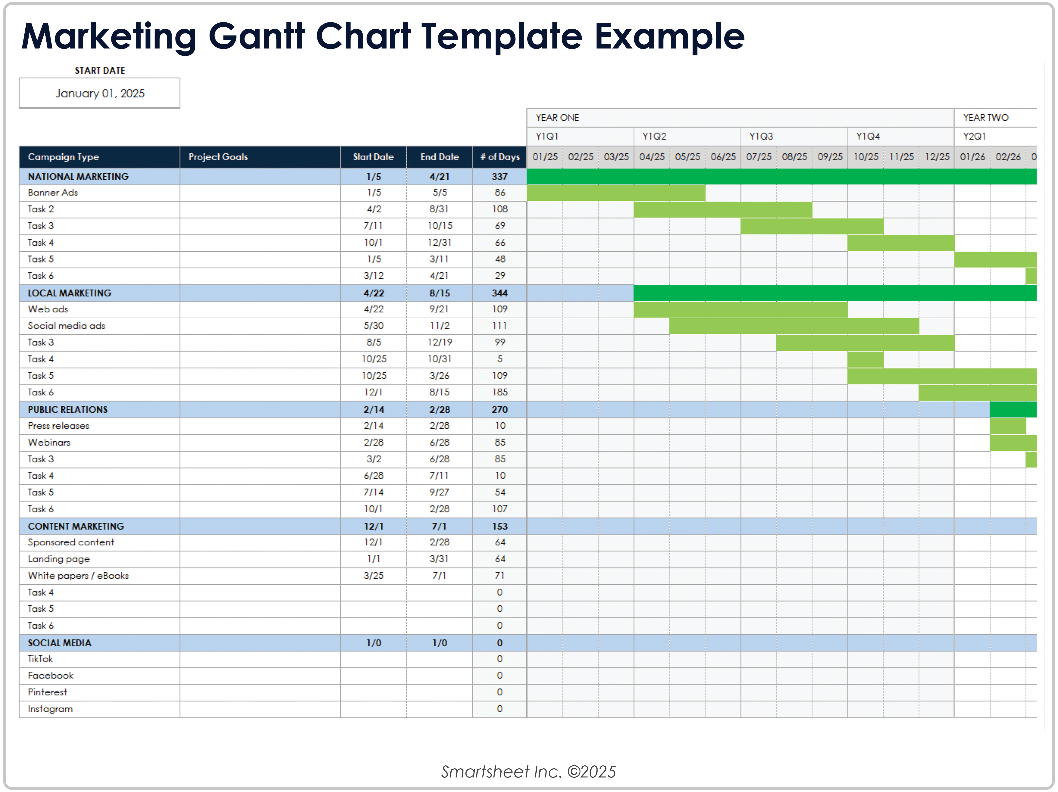

Chapter 2 – Literature Review

2.1 Overview of Previous Studies
Summarize relevant academic and industry works in the Information Systems field related to your topic.

2.2 Comparative Analysis
Compare existing systems or approaches, explain their strengths and weaknesses, and identify the gap your project addresses.

Example References (IEEE Style)
[1] J. Smith and R. Johnson, “Machine Learning Approaches for Predicting Parkinson’s Disease Progression,” IEEE Trans. Neural Syst. Rehabil. Eng., vol. 29, no. 8, pp. 1652–1661, 2021.
[2] L. Chen et al., “Anomaly Detection in Microservices Using Graph Neural Networks,” Proc. IEEE Int. Conf. Softw. Eng. (ICSE), 2022, pp. 1023–1035.
[3] M. Al-Mashaqbeh, “Artificial Intelligence in Healthcare: Predictive Modeling and Data Analytics,” IEEE Access, vol. 11, pp. 14500–14515, 2023.

Chapter 3 – Methodology
Describe the overall approach, system architecture, data sources, development tools, and testing strategy adopted for the project.
3.1 Research Design / Project Approach: Explain whether the project is qualitative, quantitative, hybrid, or purely implementation. Justify your choice.
3.2 Data Collection / Requirements Gathering: Describe how you gathered data or requirements (surveys, interviews, logs, existing systems), selection criteria, tools used.
3.3 System Design & Architecture: Present architecture diagrams, component descriptions, UML/flowcharts, technology stack.
3.4 Implementation Strategy: Outline how you built the system or model: development environment, iterations, version control, team roles.
3.5 Testing & Validation: Describe your validation methods (unit tests, integration tests, user acceptance, performance testing), metrics, how you measured success.
3.6 Ethical, Legal & Security Considerations: Address data privacy, regulatory compliance, security required by stakeholders.

Chapter 4 – Implementation and Evaluation
Explain how the system was developed, implemented, and evaluated. Include figures, screenshots, test results, and performance metrics relevant to the Information Systems domain.
4.1 Implementation
4.2 Evaluation
4.3 Individual and Group Contributions
Project Tasks & Task Assignments
TASK | DETAILS | ASSIGNED TEAM MEMERS
PROJECT SETUP
PROJECT PROPOSAL
REQUIREMENTS GATHERING AND ANALYSIS
SYSTEM DESIGN
DEVELOPMENT
TESTING & VALIDATION
DEPLOYMENT
FINAL REPORT & PRESENTATION

Chapter 5 – Conclusion and Future Work
Summarize major outcomes, highlight the contribution of your system, and suggest future enhancements or research directions.

References
Use IEEE citation style consistently for all in-text citations and the reference list.

Appendices
- Appendix A: Standards & Constraints Matrix
- Appendix B: Test Reports & Validation Results
- Appendix C: System Screenshots / Interface Designs
- Appendix D: Poster / Presentation Slides

