AUTOMATION TEST REPORT – BLAZEDEMO FLIGHT BOOKING PROJECT

Prepared By
Shivam Pal

Framework
Selenium WebDriver + Java + TestNG + Maven + Page Object Model (POM)

Project Type
Web Automation Testing

GitHub Repository-

https://github.com/Mrshivam09/Wipro_Capstone

1. Project Overview
The BlazeDemo Flight Booking Automation Project is developed to automate the complete flight booking process of the BlazeDemo web application. The primary objective of this project is to reduce manual testing effort, improve test execution speed, increase accuracy, and validate the end-to-end booking workflow through automation.
The framework is built using Selenium WebDriver with Java and follows the Page Object Model (POM) design pattern. The project automates important functionalities such as flight search, flight selection, passenger information entry, booking confirmation, screenshot capture, report generation, and result validation.
The framework also supports Data-Driven Testing using Excel files and generates detailed execution reports using TestNG and Extent Reports. Additionally, Continuous Integration and Continuous Deployment (CI/CD) practices have been implemented using Jenkins.

2. Objectives of the Project
The main objectives of this automation project are:
- Automate the complete flight booking workflow.
- Reduce repetitive manual testing activities.
- Improve test execution efficiency.
- Validate application functionality across multiple test data sets.
- Generate detailed execution reports.
- Integrate automation execution with Jenkins.
- Demonstrate industry-standard automation framework practices.

3. Technologies Used
The following technologies and tools were used during the development of this automation framework:
- Java
- Selenium WebDriver
- TestNG
- Maven
- Apache POI
- Page Object Model (POM)
- Git
- GitHub
- Jenkins
- Extent Reports
- Eclipse IDE

4. Framework Architecture
The automation framework follows the Page Object Model (POM) design pattern, which improves code reusability, maintainability, and scalability.

Project Structure

Base Package
Contains browser initialization and teardown methods.

Pages Package
Contains page classes representing application web pages.
- HomePage
- FlightSelectionPage
- PurchasePage
- ConfirmationPage

Tests Package
Contains all test execution classes.
- LaunchTest
- CrossBrowserTest
- SearchFlightTest
- FlightBookingTest

Utilities Package
Contains reusable utility classes.
- ConfigReader
- ExcelUtil
- ScreenshotUtil
- ExtentManager

Listeners Package
Contains TestNG listener implementation.
- TestListener

DataProviders Package
Signifies Data Driven approach.
- BookingDataProvider

Resources
Contains test data and configuration files.
- PassengerData.xlsx
- config.properties

5. Test Scenarios Automated

Scenario 1: Application Launch

Description
Verify that the BlazeDemo application launches successfully and the home page is displayed.

Steps
- Launch the browser.
- Navigate to the BlazeDemo URL.
- Verify the page title.

Expected Result
The BlazeDemo home page should open successfully with the correct title.

Scenario 2: Search Flights

Description
Verify that users can search for available flights by selecting departure and destination cities.

Steps
- Open the BlazeDemo application.
- Select the departure city.
- Select the destination city.
- Click on Find Flights.

Expected Result
The list of available flights should be displayed successfully.

Scenario 3: Complete Flight Booking

Description
Verify that users can complete flight booking successfully.

Steps

Read passenger details from Excel.

Enter passenger information.

Enter payment details.

Click Purchase Flight.

Expected Result
The booking should be completed successfully.

Scenario 4: Validate Booking Confirmation

Description
Verify that the booking confirmation page is displayed after successful booking.

Steps
- Complete the booking process.
- Navigate to the confirmation page.
- Validate the confirmation message.

Expected Result
The message "Thank you for your purchase today!" should be displayed successfully.

Scenario 5: Data-Driven Testing

Description
Verify the flight booking functionality using multiple test data records stored in an Excel file.

Steps
- Read multiple rows from the Excel sheet.
- Execute the booking flow for each record.
- Validate successful booking.

Expected Result
All Excel data sets should execute successfully without errors.

Scenario 6: Cross Browser Testing

Description
Verify that the application works correctly on multiple browsers.

Expected Result
The application should function correctly and tests should pass on all supported browsers.

6. Reporting Mechanism
The framework generates multiple reports for execution tracking and analysis.

TestNG Report
Location:
test-output/index.html
Features:
- Total Tests Executed
- Passed Tests
- Failed Tests
- Skipped Tests
- Execution Summary

Extent Report
Location:
Reports/ExtentReport.html
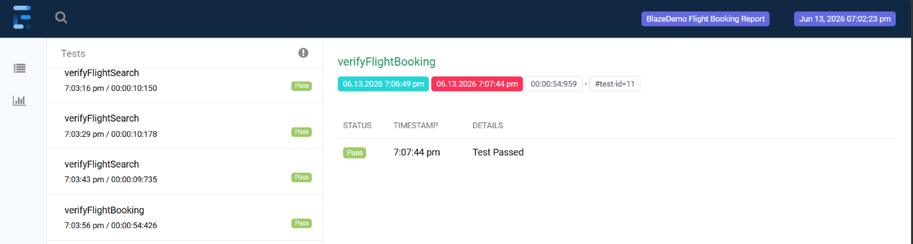
Features:
- Interactive Dashboard
- Pass/Fail Status
- Execution Timeline
- Detailed Logs
- Test Execution Summary
- Screenshot Integration

7. Screenshot Capture Functionality
The framework automatically captures screenshots during execution on failures and success .
Screenshots are captured for:
- Flight Search Page
- Flight Selection Page
- Purchase Page
- Confirmation Page
- Failed Test Cases
Benefits:
- Easier defect analysis
- Improved reporting
- Better execution evidence

8. Jenkins Integration
The automation framework is integrated with Jenkins Pipeline to enable continuous integration.

Jenkins Pipeline Stages
- Checkout Source Code
- Clean Project
- Build Project
- Execute TestNG Test Cases
- Data-Driven Test Execution
- Generate Extent Reports
- Publish Reports
- Archive Build Artifacts
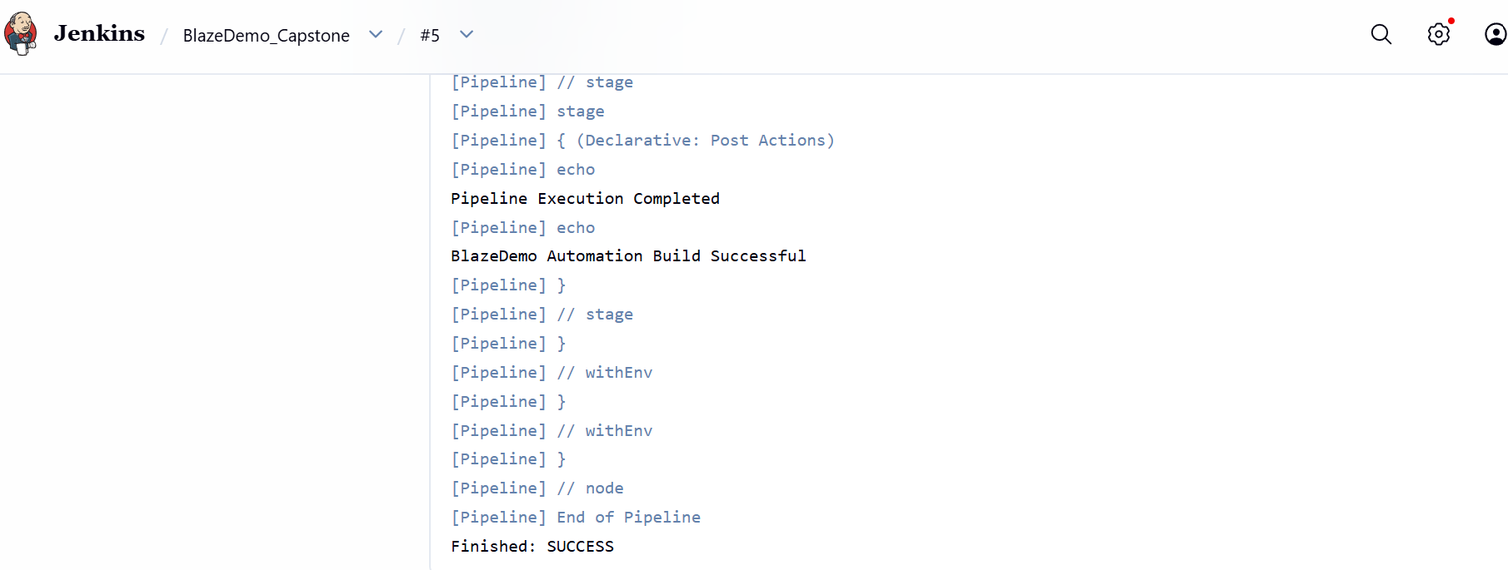
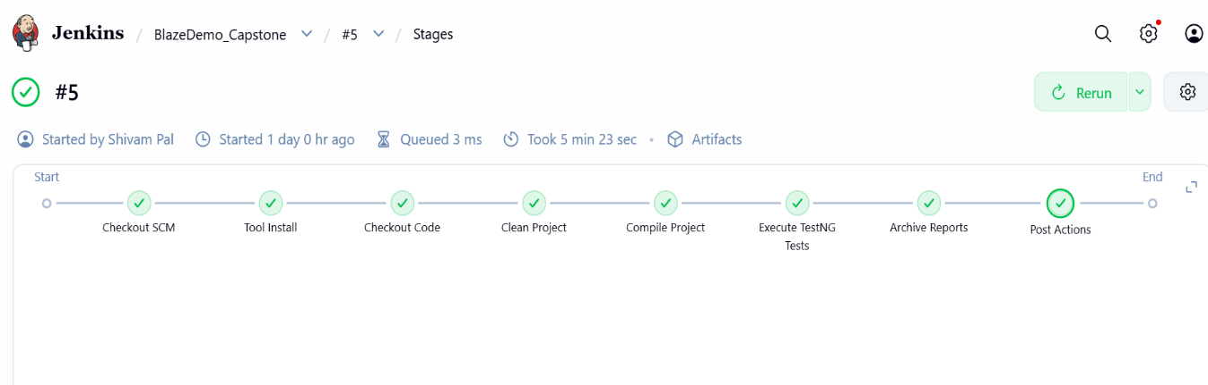

Benefits
- Automated execution
- Scheduled builds
- Faster feedback on code changes
- CI/CD implementation
- Easy monitoring of test results

9. Defects Identified During Testing
Several defects were identified during execution:
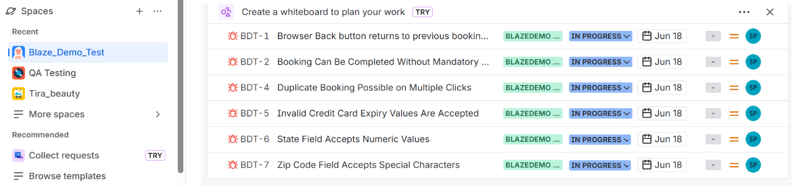

Defect 1
Browser Back Button Returns to Previous Booking Page.
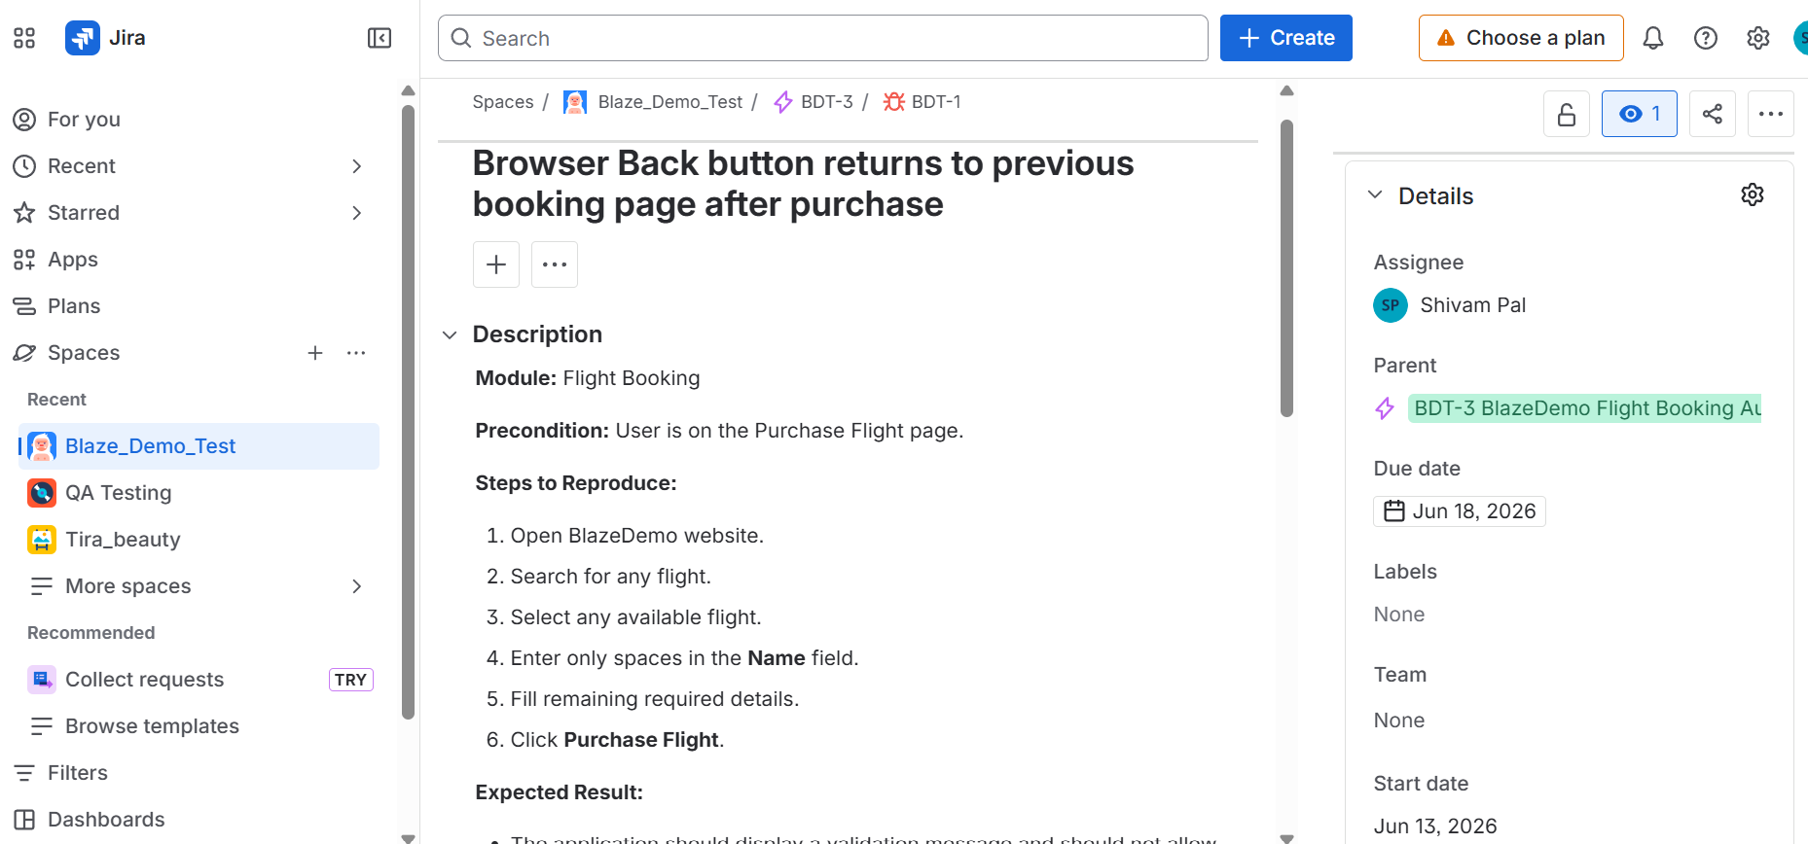

Defect 2
Booking Can Be Completed Without Mandatory Details.
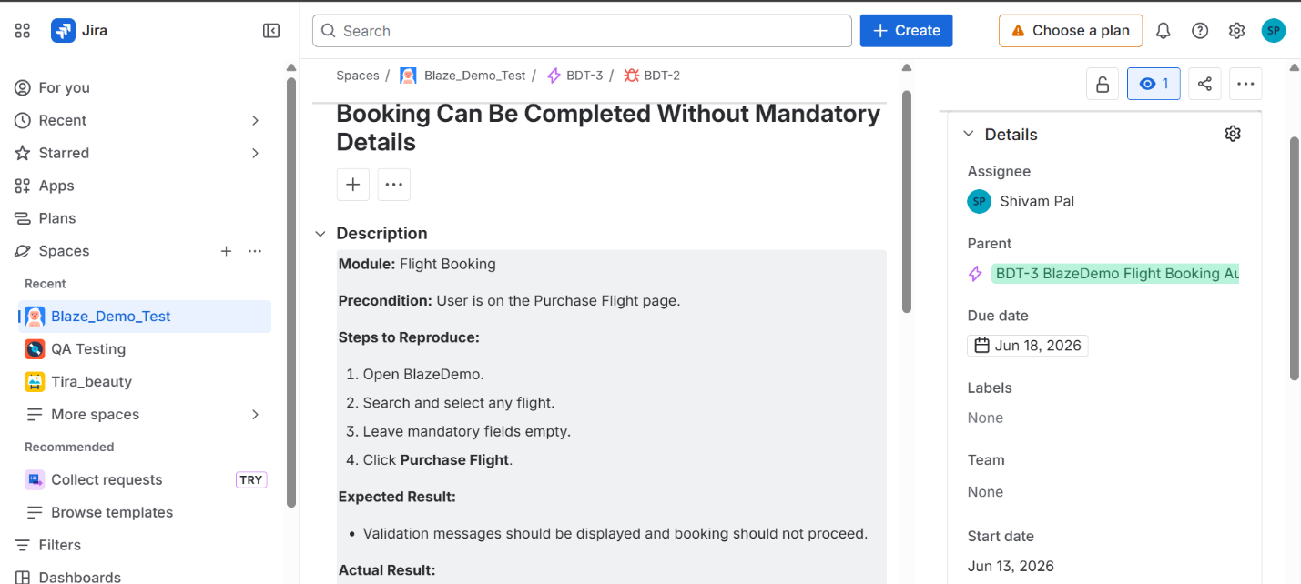

Defect 3
Duplicate Booking Possible on Multiple Clicks.
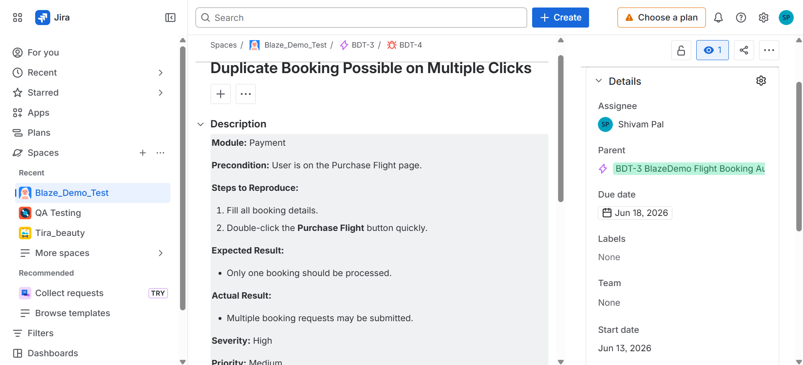

Defect 4
Invalid Credit Card Expiry Values Are Accepted.
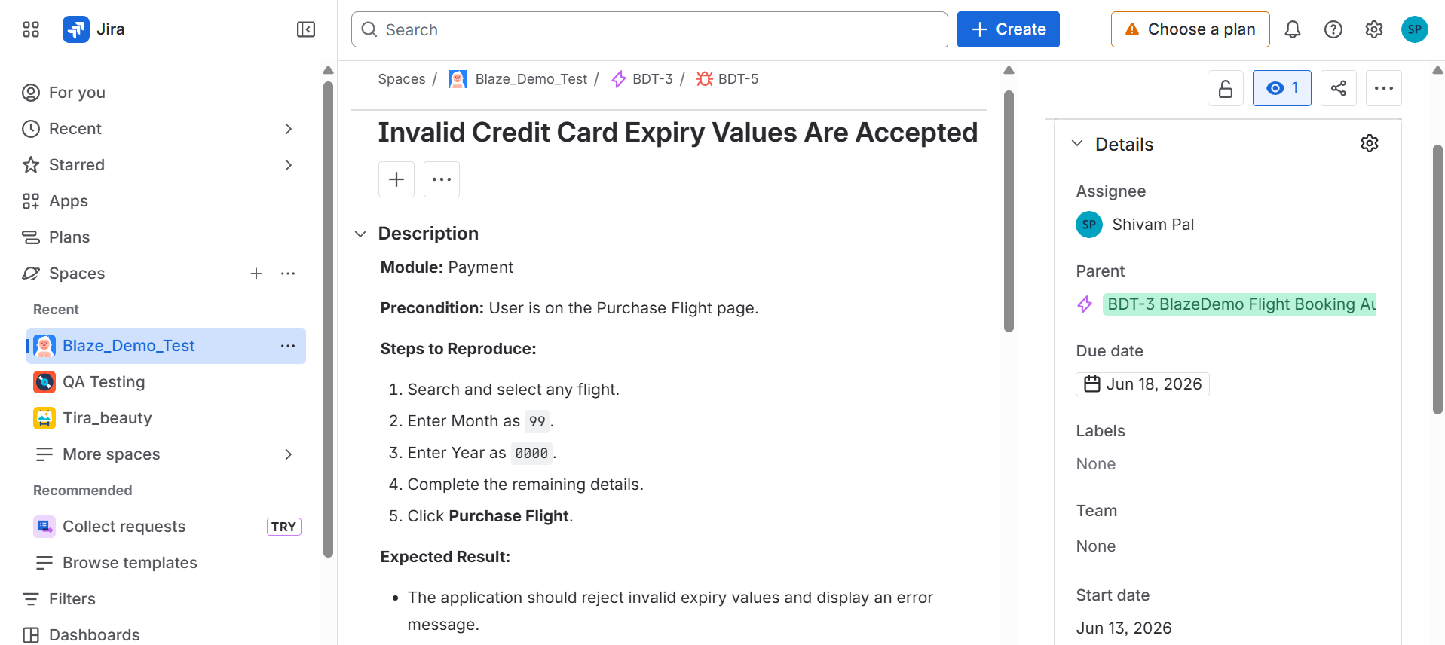

Defect 5
State Field Accepts Numeric Values.
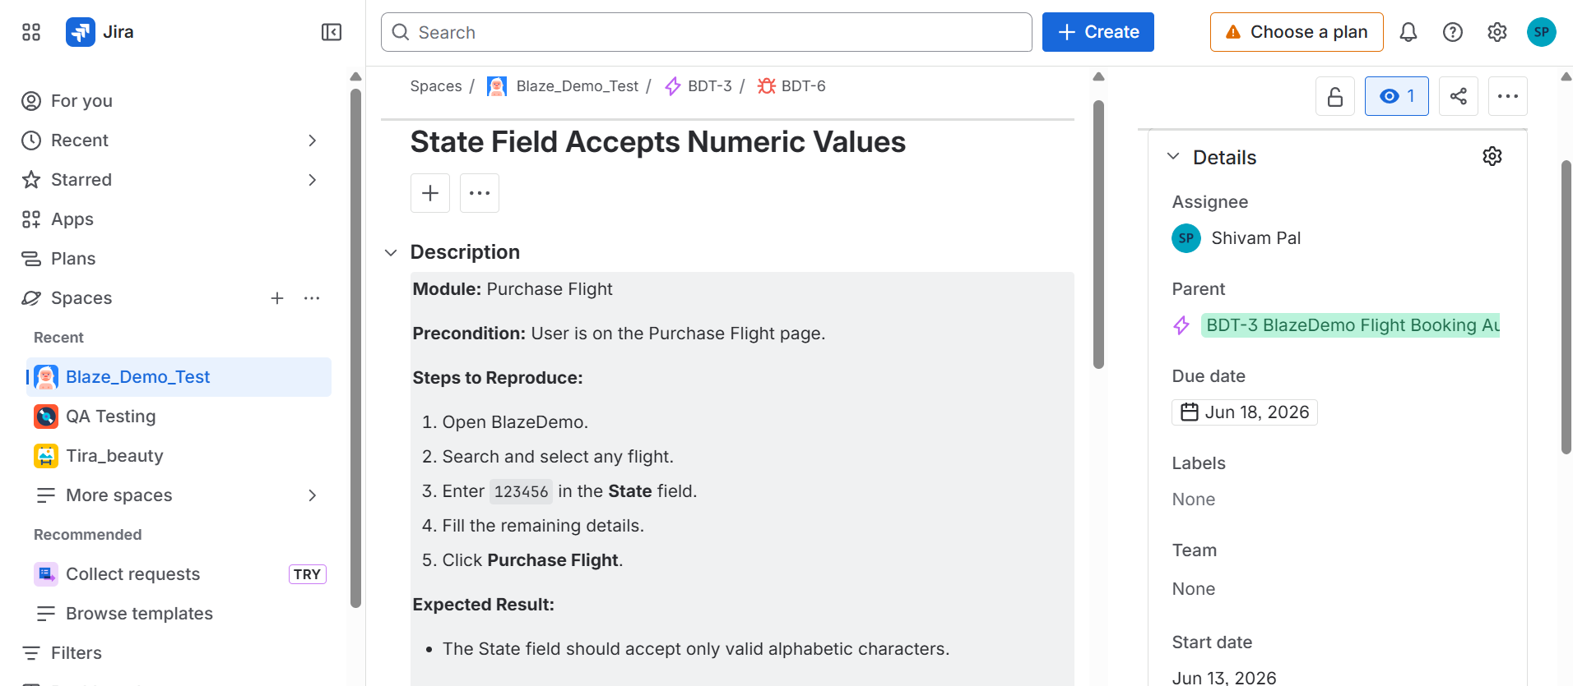

Defect 6

Zip Code Field Accepts Special Characters.

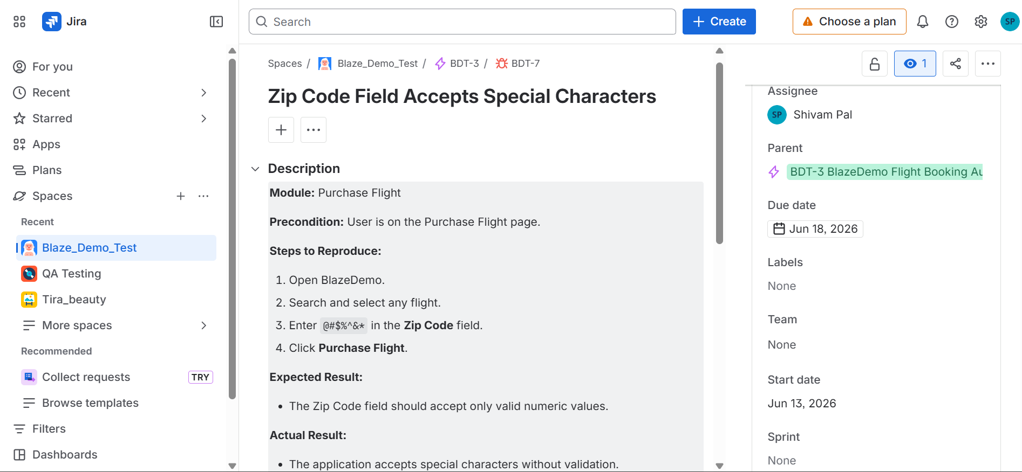

All defects were documented and tracked through Jira.

10. Challenges Faced and Solutions

Challenge 1
Cross-browser execution and browser driver compatibility issues.

Solution
Implemented WebDriverManager and browser-specific configuration using TestNG parameters for Chrome and Firefox execution.

Challenge 2
Reading multiple test data records from Excel.

Solution
Implemented Apache POI and TestNG Data Providers to support Data-Driven Testing with multiple datasets.

Challenge 3
Detailed reporting and execution evidence requirement.

Solution
Integrated Extent Reports with TestNG Listeners and automatic screenshot capture for test execution.

11. Project Achievements
- Developed Selenium WebDriver Automation Framework
- Implemented Page Object Model (POM)
- Implemented Data-Driven Testing using Excel
- Integrated TestNG Framework
- Implemented Cross-Browser Testing (Chrome & Firefox)
- Generated Extent Reports for test execution
- Implemented Automatic Screenshot Capture
- Externalized configuration using config.properties
- Integrated Jenkins for Continuous Integration (CI)
- Managed source code using Git and GitHub

12. Conclusion
The BlazeDemo Flight Booking Automation Framework successfully automates the complete flight booking process using Selenium WebDriver, Java, and TestNG. The framework follows the Page Object Model (POM) architecture to ensure code reusability and maintainability. It supports Data-Driven Testing using Excel and provides detailed execution reports through Extent Reports and TestNG. Cross-browser testing, screenshot capture, and Jenkins integration enhance the reliability and efficiency of the framework. Overall, the project demonstrates industry-standard automation testing practices and provides a scalable and maintainable solution for web application testing.

