DATA ANALYSIS REPORT
UK DEFRA Emission Factor Explorer & Carbon Calculator
Exploratory Data Analysis · Data Cleaning · Carbon Emission Calculator

Based on the UK DEFRA / BEIS Greenhouse Gas Conversion Factors 2026 dataset

Author: Data Analyst
Date: 24 September 2026

Table of Contents

If the table of contents is empty, right-click it in Word and choose “Update Field” → “Update entire table”.

1. Introduction

1.1 Background of emission factors
Emission factors convert an activity level (such as litres of fuel burned or kWh of energy consumed) into an equivalent quantity of greenhouse gases, normally expressed in kilograms of carbon-dioxide equivalent (kg CO2e). They are the arithmetic backbone of corporate carbon accounting under the GHG Protocol and national inventory systems.

1.2 Purpose of the DEFRA dataset
The UK government's Department for Environment, Food & Rural Affairs (DEFRA), together with BEIS, publishes annually-revised conversion factors for fuel combustion. This project builds a reliable, transparent toolchain on top of that export: to clean and validate it, to explore it interactively, and to apply it safely in emission calculations.

2. Project Objectives
- Produce a clean, reproducible dataset with a transparent data-quality report.
- Prevent analytical errors from comparing factors across incompatible activity units.
- Deliver a validated, unit-aware carbon emission calculator.
- Ship a modern, interactive Streamlit dashboard suitable for a professional portfolio.
- Automate generation of a chart-rich analytical report.

3. Dataset Description
The dataset comprises 221 emission factors described by 13 source columns, covering 11 distinct activity units, 2 GHG categories, 2 gas basis values and 2 GHG scopes.
Attribute | Value
Total rows (factors) | 221
Source columns | 13
Distinct activity units | 11
GHG categories | 2
Gas basis values | 2
GHG scopes | 2
Primary key | key (unique)
Data source | DEFRA_2026

3.1 Column descriptions
Column | Description
key | Stable dotted identifier for each emission factor (primary key).
name | Human-readable description of the fuel and activity.
value | The emission factor magnitude.
unit | Activity denominator, e.g. 'kg CO2e per litre'.
gas | Impact basis: CO2e (GWP-weighted) or CO2 (biogenic memo).
gwp_set | Global Warming Potential basis, e.g. AR5_100; null on biogenic memo rows.
ghg_scope | GHG Protocol scope: scope1 or outside_scopes.
ghg_category | Reporting category: stationary_combustion or biogenic_co2_memo.
source_id | Dataset edition identifier (DEFRA_2026).
source_ref | Cell provenance in the source workbook, e.g. 'Fuels'!D62.
retrieved | Date the factor was retrieved from the source.
note | Optional provenance and methodology caveats.
updated | Date the factor was last updated.

4. Data Cleaning
The raw CSV is treated as immutable; all transformations run on copies. Cleaning means normalise, validate and flag — never silently drop legitimate data.

4.1 Missing values
Column | Missing count | Missing %
gwp_set | 55 | 24.89
note | 109 | 49.32

`gwp_set` is null on 55 rows. These are the biogenic-CO2 memo factors, which are not GWP-weighted — a structural null by design, preserved rather than imputed. `note` is an optional provenance field. Unexpected nulls on core columns: 0.

4.2 Duplicate records
Exact duplicate rows removed: 0. Duplicate keys (flagged, not removed): 0.

4.3 Data-type corrections
- `value` coerced to a numeric type; non-numeric entries flagged (0 found).
- `retrieved` and `updated` parsed into proper datetime columns.
- Text fields trimmed, whitespace-collapsed and case-normalised to canonical spellings.

4.4 Data-quality issues & methodology
- Suspicious values flagged for review (never removed): 32.
- Outlier detection uses a robust z-score on log-transformed values plus a conservative Tukey fence, computed WITHIN each activity unit to respect incompatible scales.
- All legitimate DEFRA values — including genuinely high ones — are preserved.

5. Exploratory Data Analysis
Charts are generated directly from the cleaned dataset with matplotlib.

5.1 Composition
Record counts by category are always comparable, unlike raw magnitudes.
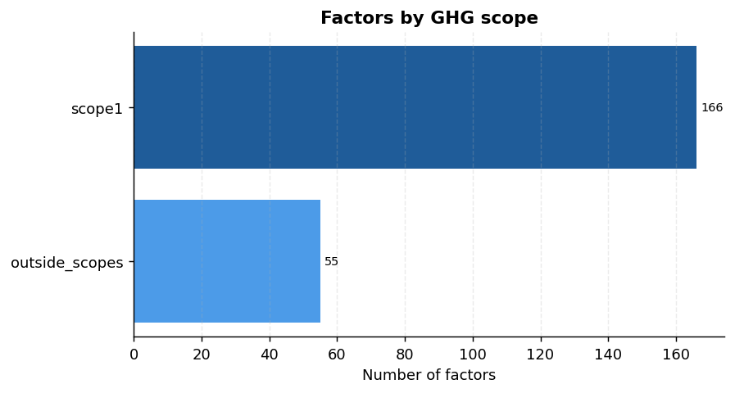
Figure 1 — Number of emission factors by GHG scope.
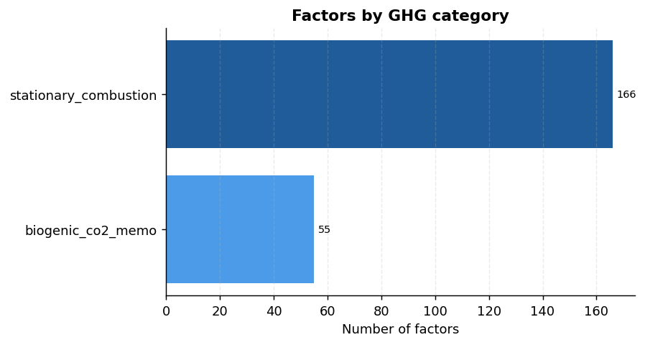
Figure 2 — Number of emission factors by GHG category.
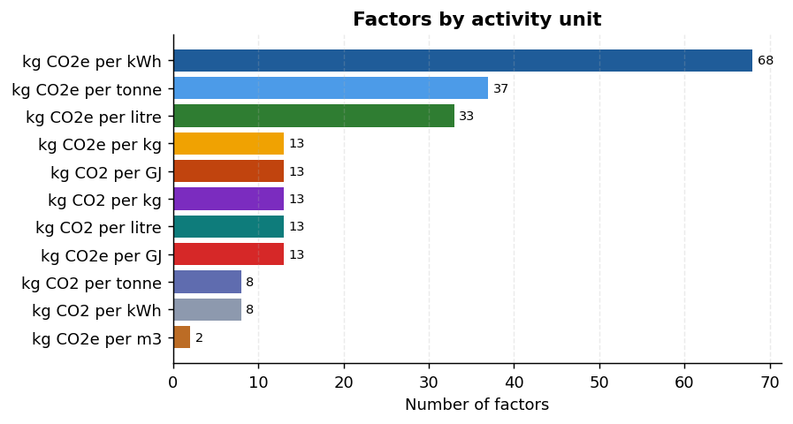
Figure 3 — Number of emission factors by activity unit.
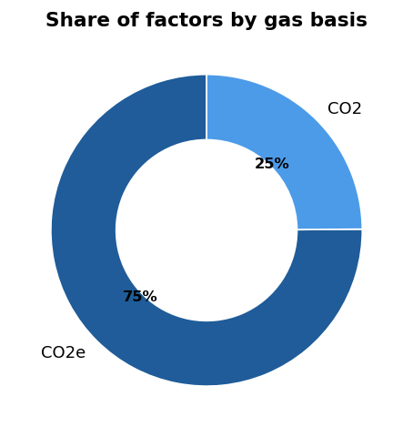
Figure 4 — Share of factors by gas basis.

5.2 Distribution (within a single unit)
Emission-factor magnitudes are only comparable within one unit. The distribution below shows the most common unit ('kg CO2e per kWh'): median 0.2555, mean 0.2392, min 0.0002, max 0.3767.
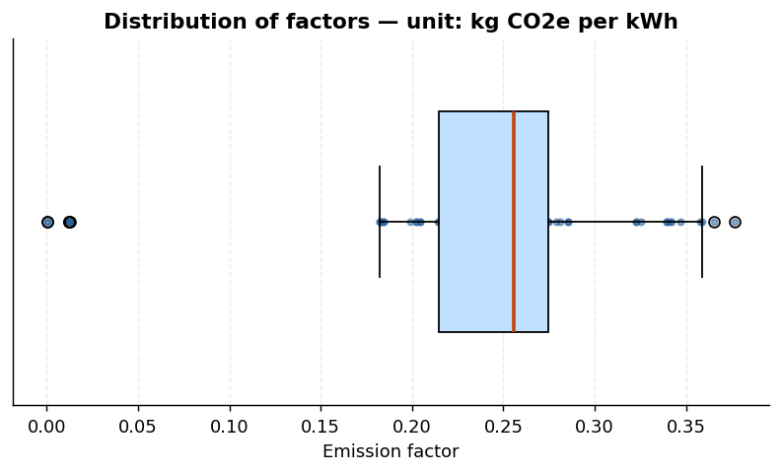
Figure 5 — Distribution of factors for unit 'kg CO2e per kWh'.
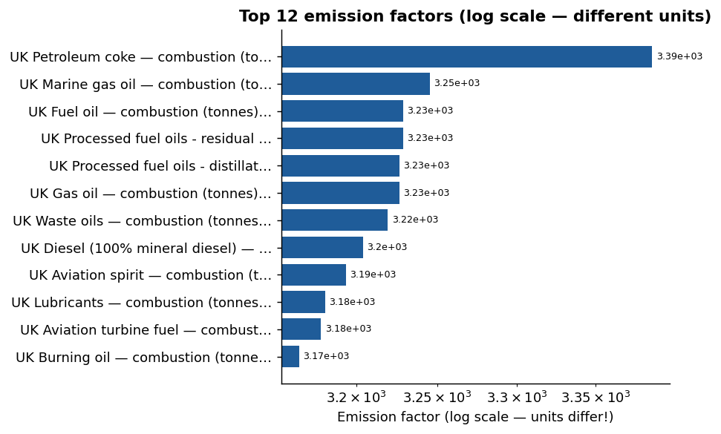
Figure 6 — Top 12 emission factors (log scale; units differ).

6. Emission Factor Analysis
Key statistics segmented by the reporting dimensions present in the dataset.

6.1 Breakdown by GHG scope
GHG scope | Count | Share %
scope1 | 166 | 75.1
outside_scopes | 55 | 24.9

6.2 Breakdown by GHG category
GHG category | Count | Share %
stationary_combustion | 166 | 75.1
biogenic_co2_memo | 55 | 24.9

6.3 Breakdown by Gas basis
Gas basis | Count | Share %
CO2e | 166 | 75.1
CO2 | 55 | 24.9

6.4 Breakdown by GWP set
GWP set | Count | Share %
AR5_100 | 166 | 75.1
(none) | 55 | 24.9

6.5 Extremes (contextualised by unit)
 | Name | Value | Unit
Highest | UK Petroleum coke — combustion (tonnes) | 3,386.5717 | kg CO2e per tonne
Lowest | UK Landfill gas — combustion non-CO2 (kWh) | 0.00020 | kg CO2e per kWh

Highest and lowest factors use different units; the comparison is descriptive only, not a ranking of climate impact.

7. Carbon Emission Calculator
Formula:
Emissions (kg CO2e) = Activity Amount × Emission Factor (kg CO2e per unit)
Emissions (tonnes CO2e) = Emissions (kg CO2e) ÷ 1000

7.1 Methodology
- The activity unit must match the emission factor's denominator; incompatible inputs are rejected.
- Negative, empty, non-numeric activity and non-positive factors are rejected.
- The underlying calculation methodology is fixed and never altered by the app.

7.2 Worked example (from the actual dataset)
Field | Value
Emission factor | UK Aviation spirit — combustion (litres)
Factor value | 2.33116 kg CO2e per litre
Activity amount | 100 litre
Result (kg CO2e) | 233.116
Result (tonnes CO2e) | 0.233116

Calculation: 100 × 2.33116 = 233.116 kg CO2e = 0.233116 tonnes CO2e.

8. Interactive Dashboard
The Streamlit application provides four sections with sidebar navigation:
- Overview — KPI cards, interactive Plotly charts and dynamically generated insights.
- Emission Factor Explorer — searchable, filterable table with filtered-data download.
- Carbon Calculator — unit-locked, validated emission computation with result export.
- Data Quality — dimensions, dtypes, missing values, duplicates, invalid and flagged records.
Screenshots can be captured by running 'streamlit run app.py' and pasted here.

9. Key Insights
The following factual insights were computed automatically from the dataset:
- 01. The dataset contains 221 DEFRA emission factors across 11 activity units.
- 02. The most common GHG category is 'stationary_combustion' with 166 factors (75% of the dataset).
- 03. The most frequently used activity unit is 'kg CO2e per kWh' (68 factors).
- 04. Factors by GHG scope -> scope1: 166, outside_scopes: 55.
- 05. The dataset covers 2 gas basis value(s): CO2e (166), CO2 (55).
- 06. GWP set information is present for 166 of 221 factors (75%); the remainder are biogenic-CO2 memo rows that are not GWP-weighted.
- 07. Highest single factor: 3,386.5717 kg CO2e per tonne (UK Petroleum coke — combustion (tonnes)).
- 08. Lowest single factor: 0.00020 kg CO2e per kWh (UK Landfill gas — combustion non-CO2 (kWh)).
- 09. Median factor within the dominant unit 'kg CO2e per kWh' is 0.2555.
- 10. All factors are attributed to source(s): DEFRA_2026 (221).
- 11. Provenance notes are attached to 112 factors (51%), documenting assumptions and paired keys.

10. Technologies Used
Technology | Role
Python 3.11 | Language / analysis runtime
pandas | Data loading, cleaning and manipulation
numpy | Numerical operations
Plotly | Interactive dashboard charts
matplotlib | Static charts embedded in this report
Streamlit | Interactive multi-page web dashboard
python-docx | Automated generation of this report

11. Project Architecture
A layered design separates concerns and keeps the modules independently testable:
- src/data_loader.py — locates the raw CSV (immutable) and the cleaned artefact.
- src/data_cleaning.py — the clean() pipeline and quality metrics.
- src/calculations.py — pure, dependency-free emission engine with validation.
- src/analysis.py — KPIs, dynamic insights and Plotly figure builders.
- src/report_charts.py — matplotlib figures for this report.
- src/ui.py — shared Streamlit helpers and cached data access.
- pages/ — the four dashboard screens driven by app.py navigation.
- tests/ — pipeline assertions and a headless AppTest smoke test.

12. Limitations
- A single snapshot of DEFRA 2026 fuel-combustion factors; no historical trend within the file.
- Factors are not cross-comparable across units; the tool enforces this but cannot convert fuels.
- The table of contents and page-number fields update when the document is opened in Word.

13. Future Improvements
- Multi-year factor comparison and change detection.
- Unit-conversion and fuel-mix modelling, plus Scope 2 and Scope 3 support.
- Business-intensity metrics and peer benchmarking.

14. Conclusion
This project demonstrates a complete, reproducible analyst workflow — from a raw government export through rigorous cleaning, unit-aware exploration and validated calculation, to an interactive dashboard and an automated report. It shows that a small, well-structured dataset can power trustworthy tools when data integrity, unit semantics and transparency are treated as first-class requirements.

15. Data Source / References
UK government, Greenhouse Gas Reporting: Conversion Factors 2026, Department for Environment, Food & Rural Affairs (DEFRA) and the Department for Energy Security & Net Zero (formerly BEIS). Emission factors are Crown data; verify against the official publication before formal reporting.

