PROJECT DOCUMENTATION
UK DEFRA Emission Factor Explorer & Carbon Calculator
Data Cleaning · Exploratory Analysis · Carbon Calculator · Streamlit Dashboard

Built on the UK DEFRA / BEIS Greenhouse Gas Conversion Factors 2026 dataset

Author: Data Analyst
Date: 24 September 2026

Table of Contents

If empty, right-click in Word → Update Field → Update entire table.

1. Introduction
The UK DEFRA Emission Factor Explorer & Carbon Calculator is an end-to-end data-analytics project that transforms a raw UK government emission-factor export into a trustworthy, interactive decision tool. It combines a reproducible data-cleaning pipeline, a rigorous exploratory analysis, a validated carbon calculation engine, and a modern Streamlit dashboard, together with an automated analytical report.
Every figure, table and insight presented in this document - and throughout the application - is derived directly from the uploaded dataset. No values are mocked or invented.

2. Objectives
- Produce a clean, reproducible dataset with a transparent data-quality report.
- Explore the emission factors interactively while preventing unit-incompatibility errors.
- Deliver a validated, unit-aware carbon emission calculator.
- Ship a modern, responsive dashboard suitable for a professional Data Analyst portfolio.
- Automate generation of chart-rich documentation and analysis reports.

3. Problem Statement
Organisations that report greenhouse gas emissions under the GHG Protocol need accurate, well-documented Scope 1 emission factors for fuel combustion. However, the raw DEFRA / BEIS conversion-factor exports are difficult to work with:
- They mix incompatible activity units (per kWh, per tonne, per litre, per GJ ...), so naive averaging or ranking across units is analytically invalid.
- They contain structural nulls (e.g. gwp_set absent on biogenic-CO2 memo rows) that are easily misread as missing data.
- Finding the correct factor and applying it to real activity data is error-prone.
- There is no single, transparent interface that both explains the data quality and computes emissions safely.
This project addresses these problems with a cleaned dataset, a unit-aware dashboard, and a validated calculator that makes correct usage the default.

4. Dataset
The dataset contains 221 emission factors described by 13 source columns. It splits into two mutually-exclusive segments: fossil factors (CO2e, scope1) and biogenic-CO2 memo factors (CO2, outside_scopes).
Attribute | Value
Total rows (factors) | 221
Source columns | 13
Distinct activity units | 11
GHG categories | 2
Gas basis values | 2
GHG scopes | 2
GWP sets present | 1
Primary key | key (unique)
Fossil segment | 166 factors (CO2e / scope1)
Biogenic memo segment | 55 factors (CO2 / outside_scopes)
Source | DEFRA_2026
Retrieved / updated | 2026-06-18 → 2026-06-18

4.1 Column descriptions
Column | Description
key | Stable dotted identifier for each emission factor (primary key).
name | Human-readable description of the fuel and activity.
value | The emission factor magnitude.
unit | Activity denominator, e.g. 'kg CO2e per litre'.
gas | Impact basis: CO2e (GWP-weighted) or CO2 (biogenic memo).
gwp_set | Global Warming Potential basis (e.g. AR5_100); null on biogenic memo rows.
ghg_scope | GHG Protocol scope: scope1 or outside_scopes.
ghg_category | Reporting category: stationary_combustion or biogenic_co2_memo.
source_id | Dataset edition identifier (DEFRA_2026).
source_ref | Cell provenance in the source workbook (e.g. 'Fuels'!D62).
retrieved | Date the factor was retrieved from the source.
note | Optional provenance and methodology caveats.
updated | Date the factor was last updated.

5. Technologies Used
The project is implemented in Python with the following libraries (actual installed versions):
Technology | Version | Role in the project
Python | 3.11.9 | Language and runtime
pandas | 2.3.3 | Data loading, cleaning and analysis
numpy | 2.3.5 | Numerical operations and outlier statistics
Plotly | 7.1.0 | Interactive dashboard charts
matplotlib | 3.10.7 | Static charts for documentation/reports
Streamlit | 1.64.0 | Interactive multi-page web dashboard
python-docx | 1.2.0 | Automated Word documentation & reports

6. Data Cleaning
The raw CSV is treated as immutable; all transformations run on copies. The cleaning philosophy is normalise, validate and flag - never silently drop legitimate data.

6.1 Cleaning methodology
- Column names standardised to snake_case.
- value coerced to numeric; non-numeric entries flagged.
- retrieved and updated parsed into proper datetime columns.
- Text fields (unit, gas, gwp_set, ghg_scope, ghg_category) trimmed, whitespace-collapsed and case-normalised to canonical spellings.
- Exact duplicate rows removed; duplicate keys flagged (never deleted).
- Structural nulls preserved and labelled; no imputation of missing scientific values.
- Suspicious values flagged for review, never removed.

6.2 Cleaning results
Quality metric | Result
Original rows | 221
Cleaned rows | 221
Exact duplicates removed | 0
Duplicate keys (flagged) | 0
Invalid (non-numeric) values | 0
Unexpected nulls on core columns | 0
gwp_set structural nulls (by design) | 55
Suspicious values flagged | 32

6.3 Missing values
Column | Missing count | Missing %
gwp_set | 55 | 24.89
note | 109 | 49.32

gwp_set is null on 55 biogenic-CO2 memo rows - a structural null by design, not a defect. note is an optional provenance field. No legitimate value was removed during cleaning.

7. EDA & Analysis
Exploratory analysis distinguishes two kinds of questions: record counts (always comparable) and magnitudes (comparable only WITHIN a single activity unit). The charts below are generated directly from the cleaned dataset.

7.1 Composition (record counts)
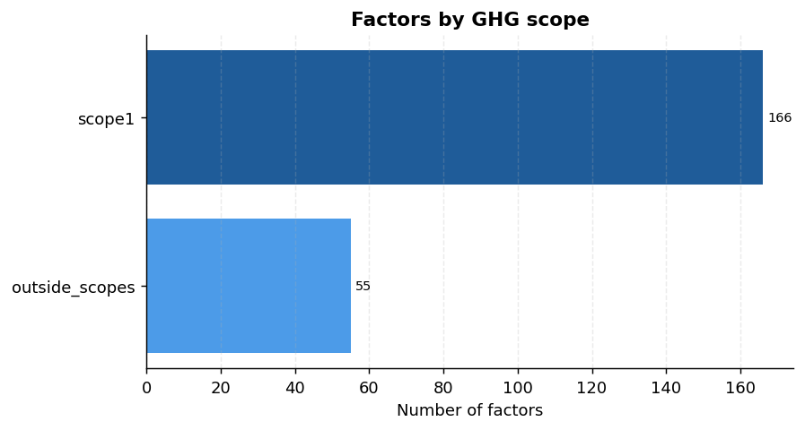
Chart 1 - Number of emission factors by GHG scope.
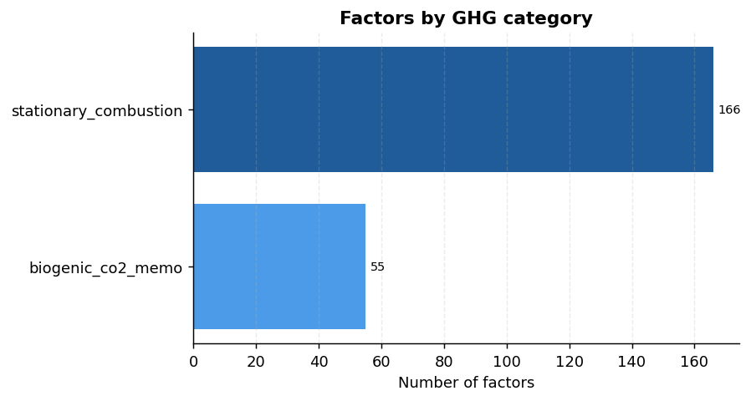
Chart 2 - Number of emission factors by GHG category.
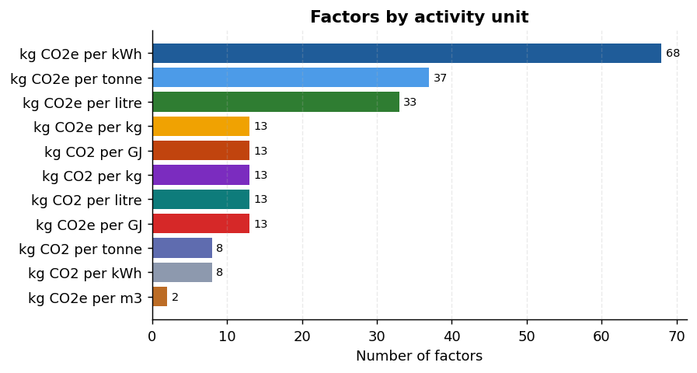
Chart 3 - Number of emission factors by activity unit.
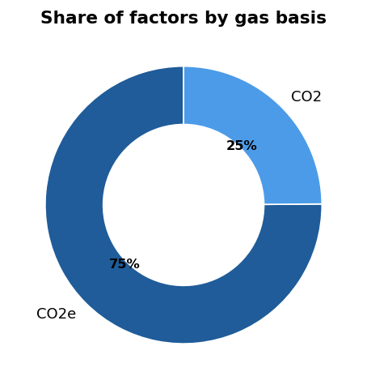
Chart 4 - Share of factors by gas basis.

7.2 Magnitude within a single unit
Because denominators differ, magnitudes are only interpreted one unit at a time. The distribution below shows the most common unit ('kg CO2e per kWh').
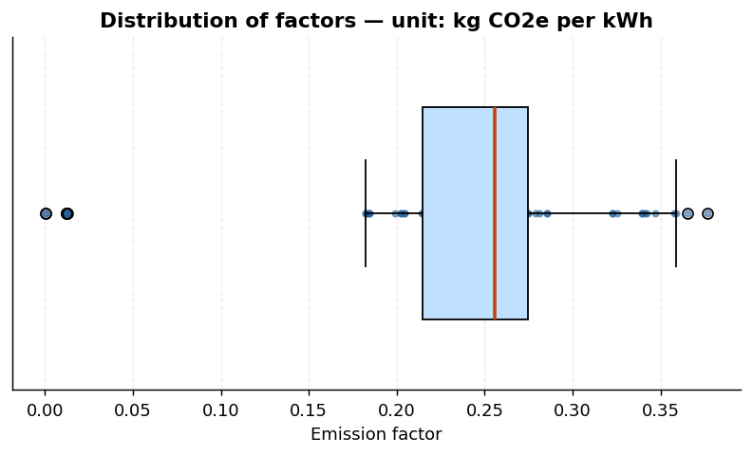
Chart 5 - Distribution of factors for unit 'kg CO2e per kWh'.
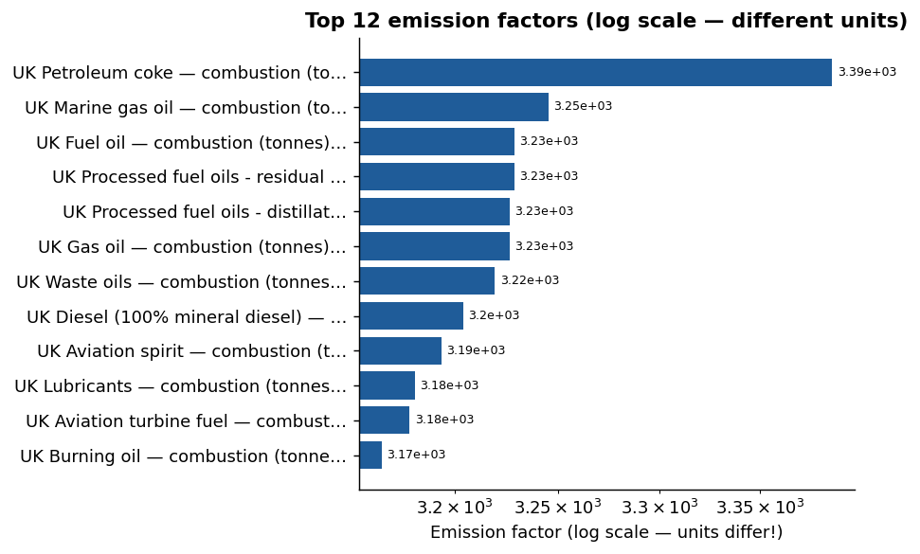
Chart 6 - Top emission factors (log scale; units differ).

7.3 Per-unit summary (illustrative)
Unit | Count | Min | Median | Max
kg CO2e per kWh | 68 | 0.0002 | 0.2555 | 0.3767
kg CO2e per tonne | 37 | 0.6977 | 2997.6323 | 3386.5717
kg CO2e per litre | 33 | 0.0021 | 1.7453 | 3.1749
kg CO2e per GJ | 13 | 0.0895 | 0.7234 | 5.0596
kg CO2e per kg | 13 | 0.0042 | 0.0318 | 0.1882
kg CO2 per GJ | 13 | 55.28 | 71.37 | 73.54

Note: these magnitudes must not be compared across rows - they use different denominators.

8. Emission Calculation Methodology
The calculator applies a fixed, standards-based formula:
Emissions (kg CO2e) = Activity Amount × Emission Factor (kg CO2e per unit)
Emissions (tonnes CO2e) = Emissions (kg CO2e) ÷ 1000

8.1 Validation rules
- The activity unit must match the emission factor's denominator; incompatible units are rejected.
- Negative, empty, or non-numeric activity amounts are rejected.
- Non-positive emission factors are rejected.
- The underlying methodology is fixed and is never altered by the application.

8.2 Worked example (from the actual dataset)
Field | Value
Emission factor | UK Aviation spirit — combustion (litres)
Factor value | 2.33116 kg CO2e per litre
Activity amount | 100 litre
Result (kg CO2e) | 233.116
Result (tonnes CO2e) | 0.233116

Calculation: 100 × 2.33116 = 233.116 kg CO2e = 0.233116 tonnes CO2e.

9. Dashboard Features
The Streamlit application provides four sidebar-navigated sections. It uses interactive Plotly charts with tooltips, KPI cards, formatted tables, and CSV download buttons.
Section | Purpose | Key features
Overview | Executive summary of the dataset | KPI cards, composition & distribution charts, dataset currency, 11 automatic insights, download
Emission Factor Explorer | Search & filter the catalogue | Text search, filters for scope/category/gas/GWP/unit, rich table, filtered download
Carbon Calculator | Compute CO2e from activity data | Factor picker, unit-locked activity input, validation, kg & tonnes CO2e, result export
Data Quality | Transparency on cleaning | Dimensions, dtypes, missing values, duplicates, invalid values, flagged outliers, provenance

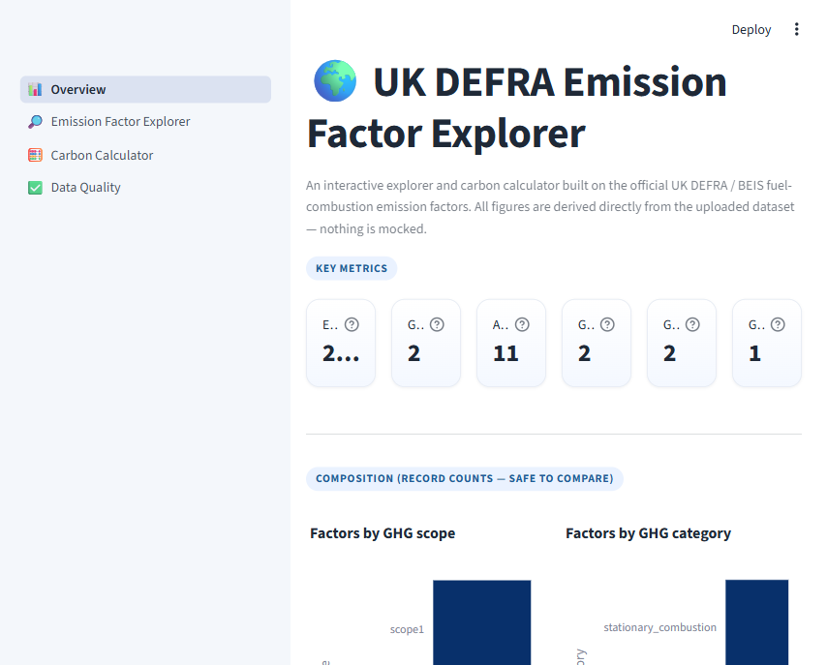
Screenshot 1 - Overview page of the live dashboard.
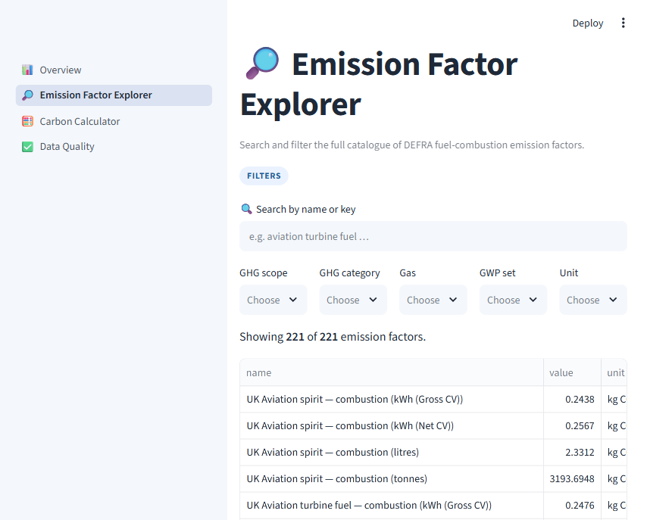
Screenshot 2 - Emission Factor Explorer page.

9.1 Project structure
defra-emission-dashboard/
├── app.py # Streamlit entry + navigation
├── data/defra_emission_factors_clean.csv
├── src/ data_loader · data_cleaning · calculations · analysis · report_charts · ui
├── pages/ overview · explorer · calculator · data_quality
├── scripts/ build_clean_dataset.py · build_report.py · build_documentation.py
├── reports/ figs/*.png · analysis & documentation .docx
├── tests/ test_pipeline.py · test_dashboard_smoke.py
├── requirements.txt
└── README.md

10. Key Insights
The following factual insights are computed automatically from the dataset (not hard-coded):
- 01. The dataset contains 221 DEFRA emission factors across 11 activity units.
- 02. The most common GHG category is 'stationary_combustion' with 166 factors (75% of the dataset).
- 03. The most frequently used activity unit is 'kg CO2e per kWh' (68 factors).
- 04. Factors by GHG scope -> scope1: 166, outside_scopes: 55.
- 05. The dataset covers 2 gas basis value(s): CO2e (166), CO2 (55).
- 06. GWP set information is present for 166 of 221 factors (75%); the remainder are biogenic-CO2 memo rows that are not GWP-weighted.
- 07. Highest single factor: 3,386.5717 kg CO2e per tonne (UK Petroleum coke — combustion (tonnes)).
- 08. Lowest single factor: 0.00020 kg CO2e per kWh (UK Landfill gas — combustion non-CO2 (kWh)).
- 09. Median factor within the dominant unit 'kg CO2e per kWh' is 0.2555.
- 10. All factors are attributed to source(s): DEFRA_2026 (221).
- 11. Provenance notes are attached to 112 factors (51%), documenting assumptions and paired keys.

11. Testing
The project ships with automated checks executed in two scripts: a logic/pipeline test and a headless dashboard smoke test using Streamlit's AppTest. A live server boot was also verified (health endpoint returned HTTP 200).
Test | What it checks | Result
Cleaning pipeline | 221 rows, 0 duplicates, 0 invalid, 0 core nulls, unique key, values>0 | PASS
Example calculation | 100 × 2.33116 → 233.116 kg CO2e / 0.233116 t CO2e | PASS
Input validation | Rejects negative/empty/non-numeric activity, zero factor, incompatible unit | PASS
Dynamic insights | At least 10 factual insights generated from data | PASS
Chart builders | 6 Plotly figures render without error | PASS
Dashboard smoke test | app navigation + all 4 pages run headless with no exceptions | PASS
Live server | streamlit run app.py → /_stcore/health returns 200 | PASS

Example assertion verified: kg=233.116, tonnes=0.233116.

12. Limitations
- A single snapshot of the DEFRA 2026 fuel-combustion factors; no historical trend within the file.
- Factors are not cross-comparable across units; the tool enforces this but cannot convert between fuels.
- Coverage is limited to fuel-combustion Scope 1 (plus biogenic memo) factors - no Scope 2/3.
- The Word table of contents and page-number fields refresh when opened in Word.

13. Future Scope
- Multi-year factor comparison and change detection.
- Unit conversion and fuel-mix modelling.
- Scope 2 and Scope 3 emission-factor support.
- Business-intensity metrics (kg CO2e per £ / per unit produced) and benchmarking.
- Scheduled refresh from the official publication and exportable static reports.

14. Conclusion
This project demonstrates a complete, reproducible analyst workflow - from a raw government export of 221 emission factors, through rigorous cleaning and unit-aware exploration, to a validated carbon calculator, an interactive dashboard, and automated documentation. By treating data integrity, unit semantics and transparency as first-class requirements, it shows how a modest but well-structured dataset can power trustworthy, portfolio-grade tools.

15. References
- UK government, Greenhouse Gas Reporting: Conversion Factors 2026 - DEFRA and DESNZ (formerly BEIS).
- GHG Protocol Corporate Accounting and Reporting Standard (Scope 1 stationary combustion).
- IPCC AR5 (AR5_100) global warming potential set referenced in the dataset.
- Streamlit documentation - https://docs.streamlit.io
- Plotly Python - https://plotly.com/python
- pandas documentation - https://pandas.pydata.org
Emission factors are Crown data; verify against the official publication before formal reporting.

