Week 3: Data Visualization and Reporting
Internship Project: YuvaIntern Data Analytics

1. Project Objective
The objective of this project is to analyze the Online Retail dataset using Python visualization libraries and identify useful sales trends, product performance, and relationships between numerical variables.

2. Tools and Technologies
Python, Pandas, Matplotlib, Seaborn, and Jupyter Notebook.

3. Visualizations and Insights

Monthly Revenue Trend
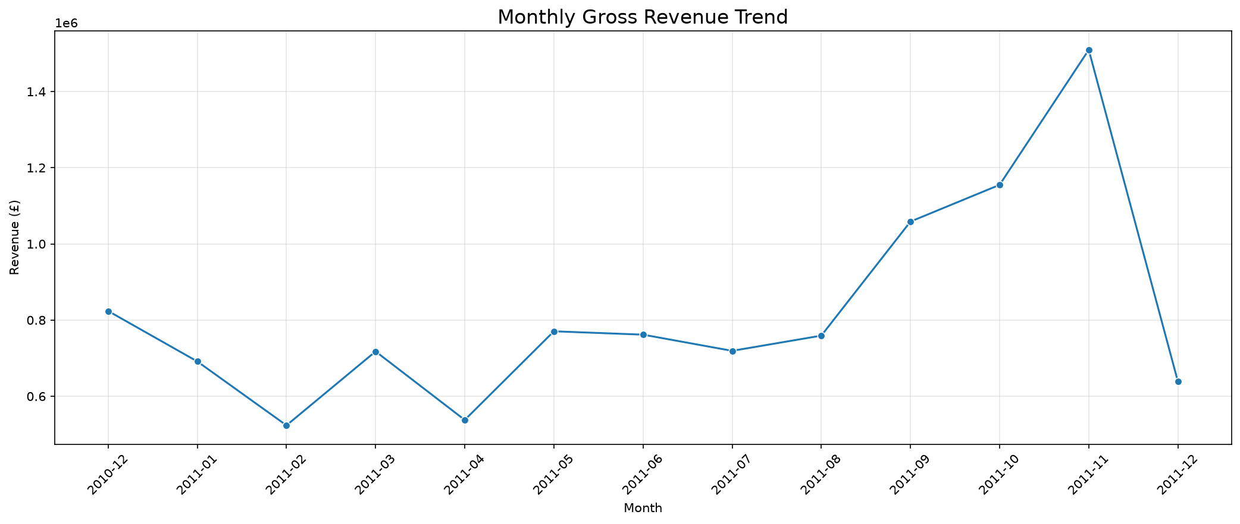
Monthly gross revenue trends help identify periods of higher and lower sales. Investigate seasonal patterns and changes over time.

Top 10 Products by Revenue
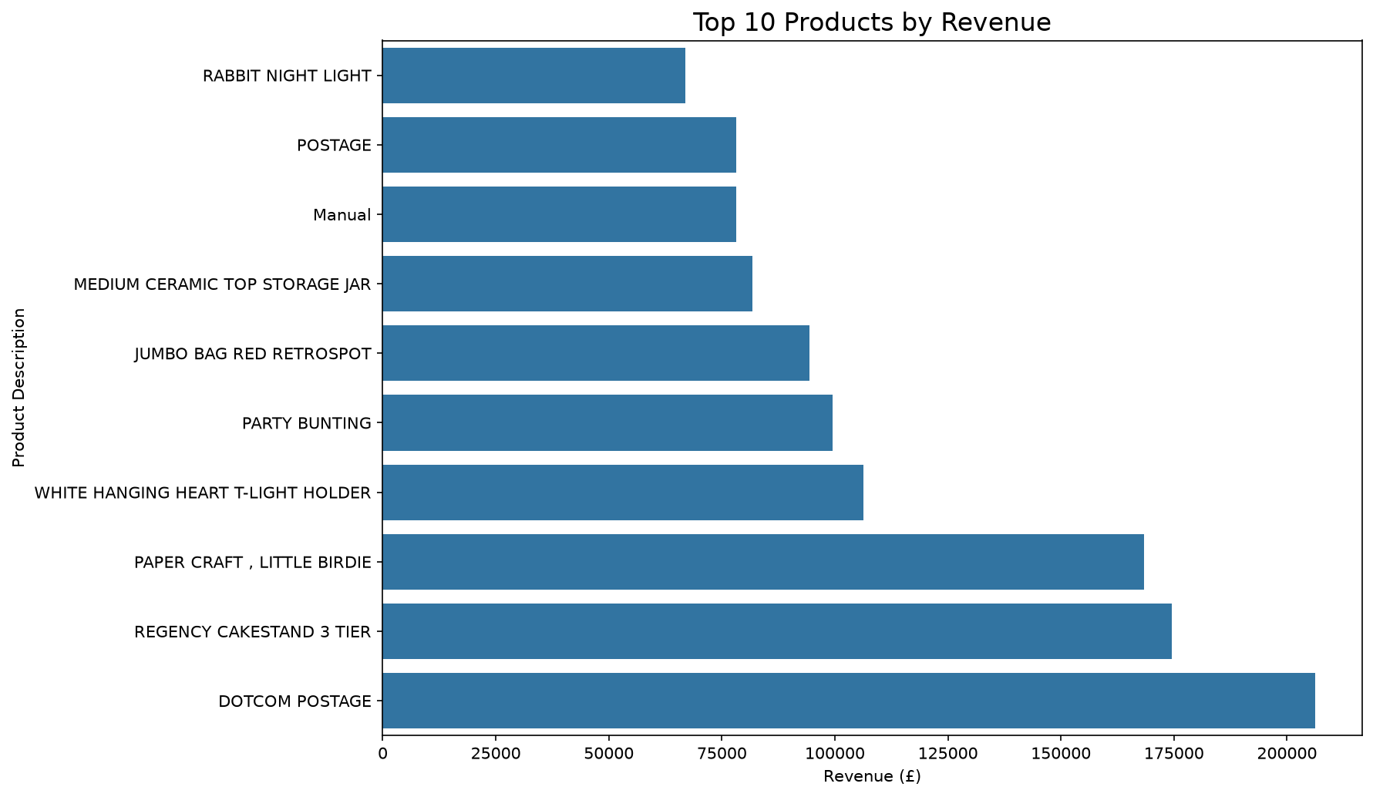
This chart compares the ten products with the highest gross revenue. Strong-performing products may deserve closer inventory and sales monitoring.

Quantity vs Revenue
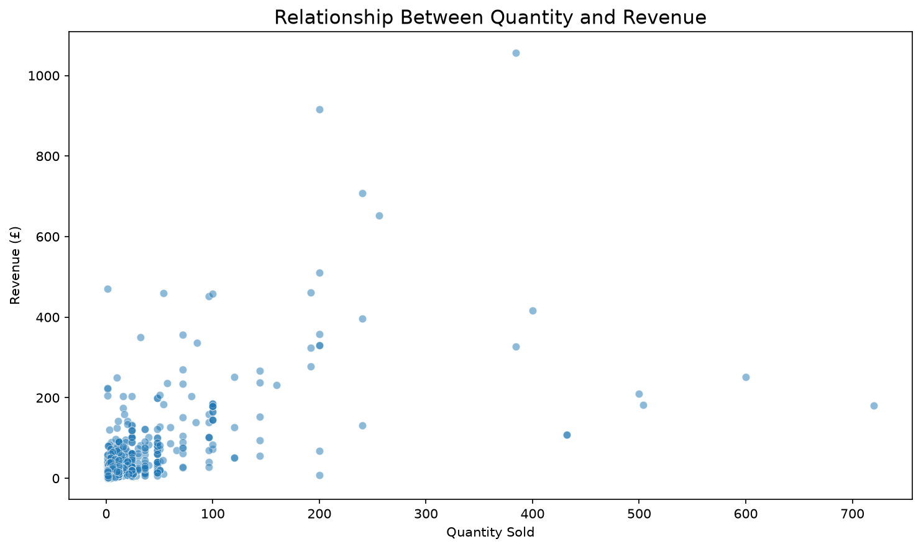
The scatter plot shows the relationship between quantity sold and revenue. Individual points represent sales records, and distant points may require further review.

Sales Correlation Heatmap
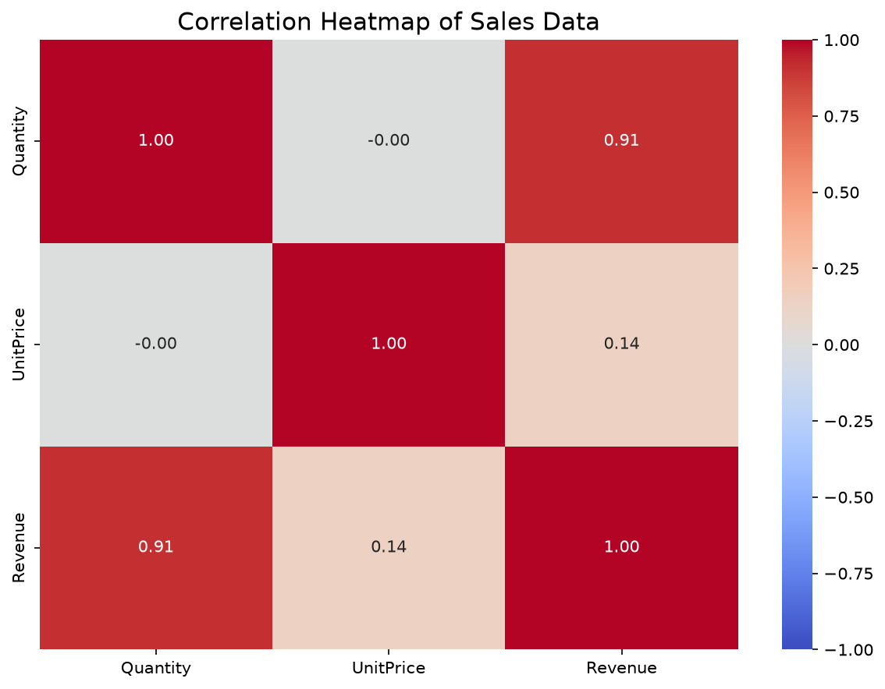
The heatmap summarizes correlations between Quantity, UnitPrice, and Revenue. Correlation describes association and does not establish causation.

4. Key Findings
The highest-revenue month was 2011-11, with gross revenue of £1,509,496.33.
The lowest-revenue month was 2011-02, with gross revenue of £523,631.89.
The top product by revenue was 'DOTCOM POSTAGE', generating £206,248.77.
The correlation between Quantity and Revenue was 0.91.

5. Business Recommendations
- Investigate low-revenue months to understand possible causes.
- Monitor top-performing products and maintain suitable stock.
- Analyze returns and cancellations separately from gross sales.
- Use regular dashboards to monitor sales performance.
- Validate findings before making business decisions.

6. Limitations
Gross revenue was calculated using records with positive quantities and positive unit prices. Returns and cancellations require separate analysis. Product descriptions are used as product identifiers because the dataset has no separate category column. Findings describe the available data and should not be interpreted as proof of causation.

