Week 5: Machine Learning Algorithms and Model Evaluation
YuvaIntern Data Analytics Internship

1. Project Objective
The objective was to build and evaluate a machine learning model using the Online Retail dataset. A Random Forest Regressor was trained to predict the next recorded sales observation's quantity for a product.

2. Tools and Technologies
Python, Pandas, NumPy, scikit-learn, Matplotlib, Seaborn, and python-docx.

3. Data Preprocessing
Invoice dates and numeric columns were converted to appropriate types. Rows with missing essential fields, non-positive quantities, and non-positive unit prices were excluded. Daily product-level sales features were created, and the next recorded observation's quantity was used as the prediction target.

4. Algorithm Selection
Random Forest Regression was selected because it can model nonlinear relationships and interactions without requiring feature scaling. The model used daily quantity, average unit price, and transaction count as input features.

5. Model Training and Hyperparameter Tuning
The data was sorted chronologically and split into earlier training observations and later test observations. RandomizedSearchCV tested combinations of n_estimators, max_depth, min_samples_split, and min_samples_leaf using three time-based cross-validation splits. The selection metric was mean absolute error.
Selected parameters: {'n_estimators': 100, 'min_samples_split': 10, 'min_samples_leaf': 1, 'max_depth': 5}
Best cross-validation MAE: 18.5865

6. Model Evaluation
Metric | Value
MAE | 20.1984
RMSE | 61.9946
R-squared | 0.0952
MAE represents average absolute prediction error. RMSE penalizes larger errors more strongly. R-squared describes the variation explained by the model and can be negative on unseen data.

7. Visualizations
Figure 1. Actual versus predicted quantity
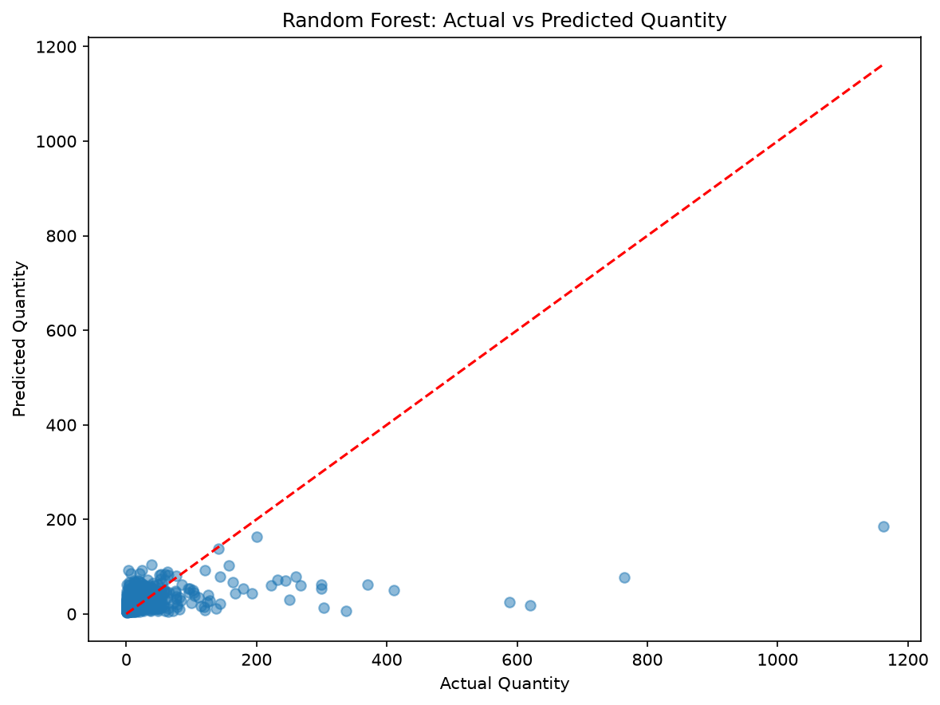
Figure 2. Random Forest feature importance
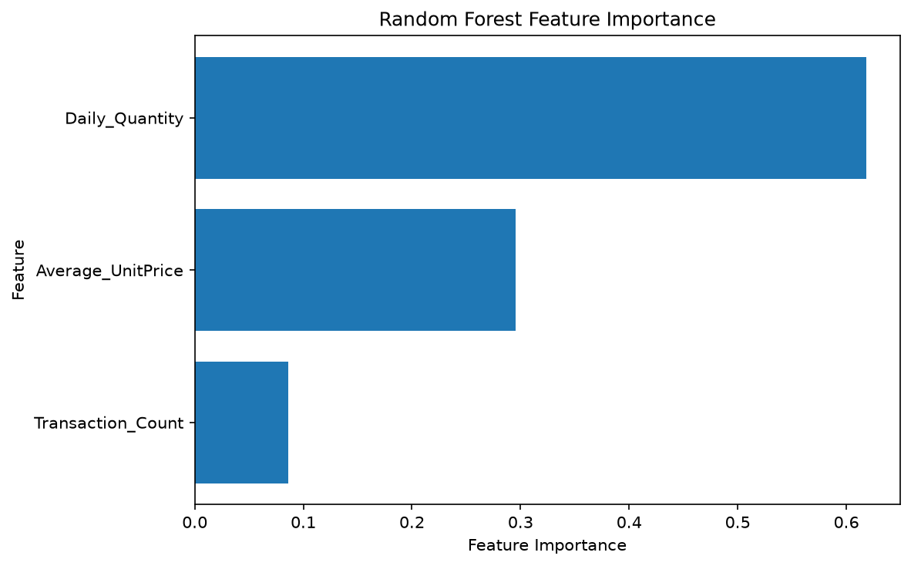

8. Limitations
The target represents the next recorded sales observation for a product, not necessarily the next calendar day. The dataset may omit days when a product had no recorded sales. The current features also do not include explicit product identity, calendar effects, or lagged sales history. Therefore, this model should not be treated as a production-ready demand forecasting system.

9. Recommendations for Improvement
Future work could build a complete product-date calendar, include zero-sales days, add lagged sales and calendar features, compare against a simple baseline, and validate the model on a later time period. Performance should be interpreted using the actual test metrics and the scale of the target.

10. Conclusion
The tuned Random Forest achieved test MAE of 20.1984, RMSE of 61.9946, and R-squared of 0.0952. These results provide an initial evaluation of the chosen approach; further validation and feature engineering are recommended.

