END-TO-END DATA ANALYSIS PROJECT
Online Retail Transaction Analysis
YuvaIntern – Week 6 Final Project
Tools: Python, Pandas, Jupyter Notebook

Executive Summary

EXECUTIVE SUMMARY
Project Title: End-to-End Data Analysis of Online Retail Transactions
1. Project Overview
This project analyzes an online retail transaction dataset to understand
sales performance, customer purchasing patterns, product performance,
and business trends.
2. Project Workflow
The project follows an end-to-end data analytics workflow:
- Data Exploration
- Data Cleaning and Quality Checks
- Data Visualization
- Statistical Analysis
- Machine Learning and Predictive Modeling
- Business Insights and Recommendations
3. Tools Used
Python and Jupyter Notebook were used for data analysis, data processing,
visualization, statistical testing, and machine learning.
4. Key Findings
The final findings will be added after verifying the actual outputs
generated in Tasks 1–5. No unverified metrics or model results will be
reported.
5. Business Value
The analysis aims to support data-driven decisions related to sales
performance, product demand, customer behavior, and retail operations.
6. Limitations
The reliability of conclusions depends on data quality, the available
observation period, the analytical methods used, and the predictive
model's evaluation results.

Introduction and Objectives

1. INTRODUCTION
Online retail businesses generate transaction data that can help explain
sales performance, product demand, and customer purchasing behavior.
Analyzing this data can help businesses identify patterns, monitor
performance, and make informed operational decisions.
This project uses the Online Retail dataset and follows an end-to-end
data analytics workflow, from initial data exploration to predictive
modeling. The work consolidates the analyses performed during Weeks 1–5
of the internship.

2. PROJECT OBJECTIVES
The main objectives are:
1. Explore the dataset and understand its structure and data quality.
2. Identify missing values, duplicate records, and invalid transactions.
3. Prepare a cleaned dataset for analysis.
4. Visualize sales trends and product performance.
5. Apply statistical methods to examine relationships and differences.
6. Build and evaluate a machine learning model for sales-related
prediction.
7. Convert verified analytical findings into practical business
recommendations.

3. PROJECT SCOPE
The project covers transaction-level retail data, including invoice
dates, products, quantities, unit prices, and customer identifiers
where available.
The analysis is limited to the fields and time period available in
the dataset. Findings will be interpreted in the context of the
dataset and the methods used.

Data Exploration

2. DATA EXPLORATION
The dataset contains 541,909 rows and 8 columns.
Duplicate rows identified: 5,268
Total missing cells: 136,534
The dataset's columns and data types were examined to understand
the structure of the transaction records. Missing values and duplicate
records were identified as part of the initial data quality assessment.
The dataset overview metrics are saved in Data_Exploration_Summary.csv.

Data Cleaning

3. DATA CLEANING
Data cleaning was performed to improve the reliability of the
transaction data before visualization, statistical analysis,
and predictive modeling.
The cleaning workflow included:
1. Identifying and handling duplicate records.
2. Examining missing product descriptions and customer identifiers.
3. Checking transactions with zero or negative quantities.
4. Checking zero or negative unit prices.
5. Creating a revenue measure using quantity and unit price.
6. Identifying cancellation or return-related transactions.
7. Extracting date-related features for time-based analysis.
Data quality decisions should be documented carefully. Missing
customer identifiers do not necessarily mean that a transaction
is invalid. Similarly, negative quantities may represent returns
or cancellations and should be interpreted in context.
The cleaned dataset and quality-check results from Task 2 should
be used to report the exact number of rows removed, retained,
or modified. These figures must be verified from the actual
Task 2 outputs before the final report is submitted.

Data Visualization

4. DATA VISUALIZATION
Visualizations were created to communicate retail sales patterns and support business interpretation.
Charts and their purposes:
- Task3_Monthly_Revenue_Line_Chart.png
Purpose: Shows changes in revenue over time.
- Task3_Quantity_vs_Revenue_Scatter_Plot.png
Purpose: Examines the relationship between quantity and revenue.
- Task3_Sales_Correlation_Heatmap.png
Purpose: Summarizes correlations between selected numerical variables.
- Task3_Top_10_Products_Bar_Chart.png
Purpose: Compares the leading products by the selected sales measure.
- Task5_Actual_vs_Predicted.png
Purpose: Review the chart and document its specific finding.
- Task5_Feature_Importance.png
Purpose: Review the chart and document its specific finding.
Interpretation:
The final report should describe the patterns visible in each chart and include numerical claims only when they have been verified from the corresponding analysis outputs.

Statistical Analysis

5. STATISTICAL ANALYSIS
Statistical analysis was conducted to investigate patterns and
relationships in the online retail transaction data.
The analyses performed in Task 4 included:
1. Welch's t-test:
Used to compare average daily revenue between January and
February 2011. The result should be interpreted alongside
sample sizes, variability, and the selected significance level.
2. Pearson correlation:
Used to measure the linear association between quantity and
revenue. Correlation does not establish causation, and the
mathematical relationship between these variables should be
considered when interpreting the result.
3. Chi-square test:
Used to examine whether month and cancellation status were
statistically associated. Expected cell counts should be
checked when assessing the validity of the test.
4. Multiple linear regression:
Used to examine how quantity and unit price relate to revenue.
Because revenue is calculated from quantity and unit price,
this relationship is partly mathematical rather than evidence
of an independent business cause.

RESULTS AND INTERPRETATION
The actual test statistics, p-values, effect sizes where applicable,
and conclusions must be taken from the Task 4 output files.
No statistical significance claim should be made without checking
the corresponding results.

Machine Learning

6. MACHINE LEARNING
Objective
The objective of this stage was to build a machine learning model
to predict product quantity using historical online retail data.
Data Preparation
The transaction data was cleaned, and records with unsuitable
quantity or unit-price values were handled according to the
preprocessing approach used in Task 5. Product-level daily sales
observations were prepared for modeling.
Model Development
A Random Forest Regressor was trained to predict the quantity
associated with the next recorded observation. RandomizedSearchCV
and TimeSeriesSplit were used for model tuning and time-aware
validation.
Important Limitation
The next recorded observation does not necessarily represent the
next calendar day because days without recorded sales may be absent.
Predictions should therefore be interpreted according to the
dataset's observation structure.
Model Evaluation
The model should be evaluated using:
- Mean Absolute Error (MAE)
- Root Mean Squared Error (RMSE)
- R-squared (R²)
Actual evaluation scores and model comparisons must be taken from
the output files generated in Task 5. The report should not claim
that the model performs well without reviewing these metrics.
Feature Importance
Feature-importance results may help describe which model inputs
contributed most to its predictions. Feature importance does not
prove that a feature causes changes in sales.
Limitations
Model performance may be affected by returns, irregular transaction
timing, limited features, data quality, and changes in customer
demand. Performance on future data may differ from validation results.

Conclusion and Recommendations

7. CONCLUSION AND BUSINESS RECOMMENDATIONS
Conclusion
This project consolidates the main stages of an end-to-end data
analytics workflow using online retail transaction data. The work
covers data exploration, cleaning, visualization, statistical
analysis, and machine learning.
The combined workflow demonstrates how transaction data can be
prepared and analyzed to understand sales trends, product demand,
and relationships between retail variables.
Final conclusions about revenue trends, product performance,
statistical significance, and predictive accuracy should be based
on the verified results from Tasks 1–5.
Business Recommendations
1. Monitor Sales Trends
Review monthly revenue and transaction patterns regularly to
identify changes in sales performance.
2. Review Product Performance
Use product-level sales reports to help plan inventory and
prioritize products based on verified demand.
3. Improve Data Quality
Establish checks for missing customer identifiers, duplicate
records, invalid prices, and unusual quantities.
4. Monitor Returns and Cancellations
Track cancellation and return patterns to identify areas that
may require further investigation.
5. Use Predictive Models Carefully
Compare model predictions with actual outcomes and retrain the
model when appropriate. Do not use predictions as guarantees
of future demand.
6. Support Decisions with Evidence
Combine visualizations, statistical results, and business
context before making operational decisions.
7. Maintain Reproducibility
Keep the notebook, datasets, charts, and result files organized
so that the analysis can be reviewed and repeated.
Project Limitations
The findings depend on the quality, coverage, and time period of
the available dataset. Statistical associations do not necessarily
indicate causation, and model performance on future data may differ
from validation results.

Appendix: Project Charts
Task3_Monthly_Revenue_Line_Chart.png
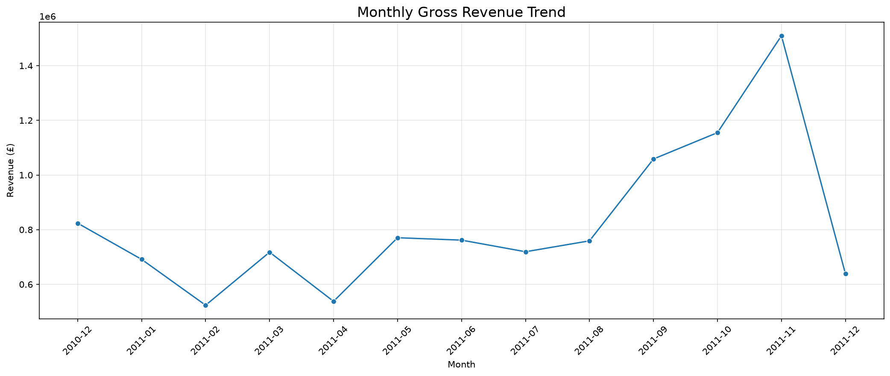
Task3_Quantity_vs_Revenue_Scatter_Plot.png
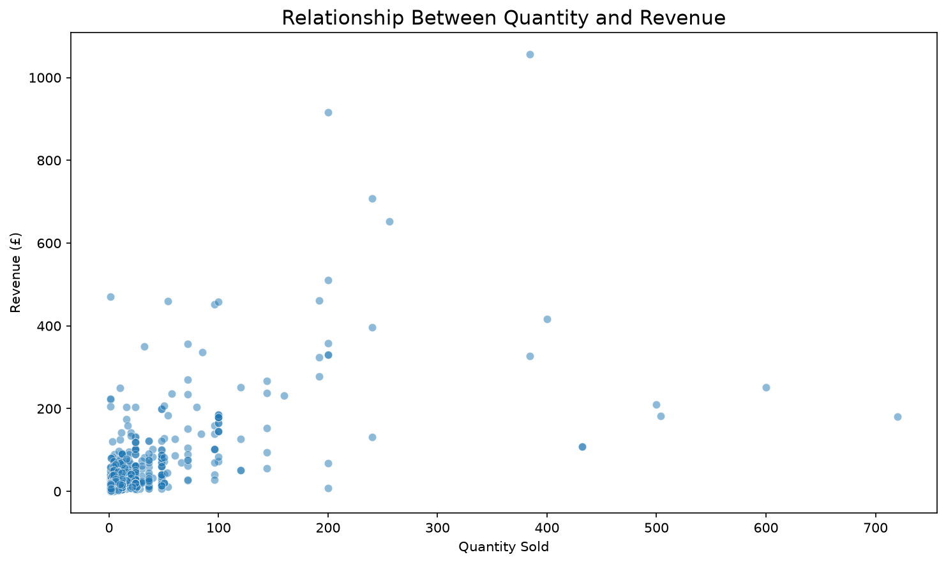
Task3_Sales_Correlation_Heatmap.png
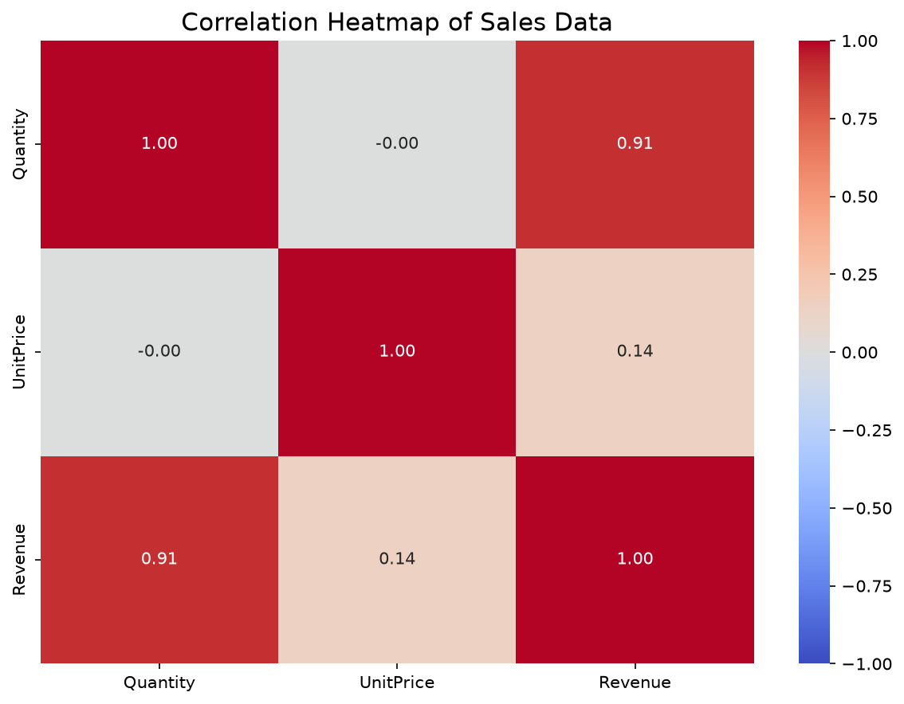
Task3_Top_10_Products_Bar_Chart.png
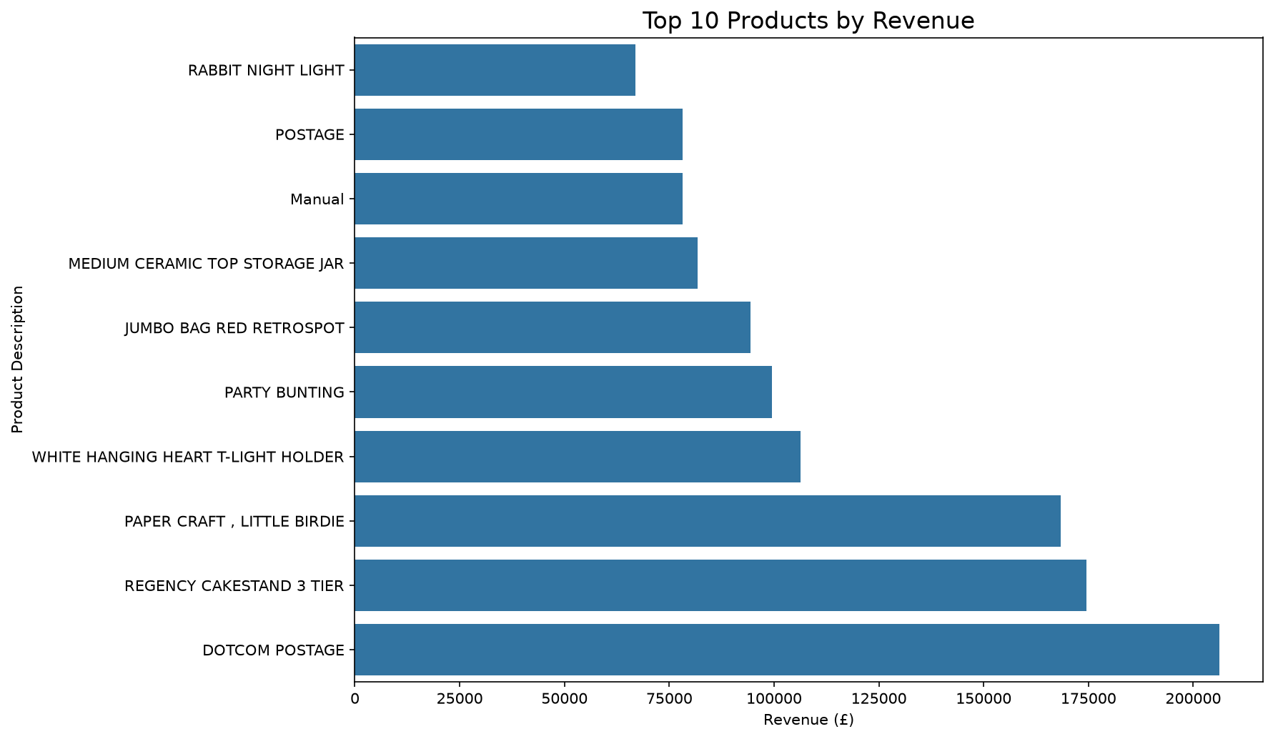
Task5_Actual_vs_Predicted.png
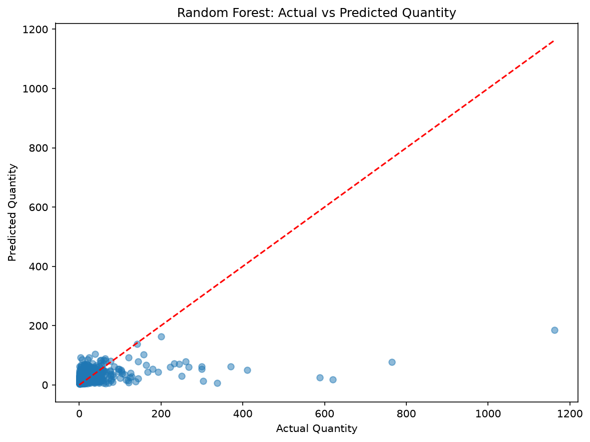
Task5_Feature_Importance.png
