Interest | 2
Binary | 3
Decimal | 4
Series | 5-6
Permutation | 7
Fibonacci | 8
Bisection | 9-12
Regula Falsi | 13-16-18
Newton Raphson | 19-23
Guess Elimination | 24-26
Guess Jordan | 27-29
Newton Forward Interpolation | 30-31
Newton Backward Interpolation | 32-33
Trapezoid and Simpson | 34-38
Range- Kutta | 39-42

1. Write a program in C and C++ to calculate Simple Interest and Compound Interest for given principal, rate, and time.
C++ Program

#include <iostream>
#include <cmath>
using namespace std;

int main() {
float p, r, t;

cout << "--------------------------------\n";

cout << "Enter Principal, Rate and Time: ";
cin >> p >> r >> t;

cout << "Simple Interest = " << (p * r * t) / 100 << endl;
cout << "Compound Interest = "
<< p * pow((1 + r / 100), t) - p << endl;

return 0;
}
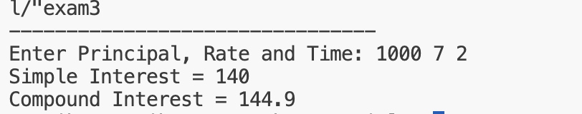

2. Write a program in C and C++ to convert a given decimal number into its binary equivalent.

C++ Program

#include <iostream>
using namespace std;

int main() {
int n;

cout << "--------------------------------\n";

cout << "Enter a decimal number: ";
cin >> n;

cout << "Binary equivalent: ";
while (n > 0) {
cout << n % 2;
n /= 2;
}

return 0;
}
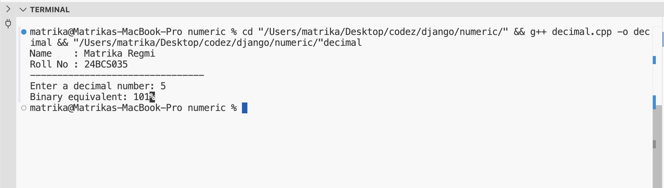

3.Write a program in C and C++ to convert a given binary number into its decimal equivalent.

C++ Program

#include <iostream>
#include <cmath>
using namespace std;

int main() {
int bin, dec = 0, i = 0;

cout << "--------------------------------\n";

cout << "Enter a binary number: ";
cin >> bin;

while (bin != 0) {
dec += (bin % 10) * pow(2, i++);
bin /= 10;
}

cout << "Decimal equivalent = " << dec;
return 0;
}

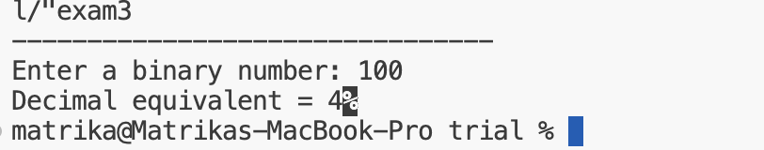

4.Write a program in C and C++ to find the sine and cosine series of a given angle using series expansion (angle given in degrees).
C++ Program

#include <iostream>
#include <cmath>
using namespace std;

int main() {
int n;
float x, sin_sum = 0, cos_sum = 0;

cout << "--------------------------------" << endl;

cout << "Enter angle in degrees : ";
cin >> x;

cout << "Enter number of terms : ";
cin >> n;

// Convert degrees to radians
x = x * 3.14159 / 180;

// Sine series
for (int i = 0; i < n; i++) {
int power = 2 * i + 1;
int fact = 1;
float term;

for (int j = 1; j <= power; j++)
fact *= j;

term = pow(x, power) / fact;

if (i % 2 == 0)
sin_sum += term;
else
sin_sum -= term;
}

// Cosine series
for (int i = 0; i < n; i++) {
int power = 2 * i;
int fact = 1;
float term;

for (int j = 1; j <= power; j++)
fact *= j;

term = pow(x, power) / fact;

if (i % 2 == 0)
cos_sum += term;
else
cos_sum -= term;
}

cout << "Sum of sine series = " << sin_sum << endl;
cout << "Sum of cosine series = " << cos_sum << endl;

return 0;
}
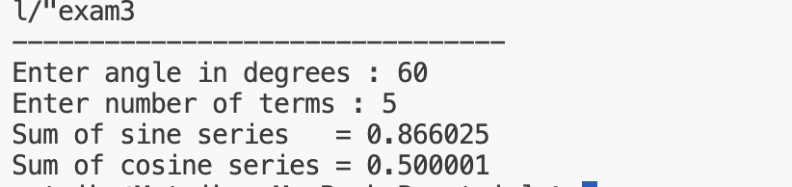

5. Write a program in C and C++ to calculate permutations and combinations for given values of n and r.

C++ Program

#include <iostream>
using namespace std;

long fact(int n) {
long f = 1;
for (int i = 1; i <= n; i++)
f *= i;
return f;
}

int main() {
int n, r;

cout << "Enter n and r: ";
cin >> n >> r;

cout << "Permutation = " << fact(n) / fact(n - r) << endl;
cout << "Combination = " << fact(n) / (fact(r) * fact(n - r));

return 0;
}
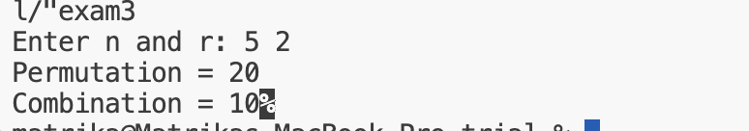

6. Write a program in C and C++ to generate the Fibonacci series up to n terms.
C++ Program

#include <iostream>
using namespace std;

int main() {
int n, a = 0, b = 1, c;

cout << "Enter number of terms: ";
cin >> n;

cout << "Fibonacci Series: ";
for (int i = 1; i <= n; i++) {
cout << a << " ";
c = a + b;
a = b;
b = c;
}

return 0;
}

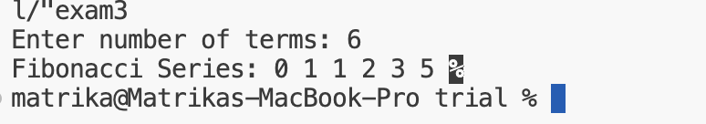

Solve the given problem using Bisection Method

1. f(x) : x⁴+2x³-x-1=0

C++ Program

#include <iostream>
#include <cmath>
using namespace std;

// Function definition for the given equation
double equation(double x)
{
return pow(x, 4) + 2 * pow(x, 3) - x - 1;
}

int main()
{
double left, right, mid;
double tolerance = 0.0001;

cout << "NAME: Matrika Regmi\nROLL NO: 24BCS035\n\n";

// Taking interval from user
cout << "Enter starting value: ";
cin >> left;

cout << "Enter ending value: ";
cin >> right;

cout << "Value at left = " << equation(left) << endl;
cout << "Value at right = " << equation(right) << endl;

// Check if interval is valid
if (equation(left) * equation(right) >= 0)
{
cout << "\nInvalid interval! f(a) and f(b) must have opposite signs.\n";
return 0;
}

// Bisection Method
while (fabs(right - left) > tolerance)
{
mid = (left + right) / 2.0;

if (equation(left) * equation(mid) < 0)
right = mid;
else
left = mid;
}

cout << "\nFinal Interval:\n";
cout << "Left Limit = " << left << endl;
cout << "Right Limit = " << right << endl;
cout << "Approximate Root = " << (left + right) / 2.0 << endl;

return 0;
}
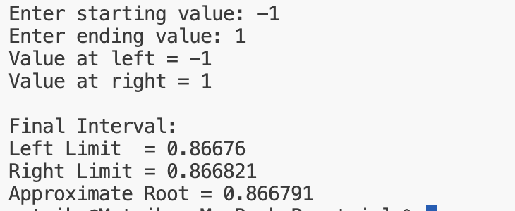

2. f(x) : xe^{x}=1

xe^{x}-1=0

C++ Program

#include <iostream>
#include <cmath>
using namespace std;

double equation(double x)
{
return x * exp(x) - 1;
}

int main()
{
double left, right;
double mid;
double tolerance = 0.0001;

cout << "Enter starting value: ";
cin >> left;

cout << "Enter ending value: ";
cin >> right;

// Check whether interval is valid
if (equation(left) * equation(right) >= 0)
{
cout << "\nInvalid interval. Try different values.\n";
return 0;
}

while (true)
{
mid = (left + right) / 2.0;

if (fabs(right - left) < tolerance)
break;

if (equation(left) * equation(mid) < 0)
right = mid;
else
left = mid;
}

cout << "\nFinal Interval:\n";
cout << "Left Limit = " << left << endl;
cout << "Right Limit = " << right << endl;
cout << "Approximate Root = " << (left + right) / 2.0 << endl;

return 0;
}

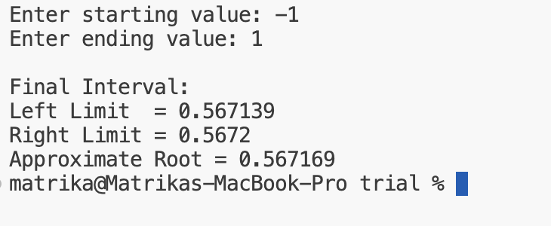

Regula Falsi Method

Solving f(x) = tan(x) + tanh(x) using Regula Falsi Method

#include <iostream>
#include <cmath>
using namespace std;

double f(double x) {
return tan(x) + tanh(x);
}

int main() {

double a, b, c;
double fa, fb, fc;
int maxIteration = 50;
double error = 0.000001;
int i = 1;

cout << "Solving f(x) = tan(x) + tanh(x) using Regula Falsi Method\n\n";

cout << "Enter first value (a): ";
cin >> a;

cout << "Enter second value (b): ";
cin >> b;

fa = f(a);
fb = f(b);

if (fa * fb > 0) {
cout << "\nInvalid interval! Root does not lie between a and b.\n";
return 0;
}

while (i <= maxIteration) {

c = (a * fb - b * fa) / (fb - fa);
fc = f(c);

if (fabs(fc) < error)
break;

if (fa * fc < 0) {
b = c;
fb = fc;
}
else {
a = c;
fa = fc;
}

i++;
}

cout << "\nApproximate Root = " << c << endl;

return 0;
}

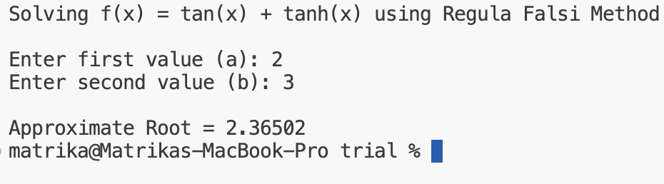

Regula Falsi Method for

f(x)=xlog10 (x)−1.2

#include <iostream>
#include <cmath>
using namespace std;

double f(double x) {
return x * log10(x) - 1.2;
}

int main() {

double a, b, c;
double fa, fb, fc;
int maxIteration = 50;
double error = 0.000001;
int i = 1;

cout << "Enter first value (a): ";
cin >> a;

cout << "Enter second value (b): ";
cin >> b;

if (a <= 0 || b <= 0) {
cout << "\nError! x must be greater than 0.\n";
return 0;
}

fa = f(a);
fb = f(b);

if (fa * fb > 0) {
cout << "\nInvalid interval!\n";
return 0;
}

while (i <= maxIteration) {

c = (a * fb - b * fa) / (fb - fa);
fc = f(c);

if (fabs(fc) < error)
break;

if (fa * fc < 0) {
b = c;
fb = fc;
}
else {
a = c;
fa = fc;
}

i++;
}

cout << "\nApproximate Root = " << c << endl;

return 0;
}

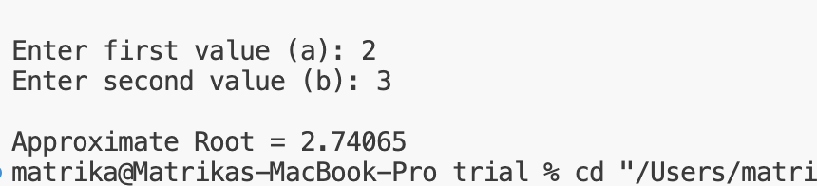

- X³-X+1=0

C++ Program

#include <iostream>
#include <cmath>
using namespace std;

double f(double x) {
return x*x*x - x + 1;
}

int main() {

double a, b, c;
double fa, fb, fc;
int maxIteration = 50;
double error = 0.000001;
int i = 1;

cout << "Enter first value (a): ";
cin >> a;

cout << "Enter second value (b): ";
cin >> b;

fa = f(a);
fb = f(b);

if (fa * fb > 0) {
cout << "\nInvalid interval!\n";
return 0;
}

while (i <= maxIteration) {

c = (a * fb - b * fa) / (fb - fa);
fc = f(c);

if (fabs(fc) < error)
break;

if (fa * fc < 0) {
b = c;
fb = fc;
} else {
a = c;
fa = fc;
}

i++;
}

cout << "\nApproximate Root = " << c << endl;

return 0;
}
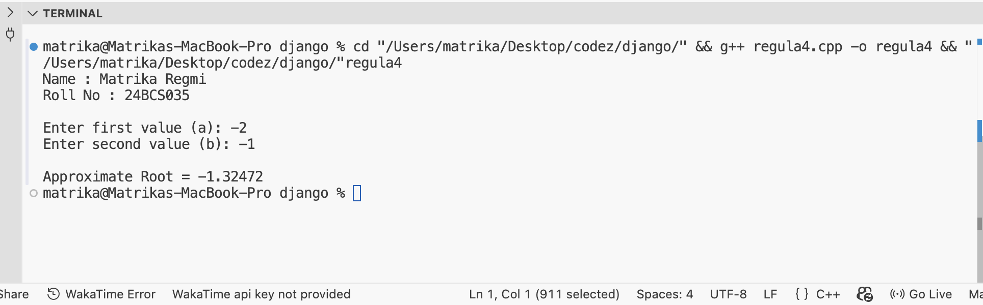

Newton Raphson
1. Solve using newton raphson method to find the root of a function f(x) : xsinx+cosx=0 correct upto three decimal place.

C++ Program

#include <iostream>
#include <cmath>
#include <iomanip>

using namespace std;

// Function: f(x) = x*sin(x) + cos(x)
double f(double x) {
return x * sin(x) + cos(x);
}

// Derivative: f'(x) = x*cos(x)
double df(double x) {
return x * cos(x);
}

int main() {

double a, b;
double x, x_new;
double tolerance = 0.0005;

// Take range from user
cout << "Enter starting value: ";
cin >> a;

cout << "Enter ending value: ";
cin >> b;

// Check valid interval
if (f(a) * f(b) > 0) {
cout << "\nInvalid range! Root does not lie between them.\n";
return 0;
}

// Initial guess = midpoint
x = (a + b) / 2.0;

cout << fixed << setprecision(6);

for (int i = 1; ; i++) {

cout << "Iteration " << i
<< ": x = " << x
<< ", f(x) = " << f(x) << endl;

// Prevent division by zero
if (df(x) == 0) {
cout << "Derivative became zero. Method failed." << endl;
return 0;
}

// Newton-Raphson formula
x_new = x - f(x) / df(x);

// Stopping condition
if (fabs(x_new - x) < tolerance) {

cout << "\nFinal Root = "
<< fixed << setprecision(3)
<< x_new << endl;

return 0;
}

x = x_new;
}

return 0;
}

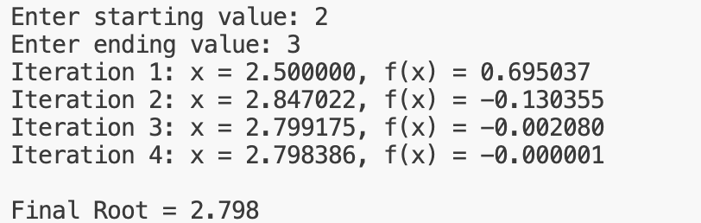

2. Using Newton raphson method evaluate (43)^{(1/5)} correct upto three decimal place.

C++ Code
#include <iostream>
#include <cmath>
#include <iomanip>

using namespace std;

// Function: f(x) = x^5 - 43
double f(double x) {
return pow(x, 5) - 43;
}

// Derivative: f'(x) = 5x^4
double df(double x) {
return 5 * pow(x, 4);
}

int main() {

double a, b;
double x, x_new;

const double tolerance = 0.0005;
const int maxIterations = 100;

// Input interval
cout << "Enter starting value: ";
cin >> a;

cout << "Enter ending value: ";
cin >> b;

// Check if root exists in interval
if (f(a) * f(b) > 0) {
cout << "\nInvalid range! Root does not lie between them.\n";
return 0;
}

// Initial guess = midpoint
x = (a + b) / 2.0;

cout << fixed << setprecision(6);

for (int i = 1; i <= maxIterations; i++) {

double fx = f(x);
double dfx = df(x);

cout << "Iteration " << i
<< ": x = " << x
<< ", f(x) = " << fx << endl;

// Prevent division by zero
if (fabs(dfx) < 1e-12) {
cout << "\nDerivative became zero. Method failed.\n";
return 0;
}

// Newton-Raphson formula
x_new = x - (fx / dfx);

// Stopping condition
if (fabs(x_new - x) < tolerance) {

cout << "\nFinal Root = "
<< fixed << setprecision(3)
<< x_new << endl;

return 0;
}

x = x_new;
}

cout << "\nMethod did not converge within "
<< maxIterations
<< " iterations.\n";

return 0;
}

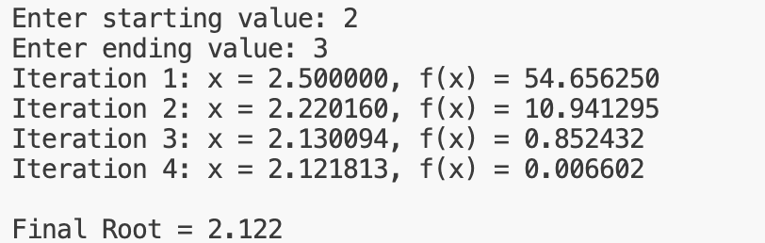

Using Gauss Elimination Method, solve the system of linear equations:

2x+y-z=1

3x+2y+z=10

x-y+2z=1

#include <iostream>
#include <iomanip>

using namespace std;

int main() {

int n;

cout << "Enter number of variables: ";
cin >> n;

// Dynamic augmented matrix
float a[20][21], x[20];

cout << "Enter coefficients of augmented matrix:\n";

for (int i = 0; i < n; i++) {
for (int j = 0; j <= n; j++) {
cin >> a[i][j];
}
}

// Forward Elimination
for (int i = 0; i < n; i++) {

if (a[i][i] == 0.0) {
cout << "Mathematical Error (Division by zero)";
return 0;
}

for (int j = i + 1; j < n; j++) {

float ratio = a[j][i] / a[i][i];

for (int k = 0; k <= n; k++) {
a[j][k] = a[j][k] - ratio * a[i][k];
}
}
}

// Back Substitution
for (int i = n - 1; i >= 0; i--) {

x[i] = a[i][n];

for (int j = i + 1; j < n; j++) {
x[i] = x[i] - a[i][j] * x[j];
}

x[i] = x[i] / a[i][i];
}

// Display Solution
cout << fixed << setprecision(3);

cout << "\nSolution:\n";

for (int i = 0; i < n; i++) {
cout << "x" << i + 1 << " = " << x[i] << endl;
}

return 0;
}
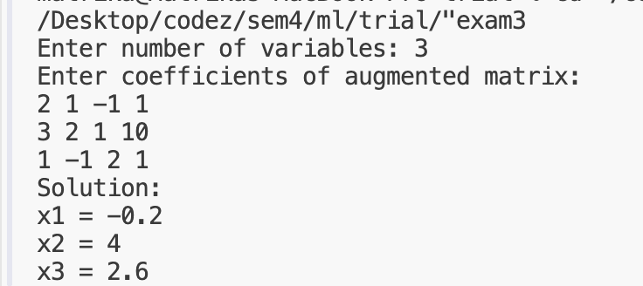

2. Using Gauss Jordan Method, solve the system of linear equations:

x+y+z=6

2x+3y+z=11

x+2y+3z=14

#include <iostream>
#include <iomanip>

using namespace std;

int main() {

int n;

cout << "Enter number of variables: ";
cin >> n;

// Augmented matrix
float a[20][21];

cout << "Enter coefficients of augmented matrix:\n";

for (int i = 0; i < n; i++) {
for (int j = 0; j <= n; j++) {
cin >> a[i][j];
}
}

// Gauss-Jordan Elimination
for (int i = 0; i < n; i++) {

// Check division by zero
if (a[i][i] == 0.0) {
cout << "Mathematical Error (Division by zero)";
return 0;
}

// Make pivot element = 1
float pivot = a[i][i];

for (int j = 0; j <= n; j++) {
a[i][j] = a[i][j] / pivot;
}

// Make other elements in column = 0
for (int k = 0; k < n; k++) {

if (k != i) {

float factor = a[k][i];

for (int j = 0; j <= n; j++) {
a[k][j] = a[k][j] - factor * a[i][j];
}
}
}
}

// Display solution
cout << fixed << setprecision(3);

cout << "\nSolution:\n";

for (int i = 0; i < n; i++) {
cout << "x" << i + 1 << " = " << a[i][n] << endl;
}

return 0;
}

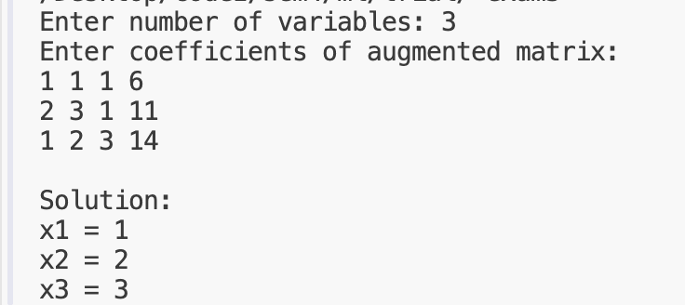

Newton Forward Interpolation(f(1.6))

#include <iostream>
using namespace std;

int main() {

int n = 4;

double x[] = {1.0, 1.4, 1.8, 2.2};
double y[10][10];
double f[] = {3.49, 4.82, 5.96, 6.50};

// Store function values
for(int i = 0; i < n; i++)
y[i][0] = f[i];

// Create forward difference table
for(int j = 1; j < n; j++)
for(int i = 0; i < n - j; i++)
y[i][j] = y[i + 1][j - 1] - y[i][j - 1];

cout << "Forward Difference Table:\n";
cout << "x\t y\t Δy\t Δ²y\t Δ³y\n";

for(int i = 0; i < n; i++) {
cout << x[i] << "\t";

for(int j = 0; j < n - i; j++)
cout << y[i][j] << "\t";

cout << endl;
}

double value;
cout << "\nEnter value of x: ";
cin >> value;

double h = x[1] - x[0];
double p = (value - x[0]) / h;

double result = y[0][0];
double term = 1;

// Newton Forward Formula
for(int i = 1; i < n; i++) {
term = term * (p - i + 1) / i;
result += term * y[0][i];
}

cout << "\nInterpolated value = " << result;

return 0;
}
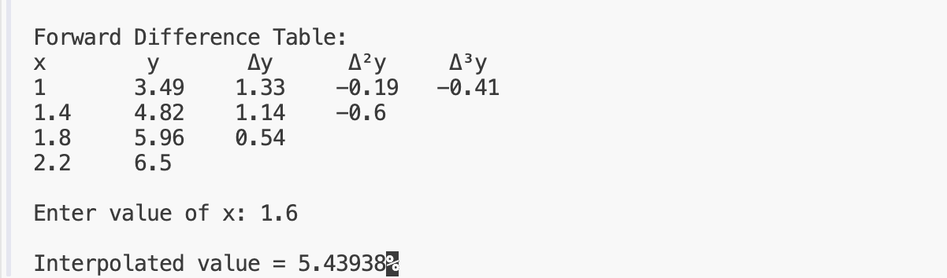

Newton’s Backward Interpolation

#include <iostream>
using namespace std;

int main() {

int n = 7;

double x[] = {1.7, 1.8, 1.9, 2.0, 2.1, 2.2, 2.3};
double y[10][10];

double f[] = {5.474, 6.050, 6.686, 7.389,
8.166, 9.025, 9.974};

// Store function values
for(int i = 0; i < n; i++)
y[i][0] = f[i];

// Create backward difference table
for(int j = 1; j < n; j++)
for(int i = n - 1; i >= j; i--)
y[i][j] = y[i][j - 1] - y[i - 1][j - 1];

double value;
cout << "Enter value of x: ";
cin >> value;

double h = x[1] - x[0];
double p = (value - x[n - 1]) / h;

double result = y[n - 1][0];
double term = 1;

// Newton Backward Formula
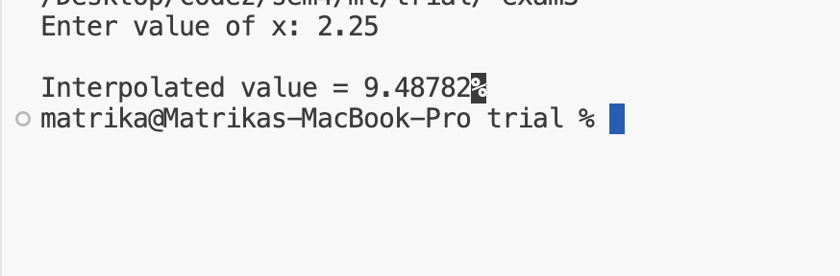
for(int i = 1; i < n; i++) {
term = term * (p + i - 1) / i;
result += term * y[n - 1][i];
}

cout << "\nInterpolated value = " << result;

return 0;
}

Trapezoidal Rule

integrate(1-0) 1/(1+x^2) dx

#include <iostream>
using namespace std;

double f(double x){
return 1.0/(1+x*x);
}

int main(){
int n;
double a=0,b=1,h,sum;

cout<<"Enter number of intervals: ";
cin>>n;

h=(b-a)/n;
sum=f(a)+f(b);

for(int i=1;i<n;i++)
sum+=2*f(a+i*h);

cout<<"Result = "<<(h/2)*sum;

return 0;
}
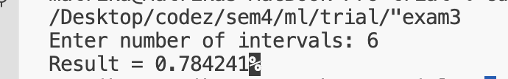

Simpson’s 3/8 Rule C++ Program

integrate(1-0) 1/(1+x^2) dx

#include <iostream>
using namespace std;

double f(double x){
return 1.0/(1+x*x);
}

int main(){
int n;
double a=0,b=1,h,sum;

cout<<"Enter number of intervals (multiple of 3): ";
cin>>n;

h=(b-a)/n;
sum=f(a)+f(b);

for(int i=1;i<n;i++){
if(i%3==0)
sum+=2*f(a+i*h);
else
sum+=3*f(a+i*h);
}

cout<<"Result = "<<(3*h/8)*sum;

return 0;
}

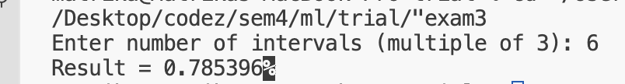

Trapezoidal Rule using sin(x)

#include <iostream>
#include <cmath>
using namespace std;

double f(double x){
return sin(x);
}

int main(){
int n;
double a=0,b=1.5708,h,sum;

cout<<"Enter number of intervals: ";
cin>>n;

h=(b-a)/n;
sum=f(a)+f(b);

for(int i=1;i<n;i++)
sum+=2*f(a+i*h);

cout<<"Result = "<<(h/2)*sum;

return 0;
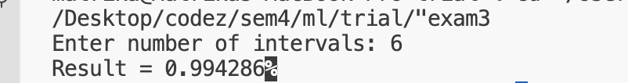
}

Simpson’s 3/8 Rule using sin(x)

#include <iostream>
#include <cmath>
using namespace std;

double f(double x){
return sin(x);
}

int main(){
int n;
double a=0,b=1.5708,h,sum;

cout<<"Enter number of intervals (multiple of 3): ";
cin>>n;

h=(b-a)/n;
sum=f(a)+f(b);

for(int i=1;i<n;i++){
if(i%3==0)
sum+=2*f(a+i*h);
else
sum+=3*f(a+i*h);
}

cout<<"Result = "<<(3*h/8)*sum;

return 0;
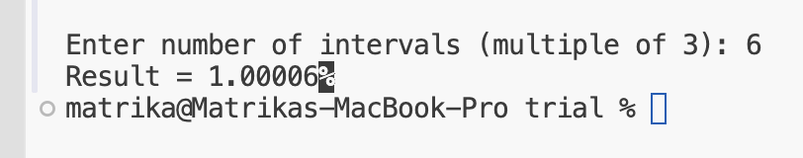
}

Runge-Kutta 4th Order Method to solve the differential equation:

dx/dy​=x+y

#include <iostream>
using namespace std;

float f(float x, float y) {
return x + y;
}

int main() {

float x0, y0, xn, h;
int n;

cout << "Enter initial value of x x(0): ";
cin >> x0;

cout << "Enter initial value of y y(0): ";
cin >> y0;

cout << "Enter value of x at which y is required (xn): ";
cin >> xn;

cout << "Enter Step size (h): ";
cin >> h;

// Calculate number of steps
n = (xn - x0) / h;

float x = x0;
float y = y0;

for (int i = 1; i <= n; i++) {

float k1 = h * f(x, y);

float k2 = h * f(x + h / 2.0, y + k1 / 2.0);

float k3 = h * f(x + h / 2.0, y + k2 / 2.0);

float k4 = h * f(x + h, y + k3);

y = y + (k1 + 2 * k2 + 2 * k3 + k4) / 6.0;

x = x + h;

cout << "After step " << i
<< " x = " << x
<< " y = " << y << endl;
}

cout << "\nFinal value of y at x = "
<< xn << " is " << y << endl;

return 0;
}
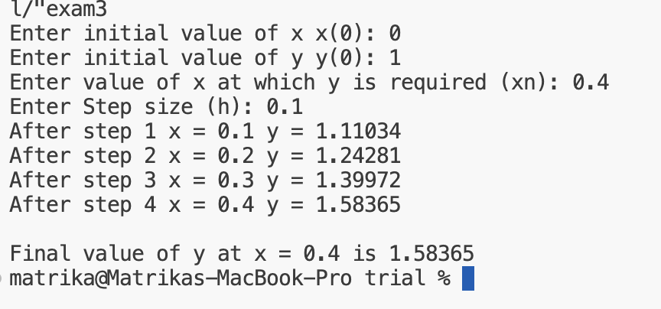

log(x+Y) using range kutta

#include <iostream>
#include <cmath>
using namespace std;

double f(double x, double y) {
return log(x + y);
}

int main() {

double x0, y0, xn, h;
int n;

cout << "Enter initial value of x x(0): ";
cin >> x0;

cout << "Enter initial value of y y(0): ";
cin >> y0;

cout << "Enter value of x at which y is required (xn): ";
cin >> xn;

cout << "Enter number of steps (n): ";
cin >> n;

// Calculate step size
h = (xn - x0) / n;

double x = x0;
double y = y0;

for (int i = 1; i <= n; i++) {

double k1 = h * f(x, y);

double k2 = h * f(x + h / 2, y + k1 / 2);

double k3 = h * f(x + h / 2, y + k2 / 2);

double k4 = h * f(x + h, y + k3);

y = y + (k1 + 2 * k2 + 2 * k3 + k4) / 6;

x = x + h;

cout << "After step " << i
<< " x = " << x
<< " y = " << y << endl;
}

cout << "\nStep size h = " << h << endl;

cout << "Final value of y at x = "
<< xn << " is " << y << endl;

return 0;
}

