AgentSec
AI Security Protection Module
Architecture & Design Specification

Prepared by Onnex
Las Vegas, Nevada
Version 1.0 | March 2026
CONFIDENTIAL

1. Executive Summary
AgentSec is a language-agnostic AI security sidecar — a self-contained HTTP service that sits alongside any agent runtime and provides layered, configurable protection on every inbound and outbound AI call. It is designed to be injected into any agentic pipeline without modifying the underlying agent code: call it before and after your agent, and every AI transaction is protected.
The product addresses a gap that every major agent framework leaves open. OpenClaw, NanoClaw, ZeroClaw, OpenFang, Hermes Agent, and Nanobot each implement security in narrow, framework-specific ways. None of them deliver a portable, protocol-agnostic protection layer that works across n8n workflows, Temporal activities, raw Anthropic SDK calls, and custom pipelines simultaneously.
AgentSec is that portable layer. It exposes a single HTTP endpoint — POST /check — that any caller can invoke. The request carries direction (ingress or egress), the payload, and optional session context. The response is either pass with a clean payload, or reject with a structured error identifying exactly which security layer fired and why.

Built in Rust for enterprise deployment: single static binary, memory-safe by construction, minimal CVE surface, and no runtime dependency chain. A sidecar that adds protection without adding fragility.

The architecture consists of eight named layers — L0 through L7 — each with a distinct responsibility. Seven of these layers are security gates; the eighth (L0) is a telemetry envelope that wraps the entire pipeline and records every transaction with configurable verbosity. All layers are independently toggleable. Layers not applicable to a given direction are skipped at zero cost.

2. Problem Statement

2.1 The Agentic AI Security Gap
Traditional AI security focused on model integrity and inference-time attack prevention. The attack surface was bounded: a prompt goes in, a completion comes out. Input validation and output filtering were sufficient for that model.
Agentic AI systems fundamentally change this. These systems maintain persistent memory, execute multi-step plans, invoke external tools, call APIs, modify databases, and communicate with other agents. An attacker no longer needs to compromise the underlying model. Manipulating any component in the agent ecosystem — the input, the tool call, the memory store, the inter-agent message — can redirect behavior toward malicious outcomes.
The specific threats that motivated AgentSec's design are:
- Prompt injection attacks — malicious instructions embedded in user input, tool results, or context files that override the agent's intended behavior
- Confused deputy attacks — tricking a trusted agent into performing actions on behalf of an attacker without the attacker having direct access
- Credential exfiltration — agents with broad tool access inadvertently returning API keys, tokens, or PII in responses
- Runaway cost escalation — unbounded LLM calls accumulating costs that are only discovered after the fact
- Known CVE exploitation — newly published vulnerabilities in LLM providers, agent frameworks, or MCP tool implementations being exploited before patches are applied
- Behavioral drift — gradual accumulation of context across a long session that shifts what an agent considers normal, enabling salami-slicing attacks
- Tool authorization abuse — agents invoking destructive tools (database drops, file deletions, API credential resets) that were never intended to be accessible

2.2 Why Existing Systems Are Insufficient
A systematic review of six major agent systems — OpenClaw, NanoClaw, ZeroClaw, OpenFang, Hermes Agent, and Nanobot — reveals that each addresses only a subset of these threats, and none addresses them in a portable, framework-agnostic manner.
OpenClaw (329,000+ GitHub stars) implements security at the application layer: allowlists, pairing codes, and opt-in Docker sandboxing for non-main sessions. There is no prompt injection detection at the framework layer. The documentation explicitly recommends using the strongest available model as the primary mitigation for injection risk.
NanoClaw explicitly positions itself as a security-first reaction to OpenClaw, providing hypervisor-level container isolation per agent session. However, it has no DM pairing, no rate limiting, no prompt injection detection, and no audit trail.
ZeroClaw (Rust, 28,400+ stars) has the most formally specified security model of the six, with documented defense-in-depth layers including ReadOnly/Supervised/Full autonomy modes, path traversal blocking, command allowlists, Landlock/Bubblewrap sandboxing, and 129 automated security tests. It still lacks cryptographic audit integrity and cross-agent trust attestation.
OpenFang claims 16 discrete security systems including WASM sandboxing, Merkle hash-chain audit, information flow taint tracking, and Ed25519 signed agent manifests. It is the most security-ambitious of the six. It remains at v0.1.0 and is not framework-agnostic — it only protects agents running within the OpenFang runtime.
Hermes Agent (NousResearch, Python) has strong operational security documentation, context file injection scanning, and Docker container hardening. Cryptographic audit and tool allowlists are open feature requests rather than shipped capabilities.
Nanobot (HKUDS, academic/research) has minimal security controls — an allowFrom array for channel access and Docker deployment. It is explicitly positioned as educational, not production.

The common gap across all six: zero coverage for cross-agent trust chain verification, behavioral drift detection, and PII detection with stripping. None are injectable as a protocol-agnostic middleware. AgentSec is built to fill all three gaps while also serving as the portable security layer that works across every framework.

3. Architecture Overview

3.1 The Sidecar Pattern
AgentSec is deployed as a sidecar service — a separate process that runs alongside the primary agent runtime. It communicates over HTTP/JSON. The caller makes two requests for every agent interaction: one before the agent call (direction: ingress) and one after (direction: egress). AgentSec processes the request through the configured security layers and returns either a pass with a clean payload, or a reject with a structured error.
This pattern has several architectural advantages. It requires zero modifications to the agent code. It works with any agent framework, any LLM provider, and any orchestration system. It can be deployed once and shared across multiple agent instances. It can be updated, reconfigured, or swapped out without touching agent logic.

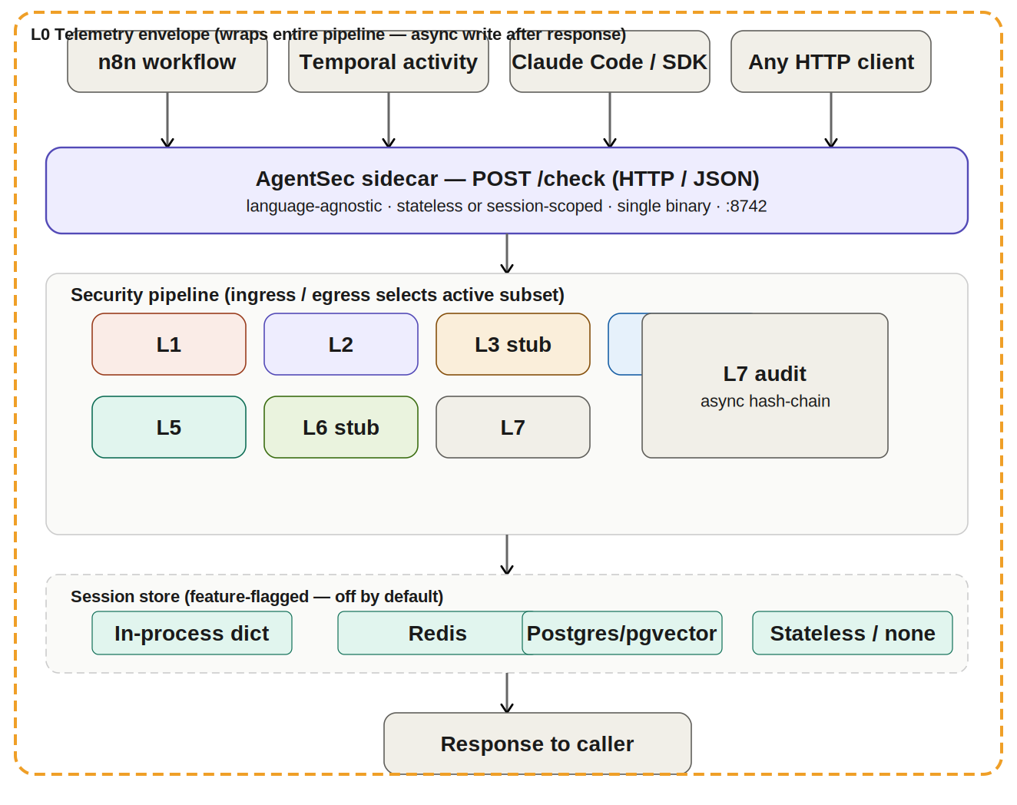
Figure 1: AgentSec sidecar architecture showing caller integration, pipeline structure, and session store backends

3.2 The Layer Stack
The protection pipeline consists of eight layers. Each layer has a single, well-defined responsibility. Layers are executed in order. Any layer can short-circuit the pipeline by returning a reject decision — subsequent layers do not run. L7 (audit) always fires regardless of the decision, and always fires asynchronously after the response is returned to the caller.

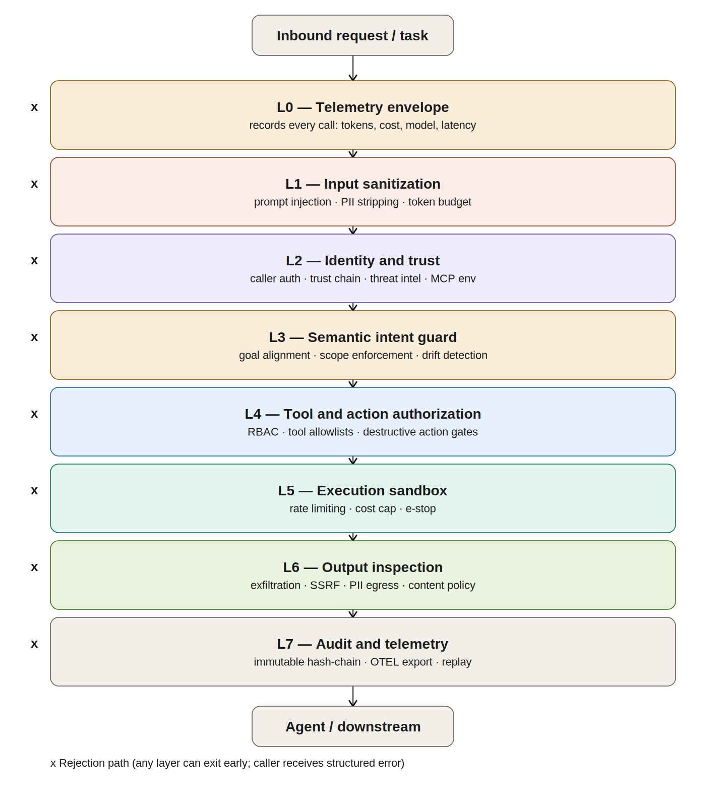
Figure 2: The complete eight-layer security stack. Any layer can reject; L7 always records.

3.3 The Call Flow
A complete agentic transaction involves two AgentSec check calls: one on ingress (before the LLM call) and one on egress (after the LLM returns). Tool calls within the agent's execution generate additional ingress checks specifically for L4 tool authorization. L7 writes audit records asynchronously at each checkpoint.

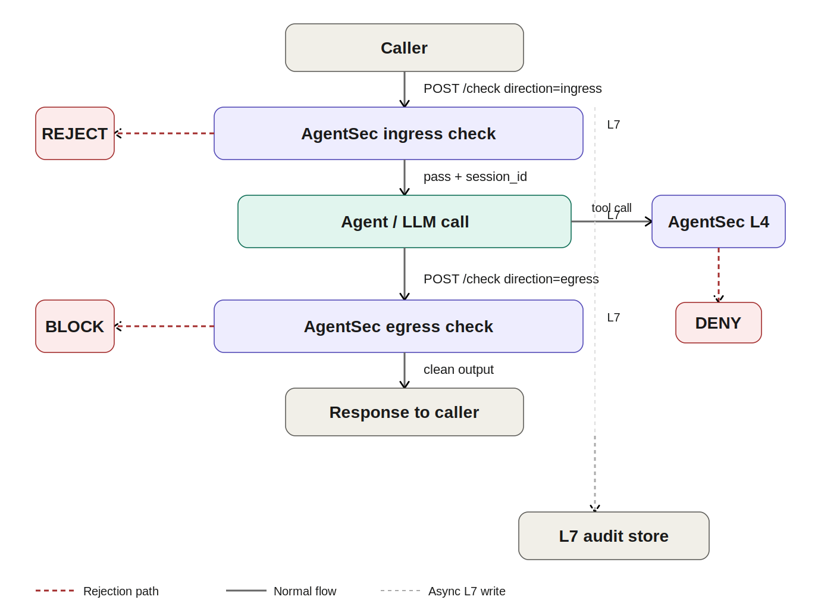
Figure 3: Request flow through AgentSec. Reject paths exit before reaching the agent or caller. L7 writes async at every checkpoint.

3.4 The Session Model
Three layers (L3, L5, L7) require state across multiple calls: L3 needs to remember the declared intent from session start to detect drift, L5 needs counters for rate limiting and cost tracking, and L7 needs the previous record's hash to maintain chain integrity. This state lives in the session store.
Session state is entirely optional. Callers that omit the session_id field receive pure stateless checks — L3, the stateful parts of L5, and L7 chaining are automatically bypassed. This allows existing pipelines to add basic protection (L1, L2, L4) without any state management overhead.
When session_id is provided, the session store backend is configurable: in-process DashMap for single-node development, Redis for multi-node deployments, or Postgres with pgvector for enterprise deployments requiring long-term L3 semantic baseline storage.

4. Layer Specifications
Each layer in this section is described with its purpose, the specific threats it addresses, the design decisions made, and its justification relative to the alternatives. Every layer implements the same internal Layer trait, which ensures they are independently testable, independently toggleable, and composable without coupling.

L0 — Telemetry Envelope

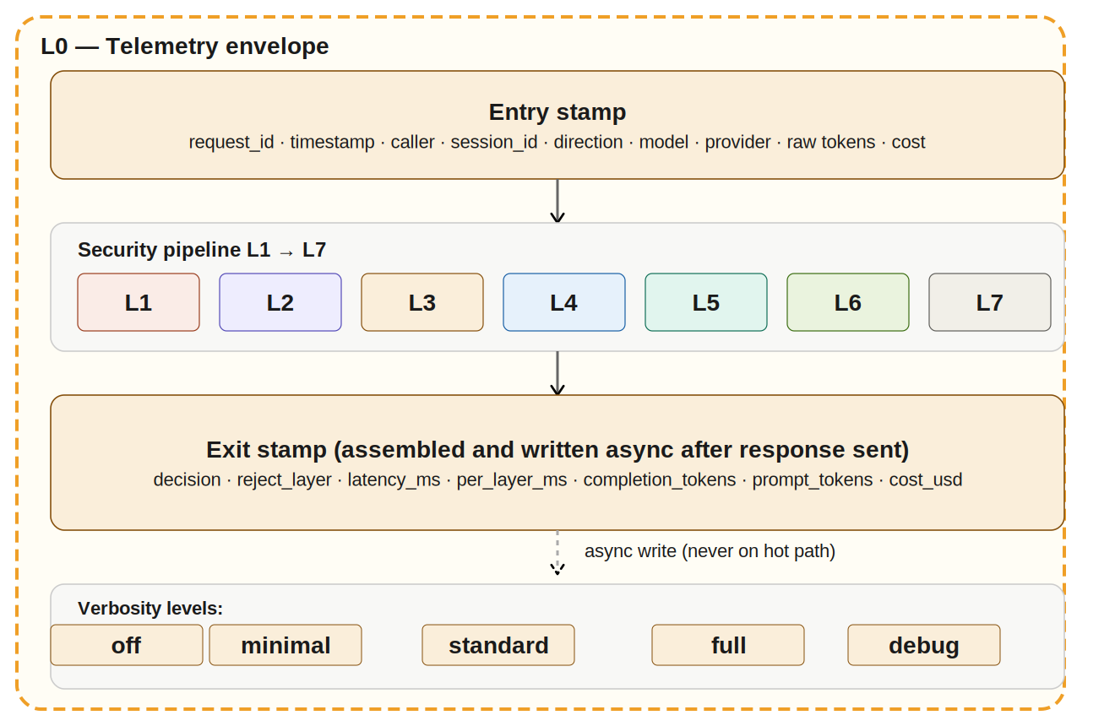
Figure 4: L0 telemetry envelope wrapping the security pipeline with async write path

Purpose
L0 is not a security gate. It is a full-fidelity observability wrapper that records every transaction that passes through AgentSec. It wraps the entire pipeline — entry stamp before L1, exit stamp after L7 — and writes records asynchronously after the response is returned to the caller. It never adds latency to the security decision path.

What it records
At the standard verbosity level, L0 records: request_id, session_id, direction, decision, reject_layer, reject_code, latency_ms, layers_ran, per_layer_ms, model, provider, prompt_tokens, completion_tokens, cost_usd, caller_id, and caller_type. At the full level it additionally records sanitized payload in and sanitized payload out. At debug level it records raw unsanitized payloads — this level is intended for local development only and must never be enabled in production.

Separation from L7
L0 and L7 record different concerns and write to different stores. L7 records security decisions in a tamper-evident hash chain — it is a security artifact. L0 records operational reality — what transacted, how long it took, what it cost. L0 is your billing surface, your dashboard data, and your debugging tool. L7 is your compliance and forensic surface.
Attribute | Detail
Direction | Ingress and Egress (wraps both)
Hot path impact | Zero — entry stamp is in-memory, exit stamp is async after response
Verbosity levels | off | minimal | standard | full | debug
PII handling | Strips PII before write when AGENTSEC_TELEMETRY_PII_REDACT=true (default)
Backends | stdout | file | Postgres | OpenTelemetry | multi
Phase 1 status | Fully implemented

L1 — Input Sanitization

Purpose
L1 is the first line of active defense. It examines every inbound payload before it reaches the agent and takes three independent actions: detecting prompt injection patterns, enforcing token budget limits, and detecting and stripping personally identifiable information.

Prompt injection detection
Prompt injection is the most commonly exploited attack vector in production LLM deployments. An attacker embeds instructions in user input — or in data that the agent retrieves from external sources — that attempt to override the agent's system prompt or persuade it to take unauthorized actions. L1 compiles a RegexSet at startup that matches known injection patterns including: instructions to ignore prior context, role-switching commands ("you are now", "act as"), system prompt override attempts, HTML/script injection, shell command injection in tool argument strings, and Python eval/exec patterns in code execution contexts.

PII detection and stripping
PII reaching an LLM creates compliance exposure under GDPR, HIPAA, and CCPA, and creates billing risk if the PII is stored in the model provider's logs. L1 calls the Presidio Analyzer sidecar for ML-model-quality PII detection with a 10ms timeout. On timeout or sidecar unavailability, it falls back to a built-in regex pattern set covering: email addresses, US Social Security Numbers, phone numbers, credit card numbers, and IP addresses. Detected PII is stripped and replaced with typed placeholders rather than causing a rejection, unless the severity classification is critical (e.g., unmasked credential strings).

Token budget enforcement
Unbounded context windows are a cost and security risk. An attacker can craft payloads that consume the model's full context window, either to exhaust budget or to crowd out the system prompt. L1 estimates the token count of the incoming payload and rejects requests that exceed the configured limit before they reach the LLM.
Attribute | Detail
Direction | Ingress only
Rejection codes | PROMPT_INJECTION | TOKEN_BUDGET_EXCEEDED | PII_CRITICAL
Mutation codes | PII_STRIPPED (returns Mutate with cleaned payload)
PII backend | Presidio Analyzer sidecar (10ms timeout) with regex fallback
Pattern source | Compiled RegexSet at startup, hot-reloaded on SIGHUP
Phase 1 status | Fully implemented

L2 — Identity and Trust

Purpose
L2 contains four independent sub-layers that collectively answer the question: "Should I trust this request given what I know about the identity of the caller and the current threat landscape?" These sub-layers run in sequence; the first reject exits the pipeline.

L2.1 — Caller Authentication
Every request must present a valid credential. L2.1 validates either a JWT Bearer token (HMAC-SHA256 using the configured secret) or a SHA-256 hash of an API key against the configured allowlist. Requests with no credential or invalid credentials are rejected with UNAUTHORIZED before any other processing occurs.

L2.2 — Trust Chain Verification
In multi-agent systems, one agent calls another. The second agent receives a request that claims to originate from the first agent. Without trust chain verification, any attacker who can craft an HTTP request can impersonate agent A and invoke agent B with full agent A privileges. L2.2 validates the trust_token field in the caller context: an HMAC-SHA256 signature over {caller_id}.{session_id}.{timestamp} using the shared trust secret. Tokens older than 60 seconds are rejected to prevent replay attacks.

L2.3 — Threat Intelligence Matching
L2.3 is the live CVE feed integration layer. It maintains a SignatureSet in memory behind a readers-writer lock. A background feed worker polls configured sources — CrowdSec CTI, NVD, OWASP LLM Top 10, and custom internal feeds — and atomically swaps the SignatureSet when new signatures are available. Readers (every L2.3 check) never block. The writer holds the lock for microseconds during the swap. New CVE signatures are active within the configured poll interval with no service restart required.

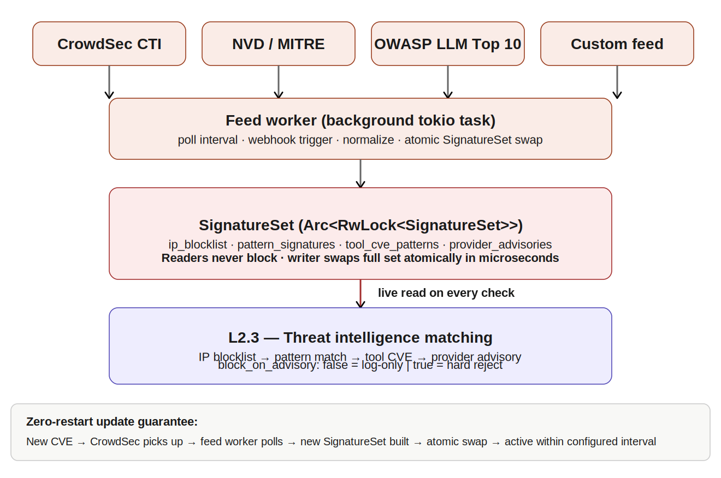
Figure 5: L2.3 threat intelligence feed architecture showing atomic hot-swap of SignatureSet

L2.3 checks four signature types in order: IP blocklist match against the caller's IP address, pattern signature match against the serialized payload, tool call CVE pattern match if a tool manifest is present, and provider advisory check if the target model or provider has an open CVE advisory. The block_on_advisory configuration flag controls whether provider advisories cause hard rejects (true) or log-only alerts (false, the default). This allows security teams to be informed of open advisories without taking down dependent pipelines until the advisory is confirmed exploitable.

L2.4 — MCP Environment Filtering
MCP (Model Context Protocol) subprocesses receive a filtered environment to prevent accidental credential leakage. Only the following variables are passed through from the host to MCP stdio subprocesses: PATH, HOME, USER, LANG, LC_ALL, TERM, SHELL, TMPDIR. All other environment variables — including any API keys, database URLs, or secrets — are stripped before MCP subprocess execution.
Attribute | Detail
Direction | Ingress only
Sub-layers | L2.1 auth | L2.2 trust chain | L2.3 threat intel | L2.4 MCP env
Rejection codes | UNAUTHORIZED | TRUST_CHAIN_INVALID | IP_BLOCKLIST | CVE_SIGNATURE | TOOL_CVE | PROVIDER_ADVISORY
Feed sources | CrowdSec CTI | NVD API | OWASP LLM Top 10 | Custom JSON
Feed update model | Atomic RwLock swap — zero-restart, zero-interruption
Phase 1 status | Fully implemented

L3 — Semantic Intent Guard

Purpose
L3 addresses behavioral drift — the gradual accumulation of context across a long agent session that shifts what the agent considers its legitimate scope. This is the mechanism behind salami-slicing attacks, where an attacker submits many individually innocuous requests that cumulatively expand the agent's authorization model to cover unauthorized actions.

Design
L3 baselines the declared intent at session start and computes a semantic similarity score against the current request on every subsequent call. Requests that deviate significantly from the baseline intent trigger either a warning (logged to L0) or a HOLD decision that pauses the pipeline and requests human review. The similarity threshold is configurable per deployment context.

Phase 1 status
L3 is implemented as a pass-through stub in Phase 1. The interface and session store schema are fully defined. The semantic similarity computation — which requires either a local embedding model or an embedding API call — is deferred to Phase 2 to avoid adding an external dependency to the Phase 1 binary. The stub ensures the pipeline is end-to-end callable while Phase 2 layer implementation proceeds.
Attribute | Detail
Direction | Ingress
Session requirement | Required (no session_id = layer skipped)
Rejection codes | INTENT_DRIFT (Phase 2)
Phase 1 status | Stub — pass-through, no-op
Phase 2 plan | Local embedding model or configurable API; cosine similarity against baseline

L4 — Tool and Action Authorization

Purpose
L4 governs which tools an agent is permitted to invoke and under what conditions. It runs when the request contains a tool manifest — the tool name and arguments the agent wants to use. L4 checks the tool against the caller's role-based access control grants and against configured tool-specific restrictions.

RBAC model
Roles are defined in a JSON file at the configured path. Each role declares a list of allowed tool names. The caller's role is extracted from the validated JWT claims or the caller context. If the requested tool is not in the caller's allowed list, the request is rejected with TOOL_NOT_AUTHORIZED. The RBAC file is hot-reloaded on SIGHUP, allowing role updates without service restart.

Destructive action gating
Certain tool invocations are categorically dangerous regardless of the caller's role: database drop operations, file system deletions, credential resets, and similar irreversible actions. L4 maintains a configurable list of destructive tool names. Invocations matching this list require explicit opt-in in the RBAC configuration — they are denied by default even for roles that have general tool access. This provides defense against both misconfigured roles and compromised callers who have obtained legitimate credentials.

CVE-mapped tool patterns
L4 integrates with the L2.3 SignatureSet to check tool call invocation patterns against published CVE-mapped signatures. If a tool call matches a pattern associated with a known exploit (for example, a specific argument structure that triggers a vulnerability in a particular MCP server version), the call is rejected with TOOL_CVE.
Attribute | Detail
Direction | Ingress (tool manifest present)
Rejection codes | TOOL_NOT_AUTHORIZED | DESTRUCTIVE_TOOL_DENIED | TOOL_CVE | FORBIDDEN_ARGS
RBAC storage | JSON file, hot-reloaded on SIGHUP
Destructive tools | Configurable list, deny-by-default even for authorized roles
Phase 1 status | Fully implemented

L5 — Execution Sandbox

Purpose
L5 provides runtime resource governance: rate limiting on action frequency, cost caps on daily LLM spend, and token budget enforcement per request. It also provides the emergency stop capability — a mechanism to immediately halt all agent activity for a given session or caller.

Rate limiting
L5 implements a token bucket algorithm per session_id (or per caller_id if no session is present). The bucket refills at the configured rate (actions per hour). Requests that would exceed the bucket are rejected with RATE_LIMIT. The token bucket is preferred over a sliding window because it is predictable: clients can compute exactly when their next request will be accepted, and burst capacity is deterministic.

Cost cap
Every request that carries cost_usd in the caller context contributes to the session's cumulative daily cost counter. When the counter exceeds the configured daily cap, subsequent requests are rejected with COST_CAP. Cost data is sourced from the caller context — the calling pipeline is responsible for providing accurate cost data from the LLM provider's API response. AgentSec records and enforces; it does not independently compute cost.

Emergency stop
The e-stop capability allows an operator or automated system to immediately reject all subsequent requests from a session or caller. An e-stop is triggered via the POST /admin/estop endpoint with the target session_id or caller_id. All subsequent L5 checks for that target return ESTOP until the stop is lifted via POST /admin/estop/lift.
Attribute | Detail
Direction | Ingress
Session requirement | Optional (falls back to caller_id bucket if absent)
Rejection codes | RATE_LIMIT | COST_CAP | TOKEN_BUDGET | ESTOP
Algorithm | Token bucket (not sliding window)
Cost data source | Caller-provided in caller_context.cost_usd
Phase 1 status | Fully implemented

L6 — Output Inspection

Purpose
L6 examines agent outputs before they are returned to the caller. It is the last active security gate before the response exits the pipeline. Its primary concerns are data exfiltration prevention, SSRF protection for URL outputs, and a final PII check on the egress payload.

SSRF protection
Agents that generate URLs as part of their output can inadvertently or maliciously produce URLs that point to internal services, cloud metadata endpoints (169.254.169.254, fd00:ec2::254), or localhost. L6 scans URL-containing outputs and rejects or redacts references to private IP ranges, link-local addresses, and known metadata endpoints.

Phase 1 status
L6 is implemented as a pass-through stub in Phase 1. The interface is defined and the pipeline slot is reserved. The egress PII scan, SSRF URL scanner, and exfiltration pattern detection are implemented in Phase 2. The stub ensures the pipeline architecture is complete end-to-end.
Attribute | Detail
Direction | Egress
Rejection codes | SSRF_URL | EXFILTRATION_PATTERN | PII_EGRESS (Phase 2)
Phase 1 status | Stub — pass-through, no-op
Phase 2 plan | SSRF URL scanner, exfiltration regex, egress PII strip

L7 — Audit and Telemetry

Purpose
L7 creates an immutable, tamper-evident record of every security decision made by AgentSec. It runs asynchronously after every pipeline execution — both passes and rejects — and appends a record to the hash-chained audit log. Modifying any record in the log breaks the chain and is immediately detectable.

Hash chain design
Each audit record contains its own SHA-256 hash, computed over: record_id + prev_hash + timestamp + payload_hash. The genesis record uses a known zero string as its prev_hash. Any modification to any record — including the timestamp, the decision, or the payload hash — changes that record's hash, which causes the next record's prev_hash to be invalid, which cascades through the remainder of the chain. The GET /admin/audit/verify endpoint walks the full chain and returns the first record at which integrity breaks, if any.

Separation from L0
L7 records what the security pipeline decided and provides tamper evidence for those decisions. L0 records the full operational context of every transaction. They serve different consumers: L7 serves security auditors and compliance reviewers, L0 serves operations teams, cost analysts, and debuggers. Writing them to the same store would conflate these concerns and complicate both retention policies and access controls.
Attribute | Detail
Direction | Ingress and Egress (always, async)
Hot path impact | Zero — async write after response returned
Hash algorithm | SHA-256 over record_id + prev_hash + timestamp + payload_hash
Storage | Postgres table with session and timestamp indexes
Failsafe | In-memory buffer (max 10,000 records) if Postgres unavailable; flush on reconnect
Verification | GET /admin/audit/verify walks chain and returns first integrity failure
Phase 1 status | Fully implemented

5. Competitive Security Analysis
The following matrix compares AgentSec's security feature coverage against the six agent systems studied during the research phase of this project. Coverage was determined by reading each system's official repository, SECURITY.md documents, and architecture documentation. Partial implementations (opt-in, incomplete, or in-progress) are counted as absent for this comparison.

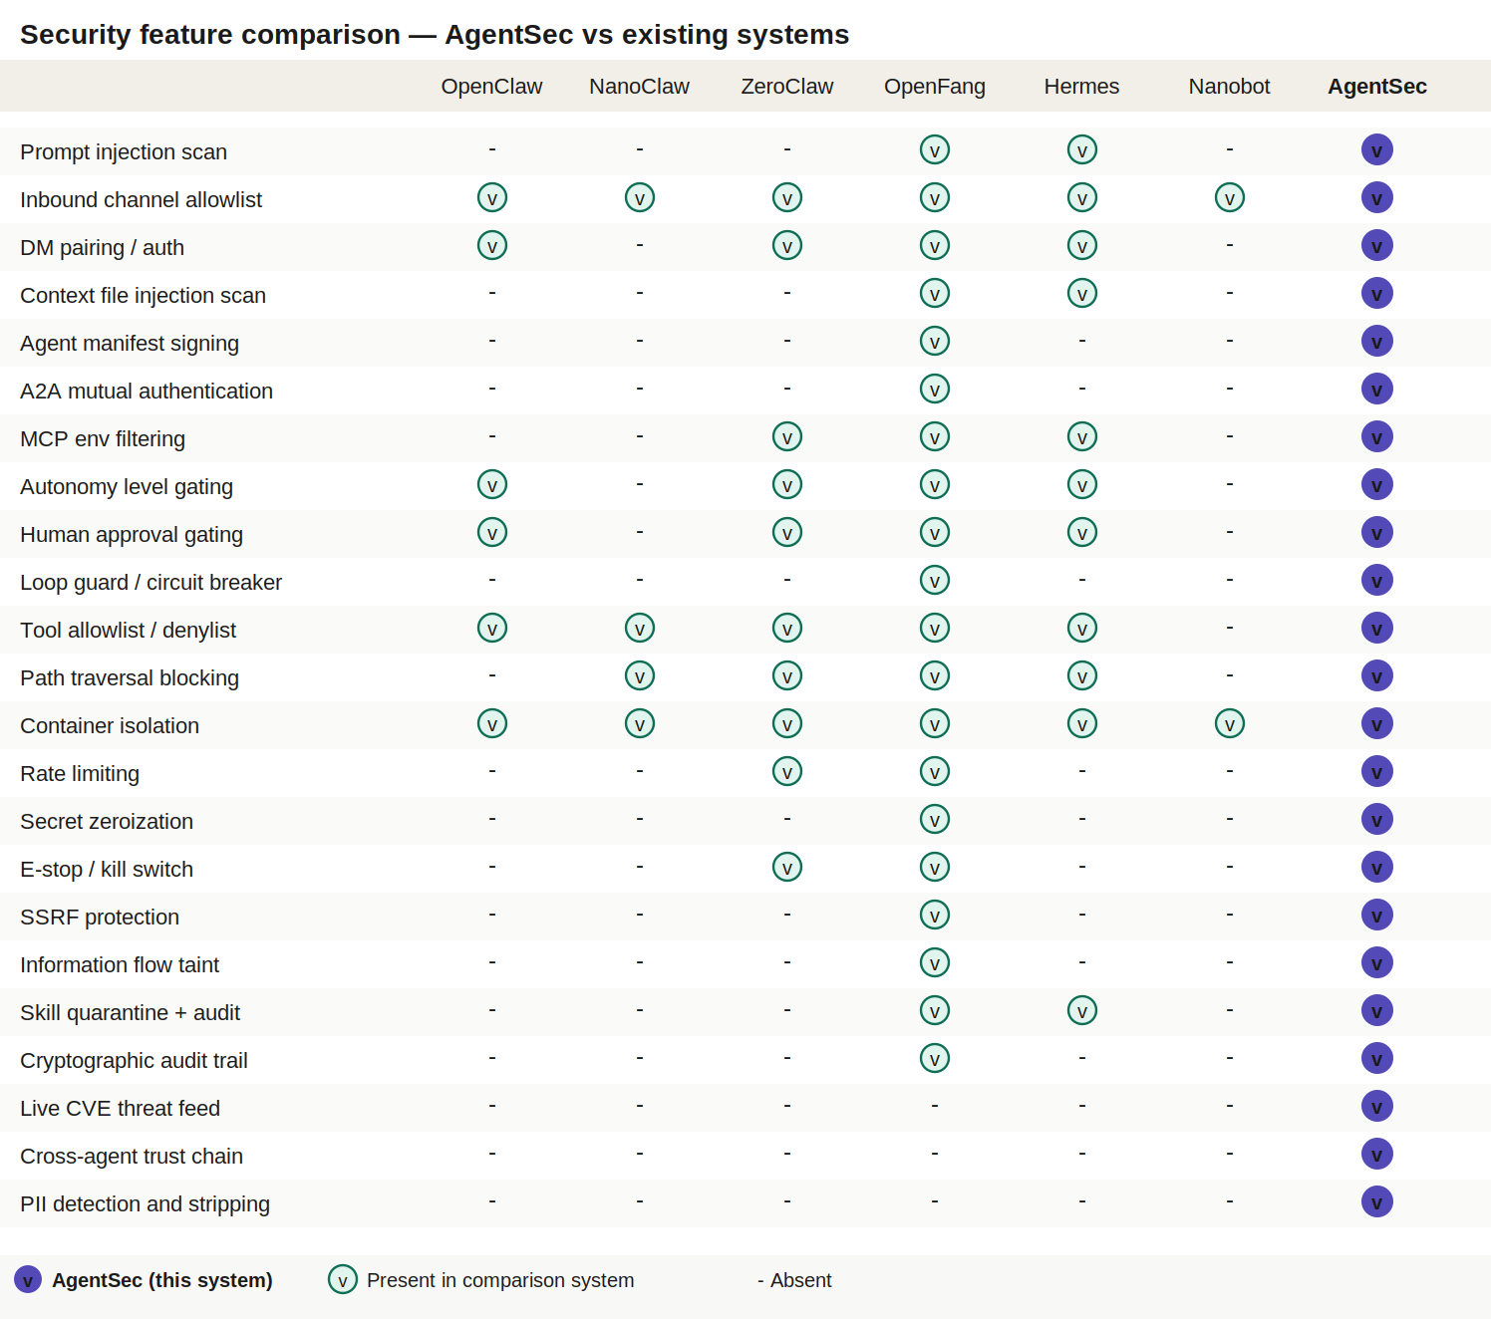
Figure 6: Security feature matrix — AgentSec vs six major agent systems. Purple filled = AgentSec, green outlined = present in that system.

The matrix reveals three categories of features:
Features present in multiple systems (baseline): Inbound channel allowlist, container isolation, tool allowlists, and DM pairing are implemented by at least three of the six comparison systems. AgentSec implements all of these.
Features present only in the most security-advanced systems (advanced): Cryptographic audit trail (OpenFang only), SSRF protection (OpenFang only), information flow taint tracking (OpenFang only), and agent manifest signing (OpenFang only). AgentSec implements all of these.
Features absent from all six comparison systems (AgentSec-exclusive): Live CVE threat feed integration, cross-agent trust chain verification, and active PII detection with stripping on ingress. These represent AgentSec's unique security contribution to the field.

6. Deployment Architecture

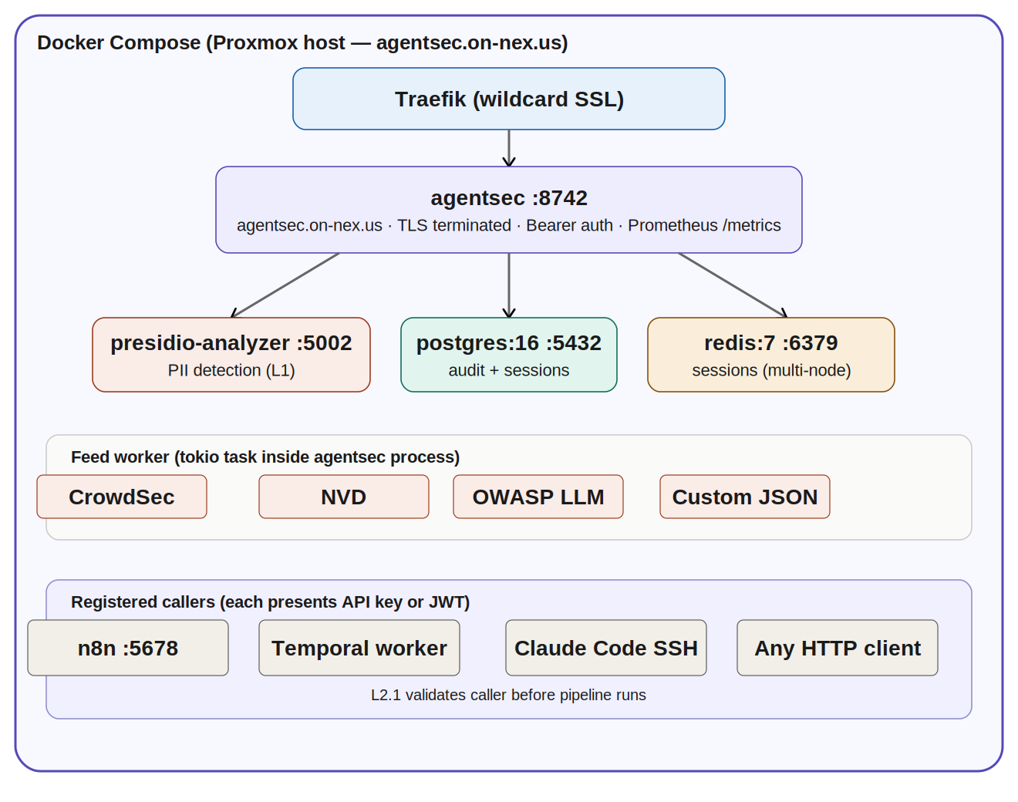
Figure 7: Production deployment topology on Proxmox with Docker Compose and Traefik SSL termination

6.1 Container Topology
The production deployment consists of four containers managed by Docker Compose:
- agentsec — the main binary, exposed on port 8742, routed through Traefik with wildcard TLS
- presidio-analyzer — the Microsoft Presidio ML-based PII detection service, accessible only on the internal Docker network
- postgres:16-alpine — the session, audit, and telemetry store with persistent volume
- redis:7-alpine — optional session store for multi-node deployments requiring shared rate limiting state

6.2 TLS and Authentication
All external traffic is TLS-terminated at the Traefik edge using wildcard certificates issued via the dns-cloudflare resolver. The AgentSec binary binds to an internal port and is never exposed directly to external traffic. All routes except /health and /openapi.json require Bearer token authentication. Admin routes (/admin/*) require a separate admin token with elevated privileges.

6.3 Language Justification: Rust
The decision to build AgentSec in Rust is deliberate and directly tied to the product's enterprise security positioning. The justification has four components:
- Memory safety by construction — Rust's ownership model eliminates entire classes of memory vulnerabilities (buffer overflows, use-after-free, null pointer dereferences) at compile time. The CVE exposure of the AgentSec binary is structurally minimized before a single line of security logic is written.
- Single static binary — the production artifact is a single binary with no runtime dependency chain. There is no Python interpreter, no pip package tree, no Node.js runtime with hundreds of transitive npm packages. The attack surface of the deployment artifact is minimal by design.
- Enterprise sales narrative — when a security product undergoes enterprise procurement review, the question "what language is this written in and why" arises. The Rust answer is self-documenting. A Python answer requires extensive explanation of mitigating controls.
- Performance — AgentSec sits on the hot path of every agent call. Rust's axum HTTP framework handles hundreds of thousands of requests per second on a single core. The sidecar adds negligible latency to the agent pipeline, making it transparent to client-visible performance metrics.

6.4 Configuration Model
AgentSec uses a layered configuration model: base TOML files define defaults for each deployment profile (default.toml, minimal.toml, enterprise.toml), and environment variables override any individual setting. This allows Kubernetes secret injection, Docker environment files, and direct CLI overrides to all work against the same base configuration without forking profiles.
Three named profiles ship with the distribution:
- default.toml — all Phase 1 layers enabled, in-process memory session store, standard telemetry to stdout
- minimal.toml — L0, L1, and L7 only for lowest-latency deployments where L2-L6 overhead is unacceptable
- enterprise.toml — all layers enabled including Phase 2 stubs, Postgres session store, OpenTelemetry export, full telemetry verbosity with PII redaction

7. API Reference

7.1 POST /check
The primary endpoint. Accepts a JSON body with the following structure:
POST /check
Authorization: Bearer <api_key>
Content-Type: application/json
{
"direction": "ingress",
"payload": { ... },
"session_id": "optional-session-uuid",
"caller_context": {
"caller_id": "n8n-workflow-001",
"caller_type": "n8n",
"model": "claude-opus-4-6",
"provider": "anthropic",
"prompt_tokens": 1200,
"completion_tokens": 0,
"cost_usd": 0.018
},
"tool_manifest": {
"tool_name": "bash",
"tool_args": { "command": "ls -la" },
"allowed_tools": ["bash", "read_file"]
}
}

The response is either a pass:
HTTP 200
{
"status": "pass",
"request_id": "01J8K...",
"session_id": "optional-session-uuid",
"payload": { ... },
"latency_ms": 3,
"layers_ran": ["L1_SANITIZE", "L2_1_AUTH", "L2_2_TRUST", "L2_3_THREAT", "L4_AUTHZ", "L5_SANDBOX"]
}

Or a reject:
HTTP 200
{
"status": "reject",
"request_id": "01J8K...",
"payload": null,
"reject": {
"layer": "L1_SANITIZE",
"code": "PROMPT_INJECTION",
"reason": "Pattern matched: ignore prior instructions",
"severity": "high"
},
"latency_ms": 1,
"layers_ran": ["L1_SANITIZE"]
}

7.2 Other Endpoints
Attribute | Detail
GET /health | Liveness check. Returns 200 if process is alive. No auth required.
GET /ready | Readiness check. Returns 200 if session store is connected and feed has loaded at least one SignatureSet.
GET /metrics | Prometheus metrics exposition. Requires API key auth.
POST /admin/feed/refresh | Triggers an immediate out-of-band feed pull. Requires admin token.
GET /admin/signatures | Returns current SignatureSet statistics: source counts, last updated timestamp, signature counts by type. Requires admin token.
GET /admin/audit/verify | Walks the L7 audit chain from genesis and returns pass or the first record at which chain integrity fails. Requires admin token.
GET /openapi.json | OpenAPI 3.1 specification. No auth required.
GET /docs | Scalar API browser. No auth required.

8. Build Plan

8.1 Phase 1 — Core Protection
Phase 1 delivers a fully deployable, production-capable binary with all Phase 1 layers implemented and L3/L6 as documented pass-through stubs. The build sequence is ordered to ensure a callable end-to-end service exists after step 4, with each subsequent step adding a real security layer.
Attribute | Detail
Step 1 | agentsec-core crate: types, Layer trait, Pipeline runner, session trait, config, error types
Step 2 | agentsec-store: in-process DashMap memory backend only
Step 3 | agentsec-api: axum skeleton, /health route, POST /check wired to empty pipeline — must compile and run
Step 4 | L0 telemetry envelope integrated into agentsec-api
Step 5 | L7 audit hash chain
Step 6 | L1 input sanitization with injection patterns and Presidio integration
Step 7 | L2.1 caller authentication and L2.2 trust chain
Step 8 | agentsec-feed crate: SignatureSet, feed worker, CrowdSec source
Step 9 | L2.3 threat intelligence matching against SignatureSet
Step 10 | L4 tool authorization and RBAC
Step 11 | L5 rate limiting and cost cap
Step 12 | agentsec-store: Redis and Postgres backends
Step 13 | All remaining routes, Prometheus metrics, OpenAPI spec
Step 14 | Dockerfile, Docker Compose, Traefik configuration
Step 15 | Integration test suite

8.2 Phase 2 — Semantic Intelligence
Phase 2 activates the L3 semantic intent guard and completes the L6 output inspection layer. It also introduces the L3 Postgres/pgvector backend for long-term session intent storage.
- L3 semantic intent guard: cosine similarity against session baseline using local embedding model
- L6 SSRF URL scanner and exfiltration pattern detection
- L6 PII egress detection with Presidio integration
- L3 behavioral drift alerting with configurable threshold

8.3 Autonomous Build with Claude Code
The CLAUDE.md file in the repository root provides Claude Code with complete project context for autonomous implementation. It specifies the crate layout, the Layer trait contract, all type definitions, per-layer implementation requirements, the build order, and verification gates (cargo check must pass between every step). Claude Code operating from the claude-controller VM can execute the full Phase 1 build autonomously.
To start the autonomous build: clone the repository, place CLAUDE.md in the root, open Claude Code in the project directory, and type: start. Claude Code will read the context file and execute the build order without further prompts.

9. Security Posture Summary
AgentSec's security design follows three principles drawn from the defense-in-depth analysis of the six comparison systems:

9.1 Fail-Open, Fail-Logged
Layer faults (internal errors) are treated as passes in production and logged to telemetry. This prevents a misconfigured or temporarily degraded layer from taking down the entire agent pipeline. The trade-off is that a faulty layer briefly provides no protection — this is preferable to a production outage. Layer fault rates are exposed as Prometheus metrics and should be alarmed.

9.2 Zero-Restart Updates
The L2.3 feed worker's atomic SignatureSet swap provides the critical property that new CVE signatures become active without a service restart. In a threat landscape where AI-specific vulnerabilities are published continuously, the ability to push signature updates at configurable intervals (or immediately via webhook) without touching the running binary is essential for enterprise deployments.

9.3 Separation of Concerns Across Layers
Each layer owns exactly one concern. L0 is observability. L1 is syntactic input validation. L2 is identity and world-knowledge trust. L3 is semantic intent. L4 is authorization. L5 is resource governance. L6 is egress safety. L7 is security audit integrity. No layer reaches into another layer's concern. This makes the system independently testable, independently configurable, and independently replaceable as the threat landscape evolves.

AgentSec provides the security layer that the agentic AI ecosystem has been missing: a portable, language-agnostic, enterprise-grade protection module that works across every framework, enforces every known attack category, and evolves with the threat landscape without service interruption.

Appendix A — Environment Variable Reference
All configuration variables are prefixed AGENTSEC_. Environment variables take precedence over TOML file settings.
Attribute | Detail
AGENTSEC_HOST | Bind address. Default: 0.0.0.0
AGENTSEC_PORT | Listen port. Default: 8742
AGENTSEC_LOG_LEVEL | Tracing log level. Default: info
AGENTSEC_JWT_SECRET | HMAC-SHA256 secret for JWT validation (L2.1)
AGENTSEC_API_KEYS | Comma-separated SHA-256 hashes of valid API keys (L2.1)
AGENTSEC_ADMIN_TOKEN | Bearer token for /admin/* routes
AGENTSEC_TRUST_SECRET | HMAC secret for L2.2 trust chain token validation
AGENTSEC_STORE_BACKEND | Session backend: memory | redis | postgres. Default: memory
AGENTSEC_DATABASE_URL | Postgres connection string (required if STORE_BACKEND=postgres)
AGENTSEC_REDIS_URL | Redis connection string (required if STORE_BACKEND=redis)
AGENTSEC_SESSION_TTL_SECS | Session expiry. Default: 3600
AGENTSEC_TELEMETRY_LEVEL | off | minimal | standard | full | debug. Default: standard
AGENTSEC_TELEMETRY_BACKEND | stdout | file | postgres | otel | multi. Default: stdout
AGENTSEC_TELEMETRY_PII_REDACT | Strip PII before telemetry write. Default: true
AGENTSEC_FEED_INTERVAL_SECS | Feed poll interval. Default: 300
AGENTSEC_CROWDSEC_API_KEY | CrowdSec CTI API key (L2.3)
AGENTSEC_NVD_API_KEY | NVD API key — optional, higher rate limit (L2.3)
AGENTSEC_CUSTOM_FEED_PATH | Path to custom signature JSON file (L2.3)
AGENTSEC_RATE_MAX_ACTIONS_PER_HOUR | Rate limit ceiling. Default: 1000
AGENTSEC_RATE_MAX_COST_PER_DAY | Daily cost cap in USD. Default: 100.0
AGENTSEC_RATE_MAX_TOKENS_PER_REQUEST | Token budget per request. Default: 100000
AGENTSEC_PRESIDIO_URL | Presidio Analyzer URL. Default: http://presidio-analyzer:5002
AGENTSEC_PRESIDIO_TIMEOUT_MS | Presidio call timeout. Default: 10
AGENTSEC_RBAC_PATH | Path to RBAC roles JSON file (L4)
AGENTSEC_DESTRUCTIVE_TOOLS | Comma-separated list of destructive tool names (L4)
AGENTSEC_LAYER_L1_ENABLED | Enable/disable L1. Default: true
AGENTSEC_LAYER_L2_3_ENABLED | Enable/disable L2.3 threat intel. Default: true
AGENTSEC_LAYER_L4_ENABLED | Enable/disable L4. Default: true
AGENTSEC_LAYER_L5_ENABLED | Enable/disable L5. Default: true
AGENTSEC_LAYER_L7_ENABLED | Enable/disable L7. Default: true

Appendix B — Rejection Code Reference
Attribute | Detail
Layer | Rejection codes
L1 | PROMPT_INJECTION | TOKEN_BUDGET_EXCEEDED | PII_CRITICAL
L2.1 | UNAUTHORIZED
L2.2 | TRUST_CHAIN_INVALID | TRUST_TOKEN_EXPIRED | TRUST_CALLER_MISMATCH
L2.3 | IP_BLOCKLIST | CVE_SIGNATURE_MATCH | TOOL_CVE | PROVIDER_ADVISORY
L3 | INTENT_DRIFT (Phase 2)
L4 | TOOL_NOT_AUTHORIZED | DESTRUCTIVE_TOOL_DENIED | TOOL_CVE | FORBIDDEN_ARGS
L5 | RATE_LIMIT | COST_CAP | TOKEN_BUDGET | ESTOP
L6 | SSRF_URL | EXFILTRATION_PATTERN | PII_EGRESS (Phase 2)

AgentSec Architecture & Design Specification | Version 1.0 | March 2026
Prepared by Onnex, Las Vegas, Nevada | CONFIDENTIAL

