Using BUSMASTER

Table of Contents

**1 – Hardware connection** 2

**2 – Playback of frames** 3

**3 – Filters and configuration** 4

**4 – Sending frame** 7

**5 – Other Functionality** 8

**6 – Database** 9

# **1 – Hardware connection**

Once the software is launched, the first thing to select is the driver for the hardware, Agco Canusb or VectorXL. To do this, simply go to the "Driver Selection" button and choose the hardware concerned, as in the attached picture below.

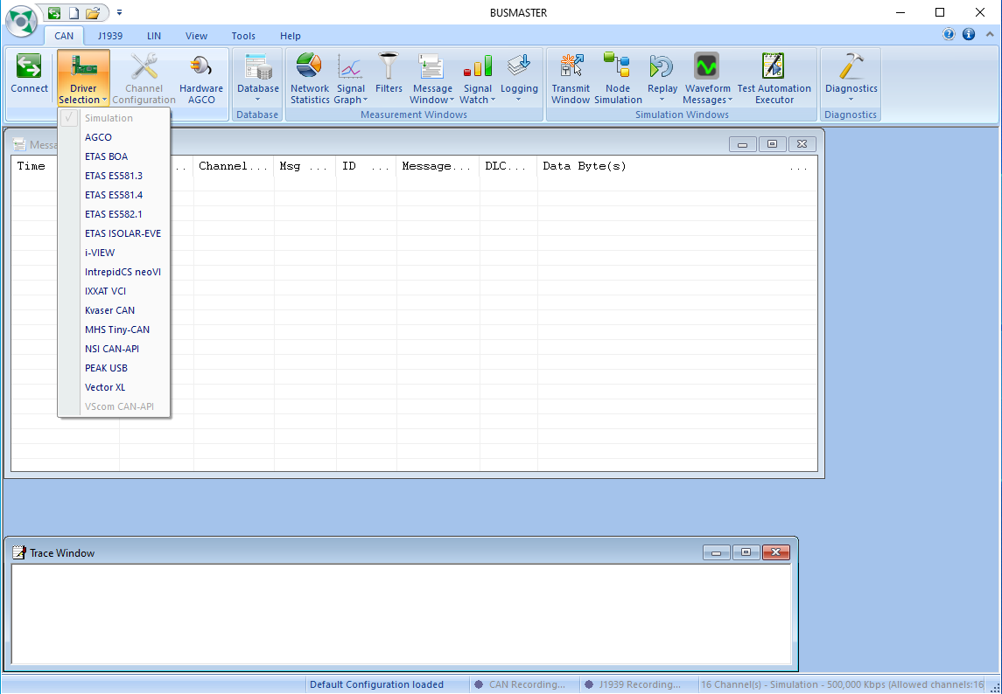

# **2 – Playback of frames**

Once the SRC is plugged in and the hardware selected, simply press the green button to start frame reception or press the red button to stop frame reception. The button is highlighted in yellow in the attached image below.



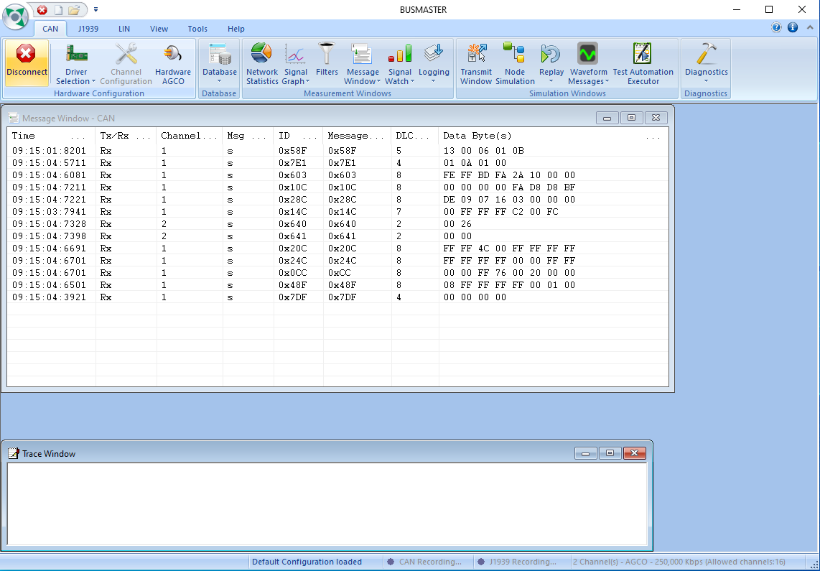

# **3 – Filters and configuration**

The "Filters" button on the CAN ribbon allows you to set filters to block or pass only certain ID groups or IDs. To determine whether a filter is "passing" or "blocking" by ID from the filter list, simply double-click on the filter type in the table on the left. All you have to do is add the IDs to be filtered and other parameters as required.

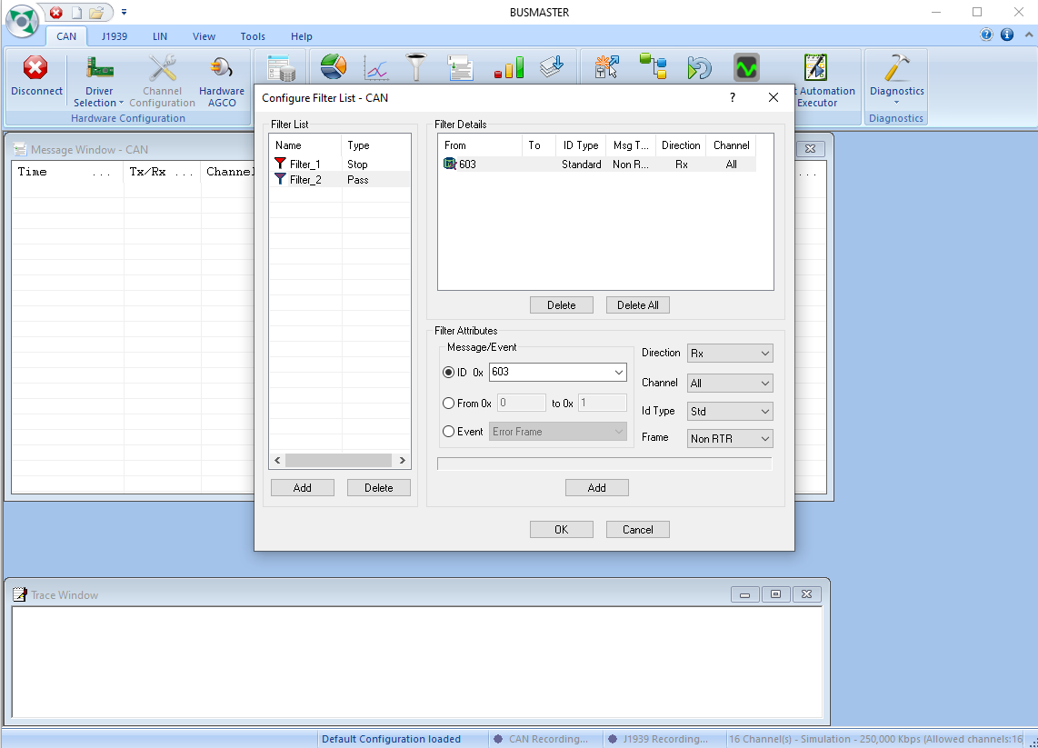

Once the filters have been configured, they must be added to the list of active filters. To do this, simply click on "Message Window", the "Configure" category is the one we are interested in, once in the open configuration window, in the "filter" tab after clicking on "Configure" there is only added or deleted the desired lists of filters.

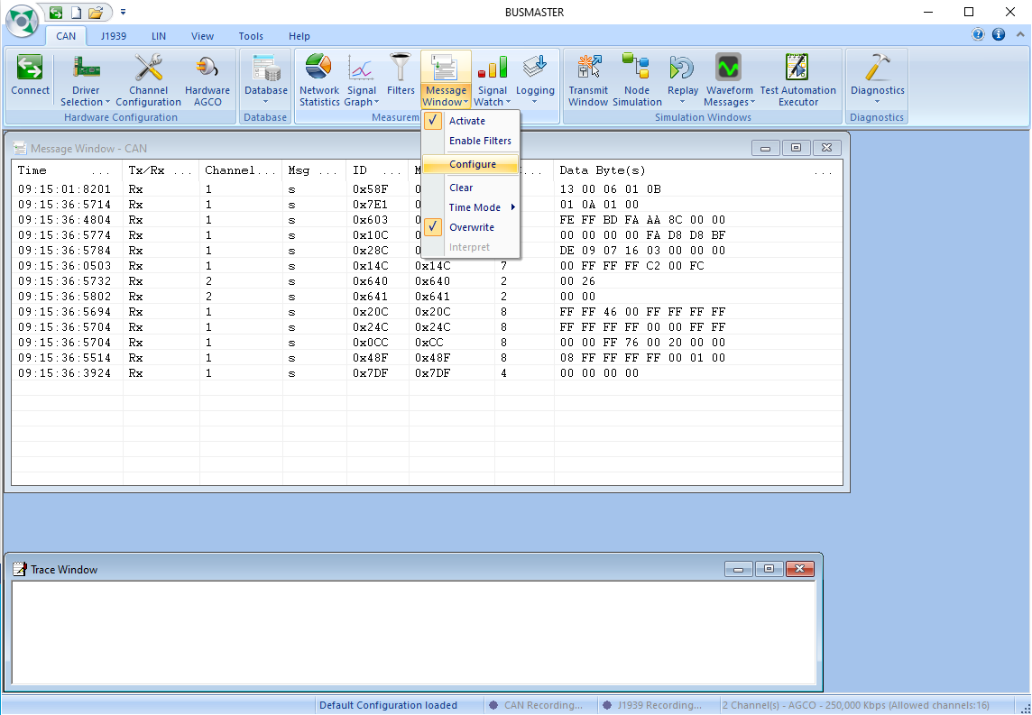

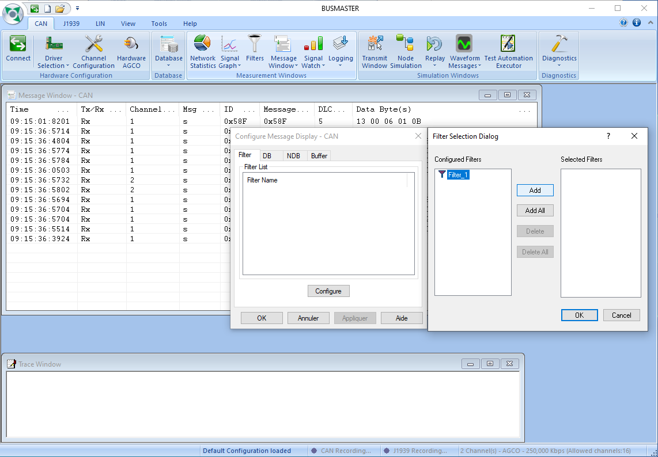

It is also possible to add color filters on identifiers via the "NDB" tab in the previous window.

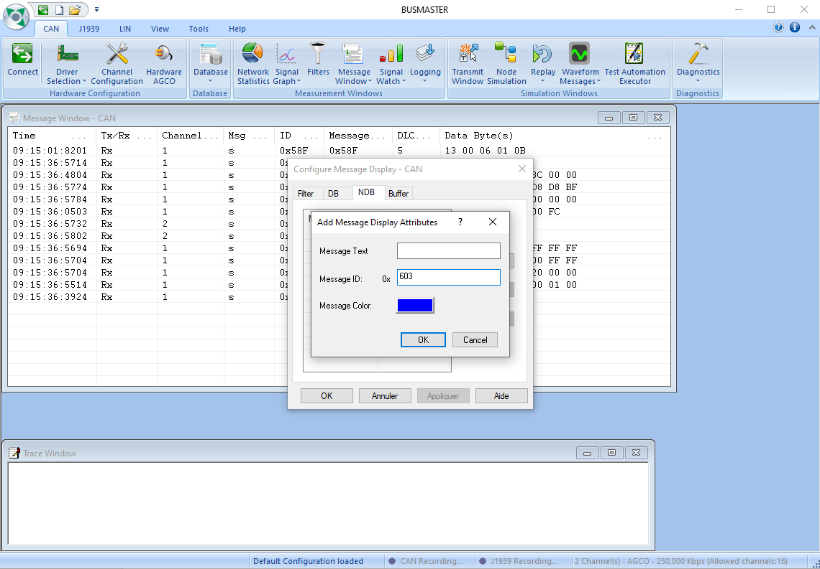

To activate these filters afterwards just click on "Enable Filters" in the drop-down menu of the "Message Window".

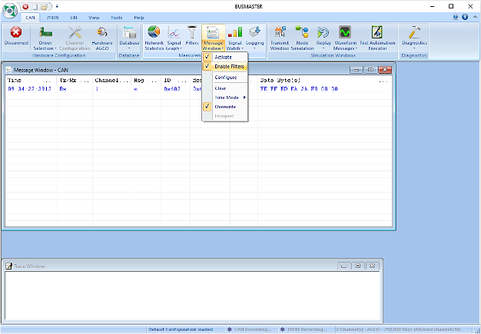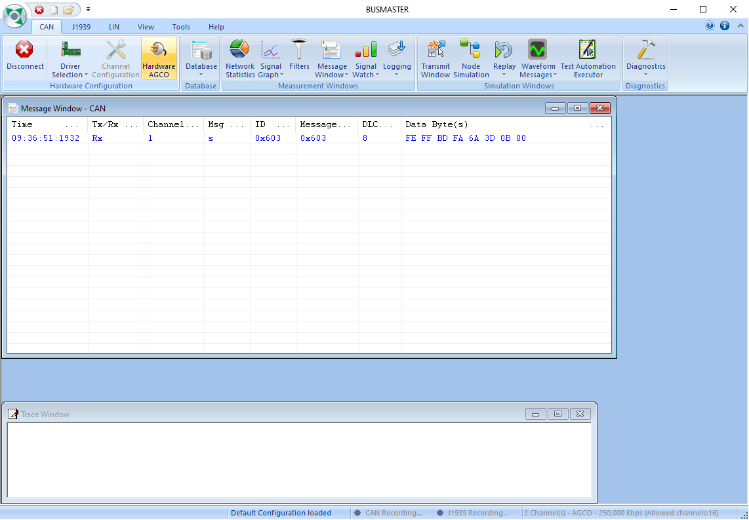

# **4 – Sending frame**

The frame is sent via a menu accessible from the "Transmit Window" button. All you have to do is fill in the form provided. The software proposes to send the frames in different ways, either a single sending or a cyclic sending where you only have to configure the periodicity. It is possible to assign a shortcut to a predefined sending.

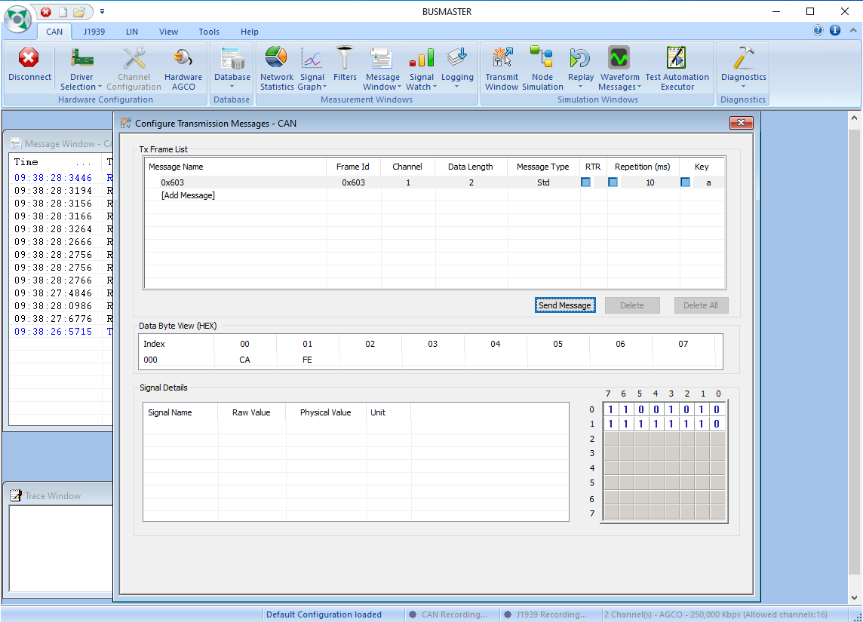

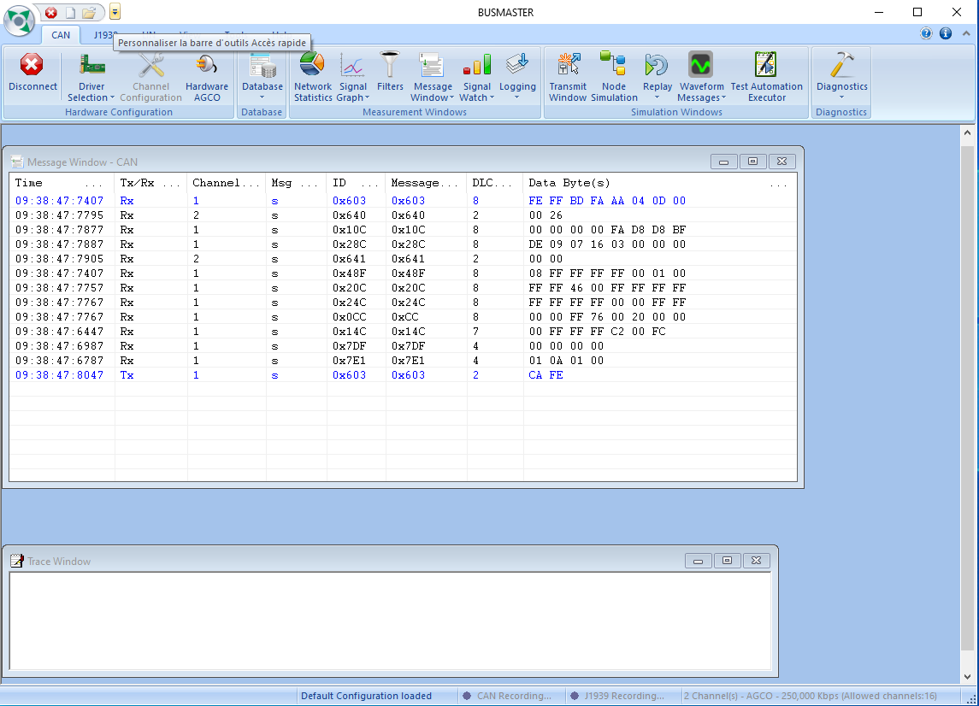

# **5 – Other Functionality**

The "Message Window" drop-down menu includes several features such as:

* Enable filters.
* Clean the frame window.
* Three different modes for timestamp.

See the frames scrolling or have them static.

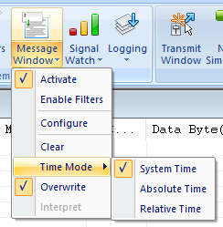

It is also possible to identify the serial number (only for AGCO cards) from the "AGCO Hardware" button in the event that more than one card is connected.

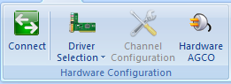

# **6 – Database**

Busmaster requires a database in .dbf format, for this, with bumaster there is a program called "Format Converter" that can be found in the location of the program, to access it just right click on the Busmaster shortcut and open the file location and open it.

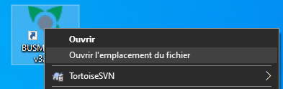

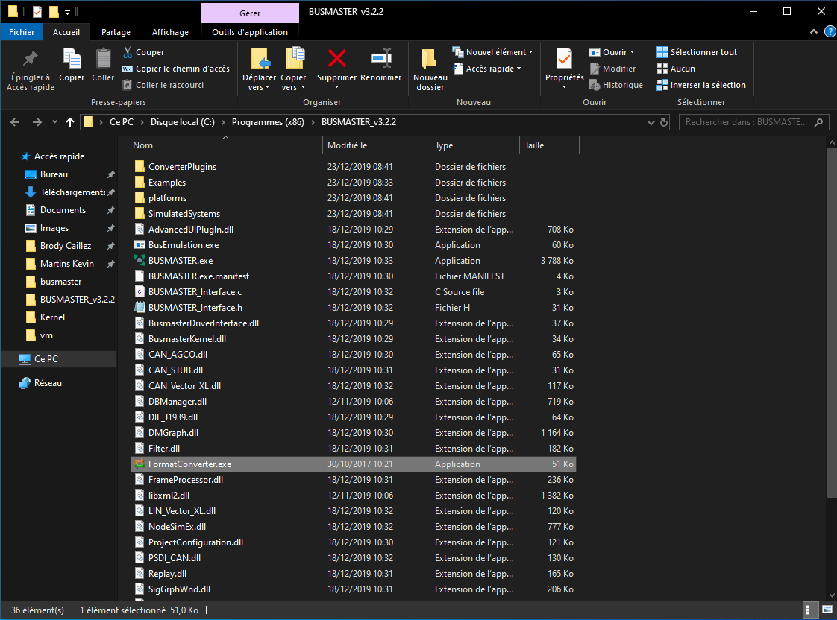

Once the software is open, in the tab "Other Converters",

You have to choose the conversion format, so DBC to DBF, then you just have to select the file you want to convert and choose the output of the conversion.

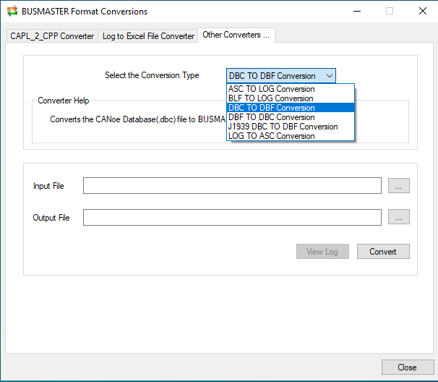

All you have to do is link it in busmaster:

