BUSMASTER

**1 – Hardware Connection**

**2 – Playback of frames**

**3 – Filter and configuration**

**4 – Sending a frame**

**5 – Other functionnality**

**1 – Hardware Connection**

Once the software starts, the first thing to select is the driver for the hardware, Agco Canusb or VectorXL. To do this, just go to the "Driver Selection" button and choose the hardware concerned, as in the attached picture below.

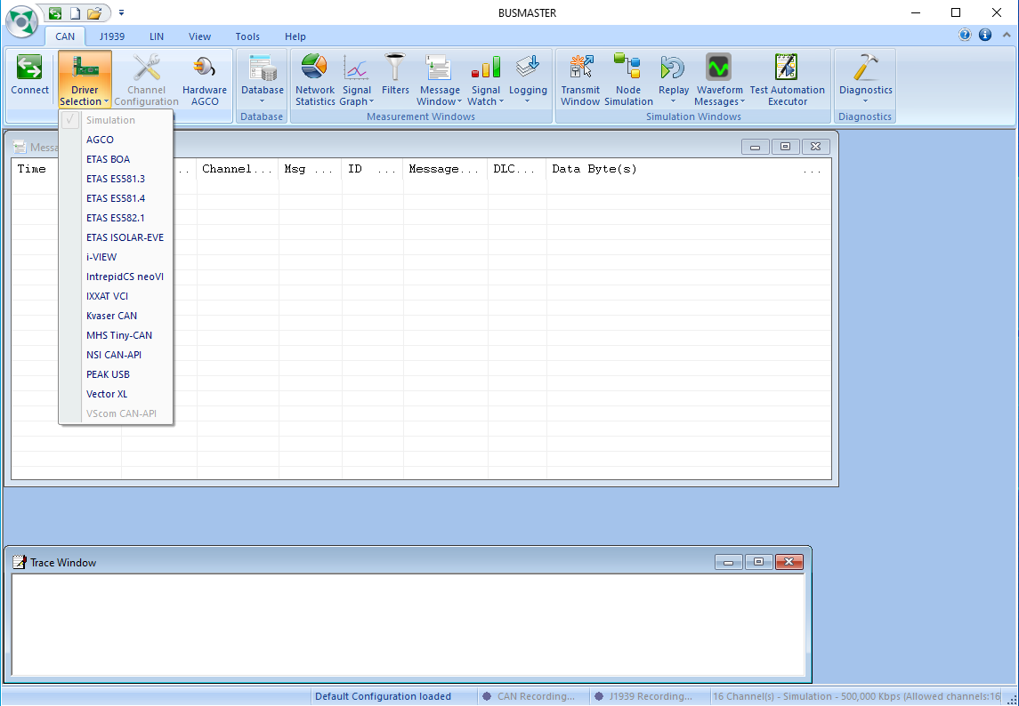

**2 – Playback of frames**

Once the src is plugged in and the hardware selected, simply press the green button to start receiving frames or to press the red button to stop frame reception. The button is highlighted in yellow in the attached image below.



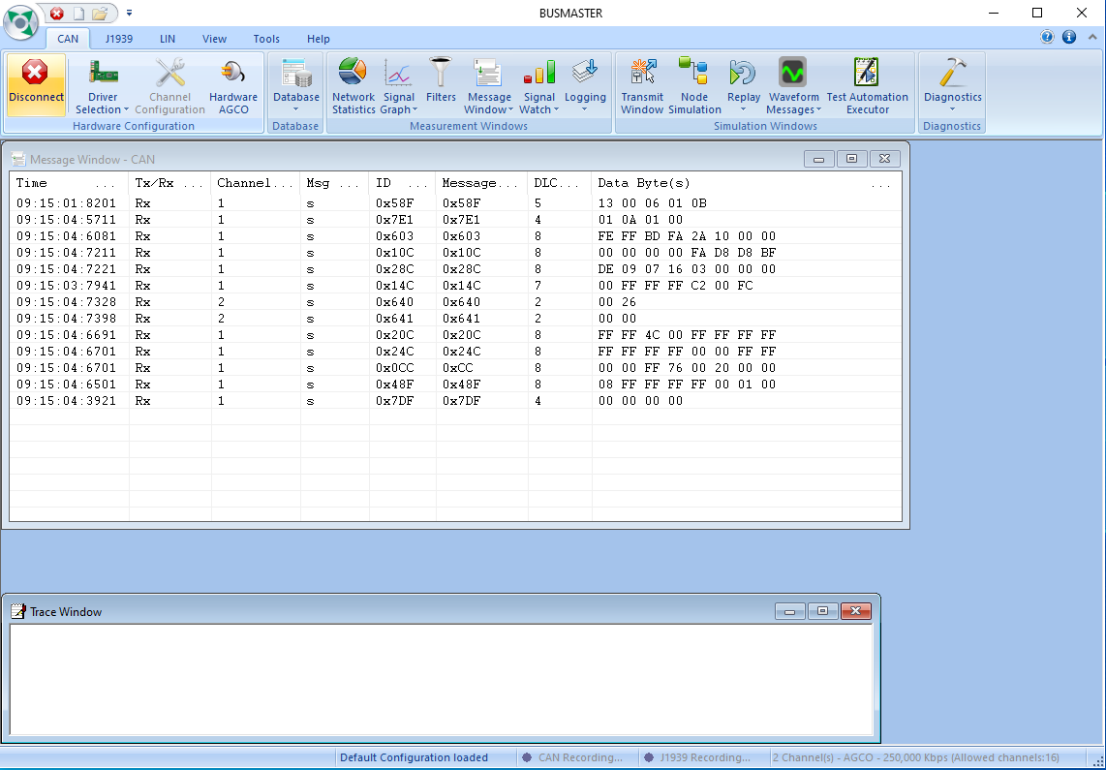

**3 – Filter and configuration**

The "Filters" button in the CAN ribbon allows you to set up filters to block or allow only certain id groups or ids to pass. To determine on the list of filters to let pass or block frames by id just double click on the type of filter concerned in the table on the left (photo attached below). Then just add the ids to be filtered and other parameters as needed.

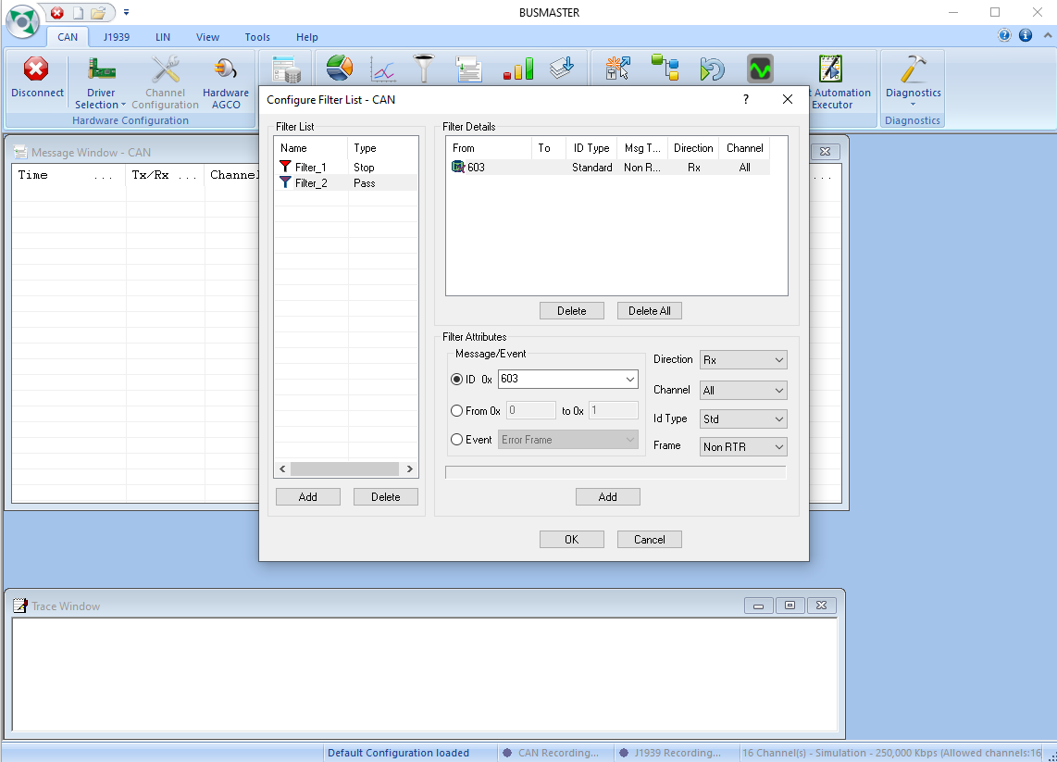

Once the filters have been configured, they must be added to the list of active filters. To do this, click on "Message Window", the "Configure" category is the one we are interested in, once in the open configuration window, in the "filter" tab, after clicking on "configure", only the desired filter lists are added or deleted. (Photo below)

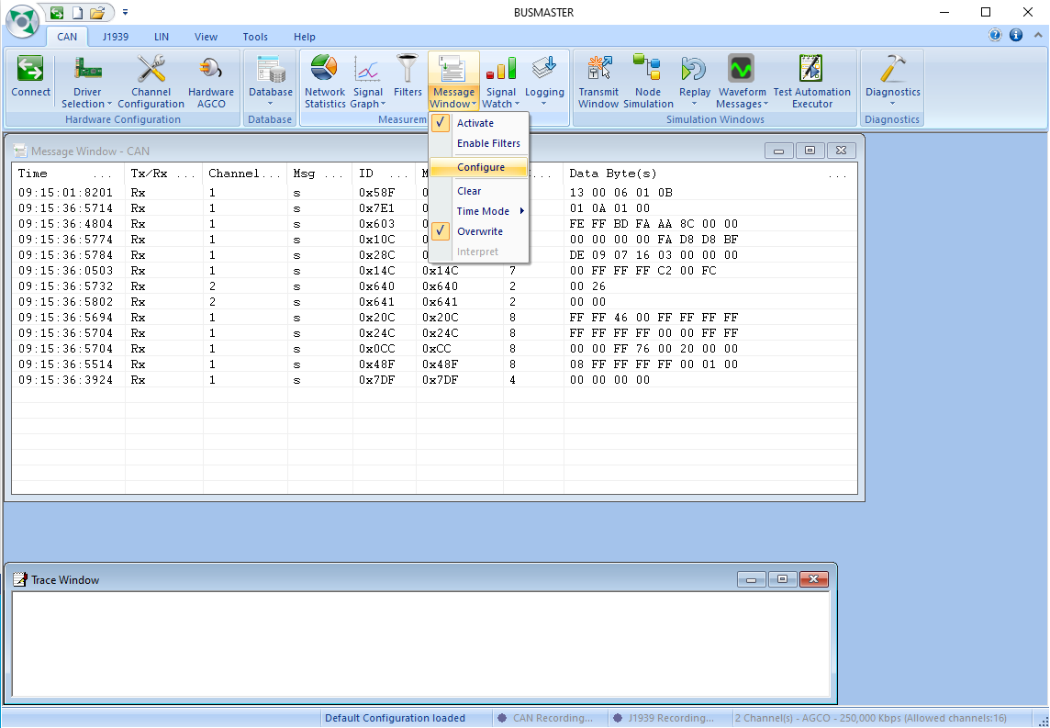

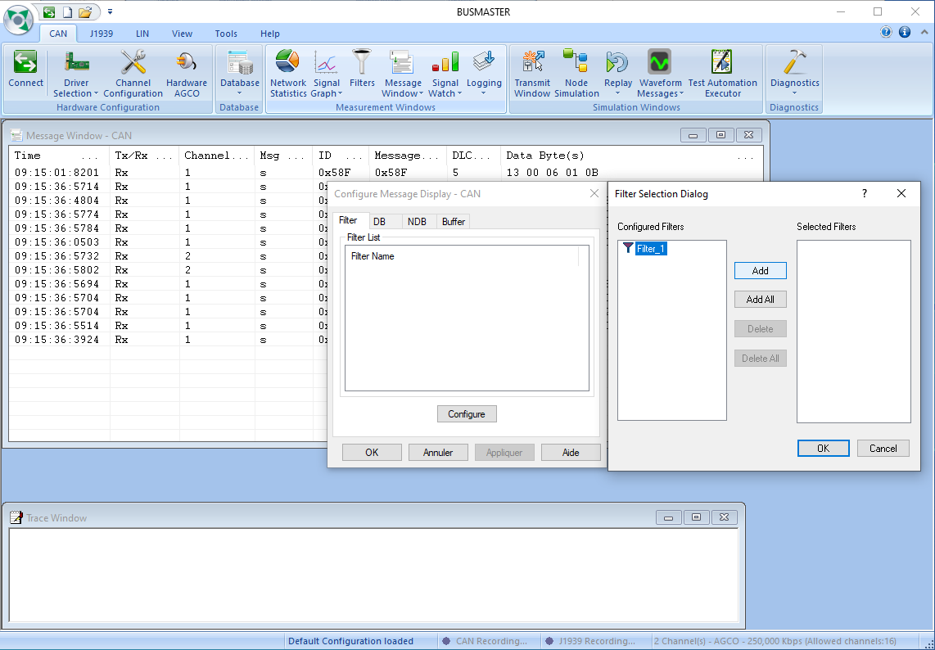

It is also possible to add color filters on identifiers the same menu configured as above but in the "NDB" tab.

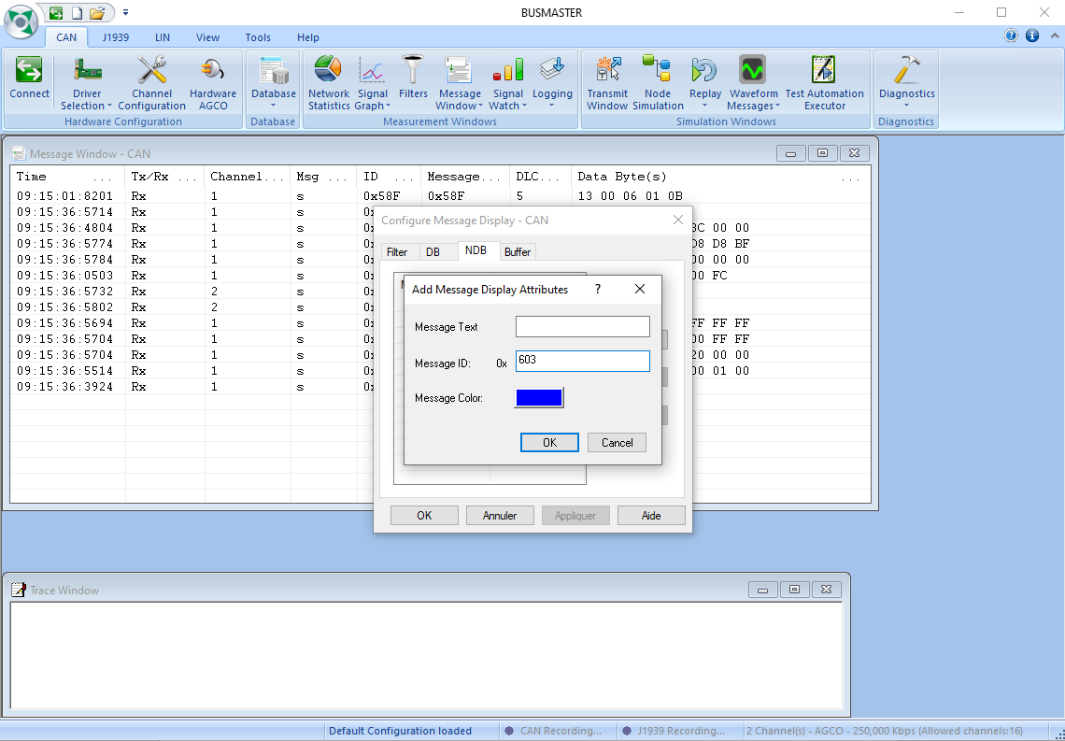

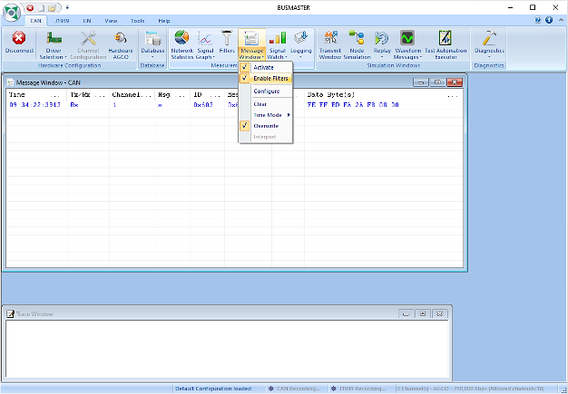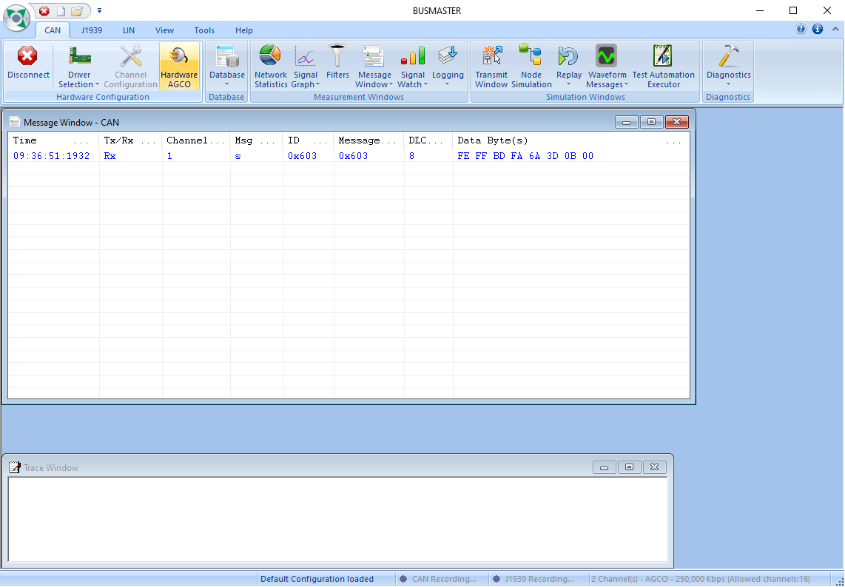To activate these filters afterwards just click on "Enable Filters" in the drop-down menu of the "Message Window".

**4 – Sending a frame**

The frame sending is done via a menu accessible from the "Transmit Window" button. Just fill in the form proposed, the software proposes to send the frames in different ways, either a single sending, or a cyclic sending where you only have to configure the time between each frame, or the frame sending via a parameter key like "a" on the picture below.

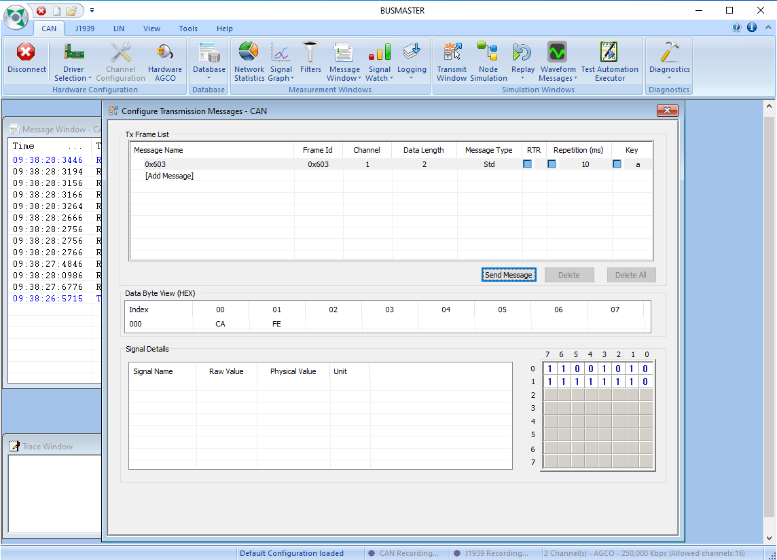

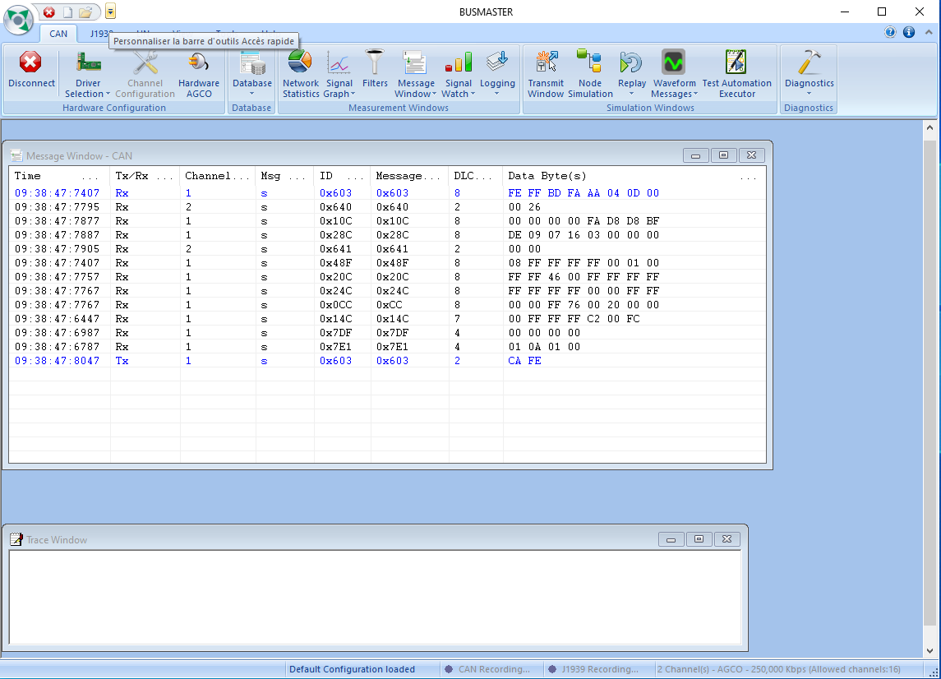

**5 – Other functionnality**

The "Message Window" drop-down menu includes several features such as:

- Activate filters

- Cleaning the trace window

- Three different modes for timestamp.

- See the frames scrolling or have them in static

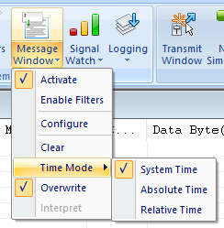

It is also possible to identify the serial number (only for AGCO cards) from the "AGCO Hardware" button in the event that more than one card is connected.

