

BURSA ULUDAĞ ÜNİVERSİTESİ

BİLGİSAYAR MÜHENDİSLİĞİ

2023-2024 EĞİTİM ÖĞRETİM YILI BAHAR DÖNEMİ

BİLGİSAYAR GRAFİKLERİ RAPORU

MURAT BERK YETİŞTİRİR

032290008

[032290008@ogr.uludag.edu.tr](mailto:032290008@ogr.uludag.edu.tr)

**SORU:**

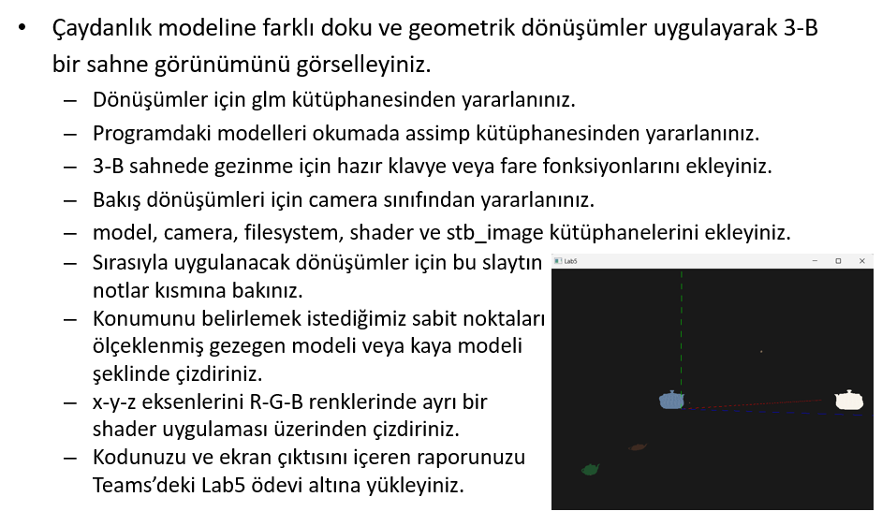

**CEVAP KODU:**

#include <glad/glad.h>

#include <GLFW/glfw3.h>

#include <stb_image.h>

#include <glm/glm.hpp>

#include <glm/gtc/matrix_transform.hpp>

#include <glm/gtc/type_ptr.hpp>

#include <learnopengl/filesystem.h>

#include <learnopengl/shader.h>

#include <learnopengl/camera.h>

#include <learnopengl/model.h>

#include <iostream>

void framebuffer_size_callback(GLFWwindow* window, int width, int height);

void mouse_callback(GLFWwindow* window, double xpos, double ypos);

void scroll_callback(GLFWwindow* window, double xoffset, double yoffset);

void processInput(GLFWwindow* window);

// settings

const unsigned int SCR_WIDTH = 800;

const unsigned int SCR_HEIGHT = 600;

#define NUM_OF_POINTS 30

// camera

Camera camera(glm::vec3(0.0f, 0.0f, 55.0f));

float lastX = (float)SCR_WIDTH / 2.0;

float lastY = (float)SCR_HEIGHT / 2.0;

bool firstMouse = true;

// timing

float deltaTime = 0.0f;

float lastFrame = 0.0f;

int main()

{

// glfw: initialize and configure

// ------------------------------

glfwInit();

glfwWindowHint(GLFW_CONTEXT_VERSION_MAJOR, 3);

glfwWindowHint(GLFW_CONTEXT_VERSION_MINOR, 3);

glfwWindowHint(GLFW_OPENGL_PROFILE, GLFW_OPENGL_CORE_PROFILE);

#ifdef __APPLE__

glfwWindowHint(GLFW_OPENGL_FORWARD_COMPAT, GL_TRUE);

#endif

// glfw window creation

// --------------------

GLFWwindow* window = glfwCreateWindow(SCR_WIDTH, SCR_HEIGHT, "LearnOpenGL", NULL, NULL);

if (window == NULL)

{

std::cout << "Failed to create GLFW window" << std::endl;

glfwTerminate();

return -1;

}

glfwMakeContextCurrent(window);

glfwSetFramebufferSizeCallback(window, framebuffer_size_callback);

glfwSetCursorPosCallback(window, mouse_callback);

glfwSetScrollCallback(window, scroll_callback);

// tell GLFW to capture our mouse

glfwSetInputMode(window, GLFW_CURSOR, GLFW_CURSOR_DISABLED);

// glad: load all OpenGL function pointers

// ---------------------------------------

if (!gladLoadGLLoader((GLADloadproc)glfwGetProcAddress))

{

std::cout << "Failed to initialize GLAD" << std::endl;

return -1;

}

// configure global opengl state

// -----------------------------

glEnable(GL_DEPTH_TEST);

// build and compile shaders

// -------------------------

Shader shader("10.2.instancing.vs", "10.2.instancing.fs");

// load models

// -----------

Model planet(FileSystem::getPath("resources/objects/planet/planet.obj"));

unsigned int texture1 = TextureFromFile("top.jpg", FileSystem::getPath("resources/objects/lab4/").c_str(),0);

unsigned int texture2 = TextureFromFile("green.png", FileSystem::getPath("resources/objects/lab4/").c_str(),0);

Model teapot(FileSystem::getPath("resources/objects/lab4/teapot/teapot.obj"));

Shader shader1("eksen.vs", "eksen.fs");

float vertices[NUM_OF_POINTS * 3];

for (int i = 0; i < NUM_OF_POINTS; i++)

{

vertices[3 * i] = i;

vertices[3 * i+1] = 0;

vertices[3 * i+2] = 0;

}

unsigned int VBO, VAO;

glGenVertexArrays(1,&VAO);

glGenBuffers(1, &VBO);

glBindVertexArray(VAO);

glBindBuffer(GL_ARRAY_BUFFER, VBO);

glVertexAttribPointer(0, 3, GL_FLOAT, GL_FALSE, 3 * sizeof(float), (void*)0);

glEnableVertexAttribArray(0);

glm::mat4 model_axis;

// render loop

// -----------

while (!glfwWindowShouldClose(window))

{

// per-frame time logic

// --------------------

float currentFrame = static_cast<float>(glfwGetTime());

deltaTime = (currentFrame - lastFrame) * 10;

lastFrame = currentFrame;

// input

// -----

processInput(window);

// render

// ------

glClearColor(0.1f, 0.1f, 0.1f, 1.0f);

glClear(GL_COLOR_BUFFER_BIT | GL_DEPTH_BUFFER_BIT);

// configure transformation matrices

glm::mat4 projection = glm::perspective(glm::radians(45.0f), (float)SCR_WIDTH / (float)SCR_HEIGHT, 0.1f, 1000.0f);

glm::mat4 view = camera.GetViewMatrix();;

shader.use();

shader.setMat4("projection", projection);

shader.setMat4("view", view);

// draw planet

glm::mat4 model = glm::mat4(1.0f);

model = glm::translate(model, glm::vec3(10.0f, 10.0f, 10.0f));

float rotAngle = 150;

model = glm::rotate(model, glm::radians(rotAngle), glm::vec3(0.0f, 1.0f, 0.0f));

model = glm::translate(model, glm::vec3(-10.0f, -10.0f, -10.0f));

shader.setMat4("model", model);

teapot.Draw(shader);

// draw fish

glm::mat4 model2 = glm::mat4(1.0f);

model2 = glm::translate(model2, glm::vec3(-10.0f, -10.0f, -10.0f));

model2 = glm::scale(model2, glm::vec3(0.7f, 0.3f, 0.3f));

model2 = glm::translate(model2, glm::vec3(10.0f, 10.0f, 10.0f));

glBindTexture(GL_TEXTURE_2D, texture1);

shader.setMat4("model", model2);

teapot.Draw(shader);

// draw teapot

glm::mat4 model3 = glm::mat4(1.0f);

model3 = glm::translate(model3, glm::vec3(-1.0f, -1.0f, -1.0f));

model3 = glm::scale(model3, glm::vec3(1.0f, 1.0f, -1.0f));

model3 = glm::translate(model3, glm::vec3(1.0f, 1.0f, 1.0f));

glBindTexture(GL_TEXTURE_2D, texture2);

shader.setMat4("model", model3);

teapot.Draw(shader);

// draw teapot

glm::mat4 model4 = glm::mat4(1.0f);

model4 = glm::translate(model4, glm::vec3(-10.0f, -10.0f, -10.0f));

model4 = glm::scale(model4, glm::vec3(0.05f, 0.05f, 0.05f));

glBindTexture(GL_TEXTURE_2D, texture2);

shader.setMat4("model", model4);

teapot.Draw(shader);

// draw teapot

glm::mat4 model5 = glm::mat4(1.0f);

model5 = glm::translate(model5, glm::vec3(10.0f, 10.0f, 10.0f));

model5 = glm::scale(model5, glm::vec3(0.05f, 0.05f, 0.05f));

glBindTexture(GL_TEXTURE_2D, texture2);

shader.setMat4("model", model5);

teapot.Draw(shader);

// draw teapot

glm::mat4 model6 = glm::mat4(1.0f);

model6 = glm::translate(model6, glm::vec3(1.0f, 1.0f, 1.0f));

model6 = glm::scale(model6, glm::vec3(0.05f, 0.05f, 0.05f));

glBindTexture(GL_TEXTURE_2D, texture2);

shader.setMat4("model", model6);

teapot.Draw(shader);

shader1.use();

shader1.setMat4("projection", projection);

shader1.setMat4("view",view);

model_axis = glm::mat4(1.0f);

shader1.setMat4("model",model_axis);

shader1.setVec4("ourColor",1.0f,0.0f,0.0f,1.0f);

glBindVertexArray(VAO);

glDrawArrays(GL_LINES,0,NUM_OF_POINTS);

model_axis = glm::rotate(model_axis, glm::radians(90.0f), glm::vec3(0, 0, 1));

shader1.setMat4("model", model_axis);

shader1.setVec4("ourColor", 0.0f, 1.0f, 0.0f, 1.0f);

glDrawArrays(GL_LINES, 0, NUM_OF_POINTS);

model_axis = glm::rotate(model_axis, glm::radians(-90.0f), glm::vec3(0, 0, 1));

shader1.setMat4("model", model_axis);

shader1.setVec4("ourColor", 0.0f, 0.0f, 1.0f, 1.0f);

glDrawArrays(GL_LINES, 0, NUM_OF_POINTS);

// glfw: swap buffers and poll IO events (keys pressed/released, mouse moved etc.)

// -------------------------------------------------------------------------------

glfwSwapBuffers(window);

glfwPollEvents();

}

glfwTerminate();

return 0;

}

// process all input: query GLFW whether relevant keys are pressed/released this frame and react accordingly

// ---------------------------------------------------------------------------------------------------------

void processInput(GLFWwindow* window)

{

if (glfwGetKey(window, GLFW_KEY_ESCAPE) == GLFW_PRESS)

glfwSetWindowShouldClose(window, true);

if (glfwGetKey(window, GLFW_KEY_W) == GLFW_PRESS)

camera.ProcessKeyboard(FORWARD, deltaTime);

if (glfwGetKey(window, GLFW_KEY_S) == GLFW_PRESS)

camera.ProcessKeyboard(BACKWARD, deltaTime);

if (glfwGetKey(window, GLFW_KEY_A) == GLFW_PRESS)

camera.ProcessKeyboard(LEFT, deltaTime);

if (glfwGetKey(window, GLFW_KEY_D) == GLFW_PRESS)

camera.ProcessKeyboard(RIGHT, deltaTime);

}

// glfw: whenever the window size changed (by OS or user resize) this callback function executes

// ---------------------------------------------------------------------------------------------

void framebuffer_size_callback(GLFWwindow* window, int width, int height)

{

// make sure the viewport matches the new window dimensions; note that width and

// height will be significantly larger than specified on retina displays.

glViewport(0, 0, width, height);

}

// glfw: whenever the mouse moves, this callback is called

// -------------------------------------------------------

void mouse_callback(GLFWwindow* window, double xposIn, double yposIn)

{

float xpos = static_cast<float>(xposIn);

float ypos = static_cast<float>(yposIn);

if (firstMouse)

{

lastX = xpos;

lastY = ypos;

firstMouse = false;

}

float xoffset = xpos - lastX;

float yoffset = lastY - ypos; // reversed since y-coordinates go from bottom to top

lastX = xpos;

lastY = ypos;

camera.ProcessMouseMovement(xoffset, yoffset);

}

// glfw: whenever the mouse scroll wheel scrolls, this callback is called

// ----------------------------------------------------------------------

void scroll_callback(GLFWwindow* window, double xoffset, double yoffset)

{

camera.ProcessMouseScroll(static_cast<float>(yoffset));

}

**CEVAP EKRAN GÖRÜNTÜSÜ**

