

BURSA ULUDAĞ ÜNİVERSİTESİ

BİLGİSAYAR MÜHENDİSLİĞİ

2023-2024 EĞİTİM ÖĞRETİM YILI BAHAR DÖNEMİ

BİLGİSAYAR GRAFİKLERİ RAPORU

MURAT BERK YETİŞTİRİR

032290008

[032290008@ogr.uludag.edu.tr](mailto:032290008@ogr.uludag.edu.tr)

**SORU:** 03_Renklendirme ve indeksleme ders notunun son slaytına bakınız.

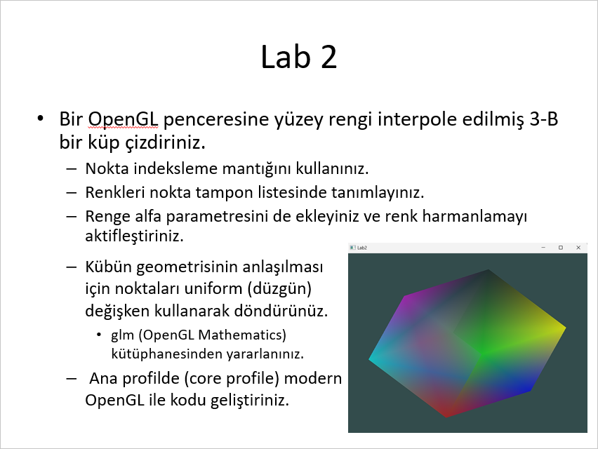

**CEVAP KODU:**

#include <glad/glad.h>

#include <GLFW/glfw3.h>

#include <glm/glm.hpp>

#include <glm/gtc/matrix_transform.hpp>

#include <glm/gtc/type_ptr.hpp>

#include <iostream>

void framebuffer_size_callback(GLFWwindow* window, int width, int height);

void processInput(GLFWwindow* window);

// settings

const unsigned int SCR_WIDTH = 800;

const unsigned int SCR_HEIGHT = 600;

const char* vertexShaderSource = "#version 330 core\n"

"layout (location = 0) in vec3 aPos;\n"

"layout (location = 1) in vec4 aColor;\n"

"out vec4 ourColor;\n"

"uniform mat4 model;"

"void main()\n"

"{\n"

" gl_Position = model * vec4(aPos,1.0);\n"

" ourColor = aColor;\n"

"}\0";

const char* fragmentShaderSource = "#version 330 core\n"

"out vec4 FragColor;\n"

"in vec4 ourColor;\n"

"void main()\n"

"{\n"

" FragColor = ourColor;\n"

"}\n\0";

int main()

{

// glfw: initialize and configure

// ------------------------------

glfwInit();

glfwWindowHint(GLFW_CONTEXT_VERSION_MAJOR, 3);

glfwWindowHint(GLFW_CONTEXT_VERSION_MINOR, 3);

glfwWindowHint(GLFW_OPENGL_PROFILE, GLFW_OPENGL_CORE_PROFILE);

#ifdef __APPLE__

glfwWindowHint(GLFW_OPENGL_FORWARD_COMPAT, GL_TRUE);

#endif

// glfw window creation

// --------------------

GLFWwindow* window = glfwCreateWindow(SCR_WIDTH, SCR_HEIGHT, "LearnOpenGL", NULL, NULL);

if (window == NULL)

{

std::cout << "Failed to create GLFW window" << std::endl;

glfwTerminate();

return -1;

}

glfwMakeContextCurrent(window);

glfwSetFramebufferSizeCallback(window, framebuffer_size_callback);

// glad: load all OpenGL function pointers

// ---------------------------------------

if (!gladLoadGLLoader((GLADloadproc)glfwGetProcAddress))

{

std::cout << "Failed to initialize GLAD" << std::endl;

return -1;

}

// build and compile our shader program

// ------------------------------------

// vertex shader

unsigned int vertexShader = glCreateShader(GL_VERTEX_SHADER);

glShaderSource(vertexShader, 1, &vertexShaderSource, NULL);

glCompileShader(vertexShader);

// check for shader compile errors

int success;

char infoLog[512];

glGetShaderiv(vertexShader, GL_COMPILE_STATUS, &success);

if (!success)

{

glGetShaderInfoLog(vertexShader, 512, NULL, infoLog);

std::cout << "ERROR::SHADER::VERTEX::COMPILATION_FAILED\n" << infoLog << std::endl;

}

// fragment shader

unsigned int fragmentShader = glCreateShader(GL_FRAGMENT_SHADER);

glShaderSource(fragmentShader, 1, &fragmentShaderSource, NULL);

glCompileShader(fragmentShader);

// check for shader compile errors

glGetShaderiv(fragmentShader, GL_COMPILE_STATUS, &success);

if (!success)

{

glGetShaderInfoLog(fragmentShader, 512, NULL, infoLog);

std::cout << "ERROR::SHADER::FRAGMENT::COMPILATION_FAILED\n" << infoLog << std::endl;

}

// link shaders

unsigned int shaderProgram = glCreateProgram();

glAttachShader(shaderProgram, vertexShader);

glAttachShader(shaderProgram, fragmentShader);

glLinkProgram(shaderProgram);

// check for linking errors

glGetProgramiv(shaderProgram, GL_LINK_STATUS, &success);

if (!success) {

glGetProgramInfoLog(shaderProgram, 512, NULL, infoLog);

std::cout << "ERROR::SHADER::PROGRAM::LINKING_FAILED\n" << infoLog << std::endl;

}

glDeleteShader(vertexShader);

glDeleteShader(fragmentShader);

// set up vertex data (and buffer(s)) and configure vertex attributes

// ------------------------------------------------------------------

/*

typedef GLint vertex3[3];

vertex3 pt[8] = {{0, 0, 0}, {0, 0.5f, 0}, {0.5f, 0, 0}, {0.5f, 0.5f, 0}, {0, 0, 0.5f}, {0, 0.5f, 0.5f}, {0.5f, 0, 0.5f}, {0.5f, 0.5f, 0.5f}};

*/

float vertices[] = {

-0.5f,-0.5f,-0.5f, 1.0f, 0.0f, 0.0f, 0.3f,

-0.5f,0.5f,-0.5f, 0.0f, 1.0f, 0.0f, 0.6f,

0.5f,-0.5f,-0.5f, 0.0f, 0.0f, 1.0f, 0.4f,

0.5f,0.5f,-0.5f, 1.0f, 1.0f, 0.0f, 0.5f,

-0.5f,-0.5f,0.5f, 0.0f, 1.0f, 1.0f, 0.4f,

-0.5f,0.5f,0.5f, 1.0f, 0.0f, 1.0f, 0.3f,

0.5f,-0.5f,0.5f, 0.9f, 0.8f, 0.9f, 0.1f,

0.5f,0.5f,0.5f, 0.0f, 0.0f, 0.0f, 0.2f

};

unsigned int indices[] = {

6,2,3,

3,7,6,

5,1,0,

0,4,5,

7,3,1,

1,5,7,

4,0,2,

2,6,4,

2,0,1,

1,3,2,

7,5,4,

4,6,7

};

unsigned int VBO, VAO, EBO;

glGenVertexArrays(1, &VAO);

glGenBuffers(1, &VBO);

glGenBuffers(1, &EBO);

// bind the Vertex Array Object first, then bind and set vertex buffer(s), and then configure vertex attributes(s).

glBindVertexArray(VAO);

glBindBuffer(GL_ARRAY_BUFFER, VBO);

glBufferData(GL_ARRAY_BUFFER, sizeof(vertices), vertices, GL_STATIC_DRAW);

glBindBuffer(GL_ELEMENT_ARRAY_BUFFER, EBO);

glBufferData(GL_ELEMENT_ARRAY_BUFFER, sizeof(indices), indices, GL_STATIC_DRAW);

glVertexAttribPointer(0, 3, GL_FLOAT, GL_FALSE, 7 * sizeof(float), (void*)0);

glEnableVertexAttribArray(0);

glVertexAttribPointer(1, 4, GL_FLOAT, GL_FALSE, 7 * sizeof(float), (void*)(3 * sizeof(float)));

glEnableVertexAttribArray(1);

// note that this is allowed, the call to glVertexAttribPointer registered VBO as the vertex attribute's bound vertex buffer object so afterwards we can safely unbind

glBindBuffer(GL_ARRAY_BUFFER, 0);

// remember: do NOT unbind the EBO while a VAO is active as the bound element buffer object IS stored in the VAO; keep the EBO bound.

//glBindBuffer(GL_ELEMENT_ARRAY_BUFFER, 0);

// You can unbind the VAO afterwards so other VAO calls won't accidentally modify this VAO, but this rarely happens. Modifying other

// VAOs requires a call to glBindVertexArray anyways so we generally don't unbind VAOs (nor VBOs) when it's not directly necessary.

glBindVertexArray(0);

// uncomment this call to draw in wireframe polygons.

//glPolygonMode(GL_FRONT_AND_BACK, GL_LINE);

//glEnable(GL_BLEND);

//glBlendFunc();

glEnable(GL_BLEND);

glBlendFunc(GL_SRC_ALPHA, GL_ONE_MINUS_SRC_ALPHA);

// render loop

// ----------

int angle = 0.0f;

while (!glfwWindowShouldClose(window))

{

// input

// -----

processInput(window);

// render

// ------

glClearColor(0.2f, 0.3f, 0.3f, 1.0f);

glClear(GL_COLOR_BUFFER_BIT | GL_DEPTH_BUFFER_BIT);

// draw our first triangle

glUseProgram(shaderProgram);

glBindVertexArray(VAO); // seeing as we only have a single VAO there's no need to bind it every time, but we'll do so to keep things a bit more organized

glBindBuffer(GL_ELEMENT_ARRAY_BUFFER, EBO);

//glDrawArrays(GL_TRIANGLES, 0, 6);

// glBindVertexArray(0); // no need to unbind it every time

glm::mat4 model = glm::mat4(1.0f);

float rotationSpeed = 0.1f; // Adjust the speed by changing this value

float rotationValue = angle * rotationSpeed;;

model = glm::rotate(model, glm::radians(rotationValue), glm::vec3(0.5f, 0.5f, 0.5f));

angle++;

unsigned int modelLoc = glGetUniformLocation(shaderProgram, "model");

glUniformMatrix4fv(modelLoc, 1, GL_FALSE, &model[0][0]);

// glfw: swap buffers and poll IO events (keys pressed/released, mouse moved etc.)

glDrawElements(GL_TRIANGLES, sizeof(indices) / sizeof(unsigned int), GL_UNSIGNED_INT, 0);

// -------------------------------------------------------------------------------

glfwSwapBuffers(window);

glfwPollEvents();

}

// optional: de-allocate all resources once they've outlived their purpose:

// ------------------------------------------------------------------------

glDeleteVertexArrays(1, &VAO);

glDeleteBuffers(1, &VBO);

glDeleteBuffers(1, &EBO);

glDeleteProgram(shaderProgram);

// glfw: terminate, clearing all previously allocated GLFW resources.

// ------------------------------------------------------------------

glfwTerminate();

return 0;

}

// process all input: query GLFW whether relevant keys are pressed/released this frame and react accordingly

// ---------------------------------------------------------------------------------------------------------

void processInput(GLFWwindow* window)

{

if (glfwGetKey(window, GLFW_KEY_ESCAPE) == GLFW_PRESS)

glfwSetWindowShouldClose(window, true);

}

// glfw: whenever the window size changed (by OS or user resize) this callback function executes

// ---------------------------------------------------------------------------------------------

void framebuffer_size_callback(GLFWwindow* window, int width, int height)

{

// make sure the viewport matches the new window dimensions; note that width and

// height will be significantly larger than specified on retina displays.

glViewport(0, 0, width, height);

}

**CEVAP EKRAN ÇIKTISI:**

