

BURSA ULUDAĞ ÜNİVERSİTESİ

BİLGİSAYAR MÜHENDİSLİĞİ

2023-2024 EĞİTİM ÖĞRETİM YILI BAHAR DÖNEMİ

BİLGİSAYAR GRAFİKLERİ RAPORU

MURAT BERK YETİŞTİRİR

032290008

[032290008@ogr.uludag.edu.tr](mailto:032290008@ogr.uludag.edu.tr)

**Soru:**

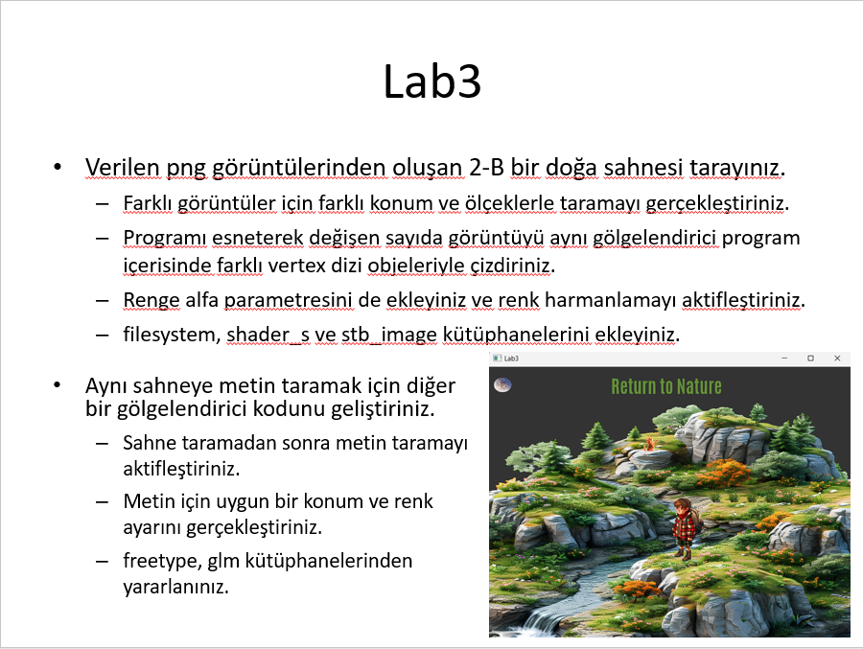

**Cevap Kodu:**

#include<iostream>

#include "glad.h"

#include<GLFW/glfw3.h>

#include"stb_image.h"

#include"Texture.h"

#include"shaderClass.h"

#include"VAO.h"

#include"VBO.h"

#include"EBO.h"

// Dag

GLfloat vertices[] =

{ //     COORDINATES     /        COLORS      /   TexCoord  //

    -0.7f, -0.7f, 0.0f,     1.0f, 0.0f, 0.0f,   0.0f, 0.0f, // Lower left corner

    -0.7f,  0.7f, 0.0f,     0.0f, 1.0f, 0.0f,   0.0f, 1.0f, // Upper left corner

     0.7f,  0.7f, 0.0f,     0.0f, 0.0f, 1.0f,   1.0f, 1.0f, // Upper right corner

     0.7f, -0.7f, 0.0f,     1.0f, 1.0f, 1.0f,   1.0f, 0.0f  // Lower right corner

};

// Indices for vertices order

GLuint indices[] =

{

    0, 2, 1, // Upper triangle

    0, 3, 2 // Lower triangle

};

// Cocuk

GLfloat vertices1[] =

{ //     COORDINATES     /        COLORS      /   TexCoord  //

    -0.4f, -0.2f, 0.0f,     1.0f, 0.0f, 0.0f,   0.0f, 0.0f, // Lower left corner

    -0.4f,  0.3f, 0.0f,     0.0f, 1.0f, 0.0f,   0.0f, 1.0f, // Upper left corner

     0.0f,  0.3f, 0.0f,     0.0f, 0.0f, 1.0f,   1.0f, 1.0f, // Upper right corner

     0.0f, -0.2f, 0.0f,     1.0f, 1.0f, 1.0f,   1.0f, 0.0f  // Lower right corner

};

// Indices for vertices order

GLuint indices1[] =

{

    0, 2, 1, // Upper triangle

    0, 3, 2 // Lower triangle

};

// Kedi

GLfloat vertices2[] =

{ //     COORDINATES     /        COLORS      /   TexCoord  //

     0.3f, -0.3f, 0.0f,     1.0f, 0.0f, 0.0f,   0.0f, 0.0f, // Lower left corner

     0.3f,  0.3f, 0.0f,     0.0f, 1.0f, 0.0f,   0.0f, 1.0f, // Upper left corner

    -0.1f,  0.3f, 0.0f,     0.0f, 0.0f, 1.0f,   1.0f, 1.0f, // Upper right corner

    -0.1f, -0.3f, 0.0f,     1.0f, 1.0f, 1.0f,   1.0f, 0.0f  // Lower right corner

};

// Indices for vertices order

GLuint indices2[] =

{

    0, 2, 1, // Upper triangle

    0, 3, 2 // Lower triangle

};

// Ay

GLfloat vertices3[] =

{ //     COORDINATES     /        COLORS      /   TexCoord  //

    -0.6f,  0.6f, 0.0f,     1.0f, 0.0f, 0.0f,   0.0f, 0.0f, // Lower left corner

    -0.6f,  0.5f, 0.0f,     0.0f, 1.0f, 0.0f,   0.0f, 1.0f, // Upper left corner

    -0.5f,  0.5f, 0.0f,     0.0f, 0.0f, 1.0f,   1.0f, 1.0f, // Upper right corner

    -0.5f,  0.6f, 0.0f,     1.0f, 1.0f, 1.0f,   1.0f, 0.0f  // Lower right corner

};

// Indices for vertices order

GLuint indices3[] =

{

    0, 2, 1, // Upper triangle

    0, 3, 2 // Lower triangle

};

int main()

{

    // Initialize GLFW

    glfwInit();

    // Tell GLFW what version of OpenGL we are using

    // In this case we are using OpenGL 3.3

    glfwWindowHint(GLFW_CONTEXT_VERSION_MAJOR, 3);

    glfwWindowHint(GLFW_CONTEXT_VERSION_MINOR, 3);

    // Tell GLFW we are using the CORE profile

    // So that means we only have the modern functions

    glfwWindowHint(GLFW_OPENGL_PROFILE, GLFW_OPENGL_CORE_PROFILE);

    // Create a GLFWwindow object of 800 by 800 pixels, naming it "YoutubeOpenGL"

    GLFWwindow* window = glfwCreateWindow(800, 800, "YoutubeOpenGL", NULL, NULL);

    // Error check if the window fails to create

    if (window == NULL)

    {

        std::cout << "Failed to create GLFW window" << std::endl;

        glfwTerminate();

        return -1;

    }

    // Introduce the window into the current context

    glfwMakeContextCurrent(window);

    //Load GLAD so it configures OpenGL

    gladLoadGL();

    // Specify the viewport of OpenGL in the Window

    // In this case the viewport goes from x = 0, y = 0, to x = 800, y = 800

    glViewport(0, 0, 800, 800);

    // Generates Shader object using shaders default.vert and default.frag

    Shader shaderProgram("default.vert", "default.frag");

    // Generates Vertex Array Object and binds it

    VAO VAO1;

    VAO1.Bind();

    // Generates Vertex Buffer Object and links it to vertices

    VBO VBO1(vertices, sizeof(vertices));

    // Generates Element Buffer Object and links it to indices

    EBO EBO1(indices, sizeof(indices));

    // Links VBO attributes such as coordinates and colors to VAO

    VAO1.LinkAttrib(VBO1, 0, 3, GL_FLOAT, 8 * sizeof(float), (void*)0);

    VAO1.LinkAttrib(VBO1, 1, 3, GL_FLOAT, 8 * sizeof(float), (void*)(3 * sizeof(float)));

    VAO1.LinkAttrib(VBO1, 2, 2, GL_FLOAT, 8 * sizeof(float), (void*)(6 * sizeof(float)));

    // Unbind all to prevent accidentally modifying them

    VAO1.Unbind();

    VBO1.Unbind();

    EBO1.Unbind();

    // Gets ID of uniform called "scale"

    GLuint uniID = glGetUniformLocation(shaderProgram.ID, "scale");

    Texture mountain("mountain.png", GL_TEXTURE_2D, GL_TEXTURE0, GL_RGBA, GL_UNSIGNED_BYTE);

    mountain.texUnit(shaderProgram, "tex0", 0);

    VAO VAO2;

    VAO2.Bind();

    // Generates Vertex Buffer Object and links it to vertices

    VBO VBO2(vertices1, sizeof(vertices1));

    // Generates Element Buffer Object and links it to indices

    EBO EBO2(indices1, sizeof(indices1));

    // Links VBO attributes such as coordinates and colors to VAO

    VAO2.LinkAttrib(VBO2, 0, 3, GL_FLOAT, 8 * sizeof(float), (void*)0);

    VAO2.LinkAttrib(VBO2, 1, 3, GL_FLOAT, 8 * sizeof(float), (void*)(3 * sizeof(float)));

    VAO2.LinkAttrib(VBO2, 2, 2, GL_FLOAT, 8 * sizeof(float), (void*)(6 * sizeof(float)));

    // Unbind all to prevent accidentally modifying them

    VAO2.Unbind();

    VBO2.Unbind();

    EBO2.Unbind();

    // Gets ID of uniform called "scale"

    GLuint uniID2 = glGetUniformLocation(shaderProgram.ID, "scale");

    Texture man("man.png", GL_TEXTURE_2D, GL_TEXTURE0, GL_RGBA, GL_UNSIGNED_BYTE);

    man.texUnit(shaderProgram, "tex0", 0);

    VAO VAO3;

    VAO3.Bind();

    // Generates Vertex Buffer Object and links it to vertices

    VBO VBO3(vertices2, sizeof(vertices2));

    // Generates Element Buffer Object and links it to indices

    EBO EBO3(indices2, sizeof(indices2));

    // Links VBO attributes such as coordinates and colors to VAO

    VAO3.LinkAttrib(VBO3, 0, 3, GL_FLOAT, 8 * sizeof(float), (void*)0);

    VAO3.LinkAttrib(VBO3, 1, 3, GL_FLOAT, 8 * sizeof(float), (void*)(3 * sizeof(float)));

    VAO3.LinkAttrib(VBO3, 2, 2, GL_FLOAT, 8 * sizeof(float), (void*)(6 * sizeof(float)));

    // Unbind all to prevent accidentally modifying them

    VAO3.Unbind();

    VBO3.Unbind();

    EBO3.Unbind();

    // Gets ID of uniform called "scale"

    GLuint uniID3 = glGetUniformLocation(shaderProgram.ID, "scale");

    Texture cat("cat.png", GL_TEXTURE_2D, GL_TEXTURE0, GL_RGBA, GL_UNSIGNED_BYTE);

    cat.texUnit(shaderProgram, "tex0", 0);

    VAO VAO4;

    VAO4.Bind();

    // Generates Vertex Buffer Object and links it to vertices

    VBO VBO4(vertices3, sizeof(vertices3));

    // Generates Element Buffer Object and links it to indices

    EBO EBO4(indices3, sizeof(indices3));

    // Links VBO attributes such as coordinates and colors to VAO

    VAO4.LinkAttrib(VBO4, 0, 3, GL_FLOAT, 8 * sizeof(float), (void*)0);

    VAO4.LinkAttrib(VBO4, 1, 3, GL_FLOAT, 8 * sizeof(float), (void*)(3 * sizeof(float)));

    VAO4.LinkAttrib(VBO4, 2, 2, GL_FLOAT, 8 * sizeof(float), (void*)(6 * sizeof(float)));

    // Unbind all to prevent accidentally modifying them

    VAO4.Unbind();

    VBO4.Unbind();

    EBO4.Unbind();

    // Gets ID of uniform called "scale"

    GLuint uniID4 = glGetUniformLocation(shaderProgram.ID, "scale");

    Texture moon("moon.png", GL_TEXTURE_2D, GL_TEXTURE0, GL_RGBA, GL_UNSIGNED_BYTE);

    moon.texUnit(shaderProgram, "tex0", 0);

    /*

    * I'm doing this relative path thing in order to centralize all the resources into one folder and not

    * duplicate them between tutorial folders. You can just copy paste the resources from the 'Resources'

    * folder and then give a relative path from this folder to whatever resource you want to get to.

    * Also note that this requires C++17, so go to Project Properties, C/C++, Language, and select C++17

    */

    // Texture

    // Original code from the tutorial

    /*Texture popCat("pop_cat.png", GL_TEXTURE_2D, GL_TEXTURE0, GL_RGBA, GL_UNSIGNED_BYTE);

    popCat.texUnit(shaderProgram, "tex0", 0);*/

    glEnable(GL_BLEND);

    glBlendFunc(GL_ONE, GL_ONE_MINUS_SRC_ALPHA);

    // Main while loop

    while (!glfwWindowShouldClose(window))

    {

        // Specify the color of the background

        glClearColor(0.07f, 0.13f, 0.17f, 1.0f);

        // Clean the back buffer and assign the new color to it

        glClear(GL_COLOR_BUFFER_BIT);

        // Tell OpenGL which Shader Program we want to use

        shaderProgram.Activate();

        // Assigns a value to the uniform; NOTE: Must always be done after activating the Shader Program

        glUniform1f(uniID, 0.5f);

        mountain.Bind();

        VAO1.Bind();

        glDrawElements(GL_TRIANGLES, 6, GL_UNSIGNED_INT, 0);

        shaderProgram.Activate();

        glUniform1f(uniID2, 0.5f);

        man.Bind();

        VAO2.Bind();

        glDrawElements(GL_TRIANGLES, 6, GL_UNSIGNED_INT, 0);

        shaderProgram.Activate();

        glUniform1f(uniID3, 0.5f);

        cat.Bind();

        VAO3.Bind();

        glDrawElements(GL_TRIANGLES, 6, GL_UNSIGNED_INT, 0);

        shaderProgram.Activate();

        glUniform1f(uniID4, 0.5f);

        moon.Bind();

        VAO4.Bind();

        // Draw primitives, number of indices, datatype of indices, index of indices

        glDrawElements(GL_TRIANGLES, 6, GL_UNSIGNED_INT, 0);

        // Swap the back buffer with the front buffer

        glfwSwapBuffers(window);

        // Take care of all GLFW events

        glfwPollEvents();

    }

    // Delete all the objects we've created

    VAO1.Delete();

    VBO1.Delete();

    EBO1.Delete();

    mountain.Delete();

    VAO2.Delete();

    VBO2.Delete();

    EBO2.Delete();

    man.Delete();

    VAO3.Delete();

    VBO3.Delete();

    EBO3.Delete();

    cat.Delete();

    VAO4.Delete();

    VBO4.Delete();

    EBO4.Delete();

    moon.Delete();

    shaderProgram.Delete();

    // Delete window before ending the program

    glfwDestroyWindow(window);

    // Terminate GLFW before ending the program

    glfwTerminate();

    return 0;

}

**Cevap Ekran Çıktısı:**

