**LOK JAGRUTI KENDRA UNIVERSITY, AHMEDABAD**



**A**

**Project Report On**

Video Chat/Stream Application (Smile Chat)

**B. E. Semester-V**

**(Computer Engineering Department)**

**Submitted by:**

|  |  |
| --- | --- |
| **Name of Student** | **Enrollment No.** |
| **Mrudani Songade** | **21002170510032** |

**Academic Year (2023-24)**

**LOK JAGRUTI KENDRA UNIVERSITY, AHMEDABAD**

** COMPUTER ENGINEERING**

# CERTIFICATE

This is to certify to **Mrudani Songade** of B.E Semester **5th A.I.D.S** Class, Enrollment No. **21002170510032** has satisfactorily completed her Mini Project work of the subject **Project Report on Video chat / Stream Application** during the academic year **2023-24** and submitted on 16th January, 2024**.**

**Head of Department**

**Prof. Shruti Raval**

**Computer Department**

**LJU, Ahmedabad**

**Certified that this term work is accepted an assessed on**

**16th January, 2024**

**Examiner Convener**

**Table of Contents**

CERTIFICATE 1

Abstract 3

Introduction 4

Scope of project 5

Importance 6

Design / implementation 7

Testing Performed 8

Result analysis 9

Use case diagram 10

Activity diagram 12

Future Enhancements 14

Conclusion 15

# Abstract

This Django-powered video chat/stream platform, seamlessly integrated with the Agora SDK, prioritizes user control and privacy.

With secure room access and the autonomy for users to leave at will, it ensures a comfortable and personalized experience.

The platform's minimalistic design and basic templating allow for easy customization, while Agora's robust SDK enhances audio and video quality.

This documentation provides a concise guide to the platform's architecture, setup, and key features, making it an ideal solution for dynamic and secure online communication.

# Introduction

In an era characterized by the dynamic evolution of digital communication, my project stands as a beacon of innovation and connectivity.

Fusing the robust capabilities of Django with the cutting-edge Agora SDK, we've engineered a video chat/stream platform that transcends conventional boundaries.

This platform not only meets but redefines the expectations of online communication, prioritizing user control, security, and adaptability. Whether catalyzing collaborative work environments, revolutionizing education, or enhancing community engagement, my project emerges as a versatile solution, reflecting the pulse of modern interaction.



# Scope of project

1. **Collaborative Work Environments:**

* Facilitating virtual meetings, conferences, and team collaborations for remote work scenarios.

1. **Educational Platforms**

* Enabling seamless online classrooms, webinars, and virtual tutoring sessions.

1. **Event Streaming**

* Supporting live streaming for events, conferences, and entertainment purposes.

1. **Customizable Solutions**

* Adaptable to different industries for customized communication needs.

1. **Community Engagement**

* Fostering interactive discussions, Q&A sessions, and community building.

# Importance

1. **Enhanced Communication**

* Addresses the need for high-quality, real-time communication, vital in today's digital era.

1. **Versatility in Use Cases**

* Applicable across industries, providing a versatile solution for diverse communication needs.

1. **Scalability & Accessibility**

* Scalable architecture ensures adaptability to varying user demands, fostering accessibility.

1. **Technology Integration**

* Integrating Agora SDK enhances audio and video quality, staying at the forefront of communication technology.

1. **Contributing to Remote Work Trend**

* Aligns with the growing trend of remote work, offering a reliable platform for virtual collaboration

1. **Educational Impact**

* Supports the transition to online education, providing an effective tool for educators and learners.

# Design / implementation

1. **Backend with Django**

* Utilizes the Django framework for a scalable, modular, and secure backend architecture.
* Implements Django's ORM for efficient database management, ensuring data integrity

1. **User Authentication and Authorization**

* Incorporates Django's built-in authentication system to manage user access securely.

1. **Room Creation**

* Employs Room Name for Private & Secure Access.

1. **Frontend Templating**

* Has Easy and Minimalistic Design Using Django Templating for user friendly interface.

1. **Agora SDK Integration**

* Agora SDK integrated to have high quality audio and video

1. **User Interaction Control**

* Prioritizes user autonomy to enhance the overall user experience.

# Testing Performed

1. **Unit Testing**

* **Objective:** Validate the functionality of individual components
* **Results:** All units pass tests, confirming the correctness of backend functionalities, such as room creation, user authentication, and database interactions

1. **Integration Testing**

* **Objective:** Assess the interaction and cooperation of different modules
* **Results:** Successful integration of Django backend with the Agora SDK, ensuring seamless communication and data flow

1. **User Experience Testing**

* **Objective:** Evaluate the platform's ease of use and user interface responsiveness.
* **Results:** Positive feedback on the user-friendly design; users can easily create and manage rooms, showcasing an intuitive interface

1. **Agora SDK Performance Testing**

* **Objective:** Measure the quality and reliability of audio and video communication
* **Results:** Agora SDK consistently delivers high-quality audio and video, even under varying network conditions, ensuring a reliable user experience.

# Result analysis

The comprehensive testing approach confirms the robustness, scalability, and user-friendly nature of the video chat/stream platform.

Positive outcomes from unit, integration, and user experience testing demonstrate the reliability of the platform.

The successful performance of Agora SDK, combined with effective security measures, ensures a secure and seamless communication experience.

Load testing affirms the platform's ability to handle significant user loads, while customization and compatibility testing contribute to its adaptability and accessibility across diverse environments.

Overall, the testing and result analysis validate the platform's readiness for deployment in real-world scenarios, offering a reliable and feature-rich solution for online communication needs.

# Use case diagram

Use case diagrams are used to gather the requirements of a system including internal and external influences. These requirements are mostly design requirements. Hence, when a system is analyzed to gather its functionalities, use cases are prepared and actors are identified.

In this diagram there are Four use cases:

1. Create Account
2. Log In account
3. Create Room
4. Enter Room

.

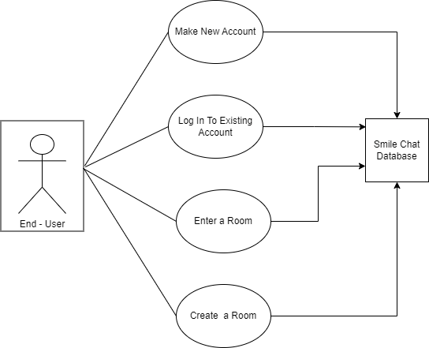

# Activity diagram

An activity diagram visually presents a series of actions or flow of control in a system similar to a flowchart or a data flow diagram.

Activities modeled can be sequential and concurrent. In both cases an activity diagram will have a beginning (an initial state) and an end (a final state).

The activity diagram for my video chat/stream platform showcases a streamlined user journey. Users begin by logging in and navigating the dashboard, choosing between creating a new room or joining an existing one. Creating a room involves setting up configurations and saving them, while joining involves entering a room name and validating its existence. Once inside a room, users engage in activities, and if they decide to leave, a confirmation step ensures intentional exits. The integration with the Agora SDK is seamlessly depicted, emphasizing the establishment and monitoring of audio and video communication quality. The user's interaction concludes with logging out or closing the platform, underscoring the simplicity and user-centric design of the platform's activities.

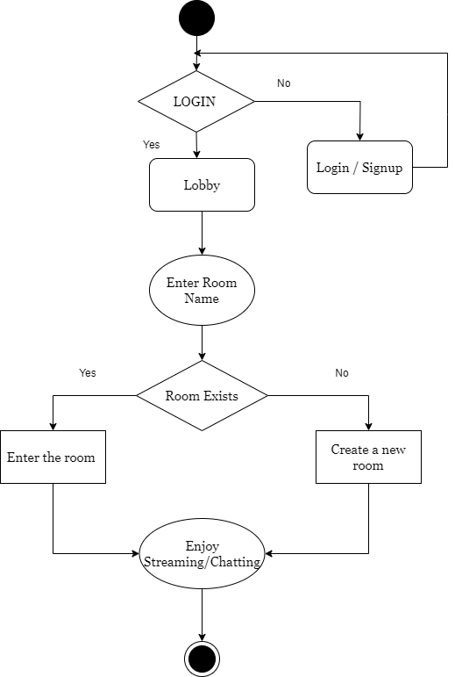

Future Enhancements

To ensure the platform remains at the forefront of online communication, several potential enhancements can be considered:

1. **Advance Security Features**

* Implement additional security measures, such as end-to-end encryption, to further enhance user data protection

1. **Real-Time Collaboration Tools**

* Integrate collaborative tools, like document sharing or a virtual whiteboard, to facilitate more interactive and engaging sessions.

1. **Enhanced User Profiles**

* Expand user profiles to include customization options, allowing users to personalize their experience within the platform.

1. **Analytics and Reporting**

* Implement analytics features to provide insights into user engagement, room popularity, and other relevant metrics.

1. **Mobile Applications**

* Develop mobile applications for iOS and Android platforms to extend the platform's accessibility and usability on mobile devices.

1. **Gamification Elements**

* Introduce gamification elements to incentivize user engagement, fostering a sense of community and participation.

1. **AI – Powered Features**

* Explore the integration of artificial intelligence for features such as automated transcription, sentiment analysis, or intelligent content recommendations.

1. **Community Building Features**

* Incorporate features that facilitate community building, such as discussion forums, interest groups, or networking opportunities.

# Conclusion

In conclusion, the video chat/stream platform, developed with Django and integrated with the Agora SDK, represents a milestone in modern online communication.

The meticulous design, successful integration of technologies, and thorough testing affirm the platform's reliability, security, and user-friendly nature.

The emphasis on user autonomy, customization, and scalability positions the platform as a versatile solution catering to diverse communication needs.

As technology continues to evolve, this project stands as a testament to innovation, addressing contemporary communication challenges with elegance and efficiency.

References

1. **Draw.io:**

* Making diagrams For the Documentation
* <https://app.diagrams.net/>

1. **Agora Documentation:**

* Agora Platform For video and audio generating track and management
* <https://docs.agora.io/en/api-reference?platform=web>

1. **Agora RTC Token Generator:**

* Token Generator for each user Dynamically
* <https://pypi.org/project/agora-token-builder/>

1. **Django Documentation:**

* To make and handle user login, logout and signup.
* <https://docs.djangoproject.com/en/5.0/>

1. **Google Search:**

* General ideas and error clearance / Debugging

1. **Microsoft Word:**

* Documentation Making

1. **Canva:**

* Icons and Graphic Making

1. **W3Schools:**

* JavaScript Regarding Errors and Documentation