**SportsNews System**

**Introduction** :

A website based system where in people will get updates about upcoming football matches with their details, like the venue, teams, and players. The final result will also be put up. There will be 2 users, Organisers and audience. The details mentioned above will be updated by the organiser, and audience will be able to view the data (login required to view the final result)

**ER Diagram** :

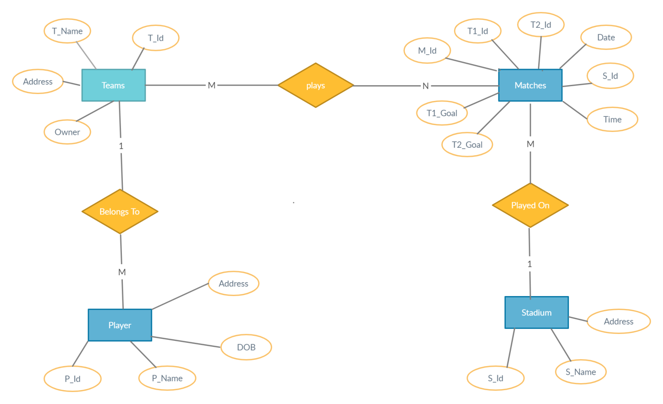

**UML Daigram** :

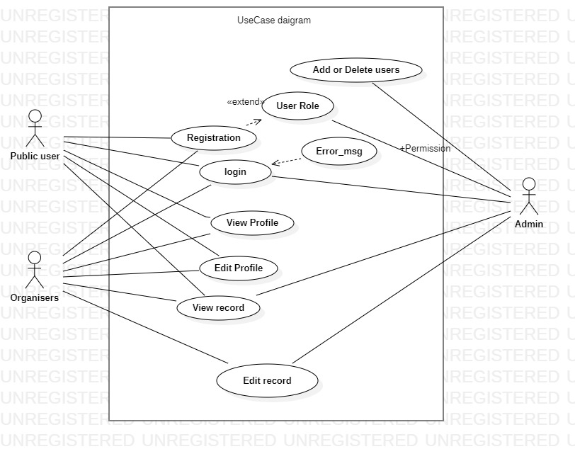

**Back End** :

SQL Developer

Creation of table according to ER Daigram

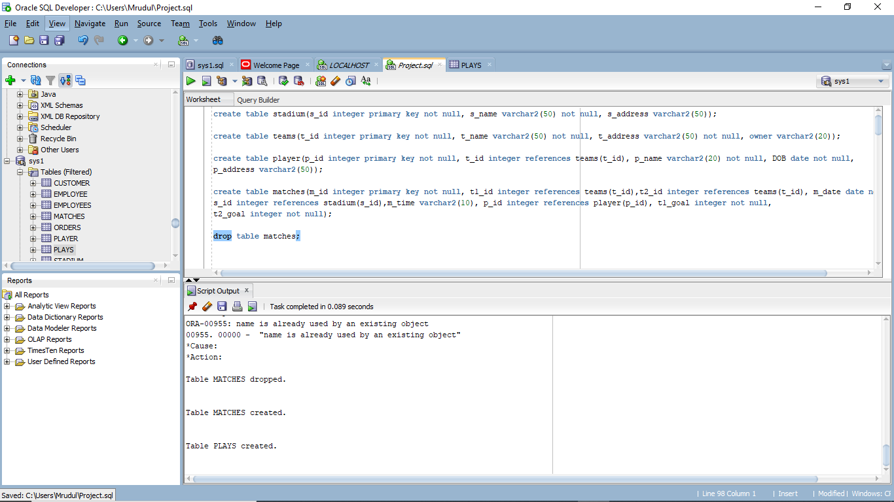

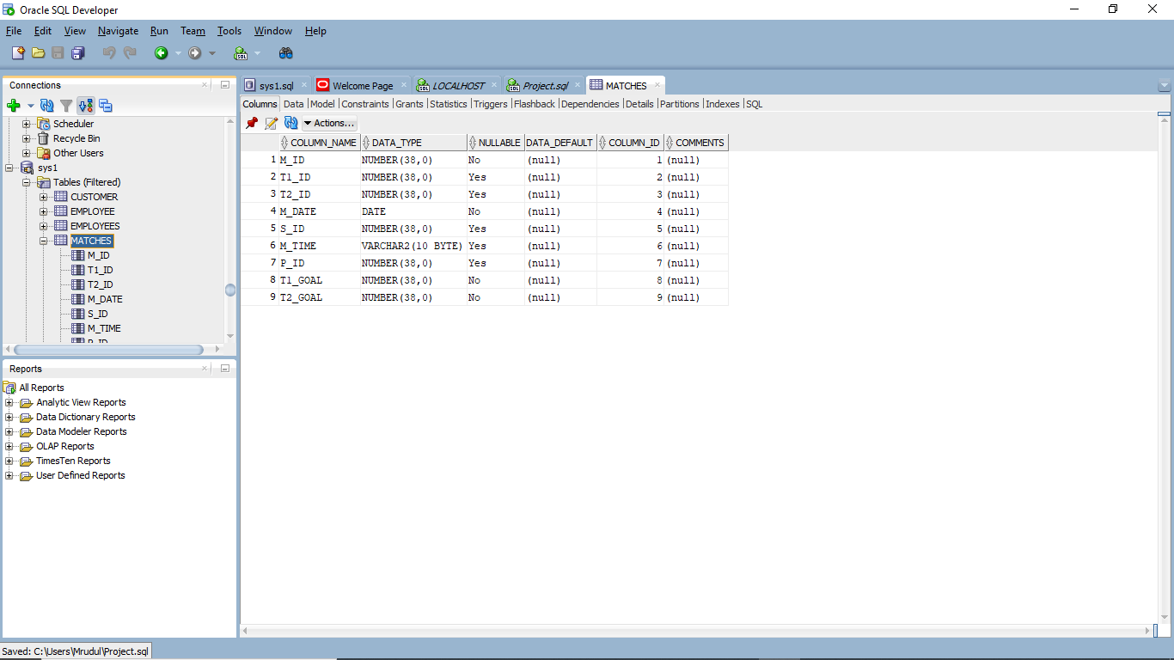

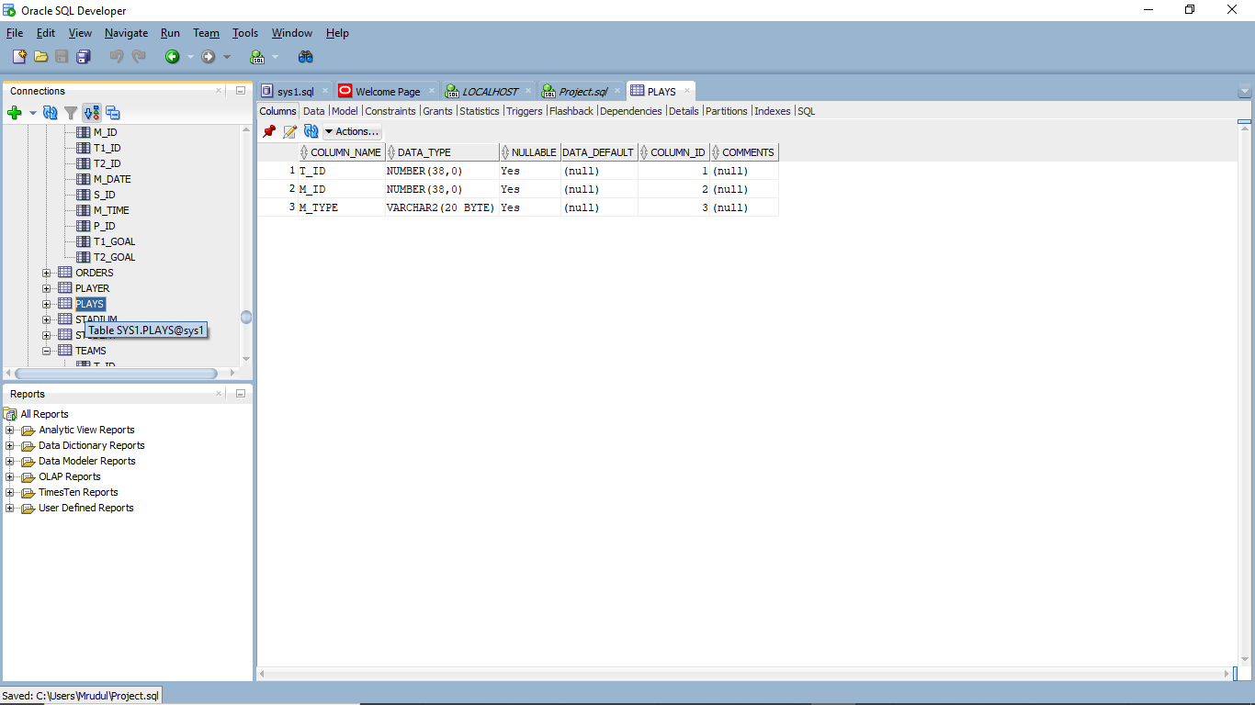

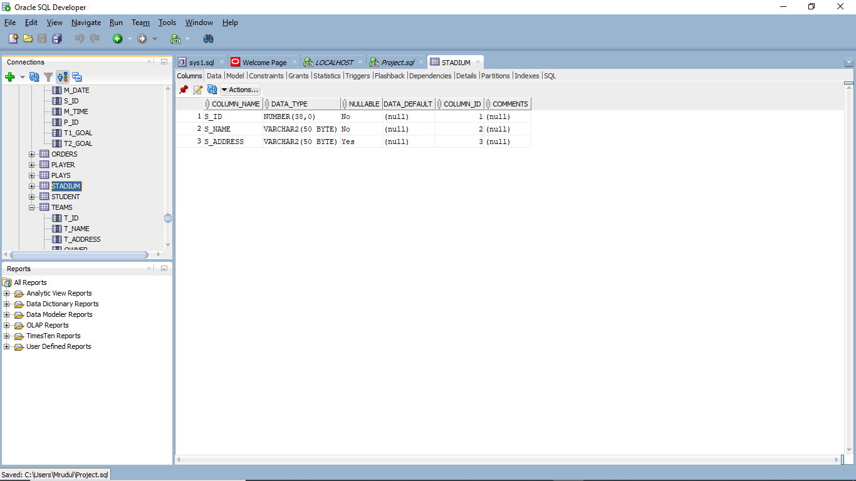

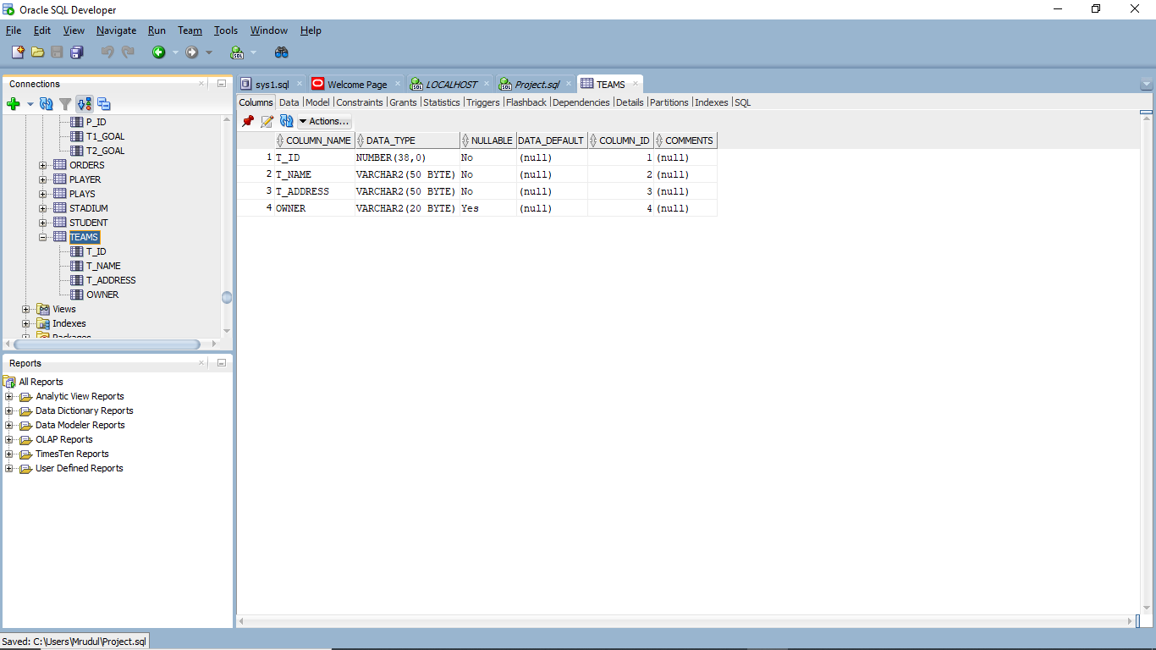

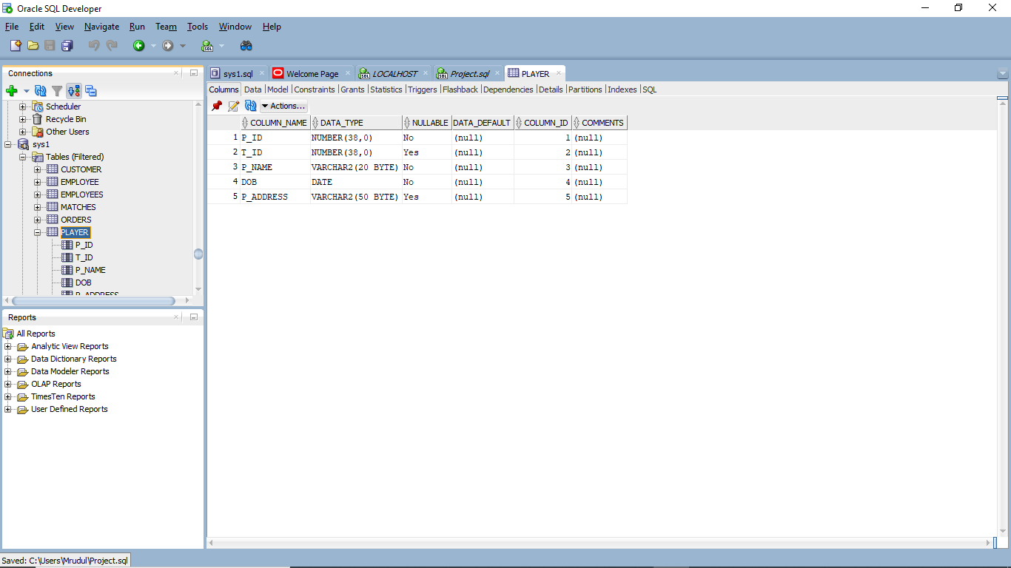

**Front End** :

Htmi,css,bootstrap

