**Benchmarks of Different Architectures on our Dataset:**

**1. InceptionNetV3 Performance:**

[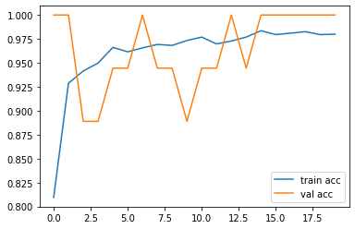](https://github.com/DARK-art108/Cotton-Leaf-Disease-Detection/blob/main/Utils/resnetacc.png)[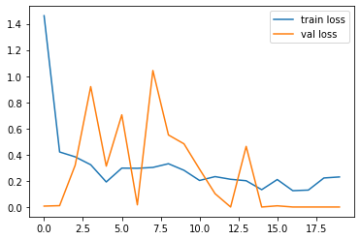](https://github.com/DARK-art108/Cotton-Leaf-Disease-Detection/blob/main/Utils/resnetv2.png)

loss: 0.2298 - accuracy: 0.9800 - val_loss: 1.8554e-05 - val_accuracy: 1.0000

**2. RESNET50 Performance:**

[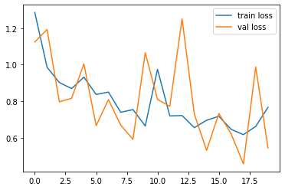](https://github.com/DARK-art108/Cotton-Leaf-Disease-Detection/blob/main/Utils/resnet50.png)

[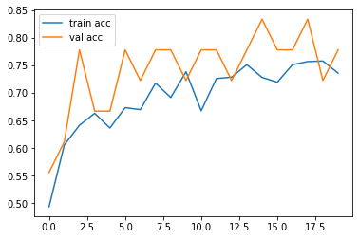](https://github.com/DARK-art108/Cotton-Leaf-Disease-Detection/blob/main/Utils/accur.png)

loss: 0.7661 - accuracy: 0.7355 - val_loss: 0.5443 - val_accuracy: 0.7778

**3. RESNET152V2 Performance:**

[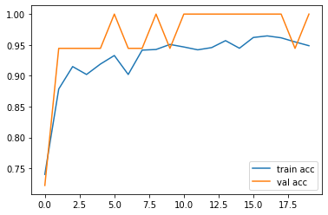](https://github.com/DARK-art108/Cotton-Leaf-Disease-Detection/blob/main/Utils/InceptionV3.png)

[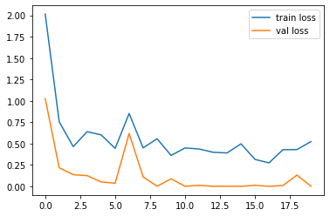](https://github.com/DARK-art108/Cotton-Leaf-Disease-Detection/blob/main/Utils/download.png)

loss: 0.5233 - accuracy: 0.9487 - val_loss: 0.0012 - val_accuracy: 1.0000

***As we have seen that Inception V3 is Performing best in comparasion to all other Transfer Learning Architecture,So we have picked up Inception V3 Architecture and Trained Our Model over it!!***