|  |  |
| --- | --- |
|  |  |

**Code for login page :**

Imports System.Data.SqlClient

Imports System.Windows

Public Class Form1

Dim conn As New SqlConnection

Dim cmdAs New SqlCommand

Dim dtAsDataTable

Dim drAsSqlDataReader

Dim da As New SqlDataAdapter

Dim strAs String

Private Sub Form1_Load(sender As Object, e As EventArgs) Handles MyBase.Load

conn.ConnectionString = "Data Source=(LocalDB)\MSSQLLocalDB;AttachDbFilename=C:\Users\USER\source\repos\Demo1\Demo1\demo1.mdf;Integrated Security=True"

End Sub

Private Sub Button1_Click(sender As Object, e As EventArgs) Handles Button1.Click

conn.Open()

str = "Select * from Demo1 where username='" & TextBox1.Text & "' and password ='" & TextBox2.Text & "'"

cmd = New SqlCommand(str, conn)

da = New SqlDataAdapter(cmd)

dt = New DataTable

da.Fill(dt)

If (dt.Rows.Count> 0) Then

MsgBox("Entry accessed")

Me.Show()

Else

MsgBox("Invalid username & password")

End If

cmd.ExecuteNonQuery()

cmd.Dispose()

conn.Close()

End Sub

End Class

**Marksheet**:

Imports System.Data.SqlClient

Public Class Form1

Dim conn As New SqlConnection

Dim cmdAs New SqlCommand

Dim da As New SqlDataAdapter

Dim dtAs New DataTable

Dim strAs String

Private Sub Form1_Load(sender As Object, e As EventArgs) Handles MyBase.Load

'TODO: This line of code loads data into the 'MarksheetDataSet.marksheet' table. You can move, or remove it, as needed.

conn.ConnectionString = "Data Source=(LocalDB)\MSSQLLocalDB;AttachDbFilename=C:\Users\AFROZ\source\repos\marksheet\marksheet\marksheet.mdf;Integrated Security=True"

End Sub

Private Sub Button1_Click(sender As Object, e As EventArgs) Handles Button1.Click

conn.Open()

str = "insert into marksheetvalues('" & TextBox1.Text & "'," & TextBox2.Text & ",'" & TextBox3.Text & "'," & TextBox4.Text & "," & TextBox5.Text & "," & TextBox6.Text & "," & TextBox7.Text & "," & TextBox8.Text & ",'" & TextBox9.Text & "')"

cmd = New SqlCommand(str, conn)

If cmd.ExecuteNonQuery() Then

MsgBox("successfully inserted")

End If

cmd.Dispose()

conn.Close()

End Sub

Private Sub Button2_Click(sender As Object, e As EventArgs) Handles Button2.Click

conn.Open()

TextBox7.Text = Val(TextBox4.Text) + Val(TextBox5.Text) + Val(TextBox6.Text)

TextBox8.Text = Val(TextBox7.Text) / 3

conn.Close()

End Sub

Private Sub Button3_Click(sender As Object, e As EventArgs) Handles Button3.Click

conn.Open()

str = "select * from marksheet"

cmd = New SqlCommand(str, conn)

da = New SqlDataAdapter(cmd)

dt = New DataTable

da.Fill(dt)

DataGridView1.DataSource = dt

cmd.Dispose()

conn.Close()

End Sub

Private Sub Button4_Click(sender As Object, e As EventArgs) Handles Button4.Click

conn.Open()

str = "delete from marksheet where name='" & TextBox1.Text & "'"

cmd = New SqlCommand(str, conn)

If cmd.ExecuteNonQuery() Then

MsgBox("successfully deleted")

End If

cmd.Dispose()

conn.Close()

End Sub

Private Sub Button5_Click(sender As Object, e As EventArgs) Handles Button5.Click

If TextBox7.Text < 300 And TextBox7.Text > 250 Then

TextBox9.Text = "S"

ElseIf TextBox7.Text < 250 And TextBox7.Text > 200 Then

TextBox9.Text = "A"

ElseIf TextBox7.Text < 200 And TextBox7.Text > 150 Then

TextBox9.Text = "B"

Else

TextBox9.Text = "invalid"

End If

End Sub

Private Sub Button6_Click(sender As Object, e As EventArgs) Handles Button6.Click

conn.Open()

str = "update marksheet set( name= '" & TextBox1.Text & "',studentid=" & TextBox2.Text & ",class='" & TextBox3.Text & "',subject1=" & TextBox4.Text & ",subject2=" & TextBox5.Text & ",subject3=" & TextBox6.Text & ",total=" & TextBox7.Text & ",average=" & TextBox8.Text & ",grade='" & TextBox9.Text & "') where studentid=" & TextBox2.Text & ""

cmd = New SqlCommand(str, conn)

If cmd.ExecuteNonQuery() Then

MsgBox("successfully updated")

End If

cmd.Dispose()

conn.Close()

End Sub

End Class

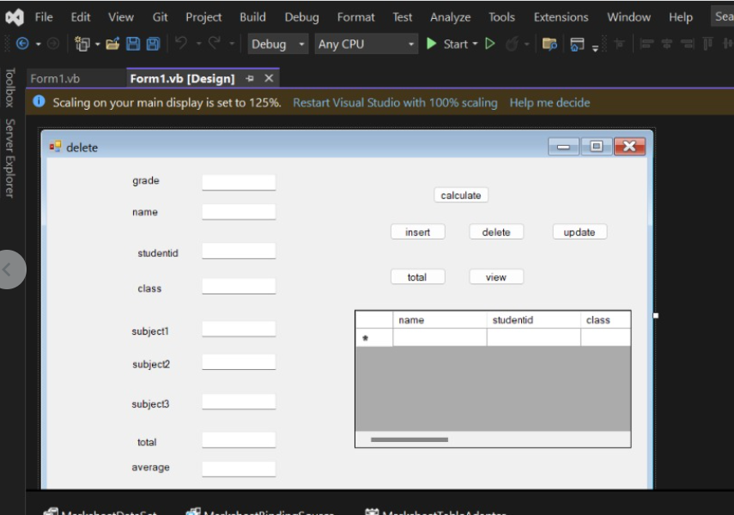

|  |
| --- |
| **SAVEETHA INSTITUTE OF MEDICAL AND TECHNICAL SCIENCES** |
| **COMPUTER SCIENCE AND ENGINEERING PROGRAMME** |

**CSA4053 – MANAGMENT INFORMATION SYSTEM**

**LAB SESSION**

1. **Develop a simple login page using service -base database in visual studio.**

**Code:** ImportsSystem.Data.SqlClient

ImportsSystem.Windows

PublicClassForm1

Dim conn AsNewSqlConnection

DimcmdAsNewSqlCommand

DimdtAsDataTable

DimdrAsSqlDataReader

Dim da AsNewSqlDataAdapter

DimstrAsString

PrivateSub Form1_Load(sender AsObject, e AsEventArgs) HandlesMyBase.Load

conn.ConnectionString = "Data Source=(LocalDB)\MSSQLLocalDB;AttachDbFilename=C:\Users\pulla\source\repos\demo1\demo1\Database1.mdf;Integrated Security=True"

EndSub

PrivateSub Button1_Click(sender AsObject, e AsEventArgs) Handles Button1.Click

conn.Open()

str = "Select * from login where username='"& TextBox1.Text &"' and password ='"& TextBox2.Text &"'"

cmd = NewSqlCommand(str, conn)

da = NewSqlDataAdapter(cmd)

dt = NewDataTable

da.Fill(dt)

If (dt.Rows.Count> 0) Then

MsgBox("Entry accessed")

Me.Show()

Else

MsgBox("Invalid username & password")

EndIf

cmd.ExecuteNonQuery()

cmd.Dispose()

conn.Close()

EndSub

EndClass

**Proof :**

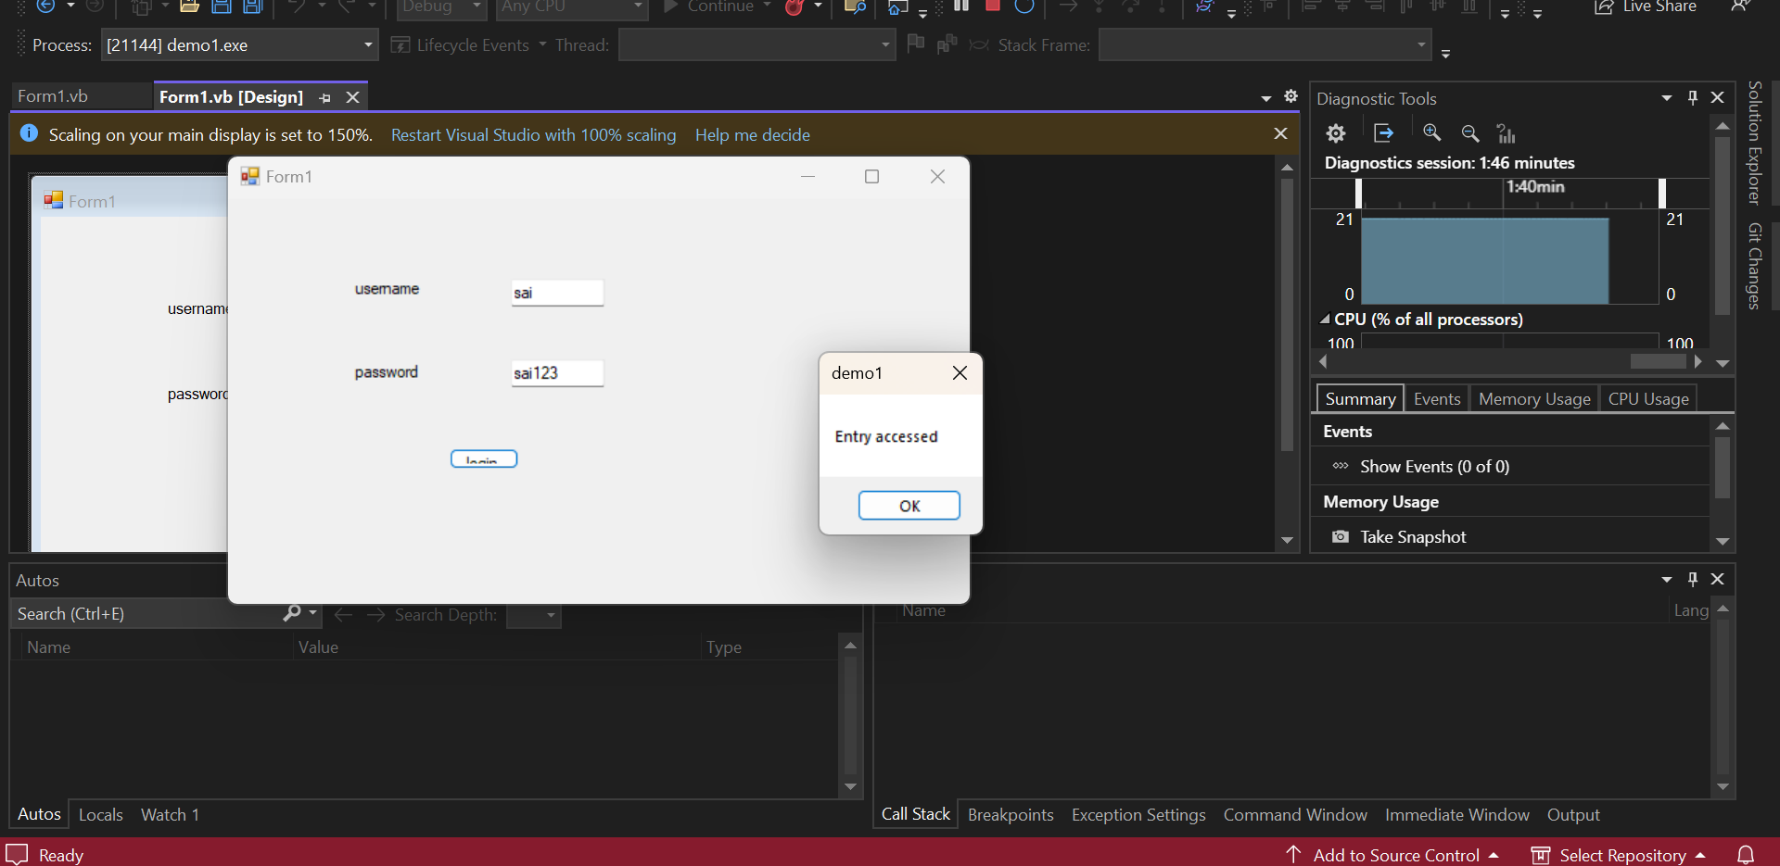

1. Develop the student details using service based database in visual studio

**Code:**

ImportsSystem.Data.SqlClient

PublicClassForm1

Dim conn AsNewSqlConnection

DimcmdAsNewSqlCommand

DimdtAsDataTable

DimdrAsSqlDataReader

Dim da AsNewSqlDataAdapter

DimstrAsString

PrivateSub Label8_Click(sender AsObject, e AsEventArgs) Handles Label8.Click

EndSub

PrivateSub Form1_Load(sender AsObject, e AsEventArgs) HandlesMyBase.Load

'TODO: This line of code loads data into the 'DetailsDataSet1.details' table. You can move, or remove it, as needed.

Me.DetailsTableAdapter.Fill(Me.DetailsDataSet1.details)

conn.ConnectionString = "Data Source=(LocalDB)\MSSQLLocalDB;AttachDbFilename=D:\folders\MIS\Program_1\Program_1\details.mdf;Integrated Security=True"

EndSub

PrivateOverloadsSubInsert(sender AsObject, e AsEventArgs) Handles Button1.Click

conn.Open()

str = "insert into details values('"& TextBox1.Text &"','"& TextBox2.Text &"','"& TextBox3.Text &"', '"& DateTimePicker1.Value.Date &"', '"& RichTextBox1.Text &"' , '"& TextBox4.Text &"','"& TextBox5.Text &"','"& TextBox6.Text &"' , '"& RichTextBox2.Text &"' )"

cmd = NewSqlCommand(str, conn)

Ifcmd.ExecuteNonQuery() Then

MsgBox("successfully inserted")

EndIf

cmd.Dispose()

conn.Close()

EndSub

PrivateOverloadsSubUpdate(sender AsObject, e AsEventArgs) Handles Button2.Click

conn.Open()

str = "update details set Name='"& TextBox1.Text &"', Regno="& TextBox2.Text &" whereRegno ="& TextBox2.Text &""

cmd = NewSqlCommand(str, conn)

Ifcmd.ExecuteNonQuery() Then

MsgBox("successfully updated")

EndIf

cmd.Dispose()

conn.Close()

EndSub

PrivateOverloadsSubDelete(sender AsObject, e AsEventArgs) Handles Button3.Click

conn.Open()

str = "Delete from details where Regno ='"& TextBox2.Text &"'"

cmd = NewSqlCommand(str, conn)

Ifcmd.ExecuteNonQuery() Then

MsgBox("successfully deleted")

EndIf

cmd.Dispose()

conn.Close()

EndSub

PrivateOverloadsSubView(sender AsObject, e AsEventArgs) Handles Button4.Click

DataGridView1.Visible = True

conn.Open()

str = "select * from details"

cmd = NewSqlCommand(str, conn)

da = NewSqlDataAdapter(cmd)

dt = NewDataTable

da.Fill(dt)

DataGridView1.DataSource = dt

cmd.Dispose()

conn.Close()

EndSub

EndClass

**Proof :**

