**TO DO LIST PROGRAM:**

import tkinter

import tkinter.messagebox

import pickle

window=tkinter.Tk()

window.title("To do list")

def task_adding():

todo=task_add.get()

if todo!="":

todo_box.insert(tkinter.END,todo)

task_add.delete(0, tkinter.END)

else:

tkinter.messagebox.showwarning(title="Attention !!", message="To add a task, please enter some task")

def task_removing():

try:

index_todo=list_frame.curselection()[0]

list_frame.delete(index_todo)

except:

tkinter.messagebox.showwarning(title="Attention !!", message="To delete a task, you must select a task !!")

def task_loading():

try:

todo_list=pickle.load(open("task.dat","rb"))

list_frame.delete(0, tkinter, END)

for todo in tasks:

list_frame.insert(tkinter.END,todo)

except:

tkinter.messagebox.showwarning(title="Attention !!",message="Cannot find task.dat")

def task_saving():

todo_list=list_frame.get(0, list_frame.size())

pickle.dump(todo_list, open("tasks.dat","wb"))

list_frame=tkinter.Frame(window)

list_frame.pack()

todo_box=tkinter.Listbox(list_frame, height=20,width=50)

todo_box.pack(side=tkinter.LEFT)

scroller=tkinter.Scrollbar(list_frame)

scroller.pack(side=tkinter.RIGHT, fill=tkinter.Y)

todo_box.config(yscrollcommand=scroller.set)

#scroller.config(command=list_frame.yview)

task_add=tkinter.Entry(window,width=70)

task_add.pack()

add_task_button=tkinter.Button(window, text="Click to add task",font=("arial",20,"bold"),background="green",width=40,command=task_adding)

add_task_button.pack()

delete_task_button=tkinter.Button(window, text="Click to delete task",font=("arial",20,"bold"),background="red",width=40,command=task_removing)

delete_task_button.pack()

load_task_button=tkinter.Button(window, text="Click to load task",font=("arial",20,"bold"),background="yellow",width=40,command=task_loading)

load_task_button.pack()

save_task_button=tkinter.Button(window, text="Click to save task",font=("arial",20,"bold"),background="blue",width=40,command=task_saving)

save_task_button.pack()

window.mainloop()

**SCREENSHOTS:**

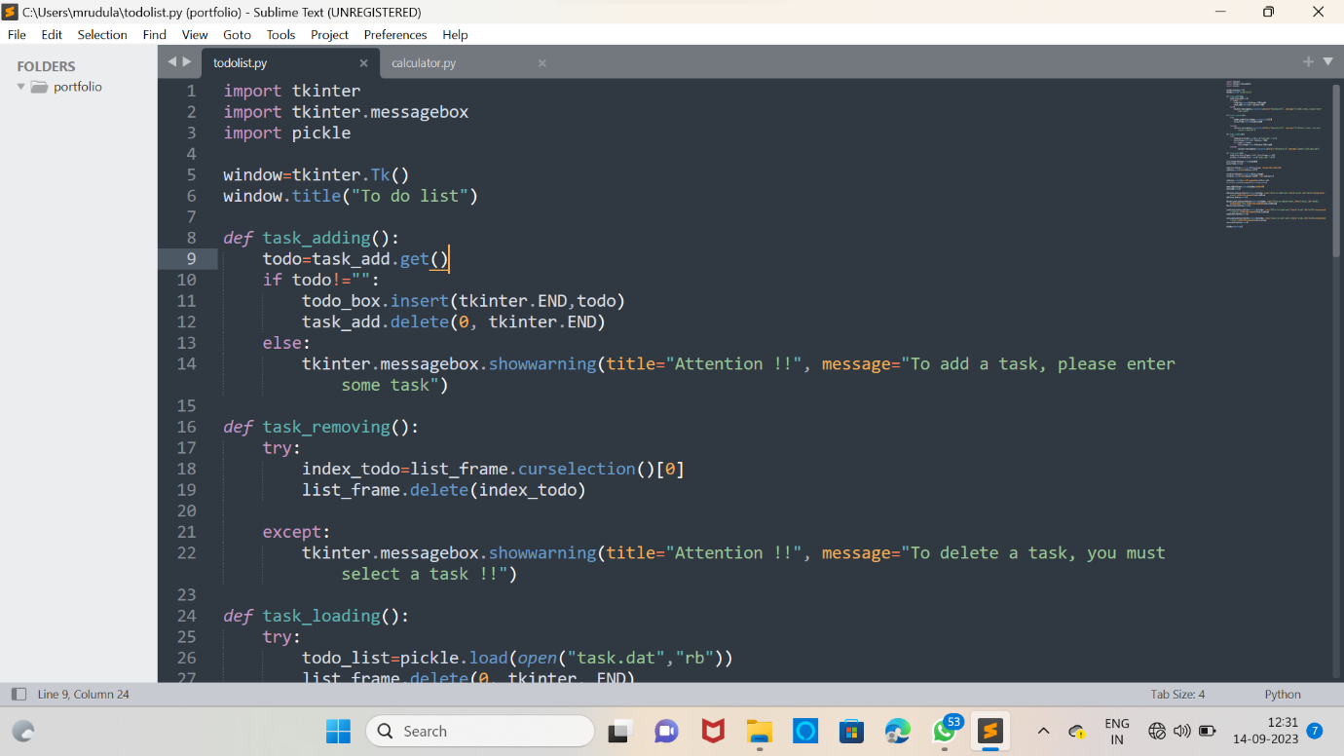

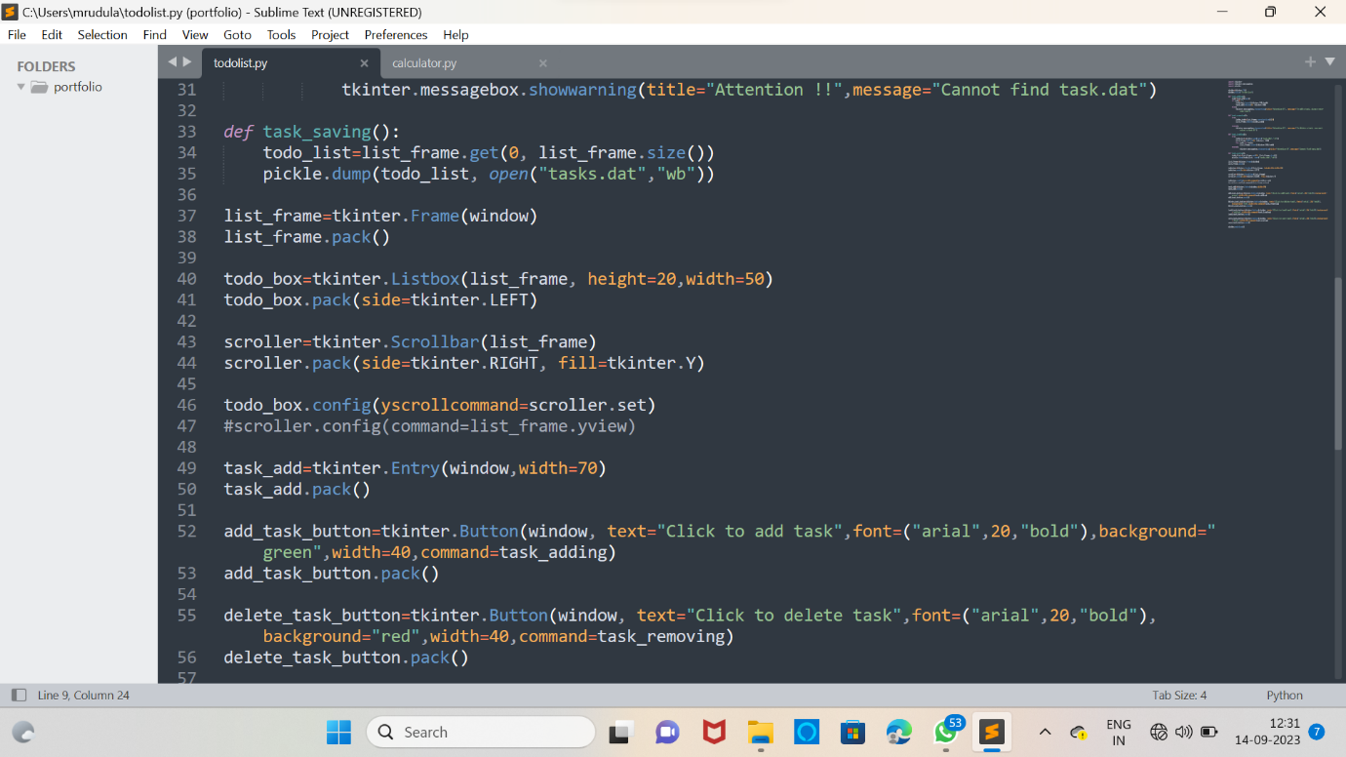

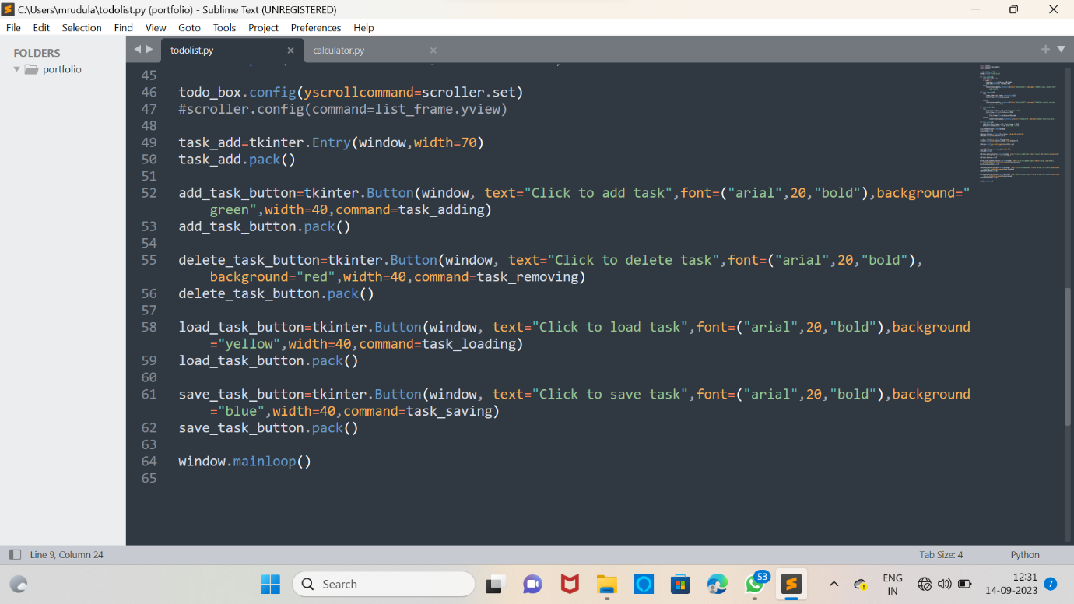

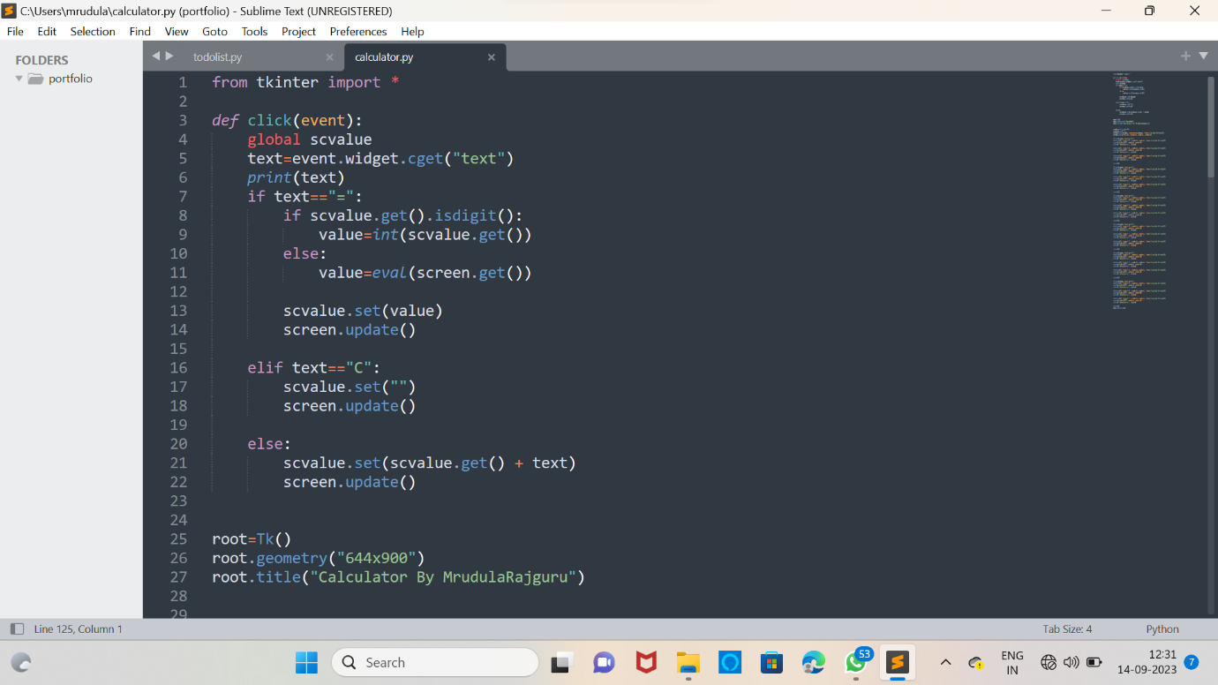

**OUTPUT:**

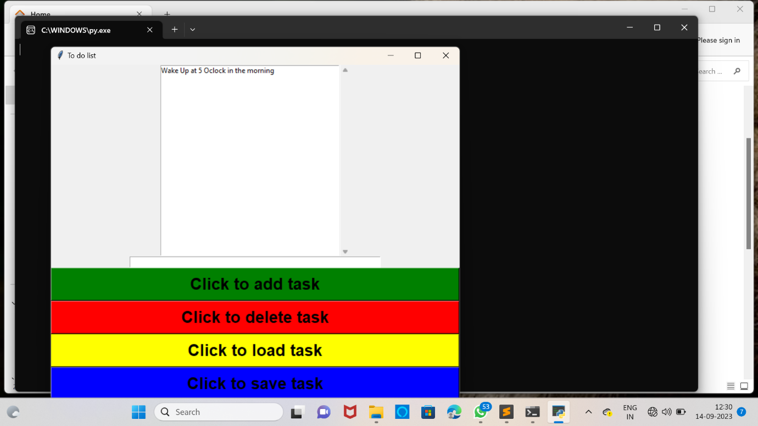

**CALCULATOR PROGRAM:**

from tkinter import *

def click(event):

global scvalue

text=event.widget.cget("text")

print(text)

if text=="=":

if scvalue.get().isdigit():

value=int(scvalue.get())

else:

value=eval(screen.get())

scvalue.set(value)

screen.update()

elif text=="C":

scvalue.set("")

screen.update()

else:

scvalue.set(scvalue.get() + text)

screen.update()

root=Tk()

root.geometry("644x900")

root.title("Calculator By MrudulaRajguru")

scvalue=StringVar()

scvalue.set("")

screen=Entry(root, textvar=scvalue, font="lucida 40 bold")

screen.pack(fill=X, ipadx=2, pady=1, padx=5)

f=Frame(root, bg="grey")

b=Button(f, text="9", padx=2, pady=1, font="lucida 35 bold")

b.pack(side=LEFT, padx=2, pady=2)

b.bind("<Button-1>", click)

b=Button(f, text="8", padx=2, pady=1, font="lucida 35 bold")

b.pack(side=LEFT, padx=2, pady=2)

b.bind("<Button-1>", click)

b=Button(f, text="7", padx=2, pady=1, font="lucida 35 bold")

b.pack(side=LEFT, padx=2, pady=2)

b.bind("<Button-1>", click)

f.pack()

f=Frame(root, bg="grey")

b=Button(f, text="6", padx=2, pady=1, font="lucida 35 bold")

b.pack(side=LEFT, padx=2, pady=2)

b.bind("<Button-1>", click)

b=Button(f, text="5", padx=2, pady=1, font="lucida 35 bold")

b.pack(side=LEFT, padx=2, pady=2)

b.bind("<Button-1>", click)

b=Button(f, text="4", padx=2, pady=1, font="lucida 35 bold")

b.pack(side=LEFT, padx=2, pady=2)

b.bind("<Button-1>", click)

f.pack()

f=Frame(root, bg="grey")

b=Button(f, text="3", padx=2, pady=1, font="lucida 35 bold")

b.pack(side=LEFT, padx=2, pady=2)

b.bind("<Button-1>", click)

b=Button(f, text="2", padx=2, pady=1, font="lucida 35 bold")

b.pack(side=LEFT, padx=2, pady=2)

b.bind("<Button-1>", click)

b=Button(f, text="1", padx=2, pady=1, font="lucida 35 bold")

b.pack(side=LEFT, padx=2, pady=2)

b.bind("<Button-1>", click)

f.pack()

f=Frame(root, bg="grey")

b=Button(f, text="0", padx=2, pady=1, font="lucida 35 bold")

b.pack(side=LEFT, padx=2, pady=2)

b.bind("<Button-1>", click)

b=Button(f, text="-", padx=2, pady=1, font="lucida 35 bold")

b.pack(side=LEFT, padx=2, pady=2)

b.bind("<Button-1>", click)

b=Button(f, text="*", padx=2, pady=1, font="lucida 35 bold")

b.pack(side=LEFT, padx=2, pady=2)

b.bind("<Button-1>", click)

f.pack()

f=Frame(root, bg="grey")

b=Button(f, text="/", padx=2, pady=1, font="lucida 35 bold")

b.pack(side=LEFT, padx=2, pady=2)

b.bind("<Button-1>", click)

b=Button(f, text="+", padx=2, pady=1, font="lucida 35 bold")

b.pack(side=LEFT, padx=2, pady=2)

b.bind("<Button-1>", click)

b=Button(f, text="=", padx=2, pady=1, font="lucida 35 bold")

b.pack(side=LEFT, padx=2, pady=2)

b.bind("<Button-1>", click)

f.pack()

f=Frame(root, bg="grey")

b=Button(f, text="C", padx=2, pady=1, font="lucida 35 bold")

b.pack(side=LEFT, padx=2, pady=2)

b.bind("<Button-1>", click)

b=Button(f, text="%", padx=2, pady=1, font="lucida 35 bold")

b.pack(side=LEFT, padx=2, pady=2)

b.bind("<Button-1>", click)

b=Button(f, text=".", padx=2, pady=1, font="lucida 35 bold")

b.pack(side=LEFT, padx=2, pady=2)

b.bind("<Button-1>", click)

f.pack()

root.mainloop()

**SCREENSHOTS:**



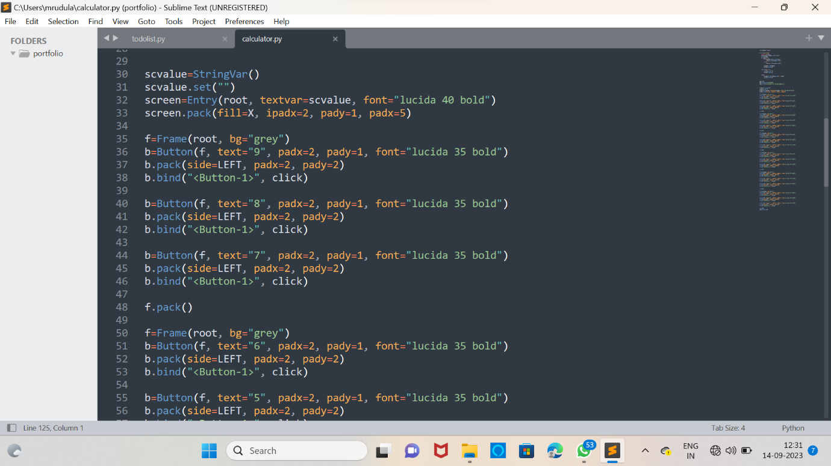

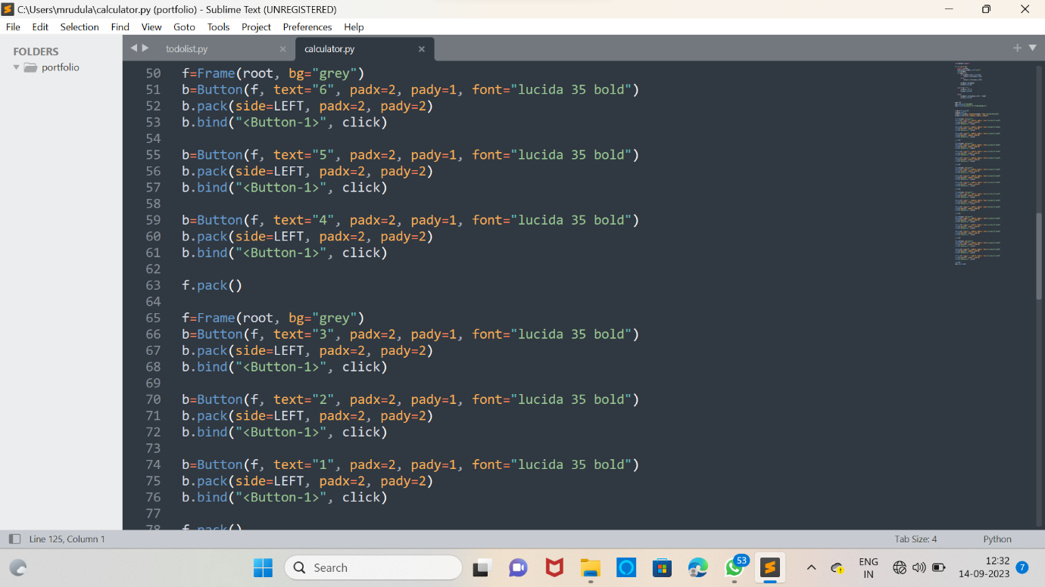

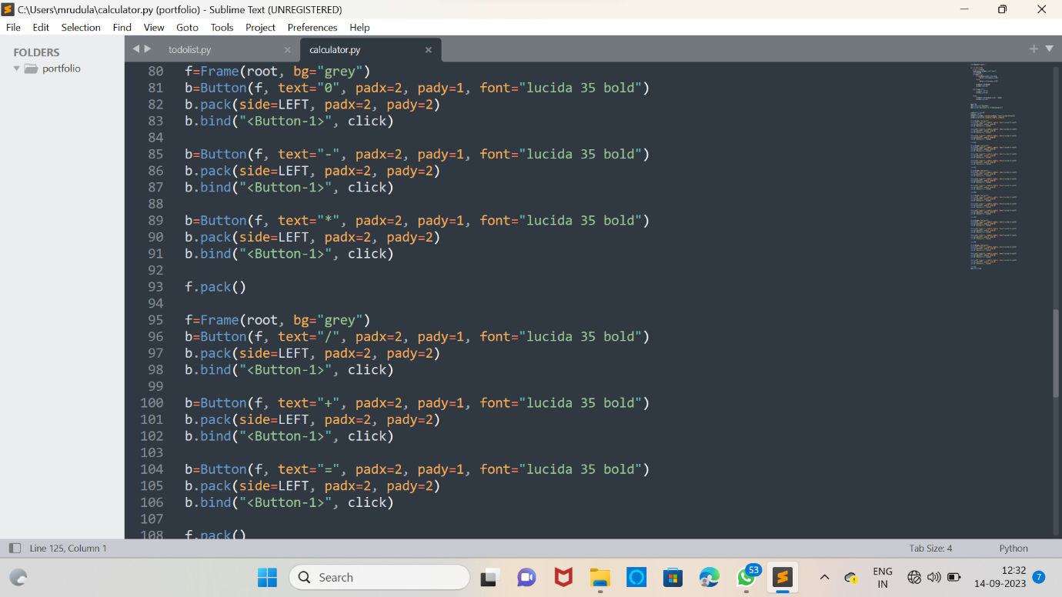

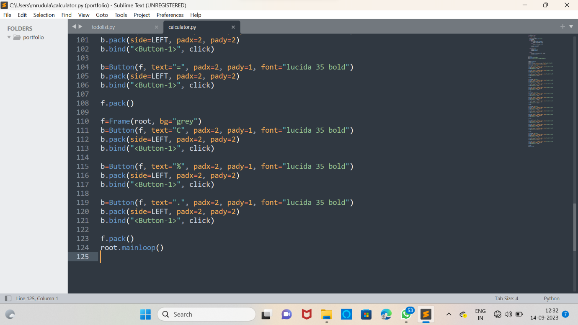

**OUTPUT:**

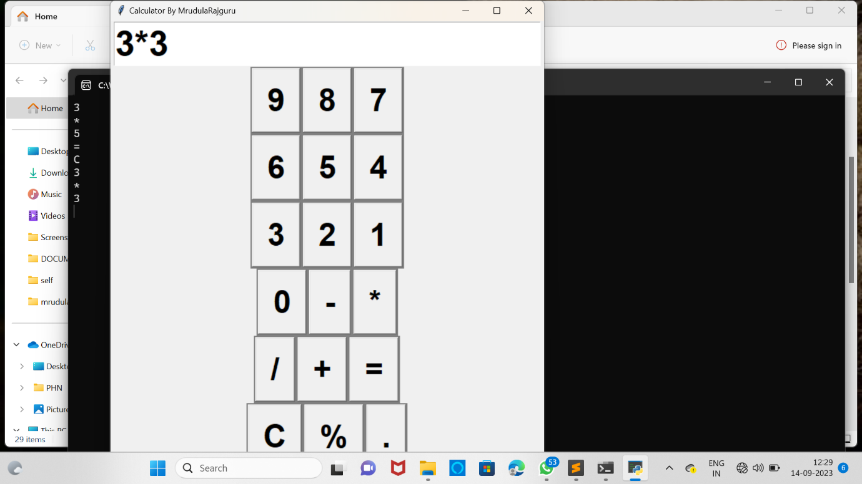

**STONE PAPER SEASOR GAME:**

import random

rock = '''

_______

---' ____)

(_____)

(_____)

(____)

---.__(___)

'''

paper = '''

_______

---' ___)___

______)

_______)

_______)

---.__________)

'''

scissors = '''

_______

---' ___)___

______)

__________)

(____)

---.__(___)

'''

game_images = [rock, paper, scissors]

user_choice = int(input("What do you choose? Type 0 for Rock, 1 for Paper or 2 for Scissors.\n"))

print(game_images[user_choice])

computer_choice = random.randint(0, 2)

print("Computer chose:")

print(game_images[computer_choice])

if user_choice >= 3 or user_choice < 0:

print("You typed an invalid number, you lose!")

elif user_choice == 0 and computer_choice == 2:

print("You win!")

elif computer_choice == 0 and user_choice == 2:

print("You lose")

elif computer_choice > user_choice:

print("You lose")

elif user_choice > computer_choice:

print("You win!")

elif computer_choice == user_choice:

print("It's a draw")