1. I have implemented the movie-catalog-service and uploaded in git.

url for git:

<https://github.com/Mrudula666/movie-catalog-service.git>

1. Configured global settings in Jenkins for jdk installations.
   1. 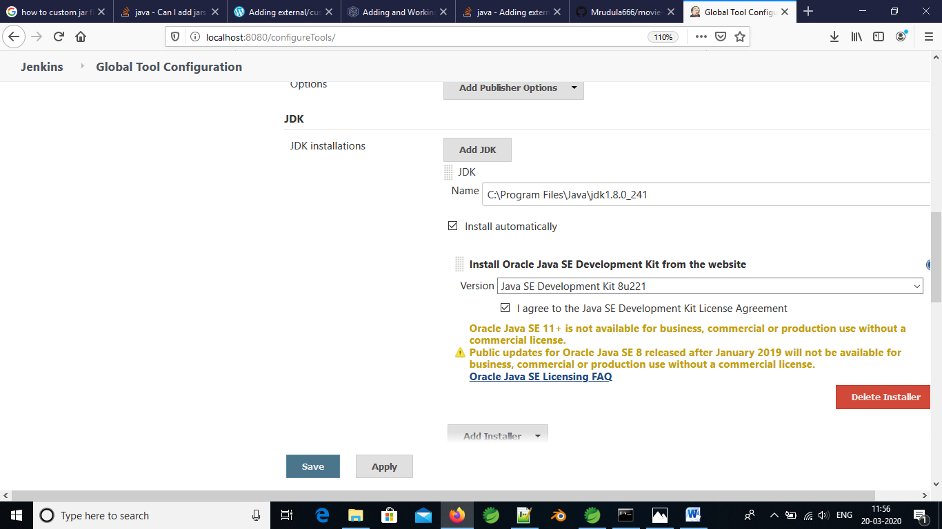
2. Uploaded the maven project in Jenkins.

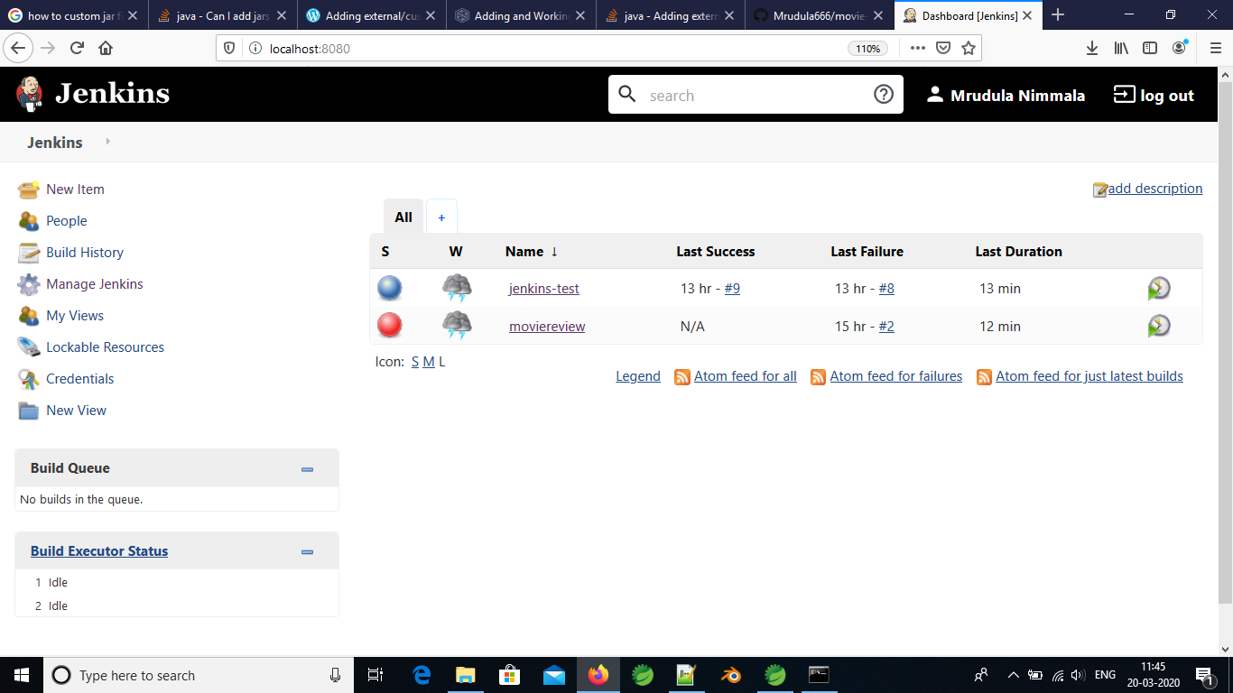

1. Configured the git url and the maven settings in Jenkins from manage Jenkins option

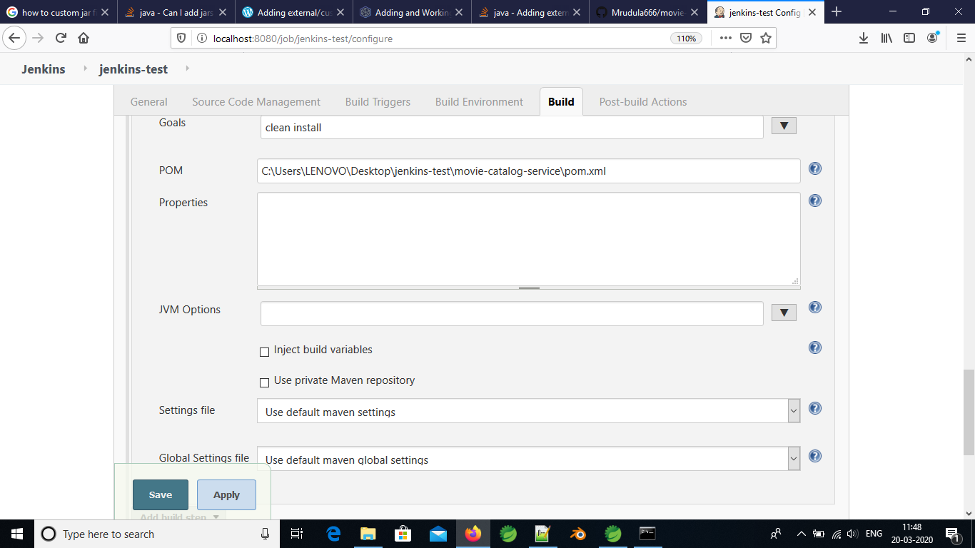

1. Run the maven command with following console output

