1. I have implemented the movie-catalog-service and uploaded in git.

url for git:

<https://github.com/Mrudula666/movie-catalog-service.git>

1. Configured global settings in Jenkins for jdk installations.
   1. 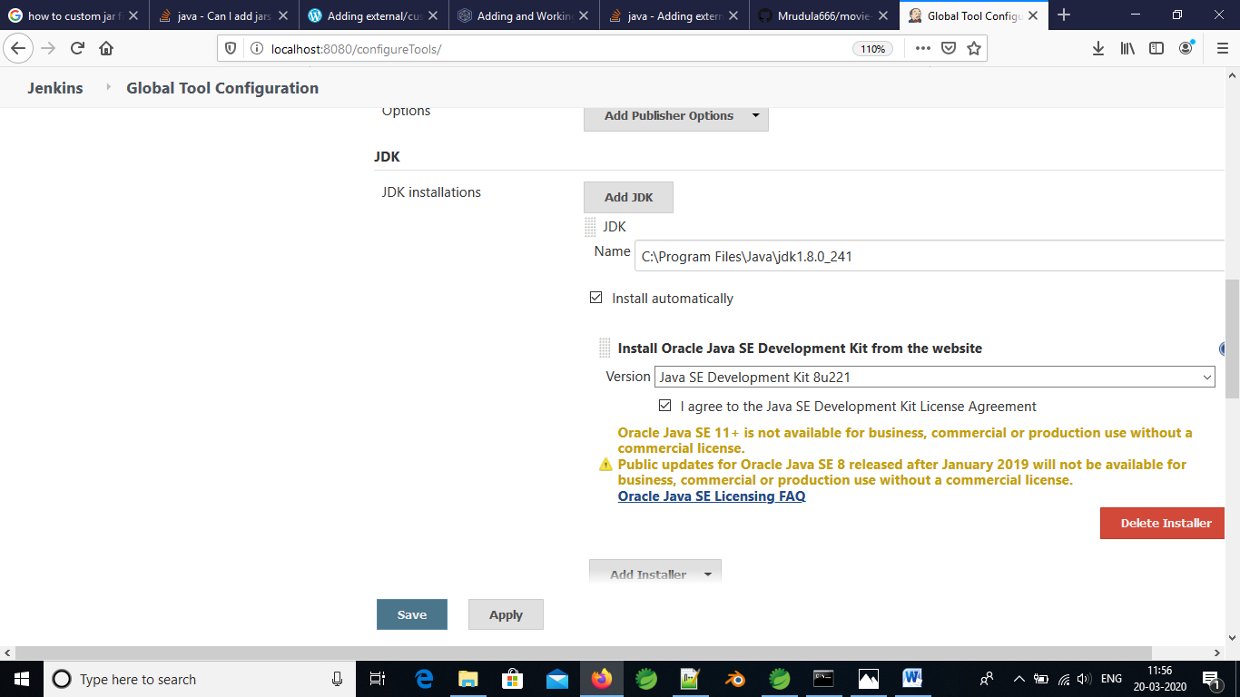
2. Uploaded the maven project in Jenkins.

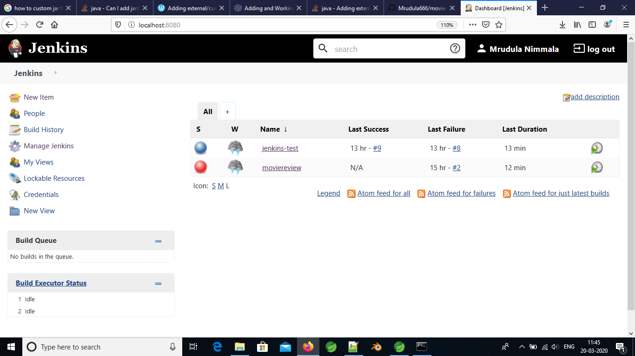

1. Configured the git url and the maven settings in Jenkins from manage Jenkins option

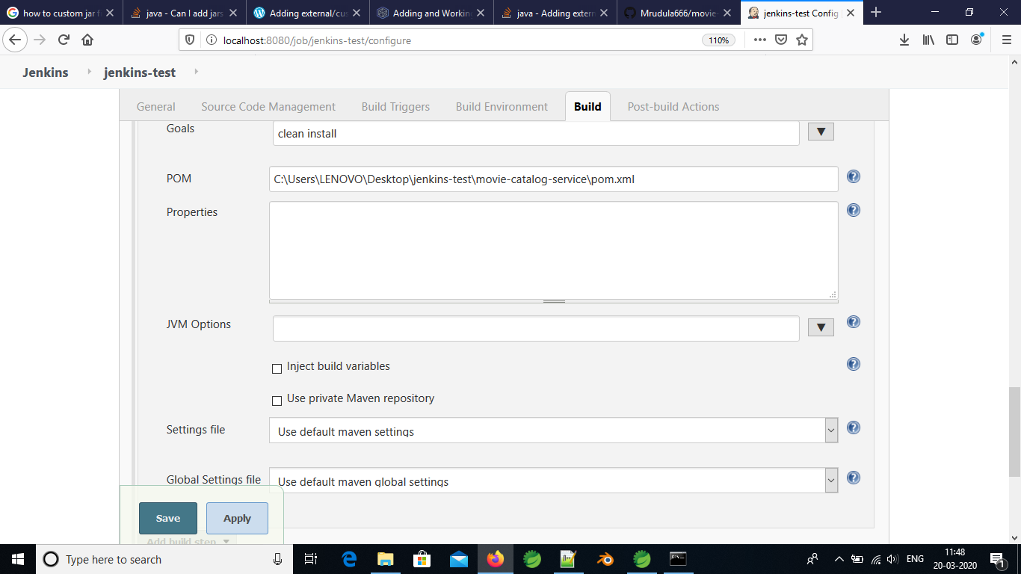

1. Run the maven command with following console output

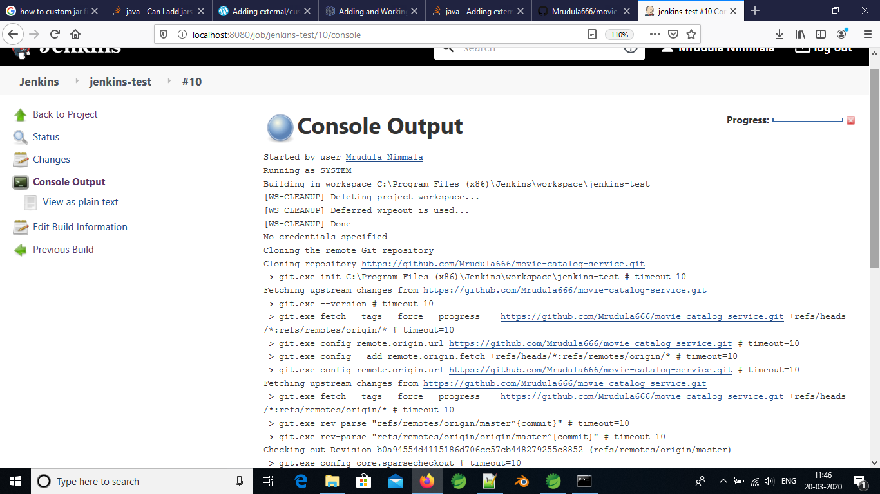

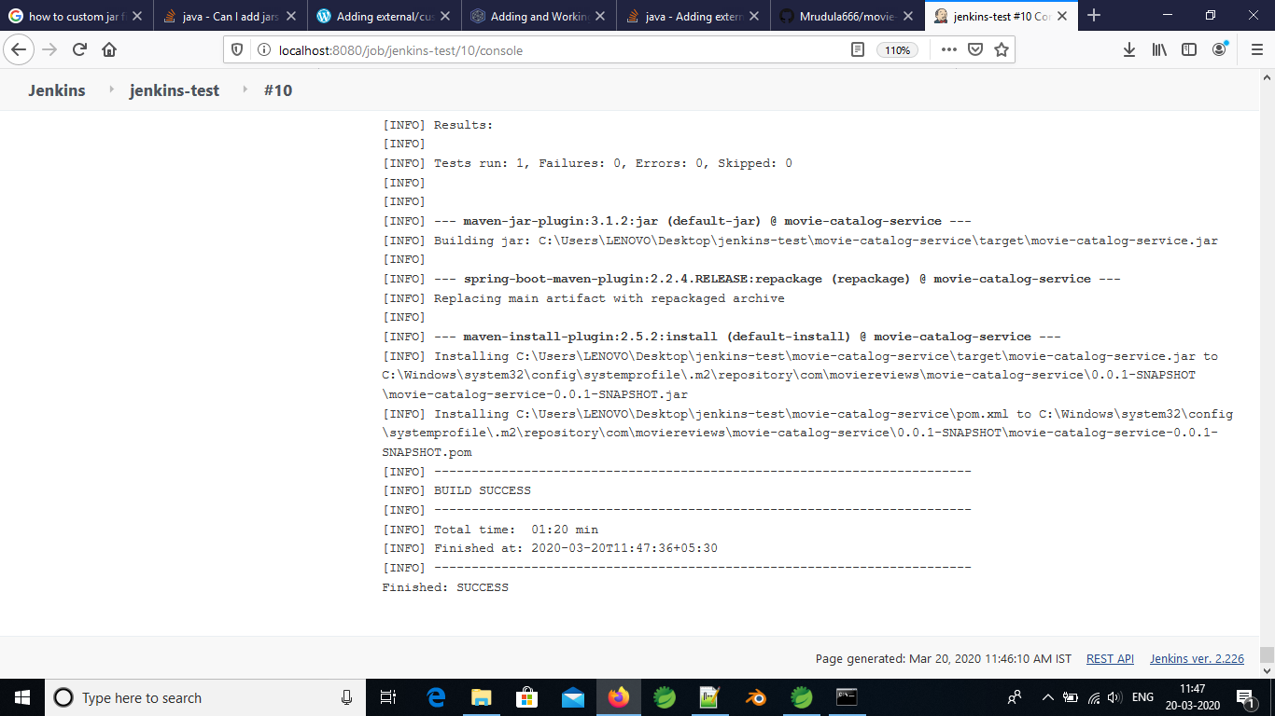

Date: 23-march-2020

**To configure the automatic build trigger for each commit.**

1. To configure the webhook we need to convert the localhost to public network.
2. To do this, we have to install ngrok in the local system and set the path in environment variables.
3. Added the webhook in github as show below.

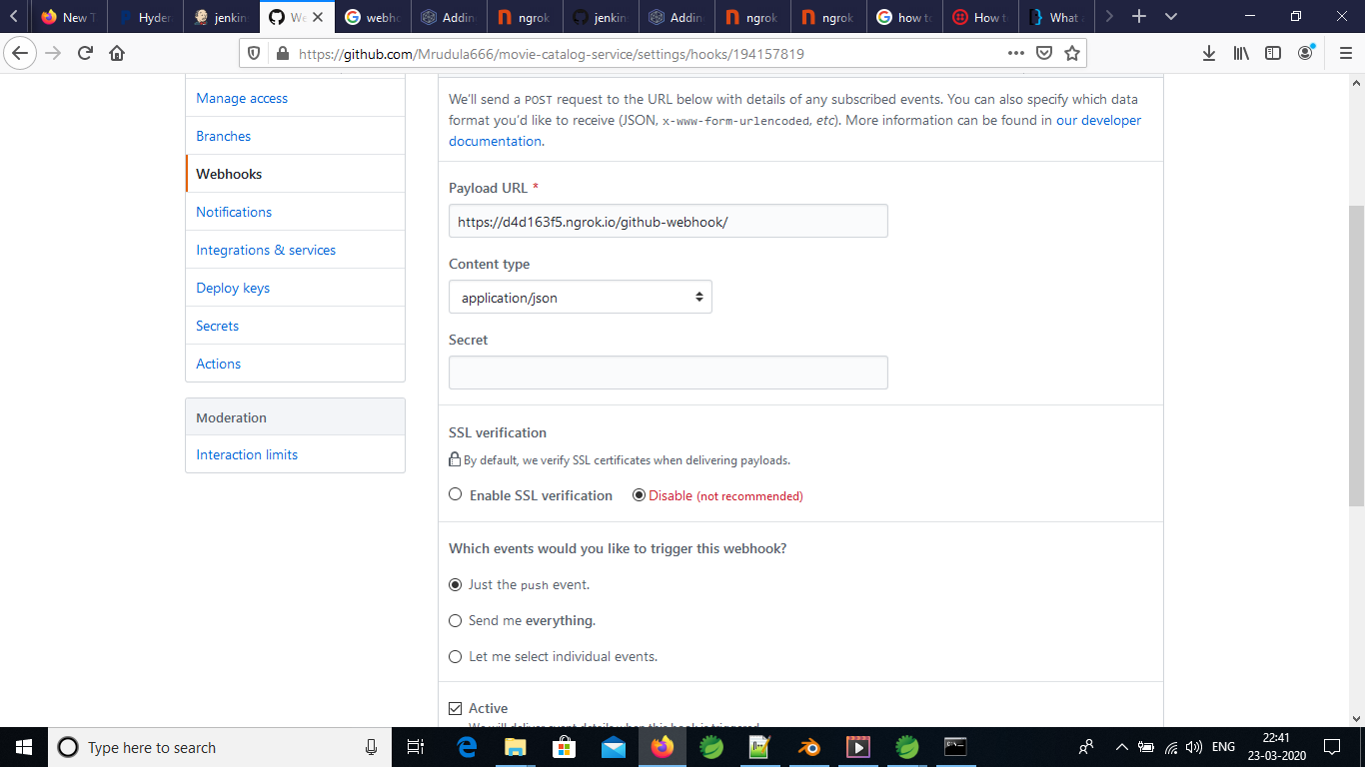

1. Configure the git pull requests in Jenkins with git repository

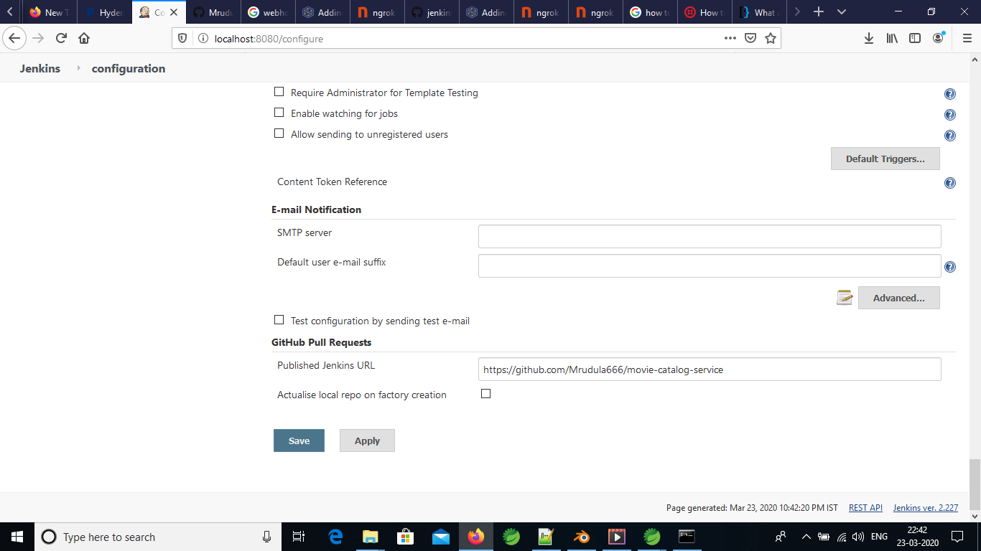

1. Modify the manage configure section in job to mark “GitHub hook trigger for GITScm polling” as below.

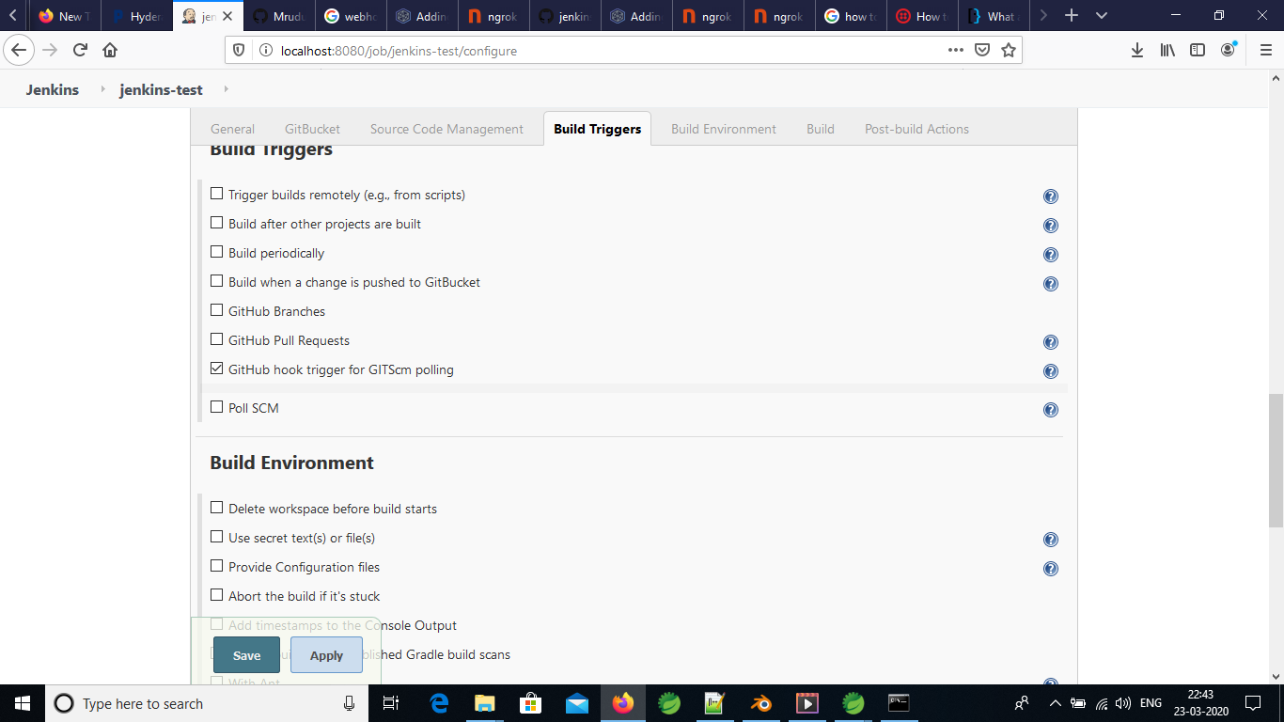

1. Refresh the Jenkins page.

Date: 27-march-2020

Task: Run the Jenkins created war in tomcat server locally

1. At Jenkins, set the goal in job as clean package where the war file is created at

C:\Program Files (x86)\Jenkins\workspace\webapp\webapp\target\webapp.war

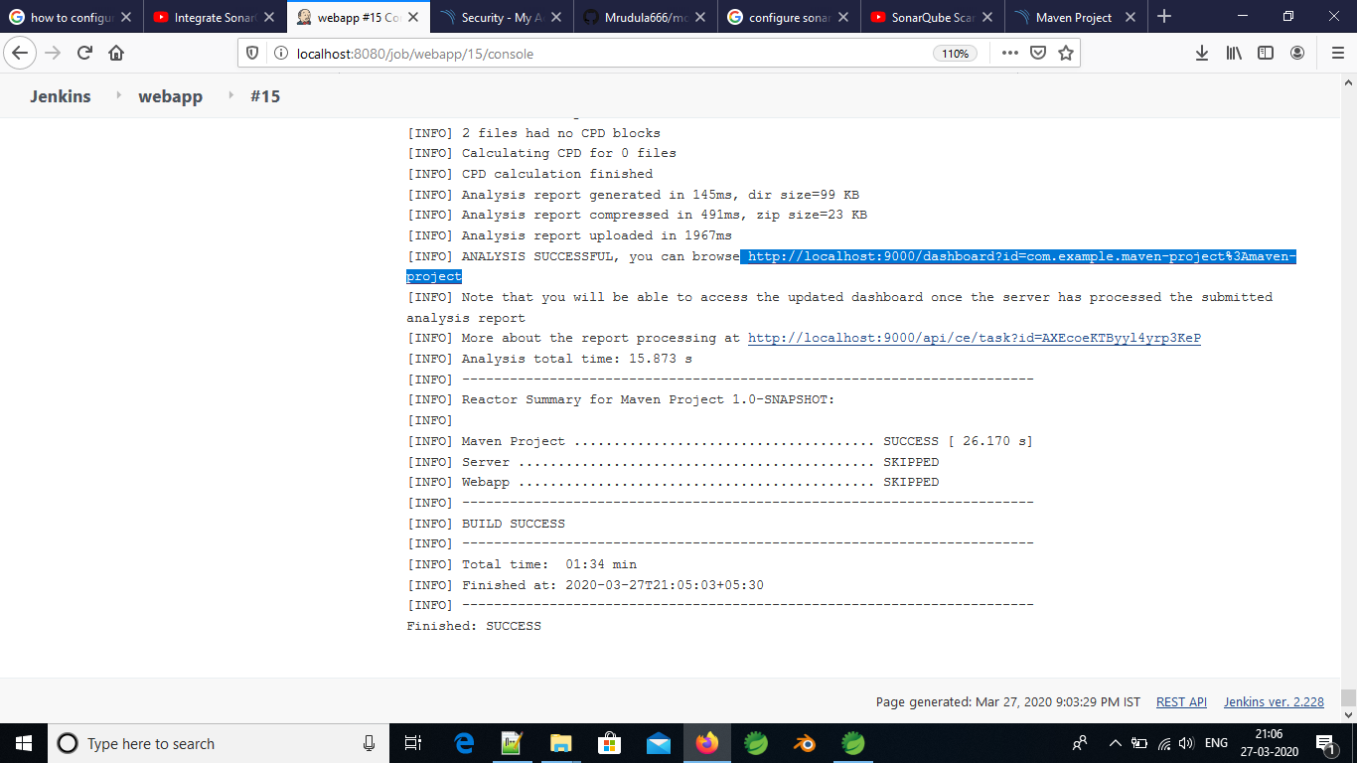

1. Copied the webapp.war file at C:\Program Files\Apache Software Foundation\Tomcat 8.5\webapps location.

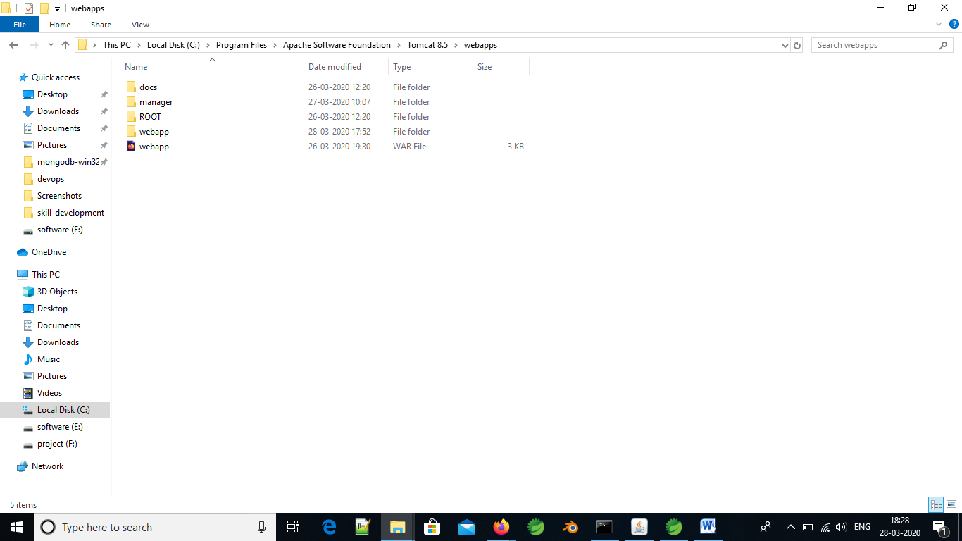

1. Started the tomcat server

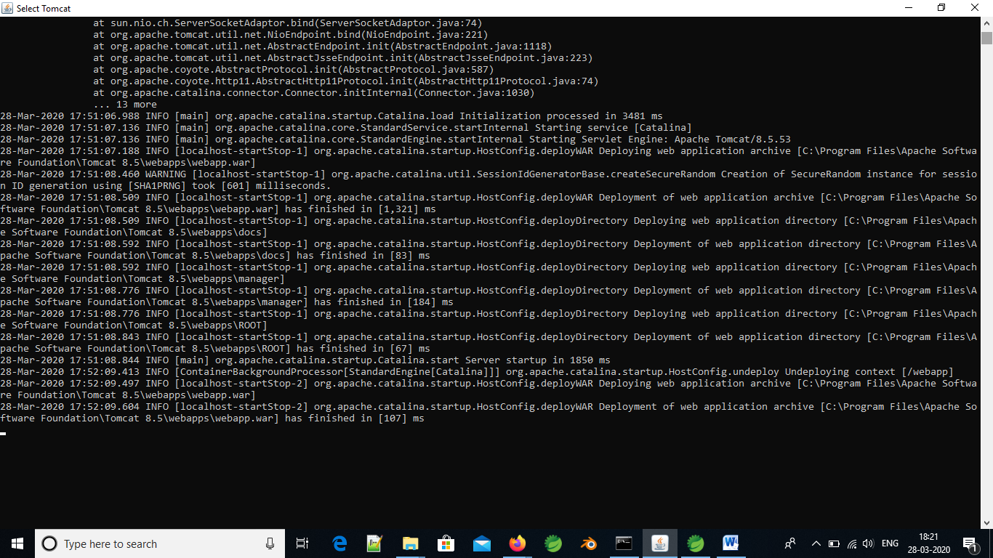

1. Ran the server at 9090 with the url <http://localhost:9090/webapp>

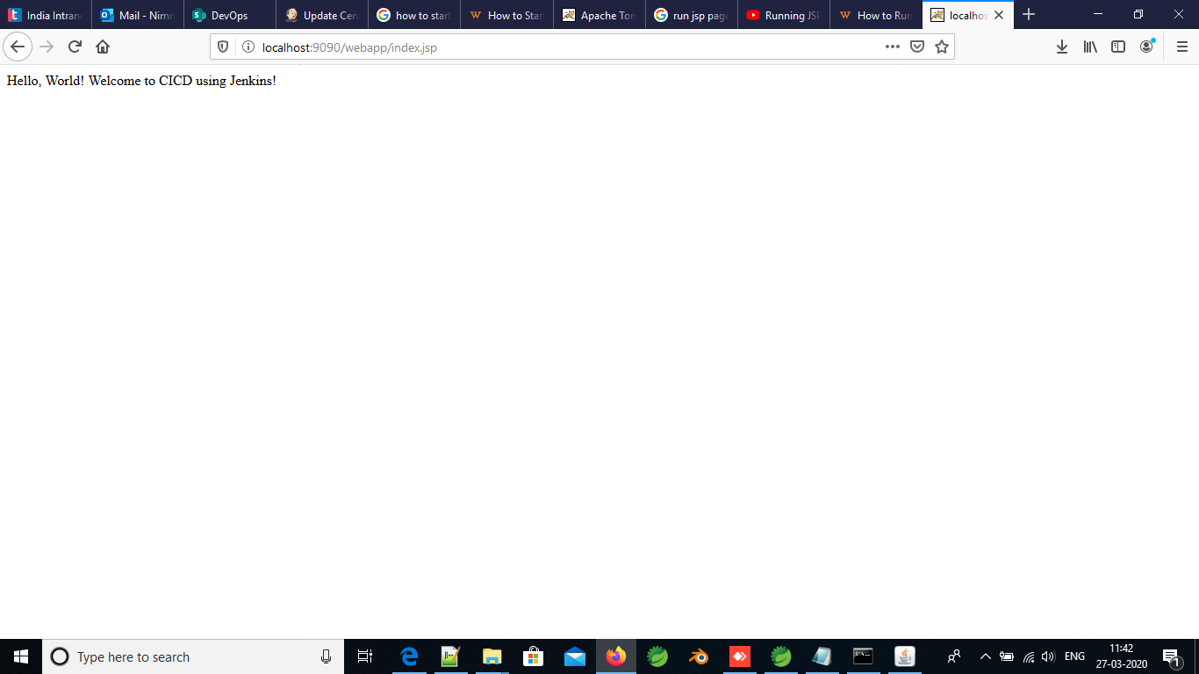

Task: Run the sonarQube in Jenkins

1. Install the sonarQube Scanner in Jenkins at manage Jenkins

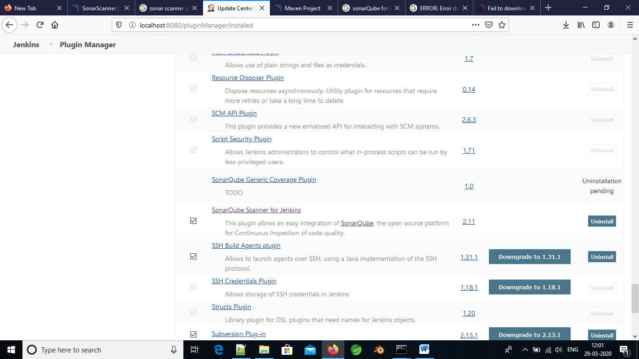

1. Configure the Jenkins in global tool configuration

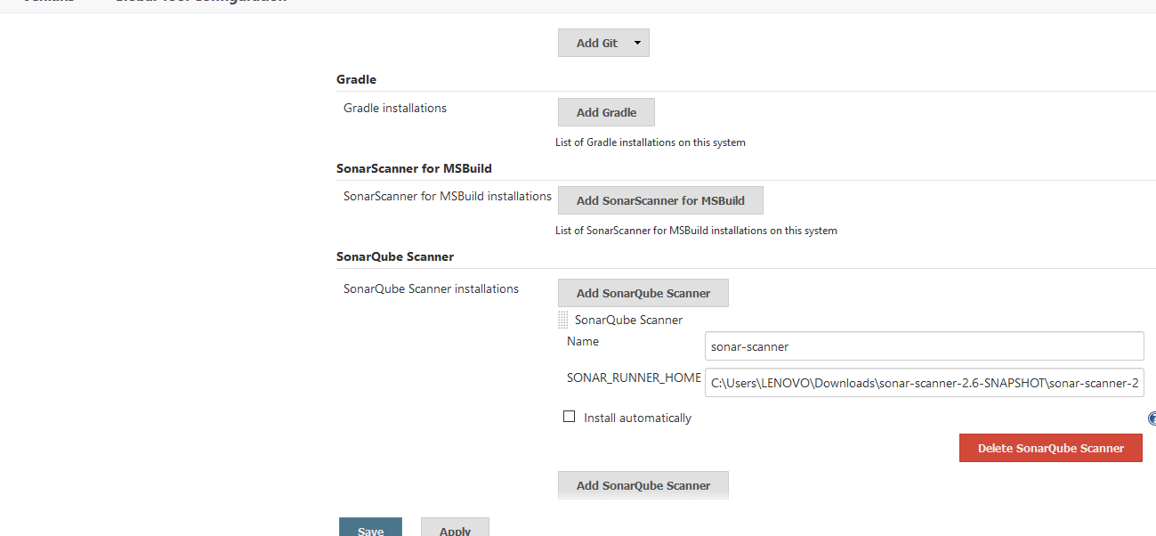

1. Configure the sonarQube server installation in configure option

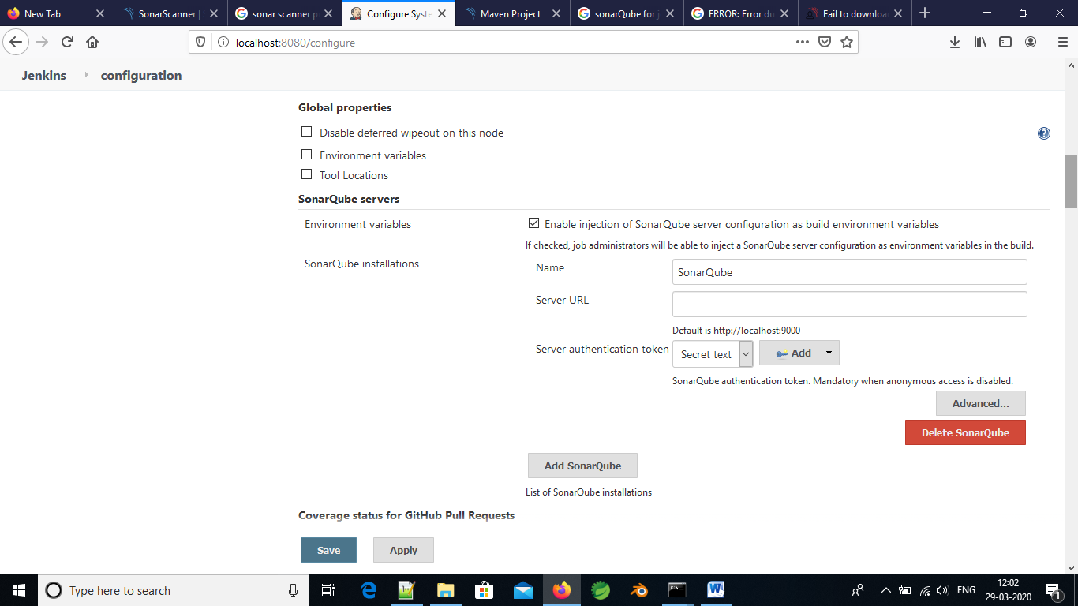

1. Build the job.
2. See the results in <http://localhost:9000>

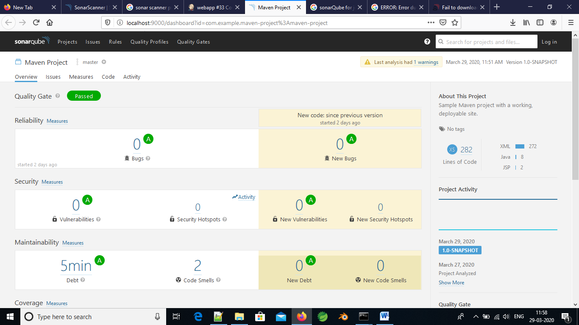

Date: 30/03/2020

Task: Run the war file that is created by the Jenkins job using the Jenkins pipeline

1. Create a new **Pipeline Job**

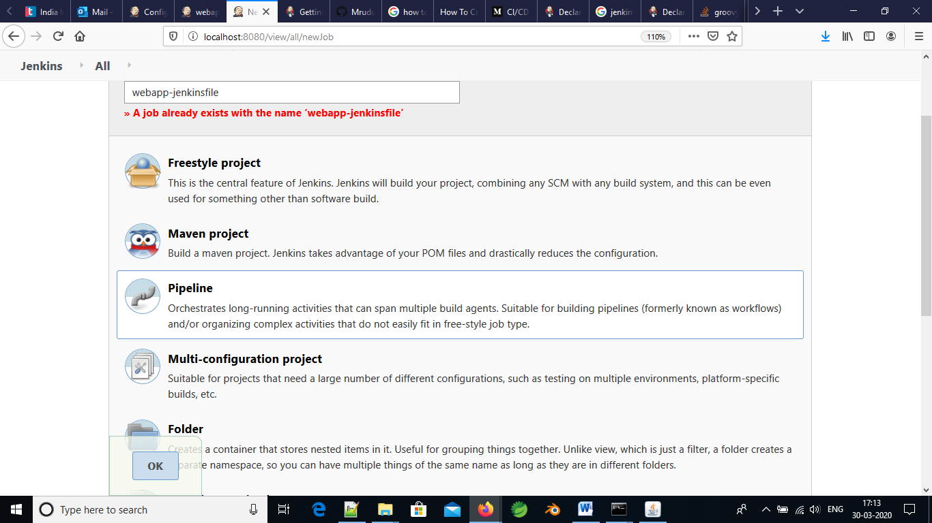

1. In the job go to **PIPELINE** section, where in the Definition section select **Pipeline script from SCM.** Give the essential git repository details in the SCM section

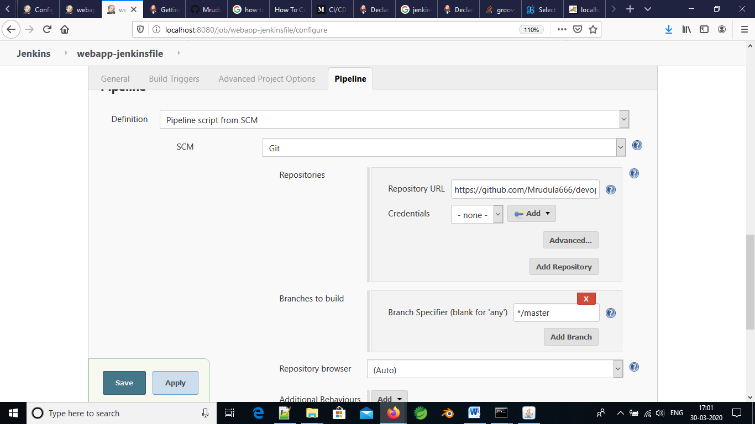

1. In git repository, create Jenkinsfile that has the configurations of the jdk and maven details. And also git url as follows

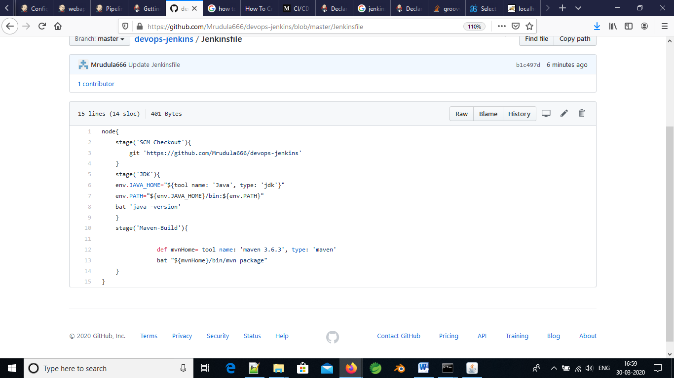

1. For maven version and jdk versions, go to the **pipeline syntax** the mention the tools needed and press **generate pipeline script** as shown below.
2. For maven:

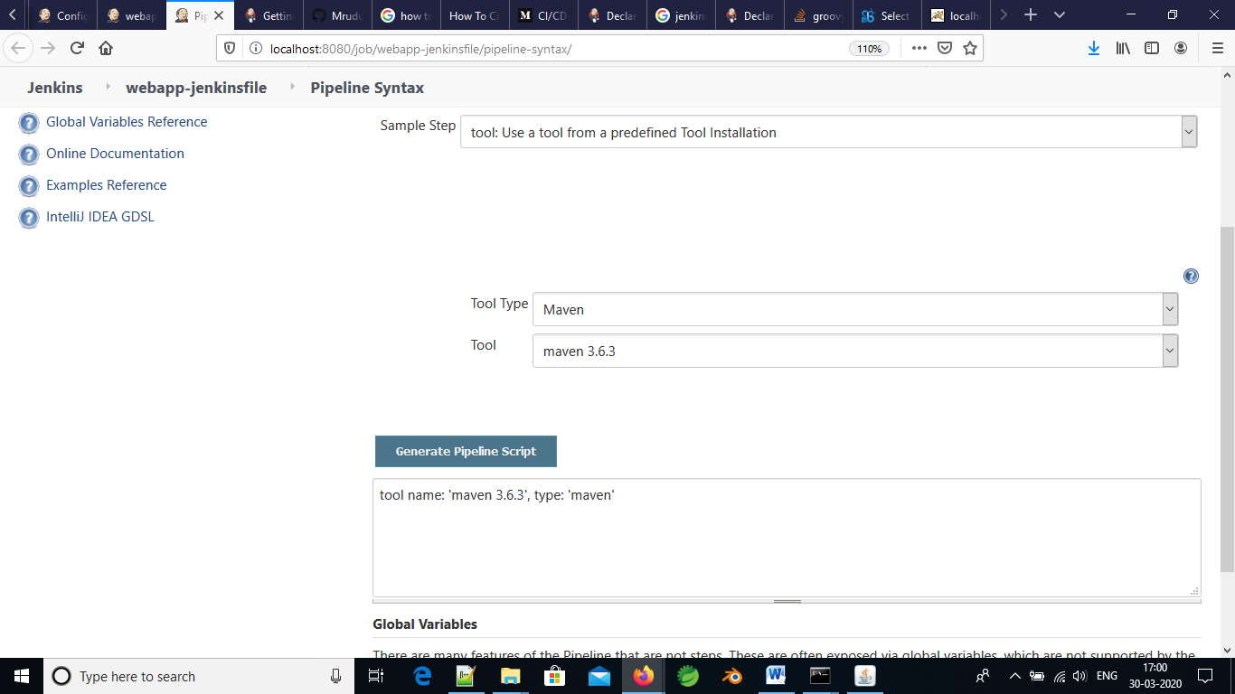

1. For Java tool:

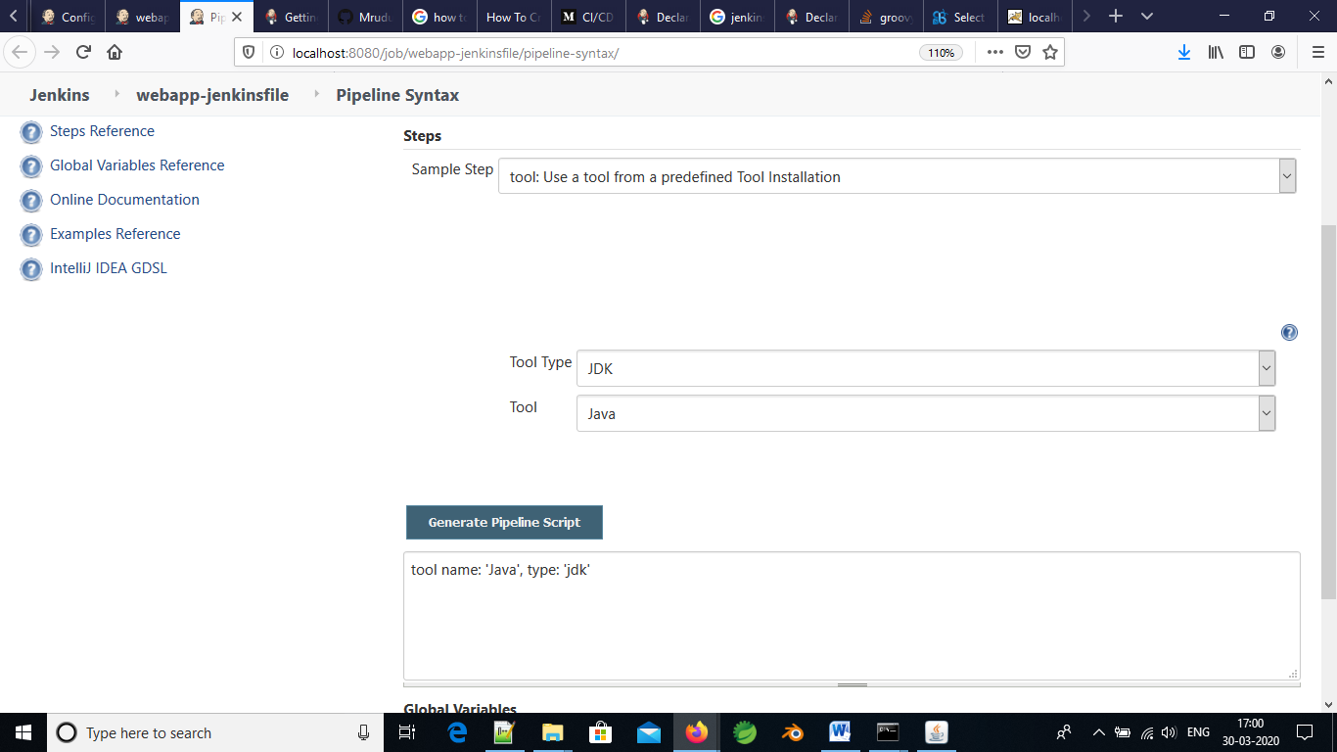

1. Now build the job, and webapp.war file is created

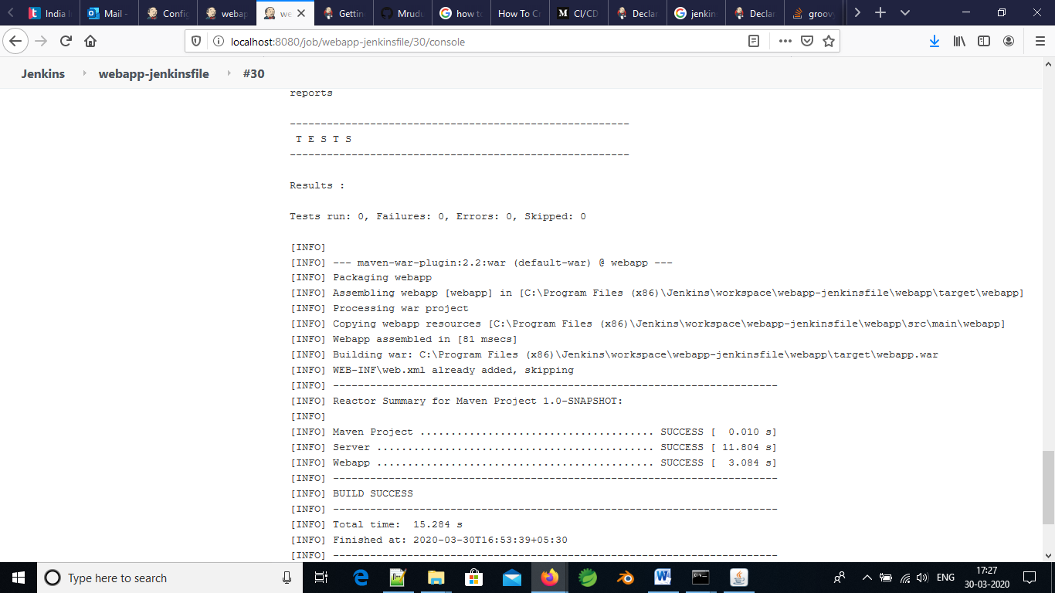

1. Start the tomcat server and run the war file as <http://localhost:9090/webapp> and see the below result

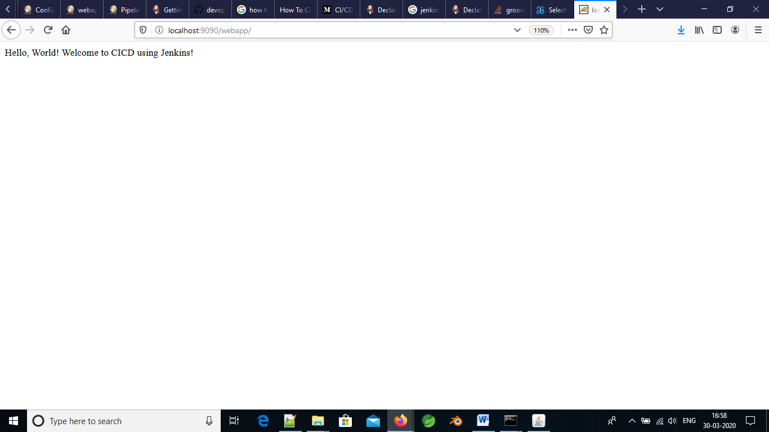

Date:31/March/2020

Aim: Adding the sonarQube server using pipeline script for above job in Jenkins

1. Just add the following script in Jenkins file and build the job.

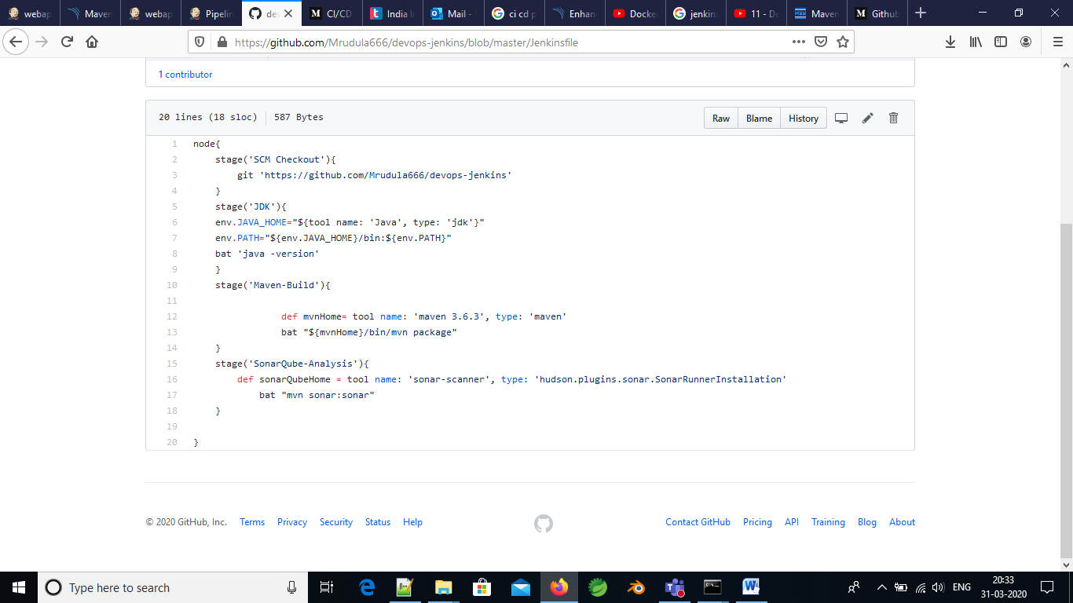

1. Build the Jenkins job

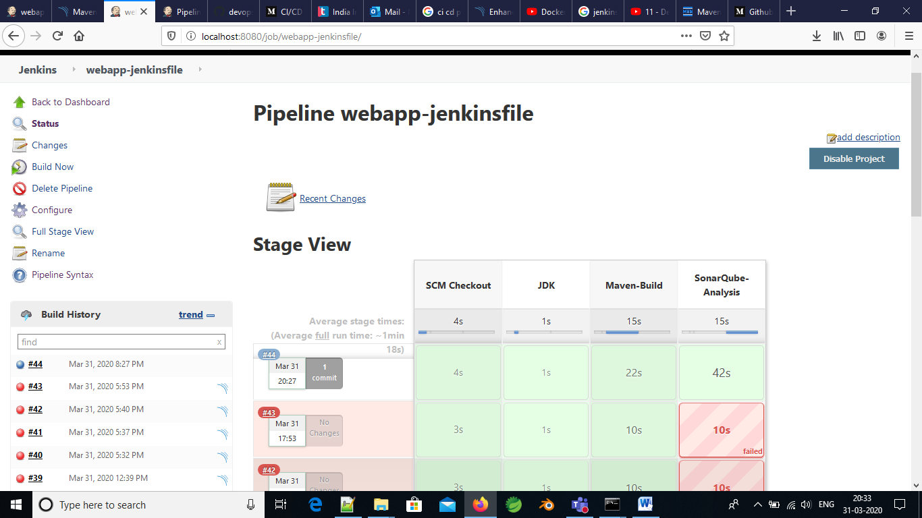

1. See the results in <http://localhost:9000>

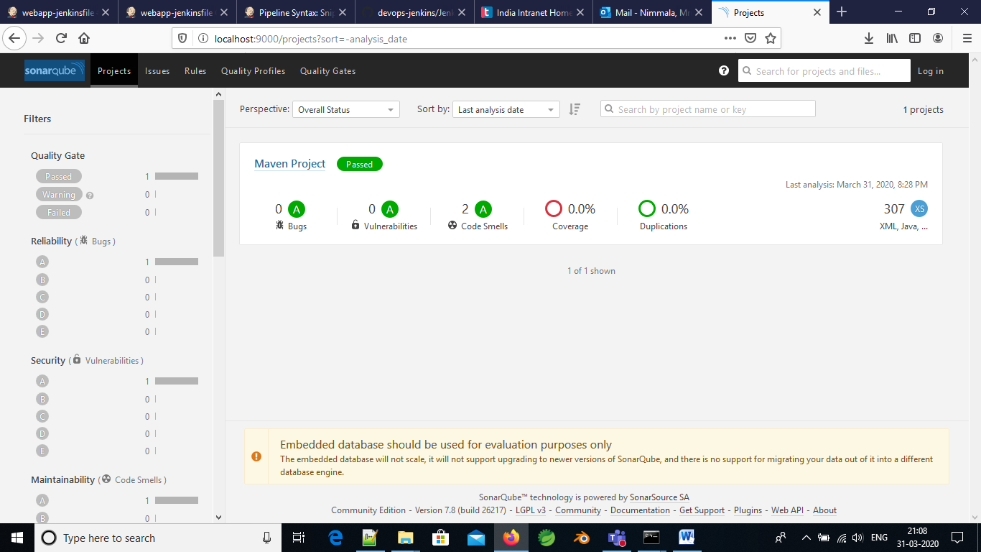

1. As we can see the there are 2 code smells in the project.

Date: 02-March-2020

Aim: Deployed the Tomcat server in Jenkins. Finally the Jenkins file contains Pipeline with the scm code+ Maven build + SonarQube Analysis + Tomcat deployer

1. To add the tomcat server in Jenkins job Configure **Deploy to Container** in the manage Jenkins option

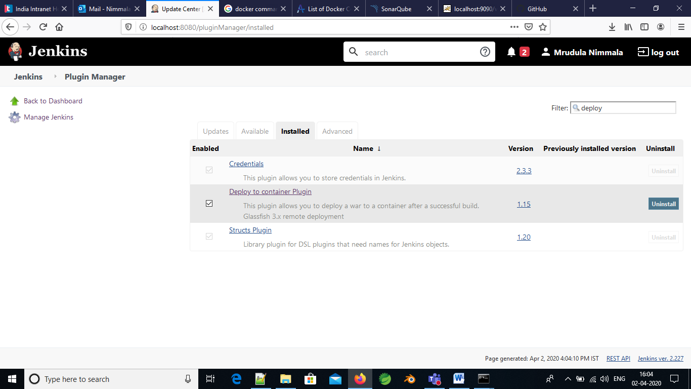

1. Add manager role, user name and password in the tomcat-users.xml in the location C:\Program Files\Apache Software Foundation\Tomcat 8.5\conf\tomcat-users.xml like below

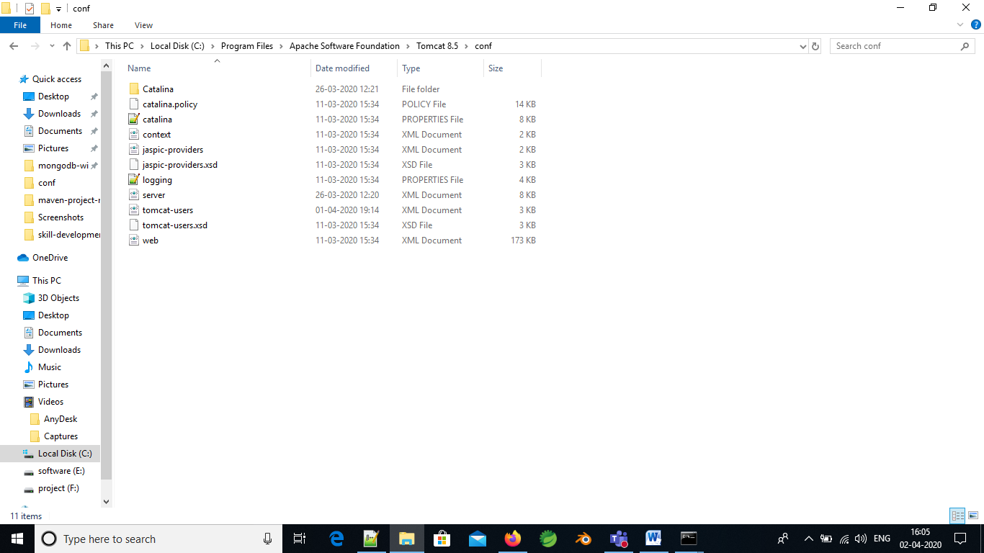

1. Generate the pipeline syntax script in the job

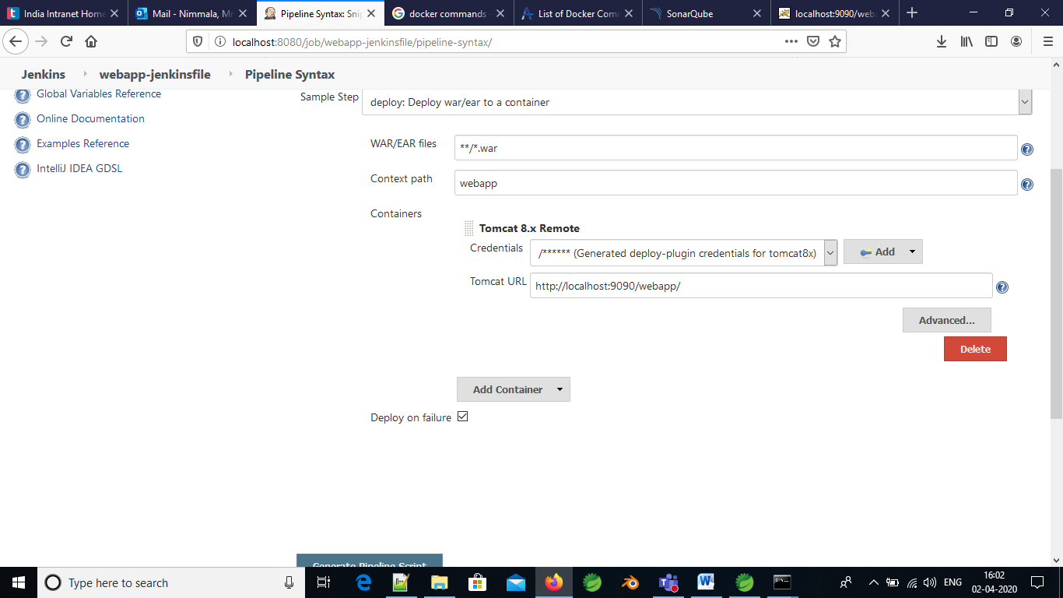

1. Add it in the Jenkinsfile in github link. The Script is **deploy adapters: [tomcat8(credentialsId: '7de1de9d-8e53-441a-8a2d-c06b708e9dcd', path: '', url: 'http://localhost:9090/webapp/')], contextPath: 'webapp', onFailure: false, war: '**/*.war'**

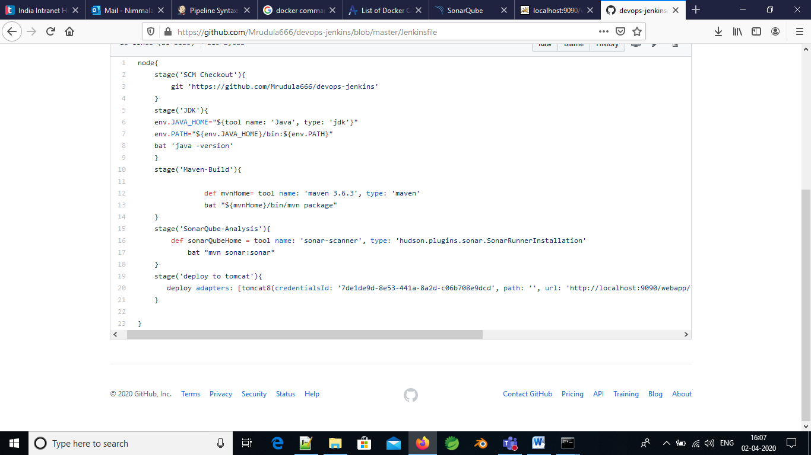

1. Build the job. See the result.

