**Laravel 5.8**

Laravel support mvc architecture

MVC :model, view and controller

Model :

Model support db connection

View : support gui part of application

Controller : support logic or coding part of application

**MVC architecture :**

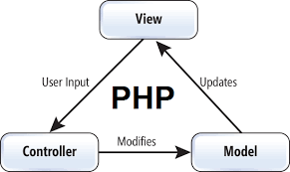

**Laravel installations :**

**How to install Laravel :**

Step1 :

Laravel.com

Step 2:

<https://laravel.com/docs/5.8>

step 3:

download composer

Composer :

<https://getcomposer.org/download/>

composer is a dependency manager i.e used for create or install Laravel without comoposer we cant install Laravel

step 4: composer will configure with xampp

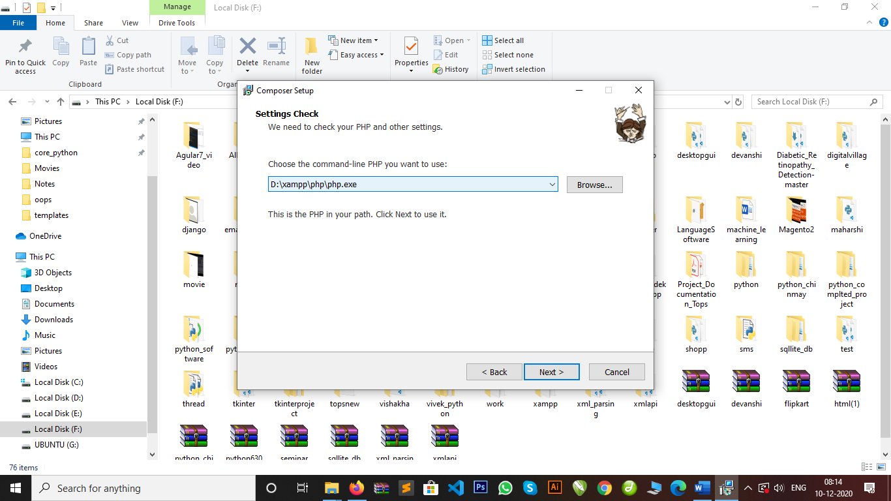

dependency manager :

composer is used to install all the dependency of Laravel or library and components of Laravel.

Step :5

How to check composer install or not

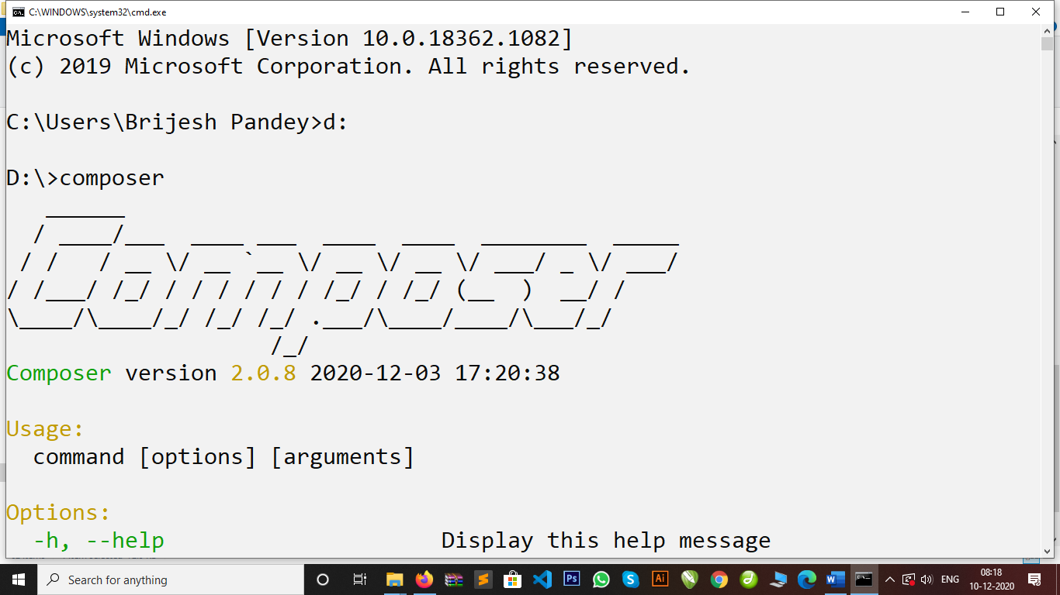

Step 6:

System requirements

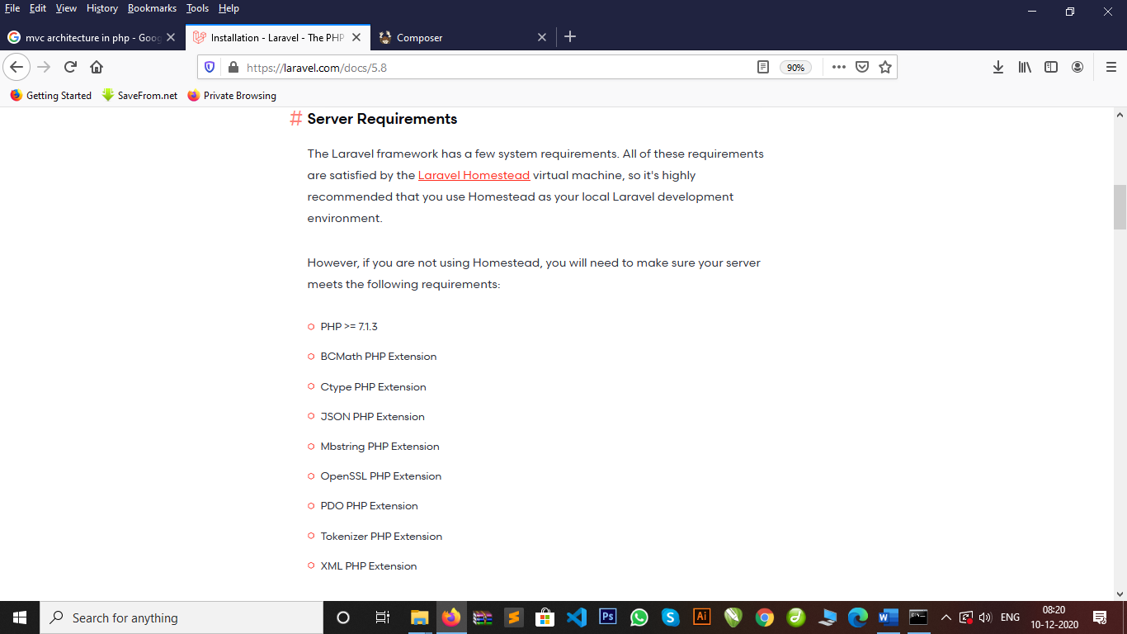

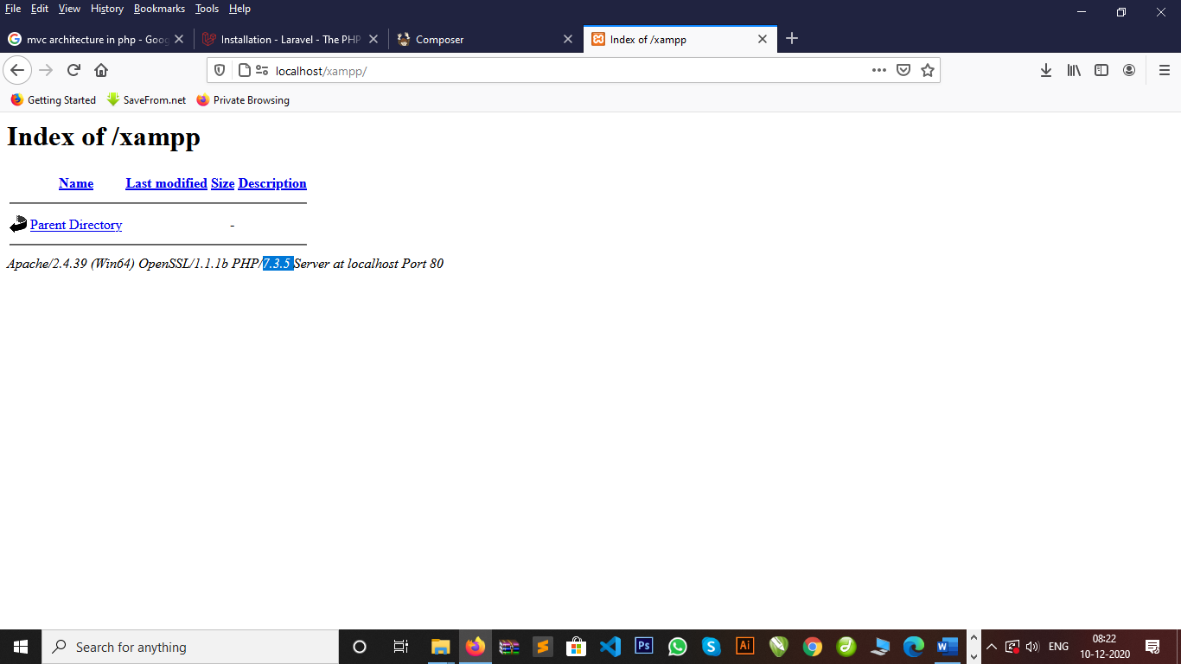

Step 7:

Install Laravel 5.8

Cmd :

composer create-project --prefer-dist laravel/laravel blog "5.8.*"

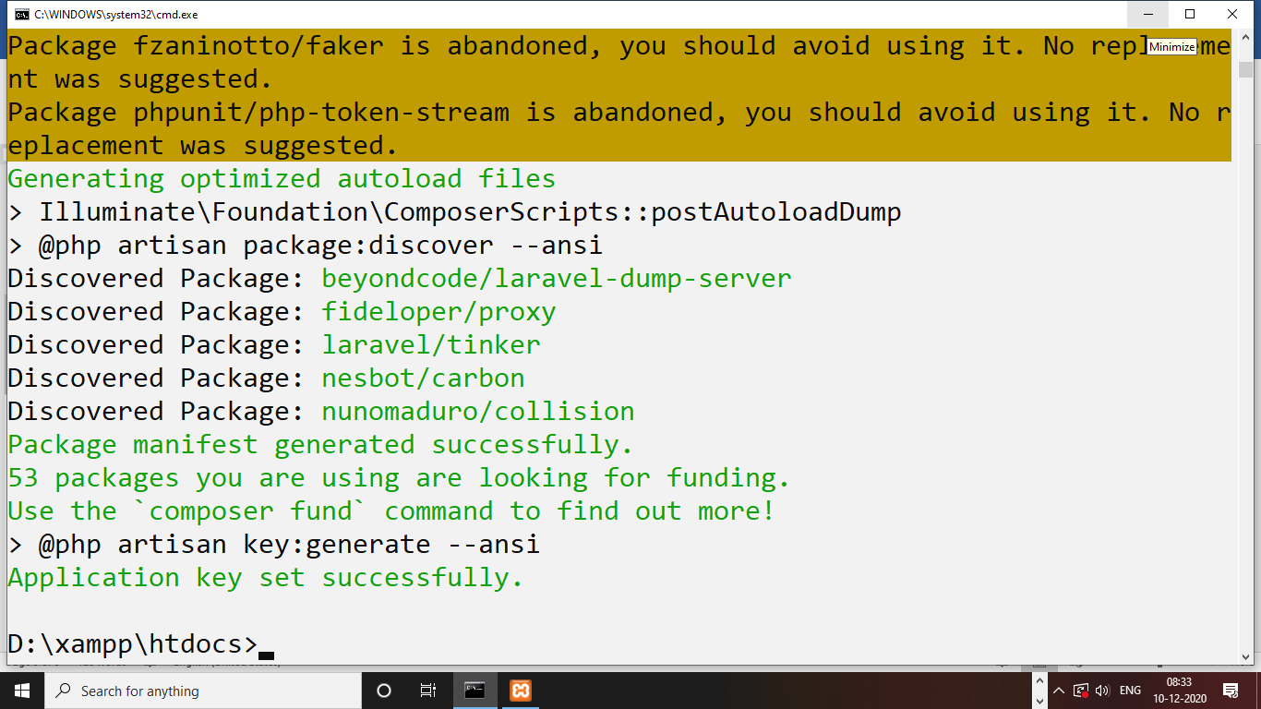

How to run Laravel project :

How to run Server development URL :

Create a artisan command of Laravel :

Artisan command:

Laravel provides a **artisan command** to create a model, controller, or database or run Laravel on server or localhost.

Cmd : php artisan serve

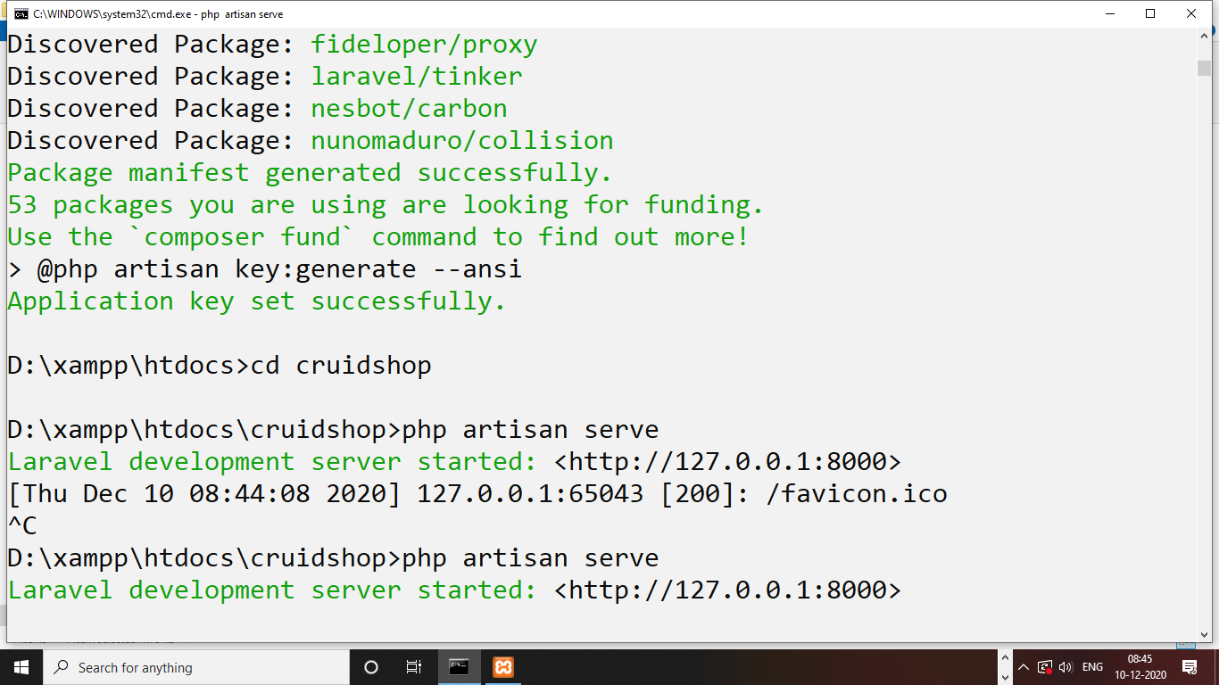

**How to load Laravel on localhost :**

Step 1 :

Go in project main directory

Step 2:

Open server.php file

Rename with index.php

<http://localhost/cruidshop/>

**Database Migrations :**

Database migrations is a version control i.e used to provide database connection and create a table structure in Laravel.

How to provide a database connection :

Step 1: open .env file in Laravel structure.

DB_CONNECTION=mysql

DB_HOST=127.0.0.1

DB_PORT=3306

DB_DATABASE=cruidapp

DB_USERNAME=root

DB_PASSWORD=

Step 2: open config->database.php

        'mysql' => [

            'driver' => 'mysql',

            'url' => env('DATABASE_URL'),

            'host' => env('DB_HOST', '127.0.0.1'),

            'port' => env('DB_PORT', '3306'),

            'database' => env('DB_DATABASE', 'cruidapp'),

            'username' => env('DB_USERNAME', 'root'),

            'password' => env('DB_PASSWORD', ''),

            'unix_socket' => env('DB_SOCKET', ''),

            'charset' => 'utf8mb4',

            'collation' => 'utf8mb4_unicode_ci',

            'prefix' => '',

            'prefix_indexes' => true,

            'strict' => true,

            'engine' => null,

            'options' => extension_loaded('pdo_mysql') ? array_filter([

                PDO::MYSQL_ATTR_SSL_CA => env('MYSQL_ATTR_SSL_CA'),

            ]) : [],

        ],

Step 3: Laravel default tables migrations provide.

Open database->migrations->2014_10_12_000000_create_users_table.php

Step 4: how to migrate database in Laravel

Cmd : database migrations

Php artisan migrate

Step 5: how to drop tables and migrate furthure

Cmd : php artisan migrate:fresh

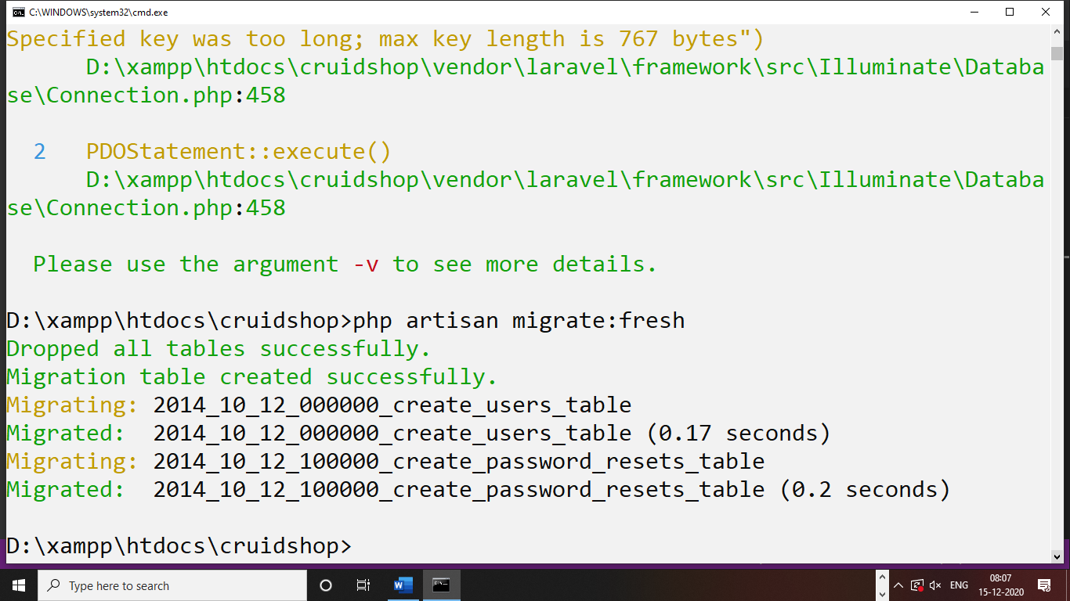

How to create a table in Laravel :

Step 1: in Laravel a table will created by database migrations command

Step 2: in Laravel a table will include columns and row

Step 3: in Laravel a table had a different-2 datatypes

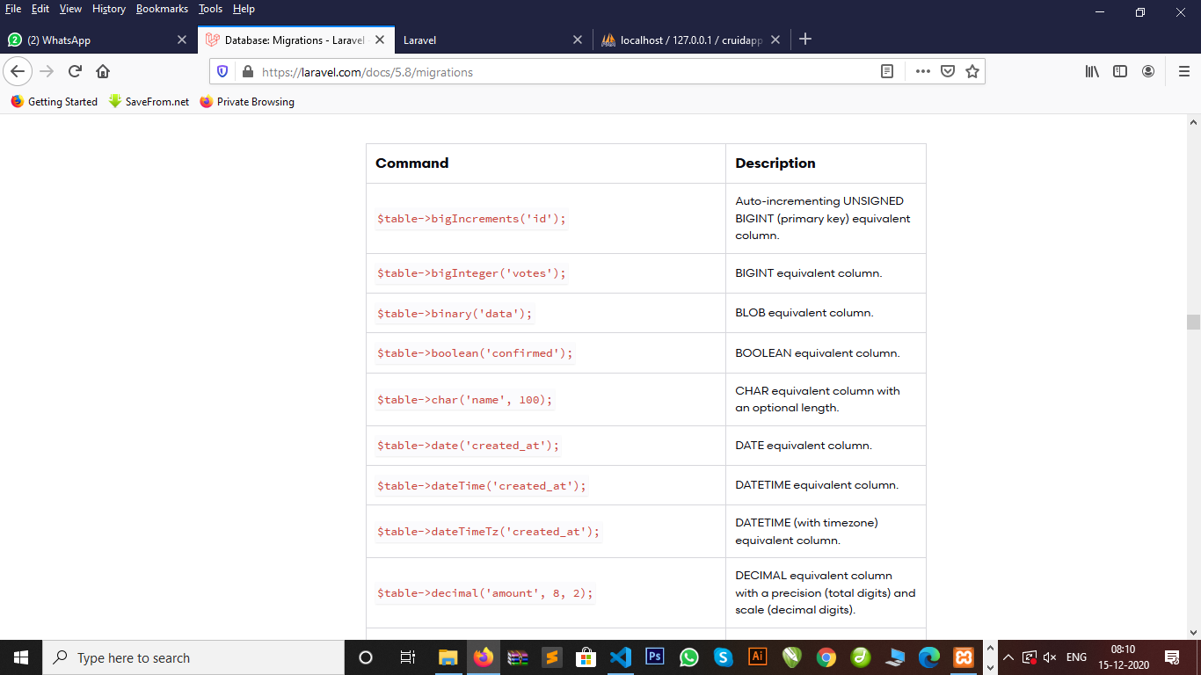

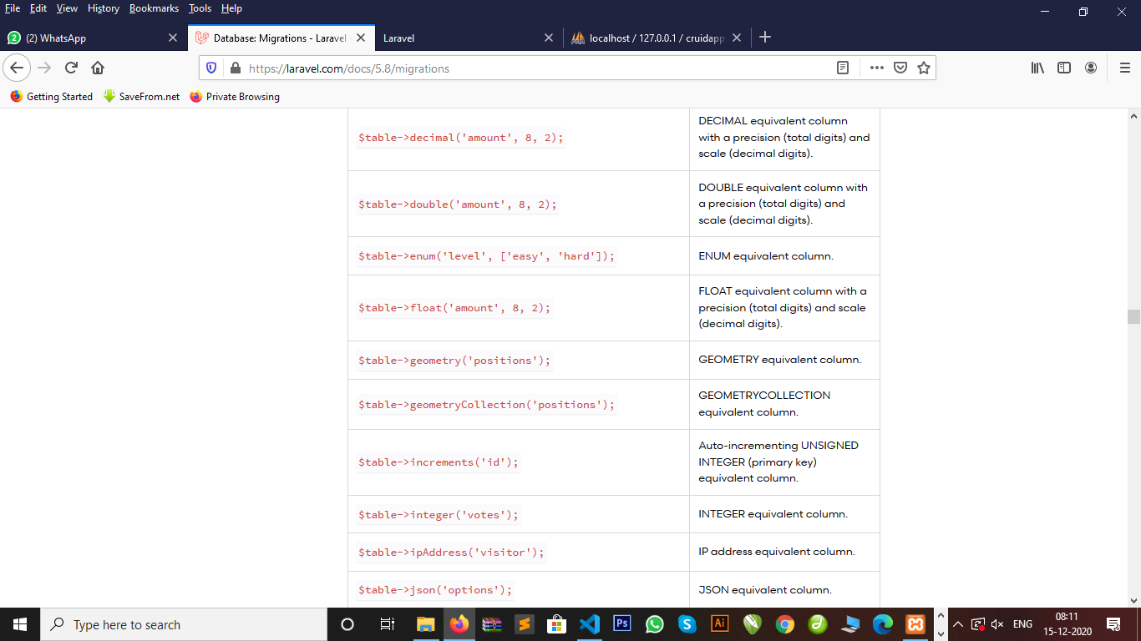

Command of migrations to creating tables in Laravel :

Step 1: php artisan make:migration create_feedbacks_table

Or

Step 2: php artisan make:migration create_registers_table –create=registers

Default migrations table file structure Laravel :

<?php

use Illuminate\Support\Facades\Schema;

use Illuminate\Database\Schema\Blueprint;

use Illuminate\Database\Migrations\Migration;

class CreateRegisters extends Migration

{

    /**

     * Run the migrations.

     *

     * @return void

     */

    public function up()

    {

        Schema::create('registers', function (Blueprint $table) {

            $table->bigIncrements('id');

            $table->timestamps();

        });

    }

    /**

     * Reverse the migrations.

     *

     * @return void

     */

    public function down()

    {

        Schema::dropIfExists('registers');

    }

}

How to create Foreign Key in Laravel database Migrations :

Step 1: php artisan make:migration create_countries_table –create=countries

Step 2: php artisan make:migration create_states_table –create=states

Step 3: php artisan make:migration create_cities_table –create=cities

Step 4: php artisan migrate:fresh –force

Php artisan force is used to delete and rollback all tables forcefuly.

<?php

use Illuminate\Support\Facades\Schema;

use Illuminate\Database\Schema\Blueprint;

use Illuminate\Database\Migrations\Migration;

class CreateCountriesTable extends Migration

{

    /**

     * Run the migrations.

     *

     * @return void

     */

    public function up()

    {

        Schema::create('countries', function (Blueprint $table) {

            $table->increments('id');

            $table->string('cname');

            $table->timestamps();

        });

    }

    /**

     * Reverse the migrations.

     *

     * @return void

     */

    public function down()

    {

        Schema::dropIfExists('countries');

    }

}

<?php

use Illuminate\Support\Facades\Schema;

use Illuminate\Database\Schema\Blueprint;

use Illuminate\Database\Migrations\Migration;

class CreateStatesTable extends Migration

{

    /**

     * Run the migrations.

     *

     * @return void

     */

    public function up()

    {

        Schema::create('states', function (Blueprint $table) {

            $table->increments('id');

            $table->integer('cid')->unsigned();

            $table->foreign('cid')->references('id')->on('countries');

            $table->string('sname');

            $table->timestamps();

        });

    }

    /**

     * Reverse the migrations.

     *

     * @return void

     */

    public function down()

    {

        Schema::dropIfExists('states');

    }

}

<?php

use Illuminate\Support\Facades\Schema;

use Illuminate\Database\Schema\Blueprint;

use Illuminate\Database\Migrations\Migration;

class CreateCitiesTable extends Migration

{

    /**

     * Run the migrations.

     *

     * @return void

     */

    public function up()

    {

        Schema::create('cities', function (Blueprint $table) {

            $table->increments('id');

            $table->integer('sid')->unsigned();

            $table->foreign('sid')->references('id')->on('states');

            $table->string('ctname');

            $table->timestamps();

        });

    }

    /**

     * Reverse the migrations.

     *

     * @return void

     */

    public function down()

    {

        Schema::dropIfExists('cities');

    }

}

File structure or directory structure :

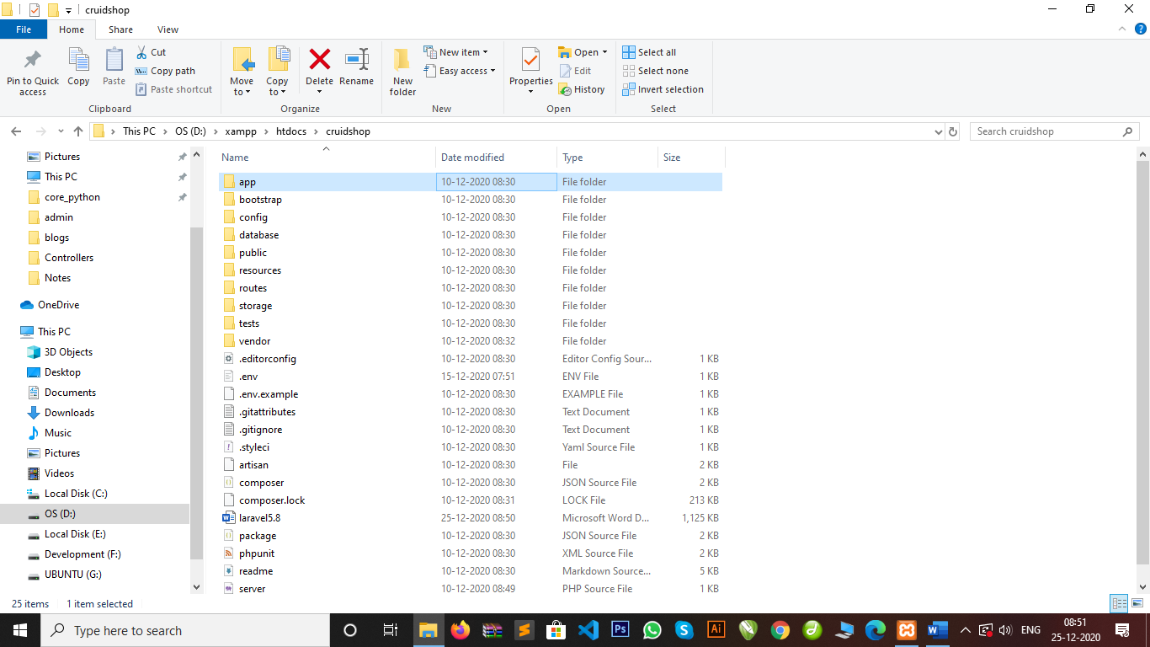

Laravel blade templating :

1. Default views file structure in Laravel build with blade templating and follow inheritance concepts
2. Extends keywords inheritance concepts
3. Ex: index.blade.php

Routing : routing is just load your appropriate user url that user wants.

:Laravel routes=>web.php

Ex: Route::get(‘/damini’, function(){

echo “Hi damini how are you”;

});

Routing: 1) get

2) post

3) resource

Resource : we used resource to post or get data using routing then we used only controller and its accept all method.

How to create a controller :

Cmd : 1) php artisan make:controller TestController

Cmd : 2) php artisan make:controller Test1Controller –resource

Note : --resource will create all function or methods of controller index(), create(), store(), update(), destroy(), edit()

How to create a Model :

Cmd : php artisan make:model TestModel

How to create a Controller

Cmd : php artisan make:controller Test2Controller –resource

Blade Templating :

Blade template is a default Laravel used for template integration

Blade template is used a inheritance concepts

Ex: index.blade.php

Structure of blade templating

1)master.blade.php =>master will handle all your assets file here

2)header.blade.php

3)navigation.balde.php

4)slider.blade.php

5)leftsidebar.blade.php

6)rightsidebar.blade.php

7)contant.blade.php

8)footer.blade.php

Public=>user=>assets ->css

->js

->images

->fonts