**Laravel 5.8**

Laravel support mvc architecture

MVC :model, view and controller

Model :

Model support db connection

View : support gui part of application

Controller : support logic or coding part of application

**MVC architecture :**

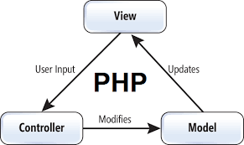

**Laravel installations :**

**How to install Laravel :**

Step1 :

Laravel.com

Step 2:

<https://laravel.com/docs/5.8>

step 3:

download composer

Composer :

<https://getcomposer.org/download/>

composer is a dependency manager i.e used for create or install Laravel without comoposer we cant install Laravel

step 4: composer will configure with xampp

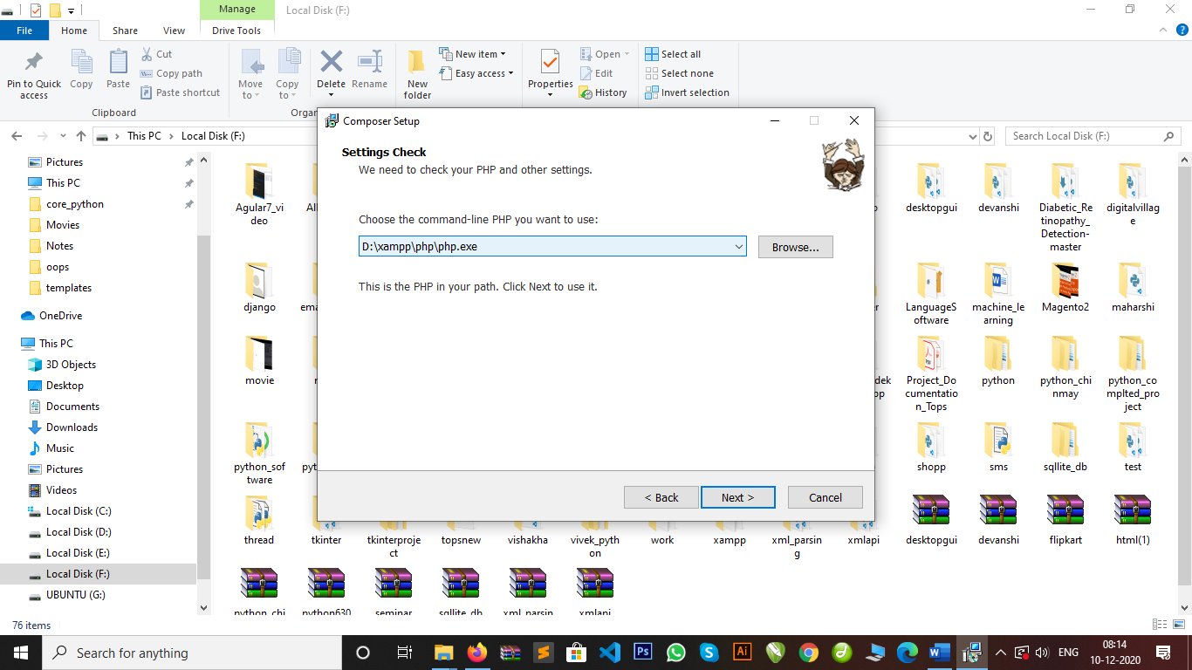

dependency manager :

composer is used to install all the dependency of Laravel or library and components of Laravel.

Step :5

How to check composer install or not

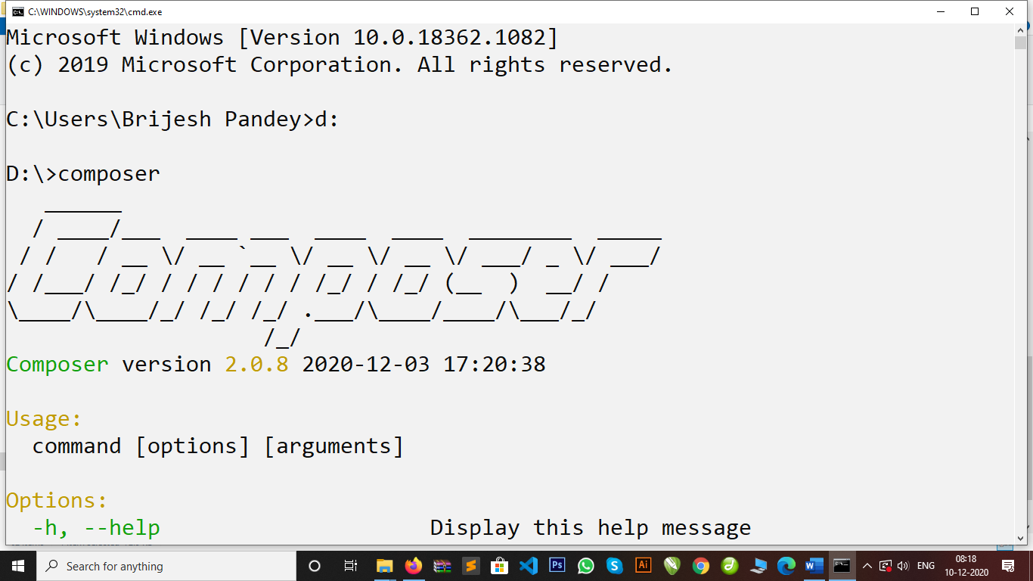

Step 6:

System requirements

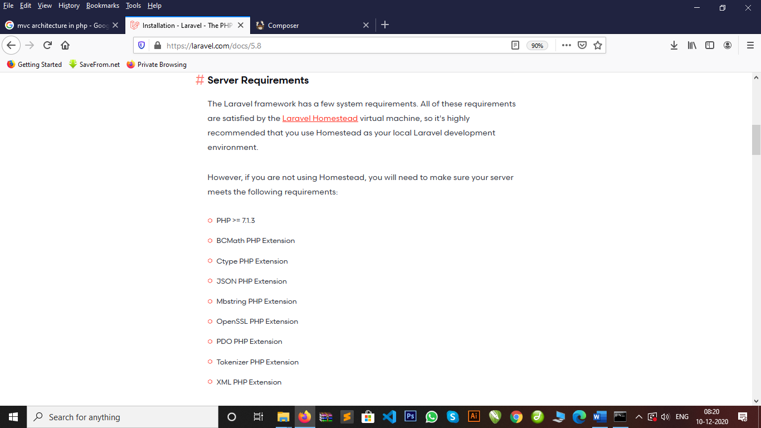

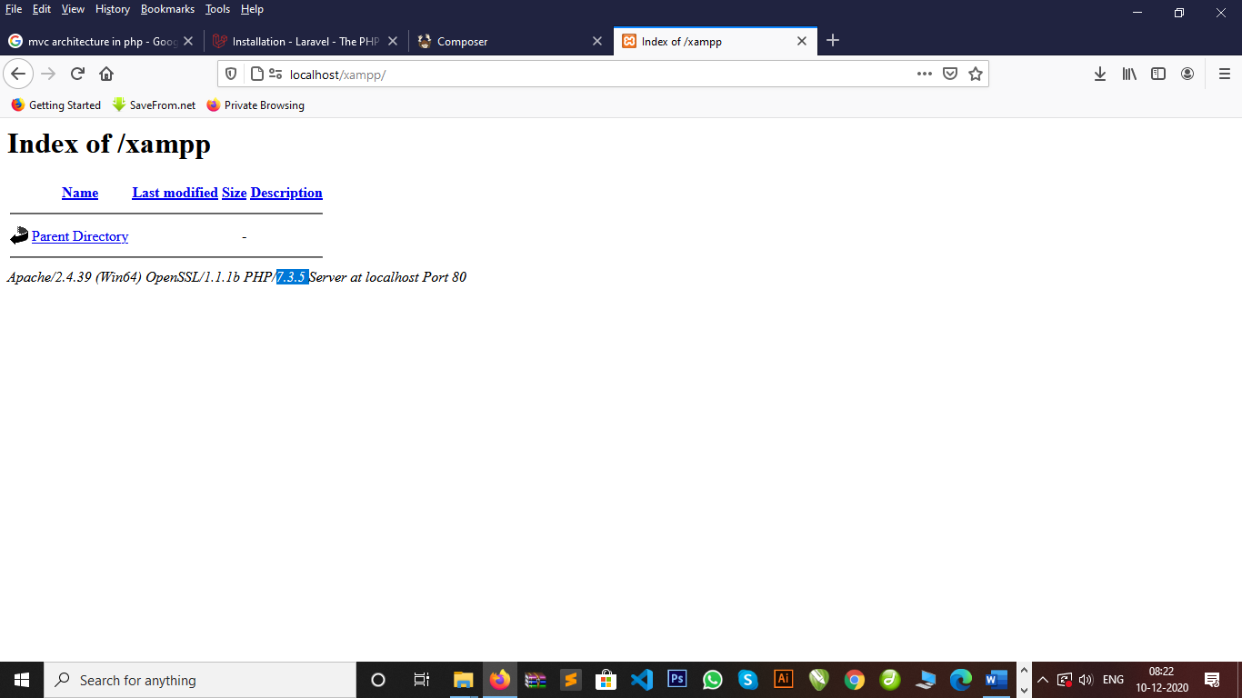

Step 7:

Install Laravel 5.8

Cmd :

composer create-project --prefer-dist laravel/laravel blog "5.8.*"

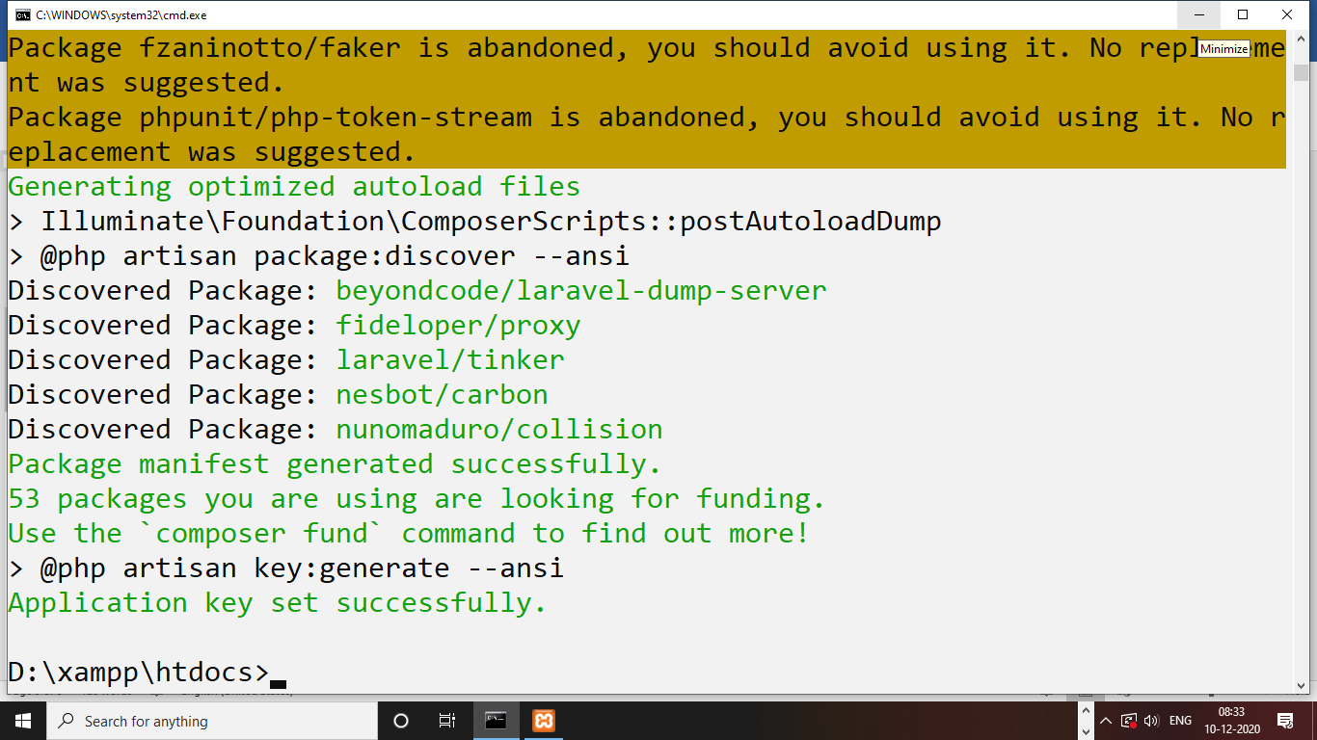

How to run Laravel project :

How to run Server development URL :

Create a artisan command of Laravel :

Artisan command:

Laravel provides a **artisan command** to create a model, controller, or database or run Laravel on server or localhost.

Cmd : php artisan serve

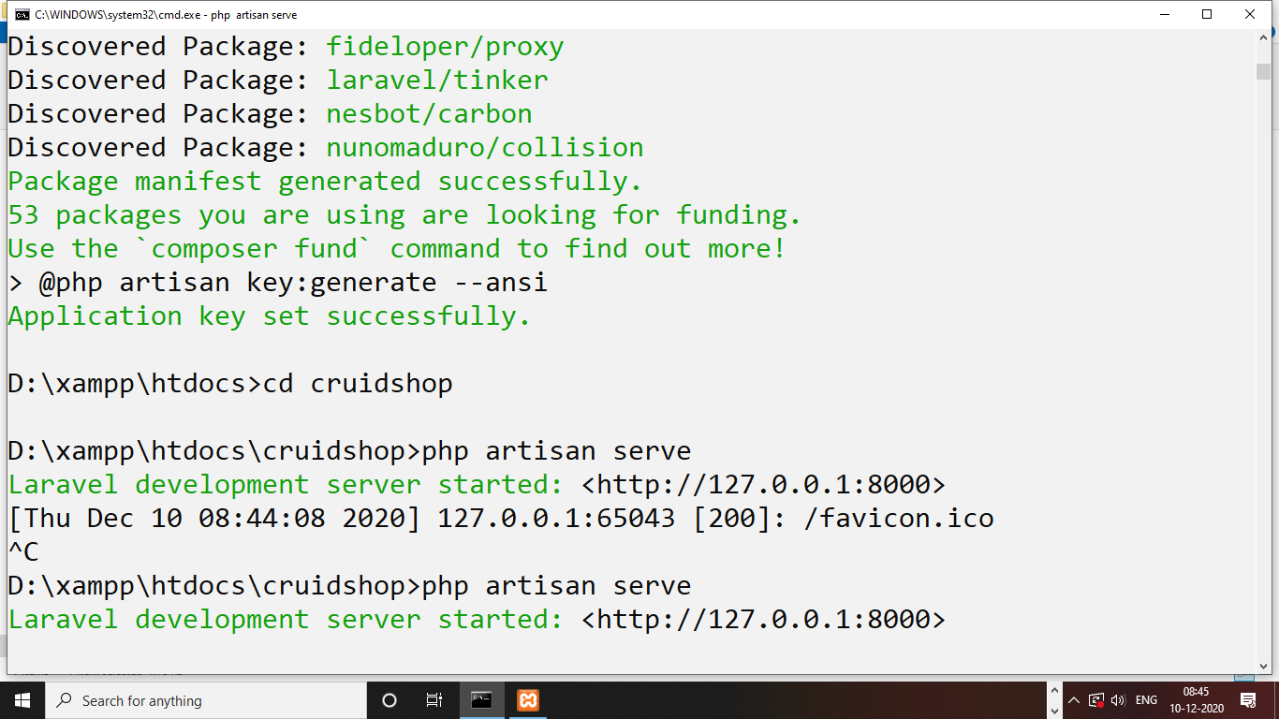

**How to load Laravel on localhost :**

Step 1 :

Go in project main directory

Step 2:

Open server.php file

Rename with index.php

<http://localhost/cruidshop/>

**Database Migrations :**

Database migrations is a version control i.e used to provide database connection and create a table structure in Laravel.

All Migrations command & CLI commands in Laravel :

php artisan migrate

php artisan migrate --force

php artisan make:migrations

php artisan migrate:rollback

php artisan migrate:refresh

php artisan migrate:refresh --seed

php artisan migrate:fresh

php artisan migrate:fresh --seed

php artisan make:auth

php artisan make:channel

php artisan make:command

php artisan make:controller

php artisan make:event

php artisan make:exception

php artisan make:factory

php artisan make:job

php artisan make:listener

php artisan make:mail

php artisan make:middleware

php artisan make:migration

php artisan make:model

php artisan make:notification

php artisan make:observer

php artisan make:policy

php artisan make:provider

php artisan make:request

php artisan make:resource

php artisan make:rule

php artisan make:seeder

php artisan make:test

How to provide a database connection :

Step 1: open .env file in Laravel structure.

DB_CONNECTION=mysql

DB_HOST=127.0.0.1

DB_PORT=3306

DB_DATABASE=cruidapp

DB_USERNAME=root

DB_PASSWORD=

Step 2: open config->database.php

        'mysql' => [

            'driver' => 'mysql',

            'url' => env('DATABASE_URL'),

            'host' => env('DB_HOST', '127.0.0.1'),

            'port' => env('DB_PORT', '3306'),

            'database' => env('DB_DATABASE', 'cruidapp'),

            'username' => env('DB_USERNAME', 'root'),

            'password' => env('DB_PASSWORD', ''),

            'unix_socket' => env('DB_SOCKET', ''),

            'charset' => 'utf8mb4',

            'collation' => 'utf8mb4_unicode_ci',

            'prefix' => '',

            'prefix_indexes' => true,

            'strict' => true,

            'engine' => null,

            'options' => extension_loaded('pdo_mysql') ? array_filter([

                PDO::MYSQL_ATTR_SSL_CA => env('MYSQL_ATTR_SSL_CA'),

            ]) : [],

        ],

Step 3: Laravel default tables migrations provide.

Open database->migrations->2014_10_12_000000_create_users_table.php

Step 4: how to migrate database in Laravel

Cmd : database migrations

Php artisan migrate

Step 5: how to drop tables and migrate furthure

Cmd : php artisan migrate:fresh

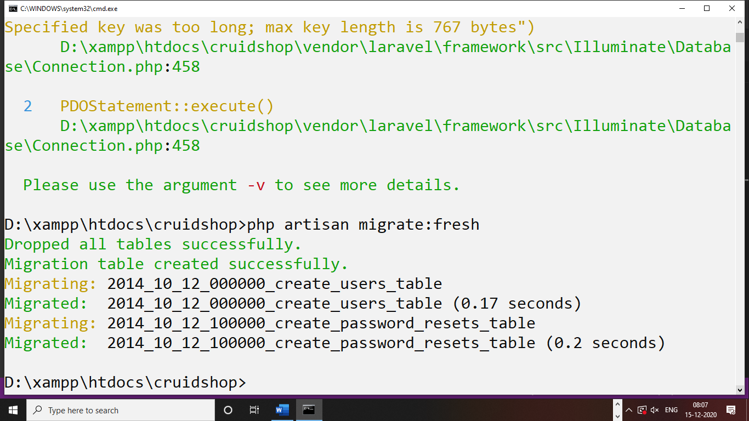

How to create a table in Laravel :

Step 1: in Laravel a table will created by database migrations command

Step 2: in Laravel a table will include columns and row

Step 3: in Laravel a table had a different-2 datatypes

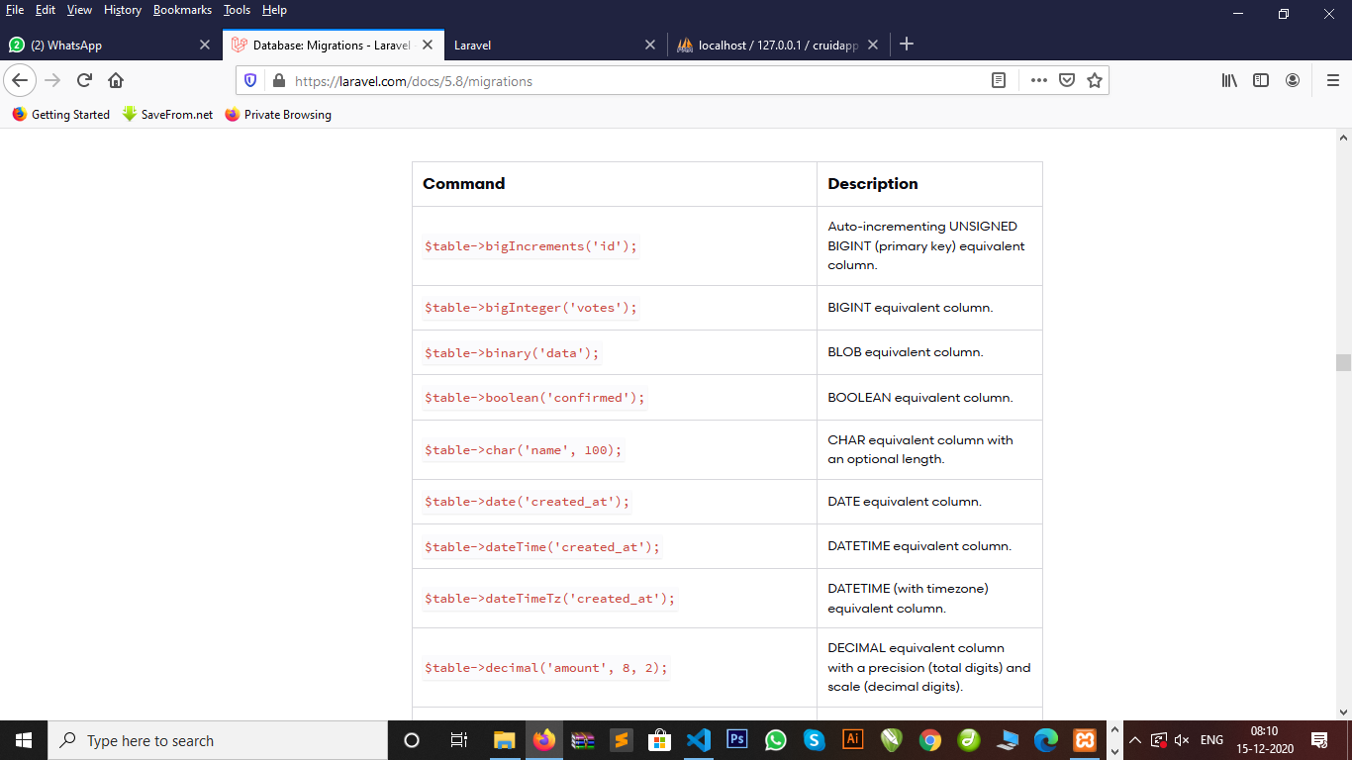

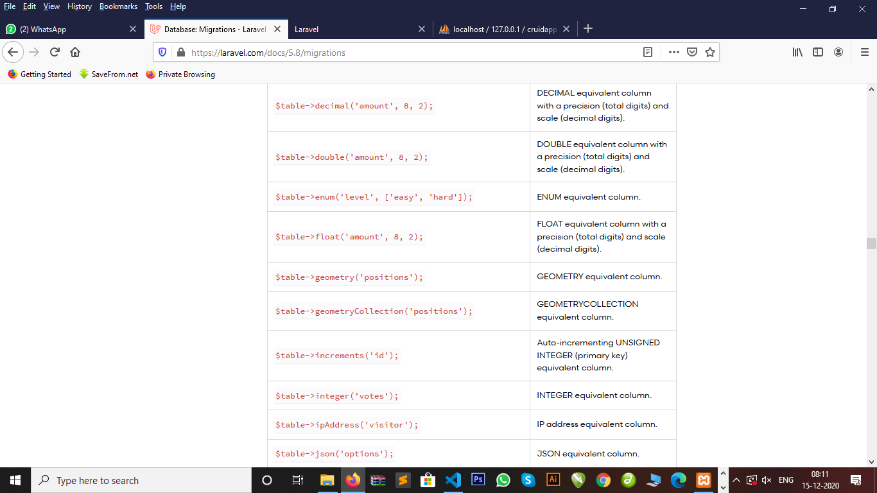

Command of migrations to creating tables in Laravel :

Step 1: php artisan make:migration create_feedbacks_table

Or

Step 2: php artisan make:migration create_registers_table –create=registers

Default migrations table file structure Laravel :

<?php

use Illuminate\Support\Facades\Schema;

use Illuminate\Database\Schema\Blueprint;

use Illuminate\Database\Migrations\Migration;

class CreateRegisters extends Migration

{

    /**

     * Run the migrations.

     *

     * @return void

     */

    public function up()

    {

        Schema::create('registers', function (Blueprint $table) {

            $table->bigIncrements('id');

            $table->timestamps();

        });

    }

    /**

     * Reverse the migrations.

     *

     * @return void

     */

    public function down()

    {

        Schema::dropIfExists('registers');

    }

}

How to create Foreign Key in Laravel database Migrations :

Step 1: php artisan make:migration create_countries_table –create=countries

Step 2: php artisan make:migration create_states_table –create=states

Step 3: php artisan make:migration create_cities_table –create=cities

Step 4: php artisan migrate:fresh –force

Php artisan force is used to delete and rollback all tables forcefuly.

<?php

use Illuminate\Support\Facades\Schema;

use Illuminate\Database\Schema\Blueprint;

use Illuminate\Database\Migrations\Migration;

class CreateCountriesTable extends Migration

{

    /**

     * Run the migrations.

     *

     * @return void

     */

    public function up()

    {

        Schema::create('countries', function (Blueprint $table) {

            $table->increments('id');

            $table->string('cname');

            $table->timestamps();

        });

    }

    /**

     * Reverse the migrations.

     *

     * @return void

     */

    public function down()

    {

        Schema::dropIfExists('countries');

    }

}

<?php

use Illuminate\Support\Facades\Schema;

use Illuminate\Database\Schema\Blueprint;

use Illuminate\Database\Migrations\Migration;

class CreateStatesTable extends Migration

{

    /**

     * Run the migrations.

     *

     * @return void

     */

    public function up()

    {

        Schema::create('states', function (Blueprint $table) {

            $table->increments('id');

            $table->integer('cid')->unsigned();

            $table->foreign('cid')->references('id')->on('countries');

            $table->string('sname');

            $table->timestamps();

        });

    }

    /**

     * Reverse the migrations.

     *

     * @return void

     */

    public function down()

    {

        Schema::dropIfExists('states');

    }

}

<?php

use Illuminate\Support\Facades\Schema;

use Illuminate\Database\Schema\Blueprint;

use Illuminate\Database\Migrations\Migration;

class CreateCitiesTable extends Migration

{

    /**

     * Run the migrations.

     *

     * @return void

     */

    public function up()

    {

        Schema::create('cities', function (Blueprint $table) {

            $table->increments('id');

            $table->integer('sid')->unsigned();

            $table->foreign('sid')->references('id')->on('states');

            $table->string('ctname');

            $table->timestamps();

        });

    }

    /**

     * Reverse the migrations.

     *

     * @return void

     */

    public function down()

    {

        Schema::dropIfExists('cities');

    }

}

File structure or directory structure :

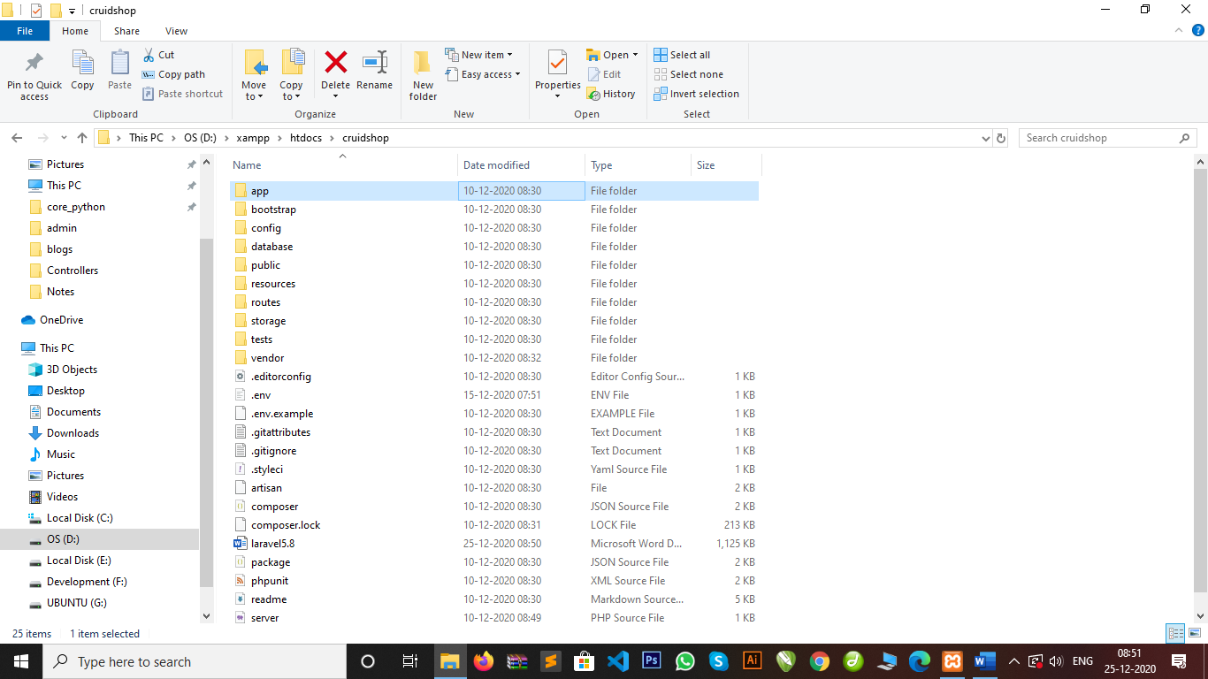

Laravel blade templating :

1. Default views file structure in Laravel build with blade templating and follow inheritance concepts
2. Extends keywords inheritance concepts
3. Ex: index.blade.php

Routing : routing is just load your appropriate user url that user wants.

:Laravel routes=>web.php

Ex: Route::get(‘/damini’, function(){

echo “Hi damini how are you”;

});

Routing: 1) get

2) post

3) resource

Resource : we used resource to post or get data using routing then we used only controller and its accept all method.

How to create a controller :

Cmd : 1) php artisan make:controller TestController

Cmd : 2) php artisan make:controller Test1Controller –resource

Note : --resource will create all function or methods of controller index(), create(), store(), update(), destroy(), edit()

How to create a Model :

Cmd : php artisan make:model TestModel

How to create a Controller

Cmd : php artisan make:controller Test2Controller –resource

Blade Templating :

Blade template is a default Laravel used for template integration

Blade template is used a inheritance concepts

Ex: index.blade.php

Structure of blade templating

1)master.blade.php =>master will handle all your assets file here

2)header.blade.php

3)navigation.balde.php

4)slider.blade.php

5)leftsidebar.blade.php

6)rightsidebar.blade.php

7)contant.blade.php

8)footer.blade.php

Public=>user=>assets ->css

->js

->images

->fonts

Laravel CRUID operations :

Using Laravel auth operations:

Auth =>auth is a Laravel default authentications operations i.e provide a default CRUID operations.

ORM Model : orm model is a Laravel mdel i.e stands for object relation mapping.

ORM model provides CRUID operations i.e created by user using model.

Cmd : php artisan make:auth

Controller =>HomeController

Model =>User.php

View=>[home.blade.php](http://home.blade.php)

View=>auth=>register.blade.php

View=>auth=>login.blade.php

View=>auth=>verify.blade.php

$this->middleware(“auth”);

Middleware =>middleware is a default URI(uniform resource interface) i.e provide default url its means user can not hit a unwanted url.

Note : middleware is a mechanism i.e used to redirect one page to another page where user authenticated with right credentials or not.

Middleware provide a convenient mechanism for inspecting and filtering HTTP requests entering your application. For example, Laravel includes a middleware that verifies the user of your application is authenticated. If the user is not authenticated, the middleware will redirect the user to your application's login screen. However, if the user is authenticated, the middleware will allow the request to proceed further into the application.

Ex : $this->middleware(“auth”);

Namespace :

Another common use-case for route groups is assigning the same PHP namespace to a group of controllers using the namespace method:

Route::namespace('Admin')->group(function () {

// Controllers Within The "App\Http\Controllers\Admin" Namespace

});

Remember, by default, the RouteServiceProvider includes your route files within a namespace group, allowing you to register controller routes without specifying the full App\Http\Controllers namespace prefix. So, you only need to specify the portion of the namespace that comes after the base App\Http\Controllers namespace.

ORM : object relation mapping

Using Model we create our own cruid operations using orm model

Cmd : php artisan make:model Flight

Cmd : php artisan make:model Flight –migration

Cmd: php artisan make:model Flight -m

### [Eloquent Model Conventions](https://laravel.com/docs/5.8/eloquent#eloquent-model-conventions)

Now, let's look at an example Flight model, which we will use to retrieve and store information from our flights database table:

<?php

namespace App;

use Illuminate\Database\Eloquent\Model;

class Flight extends Model

{

//

}

**Note : eloquent model will used to retrive , store, update or delete data using model and controller in Laravel.**

**Events :**

Eloquent models fire several events, allowing you to hook into the following points in a model's lifecycle: retrieved, creating, created, updating, updated, saving, saved, deleting, deleted, restoring, restored. Events allow you to easily execute code each time a specific model class is saved or updated in the database. Each event receives the instance of the model through its constructor.

<?php

namespace App;

use App\Ev­ents\UserSaved;

use App\Events\UserDeleted;

use Illuminate\Notifications\Notifiable;

use Illuminate\Foundation\Auth\User as Authenticatable;

class User extends Authenticatable

{

use Notifiable;

/**

* The event map for the model.

*

* @var array

*/

protected $dispatchesEvents = [

'saved' => UserSaved::class,

'deleted' => UserDeleted::class,

];

Protected $table=’users’;

}

**CSRF :**

Csrf is a form token to send any data using form there will used csrf token i.e @csrf.

Note : CSRF is a token that is used to send securely data on server using form

Ex. <form method=”post”>

@csrf

</form>

**Cruid operations :**

**Admin panel :**

**Open Controller App/http/controller:**

**AdminAddCategory.php**

<?php

namespace App\Http\Controllers;

use Illuminate\Http\Request;

use App\AddCategory;

class AdminAddCategory extends Controller

{

    /**

     * Display a listing of the resource.

     *

     * @return \Illuminate\Http\Response

     */

    public function index()

    {

        return view('blogs.admin.addcategory');

    }

    /**

     * Show the form for creating a new resource.

     *

     * @return \Illuminate\Http\Response

     */

    public function create()

    {

        //

    }

    /**

     * Store a newly created resource in storage.

     *

     * @param  \Illuminate\Http\Request  $request

     * @return \Illuminate\Http\Response

     */

    public function store(Request $request)

    {

            $request->validate([

            'catname'=>'required',

            'adddate'=>'required',

         ]);

         $data=array(

            'catname'=>$request->catname,

            'addeddate'=>$request->adddate

            );

         AddCategory::create($data);

         return redirect('/admin/AddCategory')->with('success','Blogs Category Added.');

    }

    /**

     * Display the specified resource.

     *

     * @param  int  $id

     * @return \Illuminate\Http\Response

     */

    public function show()

    {

        $data=AddCategory::all();

        return view('blogs.admin.showblogscategory',['data'=>$data]);

    }

    //read a particular one data

    public function read($id)

    {

        $data=AddCategory::where('id',$id)->first();

        return view('blogs.admin.readcategory',['data'=>$data]);

    }

    /**

     * Show the form for editing the specified resource.

     *

     * @param  int  $id

     * @return \Illuminate\Http\Response

     */

    public function edit($id)

    {

        $data=AddCategory::where('id',$id)->first();

        return view('blogs.admin.editcategory',['data'=>$data]);

    }

    /**

     * Update the specified resource in storage.

     *

     * @param  \Illuminate\Http\Request  $request

     * @param  int  $id

     * @return \Illuminate\Http\Response

     */

    public function update(Request $request, $id)

    {

        $data=array(

            'catname'=>$request->catname,

            'addeddate'=>$request->adddate

            );

         AddCategory::where('id',$id)->update($data);

         return redirect('admin/ManageCategory')->with('success','Blogs Category Updated successfuly.');

    }

    /**

     * Remove the specified resource from storage.

     *

     * @param  int  $id

     * @return \Illuminate\Http\Response

     */

    public function destroy($id)

    {

        $data=AddCategory::where('id',$id)->delete();

        return redirect('/admin/ManageCategory')->with('delsuccess','Data Deleted Successfully');

    }

}

**App/AddCategory(Model)**

**AddCategory**

<?php

namespace App;

use Illuminate\Database\Eloquent\Model;

use Illuminate\Notifications\Notifiable;

class AddCategory extends Model

{

    use Notifiable;

    protected $fillable=[

        'catname','addeddate'

    ];

    protected $table='categories';

}

**Admin Route**

//admin panel routing

#admin Login

Route::get('/admin','AdminLoginController@index');

Route::get('/admin/Dashboard', 'AdminDashboard@index');

Route::resource('/admin/AddCategory','AdminAddCategory');

Route::resource('/admin/AddBlogs','AdminAddBlog');

Route::get('/admin/ManageCategory', 'AdminAddCategory@show');

Route::get('/readcategory/{id}','AdminAddCategory@read');

Route::get('/destroy/{id}','AdminAddCategory@destroy');

Route::get('/editcategory/{id}','AdminAddCategory@edit');

Route::post('/update/{id}','AdminAddCategory@update');

**Open reqource/view**

**Addcategory.blade.php**

@extends('blogs.admin.master')

<!-- Top nav-->

@include('blogs.admin.inc.topnav')

<!-- Top nav end-->

<!-- main content-->

<div id="layoutSidenav">

<!-- side nav-->

@include('blogs.admin.inc.sidenav')

<!-- side nav end-->

<!-- content-->

<div id="layoutSidenav_content">

<!-- content-->

                <main>

                    <div class="container-fluid">

                        <h1 class="mt-4">Add Blogs Category</h1>

                        <ol class="breadcrumb mb-4">

                            <li class="breadcrumb-item active">Blogs Category</li>

                        </ol>

                        <div class="row">

                    <div class="col-xl-6 col-md-6">

                    @if(Session::has('success'))

            <div class="alert alert-success">

                <a href="#" class="close" data-dismiss="alert" aria-label="close">&times;</a>

                <strong>{!! Session::get('success') !!}</strong>

            </div>

        @endif

                         <div class="jumbotron">

                           <form method="post" action="{{ url('admin/AddCategory') }}">

                           @csrf

                        <div class="form-group">

                         <label>Enter Blog Category</label>

                         <input type="text" name="catname" placeholder="Enter Category" class="form-control @error('catname') is-invalid @enderror" value="" autocomplete="catname" autofocus>

                         @error('catname')

                        <span class="invalid-feedback" role="alert">

                              <strong>{{ $message }}</strong>

                        </span>

                        @enderror

                        </div>

                        <div class="form-group">

                         <label>Select Add Date</label>

                         <input type="date" name="adddate" placeholder="Enter Addded date" class="form-control @error('catname') is-invalid @enderror" value="" autocomplete="catname" autofocus>

                       @error('adddate')

                     <span class="invalid-feedback" role="alert">

                     <strong>{{ $message }}</strong>

                    </span>

                    @enderror

                        </div>

                        <div class="form-group">

                         <input type="submit" name="addcategory" value="AddCategory" class="btn btn-lg btn-success">

                        </div>

                        </div>

                           </form>

                    </div>

                    </div>

                    </div>

                </main>

                <!-- content-->

                <!-- footer-->

                @include('blogs.admin.inc.footer')

                <!-- footer-->

                </div>

            <!-- content end-->

        </div>

        <!-- main content end-->

**Showblogcategory.blade.php**

@extends('blogs.admin.master')

<!-- Top nav-->

@include('blogs.admin.inc.topnav')

<!-- Top nav end-->

<!-- main content-->

<div id="layoutSidenav">

<!-- side nav-->

@include('blogs.admin.inc.sidenav')

<!-- side nav end-->

<!-- content-->

<div id="layoutSidenav_content">

<!-- content-->

                <main>

                   <div class="container-fluid">

                   <br><br>

                   <div class="row">

                       <h3>Manage All Category</h3>

                       <hr>

                        <div class="card" style="width:100%">

                   @if(Session::has('delsuccess'))

            <div class="alert alert-danger">

                <a href="#" class="close" data-dismiss="alert" aria-label="close">&times;</a>

                <strong>{!! Session::get('delsuccess') !!}</strong>

            </div>

        @endif

        @if(Session::has('success'))

            <div class="alert alert-danger">

                <a href="#" class="close" data-dismiss="alert" aria-label="close">&times;</a>

                <strong>{!! Session::get('success') !!}</strong>

            </div>

        @endif

                            <div class="card-header">

                                <i class="fas fa-table mr-1"></i>

                                Show all Blogs Category

                            </div>

                            <div class="card-body">

                                <div class="table-responsive">

                                    <table class="table table-bordered" id="dataTable" width="100%" cellspacing="0">

                                        <thead>

                                            <tr>

                                                <th>Id</th>

                                                <th>Category Name</th>

                                                <th>Registered Date</th>

                                                <th>Action</th>

                                            </tr>

                                        </thead>

                                        <tbody>

                                        @foreach($data as $row)

                                            <tr>

                                                <td>{{ $row->id }}</td>

                                                <td>{{ $row->catname }}</td>

                                                <td>{{ $row->addeddate }}</td>

                                                <td>

                                                <a href='{{ url("readcategory/{$row->id}")}}' class="btn btn-sm btn-info"><span class="fa fa-read"></span> Read</a> |

                                               <a href="" class="btn btn-sm btn-success"><span class="fa fa-watsapp"></span> Sendwatsap</a> |

                                               <a href='{{ url("destroy/{$row->id}")}}' class="btn btn-sm btn-danger" onclick="return confirm('Are you sure to Delete Data')"><span class="fa fa-trash"></span> Delete</a>

                                                |

                                                <a href='{{ url("editcategory/{$row->id}")}}' class="btn btn-sm btn-info"><span class="fa fa-edit"></span> Edit</a>

                                                </td>

                                            </tr>

                                            @endforeach

                                            </tbody>

                                    </table>

                                </div>

                            </div>

                        </div>

                </main>

                </div>

                </div>

                </div>

                </div>

                <!-- content-->

                <!-- footer-->

                @include('blogs.admin.inc.footer')

                <!-- footer-->

                </div>

            <!-- content end-->

        </div>

        <!-- main content end-->

**Editcategory.blade.php**

@extends('blogs.admin.master')

<!-- Top nav-->

@include('blogs.admin.inc.topnav')

<!-- Top nav end-->

<!-- main content-->

<div id="layoutSidenav">

<!-- side nav-->

@include('blogs.admin.inc.sidenav')

<!-- side nav end-->

<!-- content-->

<div id="layoutSidenav_content">

<!-- content-->

                <main>

                    <div class="container-fluid">

                        <h1 class="mt-4">Add Blogs Category</h1>

                        <ol class="breadcrumb mb-4">

                            <li class="breadcrumb-item active">Blogs Category</li>

                        </ol>

                        <div class="row">

                    <div class="col-xl-6 col-md-6">

                    @if(Session::has('success'))

            <div class="alert alert-success">

                <a href="#" class="close" data-dismiss="alert" aria-label="close">&times;</a>

                <strong>{!! Session::get('success') !!}</strong>

            </div>

        @endif

                         <div class="jumbotron">

                           <form method="post" action="{{ url('/update',array($data->id)) }}">

                           @csrf

                        <div class="form-group">

                         <label>Enter Blog Category</label>

                         <input type="text" name="catname" placeholder="Enter Category" class="form-control @error('catname') is-invalid @enderror" value="{{ $data->catname }}" autocomplete="catname" autofocus>

                         @error('catname')

                        <span class="invalid-feedback" role="alert">

                              <strong>{{ $message }}</strong>

                        </span>

                        @enderror

                        </div>

                        <div class="form-group">

                         <label>Select Add Date</label>

                         <input type="date" name="adddate" placeholder="Enter Addded date" class="form-control @error('catname') is-invalid @enderror" value="{{ $data->addeddate }}" autocomplete="catname" autofocus>

                       @error('adddate')

                     <span class="invalid-feedback" role="alert">

                     <strong>{{ $message }}</strong>

                    </span>

                    @enderror

                        </div>

                        <div class="form-group">

                         <input type="submit" name="updcategory" value="UpdateCategory" class="btn btn-lg btn-success">

                        </div>

                        </div>

                           </form>

                    </div>

                    </div>

                    </div>

                </main>

                <!-- content-->

                <!-- footer-->

                @include('blogs.admin.inc.footer')

                <!-- footer-->

                </div>

            <!-- content end-->

        </div>

        <!-- main content end-->

**Readcategory.blade.php**

@extends('blogs.admin.master')

<!-- Top nav-->

@include('blogs.admin.inc.topnav')

<!-- Top nav end-->

<!-- main content-->

<div id="layoutSidenav">

<!-- side nav-->

@include('blogs.admin.inc.sidenav')

<!-- side nav end-->

<!-- content-->

<div id="layoutSidenav_content">

<!-- content-->

                <main>

                   <div class="container-fluid">

                   <br><br>

                   <div class="row">

                       <h3>Read Category</h3>

                       <hr>

                        <div class="card" style="width:100%">

                            <div class="card-header">

                                <i class="fas fa-table mr-1"></i>

                                Read Blogs Category

                            </div>

                            <div class="card-body">

                                <div class="table-responsive">

                                    <table class="table table-bordered" id="dataTable" width="100%" cellspacing="0">

                                    <address style="letter-spacing: 2px; background-color: aquamarine; padding:25px">

                                     <b>Id : {{$data->id }} </b><br>

                                     <b>Category : {{$data->catname }} </b><br>

                                     <b>Registered Date : {{$data->addeddate }} </b><br>

                                  <br>

                                     <a href='{{ url("destroy/{$data->id}")}}' class="btn btn-sm btn-danger" onclick="return confirm('Are you sure to Delete Data')"><span class="fa fa-trash"></span> Delete</a>

                                  </address>

                                    </table>

                                </div>

                            </div>

                        </div>

                </main>

                </div>

                </div>

                </div>

                </div>

                <!-- content-->

                <!-- footer-->

                @include('blogs.admin.inc.footer')

                <!-- footer-->

                </div>

            <!-- content end-->

        </div>

        <!-- main content end-->

**Send Email in Contact Us form :**

### Step 1 - Create Controller

php artisan make:controller SendEmailController

<?php

namespace App\Http\Controllers;

use Illuminate\Http\Request;

use Illuminate\Support\Facades\Validator;

use App\Contact;

use Illuminate\Support\Facades\Mail;

use App\Mail\SendMail;

class ContactController extends Controller

{

    /**

     * Display a listing of the resource.

     *

     * @return \Illuminate\Http\Response

     */

    public function index()

    {

        return view('blogs.contact');

    }

    /**

     * Show the form for creating a new resource.

     *

     * @return \Illuminate\Http\Response

     */

    public function create()

    {

        //

    }

    /**

     * Store a newly created resource in storage.

     *

     * @param  \Illuminate\Http\Request  $request

     * @return \Illuminate\Http\Response

     */

    public function store(Request $request)

    {

         $request->validate([

            'name'=>'required',

            'email'=>'required|email',

            'mobile' =>'required|min:10|max:10',

            'message'=>'required'

         ]);

         $data=array(

            'name'=>$request->name,

            'email'=>$request->email,

            'mobile'=>$request->mobile,

            'message'=>$request->message

            );

         Contact::create($data);

         Mail::to('bkpandey.pandey@gmail.com')->send(new SendMail($data));

return redirect('Contact')->with('success','Thanks For Contact with Us Our Admin will Contact with You Soon!');

    }

    /**

     * Display the specified resource.

     *

     * @param  int  $id

     * @return \Illuminate\Http\Response

     */

    public function show($id)

    {

        //

    }

    /**

     * Show the form for editing the specified resource.

     *

     * @param  int  $id

     * @return \Illuminate\Http\Response

     */

    public function edit($id)

    {

        //

    }

    /**

     * Update the specified resource in storage.

     *

     * @param  \Illuminate\Http\Request  $request

     * @param  int  $id

     * @return \Illuminate\Http\Response

     */

    public function update(Request $request, $id)

    {

        //

    }

    /**

     * Remove the specified resource from storage.

     *

     * @param  int  $id

     * @return \Illuminate\Http\Response

     */

    public function destroy($id)

    {

        //

    }

}

### Step 3 - Create View Contact Form

@extends('blogs.master')

@section('blogstitle')

Home Page

@endsection

@include('blogs.inc.nav')

<div class="container-fluid">

<div class="row">

  <!-- Blog Entries Column -->

    <div class="col-md-12 col-xs-12">

    <br><br><br><br><br>

<div class="col-sm-6" style="float:left">

<h2>Contact Us</h2>

<hr style="border:solid 2px gray">

<p align="justify">Contact with us Our admin will contact with you within 5 days working and your details successfully send in Our admin Too >></p>

<center>

<a href="#"><button type="button" class="btn btn-sm btn-danger" style="height:45px; font-size:18px; width:320px">Get In Touch with Us in Map</button></a>

<hr>

<iframe src="https://www.google.com/maps/embed?pb=!1m18!1m12!1m3!1d3691.631659688516!2d70.77838915011893!3d22.29193858525596!2m3!1f0!2f0!3f0!3m2!1i1024!2i768!4f13.1!3m3!1m2!1s0x3959ca248c77c099%3A0xdf5ac10af64ac8ee!2sTOPS%20Technologies%20-%20Python%2C%20Java%2C%20Android%2C%20PHP%2C%20Web%20%26%20Graphic%20Designing%20Courses!5e0!3m2!1sen!2sin!4v1596092280320!5m2!1sen!2sin" width="600" height="300" frameborder="0" style="border:0;" allowfullscreen="" aria-hidden="false" tabindex="0"></iframe>

</center>

</div>

<div class="col-sm-6"  style="float:left">

<h2>Contact US</h2>

<hr style="border:solid 1px gray">

@if($errors->any())

<div class="alert alert-danger">

<ul>

  @foreach($errors->all() as $error)

   <li> {{ $error }} </li>

   @endforeach

</ul>

</div>

@endif

@if(Session::has('success'))

<div class="alert alert-success">

<a href="#" class="close" data-dismiss="alert" aria-label="close">&times;</a>

    <strong>{!! Session::get('success') !!}</strong>

</div>

@endif

<form method="post" action="{{ route('Contact.store') }}">

@csrf

<div class="form-group">

<label>Name *</label>

<input type="text" name="name" placeholder="Name *" class="form-control">

</div>

<div class="form-group">

<label>Email *</label>

<input type="text" name="email" placeholder="Email *" class="form-control">

</div>

<div class="form-group">

<label>Mobile *</label>

<input type="text" name="mobile" placeholder="Mobile *" class="form-control">

</div>

<div class="form-group">

<label>Message *</label>

<textarea  name="message" placeholder="Message *" class="form-control"></textarea>

</div>

<input type="submit" name="sub" value="Submit" class="btn btn-sm btn-danger" style="height:45px; font-size:18px; width:100px">

</form>

</div>

    <!-- Blog Post -->

     <!-- Sidebar Widgets Column -->

</div>

</div>

</div>

</div>

@include('blogs.inc.footer')

### Step 4 - Set Route

<?php

Route::resource('/Contact','ContactController');

?>

### Step 5 - Create Mailable Class

Before make mailable class we should define email configuration in **.env** file of Laravel framework.

MAIL_DRIVER=smtp

MAIL_HOST=smtpout.secureserver.net

MAIL_PORT=80

MAIL_USERNAME=xxxxxxx

MAIL_PASSWORD=xxxxxxx

MAIL_ENCRYPTION=null

Change It :

MAIL_DRIVER=smtp

MAIL_HOST=smtp.gmail.com

MAIL_PORT=587

MAIL_USERNAME=bkpandey.pandey@gmail.com

MAIL_PASSWORD=

MAIL_ENCRYPTION=tls

Now we are ready for make mailable class for this we have to go teminal and write following command.

Cmd :

php artisan make:mail SendMail

**App\Mail\SendMail.php**

<?php

namespace App\Mail;

use Illuminate\Bus\Queueable;

use Illuminate\Mail\Mailable;

use Illuminate\Queue\SerializesModels;

use Illuminate\Contracts\Queue\ShouldQueue;

class SendMail extends Mailable

{

    use Queueable, SerializesModels;

    /**

     * Create a new message instance.

     *

     * @return void

     */

    public function __construct($data)

    {

        $this->data =$data;

    }

    /**

     * Build the message.

     *

     * @return $this

     */

    public function build()

    {

        return $this->from('bkpandey.pandey@gmail.com')->subject('New Customer Equiry Form')->view('blogs.dynamic_email_template')->with('data', $this->data);

    }

}

?>

### Step 6 - Make View file for Email Body

**resources/views/dynamic_email_template.blade.php**

<div style="background-color: cadetblue; font-size: 18px; padding:10px; color:white">

<center>

<p style="font-size:25px; letter-spacing: 2px;">This Email send By :<br><b>Brijesh Technical Guru Blogger Pvt Ltd inc.</b></p>

<p><img src="https://logos.textgiraffe.com/logos/logo-name/Brijesh-designstyle-boots-m.png" style="height: 175px; width: 95%;"></p>

<p style="color:red">Hi, <br> <b>Customer Name is  :</b> {{ $data['name'] }} </p>

<p style="color:blue"><b>Customer  email is :</b> {{ $data['email'] }} </p>

<p style="color:blue"><b>Customer Mobile Number  :</b> {{ $data['mobile'] }} </p>

<p style="color:blue"><b>Customer Message :</b> {{ $data['message'] }} </p>

<p style="color:blue">This is a send email By customer Please conatct and solve problems of Customers via Email</p>

<b>support@onlineportfolio.byethost14.com</b><br>

<b>All emails will be answered within 24 hours</b><br>

<b>WE ARE HERE FOR YOU</b><br>

<b>(+91)9998003879</b><br>

<b>10:00 a.m. to 7:00 p.m.</b>

</center>

</div>