**Assignment: Create a Jenkins job to install and start httpd and deploy index.html file.**

Step 1: Launch an EC2 instance. Port 8080 for this instance should be open.

Step 2: Install java and apache tomcat.

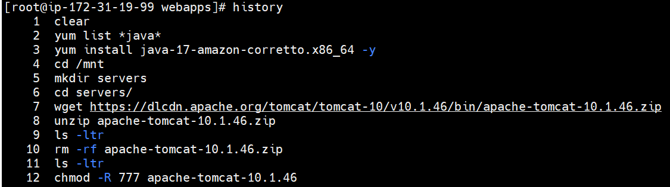

Step 3: Install Jenkins.

Go to **webapps** directory inside apache-tomcat-10.1.46 and install Jenkins using WAR file.

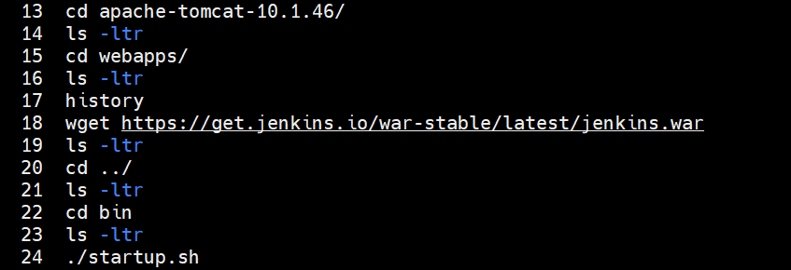

Step 4: Login into Jenkins and create a user.

If you paste the public IP of EC2 instance in the browser (http://18.232.152.2:8080/) you will see the Apache Tomcat page.

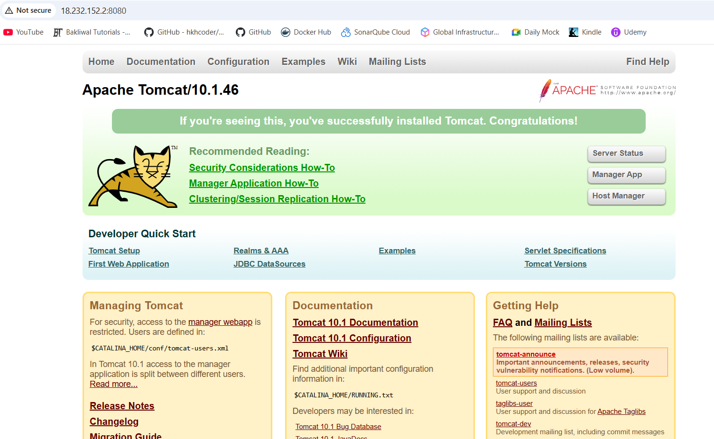

To access Jenkins, add /jenkins in the URL path (http://18.232.152.2:8080/jenkins)

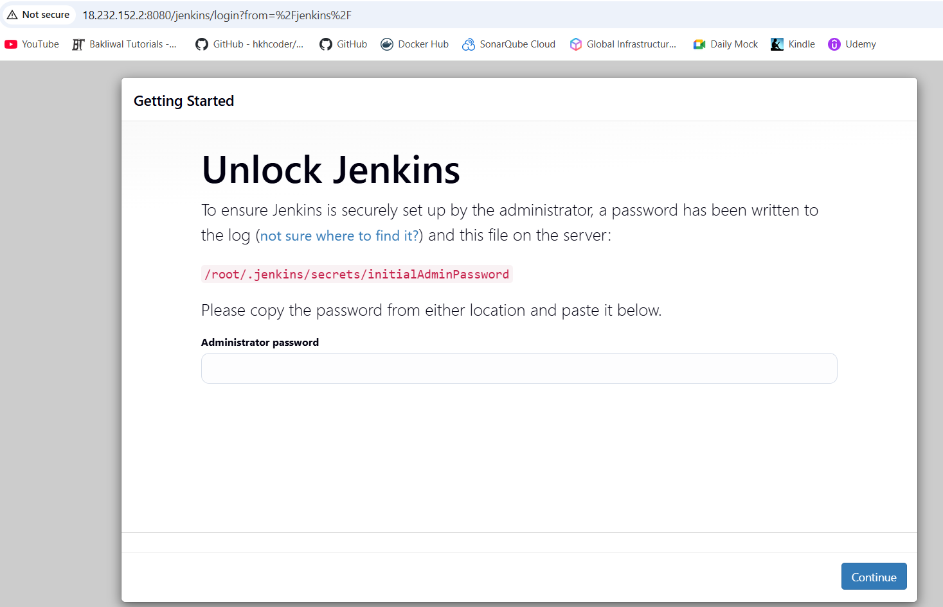

Go to .jenkins directory → go to secrets directory → there you will find initialAdminPassword file → copy the password from this file

Use this password to login → Continue → select Install suggested plugins

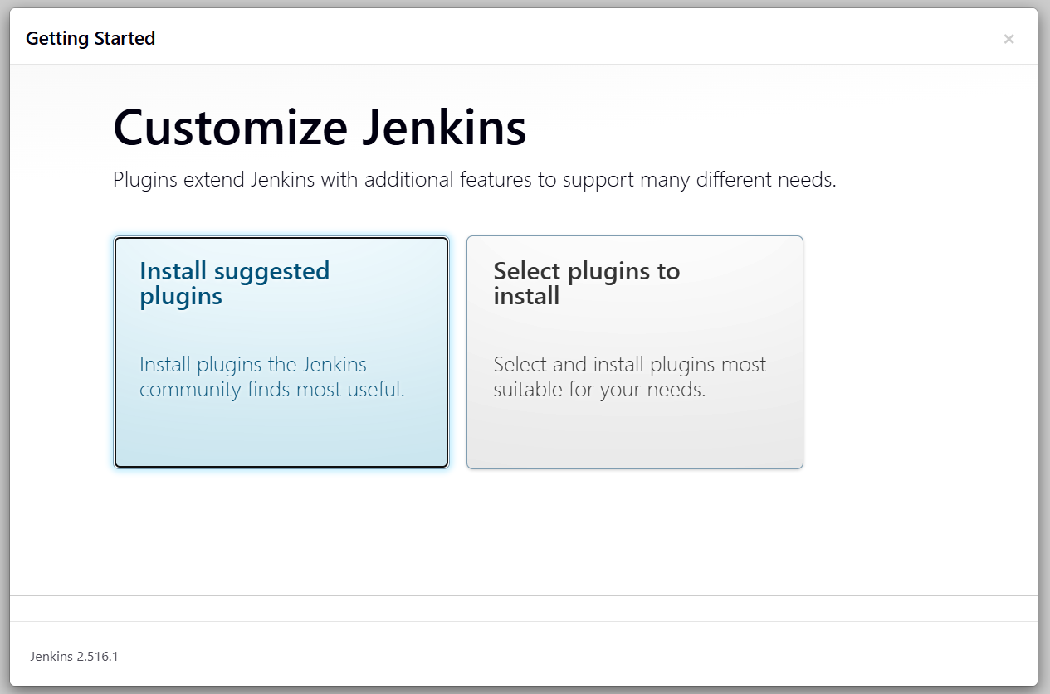

Next give username, password and email address → Save and Continue

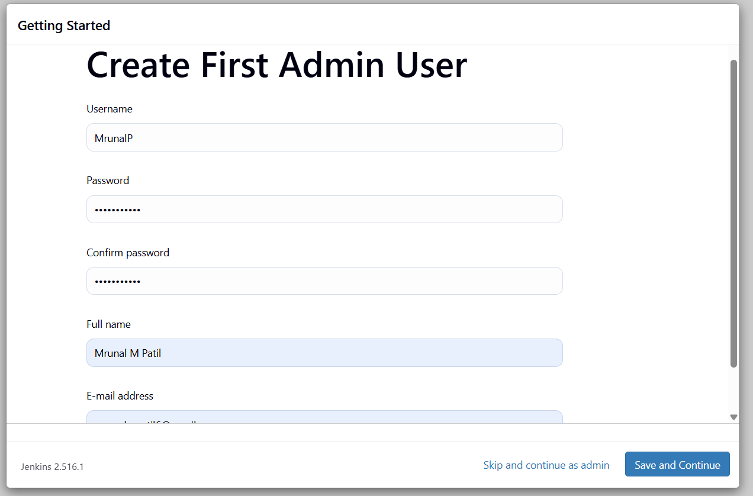

Check if the Jenkins URL matches → Save and Finish

Step 5: You will see the Jenkins Dashboard. Create a job.

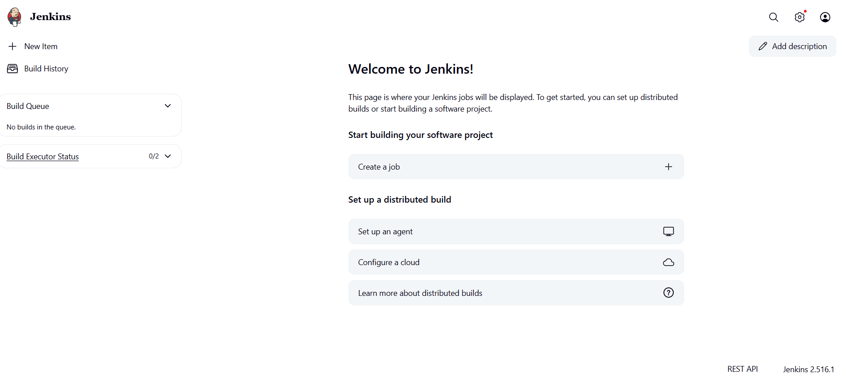

Click on new item → give name → select Freestyle project → OK

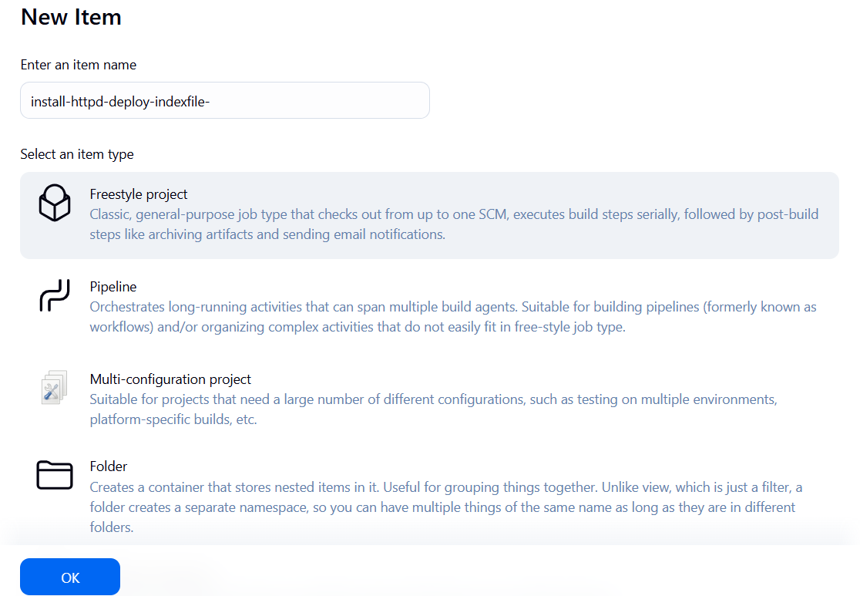

Give description

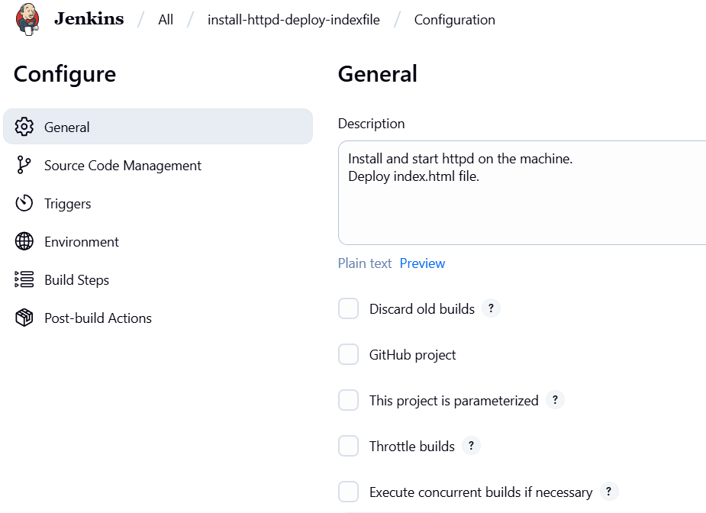

Below go to Build Steps section → Add build steps → select Execute shell

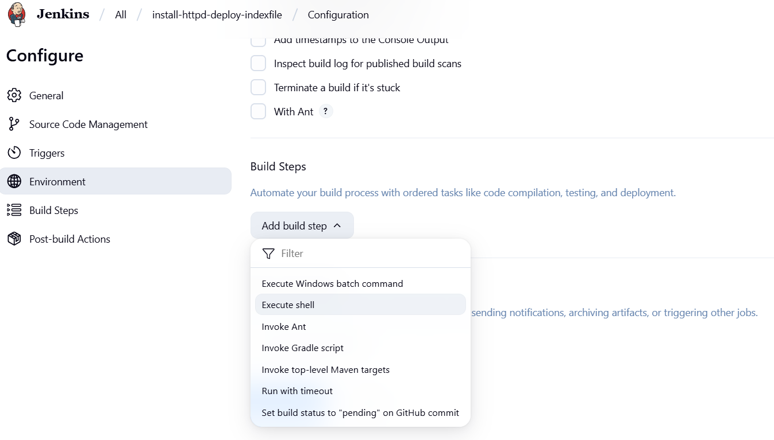

Write the commands to install and start httpd and create index.html file.

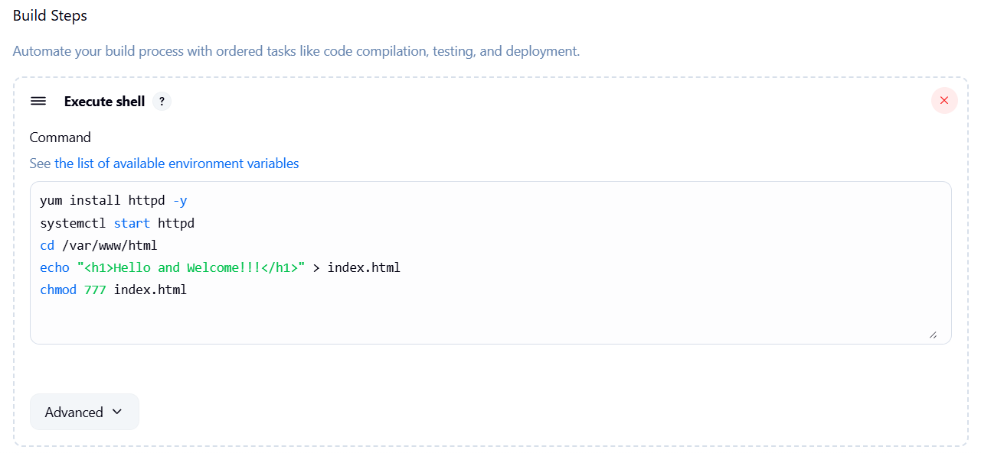

Apply → save

Step 6: Now you will see that the job has been created.

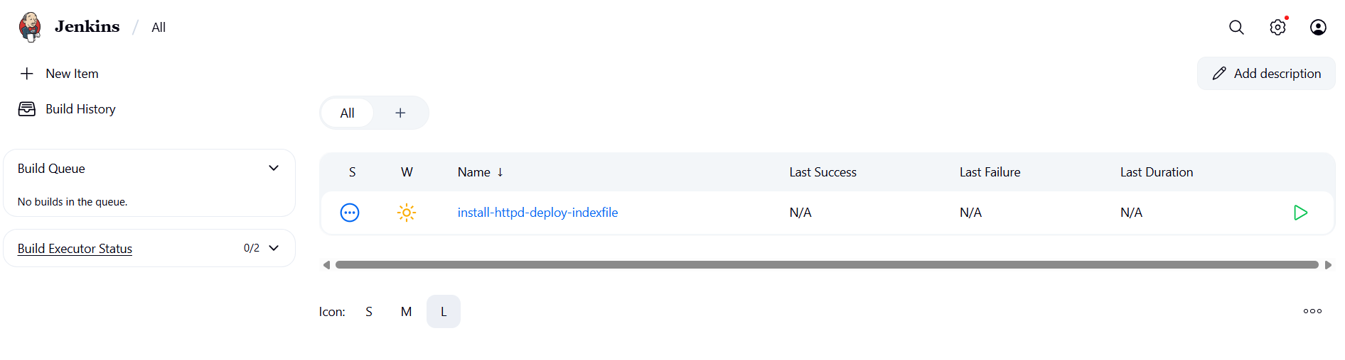

Go to job and click on build now

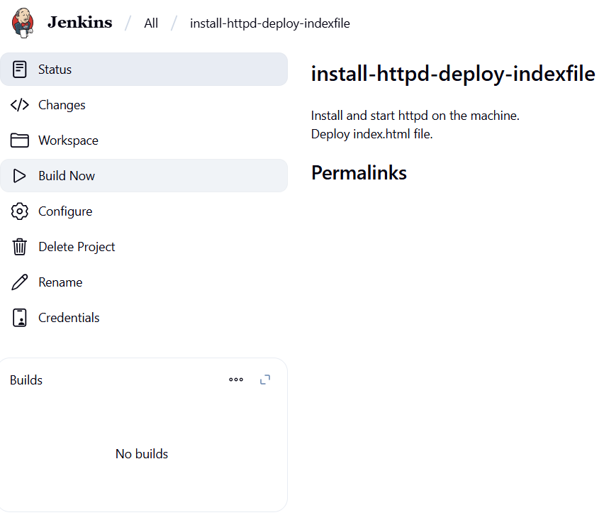

Step 7: Once the build is successful. Copy the public IP of EC2 instance and you will see the index.html file has been deployed.

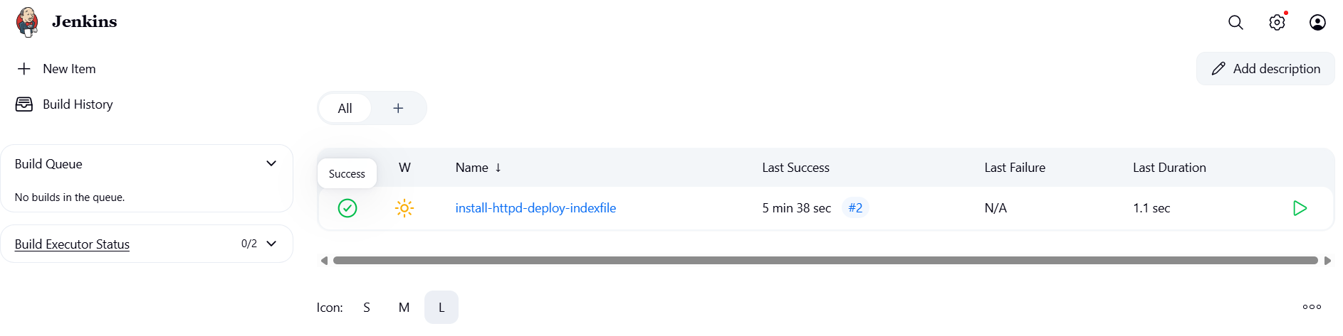

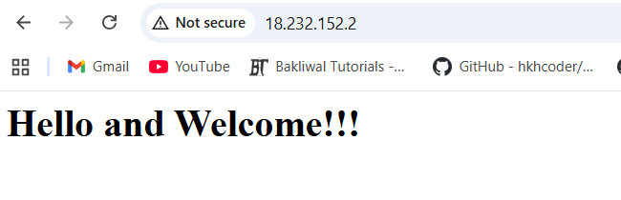

In the EC2 instance, you can check the httpd status.

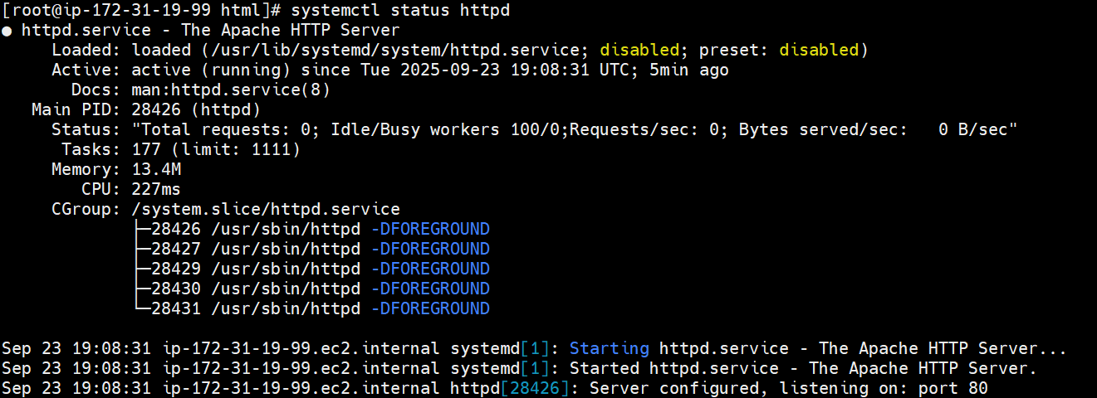

Inside the var directory, you can see www directory is created. Inside www, html directory is created which contains index.html file.

