**Assignment: Integration of Git and Jenkins**

Step 1: On the EC2 instance, install git.

yum install git -y

Step 2: In Jenkins, check that Git plugin is installed.

Go to Manage Jenkins → Plugins → Installed plugins → search git

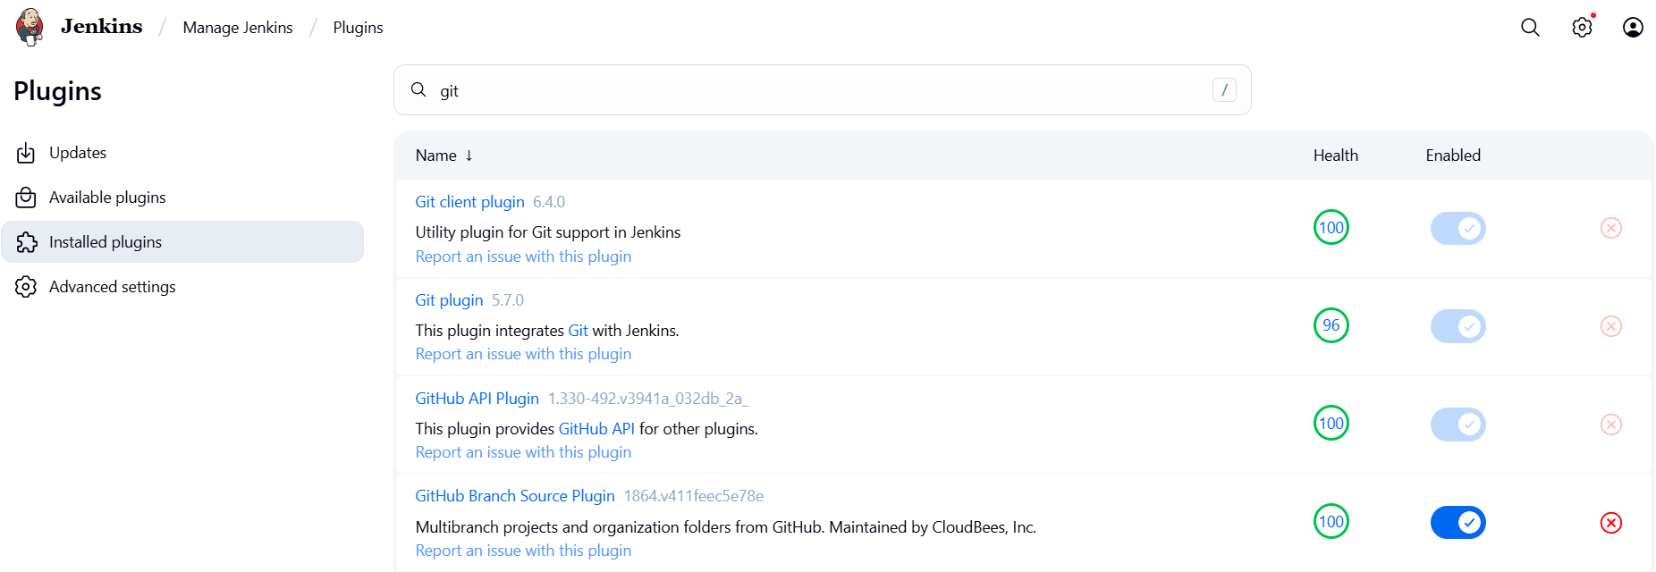

Step 2: In GitHub create 3 private repositories. Repository 1, Repository 2 and Repository 3.

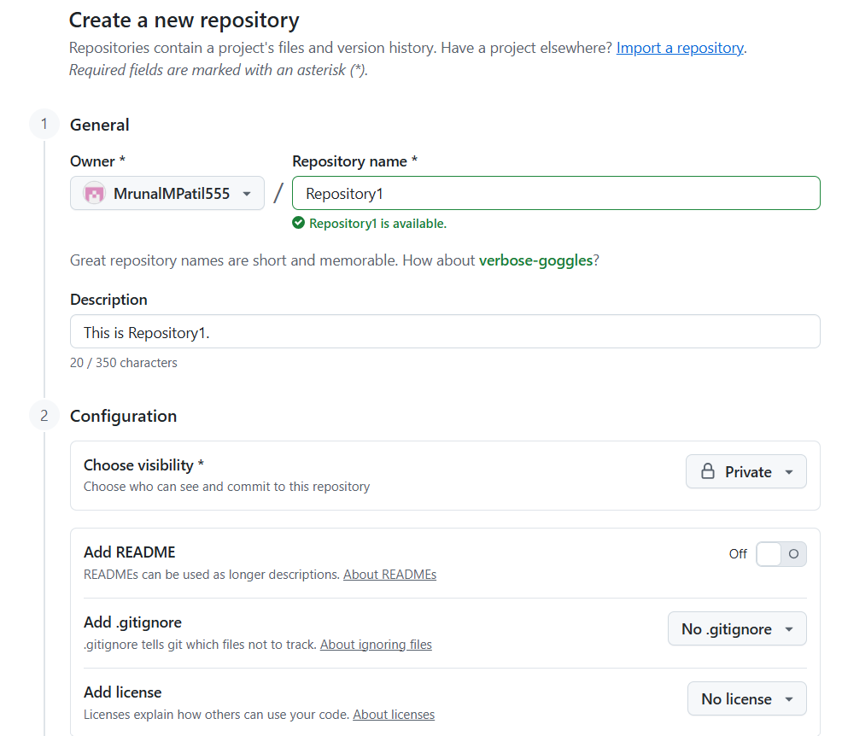

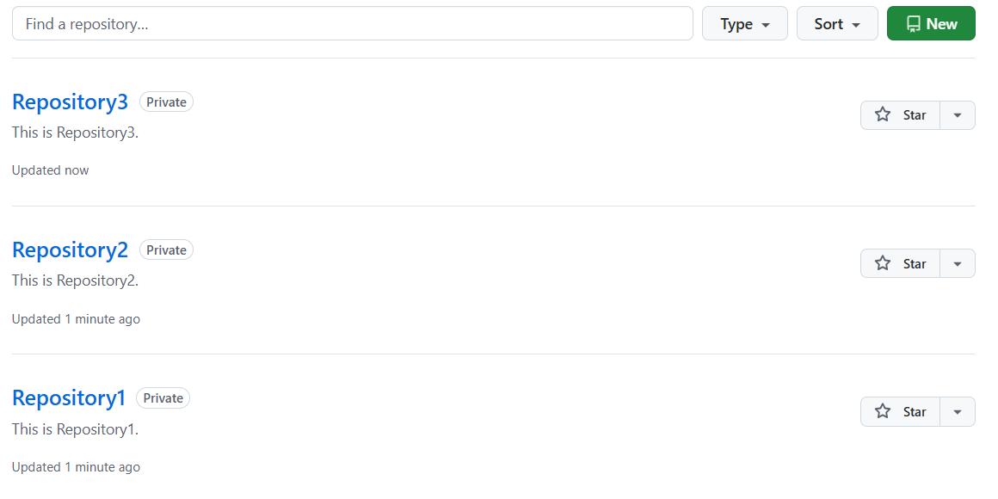

Step 4: In EC2 instance, create master branch in Repository1 and add index.html file.

git -v

git config –global user.name MrunalP

git config –global user.email mrunalmpatil6@gmail.com

cd /root

mkdir Repository1

git init

vi index.html >> Hello. This is Repository1 Master branch.

git status

git add index.html

git commit -m “This is index.html file of Repository1 master branch”

git log

git remote add origin paste_the_url_of_Repository1_from_github

git push origin master

Now, the index.html file will appear in your git repository.

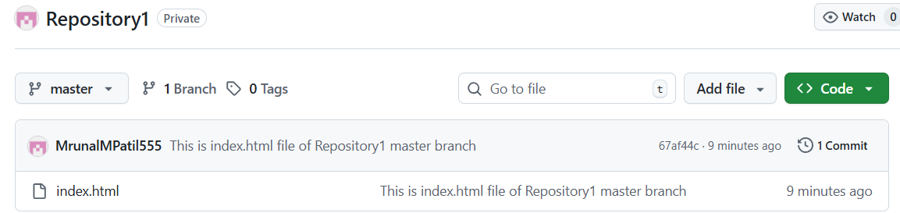

Step 5: Create a job.

Go to Jenkins → new item → give name → select Freestyle project → OK

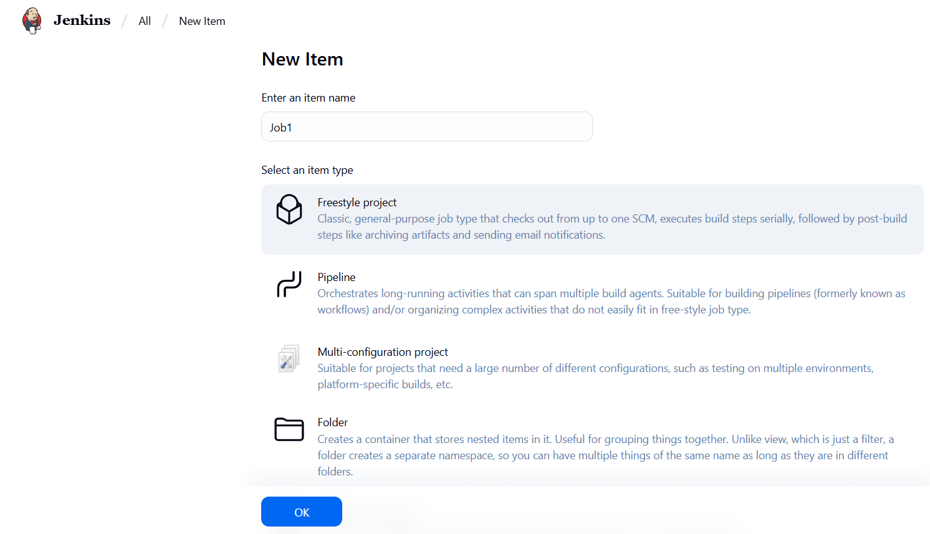

Next give description → under Source Code Management section → select Git → paste the URL of your git repository (Repository1) → Apply → Save

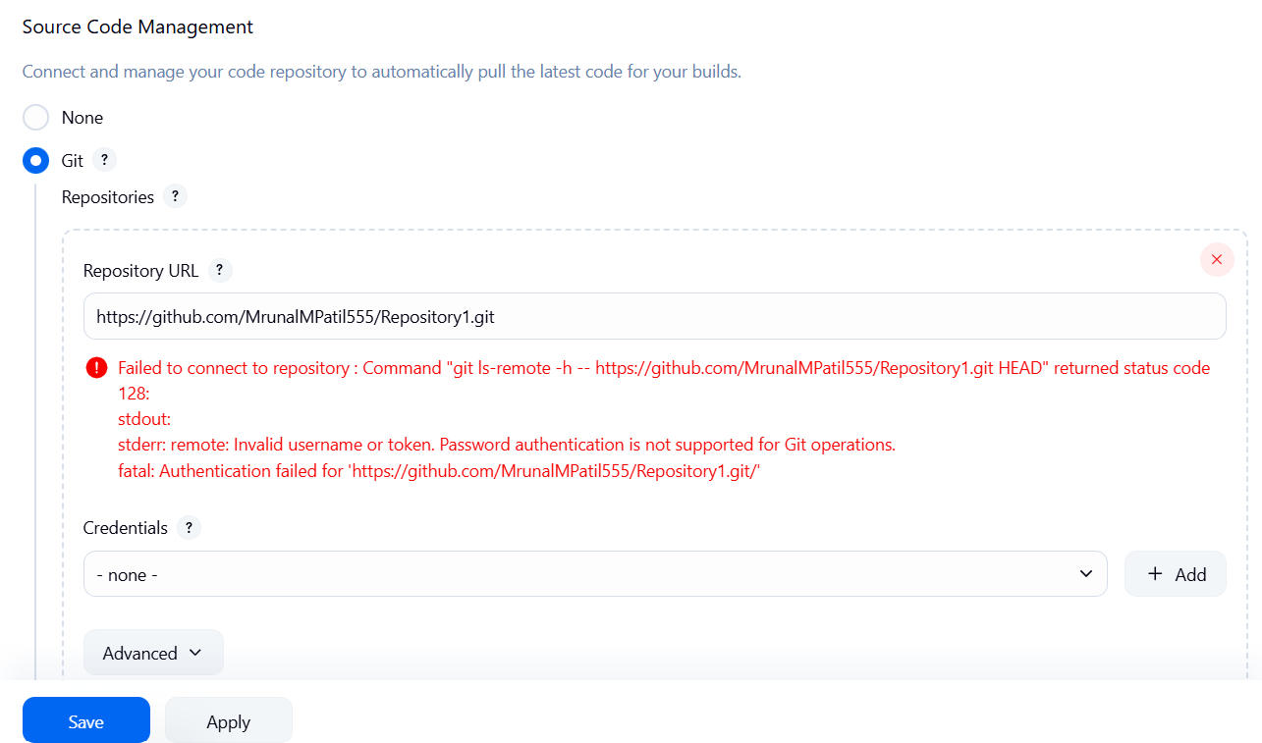

Step 6: Since the repository is private → go to Manage Jenkins → Credentials → click on global



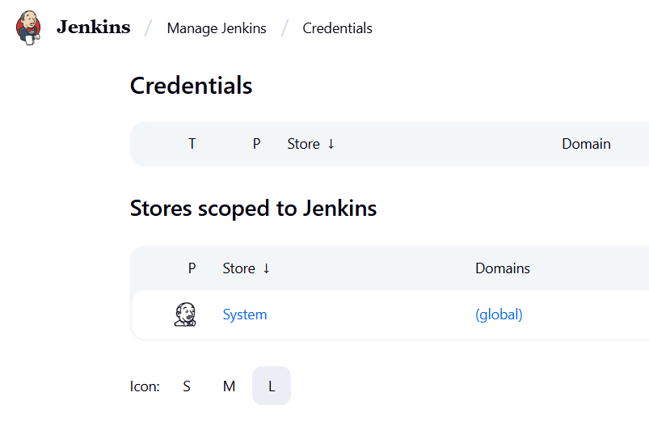

Click on Add Credentials → in the Kind drop-down menu select Username with password → give username → password will be GitHub token → give description → Create

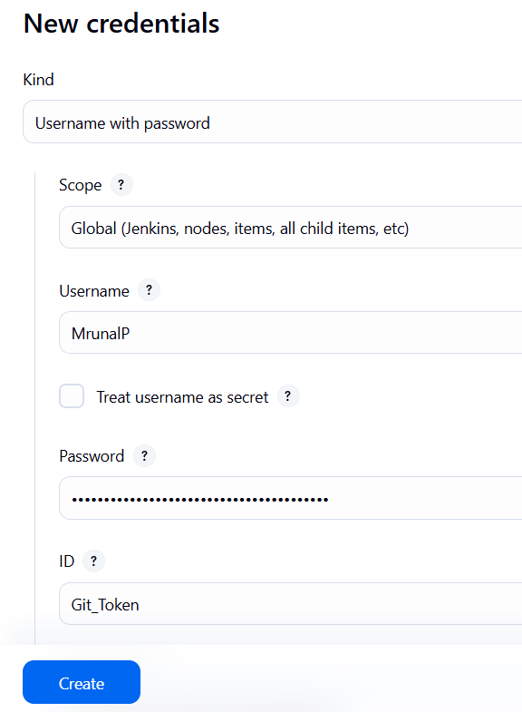

The credentials are created.

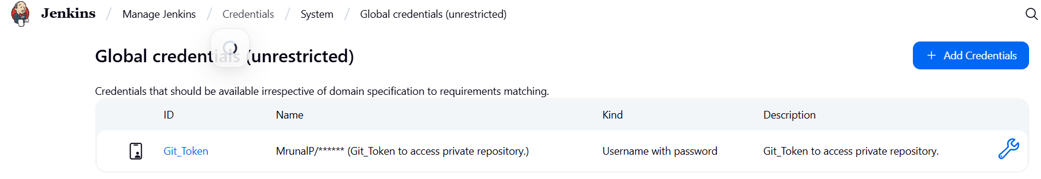

Step 7: go to job that you created → configure → in Source Code Management section → Credentials → select the credentials you created in the last step

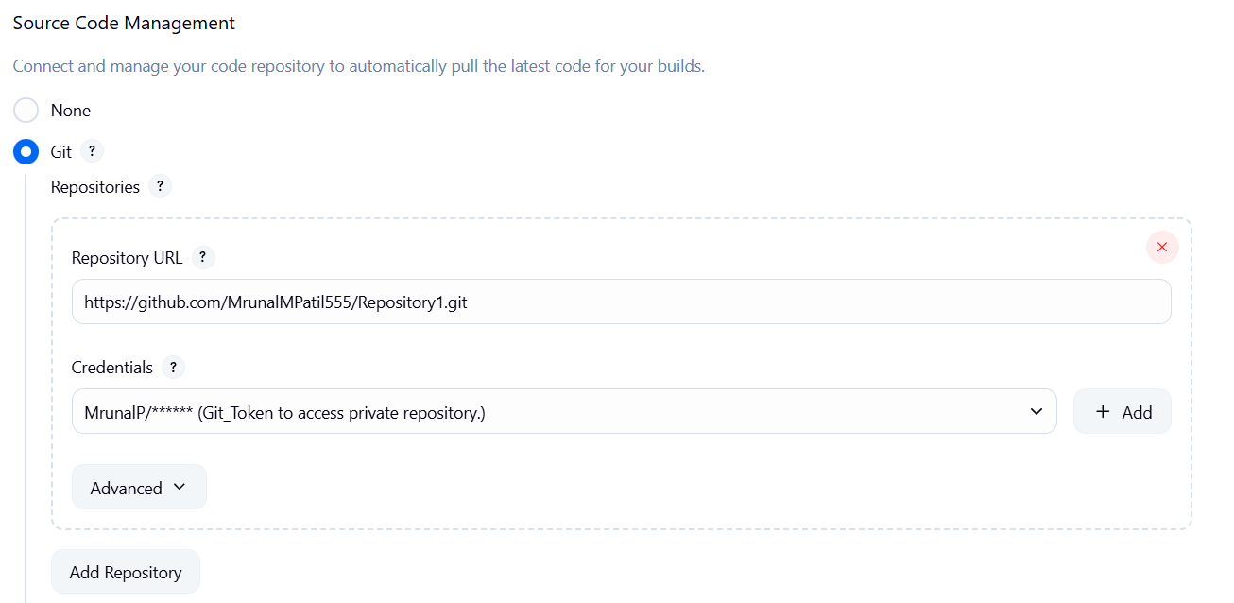

Step 8: Now below in the Build Steps section → select execute shell → write commands to start httpd and deploy index.html file → Apply → Save

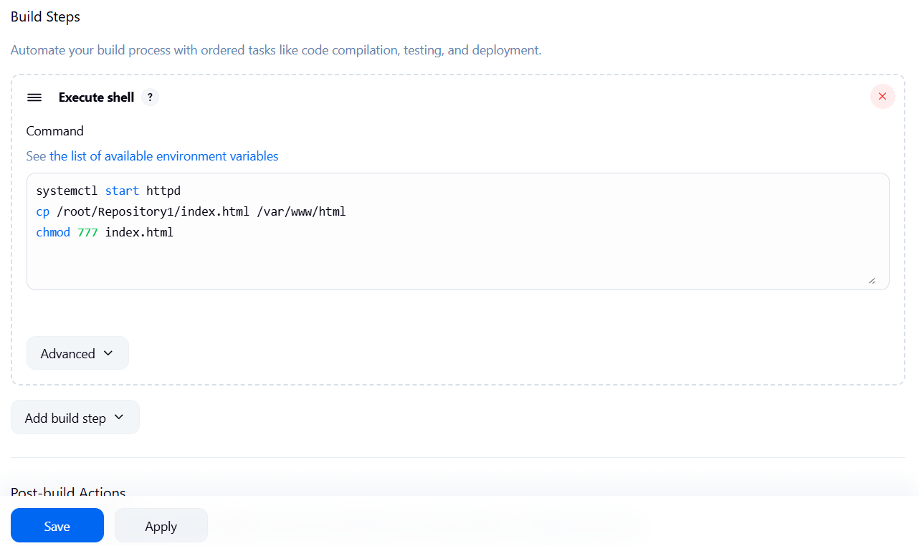

Step 9: Once the job is created, build it.

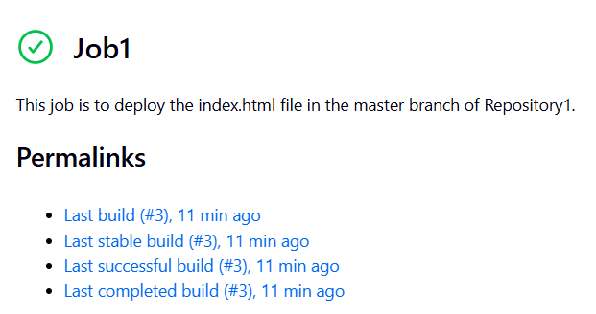

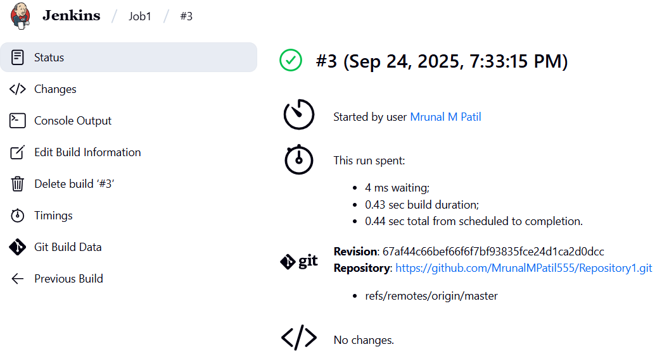

Copy the public IP of EC2 instance and paste in browser to access the index.html file.

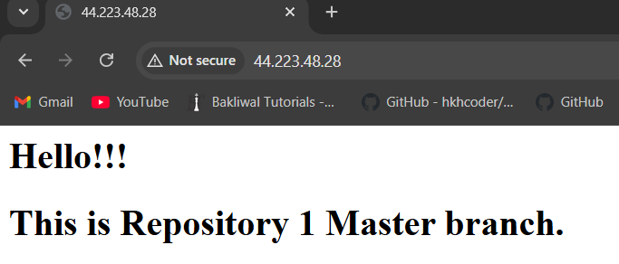

Step 10: Create index.html file in Repository2 QA branch.

mkdir Repository1

git init

vi index.html >> Hello. This is Repository2 QA branch.

git status

git switch -c qa

git add index.html

git commit -m “This is index.html file of Repository2 qa branch”

git log

git remote add origin paste_the_url_of_Repository2_from_github

git push origin master

Now, the index.html file will appear in your git repository.

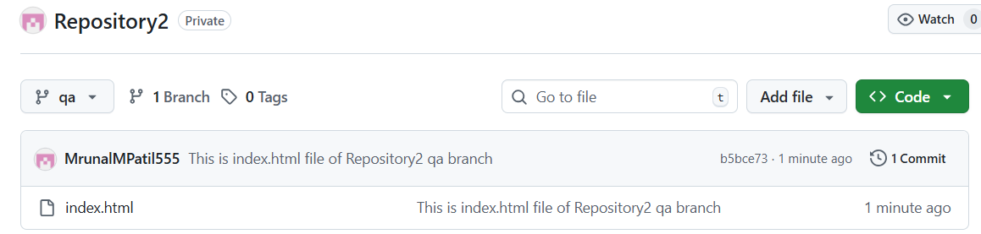

Similarly, create index.html file in Repository3 UAT branch.

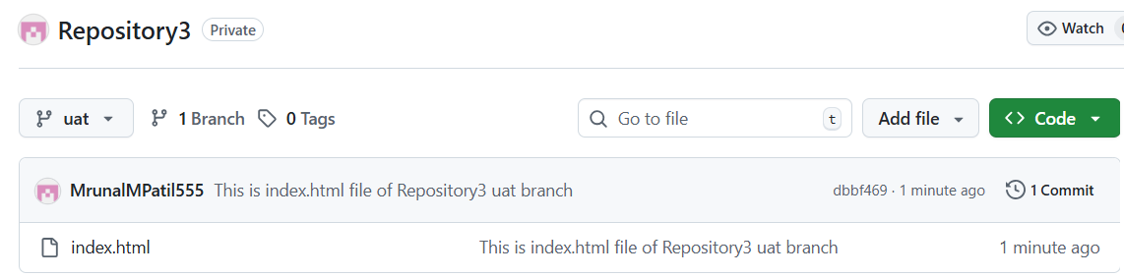

Step 11: Create 2 more jobs in Jenkins. Job2 and Job3 for Repository2 and Repository3 respectively.

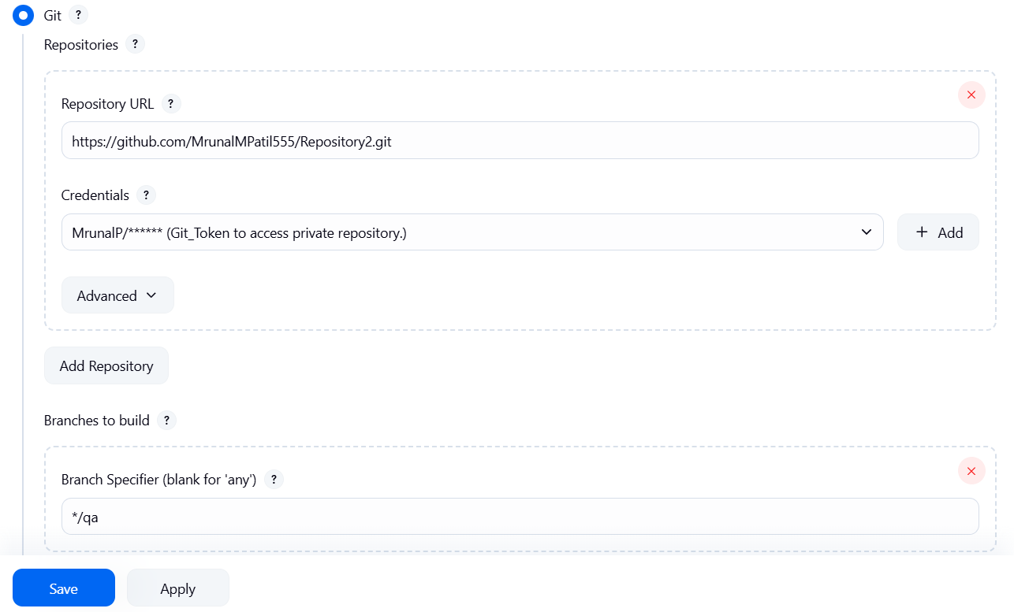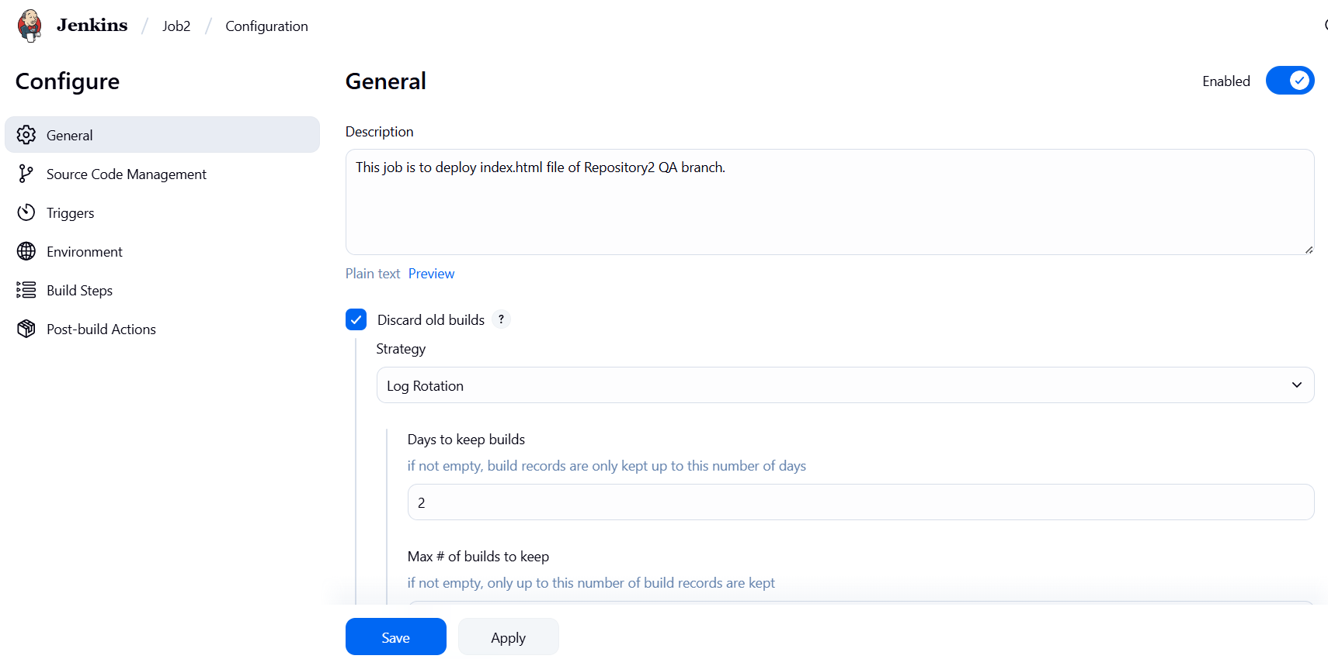

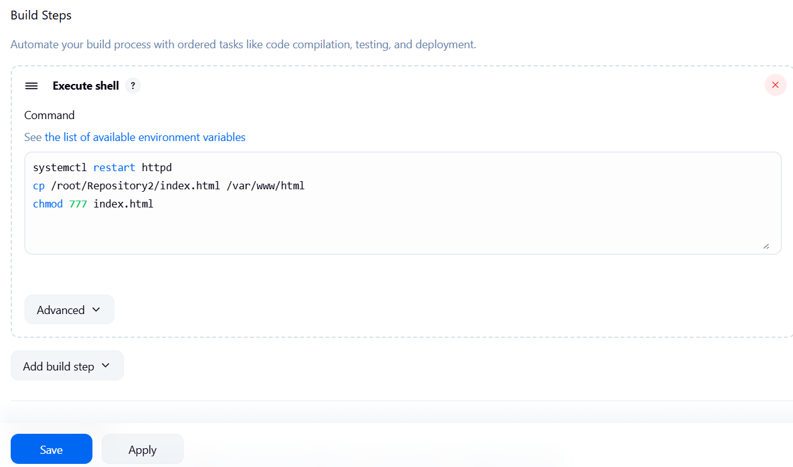

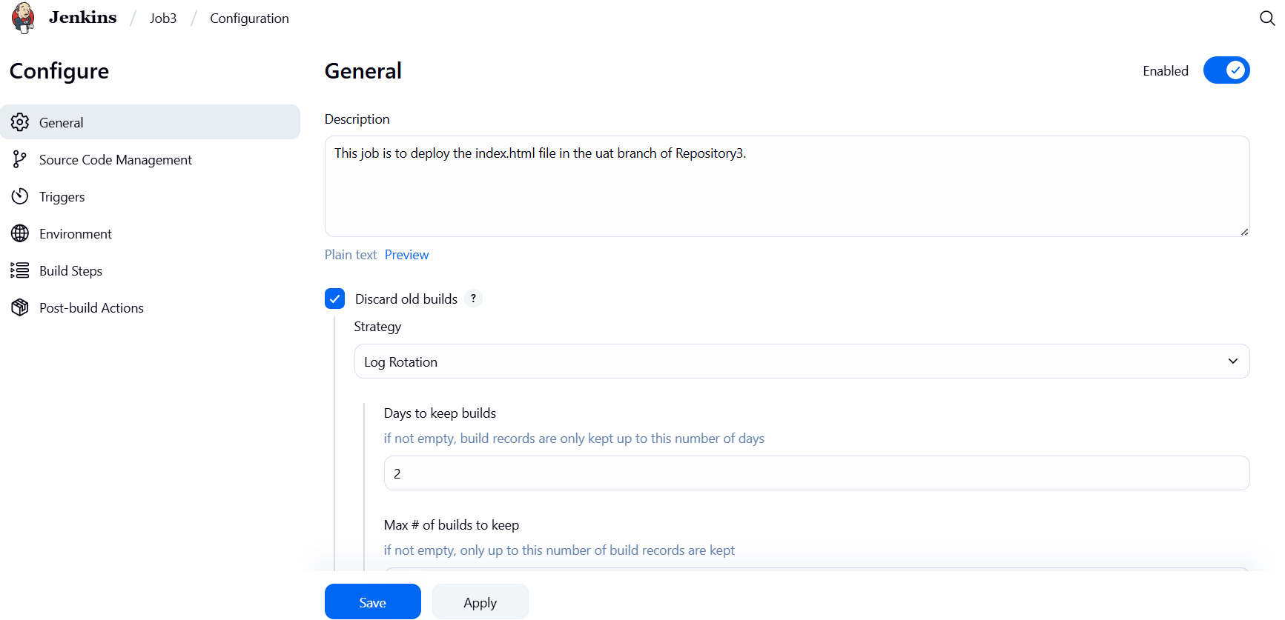

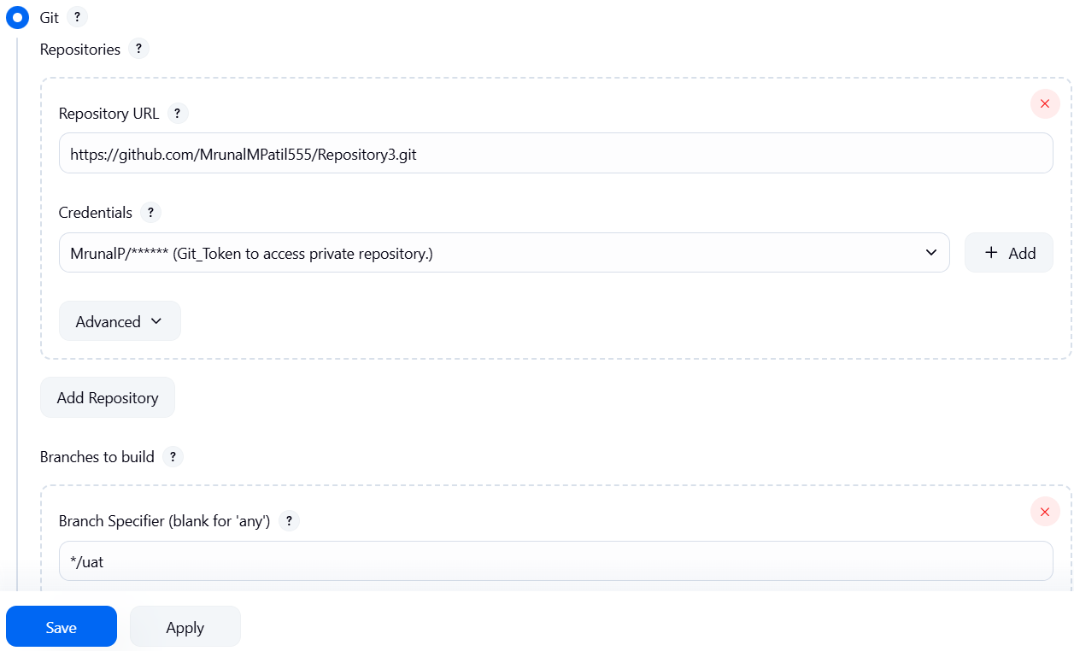

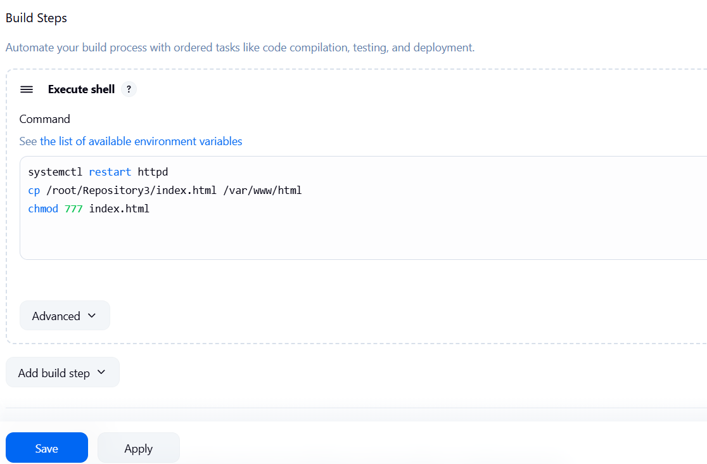

Step 12: If you build Job2 index.html in Repository2 is deployed and if you build Job3 index.html in Repository3 is deployed.

