**Assignment: Integrate Maven and Jenkins and deploy the application on a separate EC2 instance (not a Jenkins slave).**

Step 1: Launch an EC2 instance which will be Jenkins master.

On this EC2 instance, install

* Java
* Apache-tomcat
* Jenkins
* Maven
* Git

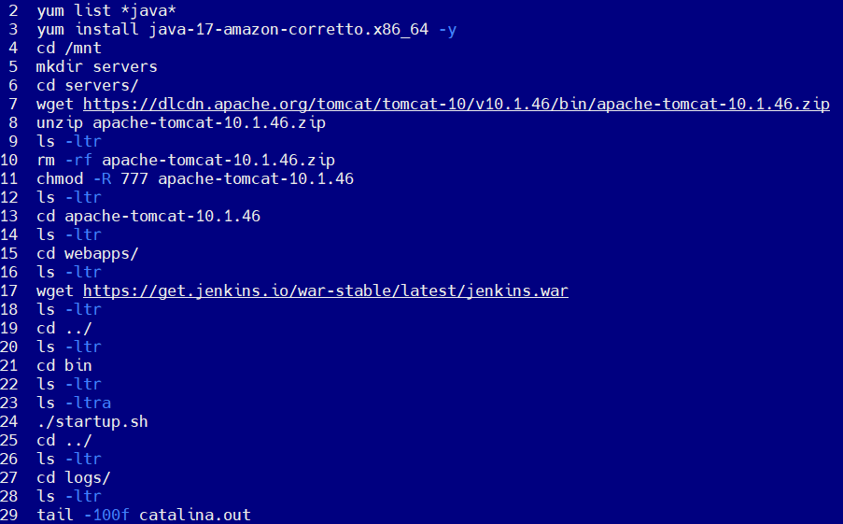

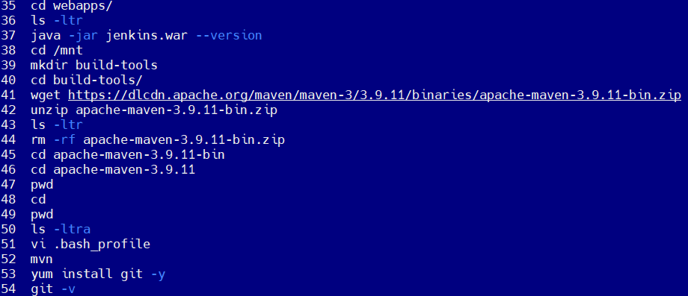

Step 2: Launch another EC2 instance which will be deployment server.

On this EC2 instance, install Apache-tomcat

Step 3: Clone git repository on your Jenkins-Master EC2 instance.

cd /root

git clone https://github.com/Shantanumajan6/project.git

Step 4: Build the project.

cd /root/project

ls -ltr

mvn install

.war file gets created.

Step 5: go to Jenkins → Manage Jenkins → Tools → Maven installations → Add Maven → give maven version and maven home path → Apply → Save

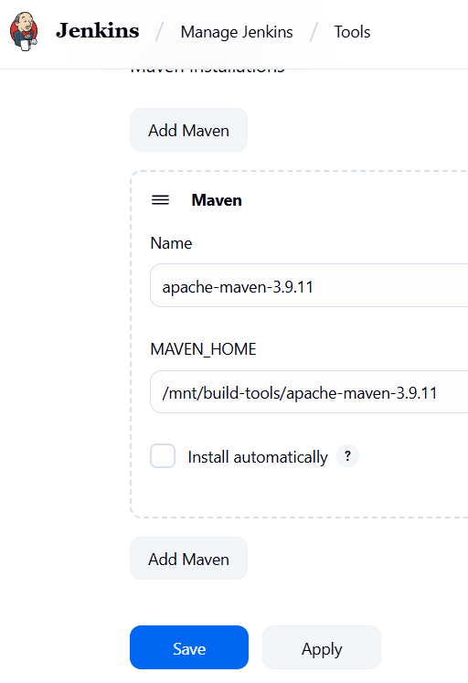

Step 6: Create a job in Jenkins.

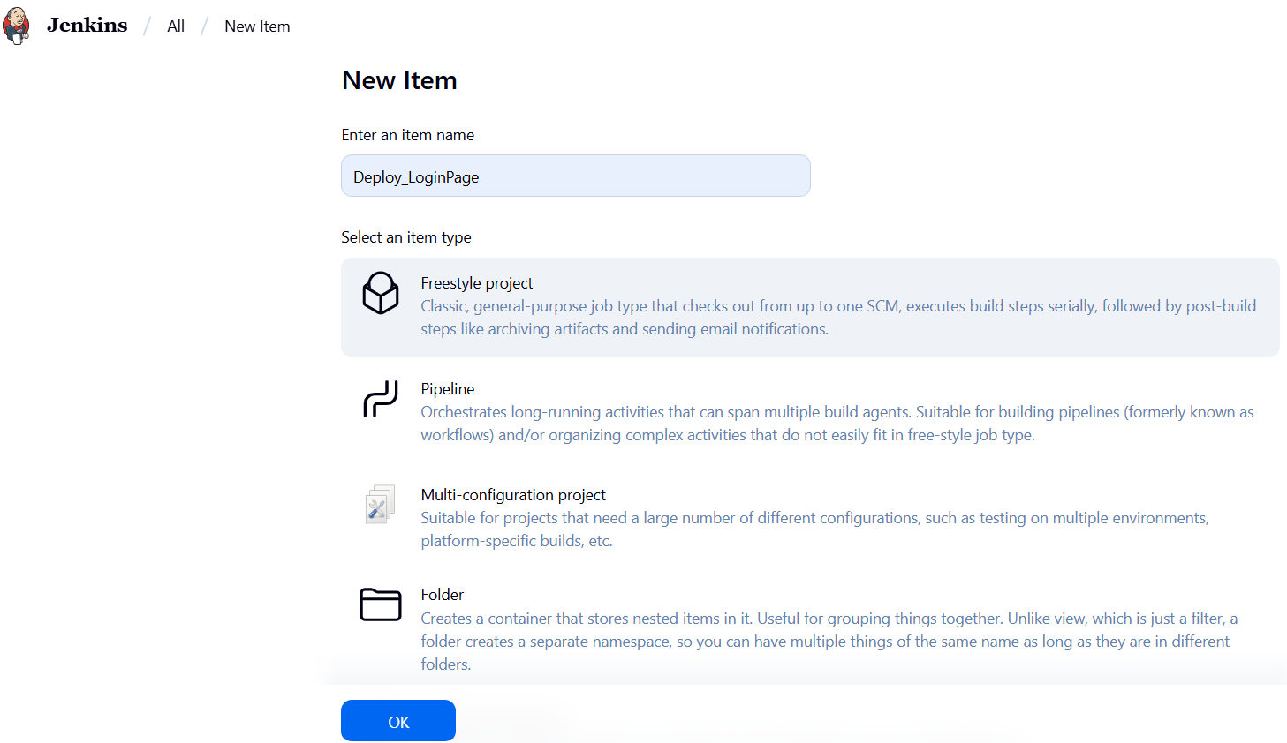

Add git repository.

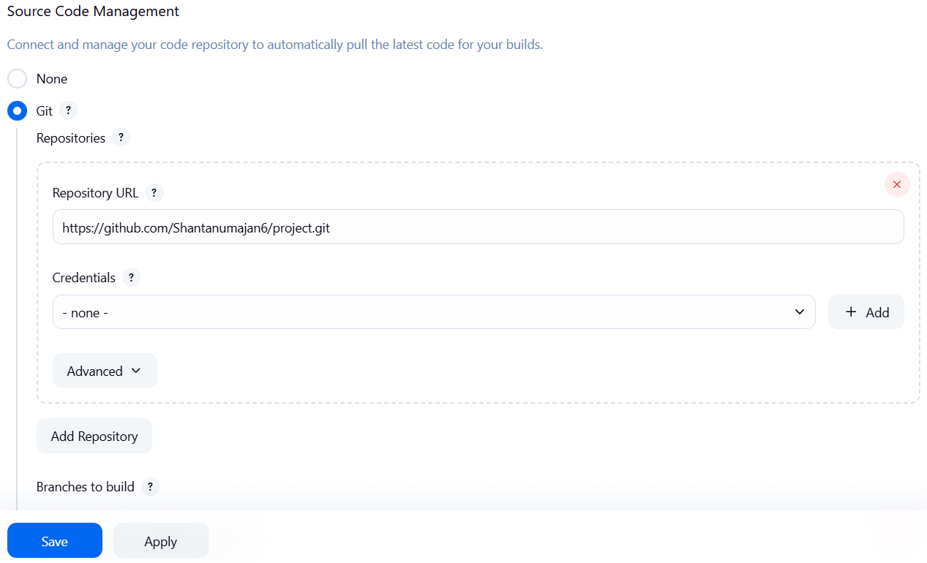

Write commands to copy file from Jenkins-Master EC2 instance to Deployment-Server EC2 instance.

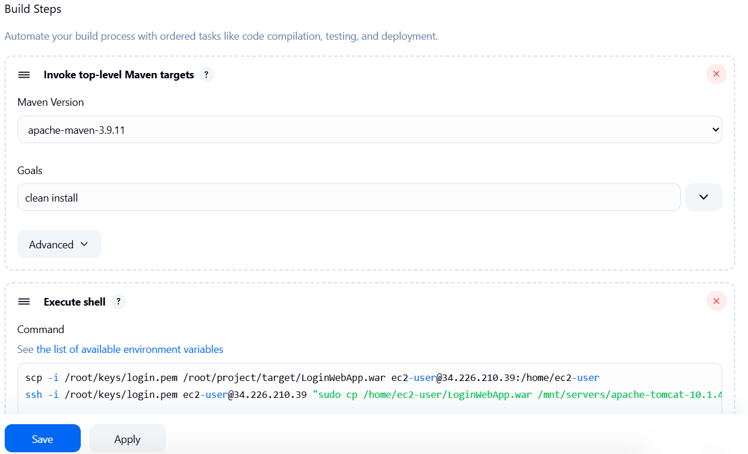

Step 7: Create a .pem file on Jenkins-Master EC2 instance to login into Deployment server EC2 instance.

Step 8: Copy the public IP of Deployment server EC2 instance and paste in brower http://publicIP:8080/LoginWebApp/

