* Tests for comparing 2 strings:

1. passTest yeild output 0 as both strings match.

2. failtest yeilds output 32 as there is difference of 32 between the first mismatch.

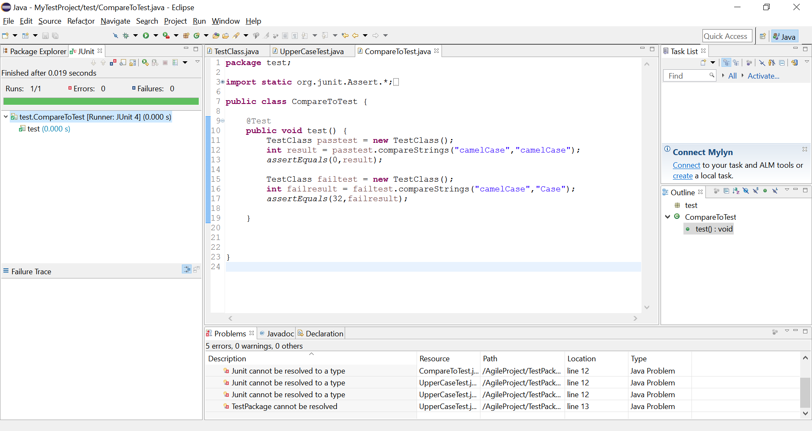

* Test to see whether the string is converted to Uppercase:

Test passes successfully as string is converted to Uppercase.

