**SSW 555 Agile Methods for Software Development**

**Homework 2**

**Name: Mrunal Phadke**

**-------------------------------------------------------------------------------------------------------------**

**1. How are user stories similar to use cases?**

**Answer:**

* A user story is a short description of something that your customer will do when they come to your website or use your application/software, focused on the value or result they get from doing this thing. They are written from the point of view of a person using your website or application, and written in the language that your customers would use.
* A use case is a description of a set of interactions between a system and one or more actors.
* Thus, User story is a smaller and informal version of Use Case. We can also say that User story is a less elaborate form of Use Case. Both of them describe the same thing (task to be completed) in different forms.

**2. How are user stories different from use cases?**

* Both "user stories" and "use cases" are terms used in gathering requirements from customers in a software development project, but there are some major differences, most notably in the level of detail of each.
* Use cases are much more detailed describing system requirements from the point of view of a user.
* User stories are short and briefly state the type of user, the feature needed, and the benefit.
* Use cases describe the interaction between one or more "actors" with the system. Actors may be end users, administrators, or any other type of role that will use the system. Actors may also be other systems or devices that interact with the system.
* The use case includes a series of events described from the point of view of the actor.
* Use cases can be specified using a visual modeling technique called Unified Modeling Language (UML).
* User stories are used in agile methodologies to gather short descriptions of customer requirements. User stories typically follow a format of:

“As a [role-based description of user] I want to [short description of feature] So that [benefit is gained]”

* These short user stories are defined by the business or product owner and are purposely left without a lot of detail so that the detailed requirements can remain relatively flexible.

**3. Give an example user story for a college registration system.**

User Story for College Registration system:

As a student, I should be able to register to the courses offered by the University.

**4. Give a corresponding use case for a college registration system.**

Use Case for College Registration System:

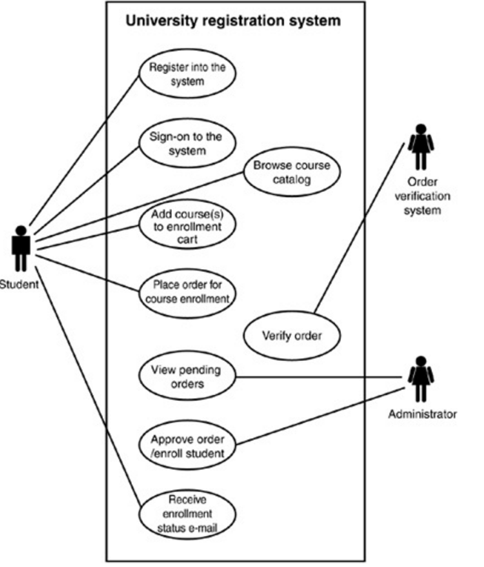

**5. Explain how your two examples support your answers to the first two questions.**

* The User Story of this example describes the task that needs to be achieved.
* On the other hand, the Use Case shows a series of events that need to be followed to reach to the final task.
* That is in this case a use case details what steps the student should take in order to register for the courses.