**Project Name: Swiggy.com**

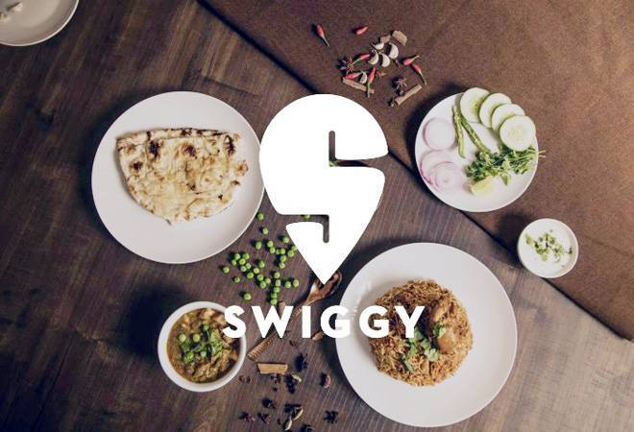

**\*Overview\***

## Swiggy is an Indian online food ordering and delivery platform.

Founded in July 2014, Swiggy is based in Bangalore and operates in 500 Indian cities as of September 2021.

1.Home page:

1.Logo

2.Search

3.Quick search

4.Login

**Footer:**

About Swiggy

Social media handle icons and links.

2.After signing in:

Images of variety of food and restaurants

Search more about different type of foods.

3.Gateway for payment:

# Selection of Address

#Way of Payment(Gpay,Phonepay,bhimupi)

#cash on delivery,credit/debit card.