Assessment-2 java

Name: Mrunali Kale

# SmartCity Citizen Service Portal Project:

This Java-based SmartCity Citizen Service Portal allows citizens to register, log complaints, and track the status of their complaints. It also includes admin functionalities like viewing complaints and performing basic analytics. The project demonstrates the use of object- oriented principles, exception handling, input validation, data serialization, and stream processing.

# Key Functionalities:

**User Registration (Citizen and Admin):**

1. Citizens and admins can register by providing details such as name, email, mobile, and password.
2. Passwords are encoded using Base64 for security.
3. Citizens can register complaints by providing a description.

# Complaint Submission and Tracking:

1. Citizens can submit complaints, and these complaints are stored in a list.
2. Complaints have a status, which can be updated (for simplicity, it is initially set as "Open").

# Data Serialization and Deserialization:

1. The list of complaints is serialized into a file (complaints.ser) so that data can be saved and reloaded, ensuring persistence across application runs.

# Phone Number Validation:

1. The mobile number is validated using a custom exception, InvalidPhoneException. The validation ensures that the number consists of exactly 10 digits.
2. Object-Oriented Programming (OOP)
3. Exception Handling
4. Data Persistence (Serialization)
5. Base64 Encodin

**Program:**

**Main.java (main file)**

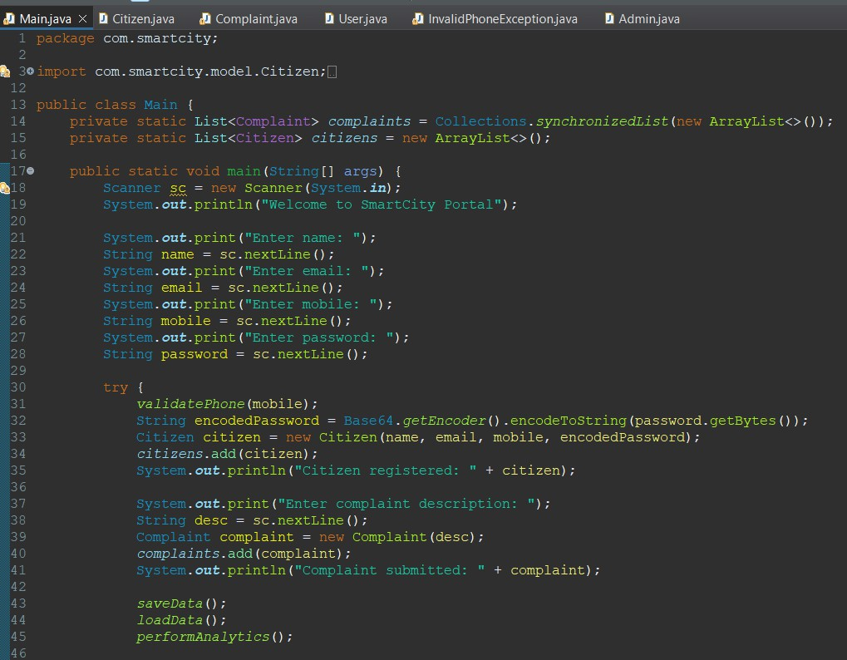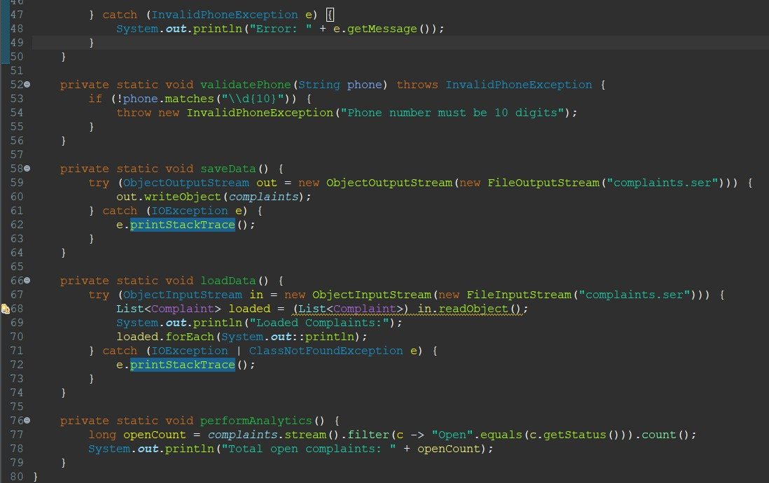

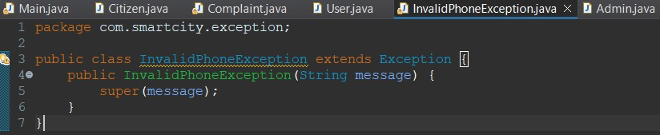

**Entities User.java**

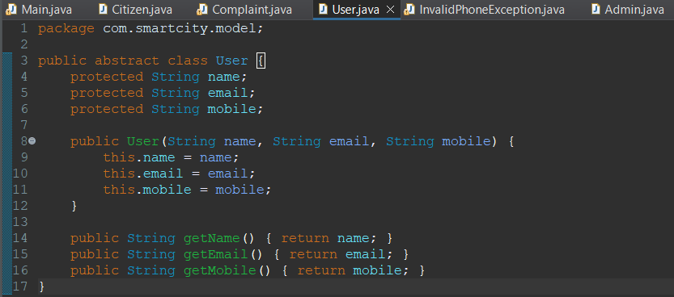

**Admin.java**

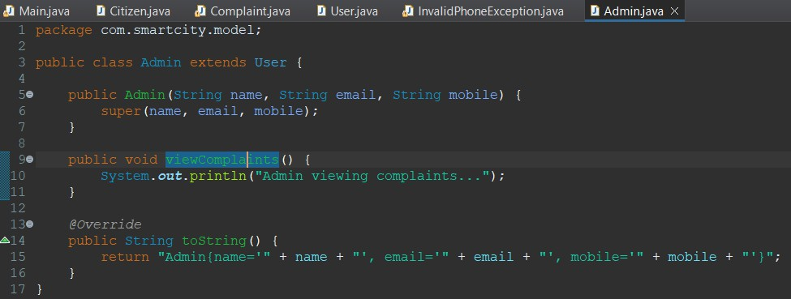

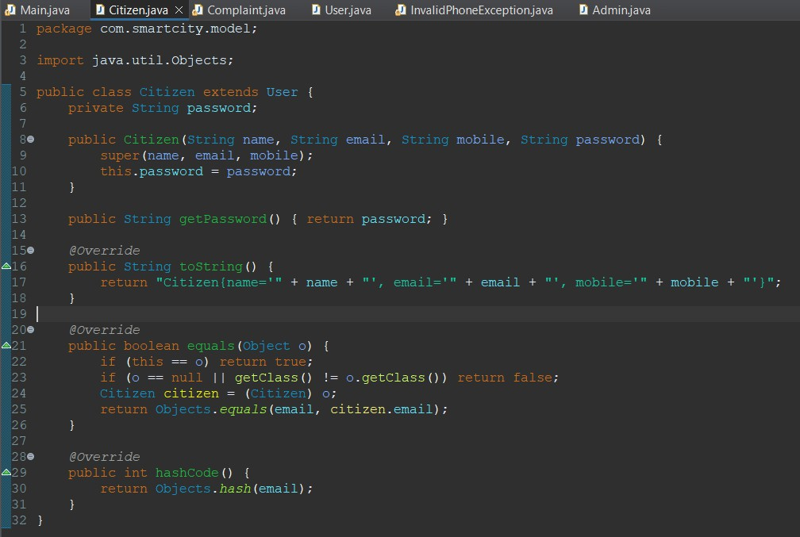

**Complain.java**



