**Chapter 1**

**Introduction**

This chapter is organized as follows Section 1.1 describes the motivation to build the system ,the problems faced by the existing sytem and why it is necessary to build an online system .Section 1.2 explains the problem statement .The problems which were stated in the motivation part and how this can be solved by our system .Section 1.3 descripes the three tier architecture of the system.The upper layer and the backend used.

* 1. **Motivation**

Currently the passes are booked manually at the pass booking centers where people have to stand in large queues to get their passes .Alternatively the risk of passes getting lost ,stolen or forged remains because the passes are made of paper and are less secure .

Passenger book passes on monthly basis and forget to get their pass updated .The passengers have to pay penalty for delayed updation of their pass .The passes can only be booked during daytime and only when the booking centers are open .It becomes difficult for the passenger to manage the time and update pass before its expiration .

The checking of the pass is manually done by the conductor which involves checking of expiration date .The pass used is belonging to the right person is also not known .Verification of the pass becomes an hectic task.

* 1. **Problem Statement**

To develop an online system which provides the user to fill their personal details as well as pass details .The system should validate the user and if applicable provide the discount on the pass payments .Students ,senior citizens should get concessions on the pass.On the expiration of the pass or 1 day before the expiration the user must get an email regarding the updation of the pass .The user should be easily able to renew the pass.

After the details are provided the pass gets downloaded on the system which can be downloaded any number of times if gets deleted by the user .The pass has the photo of the user which proves that the pass belongs to the same person .One can easily get pass without standing in long queues and at their time space.

The passwords of the user are stored in hash functions thus providing integrity to the users data.The data of the user will not be forged and will be visible to only the user .No other person can use the pass and it will not be stolen by anyone .If the user forgets to get the pass updated the system reminds the user of getting it renewed by sending the mail .The system makes the work of the user easil and time and paper is saved.

* 1. **Framework of the proposed work in the project**

The project is built using three tier architecture .

1.3.1 Front End

The front end is build using html ,css and javascript.The technology which links the frond end and the backend is php PDO.

1.3.2 PHP PDO:

PHP database objects—is a database access layer providing a uniform method of access to multiple database.

It doesn’t account for database-specific syntax ,but can allow for the the process of switching databases and platforms to be fairly painless,simply by switching the connection string in many instances.

The middle tier also performs the required functionalities which help display only useful part to the user .After successful registration of users a mail is sent to the user through PHP mailer

1.3.3PHP Mailer:

PHPMailer is a code library to send emails safely and easily via PHP code from web server .Sending mails directly by PHP requires a high familiarity to SMTP standard protocol and related issues and vulnerabilities about Email injection for spamming.

1.3.4.Back End

The back end is built using MySQL database .The database holds all the data of the users who have registered and their pass information. The database is normalized upto fifth normal form.

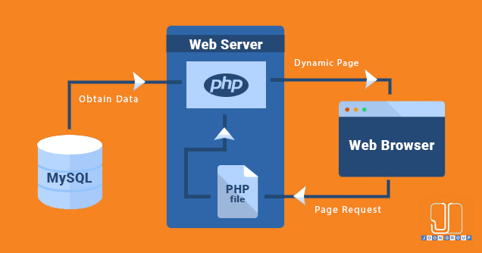

Figure 1: 3 -Tier architecture(Courtsey:jooncorporation.com)

**Chapter 2**

**Software Requirement Specification**

This chapter is organized as follows Section 2.1 describes the software specification where the operating system used is specified,the platform used and the connectivity method .Section 2.2 explains the hardware specification ,the minimum processor ,RAM required.

**2.1 Software Specification**

2.1.1 Operating System

Windows operating system is used for the project .

2.1.2 Xampp

Xampp is a [free and open-source](https://en.wikipedia.org/wiki/Free_and_open-source) [cross-platform](https://en.wikipedia.org/wiki/Cross-platform) [web server](https://en.wikipedia.org/wiki/Web_server) [solution stack](https://en.wikipedia.org/wiki/Solution_stack) package developed by Apache Friends, consisting mainly of the [Apache HTTP Server](https://en.wikipedia.org/wiki/Apache_HTTP_Server), [MariaDB](https://en.wikipedia.org/wiki/MariaDB" \o "MariaDB) [database](https://en.wikipedia.org/wiki/Database), and [interpreters](https://en.wikipedia.org/wiki/Interpreter_(computing)) for scripts written in the [PHP](https://en.wikipedia.org/wiki/PHP) and [Perl](https://en.wikipedia.org/wiki/Perl) [programming languages](https://en.wikipedia.org/wiki/Programming_language). Since most actual web server deployments use the same components as XAMPP, it makes transitioning from a local test server to a live server possible.

Xampp's ease of deployment means a [WAMP](https://en.wikipedia.org/wiki/WAMP) or [LAMP](https://en.wikipedia.org/wiki/LAMP_(software_bundle)) stack can be installed quickly and simply on an operating system by a developer. With the advantage a number of common add-in applications  can also be installed with similar ease using [Bitnami](https://en.wikipedia.org/wiki/Bitnami" \o "Bitnami) .It has integrated PHP and My SQL.

2.1.2.1 MySQL

MySQL is an open-source relational database management system (RDBMS)based on Structured Query Language (SQL). The application is used for a wide range of purposes, including data warehousing, e-commerce, and logging applications. The most common use for mySQL however is for the purpose of a web database.

The application has 4 tables which include 3primary keys and one foreign key .There are 2 procedures included in the database and one trigger in the application.

2.1.2.2 PHP

PHP is a server scripting language, and a powerful tool for making dynamic and interactive Web pages.PHP is a widely-used, free, and efficient alternative to competitors such as Microsoft's ASP .PHP PDO is used to connect the database . PHP database objects—is a database access layer providing a uniform method of access to multiple database .

**2.2 Hardware Specification**

Minimum hardware requirements for a small dataset in Project.

Table 1.1. Hardware Specification.

|  |  |
| --- | --- |
| Component | Minimum requirement |
| Processor | 64-bit,four-core,2.5 GHz,minimum per core |
| RAM | 24 GB for Developer and Evaluation Use |
| Hard disk | 80 GB for installation.  For other use you may need additional free disk space for day-to-day operations. |

**Chapter 3**

**E R Diagram**

This chapter is organized as follows Section 3.1 descries the entity relationship diagram which includes entities and their relationship with other entities.

**3.1 ER Diagram**

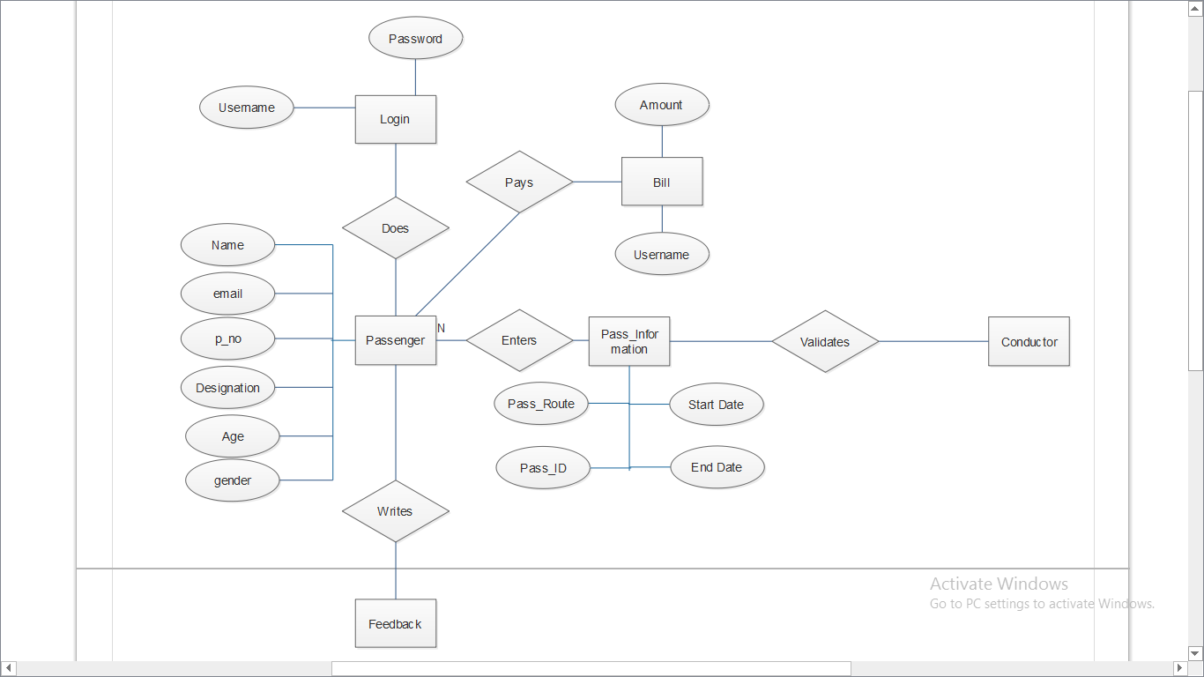

Figure 3.1 E R Diagram

**Chapter 4**

**Tables/Collection/Use Case Diagram**

This chapter is organized as follows Section 4.1 shows the use Case diagram ,Section 4.2 highlights the dataflow diagram .Section 4.3 highlights the Sequence diagram.Section 4.4 has the implementation modules.

**4.1 Use Case Diagram**

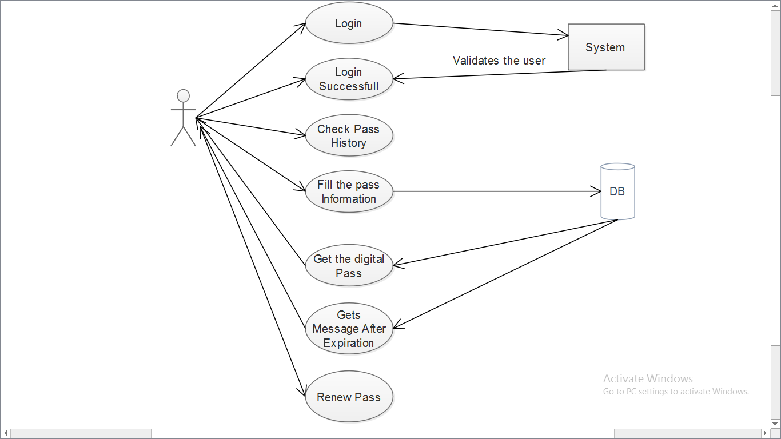

Figure 4.1 Use Case Diagram

**4.2 DataFlow Diagram**

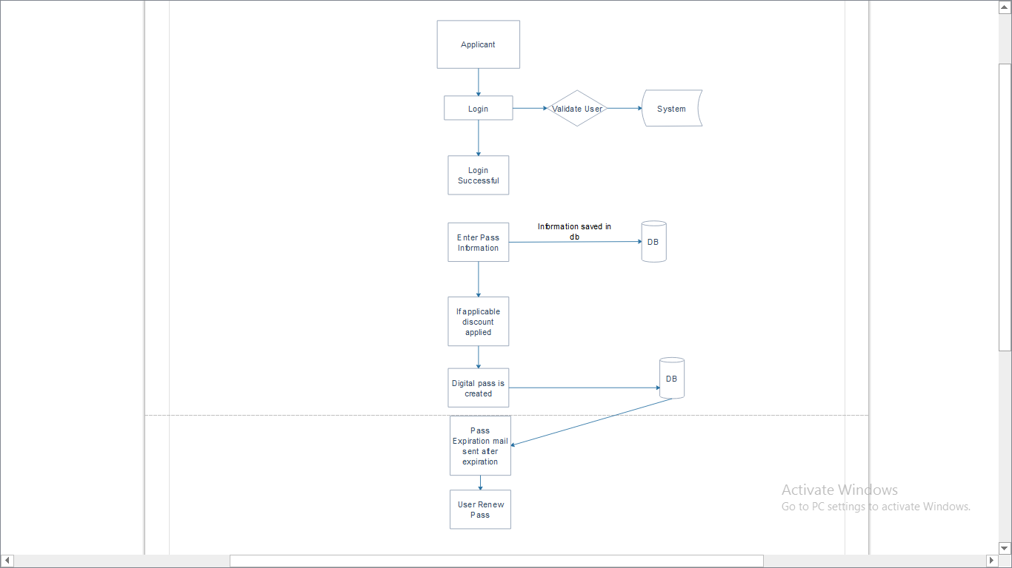

Figure 4.2 DataFlow Diagram

**4.3 Sequence Diagram**

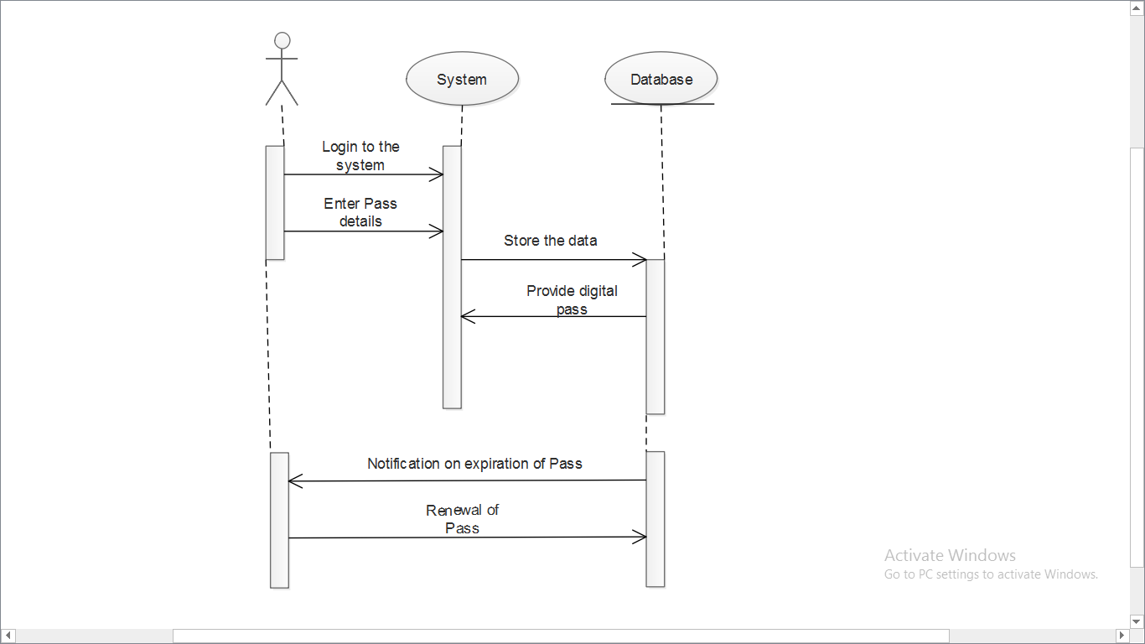

Figure 4.3 Sequence Diagram

**4.4 Implementation Modules**

4.4.1 Home Page.

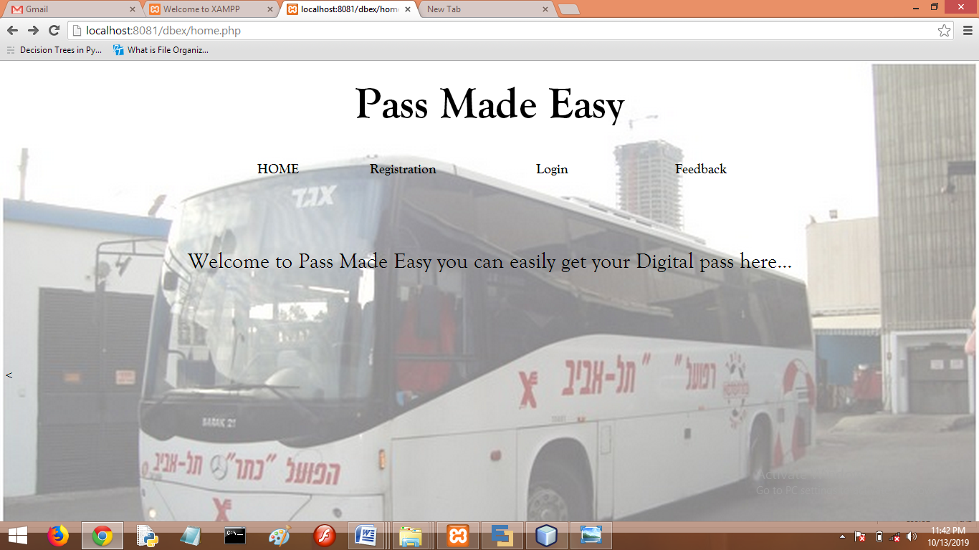

Figure 4.4.1 Home Page

4.4.2 Registration

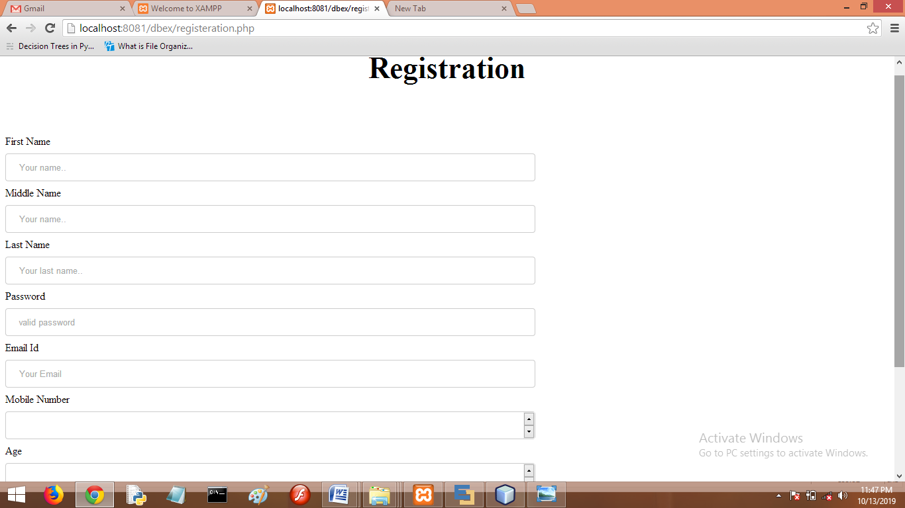

Figure 4.4.2 Registration

4.4.3 Mail Received

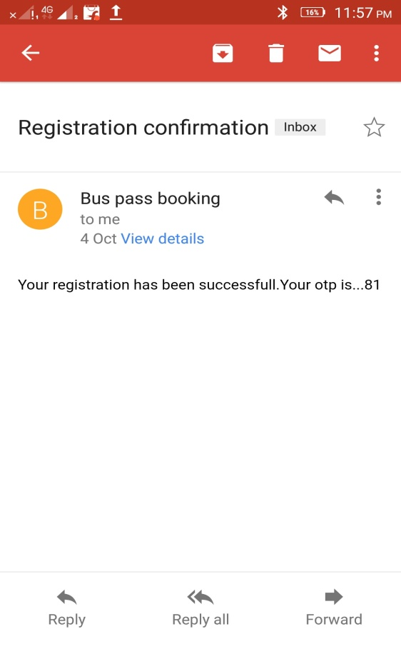

Figure 4.4.3 Mail Conformation

4.4.4 Login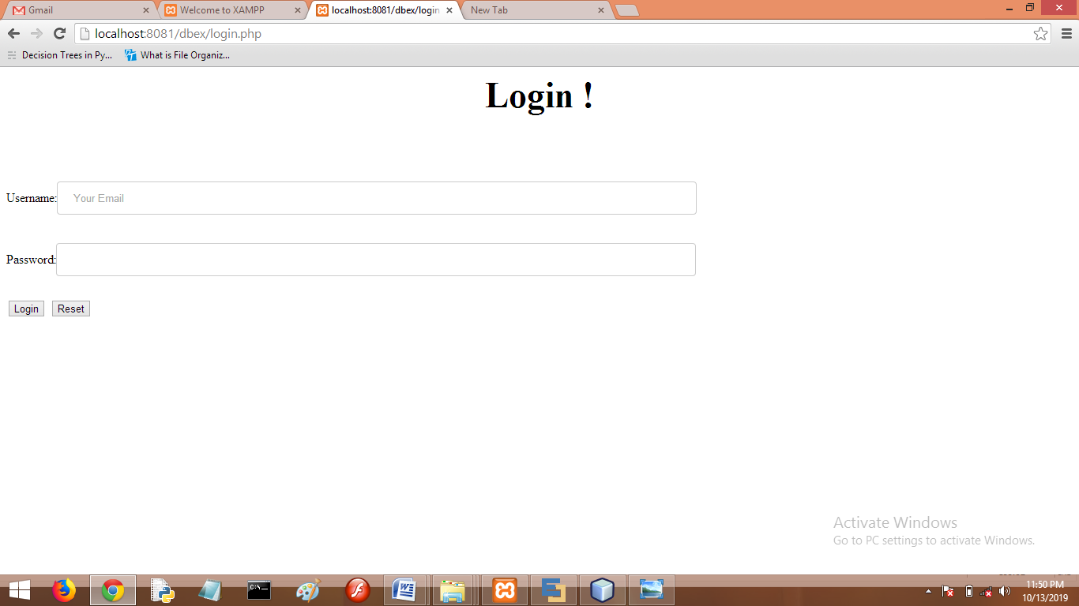

Figure 4.4.4 Login

4.4.5 Pass_Information

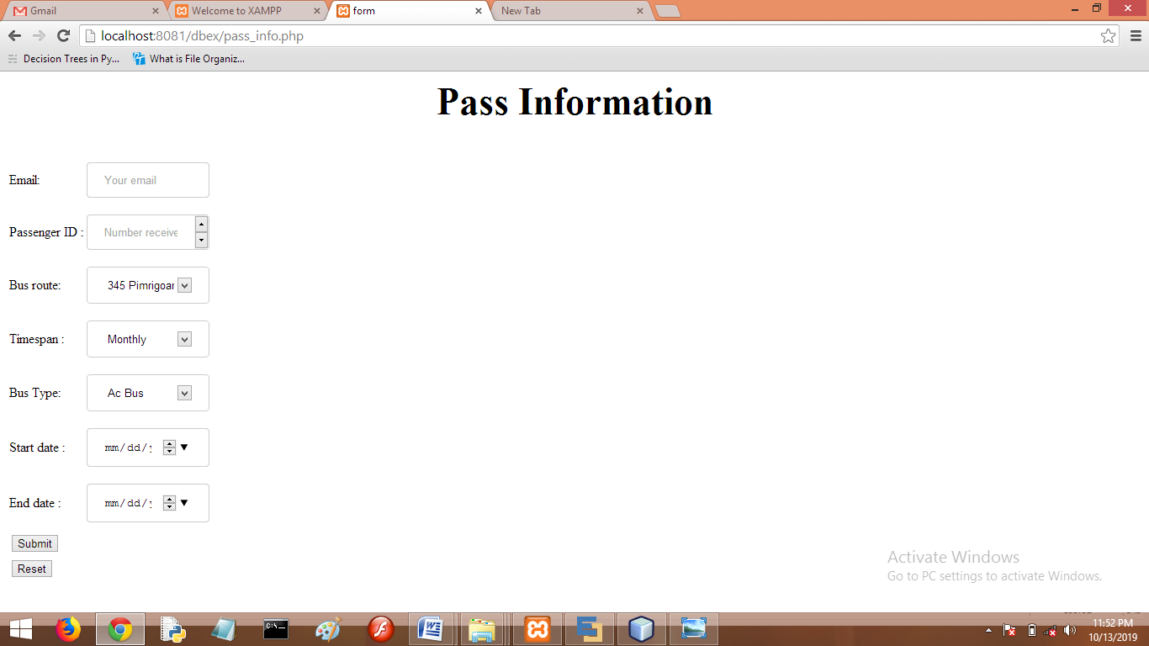

Figure 4.4.5 Pass Information

4.4.6 Digital Pass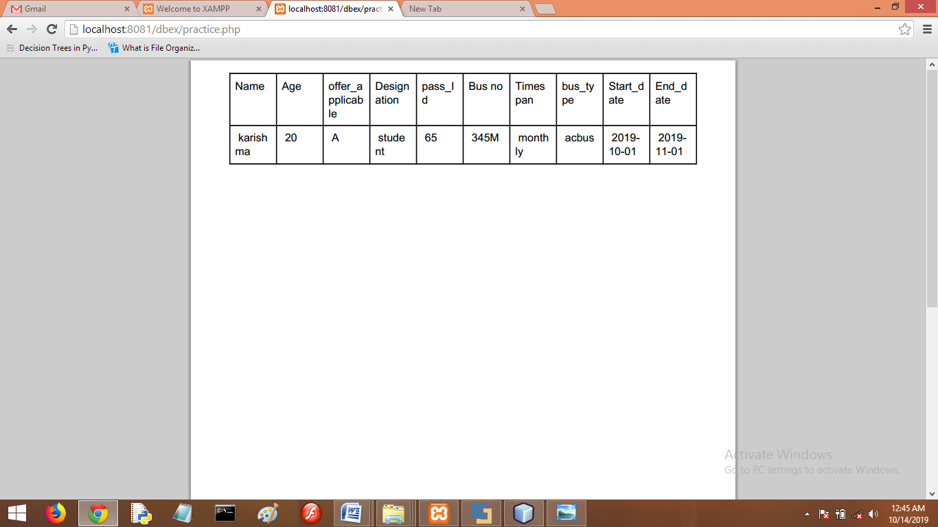

Figure 4.4.6 Digital Pass

4.4.7 Digital Pass Download

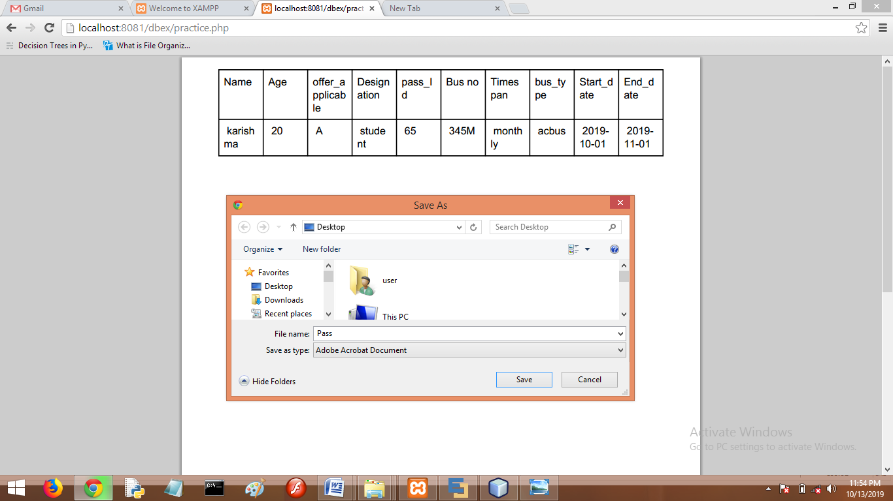

Figure 4.4.6 Digital Pass Download

**Chapter 5**

**System Development**

This chapter is organized as follows Section 5.1 explains the registration system ,Section 5.2 describes the Login System .Section 5.3 describes the describes the uploading of the pass information 5.4 describes how the data is converted into digital pass.

5.1 Registration System

The registration form has various fields such as the username as email , full name ,Password ,Phone number ,Age ,Designation ,Gender .The data when entered after submitting gets stored into the register table .The password is saves in the hashed format .The passenger Id is created by the database since it is auto incrementing Primary key .The passenger Id is received by the user through the mail .The database is connected to the frontend by using pdo objects.The mails are send to the user by the PHPMailer .

5.2 Login System

After the user registers and receives the mail ,the user can then login into the system by providing the right email and the password .If they do not match then the user is unsuccessful in getting login to the system.

5.2 Display of Pass History and Personal data

After the user gets successfully login the user gets all his/her personal details displayed on the screen .There the user can update or delete the account .By clicking the respective keys .The user can also view information of the pass centres and their opening and closing timings .There is also information about the bus routes ,the routes covered by the bus ,name of the stops ,Arrival and departure timing of the busses .If any users wishes to get the pass manually can get the pass centres information.

The user then clicks on the Get Pass button to fill the pass information . The user can get the information of the amount to be paid for the pass .

5.3 Enter the Pass Information

The user then enters all the information as such of if the pass booked will be monthly pass Yearly Pass or then One day pass .The starting date of the pass and the end date .The Passenger Id received in the email is entered here .The Pass Id gets formed automatically in the database because this field is auto incrementing and is primary key in this table .The passenger id declared in the register table becomes foreign key in pass _info table .All the information is stored and a pdf is formed of the users digital Pass .The user can then download the pass .The technology used to create pdf is the TCPdf.

TCPDF is a [free and open source software](https://en.wikipedia.org/wiki/Free_and_open_source_software) [PHP](https://en.wikipedia.org/wiki/PHP) class for generating [PDF](https://en.wikipedia.org/wiki/Portable_Document_Format) documents. TCPDF is the only PHP-based library that includes complete support for [UTF-8](https://en.wikipedia.org/wiki/UTF-8) [Unicode](https://en.wikipedia.org/wiki/Unicode) and right-to-left languages, including the bidirectional algorithm.

5.3.1 Features

* PDF annotations, including [hyperlinks](https://en.wikipedia.org/wiki/Hyperlink), text and file attachments;
* text rendering modes (fill, stroke and clipping);
* multiple columns mode;
* no-write page regions;
* bookmarks and table of content;
* text hyphenation;
* text stretching and spacing (tracking/kerning);
* automatic page break, line break and text alignments including justification;
* automatic page numbering and page groups;
* move and delete pages;
* page compression (requires php-zlib extension);

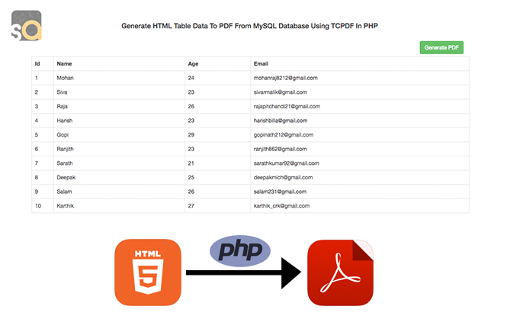

Figure 5.3.1 HTML to PDF conversion (Courtesy: [softaox.info](http://softaox.info/)).

5.4 PHP Mailer

PHPMailer is a class library for [PHP](http://php.net/) that provides a collection of functions to build and send email messages. PHPMailer supports several ways of sending email: mail(), Sendmail , qmail & direct to SMTP servers. You can use any feature of SMTP-based e-mail, multiple recepients via to, CC, BCC, etc.

In short: PHPMailer is an efficient way to send e-mail within PHP.

PHP has a built-in mail() function. So why use PHPMailer? ,before you can send a message you have to construct one correctly, and this is extremely complicated because there are so many technical considerations .

PHPMailer makes it easy to send e-mail, makes it possible to attach files, send HTML e-mail, etc. With PHPMailer you can even use your own SMTP server and avoid Sendmail routines used by the mail() function on Unix platforms.

If you don't want to use PHPMailer, use another established email library such as SwiftMailer, Zend_Mail etc (including the PHP documentation for the mail() function) has problems that can be avoided by using a library.

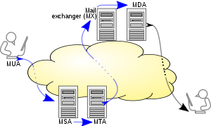

Figure 5.3.2PHPMAiler Architecture (Courtesy: Wikipedia).

**Chapter 6**

**System Testing**

This chapter is organized as follows Section 6.1 represents the Test Case 1 ,Section 6.2 represents the test case 2.

6.1 Test Case 1

Table 6.1. Test Case1.

|  |  |  |  |  |  |
| --- | --- | --- | --- | --- | --- |
| Testcase ID | TestCase Title | Data | Expected result | Actual Result | Status |
| QWE123 | To validate username field. | Number entered in username field | Invalid | Invalid | Pass |
|  |  | Characters entered in username field | Valid | Valid | Pass |
|  |  | Username left Blank | Invalid | Valid | Fail |
| QWE124 | To validate email_ID field. | '@'sign missing in email id field | Invalid | Invalid | Pass |
|  |  | Email id in correct format | Valid | Valid | Pass |
|  |  | Characters entered in upper case | Invalid | Valid | Fail |
| QWE125 | To validate password field. | Password length is less than 6 | Invalid | Valid | Fail |
|  |  | Special character entered | Valid | Valid | Pass |
|  |  | Password left blank | Invalid | Invalid | Pass |
| QWE126 | To validate Mobile number field. | Entered phone number length is greater than 10 | Invalid | Valid | Fail |
|  |  | Phone number left blank | Valid | Valid | Pass |
|  |  | Phone number is less than 10 | Invalid | Invalid | Pass |
| QWE127 | To validate Adrdess field | Address length is less than 40 | Valid | Valid | Pass |
| QWE128 | To validate SignUp button | Data is submitted | Valid | Valid | Pass |
|  |  | Data insufficient | Invalid | Invalid | Pass |

6.2 Test Case 2

Table 6.2. Test Case2.

|  |  |  |  |  |  |
| --- | --- | --- | --- | --- | --- |
| Test ID | Test Case Title | Data | Expected Result | Actual Result | Status |
| AS12 | To enter th Pass Information | 1.Enter Your Customer Id | entered | entered | Pass |
|  |  | 2.Display Pass Information | valid | valid | Pass |
| AS13 | Generation of PDF | 1.Click on generate PDF | selected | selected | Pass |
|  |  | 2.Pdf generated | valid | valid | Pass |
|  |  | 3.Save the Pdf | valid | valid | pass |

**Chapter 7**

**Features**

This chapter is organized as follows Section 7.1 represents the Features of the Project.

8.1 Features

a)An automatic solution will be implemented to obtain a digital pas. b)The pass will be send to the users mobile. c)The pass can be easily verified by the bus conductor. d)The passes will have concessions for the passes of students,national awardees,sports person,freedom fighters,etc. e)An email will be sent to the user on expiration of the pass to renew the same.

Objective: a)The creation of the pass will be easier and can be created anytime anywhere. b)The conductor can easily verify the pass. c)The pass cannot be stolen or forged.

**Chapter 8**

**Future Scope**

This chapter is organized as follows Section 8.1 represents the Future Scope of the Project.

8.1 Future Scope

The digital Pass can be intacted to the persons identity so that it may not be used by anyone else .To Make the Pass more secure by creating the unique Barcodes which will by unique to only the persons Identity so that it is used by the person himself.

The Pass verification can be made easy .When the conductor checks for the pass ,can only get the barcode and all the users information will be displayed.

**Chapter 9**

**Conclusion**

This chapter is organized as follows Section 9.1 represents the Future Scope of the Project.

9.1 Conclusion

Pass made easy is an application where the passengers can easily generate digital pass at their ease ,anytime and anywhere .The passes get downloaded on the users system from where it can be easily stored .Mails are received by the users on expiration of the passes to renew their passes.

**References**

1. <https://github.com/PHPMailer> (Marcus Bointon ,2019)
2. <https://tcpdf.org/> ( [Nicola Asuni](https://nicola.asuni.xyz/)  ,2004)