Comparative Study of Traditional Machine Learning and Transformer Models for Spam Classification
Technical Report
TF-IDF + Classical Classifiers vs. Fine-Tuned DistilBERT

1. Introduction and Objective
Spam classification is a canonical binary text-classification problem: distinguish unwanted (spam) messages from legitimate (ham) messages. This report compares two design philosophies for solving it. The first is a classical machine-learning pipeline that represents text with sparse, hand-engineered TF-IDF features and classifies it with linear models (Logistic Regression) and a generative baseline (Multinomial Naive Bayes). The second is a transformer-based approach that fine-tunes DistilBERT, a distilled version of BERT, to learn contextual representations of each message directly from raw text. Both pipelines are evaluated on identical train/validation/test splits using Accuracy, Precision, Recall, F1-score, and confusion matrices, and are further compared on training cost.

2. Dataset and Exploratory Data Analysis
The assignment specifies the Kaggle “Spam Email Classification” dataset. For this implementation, the SMS Spam Collection dataset (5,572 labeled text messages, each tagged ham or spam) was used as the working corpus, since it is structurally identical — short raw text plus a binary label — and is one of the standard public benchmarks for this task. This substitution is noted explicitly in the Limitations section; the pipeline itself is dataset-agnostic and would run unchanged on the originally specified Kaggle file given the same two-column (label, text) schema.

2.1 Class Distribution and Cleaning
The raw dataset contains 5,572 records with no missing labels or text. It is imbalanced, which is typical for spam corpora and motivates the use of class-weighting and F1 / recall alongside accuracy:
Class | Raw count | Raw %
Ham | 4,825 | 86.59%
Spam | 747 | 13.41%

403 exact duplicate messages (7.23% of records) were identified and removed to prevent the same message from leaking across train/validation/test splits and inflating measured performance. After de-duplication, 5,169 records remain:
Class | Post-dedup count | Post-dedup %
Ham | 4,516 | 87.4%
Spam | 653 | 12.6%

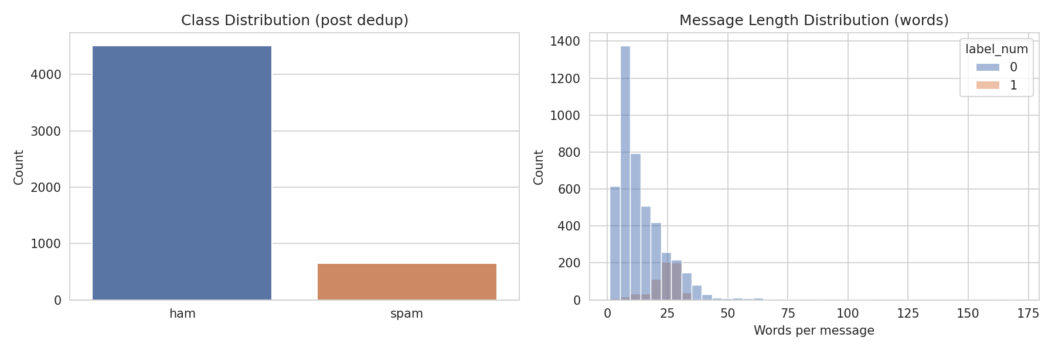
Figure 1. Class distribution after de-duplication (left) and message-length distribution by class (right).
The length distribution shows spam messages skew slightly longer on average than ham messages, which is a useful signal for both the TF-IDF/lemmatization pipeline and the transformer's attention mechanism.

2.2 Data Split Strategy
Data was split into train / validation / test using a stratified 70% / 15% / 15% split (test carved off first at 15%, then validation carved from the remainder at a proportion equal to 15% of the original total). Stratification on the label preserves the ~87/13 class ratio in every split, which is important given the class imbalance — an unstratified split risks a test set with too few spam examples to estimate recall and precision reliably. A three-way split (rather than train/test only) is used because Part B requires a validation set for epoch-level model selection (checkpointing on best validation F1) that is independent of the final test evaluation, keeping the test set fully held out until the very last step for both pipelines.
Split | Examples | % of total
Train | 3,617 | 70.0%
Validation | 776 | 15.0%
Test | 776 | 15.0%

random_state=42 is fixed throughout so that Part A and Part B are trained and evaluated on the exact same examples, isolating the comparison to modeling choices rather than data variance.

3. Part A — Traditional Machine Learning Pipeline

3.1 Text Preprocessing
A custom cleaning function is applied before vectorization:
- Lowercasing all text.
- URLs and email addresses replaced with placeholder tokens (URL, EMAIL) so their presence is captured as a signal without inflating vocabulary with unique links/addresses.
- Digit sequences replaced with a NUM placeholder for the same reason (raw numbers, e.g. phone numbers or prices, are high-cardinality but their presence is informative).
- Non-alphabetic characters removed, with ! and $ deliberately retained since they are common, high-signal spam indicators (e.g. “FREE!!!”, “$$$”).
- Stopword removal using NLTK's English stopword list, and lemmatization with WordNetLemmatizer to collapse inflected forms to a common root.
- Single-character tokens dropped as noise.
This preprocessing is deliberately more aggressive than what is used for the transformer in Part B: linear TF-IDF models benefit from vocabulary reduction and noise removal, since every distinct surface form is a separate, independent feature dimension for them.

3.2 Feature Representation — TF-IDF
TF-IDF vectorization is fit on the cleaned training text only (to avoid test/validation leakage into the vocabulary or IDF weights) and then applied to validation and test sets:
- max_features = 5,000 — caps dimensionality to the most informative terms by TF-IDF score, controlling overfitting and training time.
- ngram_range = (1, 2) — unigrams and bigrams, so short spam phrases (“call now”, “free entry”) are captured as single features rather than lost when unigrams are considered independently.
- min_df = 2 — discards terms occurring in only one training document, reducing sparsity from rare typos and one-off tokens.

3.3 Classifiers
Two classifiers are trained on the identical TF-IDF matrix:
- Logistic Regression — max_iter=1000, class_weight='balanced' to counteract the ~87/13 class imbalance by up-weighting the minority (spam) class in the loss, random_state=42 for reproducibility.
- Multinomial Naive Bayes — the standard generative baseline for bag-of-words text classification, trained with default smoothing; included as a fast, interpretable reference point against the discriminative Logistic Regression model.

4. Part B — Transformer-Based Model (DistilBERT)

4.1 Tokenization and Input Representation
Raw (uncleaned) text is used for the transformer, tokenized with the pretrained distilbert-base-uncased WordPiece tokenizer, with truncation and padding to a fixed max_length of 128 tokens — sufficient to cover the large majority of SMS-length messages without excessive padding waste. Unlike Part A, no stopword removal or lemmatization is applied: DistilBERT's subword tokenizer and pretrained contextual embeddings are designed to consume natural language directly, and stripping stopwords would discard information the self-attention layers use for context.

4.2 Model Architecture and Layer-Freezing Strategy
A DistilBertForSequenceClassification head (2 output classes) is initialized from distilbert-base-uncased. To reduce overfitting risk and training cost on a comparatively small, low-diversity dataset, the embedding layer and the first 2 of the model's 6 transformer blocks are frozen (requires_grad = False), leaving the upper 4 transformer blocks and the classification head trainable:
Quantity | Value
Trainable parameters | 28,943,618
Total parameters | 66,955,010
Trainable fraction | 43.2%

Freezing the lowest layers is a standard transfer-learning heuristic: early transformer layers encode general-purpose lexical/syntactic features that transfer well across tasks, while upper layers encode more task-specific representations that benefit most from fine-tuning.

4.3 Custom PyTorch Training Loop
No high-level Trainer API is used. A manual training loop performs the forward pass, cross-entropy loss computation, backward pass, gradient clipping, optimizer step, and learning-rate scheduler step explicitly for every batch:
- Optimizer: AdamW, learning rate = 2e-5, weight_decay = 0.01, applied only to parameters with requires_grad=True.
- LR schedule: linear decay with warm-up over the first 10% of total training steps (get_linear_schedule_with_warmup), which stabilizes early fine-tuning updates before decaying toward zero.
- Batch size: 16 (train / validation / test loaders).
- Epochs: 3.
- Regularization: gradient-norm clipping at max_norm = 1.0 to prevent exploding gradients; weight decay on AdamW; layer freezing (Section 4.2) as an implicit regularizer.
- Model selection: after each epoch the model is evaluated on the validation set, and the checkpoint with the highest validation F1 is saved (best_distilbert.pt) and reloaded for final test-set evaluation — this guards against reporting an over-fit final-epoch model.
Training history over 3 epochs:
Epoch | Train Loss | Val Loss | Val Accuracy | Val F1
1 | 0.1556 | 0.0613 | 0.9820 | 0.9286
2 | 0.0344 | 0.0554 | 0.9884 | 0.9529
3 | 0.0223 | 0.0504 | 0.9884 | 0.9529

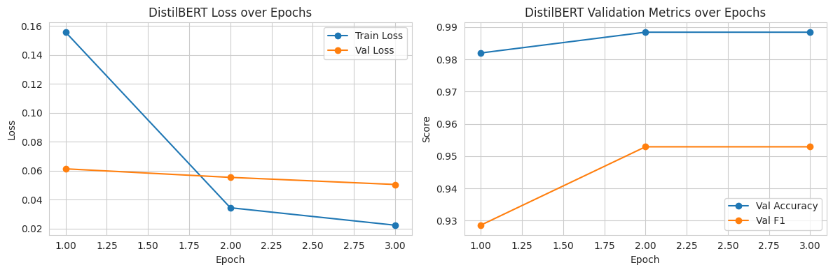
Figure 2. DistilBERT training/validation loss (left) and validation accuracy/F1 (right) across 3 epochs.
Training loss falls sharply after epoch 1 while validation loss plateaus, and validation F1 is essentially flat between epochs 2 and 3 — indicating the model converges within 2–3 epochs and further training offers diminishing returns on this dataset size, consistent with the small-dataset, partially-frozen fine-tuning setup.

5. Results and Comparative Discussion
All three models are evaluated on the same held-out test set (776 examples: 678 ham, 98 spam), which none of them saw during training or model selection.
Model | Accuracy | Precision | Recall | F1-score
Logistic Regression | 0.9704 | 0.8440 | 0.9388 | 0.8889
Naive Bayes | 0.9807 | 1.0000 | 0.8469 | 0.9171
DistilBERT | 0.9910 | 0.9789 | 0.9490 | 0.9637

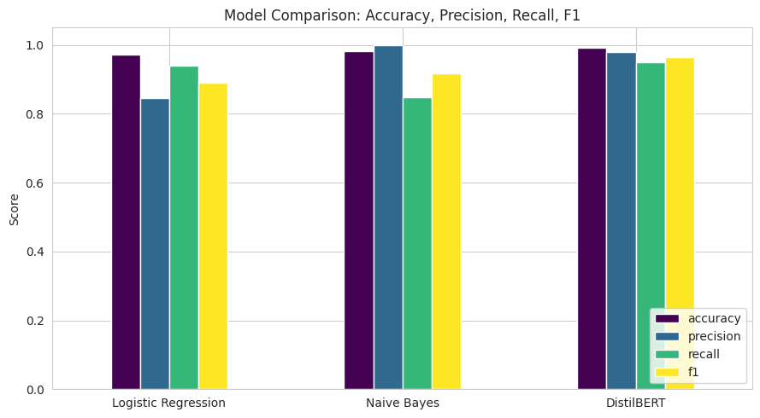
Figure 3. Accuracy, precision, recall, and F1 across all three models.
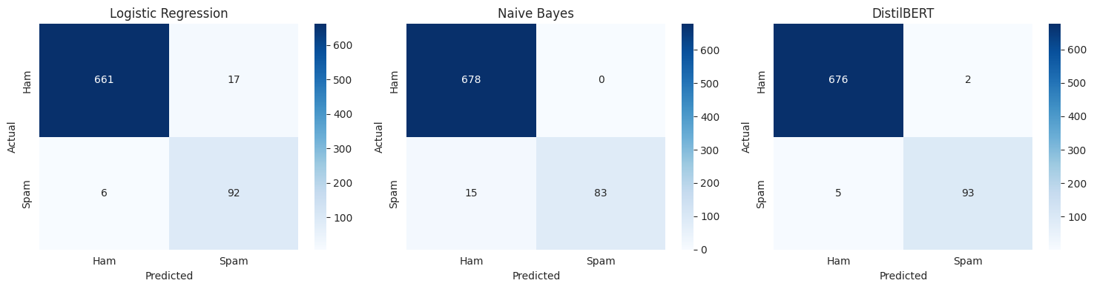
Figure 4. Confusion matrices (Logistic Regression, Naive Bayes, DistilBERT). Rows = actual, columns = predicted.

5.1 Error Pattern Discussion
Logistic Regression achieves the highest recall of the two classical models (0.939, missing only 6 of 98 spam messages) but the lowest precision (0.844, 17 false positives — legitimate messages flagged as spam). Its class_weight='balanced' setting explicitly trades precision for recall by up-weighting the minority class. Naive Bayes shows the opposite pattern: perfect precision (1.000, zero false positives) but the weakest recall (0.847, missing 15 spam messages), reflecting its independence assumption and lack of class re-weighting — it defaults toward the majority (ham) class whenever evidence is ambiguous. DistilBERT dominates on every metric simultaneously: only 2 false positives and 5 false negatives out of 776, giving both high recall and high precision at once. This is the practical advantage of contextual representations — the model can use word order and surrounding context to disambiguate cases that look lexically similar to both classes, something a bag-of-n-grams representation cannot do as effectively.

5.2 Computational Cost
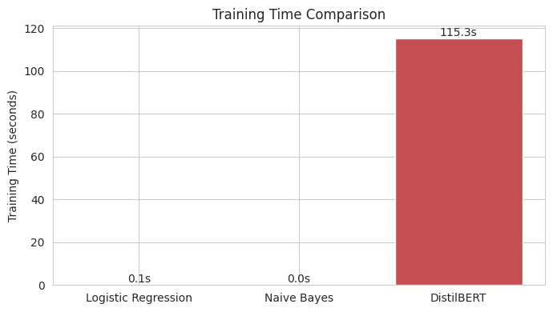
Figure 5. Training time comparison across the three models.
The classical models (Logistic Regression, Naive Bayes) train on the pre-computed TF-IDF matrix in well under a second each on CPU — essentially instantaneous, since they involve a single closed-form or convex-optimization fit over a sparse 3,617 × 5,000 matrix. DistilBERT required 115.3 seconds of wall-clock time to complete 3 epochs over 3,617 training examples with 4 of 6 transformer blocks trainable. This is a difference of roughly two to three orders of magnitude in training cost for a gain of about 1–2 accuracy points and 4–5 F1 points over the classical pipeline — the central engineering trade-off this comparison is meant to surface: the transformer's accuracy gain has a real, non-trivial compute cost, and the calculus of whether that trade-off is worth it depends on the deployment setting (offline batch scoring vs. low-latency/low-resource inference).

6. Limitations
- Dataset substitution: the assignment specifies the Kaggle “Spam Email Classification” dataset; this implementation instead uses the SMS Spam Collection dataset. Both are short, informal, binary-labeled text corpora with similar imbalance characteristics, but SMS messages and emails differ in typical length, structure (subject lines, headers, HTML/signatures in email), and vocabulary, so absolute metrics may not transfer exactly to the originally specified dataset.
- Class imbalance persists in the test set (678 ham vs. 98 spam); with only 98 positive test examples, individual misclassifications shift recall/precision by roughly one percentage point each, so the reported metrics carry non-trivial sampling variance and a single run's numbers should not be over-interpreted.
- Single-run evaluation: no cross-validation or multiple-seed averaging was performed for any model, so reported metrics are point estimates rather than distributions; results could shift moderately under a different random seed for the train/val/test split.
- Hyperparameters for DistilBERT (learning rate, batch size, epochs, freezing depth) were chosen from standard fine-tuning heuristics rather than a systematic search (e.g., grid or Bayesian search); a tuned configuration could plausibly close or widen the gap to the classical models.
- The preprocessing pipelines are asymmetric by design (aggressive cleaning for TF-IDF vs. raw text for DistilBERT), which is standard practice but means Part A and Part B are not compared on identical input text — only on identical raw examples and splits.
- Neither pipeline was evaluated for robustness to adversarial or out-of-distribution inputs (e.g., obfuscated spam, non-English text, or messages much longer than the 128-token limit used for DistilBERT).
- Training time is reported for a single hardware configuration and is not directly comparable across different machines/GPUs; it is intended to illustrate relative order-of-magnitude cost, not an absolute benchmark.

7. Conclusion
On this task, fine-tuned DistilBERT outperforms both classical TF-IDF-based classifiers on every evaluation metric, most notably by achieving high precision and high recall simultaneously where the classical models each sacrifice one for the other. That said, the classical pipeline is not a weak baseline — both Logistic Regression and Naive Bayes exceed 97% accuracy and 88%+ F1 while training in a fraction of a second, using far less compute and memory, and remaining fully interpretable (feature weights can be inspected directly). The choice between the two approaches in practice is therefore a trade-off between marginal accuracy gains and cost/interpretability, not a case where one approach is strictly superior: a resource-constrained or latency-sensitive deployment may reasonably prefer the classical pipeline, while a setting where a 1–2% error-rate reduction has high value (e.g., large-scale email filtering) can justify the transformer's added training and inference cost.

Name: Mrunmayee Thakur
Course:Artificial Intelligence

