Dear Candidate,   
  
  
Please find the online tasks for the shortlisting process. Read the following instructions carefully and complete the task within a given period of time.

* Complete minimum 5 tasks to get shortlisted for interview round
* This round will test your practical hands on skills w.r.t AWS and DevOps.
* Idea is to test your strengths rather than find your weaknesses. You can try any of the tasks. Need not be in any particular order.
* Once the task is completed kindly upload a screenshot after each question.
* Complete the task before 11.15 AM. No task will be accepted once the time is over.
* Only one task can be submitted by one person, so before submitting please review your task.

How to submit the task:   
  
Go to File >> Download this document , read the instructions given, complete the task, take a screenshot and upload it in the given space, screenshot must be included with the final result which is asked in the question, review the document, save, upload the saved documents in Google form or share the document link in given form, make sure that you have given the access to the link.   
  
  
Task 1 : Deploy Java Application on AWS 3-Tier Architecture  
  
Screenshot:

Task 2 : Deploy Scalable VPC Architecture on AWS cloud

Screenshot

Task 3 : Create a S3 bucket and upload static website content and launch a static website with public access  
  
Screenshot

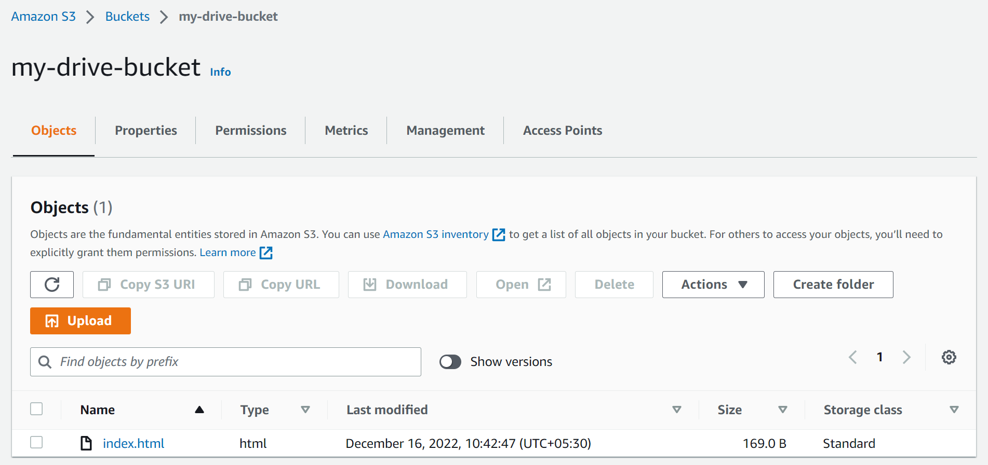



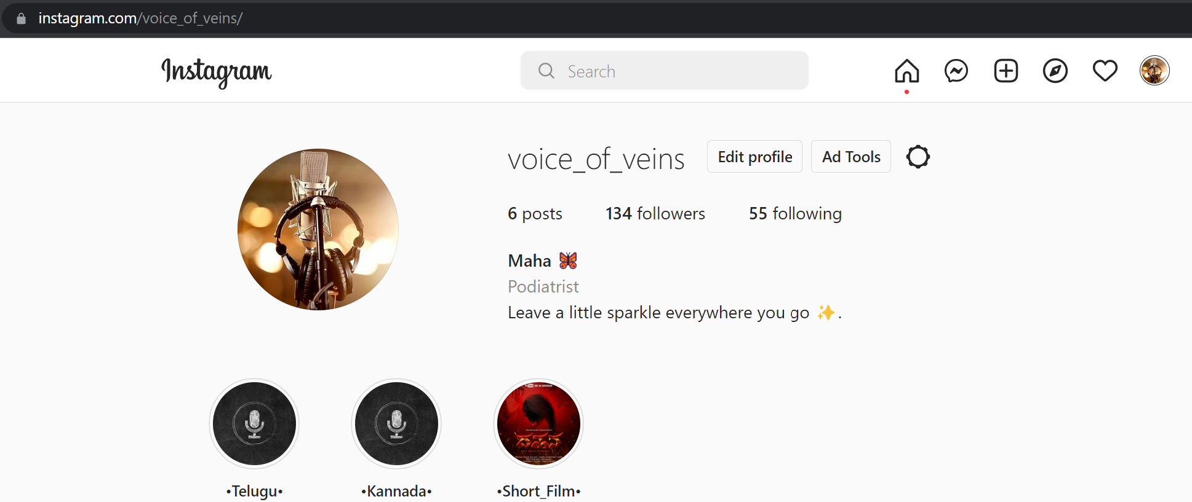

Task 4: Deploy Scalable VPC Architecture on AWS cloud  
  
Screenshot

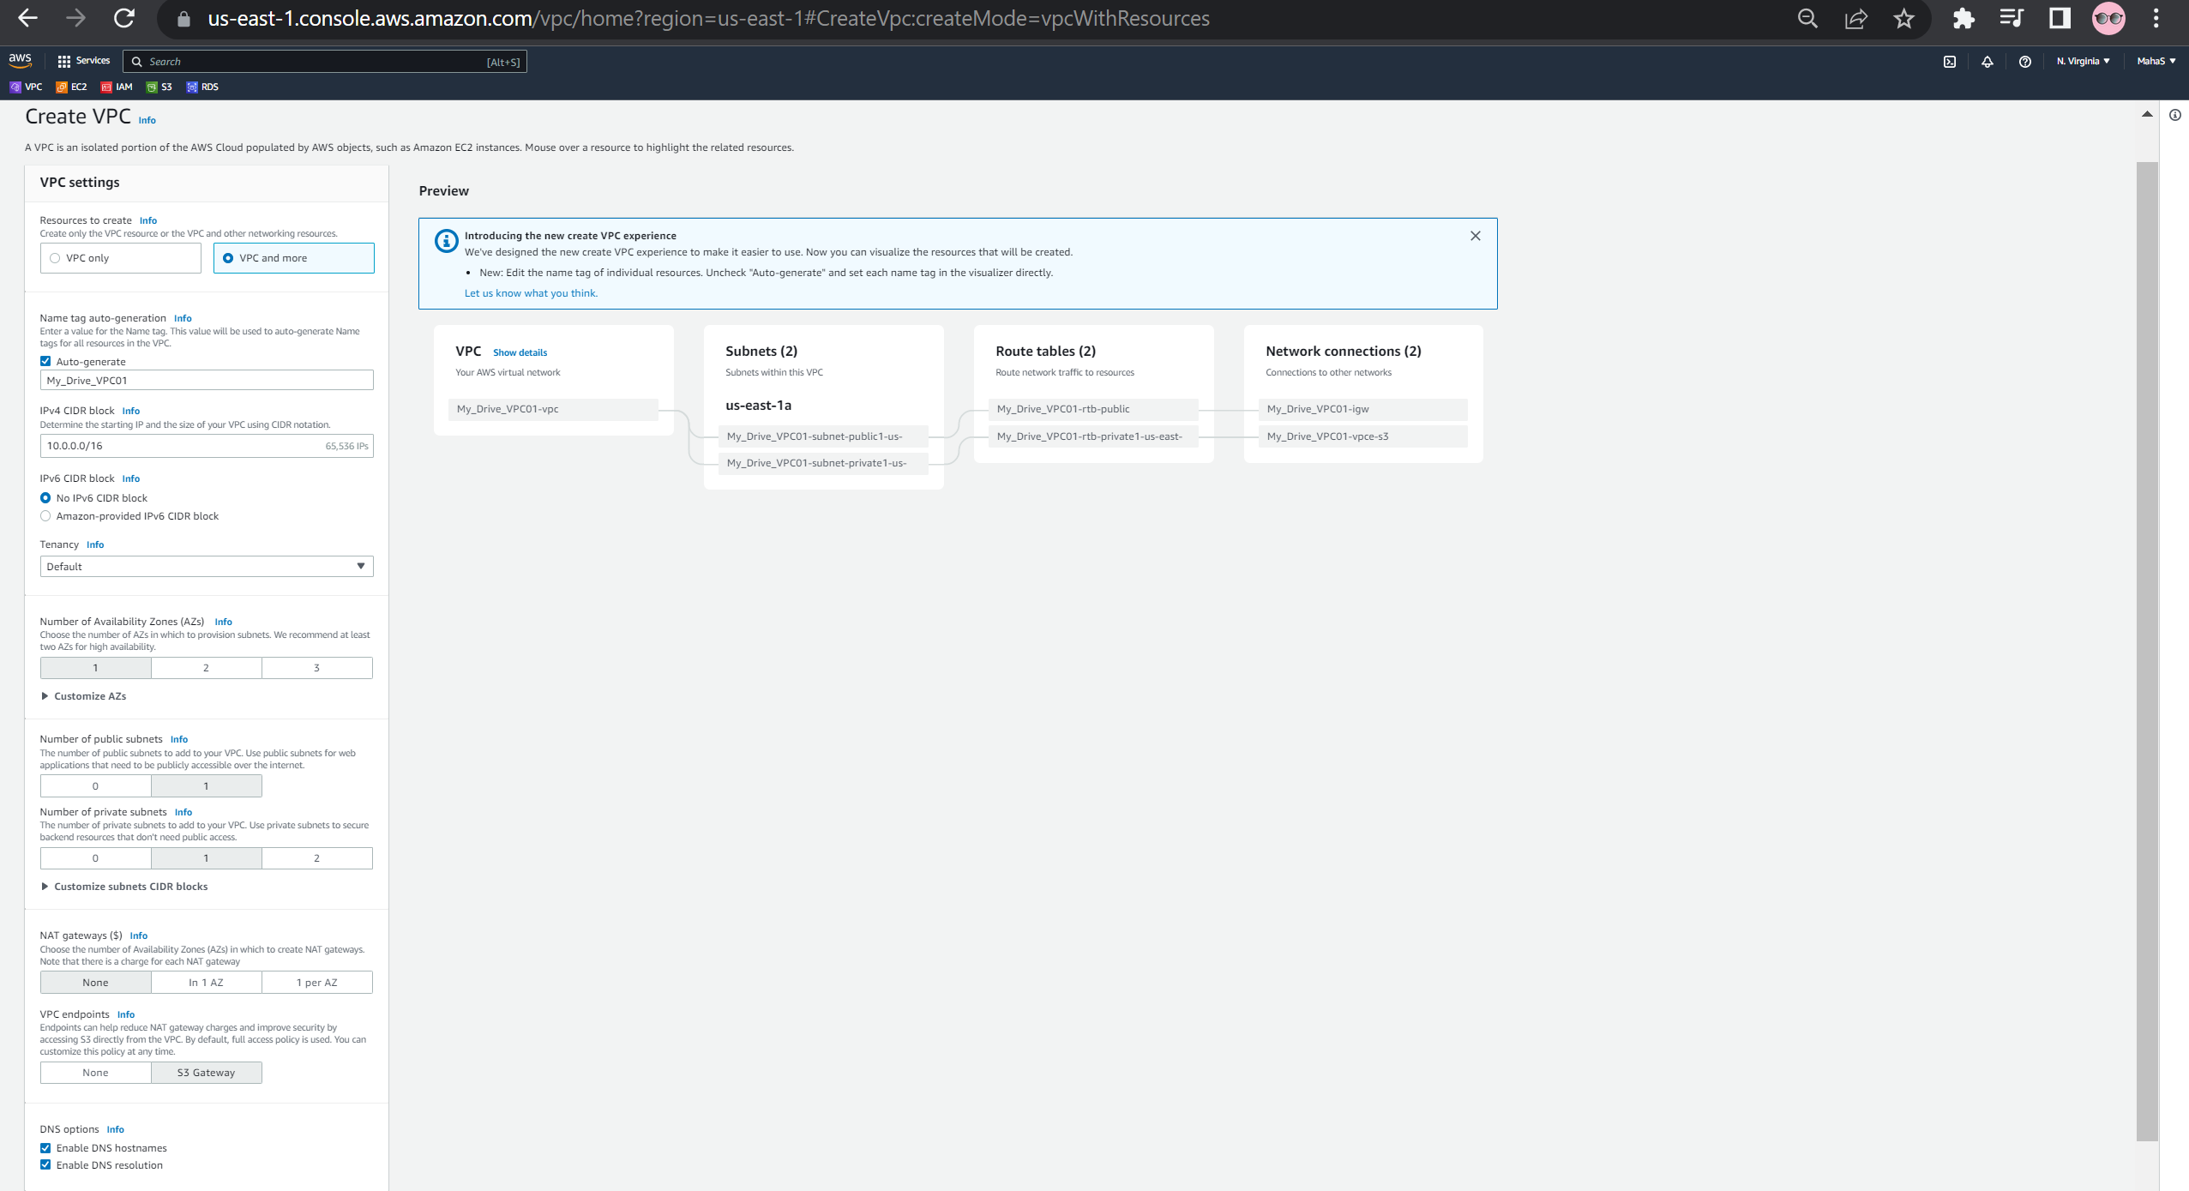

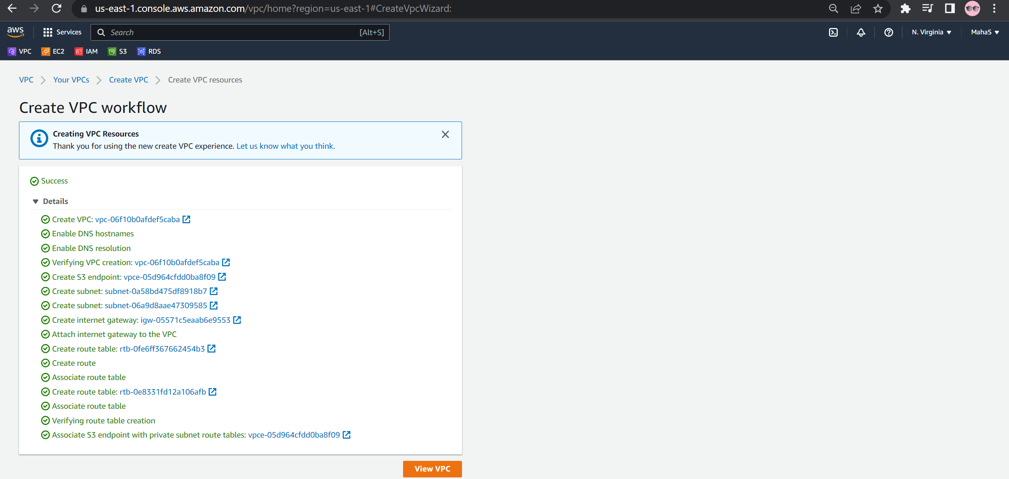

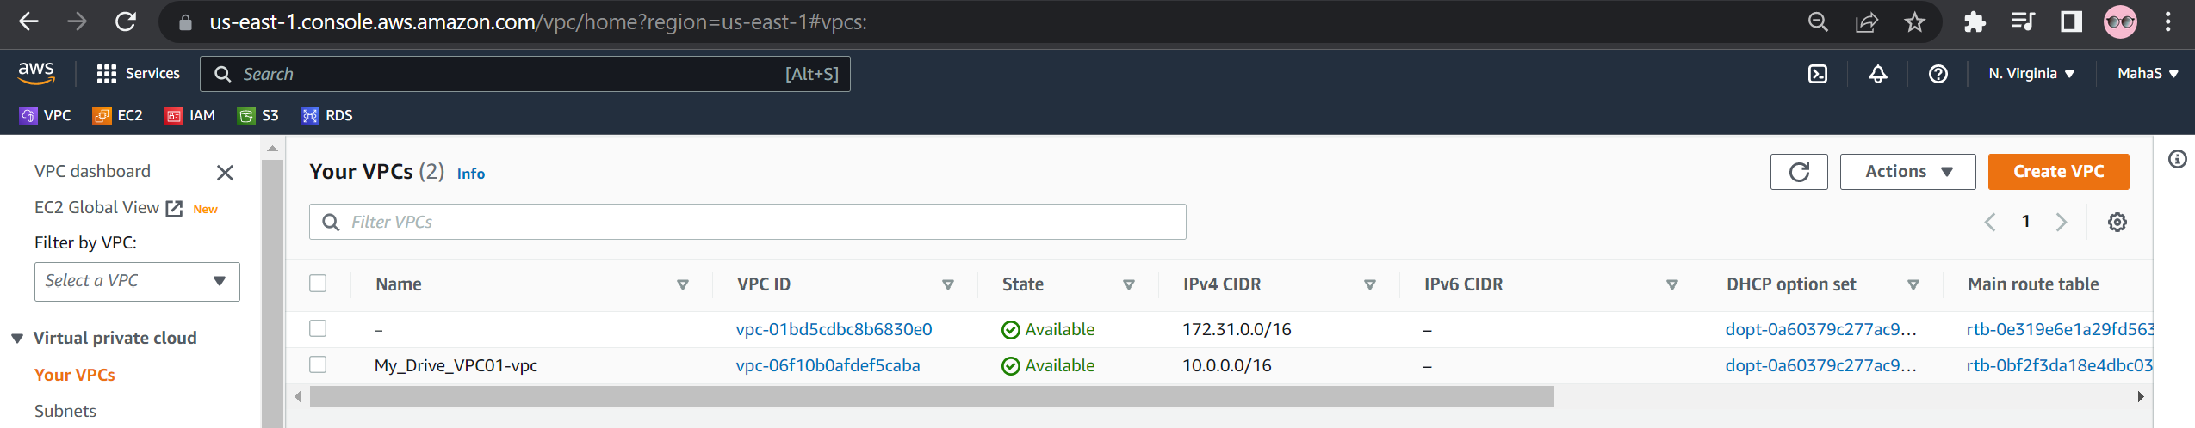

Task 5 : Deploy Disaster Recovery of Workloads on AWS: Warm Standby  
  
Screenshot

Task 6: Deploy Lambda function to create weekly EC2 AMI backup

Screensho

Task 7 : Dockerize a Java Web Application using docker-compose  
  
Screensheet

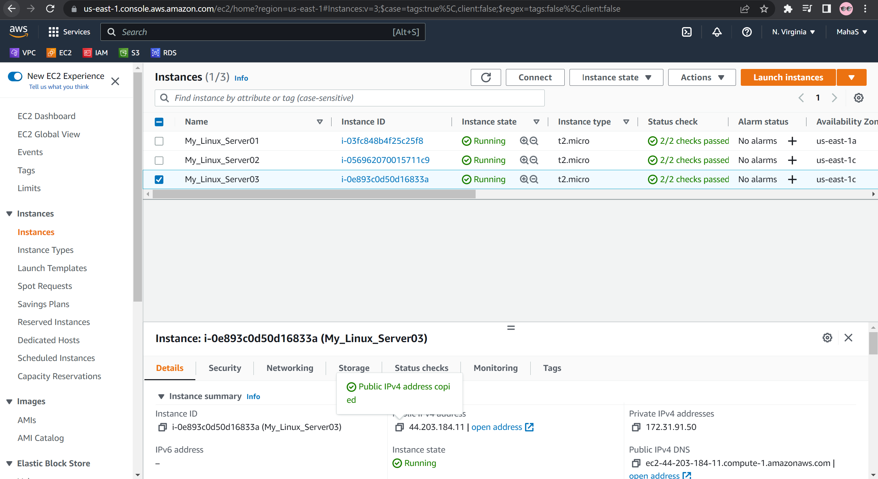

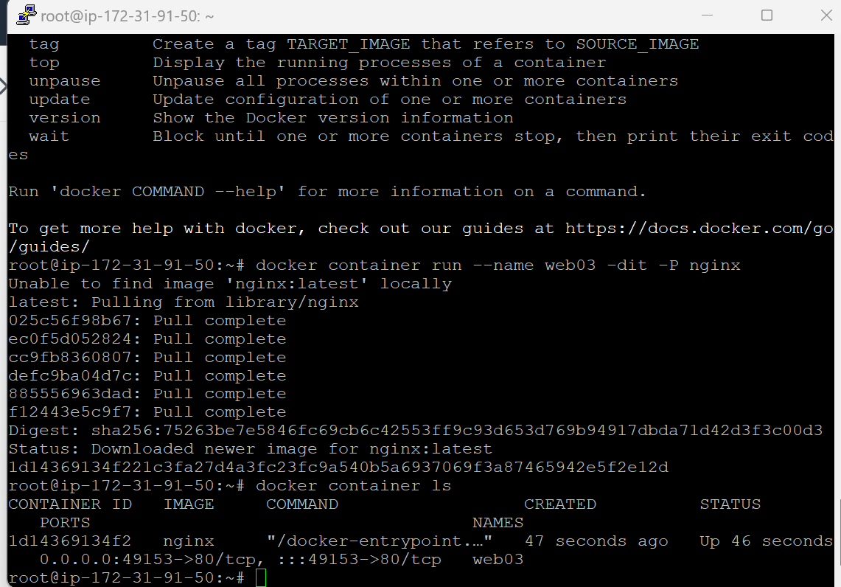

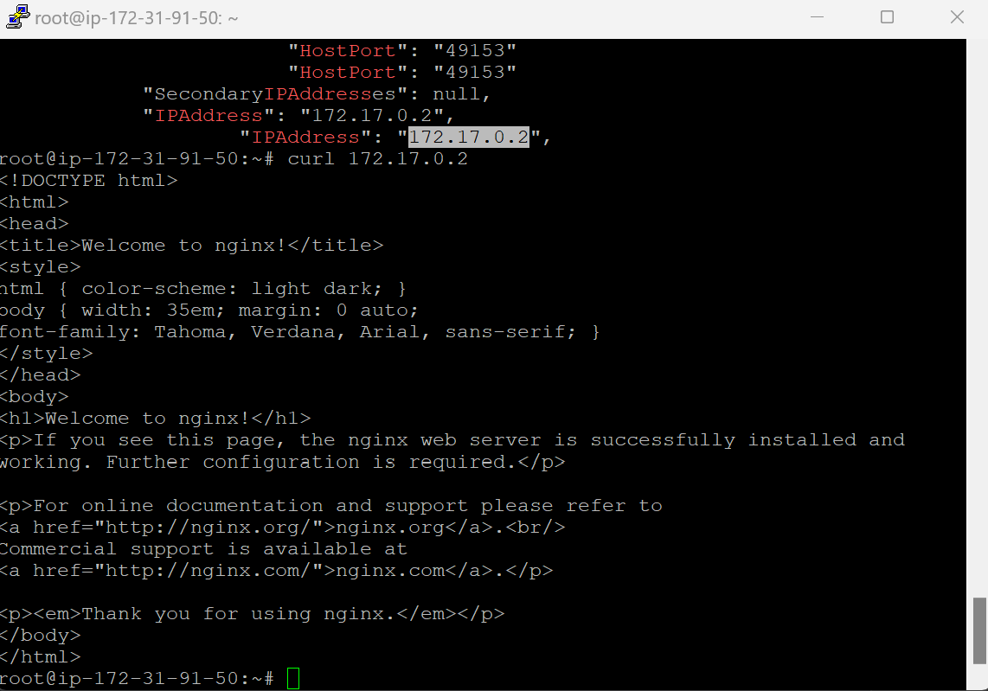

Task : 8 Deploy HTML based static web application on AWS EC2  
  
Screenshot :

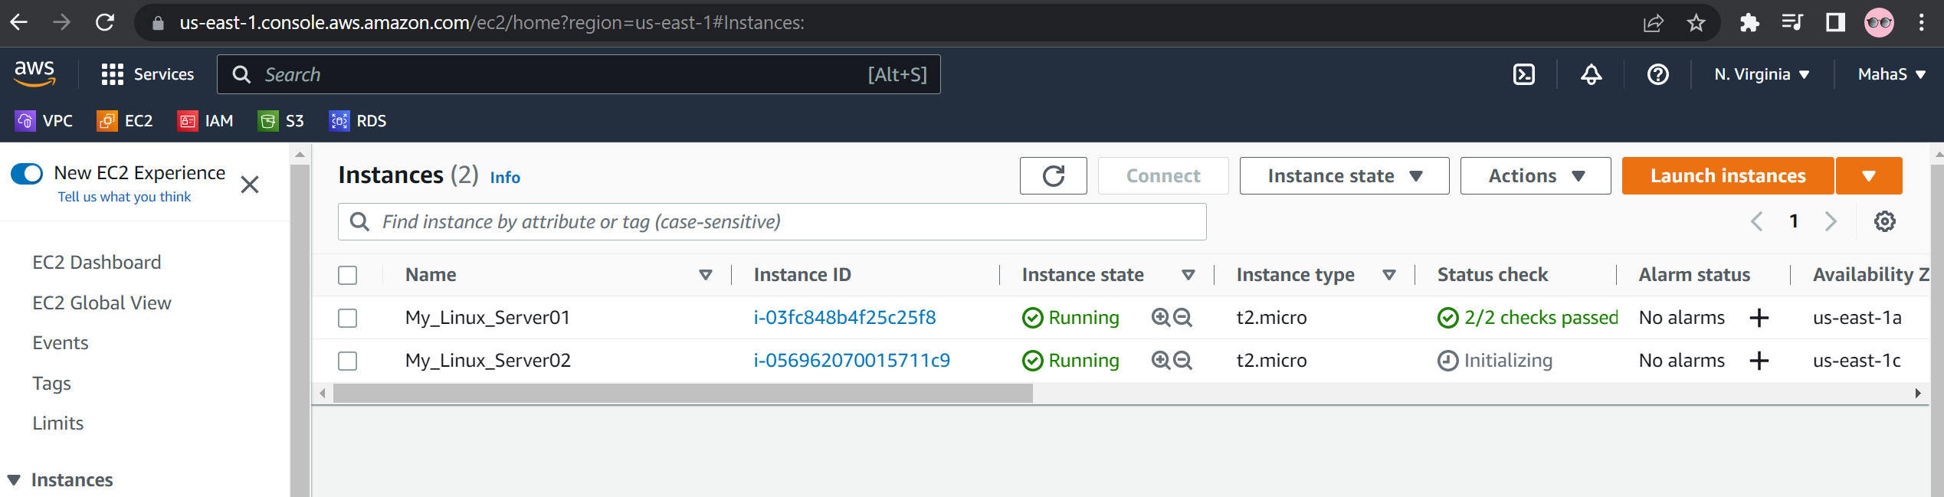

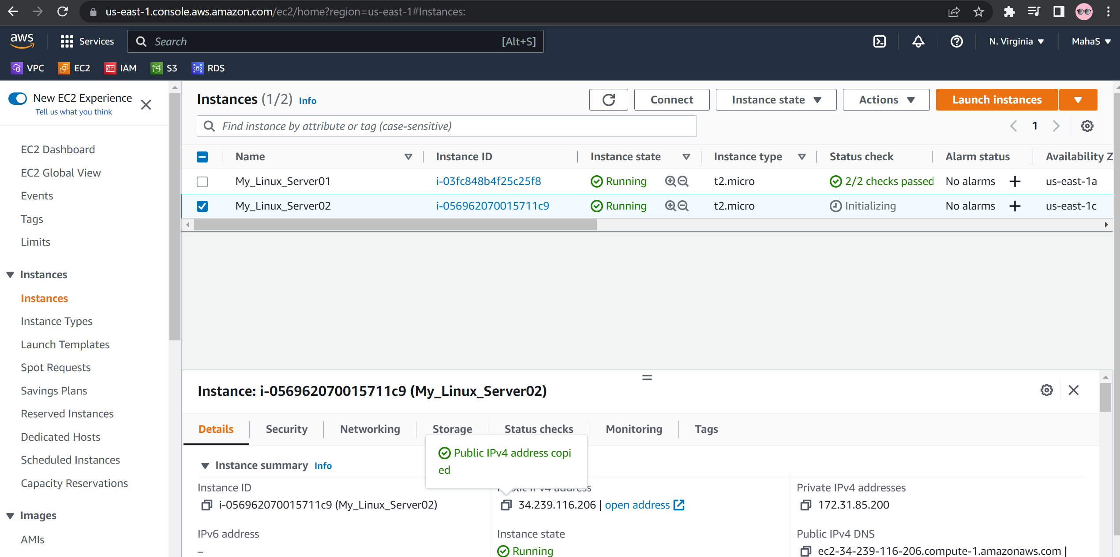

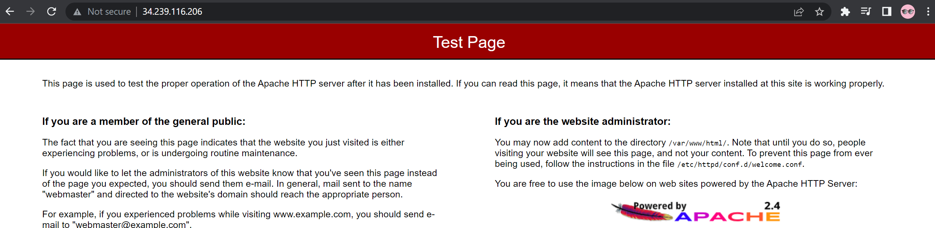

Task 9: Deploy Apache Web Server using Terraform IaC  
  
Screenshot :

Task 10: Host a basic website in a EC2 instance

Screenshot :

