**Para validar esse certificado acesse: http://2018.lapsi.latinoware.org/index.php/certified/14/1973**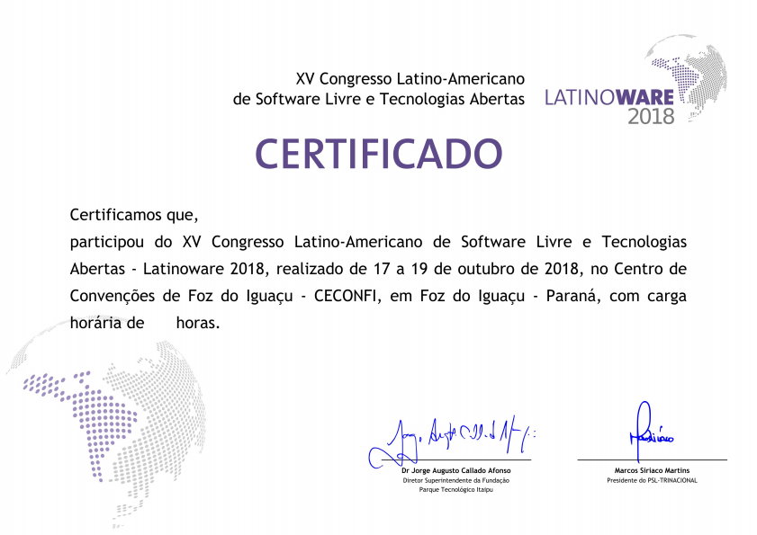

**RUAN DOS SANTOS LISBOA**

27