1. Objective and Problem Description

1.1 Dataset Description
This work uses the DIDA handwritten digit dataset (10k version), which contains approximately 10,000 labeled images of handwritten digits belonging to ten classes (0–9).
The raw images in the dataset:
- Are RGB images
- Have varying spatial resolutions
- Are not directly suitable for most classical machine learning models
All issues related to image size and color representation are addressed during preprocessing, which is described in detail in Section 2.

1.2 Problem Definition
The task is formulated as a multi-class classification problem, where each input image must be assigned exactly one label from the set {0, 1, ..., 9}.
Formally:
- Input: an image representing a handwritten digit
- Output: a single class label corresponding to the digit identity

1.3 Feature Representation
To make the data compatible with classical machine learning algorithms, each image is transformed into a numerical feature vector through the following high-level steps:
- Image resizing to a fixed resolution
- Color channel handling (RGB → grayscale or equivalent transformation)
- Flattening the final image into a one-dimensional vector
For example, a 28×28 processed image is represented as a feature vector of length 784.

Limitation of Flattening
Flattening removes the inherent two-dimensional spatial structure of the image. As a result :
- Local spatial relationships between neighboring pixels are lost
- The model cannot exploit visual patterns such as edges, strokes, or shapes directly
This limitation is particularly important when interpreting the performance of linear models and explains why more expressive models (e.g., MLPs or convolutional networks) may achieve better results.

1.4 Project Objectives
The main objectives of this project are:
- To evaluate and compare different machine learning approaches under a unified preprocessing pipeline
- To analyze how each model’s theoretical assumptions align with the characteristics of image-based data
- To understand the trade-offs between simplicity, interpretability, and predictive performance

1.5 Investigated Models
Four modeling approaches are studied:
- Linear Regression using SGDRegressor
- Direct regression on digit labels
- One-Vs-All (OVA) regression scheme
- Logistic Regression using SGDClassifier
- One-Vs-All multi-class strategy
- Gaussian Naive Bayes
- Multilayer Perceptron (MLP)
All models are trained and evaluated using the same dataset splits to ensure a fair comparison.

1.6 Evaluation Overview
Model performance is evaluated using:
- Overall classification accuracy
- Class-wise precision, recall, and F1-score
- Confusion matrices for qualitative error analysis

2. Data Preprocessing(Featuer Engineering)
Preprocessing plays a critical role in this project because the raw DIDA dataset is not directly compatible with classical machine learning models. All models in this study share the same preprocessing pipeline to ensure a fair comparison.

2.1 Image Resizing
The original DIDA images have varying spatial dimensions, which prevents direct vectorization and batch processing. Therefore, all images are resized to a fixed resolution.
- Target size: 28 × 28 pixels
- Provides a balance between information preservation and computational efficiency
- Produces a manageable feature dimension after flattening (784 features)
- Machine learning models require a constant number of input features
- Resizing ensures that every image is represented by the same number of pixels before flattening

2.2 Color Channel Handling (RGB → Grayscale)
The raw images are RGB, while most classical models do not benefit from color information for handwritten digits. As a result:
- Images are converted from RGB to grayscale
- This reduces the number of input features by a factor of three
- It focuses the models on shape and stroke intensity rather than color, which is irrelevant for digit identity
After conversion, each image contains a single intensity value per pixel.

2.3 Flattening the Image
After resizing and grayscale conversion, each image is transformed into a one-dimensional feature vector by flattening.
- A 28 × 28 image → 784-dimensional vector
- Each feature corresponds to the intensity of a single pixel
This representation enables the use of linear models, Naive Bayes, and fully connected neural networks.

Impact of Flattening
Flattening discards the 2-D spatial arrangement of pixels. Consequently:
- Neighboring pixels in the image are not explicitly treated as neighbors in the feature space
- Local patterns such as edges and curves are not modeled directly
This design choice simplifies modeling but limits the ability of models to exploit spatial structure.

2.4 Feature Scaling and Normalization
Pixel intensity values are numerical but not immediately suitable for gradient-based optimization.
Two normalization strategies are considered:
- Min–Max normalization (e.g., dividing pixel values by 255 to map them to [0,1])
- Standardization (zero mean, unit variance) using StandardScaler
For consistency:
- Standardization is applied before training linear models and MLP
- Gaussian Naive Bayes is also evaluated with standardized inputs for numerical stability
Feature scaling is especially important for:
- SGD-based models (to ensure stable and fast convergence)
- Neural networks (to prevent saturation of activation functions)

2.6 Train–Validation–Test Split
To evaluate generalization performance:
- The dataset is split into training, validation, and test sets
- Stratified sampling is used to preserve class distribution across splits
- The test set is kept completely unseen during model selection
This protocol ensures unbiased performance comparison between models.

2.7 Unified Preprocessing Pipeline
All models use the same preprocessing stages in the same order:
- Resize image
- Convert RGB → grayscale
- Flatten image
- Scale features
- Train model
Using a unified pipelin`e ensures that differences in performance are attributable to the models themselves rather than preprocessing discrepancies.

Model Analysis
  - Linear Regression (SGDRegressor)

3.1.1 Key Assumptions of Linear Regression
1- Linearity:
The target y is a linear combination of the features:
2− Independence of features:
Each feature contributes independently to the target; no strong multicollinearity.
3- Homoscedasticity:
The variance of the residuals ϵ is constant across all feature values.
4- Normality of errors:
Residuals 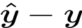 are normally distributed.
5- Continuous target variable:
The target is numeric and not categorical.

3.1.2 How These Assumptions Hold (or Fail) for Images
Let’s examine flattened 28×28 grayscale images:
- Almost all assumptions of linear regression are violated when applied directly to flattened image data.
Assumption | Reality in images | Result
Linearity | Pixels interact in complex ways to form strokes. The intensity of one pixel rarely predicts the digit label linearly. | Fails: pixel values alone cannot linearly predict digit class.
Independence of features | Neighboring pixels are highly correlated (strokes, curves, edges). | Fails: violates independence assumption.
Homoscedasticity | Variance of pixel patterns is highly non-uniform across classes. | Fails: residuals vary depending on the digit shape.
Normality of errors | The errors are discrete (digits 0–9) and non-continuous. | Fails: residuals are categorical, not continuous.
Continuous target | Digits are categorical labels (0–9). | Fails completely: treating labels as real numbers leads to meaningless predictions.

3.1.3 Why Direct Linear Regression Fails ?
1 - The model predicts continuous values, e.g., 3.7 or -1.2. Rounding them to integers does not fix misclassification.
2 - It cannot separate multiple classes effectively because linear boundaries in 784-D space cannot map categorical labels correctly.
3 - Result: 13.5% accuracy, essentially random guessing.
4 - Very high bias, almost zero variance (model underfits all digit patterns).
Linear regression cannot capture the categorical nature of the problem

3.1.4 Why OVA Linear Regression Works ?
One-Vs-All (OVA) formulation:
- Fit 10 separate regressors, one per class k:
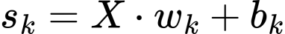
- Each regressor predicts a score for whether the image belongs to class k
- At prediction time, select the class with the highest score:
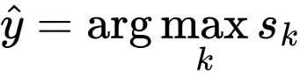
Why OVA succeeds:
- Fixes the target representation problem:
Each regressor is binary, not treating 0–9 as continuous.
2- Enables class-wise discrimination:
Each model learns to separate its class from all others, effectively creating multiple linear boundaries.
3- Reduces bias drastically:
- Accuracy jumps from 13.5% → 72.85%
- Cross-validation shows stable performance, low variance
4- Still limited by linearity:
OVA cannot capture complex pixel interactions but is good enough for coarse separation between digits.
Summary: Direct Regressin is unstable for classification , OVA fixes the categorical target issue
Direct Linear Regression :
Metric | Value
Accuracy | 13.5%
Precision (macro) | 18.08%
Recall (macro) | 13.5%
F1-score (macro) | 12.49%
Training time | 6.11 s
Linear Regression OVA :
Metric | Value
Train Accuracy | 74.71%
Test Accuracy | 72.85%
K-fold CV Train Accuracy | 75.11% ± 0.25%
K-fold CV Test Accuracy | 72.50% ± 0.77%
Precision (macro) | 73.07%
Recall (macro) | 72.85%
F1-score (macro) | 72.63%
Training time | 128.63 s

3.1.5 Observations and Discussion
1- Direct vs OVA Linear Regression
Metric | Direct | OVA
Test Accuracy | 13.5% | 72.85%
Bias | Very high | Moderate
Variance | Very low | Moderate
Training Time | 6 s | 129 s

- Accuracy jumps from 13.5% → 72.85% when using OVA
- Cross-validation shows low standard deviation, indicating stable generalization
- Bias is lower than direct regression, variance is moderate
- Training is ~20× slower than direct regression due to fitting 10 regressors, but still computationally feasible
2- Strengths of OVA Linear Regression
- Simple, interpretable
- Works reasonably well on flattened image data
- Stable cross-validation performance
3-Weaknesses / Limitations
- Cannot capture complex non-linear patterns (e.g., curved strokes, edges)
- Assumes independent contribution of each pixel, which is false for flattened images
- Slower than a single direct regressor
- Performs worse than discriminative models like logistic regression or MLP

4-Feature Selection and Extraction
Unlike Neural Networks, which often perform automatic feature extraction, traditional machine learning algorithms typically require us to manually select the input features.
However, we can automate this selection by applying L1 Regularization (Lasso). This technique penalizes the absolute size of the regression coefficients, driving the weights of less important features to exactly zero. This induces sparsity in the model, effectively filtering out irrelevant patterns.
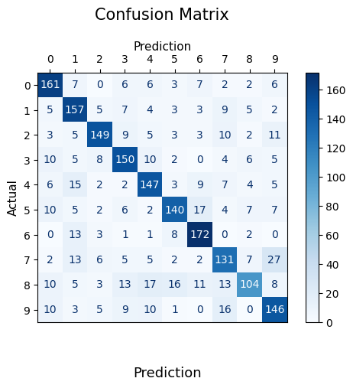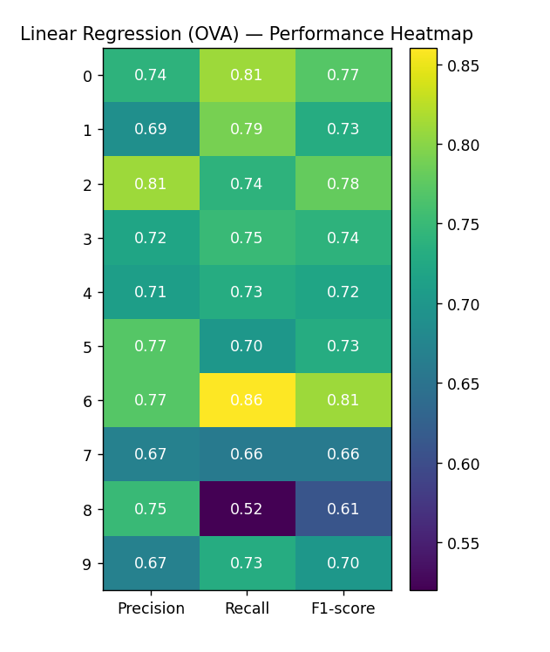
3.2 Logistic Regression (SGDClassifier with log loss)

3.2.1 Concept
Logistic regression is a discriminative model designed for classification.
1-Instead of predicting continuous values, it predicts class probabilities using the sigmoid function (binary) or softmax function (multinomial):
​
2-For multi-class problems, two common strategies are used:
- One-Vs-All (OVA): fit one classifier per class and select the class with the highest probability using sigmoid
- Multinomial (softmax): fit a single model that outputs probabilities for all classes simultaneously
- We Will consider OVA
3-Key difference from linear regression:
- Logistic regression models the probability distribution of classes instead of predicting arbitrary numeric values
- It uses cross-entropy loss, better aligned with classification objective
4-we use tolerance and max iteration criteria for determine model convergence

3.2.2 Assumptions
- Linearity in the log-odds:
The log-odds of each class is a linear function of features.
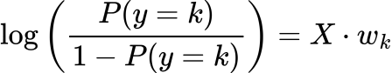
- Independent Observations
- Sufficient sample size per class:
Each class should have enough examples for stable probability estimation.
- No assuming of Normality of errors or homoscedasticity
- No Multicollinearity as Linear Regression
Why these assumptions hold better than linear regression:
- Target variable is categorical, so logistic regression naturally models classes
- Log-odds linearity is more flexible than linear regression on raw labels

3.2.3 Results (OVA / Multinomial SGDClassifier)
Metric | Value
Train Accuracy | 80.83%
Test Accuracy | 75.90%
K-fold CV Train Accuracy | 81.16% ± 0.32%
K-fold CV Test Accuracy | 75.08% ± 1.09%
Macro Precision | 75.84%
Macro Recall | 75.90%
Macro F1 | 75.79%
Training Time | 104.34 s

Observations:
- Accuracy improved over OVA linear regression (73% → 75.9%)
- Cross-validation shows low standard deviation, indicating stable generalization
- Slight train–test gap (5%) indicates some bias remains but variance is low according to standard deviation of test accuracy in k-folds (1.09%) which means stable performance.

3.2.4 Why Logistic Regression Performs Better ?
- Categorical modeling:
Logistic regression outputs probabilities rather than numeric labels, avoiding the target-representation problem of linear regression.
- Discriminative loss function:
Cross-entropy loss focuses on correctly separating classes, rather than minimizing squared error MLE (Maximize Likelihood Estimation).
- Handles overlapping distributions:
Logistic regression can learn linear boundaries in the log-odds space, which better separates classes even when pixels are correlated.
- Regularization:
- Helps prevent overfitting on highly dimensional flattened pixel data
- Controls weight magnitude to stabilize learning

3.2.5 Bias–Variance Analysis
Model | Bias | Variance
OVA Linear Regression | Moderate | Low
Logistic Regression | Lower | Slightly higher

• Logistic regression reduces bias compared to linear regression OVA because cross-entropy aligns better with the classification objective.
• Variance increases slightly because the model fits probabilities, but still manageable due to regularization.

3.2.6 Computational Considerations
- Training time: 104.34 s → slightly faster than OVA linear regression (128.63 s)
- Memory and compute requirements: modest for SGD, scalable for large datasets
- Efficient convergence with proper feature standardization (critical for SGD)

3.2.7 Summary
1- Strengths:
- Correctly handles categorical targets
- Cross-entropy loss improves decision boundaries
- Regularization stabilizes high-dimensional input learning
- Weaknesses:
- Limited to linear decision boundaries in log-odds space
- Cannot capture complex non-linear patterns like strokes or curves (needs MLP/CNN)
- Performance: 75.9% test accuracy, modest compute cost, low variance
4- Conclusion: Logistic regression is a practical, interpretable, and stable model, outperforming OVA linear regression while remaining efficient.
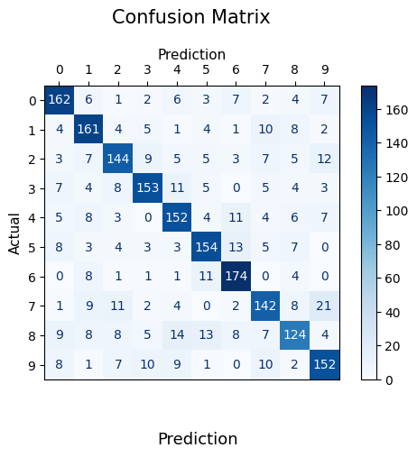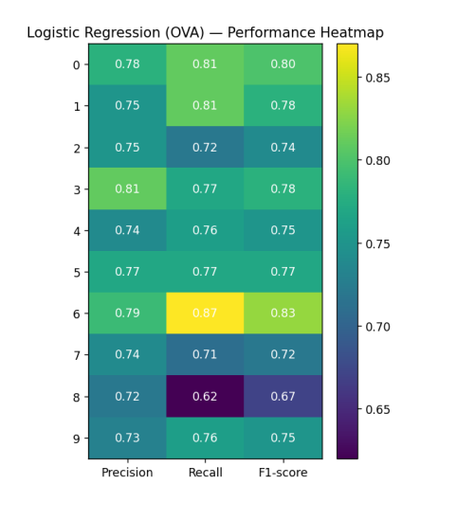

3.3 Gaussian Naive Bayes (GaussianNB)

3.3.1 Concept
Gaussian Naive Bayes (GNB) is a generative probabilistic model:
- Assumes each feature ​ is conditionally independent given the class
- Models each feature as a Gaussian distribution
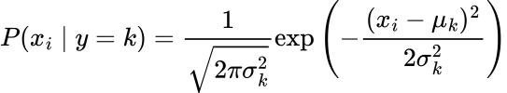
- Class probability is computed using Bayes’ theorem:
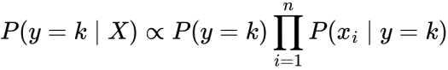
- Prediction: select class with highest posterior probability.
5- Sicket learn apply log probability and convert to summation to avoid underflow problems of multiplying low probabilities

3.3.2 Key Assumptions
- Feature independence:
Each pixel is assumed to contribute independently to the class probability.
- Gaussian distribution of features per class:
Each pixel value across images of the same digit is normally distributed.
- Sufficient data per class:
Needed to estimate mean () and variance (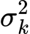) reliably.
3.3.3 How Assumptions Hold (or Fail) in Flattened Images
the strong violation of independence is the main reason for poor performance , this the reason why we call it “Naive”.
Assumption | Reality in images | Result
Feature independence | Adjacent pixels are highly correlated (strokes, edges) | Fails — the independence assumption is strongly violated
Gaussian distribution per feature | Pixel intensities are bounded [0,255] and skewed depending on stroke | Fails partially — not perfect Gaussian
Sufficient data per class | DIDA 10k has ~1k images per class | Holds — enough samples for mean/variance estimation
3.3.4 Results
Metric | Value
Train Accuracy | 53.05%
Test Accuracy | 51.40%
K-fold CV Train Accuracy | 53.34% ± 0.33%
K-fold CV Test Accuracy | 51.17% ± 0.74%
Macro Precision | 54.26%
Macro Recall | 51.40%
Macro F1 | 51.65%
Training Time | 4.45 s
Observations:
- Test accuracy barely above random (10% baseline for 10 classes) , if I know nothing then baseline probability for each class is ‘0,1’, theoretical minimum .
- Very low train–test gap (~1–2%) → model underfits severely
- Cross-validation stddev is tiny → model is stable but biased
- Extremely fast training → suitable for very large datasets if approximate performance is acceptable

3.3.5 Why GaussianNB Performs Poorly
1-Violates independence assumption:
- Flattened pixels are highly correlated → probabilities are misestimated
- Multiplying many correlated probabilities produces unreliable posteriors
2-Cannot model feature interactions:
- Digit shapes depend on pixel patterns (edges, curves) → GNB ignores them
- Linear or discriminative models handle such patterns better
3-Overly simplistic:
- Only captures mean/variance of each pixel per class
- Fails to separate complex class boundaries
3.3.6 Bias–Variance Analysis
Model | Bias | Variance
GaussianNB | Very high | Very low
• High bias: cannot fit the training data well (~53% train accuracy)
• Low variance: stable predictions across folds and test set; model underfits consistently
• Essentially a fast but inaccurate classifier for flattened image data

3.3.7 Summary
1-Strengths:
- Extremely fast
- Requires minimal tuning
- Stable (low variance)
2-Weaknesses:
- Strong independence assumption violated → low accuracy (~51%)
- Cannot capture pixel interactions or class boundaries

3-Conclusion:
GaussianNB is unsuitable for flattened image-based digit classification, but its low computational cost makes it a baseline or quick sanity check.
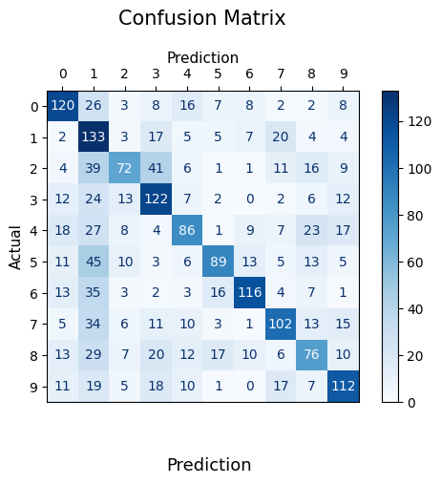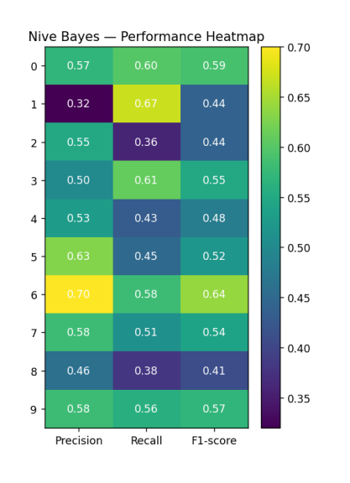
3.4 Multilayer Perceptron (MLP)
3.4.1 Concept
A Multi-Layer Perceptron (MLP) is a feedforward neural network that learns non-linear mappings from input features to class probabilities by stacking transforms and elementwise non-linearities. For a 10-class digit problem the network uses a final softmax layer to produce class probabilities:
​
where fff is the composition of linear layers and activation functions parameterized by .

3.4.2 Assumptions
- No explicit independence assumptions between features.
- The model assumes there exists a (possibly complex) non-linear function mapping inputs to class logits that can be approximated by the network given sufficient capacity and data.
- Requires enough labeled data and properly scaled inputs for stable training.

3.4.3 Why an MLP fits image data ?
Handwritten digit images are high-dimensional (784 features) and exhibit strong non-linear relationships:
- Class boundaries are not linearly separable
2- Local pixel dependencies are complex
3- Captures non-linear feature interactions (pixels → strokes → shapes).
4- Learns hierarchical features via hidden layers; no need for manual feature engineering.
5- Does not rely on the independence or linearity assumptions that break for flattened images.

3.4.4 Architecture intuition
MLP typically consists of:
- Input layer: 784 neurons (flattened 28×28 image)
- Hidden layers: tow layers with non-linear activation ( ReLU)
- Output layer: 10 neurons with Softmax (one per digit)
Each hidden layer:
- Combines pixels into abstract features (strokes → shapes → digits)
- Applies non-linear transformations impossible for linear models

3.4.5 Effect of Activation Function Choice on Convergence and Accuracy
The choice of activation function plays a critical role in both optimization dynamics and final classification performance in neural networks. Three commonly used activation functions—Sigmoid, Tanh, and ReLU—were experimentally evaluated under the same network architecture and training settings.
Activation Function | Test Accuracy | Convergence Iterations | Observations
Sigmoid | 80% | ~400 | Slow convergence, early saturation
Tanh | 79% | ~120 | Faster than sigmoid, still saturates
ReLU | 84% | ~80 | Fastest convergence, best accuracy

Sigmoid Activation
- Outputs values in the range (0, 1).
- Suffers from gradient saturation when inputs are very positive or negative.
- Leads to vanishing gradients, especially in deeper networks.
- Slower convergence and reduced final accuracy observed.
Impact in this task:
Sigmoid required approximately 400 iterations to converge and reached 80% accuracy, indicating optimization difficulty and limited representational efficiency.
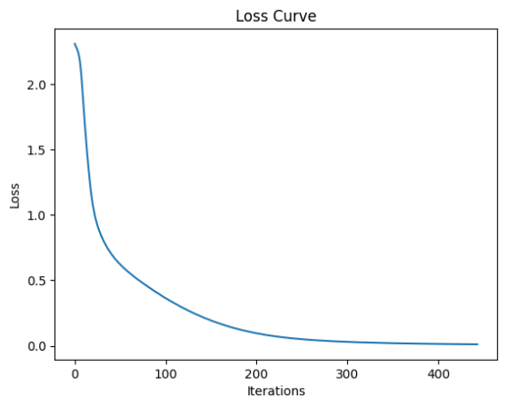

Tanh Activation
- Outputs values in the range (−1, 1).
- Zero-centered, which improves optimization compared to sigmoid.
- Still prone to saturation at large input magnitudes.
Impact in this task:
Tanh converged significantly faster (~120 iterations) than sigmoid but achieved slightly lower accuracy (79%), suggesting improved optimization but limited expressiveness under saturation.
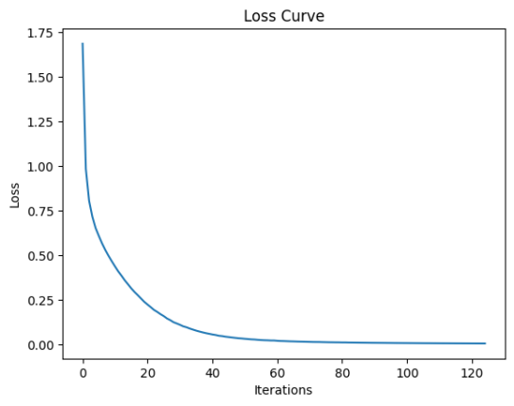

ReLU Activation
- Defined as
- Does not saturate for positive inputs, preserving gradient flow.
- Enables deeper networks to train effectively.
- Encourages sparse activations, improving generalization.
Impact in this task:
ReLU converged the fastest (~80 iterations) and achieved the highest accuracy (84%), confirming its superiority for this image classification task.
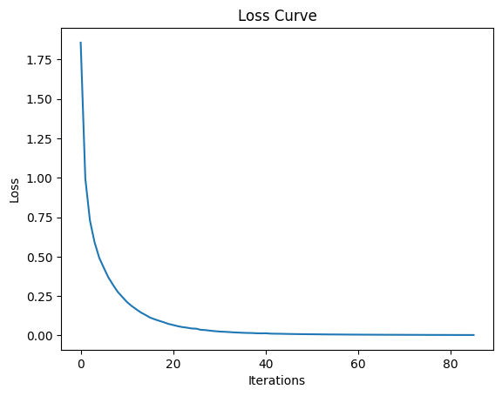

Interpretation and Relation to Vanishing Gradient Problem
- Sigmoid and tanh both compress inputs into narrow ranges, causing gradients to shrink as depth increases.
- ReLU avoids this issue by maintaining a constant gradient for positive activations.
- Faster convergence directly translates into better optimization and higher final accuracy.

3.4.6 Tunned Hyperparameters
Hyperparameter | Purpose | Effect
ReLU activation | Avoid vanishing gradients | Maintains gradient flow in deep layers
Two hidden layers (512, 256) | Increase model capacity | Captures complex non-linear digit patterns
SGD optimizer | Scalable optimization | Efficient for large datasets
Adaptive learning rate | Stable training | Decreases learning rate when improvement stalls
Initial LR = 0.01 | Fast early learning | Balanced speed and stability
Batch size = 32 | Noisy gradient updates | Improves generalization
Alpha = 0.2 (L2 regularization) | Control overfitting | Penalizes large weights
Early stopping | Prevent overfitting | Stops training when validation loss increases

3.4.7 Results
Measure | Value
Training accuracy | 98.74%
Test accuracy | 89.10%
Macro precision | 89.1758%
Macro recall | 89.10%
Macro F1 | 89.0700%
Training time | 1880.75 s
K-fold CV Train Accuracy | 98.80% ± 0.14%
K-fold CV Test Accuracy | 87.22% ± 1.20%
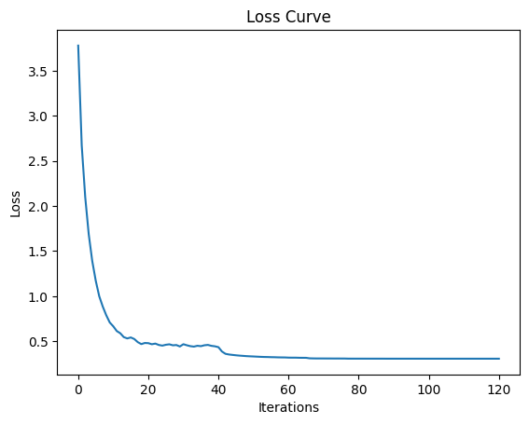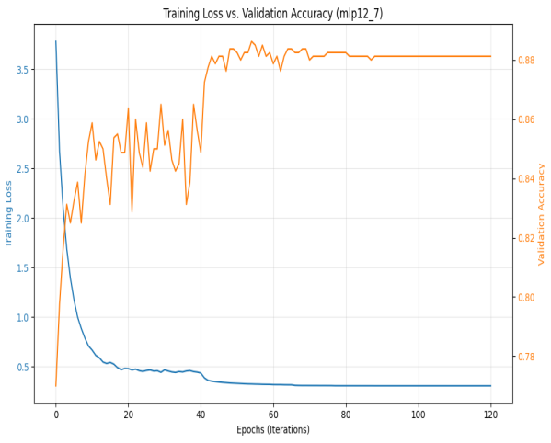

3.4.8 Why MLP can still be limited ?
- Requires careful hyperparameter tuning (architecture, learning rate, regularization).
- Prone to overfitting if capacity is large relative to data or if regularization is insufficient.
- Computationally expensive to train compared to linear models.
- Still does not exploit 2-D spatial locality as efficiently as a convolutional network (CNN) when fed flattened inputs.

3.4.9 Analysis (Bias / Variance / Stability)
- Bias: Low. Very high training accuracy (≈98.8%) shows the model has enough capacity to fit training data closely.
- Variance: Moderate. The train → test gap ≈ 9.6 percentage points (98.74 → 89.10) indicates overfitting to the training set to some degree. However, theCV test std ≈ 1.2% indicates that performance across folds is stable (the model generalizes consistently across different splits).
- Net interpretation: The MLP has low bias (expressive model) and moderate variance (some overfitting), but the combination still yields the best test performance among studied models.

3.4.10 Computational cost
- Training time ≈ 1880.8 s, much larger than linear/discriminative models.
- Memory usage and training time scale with the number of parameters (here large due to 512 + 256 hidden units).
- Tradeoff: substantially higher compute in exchange for significantly higher accuracy

3.4.11 Summary
- The Multilayer Perceptron (MLP) was the best-performing model in the digit classification task. Unlike linear and probabilistic models, the MLP can learn non-linear relationships between pixels, which is essential for image data.
- After tuning, the final model used ReLU activation, two hidden layers (512, 256), SGD , adaptive learning rate, L2 regularization, and early stopping. This configuration achieved a test accuracy of 89.1%, with stable cross-validation performance (≈87.2% average test accuracy).
- Experiments with different activation functions showed that ReLU outperformed sigmoid and tanh, converging faster and achieving higher accuracy. ReLU reduced the vanishing gradient problem, leading to more efficient training.
- The MLP showed low bias and moderate variance, reflected by a train–test gap of about 9–10%. Cross-validation results confirmed that this gap is due to limited overfitting rather than instability.
- The main drawback of the MLP is its high computational cost, but this is justified by the significant improvement in accuracy.

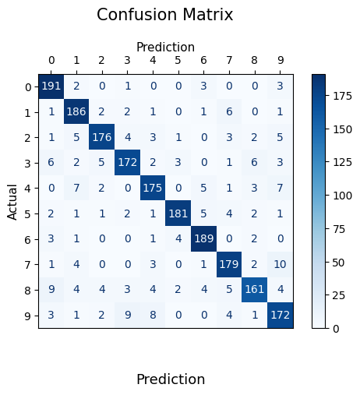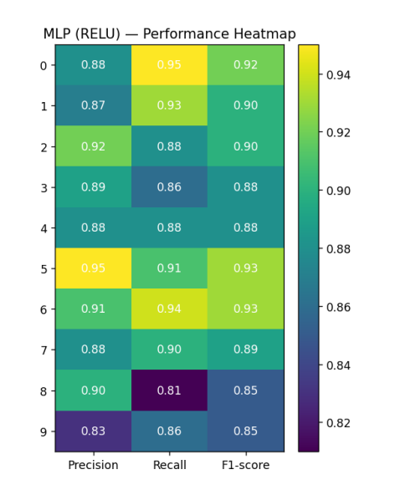

3.5 Trade-offs accuracy
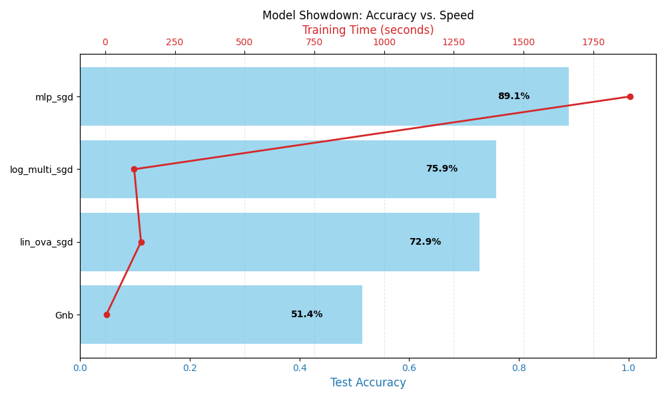

4. Conclusion

Model | Key Assumptions | Performance | Bias | Variance | Computational Cost | Final Verdict
Direct Linear Regression | Linear relationship, continuous output | Very poor (≈13.5%) | Very High | Low | Low | Not suitable for classification
Linear Regression + OVA | Linear separability per class | Moderate (≈72.9%) | High | Low | Medium | Improves baseline but limited
Logistic Regression (OVA) | Linear decision boundaries, probabilistic outputs | Good (≈75.9%) | Medium | Low | Medium | Strong linear classifier
Gaussian Naive Bayes | Pixel independence, Gaussian distribution | Low (≈51.4%) | High | Very Low | Very Low | Fast but over simplistic
MLP (ReLU) | Minimal assumptions, non-linear modeling | Best (≈89.1%) | Low | Moderate | Very High | Best overall model
Key Takeaways
Aspect | Conclusion
Best accuracy | MLP (ReLU)
Fastest training | Gaussian Naive Bayes
Lowest variance | Naive Bayes
Best linear model | Logistic Regression
Worst fit for images | Direct Linear Regression
Best bias–variance tradeoff | MLP

Final Statement
The results demonstrate that model assumptions strongly influence performance on image data. Linear and probabilistic models suffer from restrictive assumptions that do not align with the spatial and non-linear nature of images. The MLP, by relaxing these assumptions and learning hierarchical representations, achieves the best performance at the cost of increased computational resources.

