Amit Machine Learning Training

Task Research

BY: Mrwan Medhat Ibrahim

All examples code is in example.ipynb

# Magic or Dunder Methods in python

Are the methods having two prefix and suffix underscores in the method name. Dunder here means “Double Under (Underscores)”. These are commonly used for operator overloading. Few examples for magic methods are: __init__, __add__, __len__, __repr__ etc.

The __init__

method for initialization is invoked without any call and  acts as a class constructor used to pass initial arguments to a Python class.

Clean up class instantiation with del

This method will run any time you call del on a class instance. This is particularly useful whenever you have an I/O operation in the constructor in order to cleanup said I/O operations

__new__() method

. In Python the __new__() magic method is implicitly called before the __init__() method. The __new__() method returns a new object, which is then initialized by __init__().

__str__() method

It is overridden to return a printable string representation of any user defined class. We have seen str() built-in function which returns a string from the object parameter. For example, str(12) returns '12'. When invoked, it calls the __str__() method in the int class.

__add__() method

the magic method __add__() is overridden, which performs the addition of the ft and inch attributes of the two objects. The __str__() method returns the object's string representation.

__ge__() method

Is a magic method to overload operators

**Python *args**

*args parameter in a function definition allows the function to accept multiple arguments/values without knowing how many arguments,

Datatype of args is tuple,

to access all args we use for loops or accessing single value by indexing

Example:

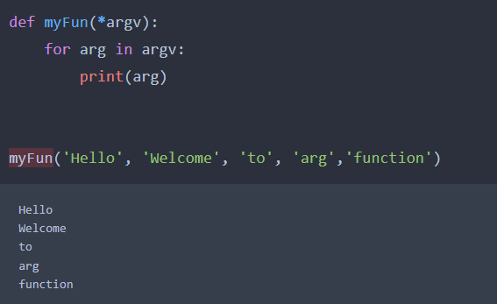

# **Python **kwargs**

****\*\*kwargs**** allows function call to pass variable number of **k**ey**w**ord (named) **arg**uments to the function

The datatype of kwargs is dictionary.

keywords and respective argument values come as key

Double asterisk ** before kwargs is the unpacking operator. It unpacks the arguments passed to the function, as dictionary.

Example:

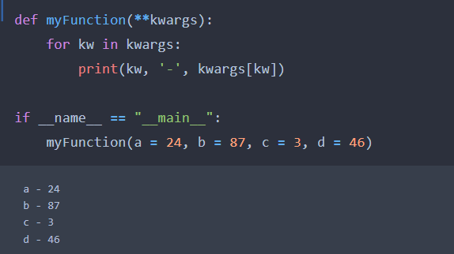

**Abstraction in Python**

It is a way to hide internal functionality of a function from users

It is used to reduce complexity and enhances the application efficiency

abstraction can be achieved by using abstract classes and interfaces in python ,class that consists of one or more Abstract method is called abstract class, And do not contain their implementation ,Abstract class can be inherited by the subclass and abstract method gets its definition in the subclass

Example:

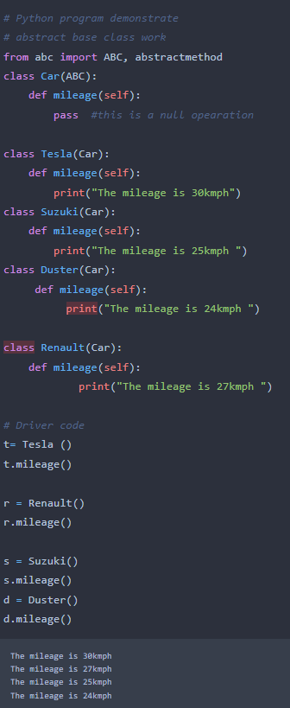

**Encapsulation in Python**

Encapsulation is one of the fundamental concepts in object-oriented programming (OOP) ,the idea of wrapping data and the methods that work on data within one unit

Used To prevent accidental change,

an object’s variable can only be changed by an object’s method.

Those types of variables are known as private variables

For Example:

