重庆邮电大学
毕业设计（论文）
（附件）

英文翻译

 | 学院名称 | 人工智能学院
 | 学生姓名 | 钱信宇
 | 专 业 | 数据科学与大数据技术
 | 班 级 | 04082202
 | 学 号 | 2022211756

2026 年 5月

英文原文

Crash risk by driver age, gender, and time of day using a new exposure methodology

Abstract
Introduction: Concerns have been raised that the nonlinear relation between crashes and travel exposure invalidates the conventional use of crash rates to control for exposure. A new metric of exposure that bears a linear association to crashes was used as basis for calculating unbiased crash risks. This study compared the two methods - conventional crash rates and new adjusted crash risk - for assessing the effect of driver age, gender, and time of day on the risk of crash involvement and crash fatality. Method: We used police reports of single-car and multi-car crashes with fatal and nonfatal driver injuries that occurred during 2002-2012 in Great Britain. Results: Conventional crash rates were highest in the youngest age group and declined steeply until age 60-69 years. The adjusted crash risk instead peaked at age 21-29 years and reduced gradually with age. The risk of nighttime driving, especially among teenage drivers, was much smaller when based on adjusted crash risks. Finally, the adjusted fatality risk incurred by elderly drivers remained constant across time of day, suggesting that their risk of sustaining a fatal injury due to a crash is more attributable to excess fragility than to crash seriousness. Conclusions: Our findings demonstrate a biasing effect of low travel exposure on conventional crash rates. This implies that conventional methods do not yield meaningful comparisons of crash risk between driver groups and driving conditions of varying exposure to risk. The excess crash rates typically associated with teenage and elderly drivers as well as nighttime driving are attributed in part to overestimation of risk at low travel exposure. Practical Applications: Greater attention should be directed toward crash involvement among drivers in their 20s and 30s as well as younger drivers. Countermeasures should focus on the role of physical vulnerability in fatality risk of elderly drivers.
Keywords: Crash rates, Age, Sex, Time of day, Low-exposure bias Age Sex Time of day Low-exposure bias

1. Introduction
Road traffic collisions are a major global health concern. They account for more than 1.2 million deaths worldwide each year and an even larger number of serious injuries. Obtaining a better understanding of the factors that contribute to driver crash risk is critical for the development of effective road safety policies and initiatives. A wealth of road safety research has assessed driver characteristics, such as age and gender, linked to elevated crash risk. These studies have typically shown that the youngest and oldest drivers have much higher fatal and non-fatal crash risks than drivers in the middle-age ranges. Several studies have also found differences in fatal and nonfatal crash risks among subgroups of older drivers. For example, there is evidence that drivers aged 70-74 exhibit lower crash risk relative to drivers aged 75-79, with the highest risk seen in drivers aged 80 and older. Road safety research has also addressed associations between driver gender and elevated crash risk. In general, female drivers are considered safer than male drivers. However, some studies suggest that while women tend to have fewer fatal crashes than men do, their risk of injury crashes may be higher. Journal of Safety Research younger age ranges. The risk of crash involvement also appears to vary with environmental factors, such as time of day. Crash risk is higher for nighttime compared with other times of day, with the difference being more pronounced for male drivers and at younger ages. Time of day has also appeared to be associated with crash severity, as drivers are more likely to sustain a fatal injury due to nighttime crashes compared to daytime crashes, particularly among the younger age groups. It is well recognized that in order to allow for meaningful comparisons of crash risk among driver groups or driving environments, it is necessary to take into account their differences in intensity of travel exposure. If travel exposure is not controlled for, one cannot determine whether a higher number of crashes for a particular group (or environment) is due to a greater tendency for crash involvement or to greater exposure to travel situations that may result in a crash. Traditionally, researchers have accounted for differences in exposure by dividing the crash counts of a particular driver group (e.g., age, gender) by either their annual travel, their group size in number of licensed drivers, or a combination of travel and group size. However, the use of crash rate to account for differences in driving exposure is appropriate as long as crash counts increase proportionally with increased driving exposure. That is, when the association between crash frequency and driving exposure, known as the ‘safety performance function,’ is linear. Crash rate can be defined as the slope of the line from the origins to a particular point on the safety performance function. If the safety performance function is non-linear, then crash rate will vary at different exposure levels. Consequently, crash rates would not allow for meaningful risk comparisons among driver groups or driving conditions with varying levels of exposure. Importantly, numerous road safety researchers reported that the relationship between annual crash counts and driving exposure is in fact nonlinear. Specifically, the relationship is often described as following a broadly logarithmic curve, with an initial rapid increase in crash counts at low exposure levels followed by gradually slowing down and finally flattening out at high exposure levels. As a result, as the distance driven increases, the crash rate per distance driven declines. Thus, it is a common finding in the literature that low-mileage drivers have greater crash rate than high-mileage drivers. There are several possible explanations for the nonlinearity of the safety performance function. First, high-mileage drivers clock a greater proportion of their miles on freeways, whereas low-mileage drivers tend to restrict their travel to relatively hazardous urban roads. Second, high-mileage drivers accumulate greater driving experience than low-mileage drivers and therefore may possess better driving skills. Finally, older drivers with visual or physical impairments tend to reduce their driving exposure; thus, a low-mileage group might include a larger number of impaired drivers who are more inclined to be involved in crashes. Regardless of the underlying reasons, the exposure-crash relationship is nonlinear, and hence crash rates become smaller with increased driving exposure. Because of this, concerns have been raised in the road safety literature that the use of crash rates may lead to biased risk comparisons when driver groups or driving conditions vary greatly in their travel exposure. Accordingly, differences in crash rate between groups or driving conditions may reflect variation in exposure rather than variation in crash tendency. Consequently, the rate-based method may lead to overestimation of crash risk for low-exposed drivers, and underestimation for high-exposed drivers. A common finding in the literature is that young and elderly drivers have lower driving exposure than other age groups in terms of distance traveled and number of license holders. It follows that in the case of age group comparisons, the use of crash rates may lead to underestimation of crash risk for low-exposed age groups, such as young and elderly drivers, and overestimation of crash risk for high-exposed age groups, such as drivers in the middle-age range. In line with this, the proportion of low-annual travel drivers as a function of age has a U-shaped curve similar to that typically observed for crash rate by age: Elevated values for younger and older drivers relative to the middle-aged drivers. This observation has led to the theoretical notion, referred to as ‘low-mileage bias,’ whereby the elevated crash risk among elderly drivers might be the result of their low distance traveled. In accordance with this reasoning, comparing subgroups of drivers of different ages matched for distance driven has led to the oldest drivers being the safest or just as safe as drivers in other age ranges. Biased estimation of crash rates might also occur for gender comparisons in crash risk. Studies have reported that women of all ages are less likely than men to have a driver's license, and those who do tend to drive lower annual mileage. It is conceivable then that the rate-based crash risk of female drivers might be underestimated, while their male counterparts might have an overestimated crash risk. The use of crash rates can be equally regarded as inappropriate for any driving conditions that differ substantially in travel exposure, such as time of day. The proportion of night driving is considerably small across all ages, as most of the driving is done during daytime. For example, in one study, researchers found that only 13% of drivers' total driving distance was made at night. The small exposure to risk during nighttime hours may therefore be associated with biased estimates of crash rates, whereby nighttime crash risk is exaggerated relative to other times of day. Moreover, given that age and gender differences in travel exposure vary with time of day, disaggregating crash risk by time of day would be of relevance for risk comparisons among driver groups. This paper aims to examine the extent to which the traditional crash rate approach is biased for risk comparisons between age-gender groups and across different times of day. To this end, we compared the results of conventional crash rates to those of adjusted risk estimators computed using a new exposure metric that provides a linear relationship for the safety performance function, as outlined below. We hypothesized that when using conventional crash rate estimators, young and elderly drivers would demonstrate a much higher risk of crash involvement for fatal and nonfatal crashes compared to drivers in the middle-age ranges; in contrast, when using adjusted risk estimators, age differences in crash involvement risk would be substantially reduced. Similarly, we hypothesized that the risk of crash involvement for nighttime driving compared to driving during the day and evening hours would be reduced when using the new adjusted risk estimators compared to the traditional crash rates. As a further consideration, we also assessed the risk of crash fatality (i.e., driver fatal injury given a crash had occurred) as estimated by the traditional and adjusted methods. Fatality risk was defined as the ratio of fatal crash involvement risk to both fatal and nonfatal crash involvement risks. Our rationale was that if small driver numbers among the young and elderly and infrequent travel at night bias traditional assessments of crash risk, then any measures of fatal injury risk based on this approach would also be biased. Single- and multi-vehicle crashes appear to differ substantially in their characteristics and contributing factors. Furthermore, it has been argued that estimating crash risk of multi-vehicle collisions requires adjusting for the travel exposure of all drivers involved. Therefore, comparisons between conventional and adjusted crash risk methods were made separately for single- and two-vehicle crashes.

2. Materials and methods

2.1. Travel exposure data
Estimates of driving exposure in terms of trip numbers and license holders were obtained from the United Kingdom (UK) National Travel Survey for the periods of 2002-2012. Trip numbers per driver were estimated annually for each driver age range (17-20, 21-29, 30-39, 40-49, 50-59, 60-69, >=70 years), gender, and time of day (daytime 06:00-18:00; evening 18:00-21:00; nighttime 21:00-06:00). Driver numbers in the population were estimated annually for each age range and gender as the product of the proportion of drivers in the UK National Travel Survey sample (14,959 drivers on average, annually) and the estimated number of UK residents.

2.2. Road accident data
The road accident data were population-wide single- and two-car collisions reported in Great Britain (England, Scotland, and Wales) during the years 2002 through 2012. The road accident data were recorded by police officials on location and were made available by the University of Essex Data Archive after being processed by the Department for Transport. Driver deaths occurring within 30 days following a road accident were classified as road accident fatalities. Non-fatal collisions included non-fatal driver injury cases.

2.3. Calculation for single-vehicle crashes
Traditional crash risk, γi, was estimated by dividing the crash counts, xi, of each driver group, i, by the product of their estimated trips per driver, yi, and their driver numbers in the population, zi, where:
$$γ_{i}=\frac{x_{i}}{y_{i}⋅z_{i}}. \left(1\right)$$
The γi values were scaled annually by dividing each by the largest across all driver groups (i.e., age, gender, time of day), whereby γi was equal to 1 for the driver group with the highest crash risk. Here, we employed the new exposure metric to provide a linear safety performance function and remedy the biasing effects of crash rates. This approach involves an alternative assessment of risk exposure. Accordingly, the adjusted exposure, ξi, of each driver group, i, is estimated on the assumption that exposure should be high if the population of a driver group is large and their trips are many, low if their population is large and their trips are few, and higher if their population is small and their trips are many than if their population is small and their trips are few. It follows that:
$$ξ_{i}=\frac{exp\left(2{\overset{‾}{z}}_{i}\right)−{\overset{‾}{y}}_{i}\left(1−{\overset{‾}{z}}_{i}\right)}{\left(1−{\overset{‾}{y}}_{i}\right)+exp\left(2{\overset{‾}{z}}_{i}\right)}. \left(2\right)$$
where total trips per driver, yi, and the population, zi, are scaled values that are calculated by dividing each value by the largest across driver groups (i.e., age, gender, time of day). The adjusted crash risk, γi′, of each driver group, i, is estimated on the assumption that the crash risk of a driver group should be high if their crashes are many and their adjusted exposure is small, low if their crashes are few and their exposure is high, and higher if their crashes are few and their exposure is low than if their crashes are many and their exposure is high. Thus:
$$γ'_{i}=αA_{i}\frac{1−\left(ξ_{i}−x_{i}\right)exp\left(−2x_{i}\right)}{1+exp\left(−2x_{i}\right)}. \left(3\right)$$
with:
$$α=\frac{exp\left(1\right)}{1−exp\left(1\right)}. \left(3a\right)$$
and:
$$A_{i}=1+x_{i}exp\left(−x_{i}\right)−ξ_{i}exp\left(ξ_{i}−1\right). \left(3b\right)$$
where crash numbers, xi, are scaled values that are calculated by dividing each value by the largest across all driver groups (i.e., age, gender, time of day). As for traditional crash risks, the adjusted crash risks, γi′, were scaled annually by dividing each by the largest across all driver groups. Relative risks and 95% confidence intervals were calculated using beta regression analyses. Fig. 1A plots the relationship between scaled conventional crash rate and exposure levels (with exposure defined as the product of trip numbers and population size). For comparison, Fig. 1B plots the relationship between the scaled adjusted crash risk and exposure levels based on the proposed exposure metric. These plots show that traditional crash rates are increased at the lowest exposure level with a rapid decrease and flattening out at higher exposure. In contrast, the adjusted crash risk remained constant with exposure, enabling comparison of driver groups that vary greatly in population numbers and amount of travel.
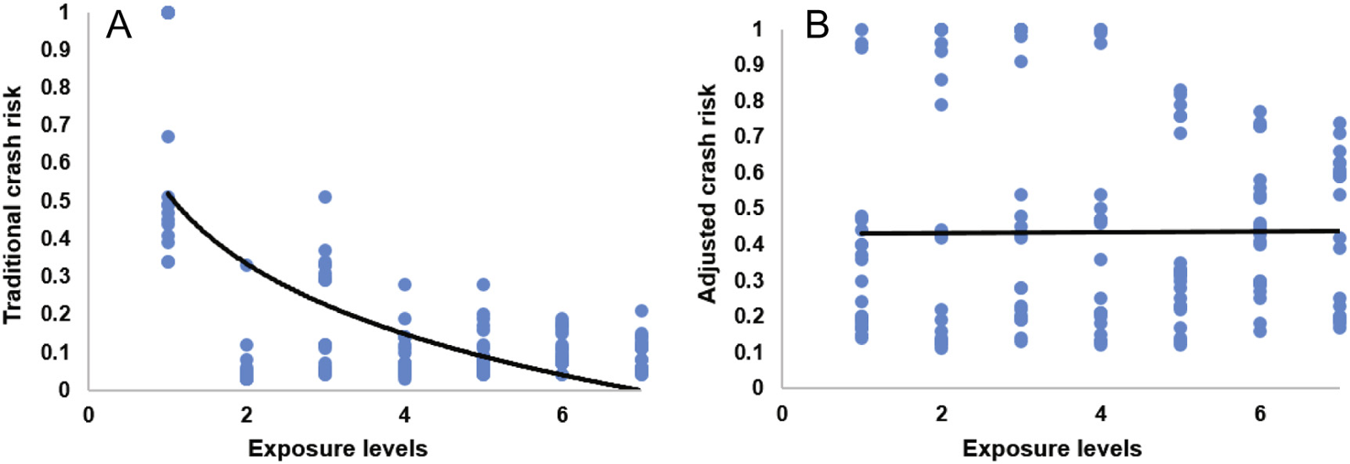
Fig. 1. Effects of increasing exposure levels based on conventional exposure estimates (A) and the new exposure metric (B) on traditional and adjusted crash risk.

2.4. Calculation for multi-vehicle crashes
Traditional crash risk for two-car collisions was calculated using Eq. (1) in the same way as for single-car crashes. In order to calculate twocar adjusted crash risk, we employed the extended adjusted crash risk metric, which explicitly accounts for all drivers involved in multicar collisions. It follows that, for two-car crashes, adjusted crash risk, γi′, is equal to the geometric mean of the adjusted crash risks across each of the other driver age ranges involved in the same collision, such that:
$$γ'_{i}={\left(\prod_{j=1}^{N}{α}A_{ij}\frac{1−\left(ξ_{ij}−x_{ij}\right)exp\left(−2x_{ij}\right)}{1+exp\left(−2x_{ij}\right)}\right)}^{1/N}. \left(4\right)$$
$$α=\frac{exp\left(1\right)}{1−exp\left(1\right)}, A_{ij}=1+x_{ij}exp\left(−x_{ij}\right)−ξ_{ij}exp\left(ξ_{ij}−1\right), ξ_{ij}=\sqrt{ξ_{i}ξ_{j}}.$$
where N indicates the number of other driver age ranges involved in the same multiple car collision. As such, the adjusted two-car crash risk of each driver age range is aggregated after having adjusted for the risk exposure of all other drivers involved in each multicar collision. As in the single-car analysis, relative risks and 95% confidence intervals were calculated using beta regression analyses.

3. Results

3.1. Driving exposure estimates
In terms of population size, as expected, the youngest and oldest drivers were fewest in number in the population (Table 1). Specifically, drivers aged 17-20 years were 87% fewer in number and drivers aged 70 years and above were 46% fewer in number than drivers aged 4049 years who represented the largest driver age group in the population. In terms of the amount of travel, Table 1 shows that, expectedly, trips per driver were fewest in number among men and women in the youngest age range of 17-20 years and in the oldest drivers aged 70+. The average number of trips per driver was highest in the 50-59 age group for men and the 40-49 age group for women. For both genders, fewer trips were made at night than during daytime or evening. In fact, only 8% of trips taken by men and 5% of trips taken by women occurred at night.

Table 1. Estimated average annual trip and driver numbers in the population by age, gender, and time of day in Great Britain, 2002-2012.
 |  | Trip numbers |  |  | Driver numbers
 |  | Day | Evening | Night
Males  Males  Males  Males  Males  Males  Males | 17-20 | 411 | 113 | 86 | 440
 | 21-29 | 482 | 114 | 67 | 1,877
 | 30-39 | 534 | 106 | 52 | 3,015
 | 40-49 | 578 | 118 | 56 | 3,282
 | 50-59 | 610 | 105 | 54 | 2,877
 | 60-69 | 594 | 74 | 38 | 2,388
 | 70+ | 513 | 45 | 22 | 2,156
Females  Females  Females  Females  Females  Females  Females | 17-20 | 391 | 99 | 56 | 391
 | 21-29 | 517 | 97 | 42 | 1,974
 | 30-39 | 609 | 88 | 29 | 2,980
 | 40-49 | 647 | 104 | 36 | 3,109
 | 50-59 | 552 | 81 | 33 | 2,542
 | 60-69 | 457 | 51 | 24 | 1,888
 | 70+ | 388 | 31 | 16 | 1,301
Note. Trip numbers are annual numbers per driver in the population; driver numbers are driver numbers in the population per 1,000 drivers.

3.2. Frequency of single-vehicle crashes
The 30-39 year age group had the highest frequency of daytime crashes, whereas the 21-29 year age group had the highest crash frequency during evening and night hours (Table 2). Crash numbers decreased gradually with age to a minimum at 70 or more years, the exception being fatal crashes where there was a slight increase in the oldest age group. Men and women showed similar trends, but with lower frequency for women.

Table 2. Single-car fatal and non-fatal crash counts by driver age, gender, and time of day in Great Britain, 2002-2012.
 |  | Fatal crash counts |  |  | Nonfatal crash counts
 |  | Day | Evening | Night | Day | Evening | Night
Males  Males  Males  Males  Males  Males  Males | 17-20 | 16 | 10 | 44 | 2,081 | 938 | 2,251
 | 21-29 | 35 | 16 | 66 | 4,101 | 1,347 | 2,616
 | 30-39 | 40 | 16 | 35 | 4,702 | 1,218 | 1,637
 | 40-49 | 28 | 10 | 19 | 4,251 | 948 | 1,112
 | 50-59 | 17 | 7 | 12 | 3,086 | 591 | 578
 | 60-69 | 12 | 2 | 5 | 1,682 | 286 | 234
 | 70+ | 19 | 2 | 2 | 1,188 | 155 | 101
Females  Females  Females  Females  Females  Females  Females | 17-20 | 3 | 1 | 6 | 949 | 342 | 568
 | 21-29 | 6 | 2 | 7 | 2,069 | 539 | 610
 | 30-39 | 6 | 2 | 4 | 2,228 | 426 | 324
 | 40-49 | 6 | 1 | 2 | 1,831 | 333 | 215
 | 50-59 | 3 | 1 | 1 | 1,079 | 182 | 108
 | 60-69 | 2 | 0 | 0 | 553 | 79 | 40
 | 70+ | 6 | 0 | 0 | 474 | 50 | 22

3.3. Single-vehicle crash involvement risk
Traditional rates of crash involvement by driver age and gender were calculated based on the estimated number of licensed drivers and trip numbers in each age-gender group. The youngest age group had an excess relative risk of being involved in fatal and nonfatal single-car crashes compared with the reference group aged 60-69 years (Table 3). Specifically, drivers aged 17 to 20, in both genders, had a nearly 19-fold the risk of fatal crash involvement compared to drivers aged 60-69 years. Similarly, the risk of non-fatal crash involvement for teen drivers was about 15 times as high as that of drivers aged 60 to 69. There was a steep decline in the relative risk of crash involvement with drivers' age, for both fatal and non-fatal crashes. The crash risk of female drivers aged 70 and over was 2.20 and 1.33 times as high as those of female drivers aged 60 to 69, for fatal and non-fatal crashes, respectively. Male drivers aged 70 and over had a fatal crash risk comparable with 60 to 60 year olds, and even showed 10% reduction in the relative risk for nonfatal crashes. Overall, with the exception of elderly drivers, the traditional method for calculating rate-based crash risks followed the familiar age pattern whereby young drivers have a much higher risk of crash involvement than other age groups. Conversely, based on the adjusted risk estimators, relative risk for fatal and non-fatal crash involvement peaked at age 21-29 years for men and at age 30-39 years for women. As illustrated in Table 3, the relative risk of fatal and nonfatal crash involvement was gradually reduced across driver age ranges. Relative to male drivers in the 60-69 age group, young male drivers aged 17 to 20 had only 1.79 and 1.67 times as much risk for fatal and nonfatal crash involvement, respectively. These relative risks of crash involvement for male teen drivers were about the same as those shown by middle-aged drivers and lower than those of drivers in their 20s and 30s. For females, teen drivers had 10% lower risk of being involved in a fatal crash and only 1.19 times as high risk of nonfatal crash involvement than drivers aged 60 to 69. Finally, the relative risk of the oldest female age group was comparable to 60-69 year olds for fatal crash involvement and even reduced by 6% for nonfatal crashes.

Table 3. Traditional and adjusted single-vehicle crash risks for fatal and nonfatal collisions by driver age and gender in Great Britain, 2002-2012.
 |  | Fatal relative risk |  | Nonfatal relative risk
 |  | Traditional | Adjusted | Traditional | Adjusted
Males  Males  Males  Males  Males  Males  Males | 17-20 | 18.6 [17.6-19.8] | 1.79 [1.75-1.83] | 15.3 [14.7-15.9] | 1.67 [1.63-1.70]
 | 21-29 | 8.50 [7.96-9.11] | 2.54 [2.50-2.59] | 5.46 [5.24-5.68] | 2.17 [2.14-2.20]
 | 30-39 | 3.88 [3.63-4.14] | 2.44 [2.39-2.49] | 2.95 [2.81-3.09] | 2.08 [2.05-2.12]
 | 40-49 | 2.01 [1.87-2.15] | 1.79 [1.75-1.83] | 1.91 [1.82-2.00] | 1.75 [1.72-1.79]
 | 50-59 | 1.59 [1.49-1.70] | 1.39 [1.35-1.43] | 1.34 [1.27-1.41] | 1.34 [1.32-1.36]
 | 60-69 | 1.00 | 1.00 | 1.00 | 1.00
 | 70+ | 0.90 [0.80-1.01] | 1.12 [1.08-1.15] | 0.90 [0.85-0.94] | 0.92 [0.90-0.93]
Females  Females  Females  Females  Females  Females  Females | 17-20 | 18.8 [16.9-20.8] | 0.94 [0.91-0.96] | 14.8 [14.2-15.5] | 1.19 [1.16-1.21]
 | 21-29 | 5.63 [4.99-6.37] | 1.19 [1.16-1.22] | 4.44 [4.26-4.63] | 1.65 [1.62-1.67]
 | 30-39 | 3.38 [2.95-3.82] | 1.39 [1.36-1.42] | 2.46 [2.36-2.58] | 1.67 [1.65-1.69]
 | 40-49 | 1.77 [1.54-2.02] | 1.24 [1.21-1.28] | 1.52 [1.46-1.58] | 1.45 [1.43-1.47]
 | 50-59 | 1.74 [1.51-1.99] | 1.13 [1.11-1.16] | 1.20 [1.15-1.26] | 1.18 [1.17-1.20]
 | 60-69 | 1.00 | 1.00 | 1.00 | 1.00
 | 70+ | 2.20 [1.90-2.51] | 1.03 [1.00-1.06] | 1.33 [1.27-1.39] | 0.94 [0.93-0.96]
Note. Crash risks were scaled annually by dividing their values by the largest across age and gender. Relative risks were estimated using beta regression analyses. Figures in brackets indicate the bootstrapped 95% confidence intervals. Drivers aged 60-69 years were used as the reference group.

When crash involvement for age-gender groups was examined by time of day, it was found that nighttime crashes accounted for 80% (95% CI, 80%-81%) of the traditional single-car fatal crash risk for 17to 20-year-old men and 85% (95% CI, 84%-86%) for women (Fig. 2A). To a lesser extent, nighttime crashes also accounted for a large proportion of teen drivers' non-fatal crash rates, with 66% (95% CI, 66%-66%) for men and 62% (95% CI, 62%-63%) for women (Fig. 2B). Hence, the traditional method of estimating driver crash risk indicates a high risk of driving at night among the youngest drivers relative to other times of the day. In contrast, the adjusted crash risk metric revealed that crashes at night accounted for a much smaller proportion of the overall crash risk in the 17-20 year age range. Nighttime crashes accounted for 61% (95% CI, 60%-61%) of the adjusted fatal crash risk for men and 53% (95% CI, 53%-54%) for women (Fig. 2C). Just 47% (95% CI, 47%-47%) of the adjusted non-fatal crash risk of 17- to 20-year-old male drivers was accounted for by nighttime crashes, compared to 42% (95% CI, 42%-42%) for female drivers (Fig. 2D).
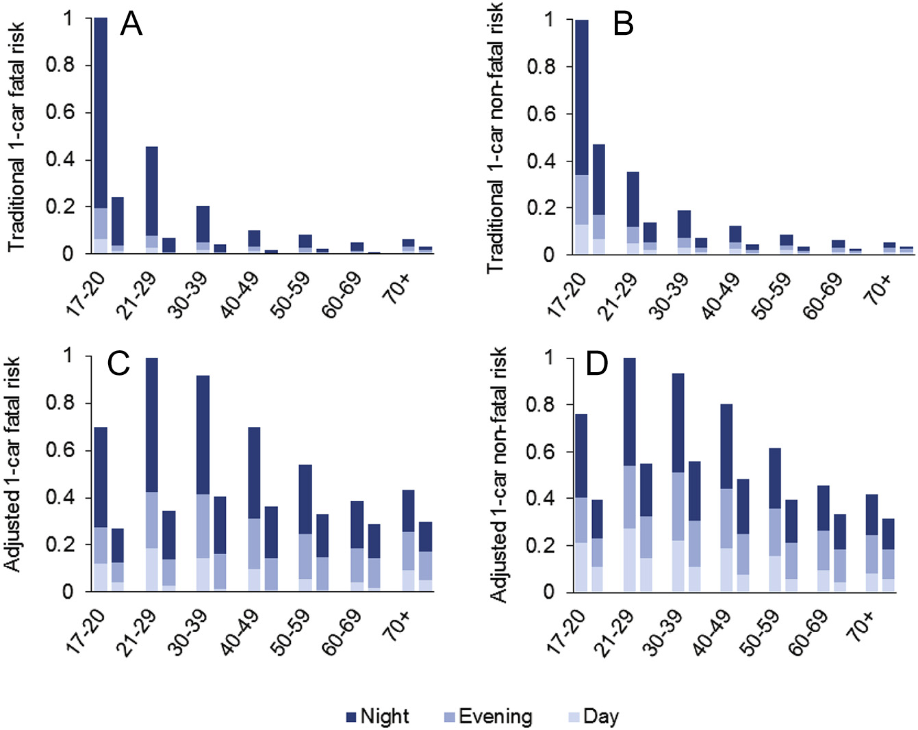
Fig. 2. Traditional single-vehicle fatal (A) and non-fatal (B) crash risk and adjusted single-vehicle fatal (C) and non-fatal (D) crash risk by driver age and gender stacked for daytime (06:00 h-18:00 h), evening (18:00 h-21:00 h), and nighttime (21:00 h-06:00 h) hours. Left and right columns represent male and female crash risks, respectively. Traditional and adjusted crash risks were each scaled annually by dividing their values by the largest across driver groups.

3.4. Single-car risk of fatal injury given crash involvement
The risk of fatal injury given crash involvement was measured as fatal crash risk divided by the sum of fatal and non-fatal crash risk. Fig. 3 shows the traditional and adjusted risk of fatal injury for each age range and gender during daytime, evening, and nighttime hours. Risk of fatal injury could range in value from 0 to 1. A value of 0.50 indicates that the fatal crash risk of a driver group relative to other groups is equal to the non-fatal crash risk relative to other groups. A value of greater than 0.50 indicates a higher relative risk of fatal injury given crash involvement and a value of less than 0.50 indicates a lower relative risk of fatal injury. Age differences in the risk of sustaining a fatal injury differed depending on the method used to compute crash involvement risks. Risk of fatal injury based on traditional crash rates showed an increase from the 60-69 year group to the oldest age group in men during daytime and evening hours (Fig. 3A) and in women (Fig. 3B) during daytime, evening, and nighttime. In contrast, when based on adjusted crash risks, risk of fatal injury increased from age 60-69 years to the oldest age group only during daytime for both men (Fig. 3C) and women (Fig. 3D). Female drivers, particularly those in the 31-39 and 41-49 age groups, had a very low risk of fatal injury during daytime. The risk of fatal injury based on traditional estimates was greater for nighttime crashes than for crashes in the evening and daytime hours, in both male (Fig. 3A) and female drivers (Fig. 3B). When based on the adjusted estimates, the risk of fatal injury for nighttime crashes was higher than that of daytime crashes, but similar to that of crashes occurring during evening hours, in both men (Fig. 3C) and women (Fig. 3D).
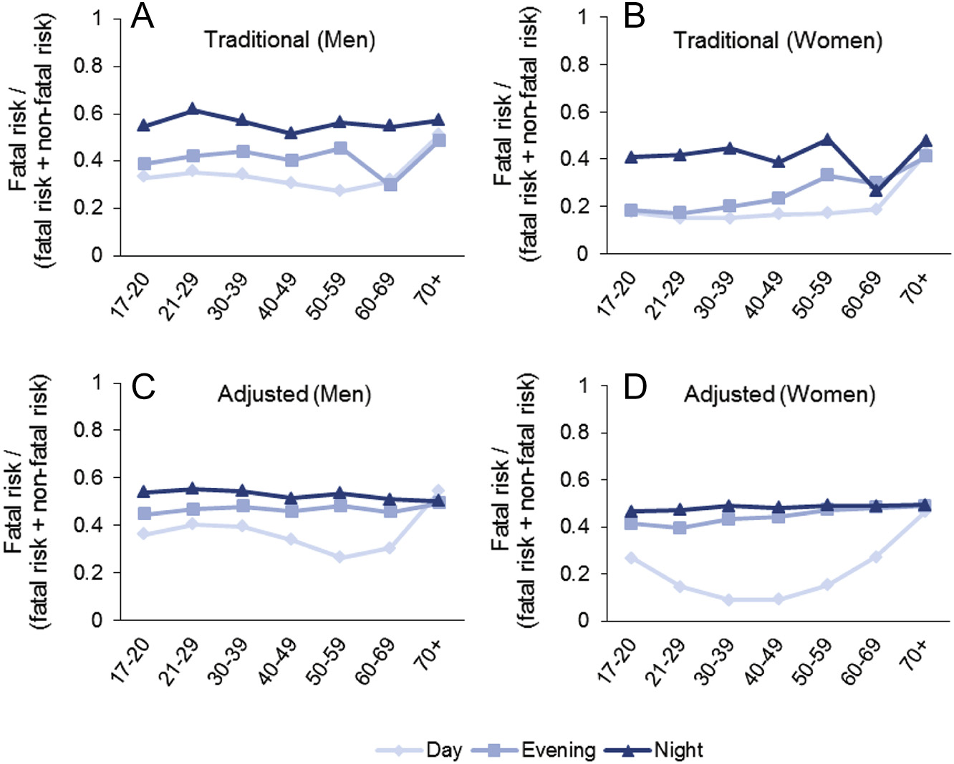
Fig. 3. Traditional and adjusted single-car risk of fatal injury given crash involvement by gender and driver age during daytime (06:00 h-18:00 h), evening (18:00 h-21:00 h), and nighttime (21:00 h-06:00 h) hours. Risk of fatal injury given crash involvement was calculated annually by dividing the single-car fatal crash risk by the sum of the single-car fatal and non-fatal crash risk.

3.5. Frequency of two-vehicle crashes
As illustrated in Table 4, on average, multicar non-fatal crashes were greatest in number among 21 to 29-year-old men and women. The fatal crash frequency of women was greatest among 21-29 year olds, whereas the fatal crash frequency of men was greatest in the 30-39 year age range. Non-fatal crash numbers declined with age to a minimum at 70+ years, whereas numbers of fatal crashes declined with age until a rise from age 60-69 years to age 70+ years. Fatal and nonfatal crashes were greater in number during the daytime for men and women than during evening or nighttime hours.

Table 4. Two-vehicle fatal and non-fatal crash counts by driver age, gender, and time of day in Great Britain, 2002-2012.
 |  | Fatal crash counts |  |  | Nonfatal crash counts
 |  | Day | Evening | Night | Day | Evening | Night
Males  Males  Males  Males  Males  Males  Males | 17-20 | 34 | 13 | 21 | 4,263 | 1,462 | 1,239
 | 21-29 | 66 | 24 | 30 | 8,449 | 2,342 | 1,787
 | 30-39 | 80 | 21 | 24 | 9,178 | 2,022 | 1,371
 | 40-49 | 74 | 20 | 18 | 7,651 | 1,501 | 933
 | 50-59 | 54 | 10 | 12 | 5,173 | 913 | 517
 | 60-69 | 34 | 5 | 6 | 3,011 | 452 | 219
 | 70+ | 64 | 6 | 5 | 2,671 | 307 | 118
Females  Females  Females  Females  Females  Females  Females | 17-20 | 8 | 2 | 3 | 1,833 | 551 | 357
 | 21-29 | 17 | 3 | 4 | 4,256 | 952 | 466
 | 30-39 | 13 | 3 | 3 | 4,423 | 778 | 305
 | 40-49 | 14 | 4 | 3 | 3,615 | 635 | 237
 | 50-59 | 13 | 2 | 2 | 2,229 | 373 | 140
 | 60-69 | 10 | 2 | 1 | 1,168 | 172 | 61
 | 70+ | 22 | 2 | 1 | 1,084 | 111 | 37

3.6. Multi-vehicle crash involvement risk
Traditional risk estimates for multi-vehicle fatal and non-fatal crash involvement were calculated by driver age and gender. Crash rates were highest among drivers aged 17 to 20 and reduced steeply with age (Table 5; Fig. 4A and B). The risk of crash involvement for teen male drivers was 7.75 and 11.1 times as high as the risk of drivers in the safest age group (60-69), for fatal and nonfatal crashes, respectively. Relative to 60-69 year olds, the crash risk of other age groups of male drivers varied between 1.15 and 3.23 for fatal crashes; and between 1.12 and 4.56 for nonfatal crashes. The oldest male group was 1.75 and 1.12 times as likely to be involved in fatal and nonfatal crashes respectively, as compared to the 60-69 age group. For female teen drivers, the risk of being involved in a fatal crash was 3.68 times as high as that among female drivers aged 60 to 69. The 2129 and oldest age groups had 1.31 and 2.29 times as high fatal crash risk as drivers aged 60 to 69. Fatal crash risk was reduced by 8% to 32% among female drivers in the middle age ranges (30s to 50s) in comparison to the 60-69 reference group. The risk of nonfatal crash involvement among female drivers was highest for the 17-20 year olds, who had a relative risk equal to 8.73; it then declined sharply with age up to the oldest age group, having 1.46 times the risk compared to the reference age group. In contrast with the age trends in traditional crash risk, adjusted multicar fatal and non-fatal crash risk was highest among the 30-39 year age range and showed a gradual decline with age (Table 5; Fig. 4C and D). Compared with drivers aged 60 to 69, teen female drivers had 14% less risk of being involved in a fatal crash and 3% less risk of being involved in a nonfatal crash. For male teen drivers, their risk of fatal crash involvement was comparable to drivers aged 60 to 69, and they were only 1.10 as likely to be involved in a nonfatal crash. Female drivers aged 70 and over had similar or slightly reduced risk of being involved in a crash as drivers in the 60-69 age group. For males, the oldest group of drivers had only 1.13 times the risk of fatal crash involvement and their nonfatal crash risk was similar to that of drivers aged 60 to 69.

Table 5. Two-vehicle fatal and nonfatal crash risks based on traditional and adjusted crash risk, by driver age and gender in Great Britain, 2002-2012.
 |  | Fatal relative risk |  | Nonfatal relative risk
 |  | Traditional | Adjusted | Traditional | Adjusted
Males  Males  Males  Males  Males  Males  Males | 17-20 | 7.75 [7.35-8.19] | 0.98 [0.96-1.00] | 11.1 [10.7-11.4] | 1.10 [1.09-1.11]
 | 21-29 | 3.23 [3.02-3.46] | 1.22 [1.20-1.25] | 4.56 [4.39-4.76] | 1.44 [1.43-1.45]
 | 30-39 | 2.04 [1.92-2.17] | 1.34 [1.32-1.37] | 2.74 [2.61-2.87] | 1.45 [1.44-1.45]
 | 40-49 | 1.51 [1.42-1.60] | 1.33 [1.31-1.35] | 1.76 [1.69-1.84] | 1.34 [1.33-1.36]
 | 50-59 | 1.15 [1.07-1.23] | 1.10 [1.08-1.13] | 1.28 [1.22-1.35] | 1.12 [1.12-1.13]
 | 60-69 | 1.00 | 1.00 | 1.00 | 1.00
 | 70+ | 1.75 [1.63-1.87] | 1.13 [1.10-1.16] | 1.12 [1.07-1.18] | 1.01 [1.00-1.02]
Females  Females  Females  Females  Females  Females  Females | 17-20 | 3.68 [3.28-4.13] | 0.86 [0.84-0.87] | 8.73 [8.37-9.09] | 0.95 [0.95-0.96]
 | 21-29 | 1.31 [1.19-1.44] | 0.97 [0.95-0.98] | 3.05 [2.94-3.18] | 1.16 [1.16-1.17]
 | 30-39 | 0.92 [0.83-1.01] | 1.12 [1.11-1.14] | 1.87 [1.79-1.95] | 1.28 [1.27-1.29]
 | 40-49 | 0.77 [0.70-0.84] | 1.10 [1.08-1.12] | 1.27 [1.22-1.32] | 1.20 [1.19-1.21]
 | 50-59 | 0.68 [0.62-0.74] | 1.02 [1.01-1.04] | 1.11 [1.06-1.17] | 1.08 [1.08-1.09]
 | 60-69 | 1.00 | 1.00 | 1.00 | 1.00
 | 70+ | 2.29 [2.11-2.49] | 1.01 [0.99-1.02] | 1.46 [1.39-1.53] | 0.97 [0.96-0.97]
Note. Crash risks were scaled annually by dividing their values by the largest across age and gender. Relative risks were estimated using beta regression analyses. Figures in brackets indicate the bootstrapped 95% confidence intervals. Drivers aged 60-69 years were used as the reference group.

Comparisons of crash involvement risk by driver group across time of day revealed that crashes at nighttime accounted for 54% (95% CI, 54%-55%) of the traditional multicar fatal crash rates among 17 to 20year-old men and 52% (95% CI, 50%-54%) among women (Fig. 4A) and accounted for 38% (95% CI, 38%-38%) of the traditional non-fatal crash risk for 17 to 20-year-old men and 38% (95% CI, 38%-39%) for women (Fig. 4B). Crash risks based on the adjusted method revealed a similar multicar crash risk during nighttime relative to other times of day. Accordingly, nighttime crashes accounted for 50% (95% CI, 50%-50%) of the adjusted fatal crash risk for 17 to 20-year-old men and 52% (95% CI, 52%-52%) for women and 43% (95% CI, 43%-43%) of the nonfatal crash risk for men and 47% (95% CI, 47%-47%) for women.

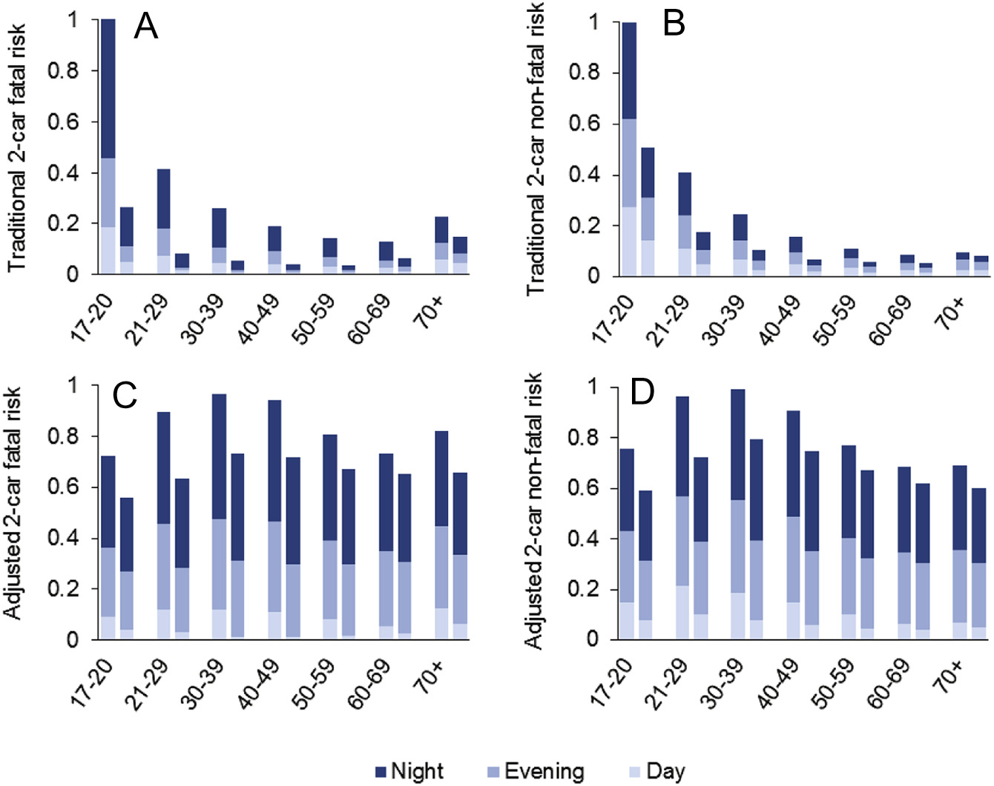
Fig. 4. Traditional 2-car fatal (A) and non-fatal (B) crash risk and adjusted 2-car fatal (C) and non-fatal (D) crash risk by driver age and gender stacked for daytime (06:00 h-18:00 h), evening (18:00 h-21:00 h), and nighttime (21:00 h-06:00 h) hours. Left and right columns represent male and female crash risks, respectively. Traditional and adjusted crash risks were each scaled annually by dividing their values by the largest across driver groups.

3.7. Multicar risk of fatal injury given crash involvement
Risk of fatal injury based on traditional crash risks was greater in nighttime crashes than in crashes during daytime or evening hours among male (Fig. 5A) and female drivers (Fig. 5B). In contrast, based on the adjusted crash risks, the risk of fatal injury for nighttime crashes was similar to that of crashes occurring during evening hours, in both men (Fig. 5C) and women (Fig. 5D). Similarly, age differences in fatal injury risk differed depending on whether they were computed by the traditional or adjusted crash risks. Based on traditional crash rates, the risk of fatal injury increased from age 60-69 years to age >70 years during daytime, evening, and nighttime hours among men (Fig. 5A) and women (Fig. 5B). In contrast, the risk of fatal injury as measured by adjusted crash risks increased from age 60-69 years to age >70 years only during the daytime for men (Fig. 5C) and women (Fig. 5D). As in the single-vehicle analysis, female drivers' fatal crash risk was extremely low during the daytime, especially among those in their 30s and 40s.

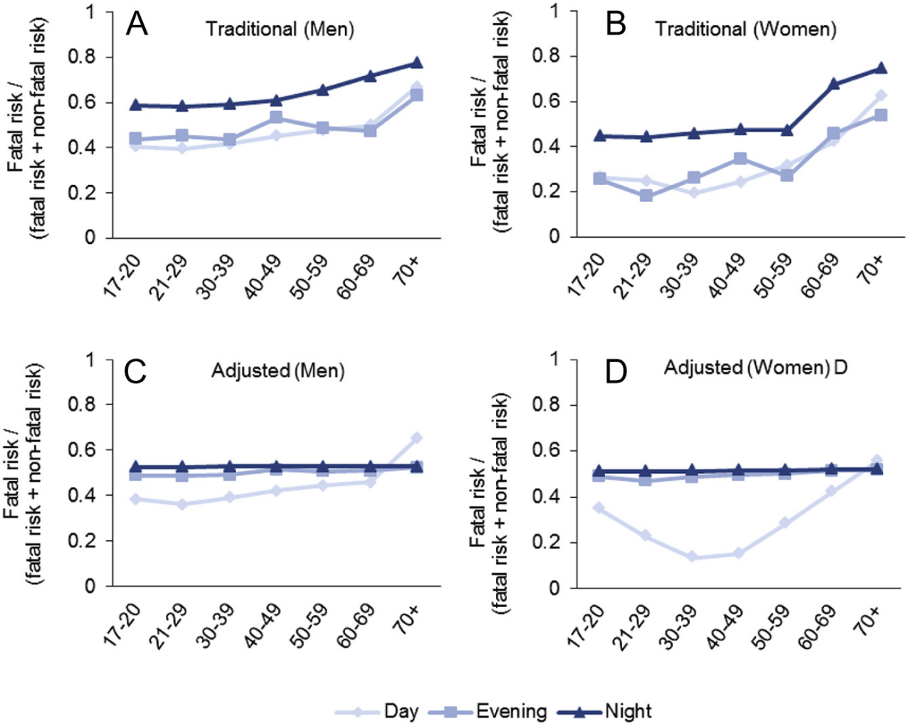
Fig. 5. Traditional and adjusted risk of fatal injury given multi-vehicle crash involvement by driver age and gender during daytime (06:00 h-18:00 h), evening (18:00 h-21:00 h), and nighttime (21:00 h-06:00 h) hours. Risk of fatal injury given crash involvement was calculated annually by dividing multi-vehicle fatal crash risk by the sum of multi-vehicle fatal and non-fatal crash risk.

4. Discussion
Crash rates are commonly used to assess the risk of different driver groups varying in exposure to risk. However, this approach requires that crash frequency and the exposure index be correlated linearly an invalid assumption when using conventional measurement of exposure. Here we applied a crash risk method based on a new exposure metric, for which the number of crashes is proportional to the amount of driving exposure. We found that traditional crash rates reduced steeply from age 17-20 years through age 60-69 years. Adjusted crash risk instead peaked at age 20-29 years and decreased gradually until age 60-69 years. Additionally, elderly drivers had reduced crash involvement and fatality risks when using the adjusted crash risk compared to conventional crash rates. Finally, nighttime driving among teen drivers accounted for a smaller proportion of their single-vehicle crash risk than implied by crash rates. The dramatic reduction in conventional crash rates from young to middle-age ranges reflects the common findings in the literature. However, the adjusted crash risks revealed a remarkably different age-trend in driver risk: Crash risk was highest among 21-29 year olds and thereon reduced gradually with age. The current results are in agreement with those obtained in studies using disaggregated models and quasi-induced exposure methods for crash risk analyses. These studies have shown that the youngest and oldest age groups are not the riskiest drivers. Rather, drivers in their 20s and 30s were those demonstrating the highest crash risk. While the robustness of our findings is supported by previous reports, we do not argue here against the enforcement of driving restrictions targeting young drivers. Justification for road safety regulations would also depend on drivers' ability to recognize their own limitations and self-regulate their driving accordingly. The present investigation merely highlights that other age groups also exhibit substantial driver crash risk and may also benefit from targeted road safety initiatives. Drivers, especially young males, are reported to have higher crash involvement rates at nighttime compared to daytime. Adjusting appropriately for the infrequency of nighttime travel, we discovered that crashes at night accounted for far less of the single-car crash risk of teen drivers compared to the traditional method. In Great Britain, young drivers are not restricted in their travel at night. Policymakers in countries where curfews are imposed on the youngest drivers should be cognizant that the contribution of nighttime driving to single-vehicle crashes of teenagers may be exaggerated by traditional methods of analyzing crash risk. Previous investigations using conventional crash rates have reported increased crash risk in older age. We found that when controlling correctly for their small driver numbers and infrequent travel, crash involvement and fatality risks of elderly drivers were reduced. These findings are consistent with past research showing that older driver crash risk appears high due to the biasing effects of their small driving exposure. Future research should include identification of age subgroups among older drivers given possible variation in their driving exposure and crash risks. Interestingly, our analysis revealed that among elderly drivers, the risk of sustaining a fatal injury from a crash remained constant across time of day. This finding lends support to the role of fragility in worsening injury outcomes for elderly drivers who are involved in crashes, since fragility (unlike crash seriousness) is not expected to be influenced by time of day. Therefore, countermeasures benefiting elderly drivers should focus on improving in-vehicle technology to reduce injury severity. In either method, young and middle-aged drivers were more likely to sustain a fatal injury from a crash that occurred at night than during daytime. This resonates with previous research. However, the adjusted method also revealed that fatal injury risk from nighttime crashes was similar to the risk from crashes in the evening. Thus, the current findings support the need to report age comparisons in crash involvement and injury severity by time of day and highlight the importance of accounting properly for the variability in travel exposure across time periods. Findings from both methods regarding gender differences in crash risk were generally consistent with prior research; male drivers are more likely to be involved in fatal and non-fatal crashes compared to female drivers. The adjusted method has also demonstrated that the fatal crash risk of women, particularly those in their 30s to 40s, was extremely low during daytime. These data fit prior travel behavior research showing that women, especially those with children, are more likely than men to make trips during daytime with the intention of serving passengers. Although the presence of passengers is associated with in-vehicle distraction, having young passengers might be more protective than harmful by reducing risk-taking behaviors among women drivers. Future studies are needed to explore this possibility. Our investigation has a number of potential limitations. First, motivated by concerns about the use of mileage in age comparisons of crash risk, we used annual trip numbers as our indicator of travel per person. In our study, traditional crash rates per trip produced the familiar pattern of excessive crash risk among the youngest drivers. Using different travel indicators might have resulted in smaller amount of risk exposure for older drivers and consequently larger crash rates in this age group. Nevertheless, previous studies have shown that reduction in travel associated with older age occurs both in terms of frequency of trips and distance traveled. Second, we used self-reports of trips made, which may be associated with reporting biases that differ with driver age. Future studies may benefit from incorporating objective measures of risk exposure. Finally, we acknowledge that the new crash risk approach is based on an exposure metric that is more complex to compute in comparison to simple crash rate. Nevertheless, the new adjusted crash risk estimators are superior to the conventional crash rates in producing unbiased risk comparisons for driver groups and driving conditions that vary in their exposure to risk.

5. Conclusion
The current study applied a new approach to model crash risks based on exposure metric that bears a linear relation with crashes. Our findings draw attention to the invalidity of crash rates for risk comparisons among groups and conditions that vary in driving exposure. Specifically, we have demonstrated that conventional crash rates overestimate the actual risk of crash involvement and fatal injury for the youngest and oldest drivers as well as for nighttime driving. This work has important practical implications for improving road safety initiatives, as meaningful comparisons are essential for identifying truly atrisk drivers and driving conditions. It is hoped that the approach presented here will facilitate development of new crash modeling methodologies that are able to account for the non-linear shape of the safety performance function, and provide reliable crash risk estimates for road safety research and policies.

译文

基于新暴露度量方法的驾驶员年龄、性别与时段的碰撞风险研究
Shirley Regev, Jonathan J. Rolison, Salissou Moutari
《安全研究杂志》, 66 (2018), 131-140. DOI: https://doi.org/10.1016/j.jsr.2018.07.002

摘要
引言：已有研究提出，碰撞事故与出行暴露之间并非线性关系，这会使传统通过碰撞率控制暴露水平的方法失效。本文采用一种与碰撞事故呈线性关联的新暴露度量作为计算无偏碰撞风险的基础。研究比较了传统碰撞率与新的调整后碰撞风险两种方法，用于评估驾驶员年龄、性别和时段对碰撞参与风险以及碰撞致死风险的影响。方法：研究使用了2002—2012年英国警方记录的单车事故和多车事故报告，这些事故涉及驾驶员死亡或非死亡伤害。结果：传统碰撞率在最年轻年龄组中最高，并在60—69岁之前快速下降；而调整后的碰撞风险在21—29岁达到峰值，并随年龄逐渐降低。基于调整后碰撞风险计算时，夜间驾驶风险，尤其是青少年驾驶员的夜间驾驶风险，明显低于传统方法所得结果。最后，老年驾驶员的调整后致死风险在不同时段保持稳定，这表明其因碰撞而遭受致命伤害的风险更多源于身体脆弱性，而非事故严重程度。结论：研究结果表明，低出行暴露会对传统碰撞率产生偏倚影响。这意味着，在不同驾驶群体和不同驾驶条件暴露水平存在差异时，传统方法不能给出有意义的碰撞风险比较。通常与青少年、老年驾驶员以及夜间驾驶相关的较高碰撞率，在一定程度上可归因于低暴露条件下风险被高估。实践应用：除年轻驾驶员外，还应更加关注20多岁和30多岁驾驶员的碰撞参与情况。针对老年驾驶员的对策应重点关注身体脆弱性在致死风险中的作用。
关键词：碰撞率；年龄；性别；时段；低暴露偏差

1. 引言
道路交通碰撞是全球范围内重要的公共健康问题。每年道路交通事故造成超过120万人死亡，并导致更多严重伤害。更深入地理解影响驾驶员碰撞风险的因素，对于制定有效的道路安全政策和干预措施具有关键意义。大量道路安全研究评估了与较高碰撞风险相关的驾驶员特征，如年龄和性别。相关研究通常表明，最年轻和最年长驾驶员的死亡及非死亡碰撞风险均明显高于中年驾驶员。也有研究发现，老年驾驶员内部不同年龄亚组的死亡和非死亡碰撞风险存在差异。例如，有证据显示，70—74岁驾驶员的碰撞风险低于75—79岁驾驶员，而80岁及以上驾驶员的风险最高。道路安全研究还关注了驾驶员性别与较高碰撞风险之间的关系。一般而言，女性驾驶员被认为比男性驾驶员更安全。不过，也有研究指出，虽然女性发生致命事故的数量通常少于男性，但其受伤事故风险可能更高。
驾驶员年龄和性别不仅影响碰撞参与情况，也会影响事故后果的严重程度，即发生碰撞后遭受致命伤害的风险。与女性驾驶员和较年轻年龄段驾驶员相比，男性和老年驾驶员在碰撞中遭受致命伤害的可能性更高。碰撞参与风险也会随环境因素而变化，例如一天中的时段。与其他时段相比，夜间碰撞风险更高，而且这种差异在男性驾驶员和较年轻驾驶员中更明显。时段也被认为与碰撞严重程度有关，尤其是在较年轻年龄组中，夜间碰撞导致驾驶员死亡的可能性高于白天碰撞。
为了在不同驾驶群体或驾驶环境之间进行有意义的碰撞风险比较，必须考虑它们在出行暴露强度上的差异。如果不控制出行暴露，就无法判断某一群体或环境中较高的碰撞数量究竟源于更高的碰撞倾向，还是源于更多暴露于可能导致碰撞的出行情境。传统上，研究者通常通过将某一驾驶群体（如年龄、性别群体）的碰撞数量除以其年出行量、持证驾驶员数量，或出行量与群体规模的组合来控制暴露差异。然而，只有当碰撞数量随驾驶暴露增加而成比例增加时，使用碰撞率控制驾驶暴露差异才是合适的。换言之，碰撞频率与驾驶暴露之间的关系，即“安全绩效函数”，需要是线性的。碰撞率可定义为从原点到安全绩效函数某一点所形成直线的斜率。如果安全绩效函数是非线性的，那么碰撞率会随暴露水平不同而变化。因此，碰撞率无法在暴露水平不同的驾驶群体或驾驶条件之间提供有意义的风险比较。
值得注意的是，许多道路安全研究者指出，年度碰撞数量与驾驶暴露之间的关系实际上是非线性的。具体而言，这种关系常被描述为近似对数曲线：在低暴露水平下，碰撞数量最初快速增加；随后增速逐渐放缓；在高暴露水平下最终趋于平缓。因此，随着行驶距离增加，单位行驶距离的碰撞率会下降。低里程驾驶员的碰撞率高于高里程驾驶员，正是文献中常见的发现。
安全绩效函数的非线性可能有若干解释。第一，高里程驾驶员有更大比例的行驶里程发生在高速公路上，而低里程驾驶员往往将出行限制在相对危险的城市道路上。第二，高里程驾驶员比低里程驾驶员积累了更多驾驶经验，因而可能具有更好的驾驶技能。最后，存在视觉或身体损伤的老年驾驶员往往会减少驾驶暴露；因此，低里程群体中可能包含更多受损驾驶员，而这些驾驶员更容易卷入碰撞。
无论其根本原因是什么，暴露—碰撞关系都是非线性的，因此碰撞率会随着驾驶暴露增加而下降。正因如此，道路安全领域有人担心，当驾驶群体或驾驶条件的出行暴露存在较大差异时，使用碰撞率可能导致风险比较产生偏倚。相应地，不同群体或驾驶条件之间的碰撞率差异可能反映的是暴露差异，而非碰撞倾向差异。因此，基于率的方法可能会高估低暴露驾驶员的碰撞风险，并低估高暴露驾驶员的碰撞风险。
文献中的一个常见发现是，就行驶距离和持证驾驶员数量而言，年轻和老年驾驶员的驾驶暴露低于其他年龄组。因此，在年龄组比较中，使用碰撞率可能会低估低暴露年龄组（如年轻和老年驾驶员）的碰撞风险，并高估高暴露年龄组（如中年驾驶员）的碰撞风险。与此相一致，低年度出行驾驶员比例随年龄变化呈U形曲线，这与通常观察到的按年龄划分的碰撞率模式相似：年轻和老年驾驶员相对于中年驾驶员数值更高。这一观察结果引出了“低里程偏差”的理论概念，即老年驾驶员较高的碰撞风险可能是其较低行驶距离造成的结果。按照这一思路，将不同行驶距离匹配后的不同年龄驾驶员亚组进行比较，所得结果显示最年长驾驶员反而最安全，或至少与其他年龄段驾驶员一样安全。
在按性别比较碰撞风险时，碰撞率估计也可能产生偏倚。研究表明，各年龄段女性持有驾驶执照的可能性均低于男性；即使持有驾照，其年均行驶里程也往往更低。因此可以推测，基于率的女性驾驶员碰撞风险可能被低估，而男性驾驶员的碰撞风险可能被高估。对于任何出行暴露存在显著差异的驾驶条件，例如一天中的时段，使用碰撞率也同样不合适。夜间驾驶在各年龄段中所占比例都相当小，因为大多数驾驶发生在白天。例如，有研究发现，夜间驾驶仅占驾驶员总行驶距离的13%。夜间时段较低的风险暴露可能导致碰撞率估计存在偏倚，即夜间碰撞风险相对于其他时段被夸大。此外，考虑到年龄和性别差异在不同时段的出行暴露中也会发生变化，按时段分解碰撞风险对于驾驶群体之间的风险比较具有重要意义。
本文旨在考察传统碰撞率方法在年龄—性别群体之间以及一天中不同时段之间进行风险比较时存在偏倚的程度。为此，本文将传统碰撞率的结果与基于新暴露度量计算的调整后风险估计量进行比较，该新度量能够为安全绩效函数提供线性关系。我们假设，在使用传统碰撞率估计量时，与中年驾驶员相比，年轻和老年驾驶员在死亡及非死亡碰撞中的参与风险会显著更高；相反，当使用调整后风险估计量时，碰撞参与风险的年龄差异会大幅减小。同样，我们假设，与白天和傍晚驾驶相比，夜间驾驶的碰撞参与风险在使用新的调整后风险估计量时会低于传统碰撞率所得结果。
作为进一步考察，本文还评估了由传统方法和调整后方法估计的碰撞致死风险，即发生碰撞后驾驶员遭受致命伤害的风险。致死风险被定义为死亡碰撞参与风险与死亡及非死亡碰撞参与风险之和的比值。我们的基本逻辑是，如果年轻和老年驾驶员群体人数较少以及夜间出行频率较低会使传统碰撞风险评估产生偏倚，那么任何基于该方法的致命伤害风险度量同样会产生偏倚。单车事故与多车事故在特征和影响因素上似乎存在显著差异。此外，也有观点认为，估计多车碰撞风险时需要调整所有涉事驾驶员的出行暴露。因此，本文分别对单车事故和双车事故比较传统碰撞风险方法与调整后碰撞风险方法。

2. 材料与方法

2.1 出行暴露数据
驾驶暴露估计值以出行次数和持证驾驶员人数表示，数据来自2002—2012年英国国家出行调查。本文按年份估计每个驾驶员年龄段（17—20岁、21—29岁、30—39岁、40—49岁、50—59岁、60—69岁、70岁及以上）、性别和时段（白天06:00—18:00；傍晚18:00—21:00；夜间21:00—06:00）的每名驾驶员出行次数。人口中的驾驶员人数按年龄段和性别逐年估计，计算方法为英国国家出行调查样本中的驾驶员比例（每年平均14,959名驾驶员）乘以英国居民估计人数。

2.2 道路事故数据
道路事故数据包括2002年至2012年期间发生在英国（英格兰、苏格兰和威尔士）的全样本单车和双车碰撞事故。道路事故数据由警方人员在现场记录，并经英国交通部处理后由埃塞克斯大学数据档案提供。道路事故发生后30天内死亡的驾驶员被归类为道路交通事故死亡。非死亡碰撞包括非致命驾驶员伤害案例。

2.3 单车事故的计算
传统碰撞风险γi通过将每个驾驶群体i的碰撞数量xi除以其估计的每名驾驶员出行次数yi与人口中驾驶员人数zi的乘积来估计，即：
$$γ_{i}=\frac{x_{i}}{y_{i}⋅z_{i}}. \left(1\right)$$
γi值按年度进行标准化，即将每个值除以所有驾驶群体（即年龄、性别和时段）中的最大值，使得碰撞风险最高的驾驶群体对应的γi等于1。本文采用新的暴露度量来构造线性安全绩效函数，并修正碰撞率的偏倚影响。该方法涉及一种替代性的风险暴露评估方式。相应地，每个驾驶群体i的调整后暴露ξi基于如下假设进行估计：如果某驾驶群体人口规模较大且出行次数较多，则暴露应较高；如果人口规模较大但出行次数较少，则暴露应较低；若人口规模较小但出行次数较多，则其暴露应高于人口规模较小且出行次数较少的情形。因此有：
$$ξ_{i}=\frac{exp\left(2{\overset{‾}{z}}_{i}\right)−{\overset{‾}{y}}_{i}\left(1−{\overset{‾}{z}}_{i}\right)}{\left(1−{\overset{‾}{y}}_{i}\right)+exp\left(2{\overset{‾}{z}}_{i}\right)}. \left(2\right)$$
其中，每名驾驶员总出行次数yi和人口规模zi均为标准化值，其计算方式是将各值除以所有驾驶群体（即年龄、性别和时段）中的最大值。每个驾驶群体i的调整后碰撞风险γi′基于如下假设进行估计：如果该群体碰撞次数较多且调整后暴露较小，则其碰撞风险应较高；如果碰撞次数较少且暴露较高，则风险应较低；同时，在碰撞次数较少且暴露较低的情形下，其风险应高于碰撞次数较多且暴露较高的情形。因此有：
$$γ'_{i}=αA_{i}\frac{1−\left(ξ_{i}−x_{i}\right)exp\left(−2x_{i}\right)}{1+exp\left(−2x_{i}\right)}. \left(3\right)$$
其中：
$$α=\frac{exp\left(1\right)}{1−exp\left(1\right)}. \left(3a\right)$$
并且：
$$A_{i}=1+x_{i}exp\left(−x_{i}\right)−ξ_{i}exp\left(ξ_{i}−1\right). \left(3b\right)$$
其中，碰撞数量xi为标准化值，其计算方式是将各值除以所有驾驶群体（即年龄、性别和时段）中的最大值。与传统碰撞风险一样，调整后碰撞风险γi′也按年度进行标准化，即将各值除以所有驾驶群体中的最大值。相对风险及其95%置信区间采用β回归分析计算。图1A绘制了标准化传统碰撞率与暴露水平（暴露定义为出行次数与人口规模的乘积）之间的关系。作为比较，图1B绘制了基于所提出暴露度量的标准化调整后碰撞风险与暴露水平之间的关系。这些图表明，传统碰撞率在最低暴露水平下升高，并随着暴露增加而迅速下降，随后在较高暴露水平下趋于平缓。相反，调整后碰撞风险随暴露变化保持稳定，从而能够比较人口数量和出行量差异较大的驾驶群体。

图1. 基于传统暴露估计（A）和新暴露度量（B）的暴露水平增加对传统碰撞风险和调整后碰撞风险的影响。

2.4 多车事故的计算
双车碰撞的传统碰撞风险采用公式（1），其计算方式与单车事故相同。为计算双车调整后碰撞风险，本文采用扩展的调整后碰撞风险度量，该度量明确考虑了多车碰撞中所有涉事驾驶员。由此，对于双车碰撞，调整后碰撞风险γi′等于同一碰撞中涉及的其他驾驶员年龄段调整后碰撞风险的几何平均值，即：
$$γ'_{i}={\left(\prod_{j=1}^{N}{α}A_{ij}\frac{1−\left(ξ_{ij}−x_{ij}\right)exp\left(−2x_{ij}\right)}{1+exp\left(−2x_{ij}\right)}\right)}^{1/N}. \left(4\right)$$
$$α=\frac{exp\left(1\right)}{1−exp\left(1\right)}, A_{ij}=1+x_{ij}exp\left(−x_{ij}\right)−ξ_{ij}exp\left(ξ_{ij}−1\right), ξ_{ij}=\sqrt{ξ_{i}ξ_{j}}.$$
其中，N表示同一多车碰撞中涉及的其他驾驶员年龄段数量。因此，每个驾驶员年龄段的调整后双车碰撞风险，是在调整同一多车碰撞中所有其他涉事驾驶员的风险暴露之后进行汇总得到的。与单车分析一样，相对风险及其95%置信区间采用β回归分析计算。

3. 结果

3.1 驾驶暴露估计
就人口规模而言，正如预期，最年轻和最年长驾驶员在人口中的数量最少（表1）。具体而言，与人口中最大的40—49岁驾驶员群体相比，17—20岁驾驶员人数少87%，70岁及以上驾驶员人数少46%。就出行量而言，表1显示，男性和女性中17—20岁最年轻年龄段以及70岁及以上最年长驾驶员的每名驾驶员出行次数最少。男性中每名驾驶员平均出行次数最高的是50—59岁组，女性中最高的是40—49岁组。对两种性别而言，夜间出行次数均少于白天或傍晚。事实上，男性出行中只有8%、女性出行中只有5%发生在夜间。

表1. 2002—2012年英国按年龄、性别和时段划分的人均年均出行次数及人口中的驾驶员人数估计
性别 | 年龄 | 出行次数 | 出行次数 | 出行次数 | 驾驶员人数
 |  | 白天 | 傍晚 | 夜间
男性 | 17-20 | 411 | 113 | 86 | 440
男性 | 21-29 | 482 | 114 | 67 | 1,877
男性 | 30-39 | 534 | 106 | 52 | 3,015
男性 | 40-49 | 578 | 118 | 56 | 3,282
男性 | 50-59 | 610 | 105 | 54 | 2,877
男性 | 60-69 | 594 | 74 | 38 | 2,388
男性 | 70+ | 513 | 45 | 22 | 2,156
女性 | 17-20 | 391 | 99 | 56 | 391
女性 | 21-29 | 517 | 97 | 42 | 1,974
女性 | 30-39 | 609 | 88 | 29 | 2,980
女性 | 40-49 | 647 | 104 | 36 | 3,109
女性 | 50-59 | 552 | 81 | 33 | 2,542
女性 | 60-69 | 457 | 51 | 24 | 1,888
女性 | 70+ | 388 | 31 | 16 | 1,301
注：出行次数为人口中每名驾驶员的年度次数；驾驶员人数为人口中每1000名驾驶员对应的驾驶员数量。

3.2 单车事故频数
30—39岁年龄组的白天碰撞频数最高，而21—29岁年龄组在傍晚和夜间的碰撞频数最高（表2）。碰撞数量随年龄逐渐下降，在70岁及以上达到最低；唯一例外是死亡事故，在最年长年龄组中略有增加。男性和女性呈现相似趋势，但女性的事故频数较低。

表2. 2002—2012年英国按驾驶员年龄、性别和时段划分的单车死亡与非死亡事故数量
性别 | 年龄 | 死亡事故次数 | 死亡事故次数 | 死亡事故次数 | 非死亡事故次数 | 非死亡事故次数 | 非死亡事故次数
 |  | 白天 | 傍晚 | 夜间 | 白天 | 傍晚 | 夜间
男性 | 17-20 | 16 | 10 | 44 | 2,081 | 938 | 2,251
男性 | 21-29 | 35 | 16 | 66 | 4,101 | 1,347 | 2,616
男性 | 30-39 | 40 | 16 | 35 | 4,702 | 1,218 | 1,637
男性 | 40-49 | 28 | 10 | 19 | 4,251 | 948 | 1,112
男性 | 50-59 | 17 | 7 | 12 | 3,086 | 591 | 578
男性 | 60-69 | 12 | 2 | 5 | 1,682 | 286 | 234
男性 | 70+ | 19 | 2 | 2 | 1,188 | 155 | 101
女性 | 17-20 | 3 | 1 | 6 | 949 | 342 | 568
女性 | 21-29 | 6 | 2 | 7 | 2,069 | 539 | 610
女性 | 30-39 | 6 | 2 | 4 | 2,228 | 426 | 324
女性 | 40-49 | 6 | 1 | 2 | 1,831 | 333 | 215
女性 | 50-59 | 3 | 1 | 1 | 1,079 | 182 | 108
女性 | 60-69 | 2 | 0 | 0 | 553 | 79 | 40
女性 | 70+ | 6 | 0 | 0 | 474 | 50 | 22

3.3 单车碰撞参与风险
传统方法根据各年龄—性别群体中估计的持证驾驶员人数和出行次数，计算驾驶员年龄与性别对应的碰撞参与率。与60—69岁参照组相比，最年轻年龄组参与死亡和非死亡单车事故的相对风险过高（表3）。具体而言，17—20岁男性和女性驾驶员参与死亡碰撞的风险几乎是60—69岁驾驶员的19倍。同样，青少年驾驶员参与非死亡碰撞的风险约为60—69岁驾驶员的15倍。对于死亡和非死亡碰撞而言，碰撞参与相对风险均随驾驶员年龄显著下降。70岁及以上女性驾驶员的死亡和非死亡碰撞风险分别是60—69岁女性驾驶员的2.20倍和1.33倍。70岁及以上男性驾驶员的死亡碰撞风险与60—69岁驾驶员相当，非死亡碰撞相对风险甚至下降了10%。总体而言，除老年驾驶员外，传统基于率的碰撞风险计算方法呈现出熟悉的年龄模式，即年轻驾驶员的碰撞参与风险远高于其他年龄组。
相反，基于调整后风险估计量，男性死亡和非死亡碰撞参与相对风险在21—29岁达到峰值，女性则在30—39岁达到峰值。如表3所示，死亡和非死亡碰撞参与相对风险总体上随驾驶员年龄逐渐降低。相对于60—69岁男性驾驶员，17—20岁年轻男性驾驶员的死亡和非死亡碰撞参与风险分别仅为1.79倍和1.67倍。这些男性青少年驾驶员的碰撞参与相对风险与中年驾驶员大致相当，并低于20多岁和30多岁驾驶员。对于女性而言，青少年驾驶员参与死亡碰撞的风险低10%，参与非死亡碰撞的风险仅为60—69岁驾驶员的1.19倍。最后，最年长女性组的死亡碰撞参与相对风险与60—69岁驾驶员相当，非死亡碰撞风险甚至降低了6%。

表3. 2002—2012年英国按驾驶员年龄和性别划分的单车死亡与非死亡碰撞的传统风险和调整后风险
性别 | 年龄 | 死亡相对风险 | 死亡相对风险 | 非死亡相对风险 | 非死亡相对风险
 |  | 传统方法 | 调整方法 | 传统方法 | 调整方法
男性 | 17-20 | 18.6 [17.6-19.8] | 1.79 [1.75-1.83] | 15.3 [14.7-15.9] | 1.67 [1.63-1.70]
男性 | 21-29 | 8.50 [7.96-9.11] | 2.54 [2.50-2.59] | 5.46 [5.24-5.68] | 2.17 [2.14-2.20]
男性 | 30-39 | 3.88 [3.63-4.14] | 2.44 [2.39-2.49] | 2.95 [2.81-3.09] | 2.08 [2.05-2.12]
男性 | 40-49 | 2.01 [1.87-2.15] | 1.79 [1.75-1.83] | 1.91 [1.82-2.00] | 1.75 [1.72-1.79]
男性 | 50-59 | 1.59 [1.49-1.70] | 1.39 [1.35-1.43] | 1.34 [1.27-1.41] | 1.34 [1.32-1.36]
男性 | 60-69 | 1.00 | 1.00 | 1.00 | 1.00
男性 | 70+ | 0.90 [0.80-1.01] | 1.12 [1.08-1.15] | 0.90 [0.85-0.94] | 0.92 [0.90-0.93]
女性 | 17-20 | 18.8 [16.9-20.8] | 0.94 [0.91-0.96] | 14.8 [14.2-15.5] | 1.19 [1.16-1.21]
女性 | 21-29 | 5.63 [4.99-6.37] | 1.19 [1.16-1.22] | 4.44 [4.26-4.63] | 1.65 [1.62-1.67]
女性 | 30-39 | 3.38 [2.95-3.82] | 1.39 [1.36-1.42] | 2.46 [2.36-2.58] | 1.67 [1.65-1.69]
女性 | 40-49 | 1.77 [1.54-2.02] | 1.24 [1.21-1.28] | 1.52 [1.46-1.58] | 1.45 [1.43-1.47]
女性 | 50-59 | 1.74 [1.51-1.99] | 1.13 [1.11-1.16] | 1.20 [1.15-1.26] | 1.18 [1.17-1.20]
女性 | 60-69 | 1.00 | 1.00 | 1.00 | 1.00
女性 | 70+ | 2.20 [1.90-2.51] | 1.03 [1.00-1.06] | 1.33 [1.27-1.39] | 0.94 [0.93-0.96]
注：碰撞风险按年度进行标准化，即将其数值除以各年龄和性别组合中的最大值。相对风险采用β回归分析估计。方括号中的数值表示自助法95%置信区间。60—69岁驾驶员作为参照组。

当按时段考察年龄—性别群体的碰撞参与情况时发现，夜间碰撞占17—20岁男性传统单车死亡碰撞风险的80%（95% CI，80%—81%），占女性的85%（95% CI，84%—86%）（图2A）。在较低程度上，夜间碰撞也占青少年驾驶员非死亡碰撞率的较大比例，男性为66%（95% CI，66%—66%），女性为62%（95% CI，62%—63%）（图2B）。因此，传统驾驶员碰撞风险估计方法表明，与一天中的其他时段相比，最年轻驾驶员夜间驾驶风险较高。相反，调整后碰撞风险度量显示，在17—20岁年龄段，夜间碰撞在总体碰撞风险中所占比例明显较小。夜间碰撞占男性调整后死亡碰撞风险的61%（95% CI，60%—61%），占女性的53%（95% CI，53%—54%）（图2C）。在17—20岁男性驾驶员的调整后非死亡碰撞风险中，仅有47%（95% CI，47%—47%）由夜间碰撞构成；女性驾驶员对应比例为42%（95% CI，42%—42%）（图2D）。


图2. 按驾驶员年龄和性别划分的传统单车死亡（A）与非死亡（B）碰撞风险，以及调整后单车死亡（C）与非死亡（D）碰撞风险，并按白天（06:00—18:00）、傍晚（18:00—21:00）和夜间（21:00—06:00）堆叠显示。左右两列分别表示男性和女性碰撞风险。传统与调整后碰撞风险均按年度除以所有驾驶群体中的最大值进行标准化。

3.4 单车碰撞参与后的致命伤害风险
碰撞参与后的致命伤害风险以死亡碰撞风险除以死亡和非死亡碰撞风险之和来衡量。图3展示了各年龄段和性别在白天、傍晚和夜间的传统及调整后致命伤害风险。致命伤害风险取值范围为0到1。数值0.50表示某一驾驶群体相对于其他群体的死亡碰撞风险等于其相对于其他群体的非死亡碰撞风险。大于0.50表示碰撞参与后的致命伤害相对风险较高，小于0.50则表示致命伤害相对风险较低。
致命伤害风险的年龄差异会随碰撞参与风险计算方法不同而变化。基于传统碰撞率的致命伤害风险显示，男性在白天和傍晚（图3A）、女性在白天、傍晚和夜间（图3B）均从60—69岁组到最年长年龄组有所增加。相反，当基于调整后碰撞风险时，男性（图3C）和女性（图3D）的致命伤害风险仅在白天从60—69岁增加到最年长年龄组。女性驾驶员，尤其是31—39岁和41—49岁组，在白天的致命伤害风险非常低。基于传统估计的致命伤害风险在夜间碰撞中高于傍晚和白天碰撞，男性（图3A）和女性（图3B）均如此。基于调整后估计时，夜间碰撞的致命伤害风险高于白天碰撞，但与傍晚碰撞相近，男性（图3C）和女性（图3D）均呈现这一模式。


图3. 按性别和驾驶员年龄划分的白天（06:00—18:00）、傍晚（18:00—21:00）和夜间（21:00—06:00）单车碰撞参与后的传统及调整后致命伤害风险。碰撞参与后的致命伤害风险按年度以单车死亡碰撞风险除以单车死亡与非死亡碰撞风险之和计算。

3.5 双车事故频数
如表4所示，平均而言，多车非死亡事故数量在21—29岁男性和女性中最高。女性的死亡事故频数在21—29岁驾驶员中最高，而男性的死亡事故频数在30—39岁年龄段最高。非死亡事故数量随年龄下降，并在70岁及以上达到最低；死亡事故数量随年龄下降至60—69岁，随后在70岁及以上出现上升。男性和女性在白天发生的死亡和非死亡事故均多于傍晚或夜间。

表4. 2002—2012年英国按驾驶员年龄、性别和时段划分的双车死亡与非死亡事故数量
性别 | 年龄 | 死亡事故次数 | 死亡事故次数 | 死亡事故次数 | 非死亡事故次数 | 非死亡事故次数 | 非死亡事故次数
 |  | 白天 | 傍晚 | 夜间 | 白天 | 傍晚 | 夜间
男性 | 17-20 | 34 | 13 | 21 | 4,263 | 1,462 | 1,239
男性 | 21-29 | 66 | 24 | 30 | 8,449 | 2,342 | 1,787
男性 | 30-39 | 80 | 21 | 24 | 9,178 | 2,022 | 1,371
男性 | 40-49 | 74 | 20 | 18 | 7,651 | 1,501 | 933
男性 | 50-59 | 54 | 10 | 12 | 5,173 | 913 | 517
男性 | 60-69 | 34 | 5 | 6 | 3,011 | 452 | 219
男性 | 70+ | 64 | 6 | 5 | 2,671 | 307 | 118
女性 | 17-20 | 8 | 2 | 3 | 1,833 | 551 | 357
女性 | 21-29 | 17 | 3 | 4 | 4,256 | 952 | 466
女性 | 30-39 | 13 | 3 | 3 | 4,423 | 778 | 305
女性 | 40-49 | 14 | 4 | 3 | 3,615 | 635 | 237
女性 | 50-59 | 13 | 2 | 2 | 2,229 | 373 | 140
女性 | 60-69 | 10 | 2 | 1 | 1,168 | 172 | 61
女性 | 70+ | 22 | 2 | 1 | 1,084 | 111 | 37

3.6 多车碰撞参与风险
本文按驾驶员年龄和性别计算了多车死亡及非死亡碰撞参与的传统风险估计。碰撞率在17—20岁驾驶员中最高，并随年龄快速下降（表5；图4A和图4B）。男性青少年驾驶员参与死亡和非死亡碰撞的风险分别是最安全年龄组（60—69岁）的7.75倍和11.1倍。相对于60—69岁驾驶员，其他男性年龄组的死亡碰撞风险介于1.15倍至3.23倍之间；非死亡碰撞风险介于1.12倍至4.56倍之间。与60—69岁年龄组相比，最年长男性组参与死亡和非死亡碰撞的可能性分别为1.75倍和1.12倍。
对于女性青少年驾驶员，其参与死亡碰撞的风险是60—69岁女性驾驶员的3.68倍。21—29岁组和最年长年龄组的死亡碰撞风险分别是60—69岁驾驶员的1.31倍和2.29倍。与60—69岁参照组相比，中年女性驾驶员（30多岁至50多岁）的死亡碰撞风险降低了8%至32%。女性驾驶员的非死亡碰撞参与风险在17—20岁组中最高，其相对风险为8.73；随后随年龄快速下降，至最年长年龄组时为参照年龄组的1.46倍。
与传统碰撞风险的年龄趋势相反，调整后多车死亡和非死亡碰撞风险在30—39岁年龄段最高，并随年龄逐渐下降（表5；图4C和图4D）。与60—69岁驾驶员相比，女性青少年驾驶员参与死亡碰撞的风险低14%，参与非死亡碰撞的风险低3%。男性青少年驾驶员参与死亡碰撞的风险与60—69岁驾驶员相当，参与非死亡碰撞的可能性仅为后者的1.10倍。70岁及以上女性驾驶员参与碰撞的风险与60—69岁组相近或略低。对于男性，最年长驾驶员群体的死亡碰撞参与风险仅为1.13倍，非死亡碰撞风险与60—69岁驾驶员相似。

表5. 2002—2012年英国按驾驶员年龄和性别划分的双车死亡与非死亡碰撞传统风险和调整后风险
性别 | 年龄 | 死亡相对风险 | 死亡相对风险 | 非死亡相对风险 | 非死亡相对风险
 |  | 传统方法 | 调整方法 | 传统方法 | 调整方法
男性 | 17-20 | 7.75 [7.35-8.19] | 0.98 [0.96-1.00] | 11.1 [10.7-11.4] | 1.10 [1.09-1.11]
男性 | 21-29 | 3.23 [3.02-3.46] | 1.22 [1.20-1.25] | 4.56 [4.39-4.76] | 1.44 [1.43-1.45]
男性 | 30-39 | 2.04 [1.92-2.17] | 1.34 [1.32-1.37] | 2.74 [2.61-2.87] | 1.45 [1.44-1.45]
男性 | 40-49 | 1.51 [1.42-1.60] | 1.33 [1.31-1.35] | 1.76 [1.69-1.84] | 1.34 [1.33-1.36]
男性 | 50-59 | 1.15 [1.07-1.23] | 1.10 [1.08-1.13] | 1.28 [1.22-1.35] | 1.12 [1.12-1.13]
男性 | 60-69 | 1.00 | 1.00 | 1.00 | 1.00
男性 | 70+ | 1.75 [1.63-1.87] | 1.13 [1.10-1.16] | 1.12 [1.07-1.18] | 1.01 [1.00-1.02]
女性 | 17-20 | 3.68 [3.28-4.13] | 0.86 [0.84-0.87] | 8.73 [8.37-9.09] | 0.95 [0.95-0.96]
女性 | 21-29 | 1.31 [1.19-1.44] | 0.97 [0.95-0.98] | 3.05 [2.94-3.18] | 1.16 [1.16-1.17]
女性 | 30-39 | 0.92 [0.83-1.01] | 1.12 [1.11-1.14] | 1.87 [1.79-1.95] | 1.28 [1.27-1.29]
女性 | 40-49 | 0.77 [0.70-0.84] | 1.10 [1.08-1.12] | 1.27 [1.22-1.32] | 1.20 [1.19-1.21]
女性 | 50-59 | 0.68 [0.62-0.74] | 1.02 [1.01-1.04] | 1.11 [1.06-1.17] | 1.08 [1.08-1.09]
女性 | 60-69 | 1.00 | 1.00 | 1.00 | 1.00
女性 | 70+ | 2.29 [2.11-2.49] | 1.01 [0.99-1.02] | 1.46 [1.39-1.53] | 0.97 [0.96-0.97]
注：碰撞风险按年度进行标准化，即将其数值除以各年龄和性别组合中的最大值。相对风险采用β回归分析估计。方括号中的数值表示自助法95%置信区间。60—69岁驾驶员作为参照组。

按时段比较不同驾驶群体的碰撞参与风险显示，夜间碰撞占17—20岁男性传统多车死亡碰撞率的54%（95% CI，54%—55%），占女性的52%（95% CI，50%—54%）（图4A）；同时占17—20岁男性传统非死亡碰撞风险的38%（95% CI，38%—38%），占女性的38%（95% CI，38%—39%）（图4B）。基于调整后方法的碰撞风险显示，夜间多车碰撞风险相对于其他时段相近。相应地，夜间碰撞占17—20岁男性调整后死亡碰撞风险的50%（95% CI，50%—50%），占女性的52%（95% CI，52%—52%）；占男性非死亡碰撞风险的43%（95% CI，43%—43%），占女性的47%（95% CI，47%—47%）。

图4. 按驾驶员年龄和性别划分的传统双车死亡（A）与非死亡（B）碰撞风险，以及调整后双车死亡（C）与非死亡（D）碰撞风险，并按白天（06:00—18:00）、傍晚（18:00—21:00）和夜间（21:00—06:00）堆叠显示。左右两列分别表示男性和女性碰撞风险。传统与调整后碰撞风险均按年度除以所有驾驶群体中的最大值进行标准化

3.7 多车碰撞参与后的致命伤害风险
基于传统碰撞风险计算时，男性（图5A）和女性（图5B）驾驶员夜间碰撞的致命伤害风险高于白天或傍晚碰撞。相反，基于调整后碰撞风险计算时，男性（图5C）和女性（图5D）夜间碰撞的致命伤害风险与傍晚碰撞相近。同样，致命伤害风险的年龄差异也取决于其依据传统碰撞风险还是调整后碰撞风险计算。基于传统碰撞率时，男性（图5A）和女性（图5B）在白天、傍晚和夜间的致命伤害风险均从60—69岁增加到70岁以上。相反，基于调整后碰撞风险时，男性（图5C）和女性（图5D）的致命伤害风险仅在白天从60—69岁增加到70岁以上。与单车分析类似，女性驾驶员在白天的死亡碰撞风险极低，尤其是30多岁和40多岁女性。
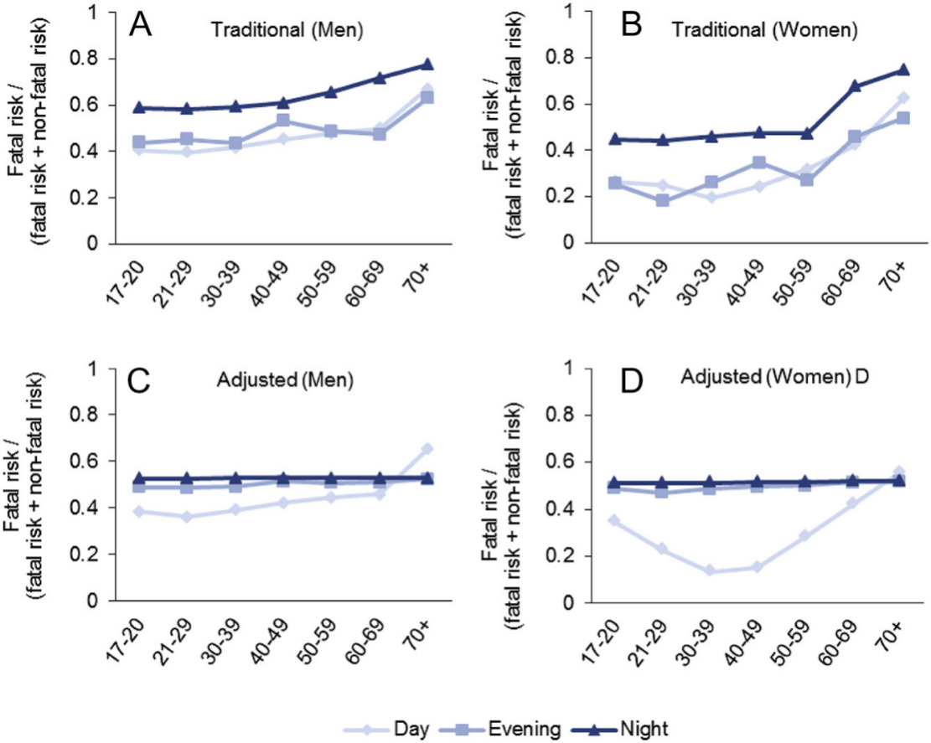

图5. 按驾驶员年龄和性别划分的白天（06:00—18:00）、傍晚（18:00—21:00）和夜间（21:00—06:00）多车碰撞参与后的传统及调整后致命伤害风险。碰撞参与后的致命伤害风险按年度以多车死亡碰撞风险除以多车死亡与非死亡碰撞风险之和计算

4. 讨论
碰撞率通常用于评估不同驾驶群体在不同风险暴露水平下的风险。然而，这种方法要求碰撞频率与暴露指标之间呈线性相关，而在使用传统暴露测量时这一假设并不成立。本文应用了一种基于新暴露度量的碰撞风险方法，在该度量下，碰撞数量与驾驶暴露量成比例。研究发现，传统碰撞率从17—20岁到60—69岁快速下降；而调整后碰撞风险在20—29岁达到峰值，并逐渐下降至60—69岁。此外，与传统碰撞率相比，使用调整后碰撞风险时，老年驾驶员的碰撞参与风险和致死风险均有所降低。最后，青少年驾驶员夜间驾驶在其单车碰撞风险中所占比例也低于传统碰撞率所显示的水平。
传统碰撞率从年轻年龄段到中年年龄段的急剧下降，反映了文献中常见的发现。然而，调整后碰撞风险揭示了明显不同的驾驶员风险年龄趋势：碰撞风险在21—29岁驾驶员中最高，随后随年龄逐渐降低。当前结果与使用分解模型和准诱导暴露方法进行碰撞风险分析的研究结果一致。这些研究表明，最年轻和最年长年龄组并非风险最高的驾驶员；相反，20多岁和30多岁驾驶员表现出最高的碰撞风险。虽然以往报告支持本文发现的稳健性，但本文并不反对针对年轻驾驶员实施驾驶限制。道路安全法规的正当性还取决于驾驶员能否认识自身局限并相应地自我调节驾驶行为。本文仅强调，其他年龄组同样存在较高驾驶员碰撞风险，也可能受益于有针对性的道路安全措施。
已有研究显示，驾驶员，尤其是年轻男性驾驶员，在夜间的碰撞参与率高于白天。在适当调整夜间出行较少这一因素后，本文发现与传统方法相比，夜间碰撞在青少年驾驶员单车碰撞风险中所占比例要低得多。在英国，年轻驾驶员夜间出行并不受限制。在对最年轻驾驶员实施宵禁限制的国家，政策制定者应认识到，传统碰撞风险分析方法可能会夸大夜间驾驶对青少年单车碰撞的贡献。
以往使用传统碰撞率的研究报告称，老年阶段碰撞风险会增加。本文发现，在正确控制老年驾驶员人数较少和出行不频繁之后，老年驾驶员的碰撞参与风险和致死风险均有所降低。这些发现与既有研究一致，即老年驾驶员看似较高的碰撞风险是其较低驾驶暴露所造成偏倚的结果。未来研究应进一步识别老年驾驶员内部的年龄亚组，因为其驾驶暴露和碰撞风险可能存在差异。
值得注意的是，本文分析显示，在老年驾驶员中，发生碰撞后遭受致命伤害的风险在不同时段保持稳定。这一发现支持了身体脆弱性在老年驾驶员碰撞伤害后果恶化中的作用，因为身体脆弱性（不同于事故严重程度）通常不应受到时段影响。因此，有利于老年驾驶员的对策应重点关注改善车内技术，以降低伤害严重程度。
无论采用哪种方法，年轻和中年驾驶员在夜间发生碰撞时遭受致命伤害的可能性均高于白天。这与既有研究相一致。不过，调整后方法还显示，夜间碰撞造成的致命伤害风险与傍晚碰撞相近。因此，本文结果支持在报告碰撞参与和伤害严重程度的年龄比较时按时段进行区分，并强调正确考虑不同时段出行暴露变异性的重要性。
两种方法关于性别差异的发现总体上与以往研究一致：男性驾驶员比女性驾驶员更可能参与死亡和非死亡碰撞。调整后方法还显示，女性驾驶员，尤其是30多岁至40多岁女性，在白天的死亡碰撞风险极低。这些数据符合既有出行行为研究，即女性，特别是有子女的女性，更可能在白天出行为乘客服务。虽然乘客存在会带来车内分心，但有年幼乘客在场可能通过降低女性驾驶员的冒险行为而产生保护作用，而非造成伤害。未来研究需要进一步探索这一可能性。
本研究存在若干潜在局限。第一，出于对使用里程比较不同年龄组碰撞风险的担忧，本文采用年度出行次数作为个人出行暴露指标。在本研究中，传统的每次出行碰撞率产生了最年轻驾驶员碰撞风险过高的熟悉模式。如果使用不同的出行指标，可能会使老年驾驶员的风险暴露更小，从而导致该年龄组碰撞率更高。尽管如此，已有研究表明，与年龄增长相关的出行减少同时体现在出行频率和行驶距离两个方面。第二，本文使用的是自报出行次数，该指标可能存在随驾驶员年龄而变化的报告偏差。未来研究可纳入客观的风险暴露测量。最后，本文承认，与简单碰撞率相比，新的碰撞风险方法所基于的暴露度量计算更为复杂。尽管如此，在对暴露于风险程度不同的驾驶群体和驾驶条件进行无偏风险比较方面，新的调整后碰撞风险估计量优于传统碰撞率。

5. 结论
本研究采用一种新方法，基于与碰撞呈线性关系的暴露度量来建模碰撞风险。研究结果指出，在不同群体和不同驾驶条件的驾驶暴露存在差异时，使用碰撞率进行风险比较是无效的。具体而言，本文证明了传统碰撞率会高估最年轻和最年长驾驶员以及夜间驾驶的实际碰撞参与风险和致命伤害风险。该研究对改进道路安全措施具有重要实践意义，因为有意义的风险比较是识别真正高风险驾驶员和高风险驾驶条件的基础。希望本文提出的方法能够促进新的碰撞建模方法的发展，使其能够考虑安全绩效函数的非线性形态，并为道路安全研究和政策制定提供可靠的碰撞风险估计。

