- 编码
- 库存管理。
包括：更改数量、更改库存地编码、更改零件型号和删除库存记录。其中更改零件型号和更改库存地编码后，若库存中已存在该条记录则会自动合并库存数量。若库存表单中不存在该条记录，则插入该条记录到库存表中。进行删除记录操作后，相应的库存记录会直接删除。
- Sevlet代码：
- @WebServlet("/ModifyQueryRepertory")
- public class ModifyQueryRepertoryServlet extends HttpServlet {
- private static final long serialVersionUID = 1L;

- protected void doGet(HttpServletRequest request, HttpServletResponse response) throws ServletException, IOException {
- request.setCharacterEncoding("utf-8");
- response.setCharacterEncoding("utf-8");

- IFSMService FSMService = new FSMServiceImpl();
- List<ReWaCo> list = FSMService.QueryRepertory();
- String strList = EntityUtil.modifyRepertoryList(list);

- if(strList.equals("empty")) {
- System.out.println("无内容！");
- request.setAttribute("detail", "暂无内容！");
- }else {
- System.out.println("查询成功！");
- request.setAttribute("detail", strList);
- }

- request.getRequestDispatcher("modifyInfo.jsp").forward(request, response);
- }

- protected void doPost(HttpServletRequest request, HttpServletResponse response) throws ServletException, IOException {
- // TODO Auto-generated method stub
- doGet(request, response);
- }

- }
- @WebServlet("/ModifyRepertoryCompId")
- public class ModifyRepertoryCompIdServlet extends HttpServlet {
- private static final long serialVersionUID = 1L;

- protected void doGet(HttpServletRequest request, HttpServletResponse response) throws ServletException, IOException {
- request.setCharacterEncoding("utf-8");
- response.setCharacterEncoding("utf-8");

- String wareId = request.getParameter("wareId");
- String compId = request.getParameter("compId");
- int num = Integer.parseInt(request.getParameter("num"));
- String origCompId = request.getParameter("origCompId");

- IFSMService FSMService = new FSMServiceImpl();

- Repertory repertory = new Repertory(wareId, compId, num);
- Repertory origRepertory = new Repertory(wareId, origCompId, num);

- String res = FSMService.UpdateRepertoryWCId(repertory, origRepertory);

- System.out.println("update num:"+res);

- if(res.equals("update and insert fail")) {
- request.setAttribute("feedback1", wareId);
- request.setAttribute("feedback2", origCompId);
- request.setAttribute("feedback3", num);
- request.setAttribute("feedback4", "修改失败，请联系技术人员！");
- }else if(res.equals("insert ok")){
- request.setAttribute("feedback1", wareId);
- request.setAttribute("feedback2", compId);
- request.setAttribute("feedback3", num);
- request.setAttribute("feedback4", "修改零件型号成功，已新增库存！");
- }else if(res.equals("update ok")) {
- request.setAttribute("feedback1", wareId);
- request.setAttribute("feedback2", compId);
- request.setAttribute("feedback3", num);
- request.setAttribute("feedback4", "修改零件型号成功，已合并库存！");
- }

- request.getRequestDispatcher("modifyCompId.jsp").forward(request, response);

- }

- protected void doPost(HttpServletRequest request, HttpServletResponse response) throws ServletException, IOException {
- // TODO Auto-generated method stub
- doGet(request, response);
- }

- }
- @WebServlet("/DeleteRepertory")
- public class DeleteRepertoryServlet extends HttpServlet {
- private static final long serialVersionUID = 1L;

- protected void doGet(HttpServletRequest request, HttpServletResponse response) throws ServletException, IOException {
- request.setCharacterEncoding("utf-8");
- response.setCharacterEncoding("utf-8");

- String wareId = request.getParameter("wareId");
- String compId = request.getParameter("compId");

- Repertory repertory = new Repertory(wareId, compId);

- IFSMService FSMService = new FSMServiceImpl();

- String res = FSMService.DeleteRepertory(repertory);

- List<ReWaCo> list = FSMService.QueryRepertory();
- String strList = EntityUtil.modifyRepertoryList(list);

- System.out.println("delete repertory: " + res);

- if(res.equals("yes")) {
- request.setAttribute("feedback", "删除成功！");
- }else {
- request.setAttribute("feedback", "删除失败，请联系技术人员！");
- }

- if(strList.equals("empty")) {
- System.out.println("无内容！");
- request.setAttribute("detail", "暂无内容！");
- }else {
- System.out.println("查询成功！");
- request.setAttribute("detail", strList);
- }

- request.getRequestDispatcher("modifyInfo.jsp").forward(request, response);

- }

- protected void doPost(HttpServletRequest request, HttpServletResponse response) throws ServletException, IOException {
- // TODO Auto-generated method stub
- doGet(request, response);
- }

- }

- Service层和Dao层函数：
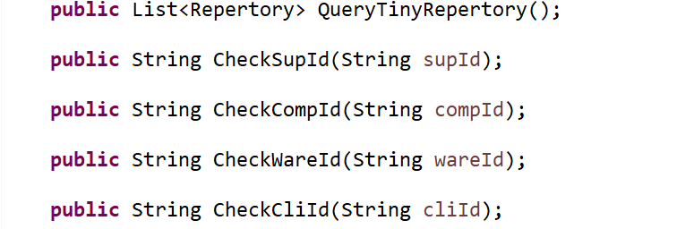

- 测试
- 库存管理：
- 修改仓库号
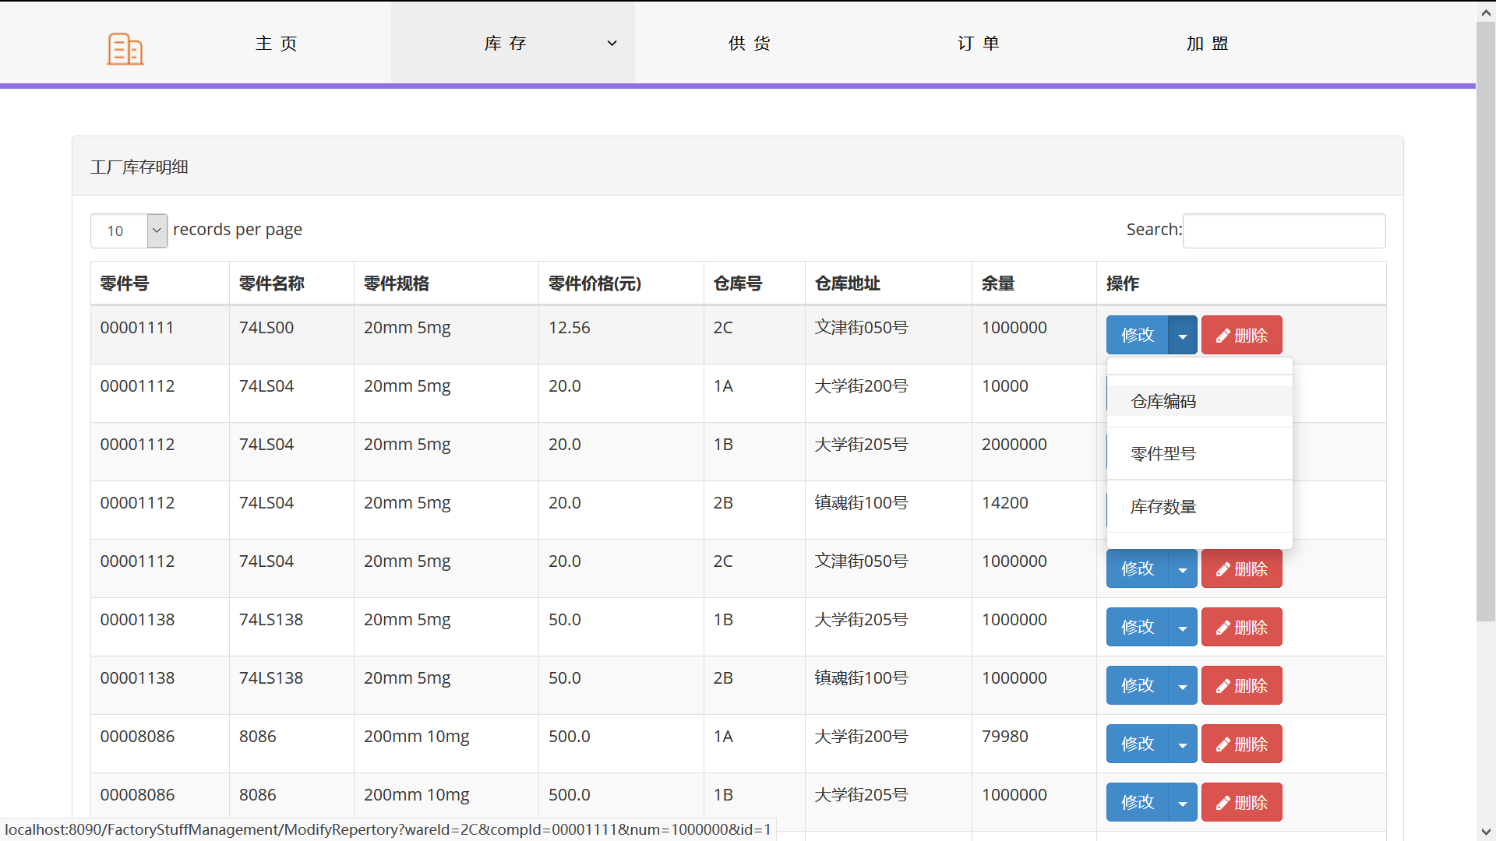
修改之后：
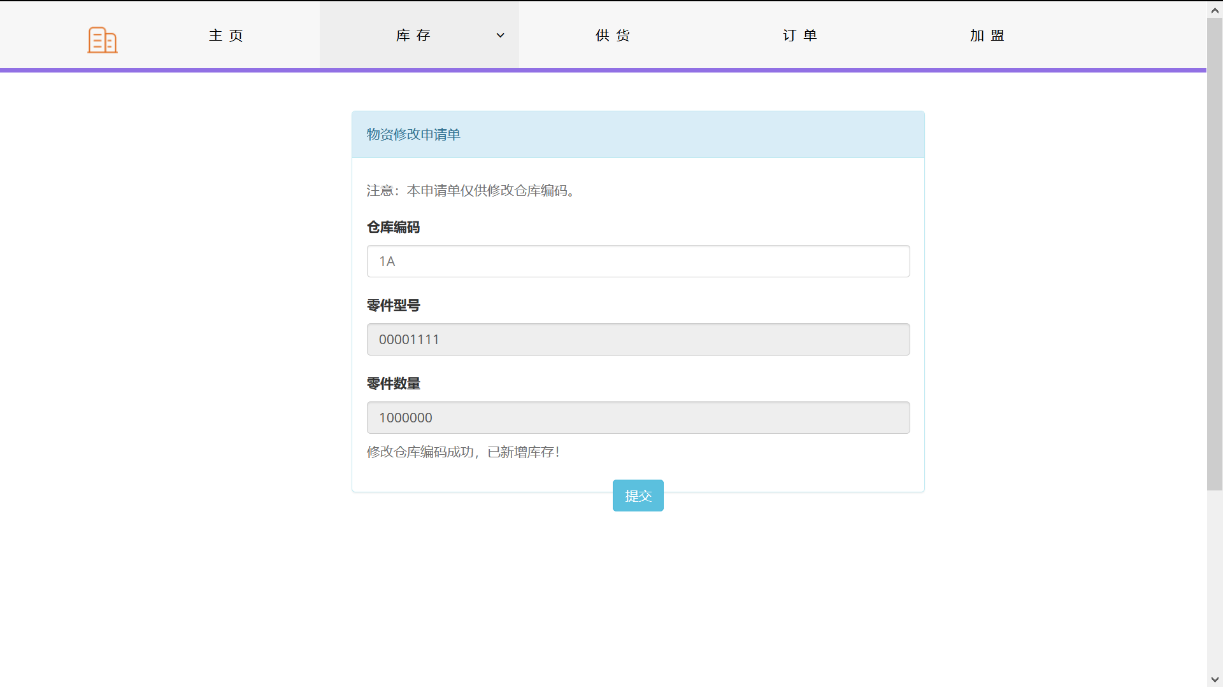
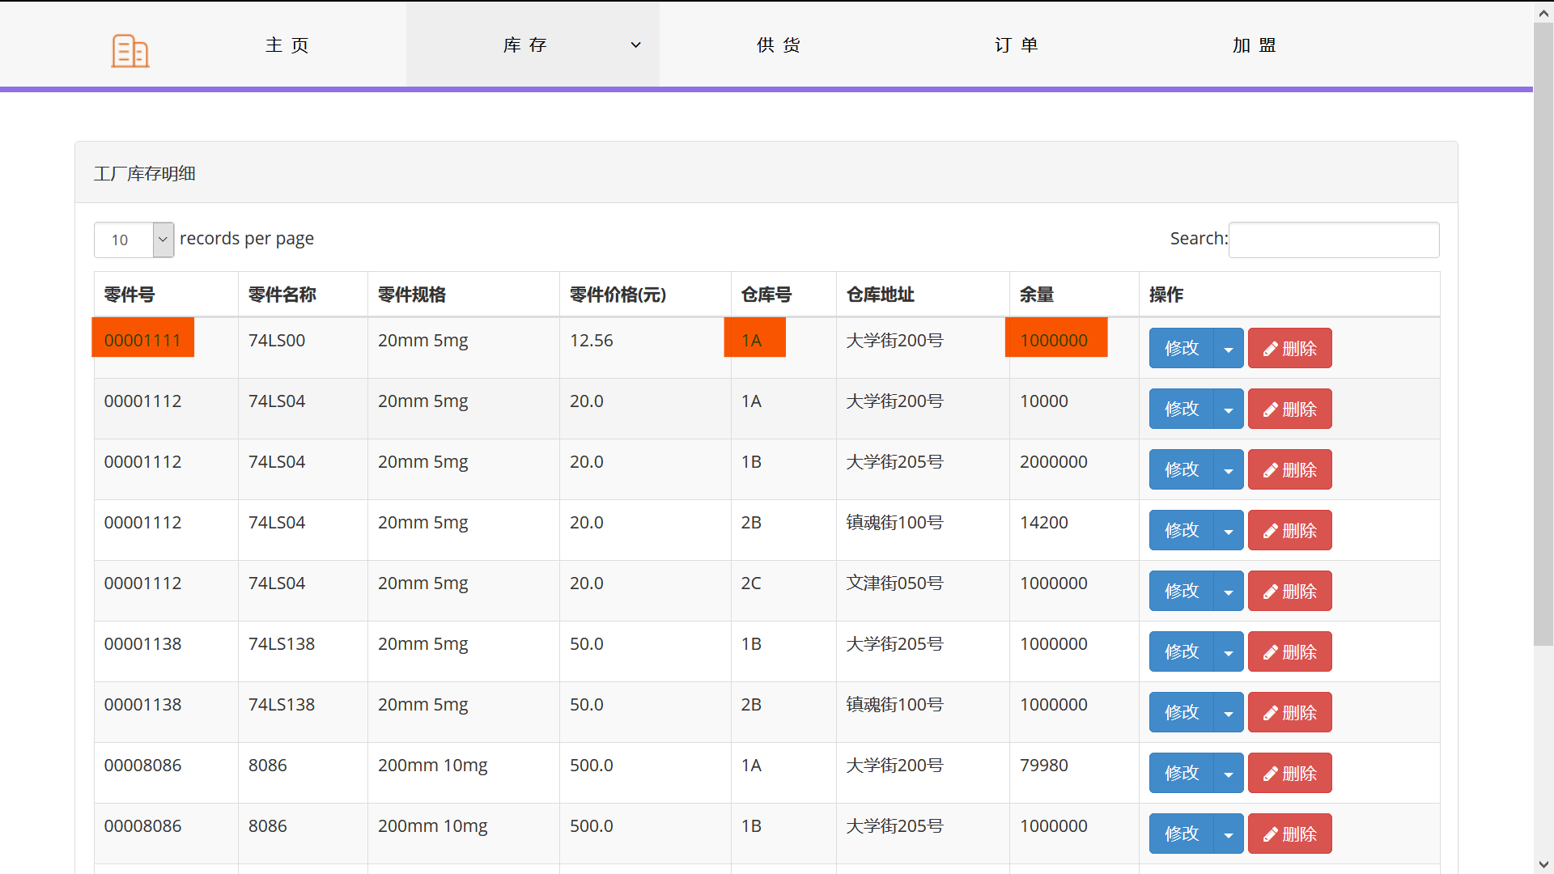
- 修改零件号:
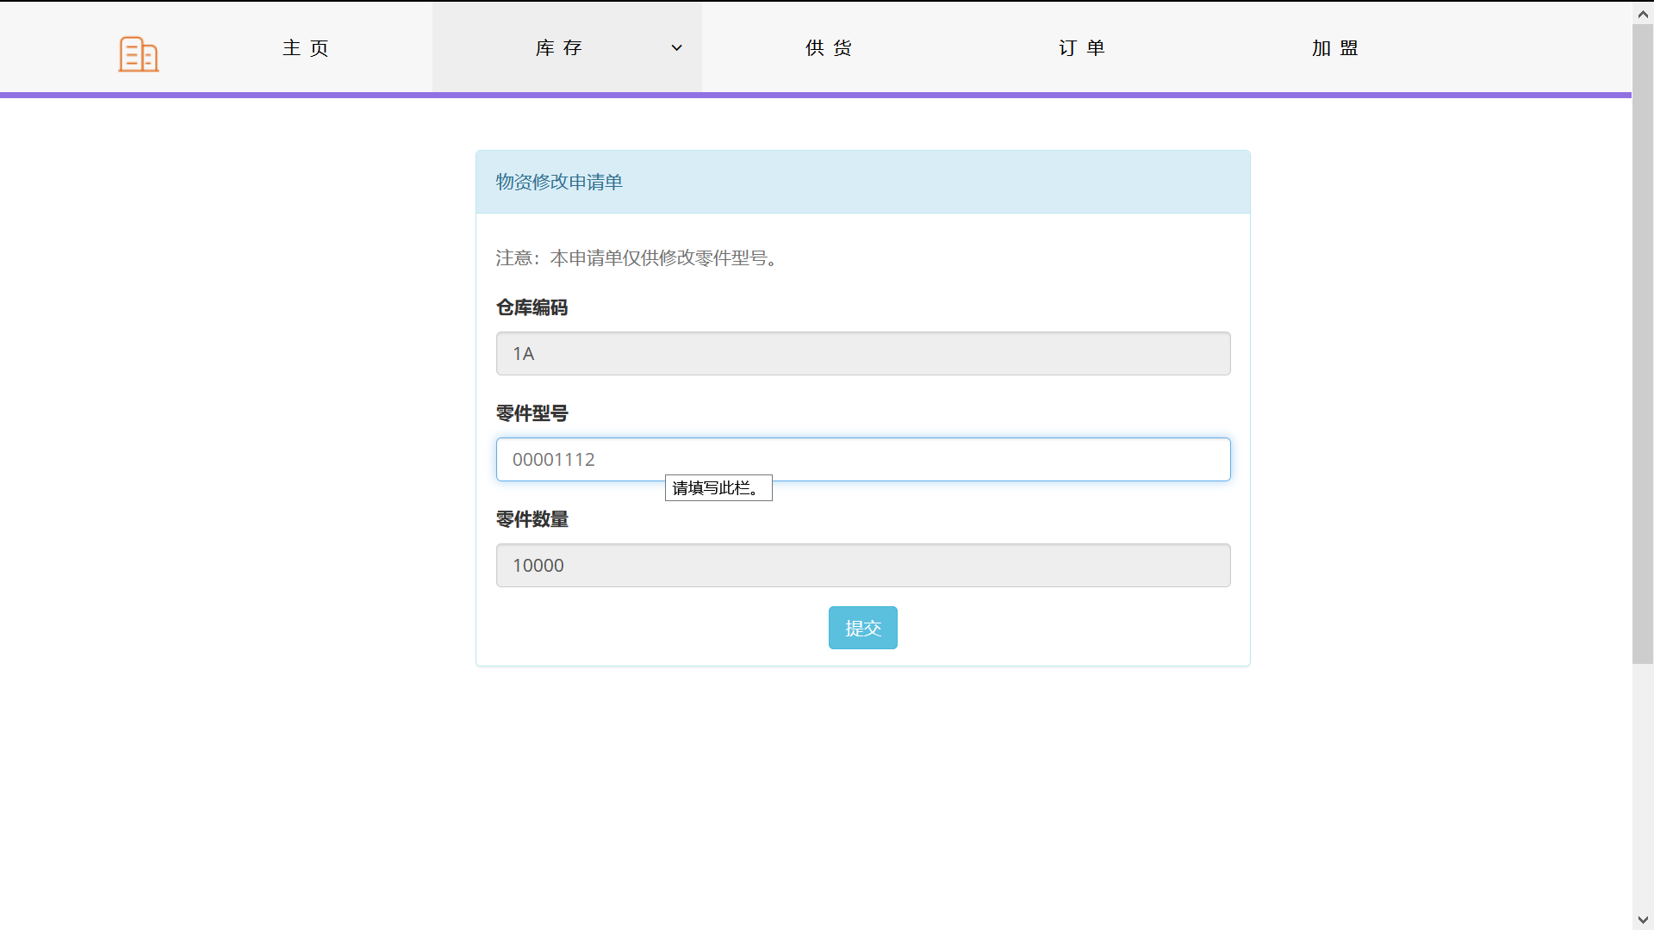
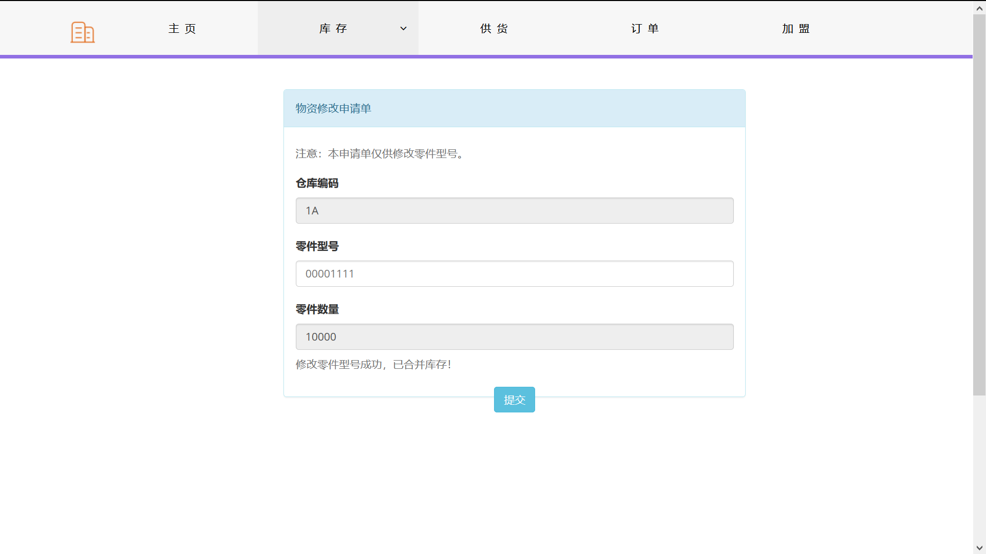
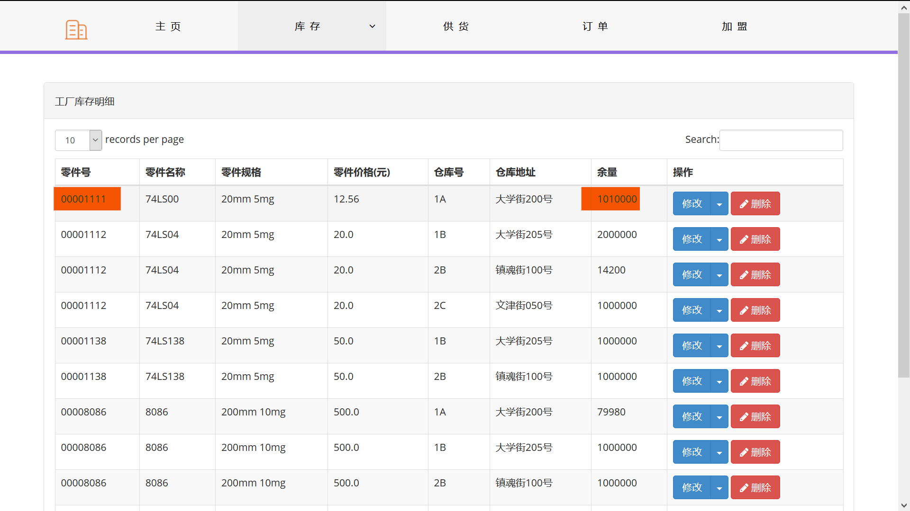
- 修改库存数量
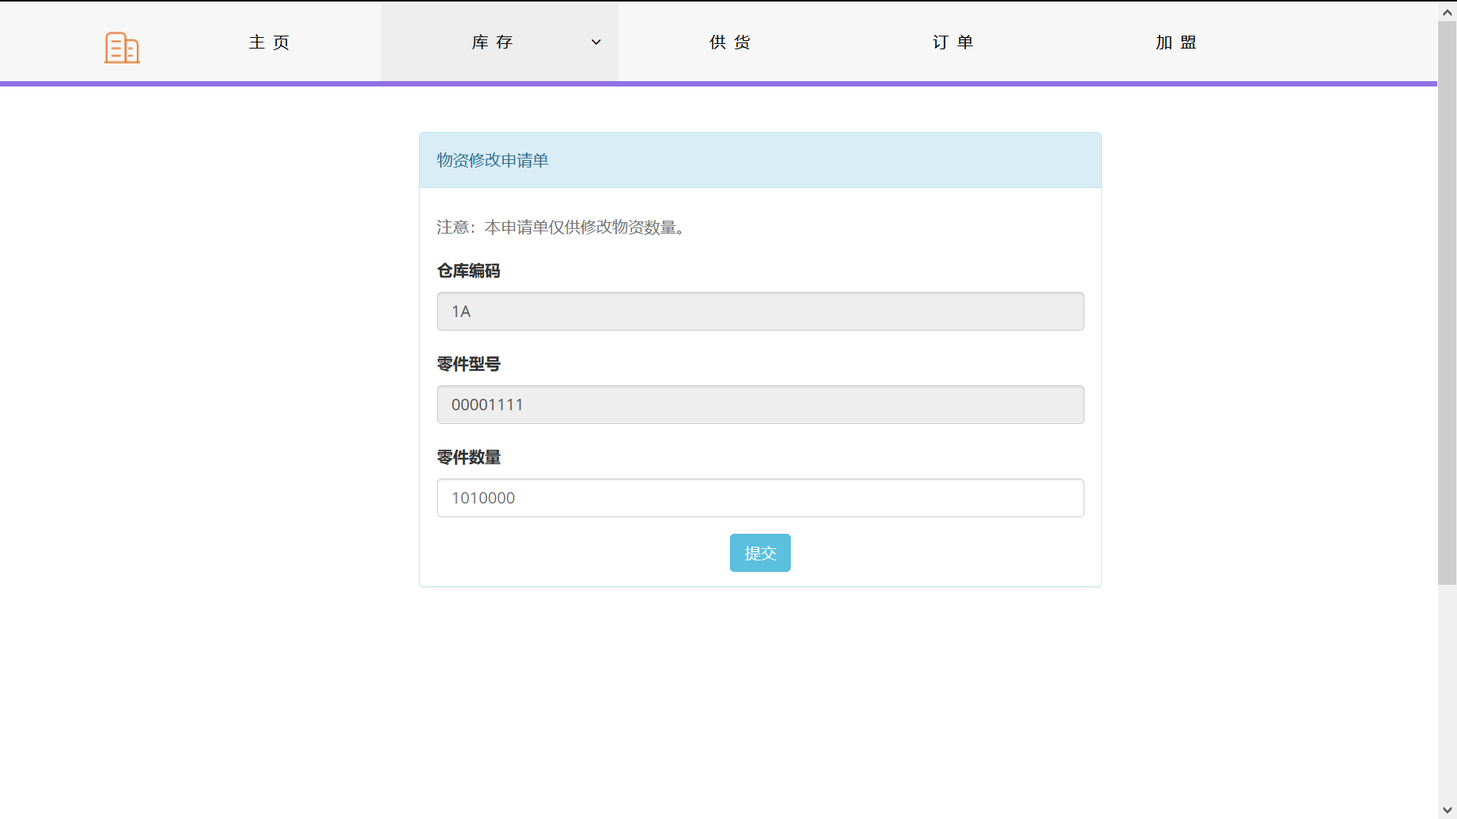
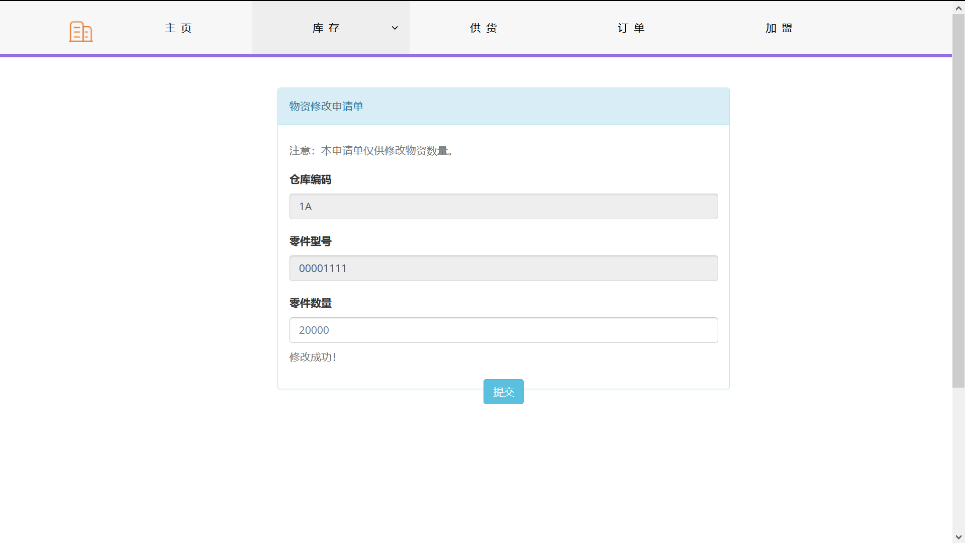
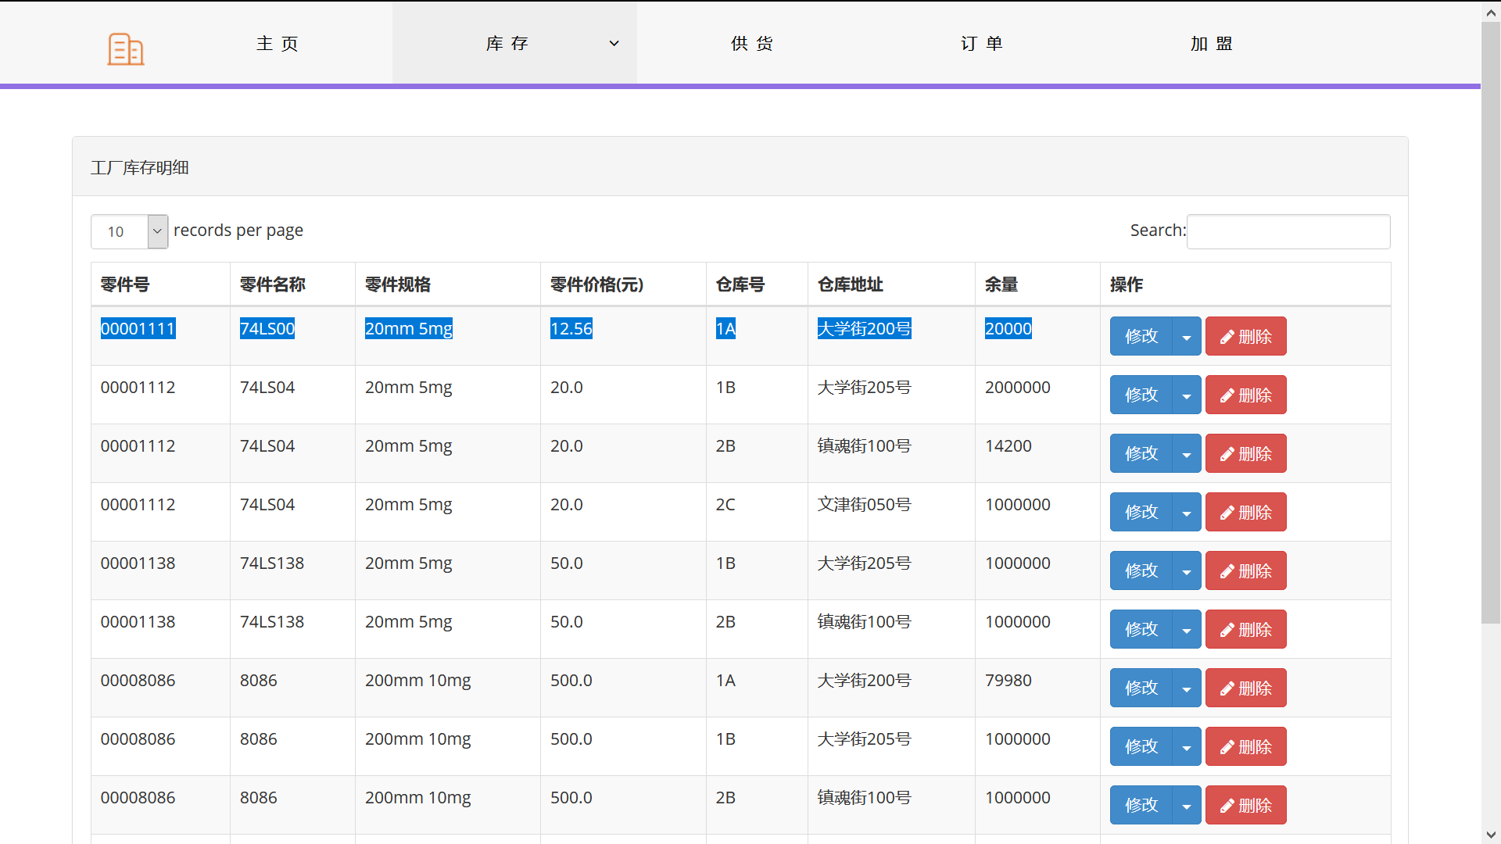
- 删除零件：
