University administration database
- Global analysis
University educational administration system can be roughly divided into two main parts: student information managemnt and teacher information management. Student information and teacher information contain the same parts, such as name, gender, age, Department, etc. Meanwhile, there are some differences between the two entity sets, such as the students need to select courses, and need to record the students' marks in their selecting courses. Of course, there are other parts (or entity sets), such as course, classroom, department, etc. But it can be said that almost all of the information of the University revolves around students and teachers. Starting from students and teachers, we can build a complete database system gradually.
First of all, we should establish E-R model diagram (entity relationship diagram) for "university educational administration database". During the process of building model graph, we can get the entity set, the relation set among the entity sets and so on. After that, E-R graph needs to be transformed into relationship schemas. During this process, we can get the foreign key constraints between entity set and relation set between entity set. At last, we should add "cascade delete" to these foreign key constraints, which also named integrity constraints. According to the relationship schema, we can get the schema diagram containing the constraints of the primary key and the foreign key. The following steps mainly follow the analysis above.
- Database analysis and some operations
  - E-R diagram analysis:
- First of all, there is a advisor relationship between students and teachers. In the current situation, a teacher teaches more than one student, so teachers and students are a one to many mapping relationships.
- Also, there is a relation set "advisor" between student and instructor.
- Student and instructor are two entity sets, each of them has its own department. Each department has a department name, building name and budget name. The department name can uniquely identify this tuple, so the department entity set can be abstracted lonely.
- There are also relation sets “stu_dept” between students and departments and “ins_dept” between instructor and departments.
- Students need to choose courses. The courses students taken have credits, start time and course name, etc. One course can be uniquely defined by course_id, section_id, semester, year and start time, etc. It has many attributes, and it can be divided more carefully. Course can be defined lonely, because the number of courses is definite before. There are just some changes in the section time and the taught teachers. So course is a entity set. Sometimes we need to find the previous course of some courses, so it is useful to set a role called “prereq” between course entity set itself.
- As previous one saying, more sets should be defined from course. It can be also found that “section” and time related should be defined. A section entity set should include the detailed information about unique course. And one course may have many sections. So, there should be some attributes like “sec_id”, “semester”, “year” in the entity set. I think the detailed time can be added into this entity set, but it is better to make the detailed time another entity set – “time_slot”. And the relationship set between them is “sec_time_slot”. I think the reason probably be that one particular time may correspond many courses (of course not in the same space), and do this can prevent the redundancy of time. The section entity is a weak entity, so it must depend on another strong entity set through their relationship set. And the mapping cardinality is “n-1”. The diagram describes this two sets is shown in Graph a.1.
- Then it should be considered where student take courses. Just as previous point said, section entity has been abstracted. So different sections should be related to particular classrooms. Classroom should own building name, room number and capacity number. One classroom can be uniquely defined by its building name and room number. One classroom may have many course sections, so the mapping cardinality between them is “1-n”. The relationship set between them is “sec_class”. Obviously, every section has its own space or say classroom to carry on. But one classroom can be unused. So, section is total participation to this relationship set. The diagram describes this can be seen in Graph a.2.
- After considering the part of “course”, it is the time to consider the relationship among course part, student and instructor. It is known that students take courses, more detailed, that student take the sections of course. So, the relationship “takes” can be defined. The mapping cardinality is “1-n”. Another attribute called grade should be added to the relationship.
- And the relationship between instructor and section is “teaches”. Also, the mapping cardinality is “1-n”.
- At last, it should be considered about the remaining relationship set around department after other sets were constructed. Courses can be divided into many classes by their subject. So there is a relationship called “course_dept” between course entity and department entity. Every course belongs to one particular department (of course there exists some intercross subjects, their quantity is very few in our university), and some department like government department do not own course. So, course is total participate. And the mapping cardinality between them is “n-1”.
- Finally, the E-R diagram is shown on Graph a.3
Graph a.1
Graph a.2
Graph a.3
  - Schema diagram analysis
- In this part, I will give the result (constraint of every entity sets and relationship sets), the relation schema diagram and list the reason of each of them stay close to the front or follow closely behind.
- First, the strong entity set with simple attributes can be defined easily. It is same as those attributes in E-R diagram. So, we can get them:
student (ID, name, age, gender, tot_credit);
instructor (ID, name, age, gender, salary);
department (dept_name, building, budget);
course (course_id, title, credits);
classroom (building, room_number, capacity);
- Second, the strong entity set with complex attributes can be divided into three parts: multivalued, derived, compound attributes. In the E-R diagram above, it can be found that the time_slot has both multivalued and compound attributes. So, it can be written that time_slot (time_slot_id, day, start_time, end_time). And the primary key is “time_slot_id, day, start_time, end_time”. Because time_slot_id is primary key in E-R diagram, and others are multivalued attributes. And because of the length of one class is locked, we can just use day and start time as the rest part of attributes. The result is
time_slot (time_slot_id, day, start_time, end_time);
- Third, considering about the weak entity set – section. This set is consisted of the primary key of the strong entity set and its own attribute. The primary key of this schema is consisted of the primary key of the strong entity set and its own resolution character. So, the result is:
section (course_id, sec_id, semester, year);
We should also add that course_id foreign key reference course, and set up the integrity constraint by using “cascading deletion”.
- Fourth, it is time to think about relation sets. Consisted of all the primary key of the relation schemas of entity sets. And the way to select primary key of this relation schema is to choose those whose mapping cardinality is bigger. And set up the foreign constraint of each relation set reference the relation schemas of their entity sets. So, the results are:
advisor (s_ID, i_ID);
teaches (i_ID, course_id, sec_id, semester, year);
takes (s_ID, course_id, sec_id, semester, year, grade);
stu_dept (s_ID, dept_name);
ins_dept (i_ID, dept_name);
course_dept (course_id, dept_name);
sec_course (course_id, sec_id, semester, year);
sec_class (course_id, sec_id, semester, year, building, room_number);
sec_time_slot (course_id, sec_id, semester, year, time_slot_id, day, start_time);
prereq (course_id, prereq_id);
- Fifth, considering about the combination of schemas. In the above point, we have got the schemas of all the relation sets. If there exists two entity sets A and B. A-B is n-1, and A is total participation. We can combine relation set AB with A. The foreign key reference A is abandoned. And referring B is remained to the new schema. The primary key follow with A. So, we can get this:
section (course_id, sec_id, semester, year, building, room_number, time_slot_id, day, start_time);
course (course_id, title, credits, dept_name);
student (ID, name, age, gender, tot_credit, dept_name);
instructor (ID, name, age, gender, salary, dept_name);
And we abandon them: stu_dept, ins_dept, course_dept, sec_course, sec_class, sec_time_slot.
- Finally, we can get the schema diagram shown on Graph b.1. I delete the time_slot schema, because the foreign constraint is not really useful.
Graph b.1
  - Interactive SQL operation
Considering of the demand in question d), it is better to add an entity set whose name is class.
  - Class is a weak entity, attributes are class_num, capacity, depend on department.
  - Class-student is 1-n, each class has students, each student has class.
  - Class-section is n-n, each class has sections, each section has classes.
  - Class-department is n-1, each class has department, some departments don’t have class.
So, it is easy to get the E-R diagram and relational schema about class shown on Graph c.1 and c.2. In Graph c.1, double arrow represents total participation and 1 mapping cardinality.
Graph c.1
Graph c.2
Then, I will list the SQL operations.
- First, creating tables base on Graph b.1 and c.2. The structure can be seen on Graph c.3.
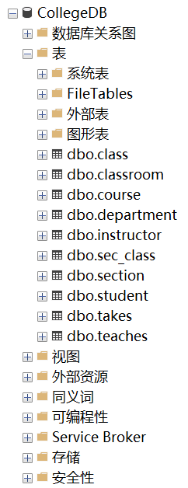
Graph c.3
- Second, inserting data into each tables, and part of the results are shown on Graph c.4, c.5 and c.6
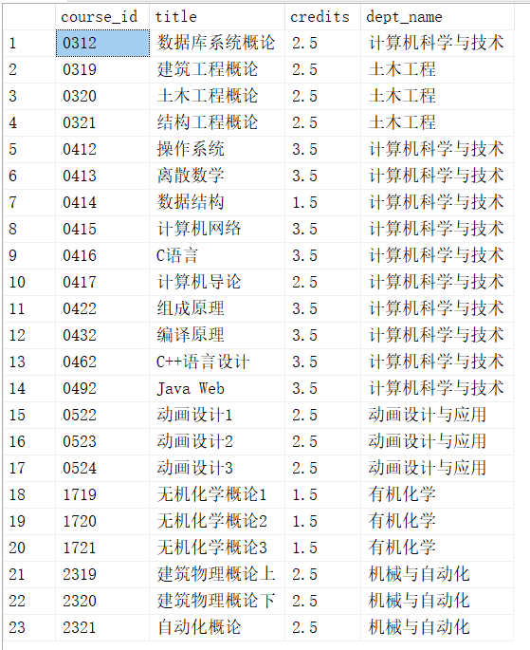
Graph c.4
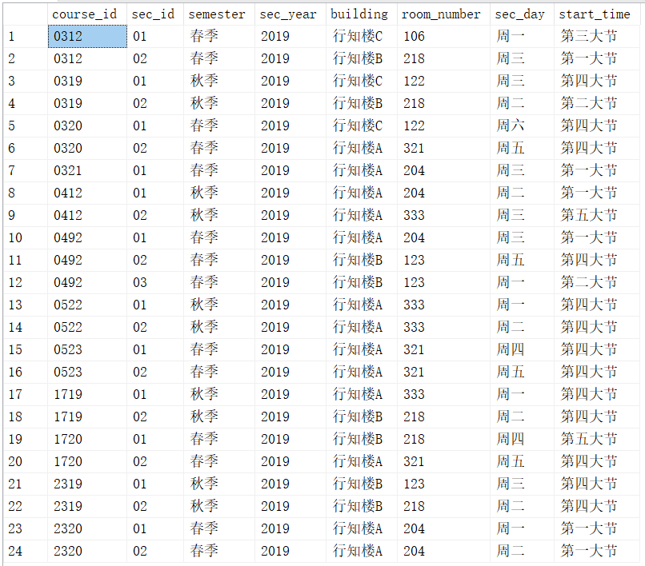
Graph c.5
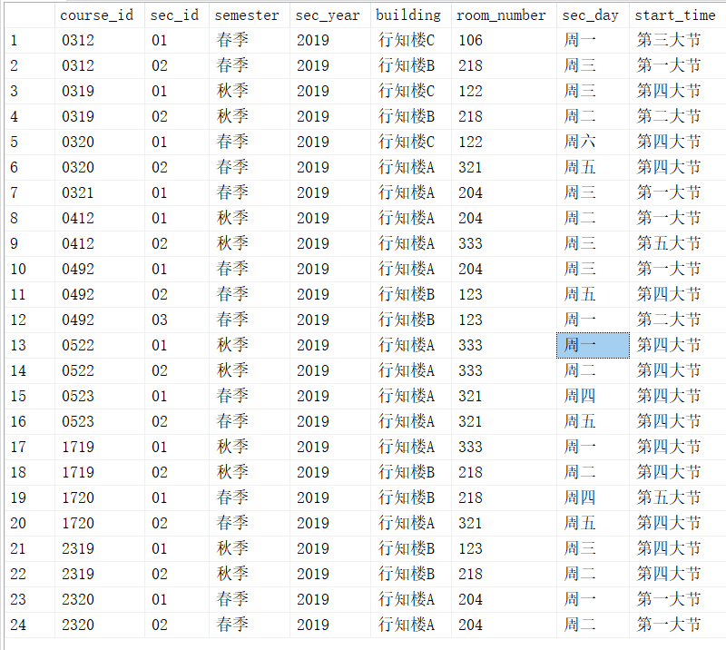
Graph c.6
- Finally, it is about the basic operation of SQL, such as update, delete and query. Those operations have been shown on Database experiment, there will not give unnecessary details. But this point will give a query about some different courses. The SQL sentences are shown on Graph c.7, and result on Graph c.8.
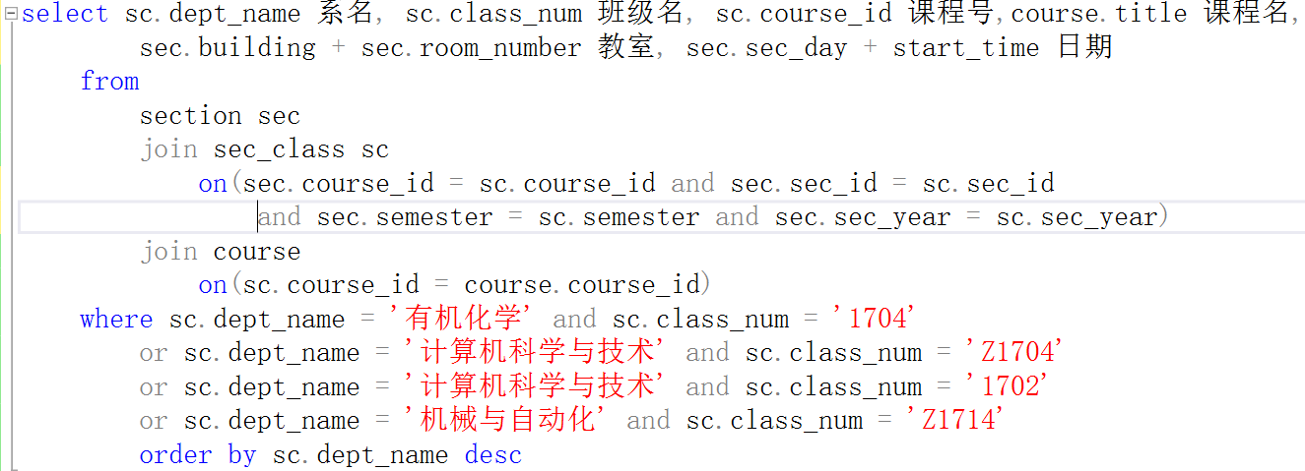
Graph c.7
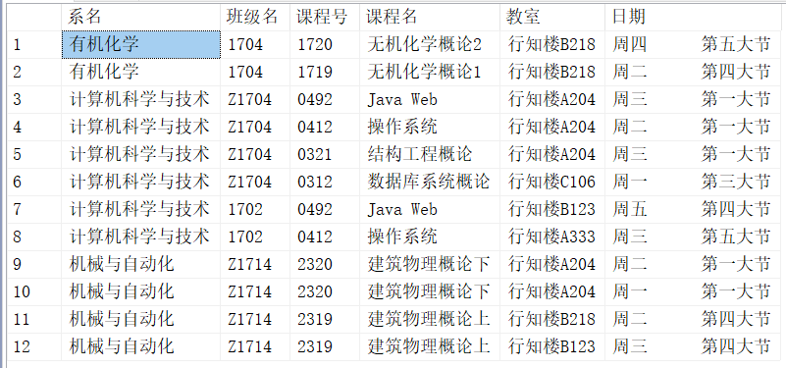
Graph c.8

  - Function design and implantations.
- Query class tables. SQL code shown follow behind, result shown on Graph d.1.
- create function classTable(@dept_name varchar(20), @class_num char(10))
- returns table
- as
- return (select sc.dept_name 系名, sc.class_num 班级名, sc.course_id 课程号,course.title 课程名,
- sec.building + sec.room_number 教室, sec.sec_day + start_time 日期
- from
- section sec
- join sec_class sc
- on(sec.course_id = sc.course_id and sec.sec_id = sc.sec_id
- and sec.semester = sc.semester and sec.sec_year = sc.sec_year)
- join course
- on(sc.course_id = course.course_id)
- where sc.dept_name = @dept_name and sc.class_num = @class_num
- )
- go
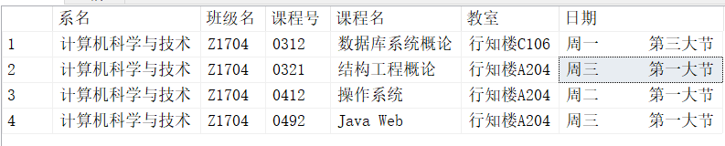
Graph d.1

- Query instructor tables. SQL code shown follow behind, result shown on Graph d.2.
- create function insTable(@ins_num varchar(20))
- returns table
- as return(
- select instructor.ID 教工编号, instructor.i_name 教工姓名, sec.course_id 课程号, sec.sec_id 课程段,
- course.title 课程名, sec.building+sec.room_number 课程教室, sec.sec_day+sec.start_time 上课时间,
- sec.sec_year+'年'+sec.semester 学期信息
- from
- teaches
- join section sec
- on(sec.course_id = teaches.course_id and sec.sec_id = teaches.sec_id
- and sec.semester = teaches.semester and sec.sec_year = teaches.sec_year)
- join instructor
- on(teaches.i_ID = instructor.ID)
- join course
- on(teaches.course_id = course.course_id)
- where teaches.i_ID = @ins_num

- )
- go
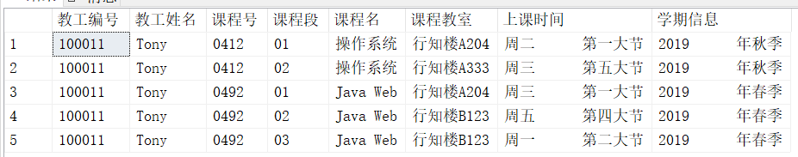
Graph d.2

- Query class grade tables. SQL code shown follow behind, result shown on Graph d.3 and d.4 (Graph d.3 is the details about ‘Z1704’, and d.4 is the result).
- create function classGrade(@dept_name varchar(20), @class_num char(10))
- returns table
- as return(
- select course.title 课程名,
- MAX(takes.grade) 最高分, AVG(takes.grade) 平均分, MIN(takes.grade) 最低分
- from student join class on(student.dept_name = class.dept_name and student.class_num = class.class_num)
- join takes on(student.ID = takes.s_ID) join course on(takes.course_id = course.course_id)
- where class.dept_name = @dept_name and class.class_num = @class_num
- group by course.title
- )
- go
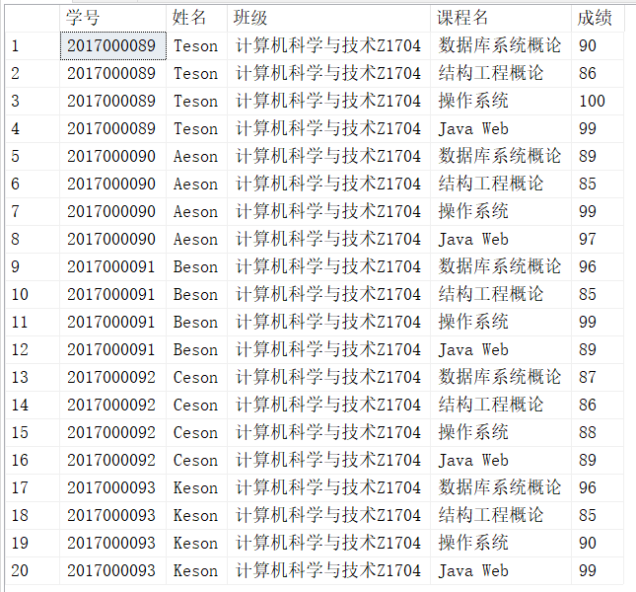
Graph d.3
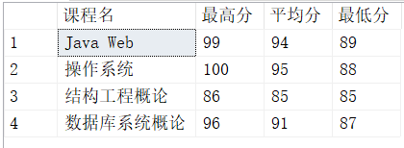
Graph d.4
- Query student grade tables. SQL code shown follow behind, result shown on Graph d.5.
- create function stuGrade(@s_ID varchar(20))
- returns table
- as return(
- select student.ID 学号, student.s_name 姓名, student.dept_name+student.class_num 班级, course.title 课程名, takes.grade 成绩
- from student join takes on(student.ID = takes.s_ID) join course on(takes.course_id = course.course_id)
- where student.ID = @s_ID
- )
- go
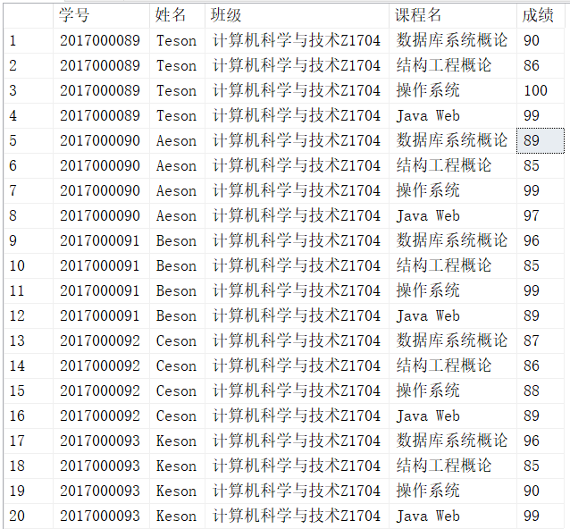
Graph d.5

- Finally, the trigger of takes about students. SQL code shown follow behind, result shown on Graph d.6 and d.7 (Graph d.6 is the previous information, d.7 is the information after insert data into takes).
- CREATE TRIGGER tr_INSERT ON takes FOR INSERT
- AS
- --声明变量
- DECLARE @s_ID varchar(20)
- DECLARE @credit float
- --提取插入的数据
- SELECT @s_ID = s_ID from takes inserted
- --提取学生的总学分
- SELECT @credit = course.credits FROM takes join course ON(takes.course_id = Course.course_id)
- WHERE takes.s_ID = @s_ID
- --更新总学分
- UPDATE student SET tot_credit = tot_credit+ @credit WHERE ID = @s_ID
- GO
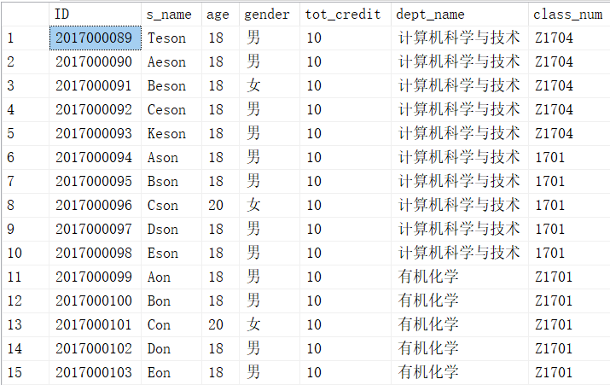
Graph d.6
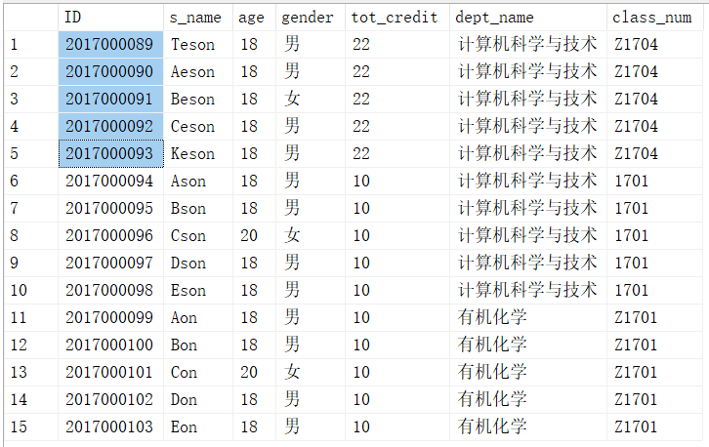
Graph d.7

  - User interface design.
- In this point, I will give the html interface of four functions list above. This part is about Java Web. And those codes are based on MVC pattern. The package of java and jsp pages are put in the homework folder. The home page “index.jsp” and result page “show.jsp” are shown on Graph e.1 and e.2.
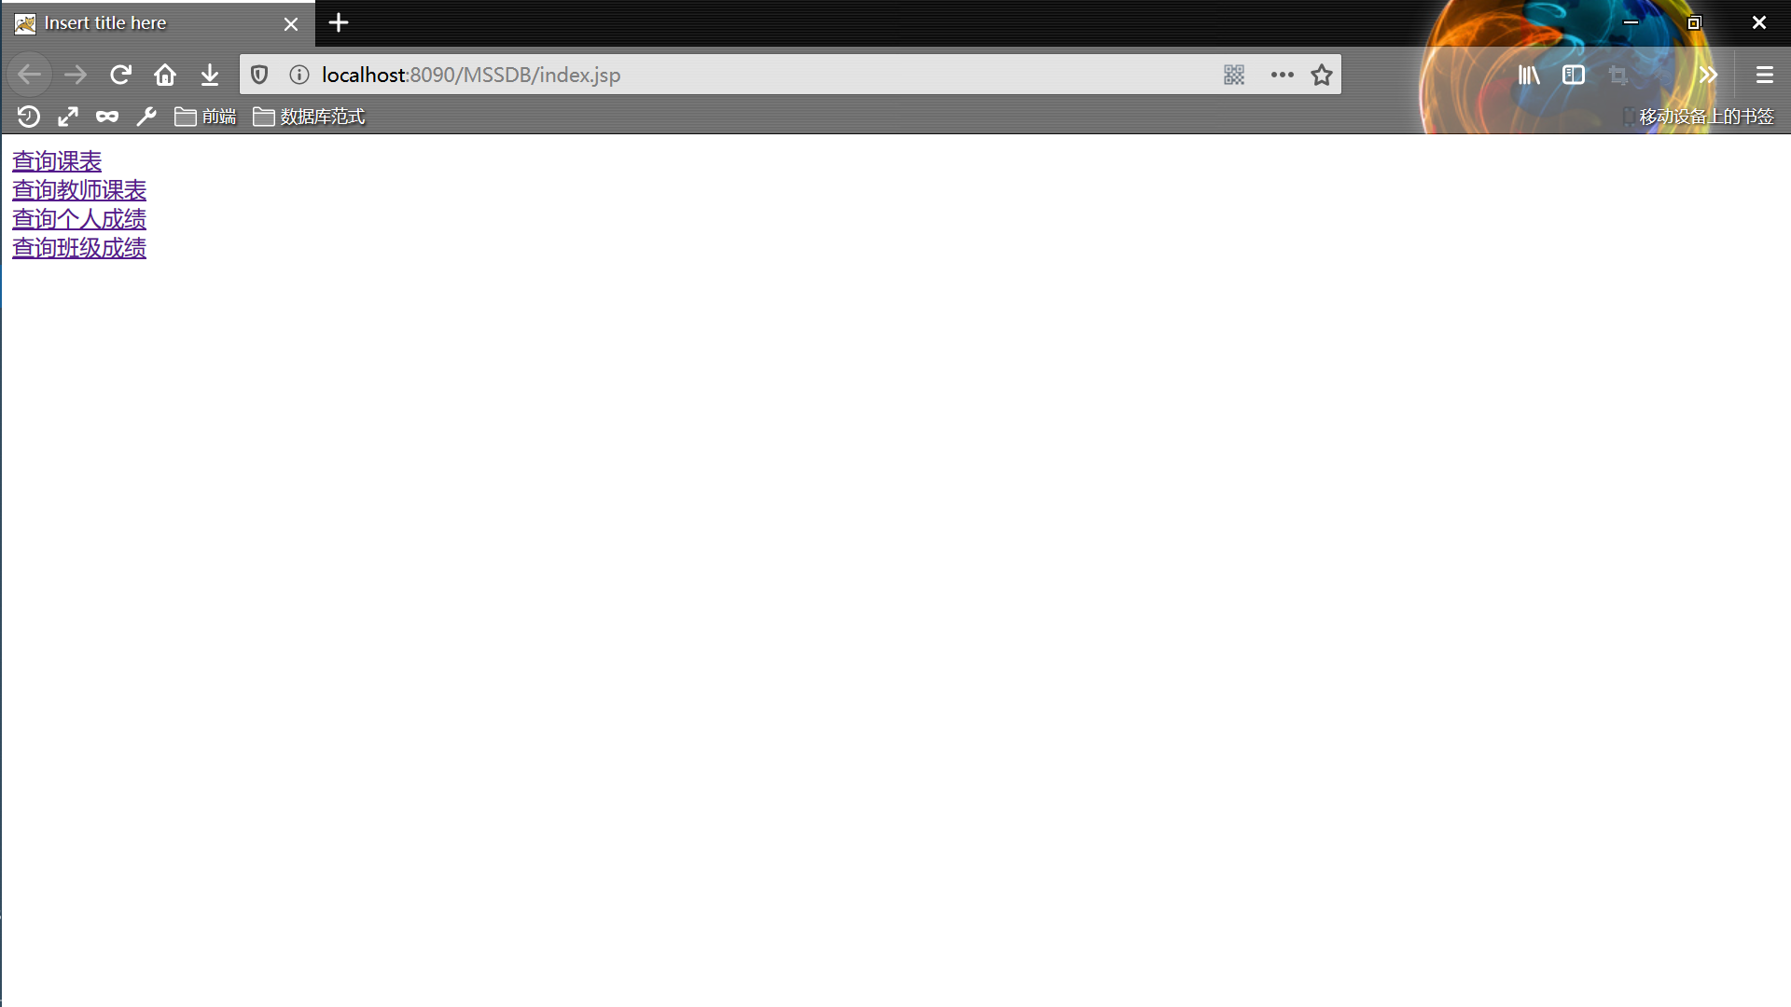
Graph e.1
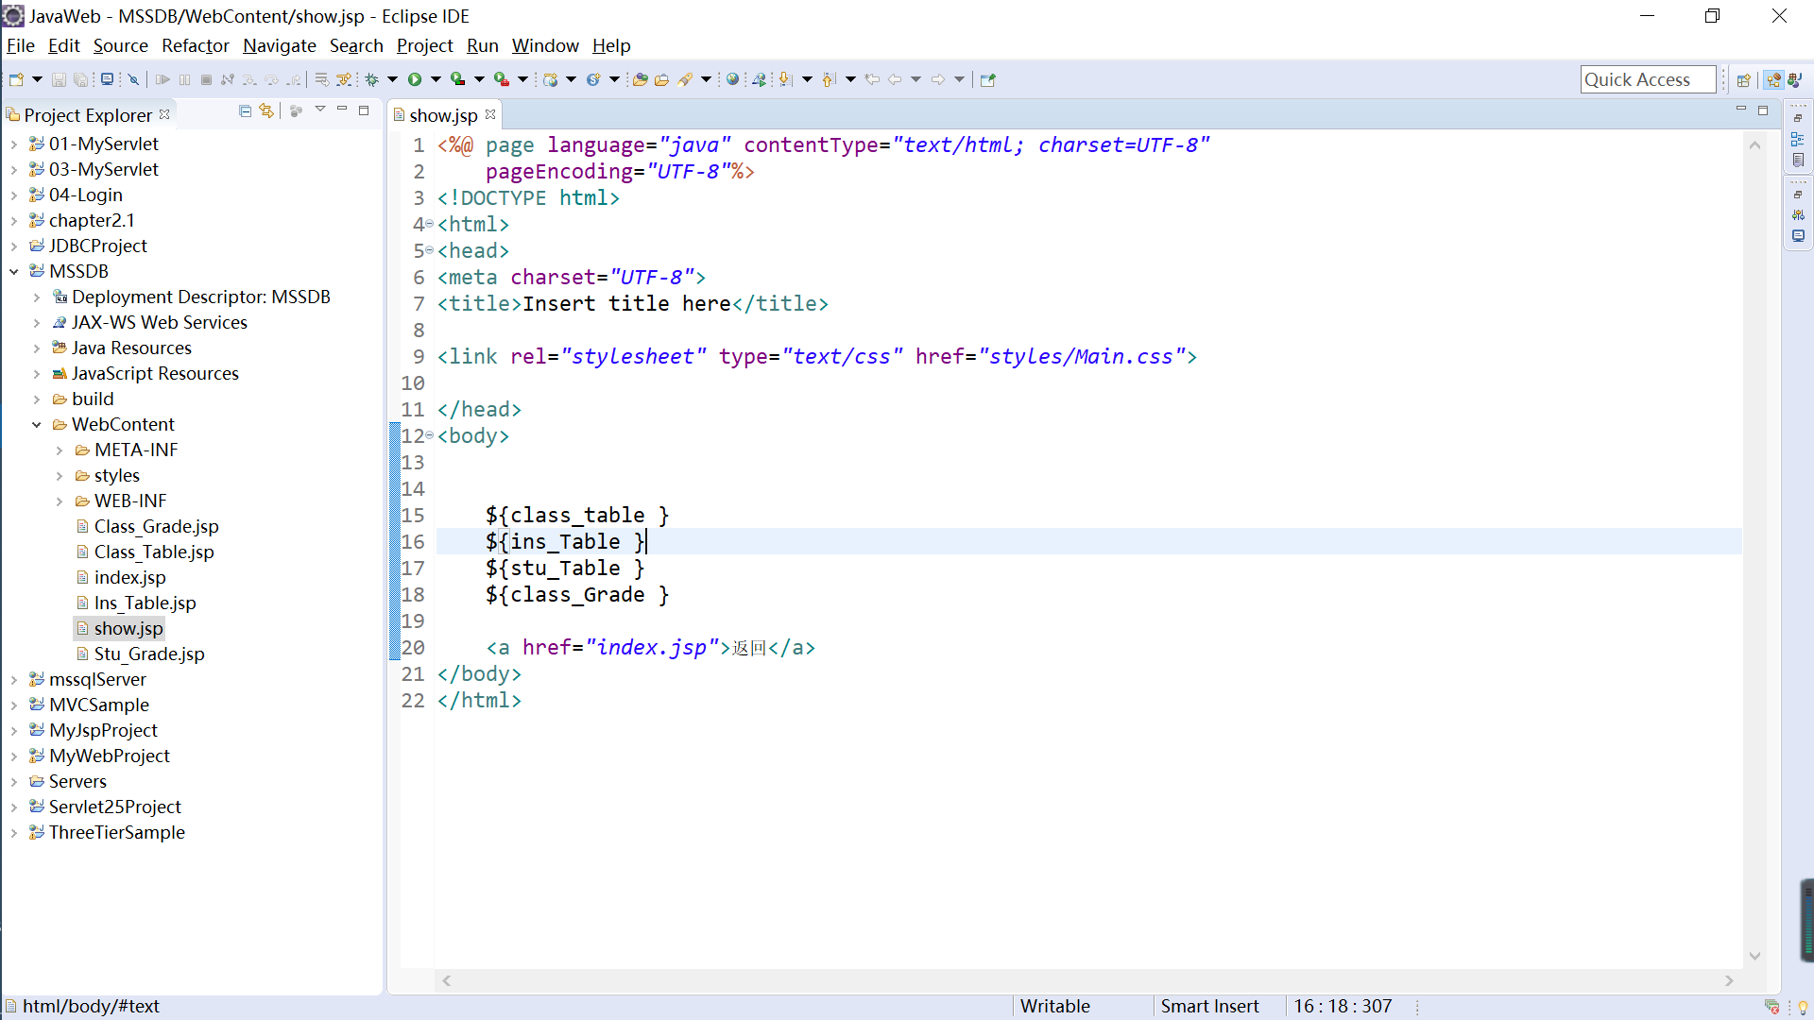
Graph e.2

- First, it is about class table. The results are shown on Graph e.3 and e.4.
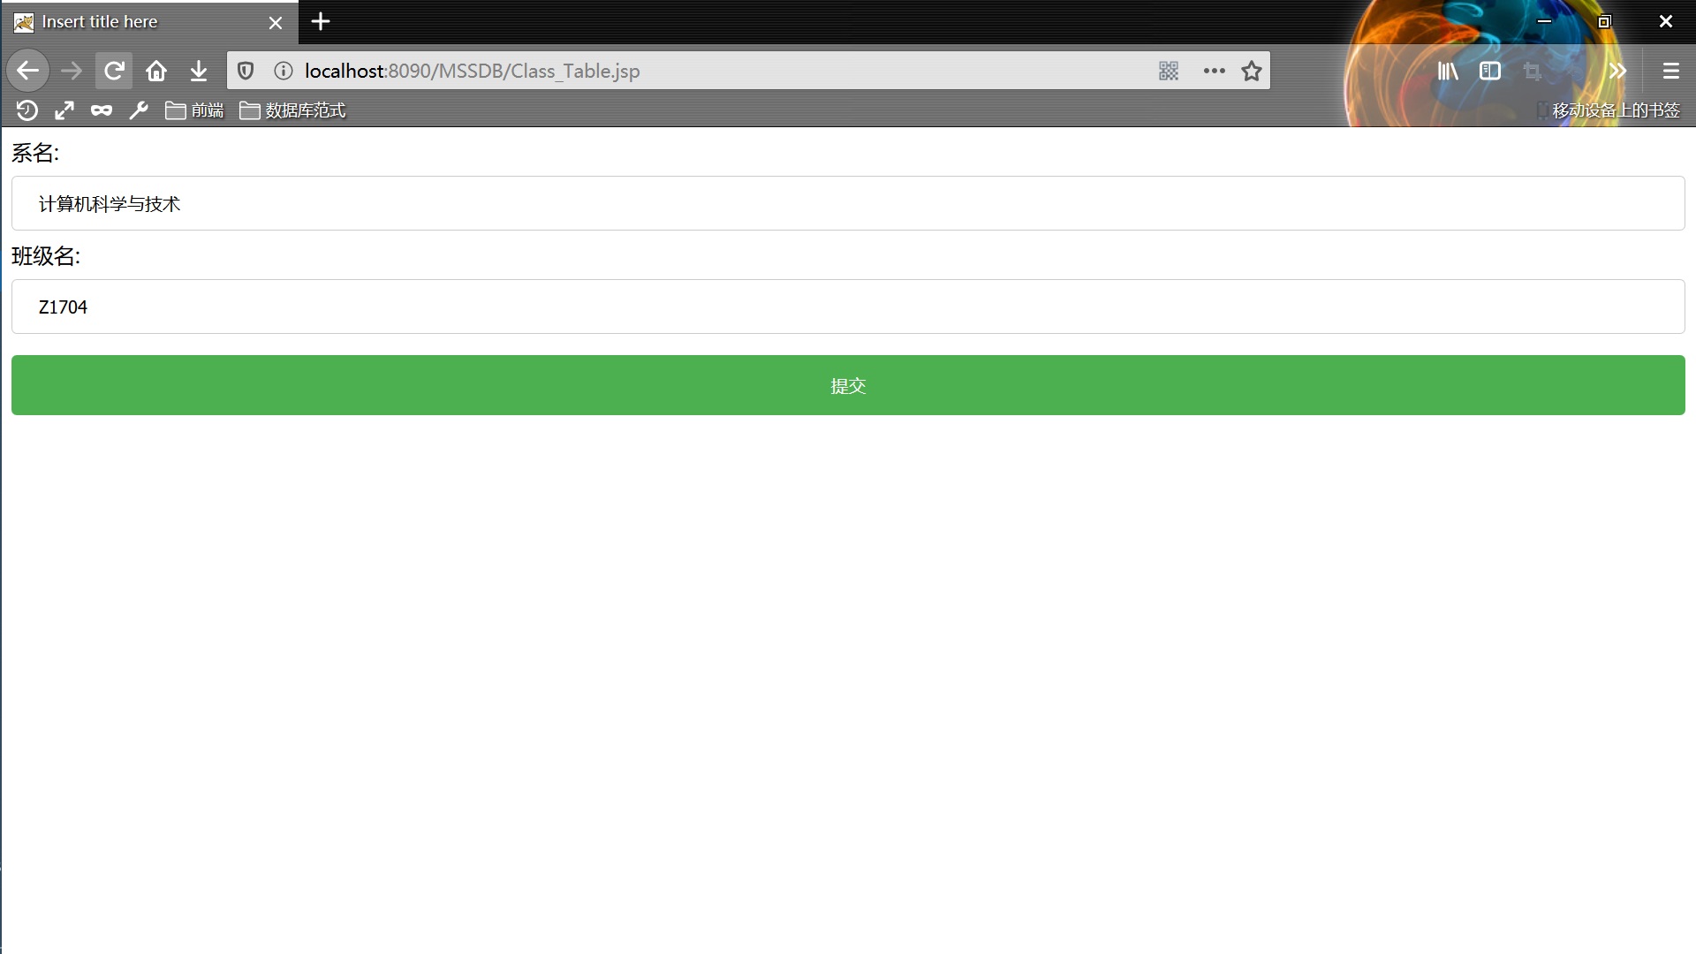
Graph e.3
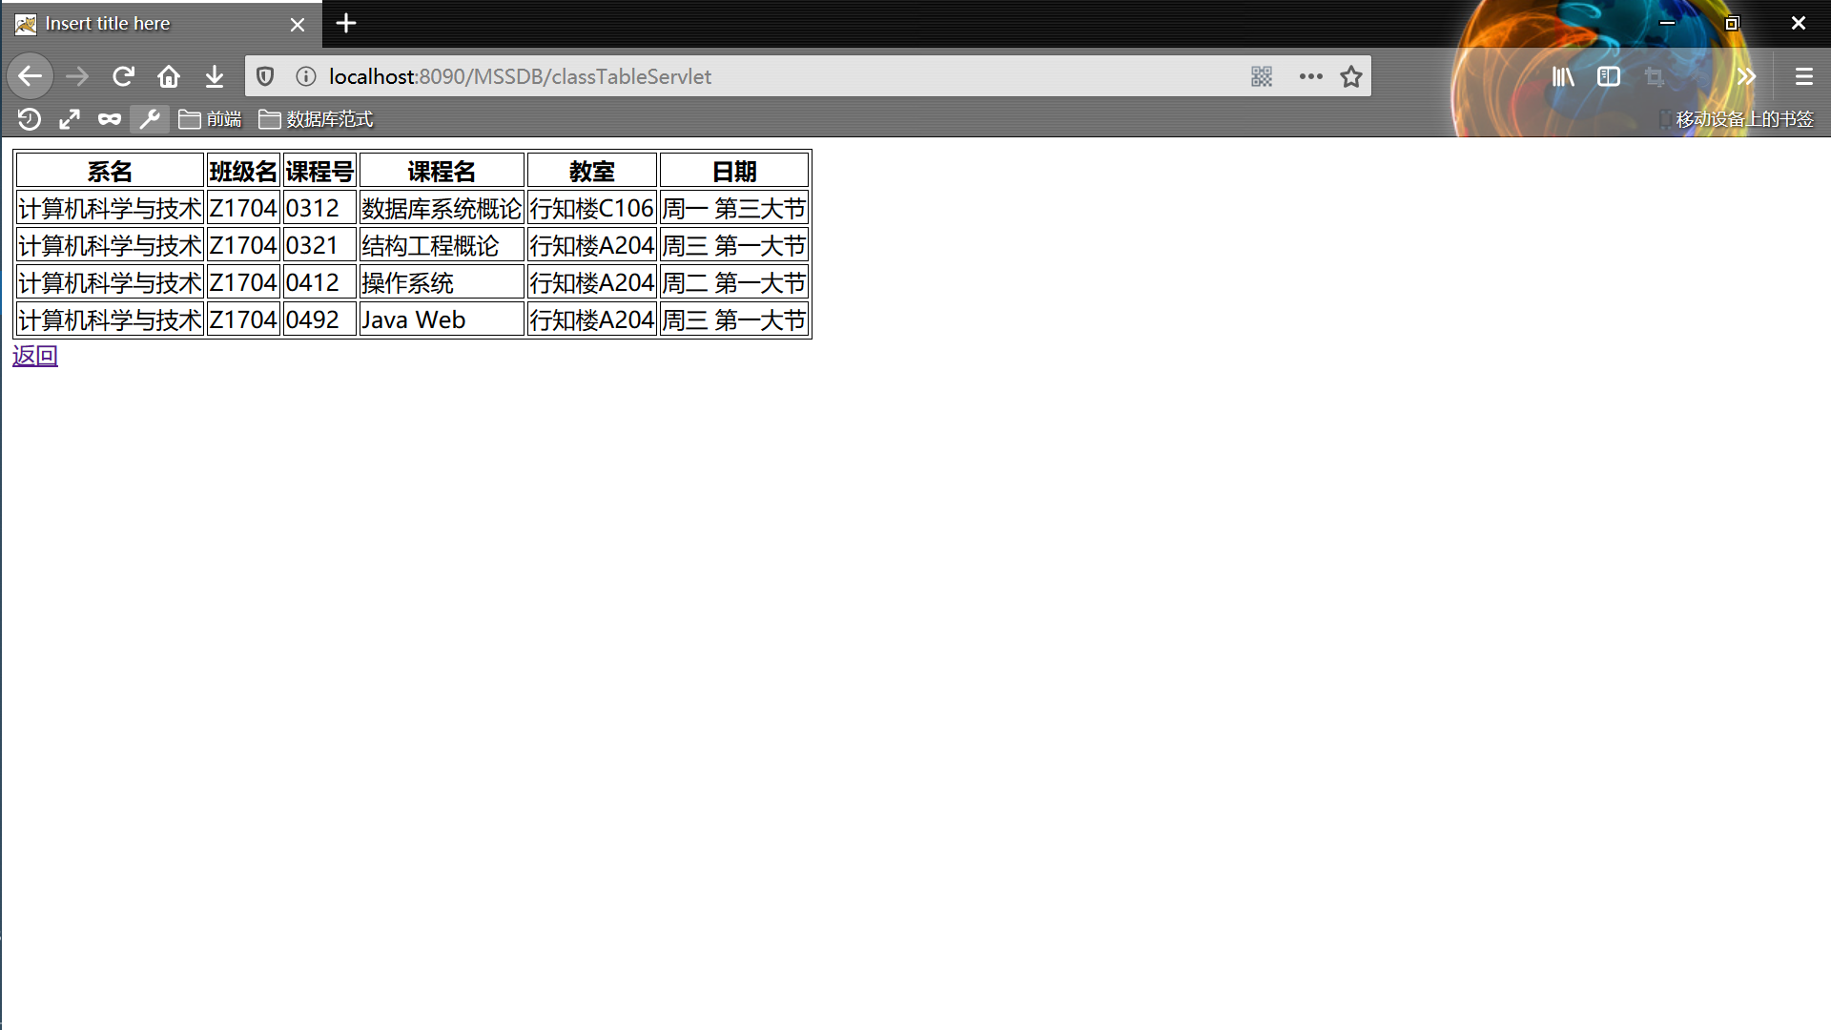
Graph e.4

- Second, it is about instructor table. The results are shown on Graph e.5 and e.6.
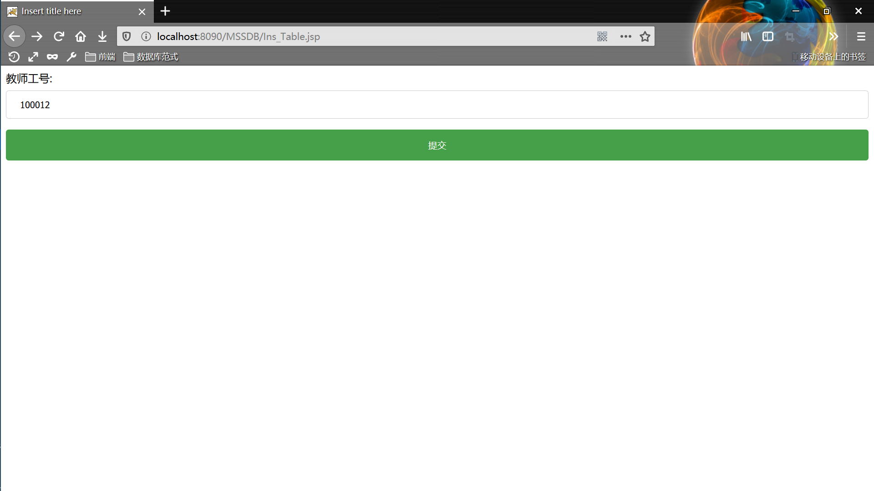
Graph e.5
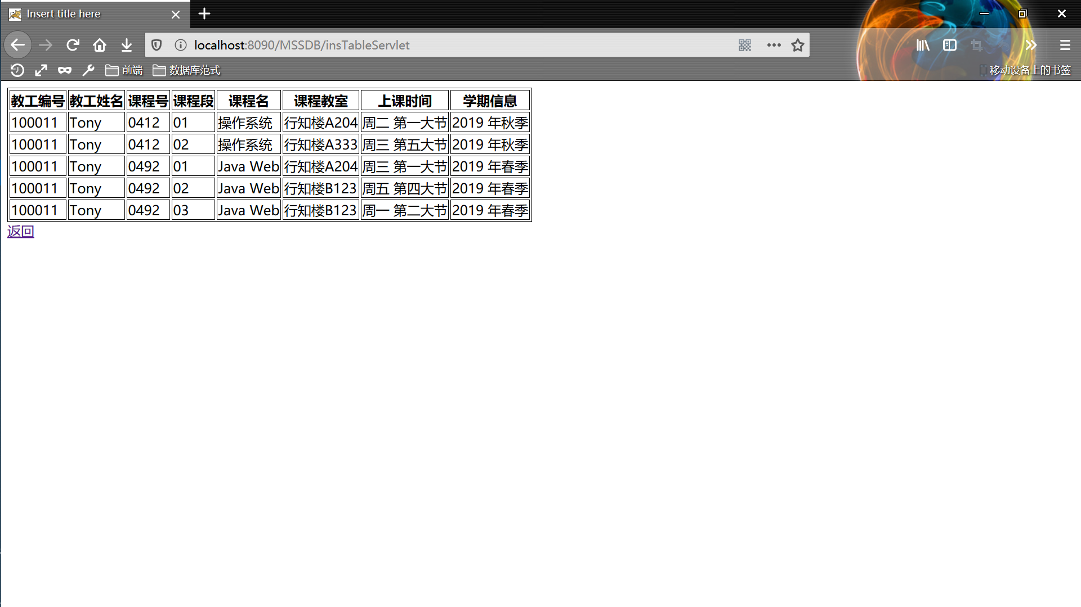
Graph e.6

- Third, it is about student personal grade. The results are shown on Graph e.7 and e.8.
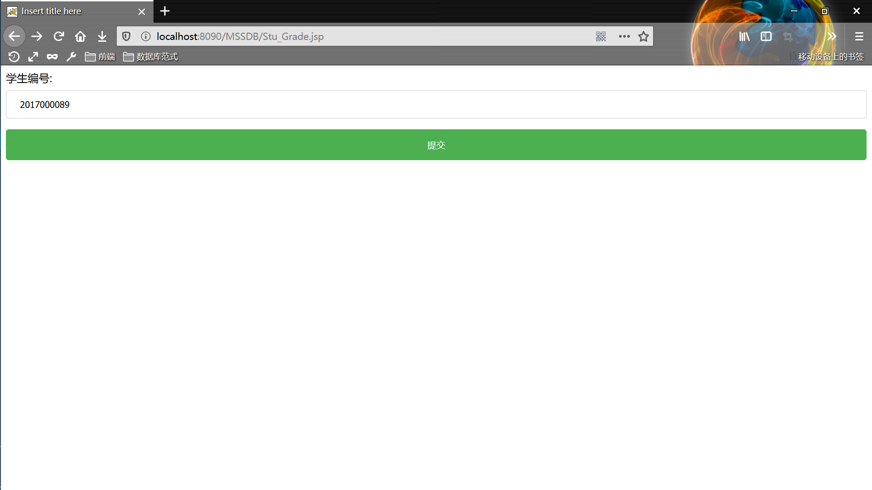
Graph e.7
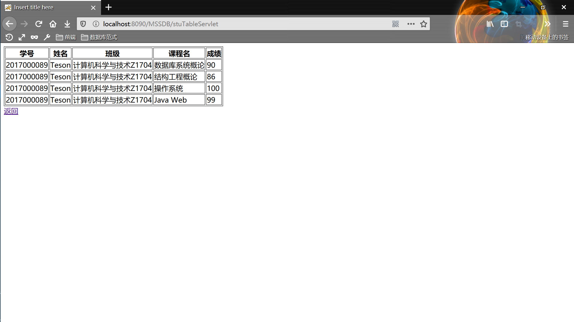
Graph e.8

- Finally, it is about class grade. The results are shown on Graph e.9 and e.10.
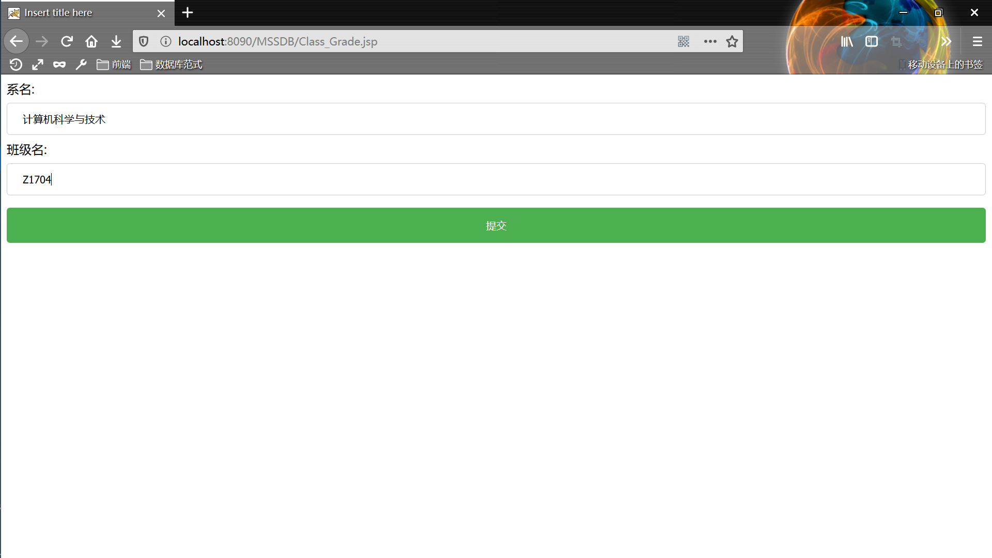
Graph e.9
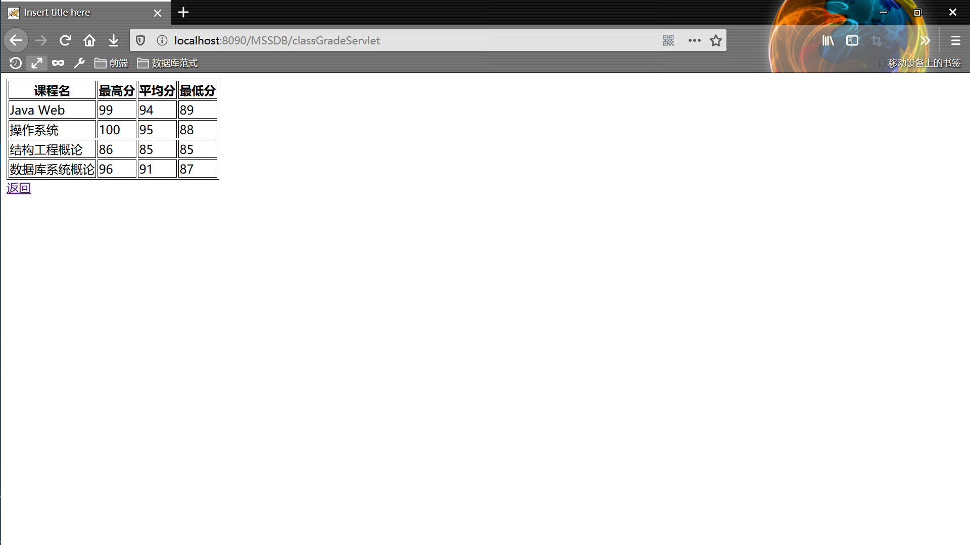
Graph e.10

