Big Mountain Price Model Results

Big Mountain Resort is, by many metrics, one of the top ski resorts in its market segment, and is worth being priced accordingly. We have recently made a $1.5 million investment in a new chairlift to better serve our customers. To offset these costs, we need to choose a strategy to either increase revenue, decrease costs, or some combination of the two. We've turned to a machine learning model to predict the outcome of several possible decisions.

We analyzed data on 330 ski resorts across the United States, with features such as acres of skiable terrain, and days open last year. Our target feature was the ticket price, but there were two different ticket prices—Adult Weekend and Adult Weekday. About 14% of the resorts were missing either price, and 3% were missing one or the other.

We also discovered a few likely errors in the data. One resort with an implausibly high skiable area was checked manually and fixed to the value given on their website. Another resort with an inconsistent skiable area turned out to have no pricing information, so it was disregarded. For the Fast Eight column, only one resort had a value that was both present and above 0, so the feature was dropped. One resort listed that it had been open for 2019 years. Even if it meant that the opening year were 2019, there was no information given on when the data was collected, and it would have been the youngest resort on the list, so the resort was dropped.

Next, we created aggregate information by state, including information about the states themselves, and the total values of some of the features in each state (such as total days open, and total skiable area). Once we had made this use of the resorts, we dropped the resorts with no price data. Since Adult Weekend and Adult weekday were highly correlated, we dropped the one with more values missing and based the rest of our analysis on Adult Weekend tickets.

In our exploratory data analysis, we created new state features, such as a ratio of resorts in a state to the population and area of the state. Montana scores high on the population ratio, with more than one resort per 100,000 people. After applying a PCA transformation, we ran a chart to see if the variance of features between states had any association with the average ticket prices in that state.

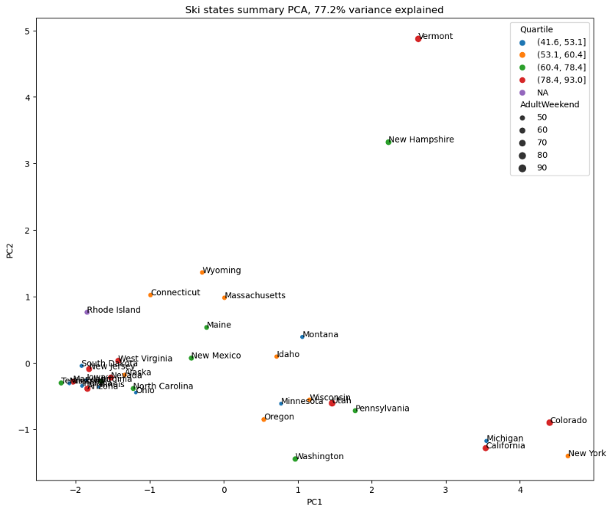

In this image, the size of the dots represent the average ticket price in the state, with the quartiles split into color. There does not appear to be a relationship between features of the state and that state's average ticket prices, so for the rest of the analysis, the state label was disregarded.

Finally, we trained our model. At this point, we discovered that the strongest predictors of ticket price across every resort in our data set were the vertical drop, the acres of snow-making land, the total chairs, and the number of runs. In each of these categories and more, Big Mountain is well above the national average. In Montana, Big Mountain is often at the very top of the state. This justifies not only Big Mountain's premium pricing strategy, but also a suggested price increase.

Our model suggests that the value Big Mountain provides could sustain ticket prices of about $96, up from the current price of $81. Even the most conservative strategy, factoring in the average error in our model's predictions, suggests that our customers would be willing to pay at least $89. If we predict based on the expectation of 350,000 guests this season, each of whom buy 5 tickets, these price changes could have a massive effect. Changing ticket prices alone would create a projected change in revenue of $14 million with the conservative price change, or $26 million if we use the value predicted by the model – more than enough to offset the operating cost of our new chairlift, even with no other changes.

There were other changes proposed, either to cut costs or to increase the value of a ticket. One proposal was to close between one and ten of the least used runs. The model indicates that closing one run would have no effect on the value of a ticket to customers. If it would cut costs, it might be worth doing. If we're going to cut more than one, the optimal number seems to be 5, after which ticket prices take a significant dip (See figure below). Closing six runs, and cutting ticket prices by the recommended $0.66, is projected to decrease revenue by about $1.2 million. If the operations costs saved by the shutdown outweigh the loss, it might be worth doing.

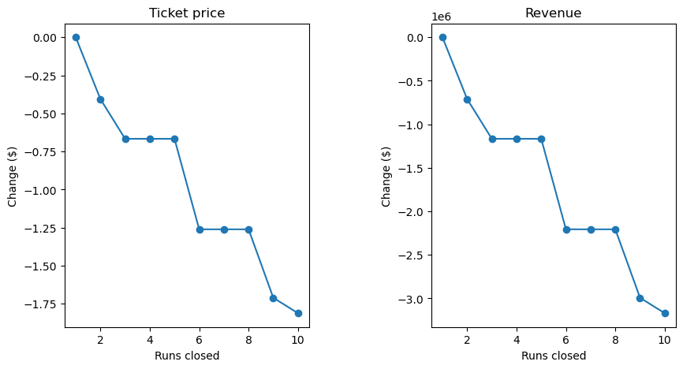

Another proposal suggested adding a run, increasing the vertical drop by 150ft, and adding an additional chairlift. If this proposal were enacted, the model suggests that we could increase the ticket price by about $2, increasing revenue over the course of the season by about $3.5 million. With our last chairlift increasing costs by $1.5 million, this gives room for $2 million of cost to increase the vertical drop and add the extra run, just to break even. This might be cutting it close. The proposed addition to this scenario of adding another 2 acres of snow making did not add any appreciable value to ticket sales, and is not recommended.

The last proposal, increasing the longest run by 0.2 miles and adding a matching 4 acres of snow making capability, did nothing to increase the projected revenue, and should not be considered unless circumstances outside the scope of the model are taken into consideration.

To sum up, a comparison of the prices and features of ski resorts across the country indicated that Big Mountain Resort's prices, while relatively high, are still lower than what they could support. A price increase of at least $8 for a ticket is recommended. Modeling indicates that with the amenities Big Mountain offers, it can support a price increase of around $15. Although certain other cost-cutting or revenue-enhancing measures could increase profit to some extent, the price change alone will have a strong enough impact to offset the cost of the new chairlift ten times over.